INDOOR AIR QUALITY REASSESSMENT

L.B. Merrill Elementary School
687 Pleasant Street
Raynham, Massachusetts

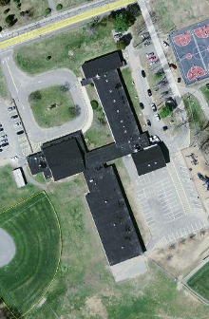

Prepared by:
Massachusetts Department of Public Health
Bureau of Environmental Health
Indoor Air Quality Program
April 2010

Background/Introduction
At the request of Al Baroncelli, Facilities Director for the Bridgewater-Raynham Regional School District, the Massachusetts Department of Public Health (MDPH), Bureau of Environmental Health (BEH) provided assistance and consultation in an on-going effort to monitor and improve indoor air quality in Bridgewater-Raynham Regional schools. On March 9, 2010, Cory Holmes, Environmental Analyst/Regional Inspector for BEH’s Indoor Air Quality (IAQ) Program conducted a reassessment at the L. B. Merrill Elementary School (MES), 687 Pleasant Street, Raynham, Massachusetts. The building was previously visited by BEH staff in October, 2008. A report was issued detailing conditions observed at the time and provided recommendations to improve IAQ (MDPH, 2008).

Actions on MDPH Recommendations
As mentioned, MDPH staff had previously visited the building and issued a report with recommendations to improve indoor air quality (MDPH, 2008). A summary of actions taken on previous recommendations is included as Appendix A.

Methods
Air tests for carbon dioxide, carbon monoxide, temperature and relative humidity were conducted with the TSI, Q-TRAK™ IAQ Monitor, Model 7565. Air tests for airborne particulate matter with a diameter less than 2.5 micrometers were taken with the TSI, DUSTTRAK™ Aerosol Monitor Model 8520. BEH staff also performed a visual inspection of building materials for water damage and/or microbial growth.

Results
The MES currently houses grades pre-K and 1st, with a student population of approximately 365 and a staff of approximately 45. Tests were taken under normal operating conditions and results appear in Table 1.

Discussion

Ventilation
It can be seen from Table 1 that carbon dioxide levels were below 800 parts per million (ppm) in all areas surveyed, indicating adequate air exchange throughout the building the day of the assessment. Fresh air in classrooms is supplied by unit ventilator (univent) systems (Figure 1). A univent draws air from the outdoors through a fresh air intake located on the exterior wall of the building and returns air through an air intake located at the base of the unit. Fresh and return air are mixed, filtered, heated and provided to classrooms through an air diffuser located in the top of the unit. Adjustable louvers control the ratio of outside to recirculated air. Items were seen on top of univents is some areas, which can restrict airflow (Picture 1).
The mechanical exhaust ventilation system consists of ceiling or wall-mounted vents ducted to rooftop motors. In a number of areas exhaust vents are located in close proximity to classroom doors. When classroom doors are left open, the exhaust system not only exhausts air from the classroom but also draws air from the hallway as well, compromising the efficiency of the exhaust system.
To maximize air exchange, the MDPH recommends that both supply and exhaust ventilation operate continuously during periods of school occupancy. In order to have proper ventilation with a mechanical supply and exhaust system, the systems must be balanced to provide an adequate amount of fresh air to the interior of a room while removing stale air from the room. It is recommended that HVAC systems be re-balanced every five years to ensure adequate air systems function (SMACNA, 1994).
The Massachusetts Building Code requires that each room have a minimum ventilation rate of 15 cubic feet per minute (cfm) per occupant of fresh outside air or openable windows (SBBRS, 1997; BOCA, 1993). The ventilation must be on at all times that the room is occupied. Providing adequate fresh air ventilation with open windows and maintaining the temperature in the comfort range during the cold weather season is impractical. Mechanical ventilation is usually required to provide adequate fresh air ventilation.
Carbon dioxide is not a problem in and of itself. It is used as an indicator of the adequacy of the fresh air ventilation. As carbon dioxide levels rise, it indicates that the ventilating system is malfunctioning or the design occupancy of the room is being exceeded. When this happens, a buildup of common indoor air pollutants can occur, leading to discomfort or health complaints. The Occupational Safety and Health Administration (OSHA) standard for carbon dioxide is 5,000 parts per million parts of air (ppm). Workers may be exposed to this level for 40 hours/week, based on a time-weighted average (OSHA, 1997).
The MDPH uses a guideline of 800 ppm for publicly occupied buildings. A guideline of 600 ppm or less is preferred in schools due to the fact that the majority of occupants are young and considered to be a more sensitive population in the evaluation of environmental health status. Inadequate ventilation and/or elevated temperatures are major causes of complaints such as respiratory, eye, nose and throat irritation, lethargy and headaches. For more information concerning carbon dioxide, consult Appendix B.
Indoor temperature measurements ranged from 69º F to 73º F, which were within or very close to the lower end of the MDPH recommended comfort guidelines on the day of the assessment (Table 1). The MDPH recommends that indoor air temperatures be maintained in a range of 70° F to 78° F in order to provide for the comfort of building occupants. In many cases concerning indoor air quality, fluctuations of temperature in occupied spaces are typically experienced, even in a building with an adequate fresh air supply.
The relative humidity measured in the building ranged from 16 to 25 percent, which was below the MDPH recommended comfort range in all areas surveyed during the assessment (Table 1). The MDPH recommends a comfort range of 40 to 60 percent for indoor air relative humidity. Relative humidity levels in the building would be expected to drop during the winter months due to heating. The sensation of dryness and irritation is common in a low relative humidity environment. Low relative humidity is a very common problem during the heating season in the northeast part of the United States.

Microbial/Moisture Concerns
Water damaged ceiling tiles were observed in a number of areas, which indicate current/historic plumbing or roof leaks (Pictures 2 and 3/Table 1). Water damaged ceiling tiles can provide a source of mold and should be replaced after a water leak is discovered and repaired. Missing tiles were observed in classroom 9, where the occupant reported a current roof leak (Picture 4).
The US Environmental Protection Agency (US EPA) and the American Conference of Governmental Industrial Hygienists (ACGIH) recommend that porous materials be dried with fans and heating within 24 to 48 hours of becoming wet (US EPA, 2001; ACGIH, 1989). If not dried within this time frame, mold growth may occur. Once mold has colonized porous materials, they are difficult to clean and should be removed and discarded.
BEH staff examined conditions on the exterior of the building for potential sources of water pooling/penetration. Gutters and downspouts along the rear of the cafeteria were observed damaged, disconnected and/or in disrepair (Picture 5), which can allow water to accumulate against the building. Also observed on the exterior of the building was missing/damaged brick and mortar around masonry (Picture 6). Over time, these conditions can undermine the integrity of the building envelope and provide a means of water entry into the building via capillary action through foundation concrete and masonry (Lstiburek & Brennan, 2001).

Other IAQ Evaluations
Indoor air quality can be negatively influenced by the presence of respiratory irritants, such as products of combustion. The process of combustion produces a number of pollutants. Common combustion emissions include carbon monoxide, carbon dioxide, water vapor, and smoke (fine airborne particle material). Of these materials, exposure to carbon monoxide and particulate matter with a diameter of 2.5 micrometers (μm) or less (PM2.5) can produce immediate, acute health effects upon exposure. To determine whether combustion products were present in the indoor environment, BEH staff obtained measurements for carbon monoxide and PM2.5.

Carbon Monoxide
Carbon monoxide is a by-product of incomplete combustion of organic matter (e.g., gasoline, wood and tobacco). Exposure to carbon monoxide can produce immediate and acute health affects. Several air quality standards have been established to address carbon monoxide and prevent symptoms from exposure to these substances. The MDPH established a corrective action level concerning carbon monoxide in ice skating rinks that use fossil-fueled ice resurfacing equipment. If an operator of an indoor ice rink measures a carbon monoxide level over 30 ppm, taken 20 minutes after resurfacing within a rink, that operator must take actions to reduce carbon monoxide levels (MDPH, 1997).
The American Society of Heating Refrigeration and Air-Conditioning Engineers (ASHRAE) has adopted the National Ambient Air Quality Standards (NAAQS) as one set of criteria for assessing indoor air quality and monitoring of fresh air introduced by HVAC systems (ASHRAE, 1989). The NAAQS are standards established by the US EPA to protect the public health from six criteria pollutants, including carbon monoxide and particulate matter (US EPA, 2006). As recommended by ASHRAE, pollutant levels of fresh air introduced to a building should not exceed the NAAQS levels (ASHRAE, 1989). The NAAQS were adopted by reference in the Building Officials & Code Administrators (BOCA) National Mechanical Code of 1993 (BOCA, 1993), which is now an HVAC standard included in the Massachusetts State Building Code (SBBRS, 1997). According to the NAAQS, carbon monoxide levels in outdoor air should not exceed 9 ppm in an eight-hour average (US EPA, 2006).
Carbon monoxide should not be present in a typical, indoor environment. If it is present, indoor carbon monoxide levels should be less than or equal to outdoor levels. Outdoor carbon monoxide concentrations were non-detect (ND) the day of the assessment (Table 1). No measureable levels of carbon monoxide were detected in the building during the assessment (Table 1).

Particulate Matter
The US EPA has established NAAQS limits for exposure to particulate matter. Particulate matter is airborne solids that can be irritating to the eyes, nose and throat. The NAAQS originally established exposure limits to particulate matter with a diameter of 10 μm or less (PM10). According to the NAAQS, PM10 levels should not exceed 150 microgram per cubic meter (μg/m³) in a 24-hour average (US EPA, 2006). These standards were adopted by both ASHRAE and BOCA. Since the issuance of the ASHRAE standard and BOCA Code, US EPA established a more protective standard for fine airborne particles. This more stringent PM2.5 standard requires outdoor air particle levels be maintained below 35 μg/m³ over a 24-hour average (US EPA, 2006). Although both the ASHRAE standard and BOCA Code adopted the PM10 standard for evaluating air quality, MDPH uses the more protective PM2.5 standard for evaluating airborne particulate matter concentrations in the indoor environment.
Outdoor PM2.5 concentrations were measured at 12 μg/m³ (Table 1). PM2.5 levels measured indoors ranged from 5 to 9 μg/m³ (Table 1), which were below the NAAQS PM2.5 level of 35 μg/m³ (Table 1). Frequently, indoor air levels of particulates (including PM2.5) can be at higher levels than those measured outdoors. A number of mechanical devices and/or activities that occur indoors can generate particulate during normal operations. Sources of indoor airborne particulates may include but are not limited to particles generated during the operation of fan belts in the HVAC system, cooking in the cafeteria stoves and microwave ovens; use of photocopiers, fax machines and computer printing devices; operation of an ordinary vacuum cleaner and heavy foot traffic indoors.

Volatile Organic Compounds
Indoor air concentrations can be greatly impacted by the use of products containing volatile organic compounds (VOCs). VOCs are carbon-containing substances that have the ability to evaporate at room temperature. Frequently, exposure to low levels of total VOCs (TVOCs) may produce eye, nose, throat and/or respiratory irritation in some sensitive individuals. For example, chemicals evaporating from a paint can stored at room temperature would most likely contain VOCs. Materials containing VOCs were present in the school.
Several classrooms contained dry erase boards and dry erase board markers. Materials such as permanent markers, dry erase markers and dry erase board cleaners may contain VOCs, such as methyl isobutyl ketone, n-butyl acetate and butyl-cellusolve (Sanford, 1999), which can be irritating to the eyes, nose and throat.

Other Conditions
Other conditions that can affect indoor air quality were observed during the assessment. A number of personal fans were observed to have accumulated dust/debris (Picture 7). These fans should be cleaned in order to prevent dust/debris from being aerosolized and redistributed throughout the room when activated. This observation was documented previously by MDPH (MDPH, 2008).

Conclusions/Recommendations
BRRS officials, working in conjunction with private contractors, MES administration, faculty members and school maintenance staff, have improved indoor environmental conditions in the building by implementing a number of MDPH’s previous recommendations. As indicated in Appendix A, several of these recommendations need further action. In view of the findings at the time of this visit, the following additional recommendations are made to further improve indoor air quality:
- Continue to operate all ventilation systems throughout the building (e.g., gym, cafeteria, classrooms) continuously during periods of school occupancy.
- Close classroom doors to maximize exhaust capabilities.
- Use openable windows in conjunction with classroom univents and exhaust vents to facilitate air exchange. Care should be taken to ensure windows are properly closed at night and weekends to avoid the freezing of pipes and potential flooding.
- Remove all blockages in classrooms from univents to ensure adequate airflow.
- Consider adopting a balancing schedule of every 5 years for all mechanical ventilation systems, as recommended by ventilation industrial standards (SMACNA, 1994).
- For buildings in New England, periods of low relative humidity during the winter are often unavoidable. Therefore, scrupulous cleaning practices should be adopted to minimize common indoor air contaminants whose irritant effects can be enhanced when the relative humidity is low. To control dusts, a high efficiency particulate arrestance (HEPA) filter equipped vacuum cleaner in conjunction with wet wiping of all surfaces is recommended. Avoid the use of feather dusters. Drinking water during the day can help ease some symptoms associated with a dry environment (throat and sinus irritations).
- Repair/replace damaged gutters and downspouts, particulary along the rear of the cafeteria.
- Repoint/repair damaged brick/masonry around the exterior of the building.
- Ensure all roof leaks are repaired (e.g., classroom 9), and replace water damaged ceiling tiles. Examine the area above and around water-damaged areas for mold growth. Disinfect areas with an appropriate antimicrobial as needed.
- Relocate or consider reducing the amount of materials stored in classrooms to allow for more thorough cleaning of classrooms. Clean items regularly with a wet cloth or sponge to prevent excessive dust build-up.
- Clean accumulated dust and debris periodically from the surface of personal fans.
- Consider adopting the US EPA (2000) document, “Tools for Schools”, as an instrument for maintaining a good indoor air quality environment in the building. This document is available at: http://www.epa.gov/iaq/schools/index.html.
- Refer to resource manual and other related indoor air quality documents located on the MDPH’s website for further building-wide evaluations and advice on maintaining public buildings. This includes MDPH’s newest guidance document related to PCBs in building materials. These documents are available at: http://mass.gov/dph/iaq.

References
ACGIH. 1989. Guidelines for the Assessment of Bioaerosols in the Indoor Environment. American Conference of Governmental Industrial Hygienists, Cincinnati, OH.
ASHRAE. 1989. Ventilation for Acceptable Indoor Air Quality. American Society of Heating, Refrigeration and Air Conditioning Engineers. ANSI/ASHRAE 62-1989.
BOCA. 1993. The BOCA National Mechanical Code/1993. 8th ed. Building Officials & Code Administrators International, Inc., Country Club Hills, IL.
Lstiburek, J. & Brennan, T. 2001. Read This Before You Design, Build or Renovate. Building Science Corporation, Westford, MA. U.S. Department of Housing and Urban Development, Region I, Boston, MA
MDPH. 2008. Indoor Air Quality Assessment. L.B. Merrill Elementary School, Raynham, MA. Massachusetts Department of Public Health, Bureau of Environmental Health, Boston, MA.
MDPH. 1997. Requirements to Maintain Air Quality in Indoor Skating Rinks (State Sanitary Code, Chapter XI). 105 CMR 675.000. Massachusetts Department of Public Health, Boston, MA.
OSHA. 1997. Limits for Air Contaminants. Occupational Safety and Health Administration. Code of Federal Regulations. 29 C.F.R 1910.1000 Table Z-1-A.
Sanford. 1999. Material Safety Data Sheet (MSDS No: 198-17). Expo® Dry Erase Markers Bullet, Chisel, and Ultra Fine Tip. Sanford Corporation. Bellwood, IL.
SBBRS. 1997. Mechanical Ventilation. State Board of Building Regulations and Standards. Code of Massachusetts Regulations. 780 CMR 1209.0
SMACNA. 1994. HVAC Systems Commissioning Manual. 1st ed. Sheet Metal and Air Conditioning Contractors’ National Association, Inc., Chantilly, VA.
US EPA. 2000. Tools for Schools. Office of Air and Radiation, Office of Radiation and Indoor Air, Indoor Environments Division (6609J). EPA 402-K-95-001, Second Edition. http://www.epa.gov/iaq/schools/tools4s2.html
US EPA. 2001. “Mold Remediation in Schools and Commercial Buildings”. Office of Air and Radiation, Indoor Environments Division, Washington, DC. EPA 402-K-01-001. March 2001. Available at: http://www.epa.gov/iaq/molds/mold_remediation.html
US EPA. 2006. National Ambient Air Quality Standards (NAAQS). US Environmental Protection Agency, Office of Air Quality Planning and Standards, Washington, DC. http://www.epa.gov/air/criteria.html.
Picture 1



Various Items on top of Univent Air Diffuser

Picture 2

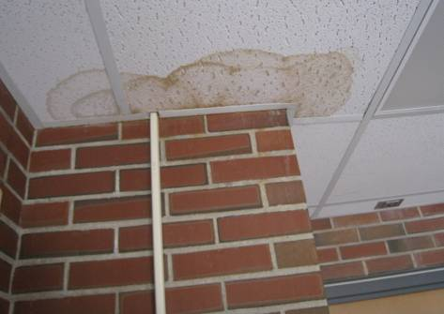

Water Damaged Ceiling Tiles in Gym Hallway

Picture 3

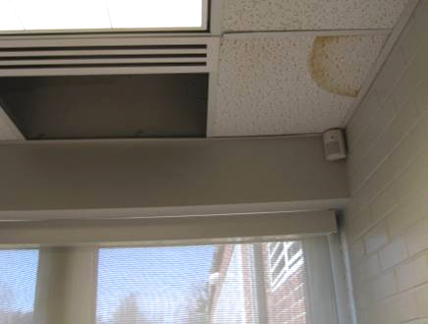

Water Damaged/Missing Ceiling Tiles in Classroom

Picture 4

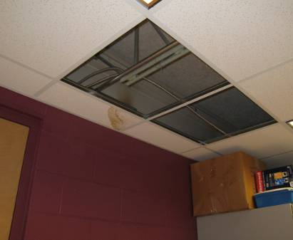

Active Leak Reported in Classroom 9, Note Water Damaged/Missing Ceiling Tiles

Picture 5

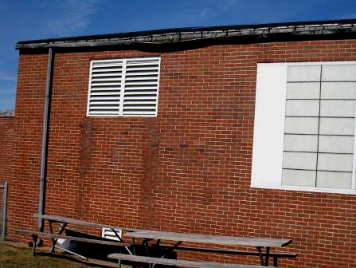

Damaged Gutter and Disconnected Elbow at Base of Downspout to Rear of Cafeteria

Picture 6

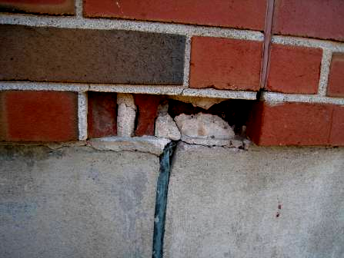

Missing/Damaged Brick/Mortar

Picture 7

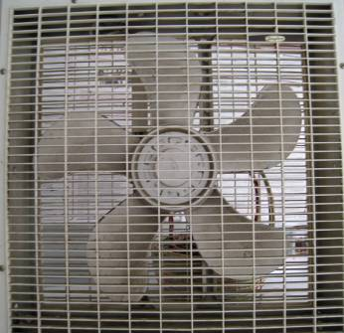

Fan in Classroom with Accumulated Dust and Debris
Location/ Room | Occupants  in Room | Temp  (°F) | Relative  Humidity  (%) | Carbon  Dioxide  (ppm) | Carbon Monoxide  (ppm) | PM2.5  (µg/m³) | Windows  Openable | Ventilation |  | Remarks
 |  |  |  |  |  |  |  | Supply | Exhaust | Remarks
background |  | 57 | 18 | 333 | ND | 12 |  |  |  | Cool, sunny, scattered clouds, NW winds 4-15 mph gusts up to 23 mph
Holt | 21 | 70 | 24 | 638 | ND | 8 | Y | Y | Y | PF, DO
Computer Lab | 0 | 69 | 20 | 479 | ND | 9 | Y | Y | Y | Plants, PF
12 | 25 | 70 | 25 | 671 | ND | 9 | Y | Y | Y | DO
11 | 23 | 72 | 21 | 608 | ND | 9 | Y | Y | Y | DO, PF
10 | 23 | 72 | 23 | 666 | ND | 9 | Y | Y | Y | DO, plants
9 | 13 | 73 | 18 | 521 | ND | 8 | Y | Y | Y | MT (2) reportedly due to active roof leak
8 | 2 | 73 | 16 | 390 | ND | 9 | Y | Y | Y | 23 occupants gone 5 minutes, DO, PF, items on UV
7 | 12 | 73 | 18 | 531 | ND | 8 | Y | Y | Y | DO, AC
6 | 25 | 71 | 22 | 719 | ND | 8 | Y | Y | Y | DO
5 | 20 | 73 | 19 | 599 | ND | 9 | Y | Y | Y | DO, humidifier (clean/dry)
4 Teachers’ Work Room | 4 | 72 | 19 | 435 | ND | 8 | Y | Y | Y | DO, PF-dirty, lamination machines, PCs (recommend shutting door during lamination & photocopying activities)
Library | 0 | 71 | 16 | 359 | ND | 9 | Y | Y | Y | DO
Pupil Support | 4 | 70 | 21 | 470 | ND | 9 | Y | N | Y | UV in speech therapy room
Speech Therapy | 0 | 70 | 18 | 364 | ND | 7 | N | Y | Y | DO
Conference Room | 0 | 70 | 22 | 454 | ND | 7 | N | Y | Y
School Psychologist | 1 | 71 | 22 | 483 | ND | 7 | Y | Y | Y | 2 WD CT near vent
Office 151 | 1 | 73 | 22 | 562 | ND | 8 | Y | Y | Y | WD CT/MT leak?
Nurse’s Office | 1 | 73 | 21 | 548 | ND | 7 | Y | Y | Y | DO
Staff Lounge | 1 | 73 | 19 | 430 | ND | 7 | Y | Y | Y | PF-dirty
Gym | 23 | 72 | 22 | 562 | ND | 8 | Y | Y | Y | DO
Hallway near Gym |  |  |  |  |  |  |  |  |  | 2 WD CTs
13 | 23 | 73 | 20 | 545 | ND | 8 | Y | Y | Y | DO
14 | 23 | 73 | 21 | 623 | ND | 7 | Y | Y | Y | DO, AC
16 | 21 | 72 | 20 | 588 | ND | 9 | Y | Y | Y | Plants, DO
15 | 21 | 71 | 18 | 600 | ND | 7 | Y | Y | Y | Items on UV, terrarium, plants
17 | 20 | 71 | 20 | 591 | ND | 9 | Y | Y | Y | DO, broken window, (double paned)
18 | 0 | 72 | 19 | 450 | ND | 7 | Y | Y | Y | PF-dirty
Cafeteria | 0 | 72 | 18 | 422 | ND | 5 | Y | Y | Y | TB-table, ceiling fans
Main Hallway (outside café) |  |  |  |  |  |  |  |  |  | 4 WD CTs

Actions on MDPH Recommendations, Merrill Elementary School,
Raynham, MA

The following is a status report of action(s) taken on MDPH recommendations (in bold) based on reports from school officials, maintenance staff, documents, photographs and MDPH staff observations.
- Continue to operate all ventilation systems throughout the building (e.g., gym, auditorium, classrooms) continuously during periods of school occupancy independent of thermostat control to maximize air exchange.
- Action: All systems were operating during the assessment.
- Close classroom doors to facilitate air exchange.
- Action: Doors remain open in many rooms throughout the building at the request of school staff.
- Use openable windows in conjunction with mechanical ventilation to supplement air exchange.
- Action: No windows were open during the assessment.
- Inspect gutters and downspouts around the perimeter of building periodically for integrity/proper drainage, make repairs as needed.
- Action: Gutters/downspouts were in disrepair outside of the cafeteria.
- Ensure plants have drip pans. Examine drip pans periodically for mold growth and disinfect with an appropriate antimicrobial where necessary. Remove plants from the air stream of mechanical ventilation.
- Action: Plants appeared to be properly maintained.
- Clean accumulated dust and debris periodically from the interior of univent air diffusers, exhaust vents and blades of personal fans.
- Action: A number of personal fans in classrooms were observed to have accumulated dust/debris and should be cleaned prior to activation.
- Store cleaning products properly and out of reach of students.
- Action: Cleaning products were stored properly at the time of the assessment.

