INDOOR AIR QUALITY ASSESSMENT

L. B. Merrill Elementary School
687 Pleasant Street
Raynham, Massachusetts 02767



Prepared by:
Massachusetts Department of Public Health
Bureau of Environmental Health
Indoor Air Quality Program
December 2008

Background/Introduction
At the request of Al Baroncelli, Facilities Director for the Bridgewater-Raynham Regional School District, the Massachusetts Department of Public Health (MDPH), Bureau of Environmental Health (BEH) provided assistance and consultation in an on-going effort to monitor and improve indoor air quality in each of the Bridgewater-Raynham Regional schools. On October 24, 2008, Cory Holmes, Environmental Analyst/Regional Inspector for BEH’s Indoor Air Quality (IAQ) Program conducted an assessment at the L. B. Merrill Elementary School (MES), 687 Pleasant Street, Raynham, Massachusetts.
The MES is a one-story, red-brick building constructed in 1959. An addition was built in the late 1960’s. The building underwent extensive renovations in 2003, which included new windows, mechanical ventilation, and interior renovation of building materials. The roof was not replaced during this renovation; however, it is reported to be included in future capital improvement plans. The school consists of general classrooms, gymnasium, kitchen/cafeteria, media center, art room/music room, teacher work rooms and office space. Windows are openable throughout the building.

Methods
Air tests for carbon dioxide, carbon monoxide, temperature and relative humidity were conducted with the TSI, Q-TRAK™ IAQ Monitor, Model 8554. Air tests for airborne particulate matter with a diameter less than 2.5 micrometers were taken with the TSI, DUSTTRAK™ Aerosol Monitor Model 8520. BEH staff also performed a visual inspection of building materials for water damage and/or microbial growth.

Results
The MES currently houses grades pre-K and 1st, with a student population of 363 and a staff of approximately 45-50. Tests were taken under normal operating conditions and results appear in Table 1.

Discussion

Ventilation
It can be seen from Table 1 that carbon dioxide levels were below 800 parts per million (ppm) in all but one area surveyed, indicating adequate air exchange throughout the building on the day of the assessment. It is important to note that several areas with carbon dioxide levels below 800 ppm were sparsely populated, unoccupied and/or had windows open, which can greatly reduce carbon dioxide levels. Carbon dioxide levels would be expected to be higher with full occupancy and with windows shut.
Fresh air in exterior classrooms is supplied by unit ventilator (univent) systems (Picture 1). A univent is designed to draw air from outdoors through a fresh air intake located on the exterior wall of the building (Picture 2). Return air is drawn through an air intake located at the base of the unit (Figure 1). Fresh and return air are mixed, filtered, heated and provided to classrooms through an air diffuser located in the top of the unit.
Exhaust ventilation in classrooms is provided by wall or ceiling-mounted vents (Pictures 3 and 4) powered by rooftop motors. Exhaust vents were operating in all areas surveyed the day of the assessment. It is important to note that the location of some exhaust vents can limit exhaust efficiency. In some classrooms, exhaust vents are located above hallway doors (Pictures 3 and 4). When classroom doors are open, exhaust vents tend to draw air from the hallway, thereby reducing the effectiveness of the vents to remove common environmental pollutants from classrooms.
Fresh air for common areas such as the gymnasium, cafeteria, library and administrative areas is provided by rooftop or ceiling-mounted air handling units (AHUs) (Pictures 5 through 7). AHUs draw in air through outdoor air intakes (Picture 8); filter, heat and/or cool the air, and then distribute it to occupied areas via ceiling-mounted air diffusers. Exhaust air is returned back to the AHUs via ceiling-mounted return vents, with the exception of the gym where air is removed directly by local exhaust motors (Picture 9). These systems appeared to be operating during the assessment.
To maximize air exchange, the MDPH recommends that both supply and exhaust ventilation operate continuously during periods of school occupancy. In order to have proper ventilation with a mechanical supply and exhaust system, the systems must be balanced to provide an adequate amount of fresh air to the interior of a room while removing stale air from the room. It is recommended that existing ventilation systems be re-balanced every five years to ensure adequate air systems function (SMACNA, 1994). The date of the last balancing of these systems was not available at the time of the assessment, but should have occurred at some point after renovations in 2003.
The Massachusetts Building Code requires a minimum ventilation rate of 15 cubic feet per minute (cfm) per occupant of fresh outside air or have openable windows in each room (SBBRS, 1997; BOCA, 1993). The ventilation must be on at all times that the room is occupied. Providing adequate fresh air ventilation with open windows and maintaining the temperature in the comfort range during the cold weather season is impractical. Mechanical ventilation is usually required to provide adequate fresh air ventilation.
Carbon dioxide is not a problem in and of itself. It is used as an indicator of the adequacy of the fresh air ventilation. As carbon dioxide levels rise, it indicates that the ventilating system is malfunctioning or the design occupancy of the room is being exceeded. When this happens a buildup of common indoor air pollutants can occur, leading to discomfort or health complaints. The Occupational Safety and Health Administration (OSHA) standard for carbon dioxide is 5,000 parts per million parts of air (ppm). Workers may be exposed to this level for 40 hours/week based on a time weighted average (OSHA, 1997).
The MDPH uses a guideline of 800 ppm for publicly occupied buildings. A guideline of 600 ppm or less is preferred in schools due to the fact that the majority of occupants are young and considered to be a more sensitive population in the evaluation of environmental health status. Inadequate ventilation and/or elevated temperatures are major causes of complaints such as respiratory, eye, nose and throat irritation, lethargy and headaches. For more information concerning carbon dioxide, please see Appendix A.
Temperature readings indoors on the day of the assessment ranged from 69º F to 74º F, which were within or very close to the lower level of the MDPH comfort guidelines. The MDPH recommends that indoor air temperatures be maintained in a range of 70 º F to 78 º F in order to provide for the comfort of building occupants. In many cases concerning indoor air quality, fluctuations of temperature in occupied spaces are typically experienced, even in a building with an adequate fresh air supply.
The relative humidity measurements ranged from 24 to 30 percent, which were below the MDPH recommended comfort range the day of the assessment. The MDPH recommends a comfort range of 40 to 60 percent for indoor air relative humidity. Relative humidity levels in the building would be expected to drop during the winter months due to heating. The sensation of dryness and irritation is common in a low relative humidity environment. Low relative humidity is a very common problem during the heating season in the northeast part of the United States.

Microbial/Moisture Concerns
Plants were noted in several classrooms. Plants can be a source of pollen and mold, which can be respiratory irritants for some individuals. Plants should be properly maintained and equipped with drip pans to prevent water damage to porous building materials, which can lead to mold growth. Plants should also be located away from ventilation sources (e.g., air intakes, univent diffusers) to prevent the entrainment and/or aerosolization of dirt, pollen or mold.
BEH staff examined conditions on the exterior of the building for potential sources of water pooling/penetration. Gutters and downspouts along the rear of the cafeteria were observed damaged, disconnected or in of repair (Pictures 10 and 11), which can allow water to accumulate against the building. Over time, these conditions can undermine the integrity of the building envelope and provide a means of water entry into the building via capillary action through foundation concrete and masonry (Lstiburek & Brennan, 2001).

Other IAQ Evaluations
Indoor air quality can be negatively influenced by the presence of respiratory irritants, such as products of combustion. The process of combustion produces a number of pollutants. Common combustion emissions include carbon monoxide, carbon dioxide, water vapor and smoke (fine airborne particle material). Of these materials, exposure to carbon monoxide and particulate matter with a diameter of 2.5 micrometers (μm) or less (PM2.5) can produce immediate, acute health effects upon exposure. To determine whether combustion products were present in the school environment, BEH staff obtained measurements for carbon monoxide and PM2.5.
Carbon Monoxide
Carbon monoxide is a by-product of incomplete combustion of organic matter (e.g., gasoline, wood and tobacco). Exposure to carbon monoxide can produce immediate and acute health affects. Several air quality standards have been established to address carbon monoxide and prevent symptoms from exposure to these substances. The MDPH established a corrective action level concerning carbon monoxide in ice skating rinks that use fossil-fueled ice resurfacing equipment. If an operator of an indoor ice rink measures a carbon monoxide level over 30 ppm, taken 20 minutes after resurfacing within a rink, that operator must take actions to reduce carbon monoxide levels (MDPH, 1997).
The American Society of Heating Refrigeration and Air-Conditioning Engineers (ASHRAE) has adopted the National Ambient Air Quality Standards (NAAQS) as one set of criteria for assessing indoor air quality and monitoring of fresh air introduced by HVAC systems (ASHRAE, 1989). The NAAQS are standards established by the US EPA to protect the public health from six criteria pollutants, including carbon monoxide and particulate matter (US EPA, 2006). As recommended by ASHRAE, pollutant levels of fresh air introduced to a building should not exceed the NAAQS levels (ASHRAE, 1989). The NAAQS were adopted by reference in the Building Officials & Code Administrators (BOCA) National Mechanical Code of 1993 (BOCA, 1993), which is now an HVAC standard included in the Massachusetts State Building Code (SBBRS, 1997). According to the NAAQS, carbon monoxide levels in outdoor air should not exceed 9 ppm in an eight-hour average (US EPA, 2006).
Carbon monoxide should not be present in a typical, indoor environment. If it is present, indoor carbon monoxide levels should be less than or equal to outdoor levels. On the day of assessment, outdoor carbon monoxide concentrations were non-detect (ND). No measurable levels of carbon monoxide were detected in the building (Table 1).
Particulate Matter (PM2.5)
The US EPA has established NAAQS limits for exposure to particulate matter. Particulate matter is airborne solids that can be irritating to the eyes, nose and throat. The NAAQS originally established exposure limits to particulate matter with a diameter of 10 μm or less (PM10). According to the NAAQS, PM10 levels should not exceed 150 microgram per cubic meter (μg/m³) in a 24-hour average (US EPA, 2006). These standards were adopted by both ASHRAE and BOCA. Since the issuance of the ASHRAE standard and BOCA Code, US EPA proposed a more protective standard for fine airborne particles. This more stringent PM2.5 standard requires outdoor air particle levels be maintained below 35 μg/m³ over a 24-hour average (US EPA, 2006). Although both the ASHRAE standard and BOCA Code adopted the PM10 standard for evaluating air quality, MDPH uses the more protective proposed PM2.5 standard for evaluating airborne particulate matter concentrations in the indoor environment.
Outdoor PM2.5 concentrations were measured at 22 μg/m³ (Table 1). PM2.5 levels measured indoors ranged from 9 to 23 μg/m³ (Table 1). Both indoor and outdoor PM2.5 levels were below the NAAQS PM2.5 level of 35 μg/m³. Frequently, indoor air levels of particulates (including PM2.5) can be at higher levels than those measured outdoors. A number of mechanical devices and/or activities that occur in schools can generate particulate during normal operations. Sources of indoor airborne particulates may include but are not limited to particles generated during the operation of fan belts in the HVAC system, cooking in the cafeteria stoves and microwave ovens; use of photocopiers, fax machines and computer printing devices; operation of an ordinary vacuum cleaner and heavy foot traffic indoors.
Volatile Organic Compounds
Indoor air quality can also be impacted by the presence of materials containing volatile organic compounds (VOCs). VOCs are substances that have the ability to evaporate at room temperature. Frequently, exposure to low levels of total VOCs (TVOCs) may produce eye, nose, throat and/or respiratory irritation in some sensitive individuals. For example, chemicals evaporating from a paint can stored at room temperature would most likely contain VOCs. In an effort to identify materials that can potentially increase indoor VOC concentrations, BEH staff examined classrooms for products containing these respiratory irritants.
The majority of classrooms contained dry erase boards and related materials. Materials such as dry erase markers and dry erase board cleaners may contain VOCs, such as methyl isobutyl ketone, n-butyl acetate and butyl-cellusolve (Sanford, 1999), which can be irritating to the eyes, nose and throat. Cleaning products were also observed on countertops or below sinks in a number of classrooms. Like dry erase materials, cleaning products contain VOCs and other chemicals. These chemicals can be irritating to the eyes, nose and throat and should be kept out of reach of students.
Other Conditions
Other conditions that can affect indoor air quality were observed during the assessment. The univent in classroom 10 had debris inside the unit/diffuser (Picture 12). Debris inside the univent can become heated and provide a source of irritating odors when the heat/fan is activated, other material can become airborne and provide a source of eye and respiratory irritation.
Finally, a number of classrooms contained personal fans that had accumulated dust (Picture 13). If exhaust vents are not functioning, backdrafting can occur, which can re-aerosolize dust particles. In addition, these materials can accumulate on flat surfaces (e.g., desktops, shelving and carpets) in occupied areas and subsequently be re-aerosolized causing further irritation. Dust can be irritating to eyes, nose and the respiratory tract.

Conclusions/Recommendations
In view of the findings at the time of the visit, the following recommendations are made to improve indoor air quality:
- Continue to operate all ventilation systems throughout the building (e.g., gym, auditorium, classrooms) continuously during periods of school occupancy independent of thermostat control to maximize air exchange.
- Close classroom doors to facilitate air exchange.
- Use openable windows in conjunction with mechanical ventilation to supplement air exchange. Care should be taken to ensure windows are properly closed at night and on weekends to avoid the freezing of pipes and potential flooding.
- For buildings in New England, periods of low relative humidity during the winter are often unavoidable. Therefore, scrupulous cleaning practices should be adopted to minimize common indoor air contaminants whose irritant effects can be enhanced when the relative humidity is low. To control for dusts, a high efficiency particulate arrestance (HEPA) filter equipped vacuum cleaner in conjunction with wet wiping of all surfaces is recommended. Avoid the use of feather dusters. Drinking water during the day can help ease some symptoms associated with a dry environment (throat and sinus irritations).
- Inspect gutters and downspouts around the perimeter of building periodically for integrity/proper drainage, make repairs as needed.
- Ensure plants have drip pans. Examine drip pans periodically for mold growth and disinfect with an appropriate antimicrobial where necessary. Remove plants from the air stream of mechanical ventilation.
- Clean accumulated dust and debris periodically from the interior of univent air diffusers, exhaust vents and blades of personal fans.
- Store cleaning products properly and out of reach of students.
- Consider adopting the US EPA (2000) document, “Tools for Schools”, to maintain a good indoor air quality environment on the building. This document can be downloaded from the Internet at: http://www.epa.gov/iaq/schools/index.html.
- Refer to resource manuals and other related indoor air quality documents for further building-wide evaluations and advice on maintaining public buildings. Copies of these materials are located on the MDPH’s website: http://mass.gov/dph/indoor_air

References
ASHRAE. 1989. Ventilation for Acceptable Indoor Air Quality. American Society of Heating, Refrigeration and Air Conditioning Engineers. ANSI/ASHRAE 62-1989
BOCA. 1993. The BOCA National Mechanical Code/1993. 8th ed. Building Officials & Code Administrators International, Inc., Country Club Hills, IL.
Lstiburek, J. & Brennan, T. 2001. Read This Before You Design, Build or Renovate. Building Science Corporation, Westford, MA. U.S. Department of Housing and Urban Development, Region I, Boston, MA
MDPH. 1997. Requirements to Maintain Air Quality in Indoor Skating Rinks (State Sanitary Code, Chapter XI). 105 CMR 675.000. Massachusetts Department of Public Health, Boston, MA.
OSHA. 1997. Limits for Air Contaminants. Occupational Safety and Health Administration. Code of Federal Regulations. 29 C.F.R 1910.1000 Table Z-1-A.
Sanford. 1999. Material Safety Data Sheet (MSDS No: 198-17). Expo® Dry Erase Markers Bullet, Chisel, and Ultra Fine Tip. Sanford Corporation, Bellwood, IL.
SBBRS. 1997. Mechanical Ventilation. State Board of Building Regulations and Standards. Code of Massachusetts Regulations. 780 CMR 1209.0.
SMACNA. 1994. HVAC Systems Commissioning Manual. 1st ed. Sheet Metal and Air Conditioning Contractors’ National Association, Inc., Chantilly, VA.
US EPA. 2000. Tools for Schools. Office of Air and Radiation, Office of Radiation and Indoor Air, Indoor Environments Division (6609J). EPA 402-K-95-001, Second Edition. http://www.epa.gov/iaq/schools/tools4s2.html
US EPA. 2006. National Ambient Air Quality Standards (NAAQS). . US Environmental Protection Agency, Office of Air Quality Planning and Standards, Washington, DC. http://www.epa.gov/air/criteria.html.
Picture 1

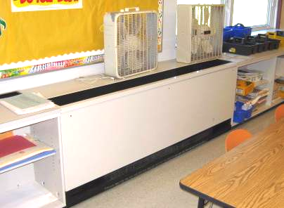

Classroom Univent

Picture 2

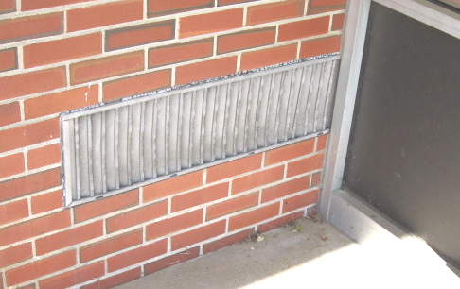

Univent Fresh Air Intake on Exterior Wall
Picture 3

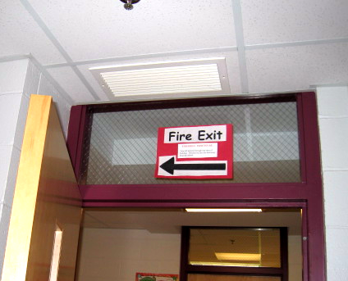

Ceiling-Mounted Exhaust Vent over Classroom/Hallway Door

Picture 4

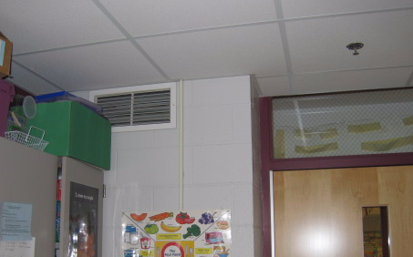

Wall-Mounted Exhaust Vent near Classroom/Hallway Door
Picture 5

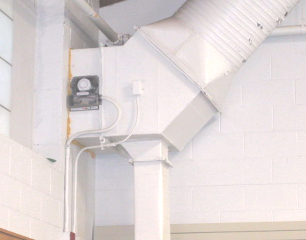

Ceiling-Mounted AHU in Gymnasium

Picture 6

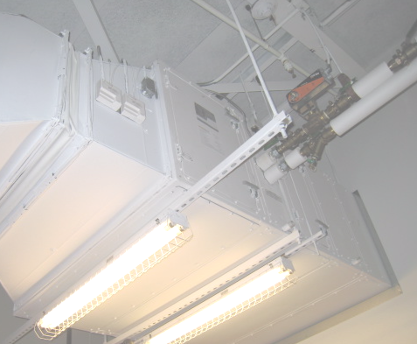

Ceiling-Mounted AHU in Cafeteria
Picture 7

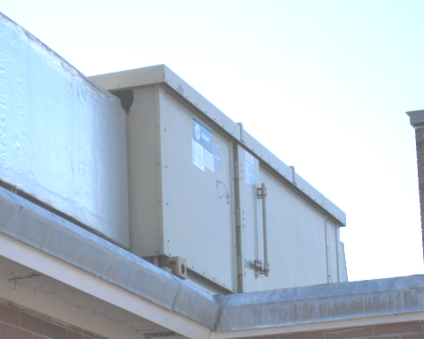

Rooftop AHU

Picture 8

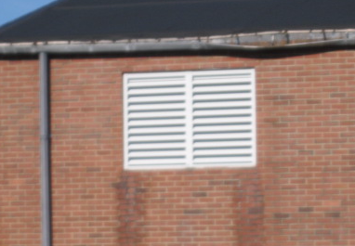

Outside Air Intake for Cafeteria AHU
Picture 9

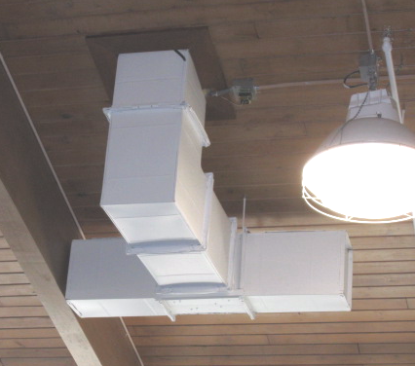

Local Exhaust Vent/Motor for Gymnasium

Picture 10

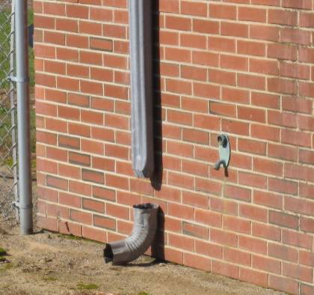

Damaged/Disconnected Downspout/Elbow Rear of Cafeteria
Picture 11

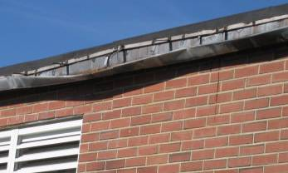

Damaged Gutters along Roof of Cafeteria

Picture 12

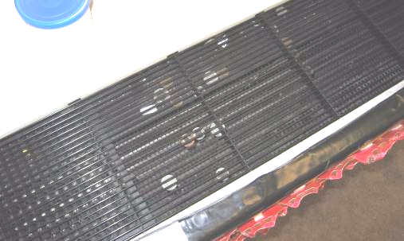

Debris inside Univent Air Diffuser Classroom 10
Picture 13

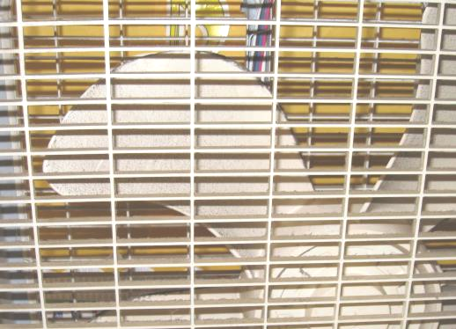

Accumulated Dust/Debris on Fan Blades
Location/ Room | Occupants  in Room | Temp  (°F) | Relative  Humidity  (%) | Carbon  Dioxide  (ppm) | Carbon Monoxide  (ppm) | PM2.5  (µg/m³) | Windows  Openable | Ventilation |  | Remarks
 |  |  |  |  |  |  |  | Supply | Exhaust | Remarks
background |  | 54 | 41 | 407 | ND | 22 |  |  |  | Cool, clear, sunny
Art/Music | 0 | 70 | 24 | 489 | ND | 14 | Y | Y | Y | PF
End Classroom | 22 | 69 | 27 | 714 | ND | 23 | Y | Y | Y | DO, PF, CP-sink
12 | 23 | 71 | 29 | 743 | ND | 21 | Y | Y | Y | CP on floor under sink, PF-dusty
11 | 20 | 71 | 24 | 579 | ND | 19 | Y | Y | Y | Windows open, DO, PF
10 | 24 | 72 | 28 | 746 | ND | 17 | Y | Y | Y | DO, PF
9 | 18 | 72 | 26 | 779 | ND | 17 | Y | Y | Y | DO, PF
8 | 27 | 70 | 28 | 781 | ND | 16 | Y | Y | Y | CP on sink countertop, DO
7 | 12 | 71 | 25 | 646 | ND | 17 | Y | Y | Y | AC
6 | 24 | 69 | 29 | 782 | ND | 15 | Y | Y | Y | CP on sink, plants, DO, PF, aqua
5 | 17 | 71 | 25 | 639 | ND | 16 | Y | Y | Y | AC
4  Staff Work Room | 4 | 70 | 27 | 509 | ND | 16 | Y | Y | Y | PF, laminator, DO
3 Library | 24 | 74 | 25 | 601 | ND | 17 | Y | Y | Y | DO
Pupil Support | 2 | 71 | 27 | 701 | ND | 16 | N | N | Y
Speech Therapy | 2 | 71 | 27 | 633 | ND | 14 | Y | Y | N
School Psychologist | 1 | 72 | 26 | 616 | ND | 15 | Y | Y | Y
Office 151 | 0 | 73 | 24 | 560 | ND | 14 | Y | Y | Y
Nurse’s Office | 3 | 73 | 27 | 707 | ND | 17 | N | Y | Y | DO
Stage Area | 4 | 72 | 25 | 679 | ND | 15 | N | Y | Y
Cafeteria | 50 | 71 | 24 | 587 | ND | 9 | Y | Y | Y | DO, CF
Staff Lounge | 0 | 71 | 25 | 531 | ND | 12 | Y | Y | Y | DO
Gym | 22 | 72 | 30 | 762 | ND | 19 | Y | Y | Y | DO
13 | 20 | 70 | 25 | 674 | ND | 15 | Y | Y | Y | DO, CP
14 | 17 | 69 | 27 | 649 | ND | 13 | Y | Y | Y | DO, CP
15 | 0 | 70 | 24 | 470 | ND | 14 | Y | Y | Y | DO, CP
16 | 23 | 71 | 28 | 660 | ND | 17 | Y | Y | Y | DO, Plants
17 | 9 | 72 | 25 | 630 | ND | 18 | Y | Y | Y | AC (2)
18 | 0 | 73 | 29 | 735 | ND | 18 | Y | Y | Y | 22 occupants gone 5 mins, aqua, DO
19-B | 17 | 71 | 28 | 888 | ND | 12 | Y | Y | Y | AC
19-A | 16 | 71 | 27 | 690 | ND | 13 | Y | Y | Y
Main Office | 2 | 71 | 25 | 632 | ND | 13 | N | N | N
Admin Work Room | 0 | 72 | 25 | 560 | ND | 13 | Y | Y | N
Principal’s Office | 1 | 73 | 26 | 498 | ND | 11 | Y | Y | Y

