MassDEP Drinking Water Program

SERVICE LINE INVENTORY PRESS & MEDIA OUTREACH TOOLKIT

\

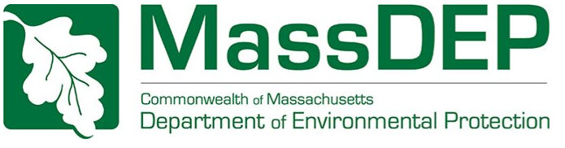

Table of Contents
Introduction……………………………………….2
Web Application Information……………………...3
Social Media Posts
Web App Introduction…………………………….4
Web App Design #1……………..………………..5
Web App Design #2………………………………6
Lead Service Line 101 #1……….……….……….8
Lead Service Line 101 #2………………….……..9
Lead Service Line 101 #3………..………….…..10
Lead Service Line 101 #4………..………….…..11
Other Materials
How to Identify Your Service Line Video….……12
PowerPoint Materials……………………....…….13
Article……………………………..………..……14
Service Line Inventory Statistics…………………16

Introduction

This Toolkit is a compilation of materials that can be shared digitally (social media), physically (flyers) and through broadcasting (a slide deck) to your community, to interest your community into helping local public water suppliers to identify service lines in their service area.

Why is this needed?
Public Water Systems (PWS) are required to inventory (identify) all service lines in their service area under the Lead and Copper Rule Revisions (LCRR), a federal regulation enforced by the United States Environmental Protection Agency (USEPA/EPA). This regulation requires PWS to submit their Service Line Inventory (SLI) by October 16th, 2024, to the Massachusetts Department of Environmental Protection (MassDEP). Many PWS are doing their best to identify all service lines, however some do not have complete written records of the service lines, or do not have updated records. PWS are doing their best to reach out to their consumers to identify all service lines if records are not available, however some have seen pushback or a lack of response to their outreach from customers. This is for various reasons, from the wariness of customers to allow PWS staff into their homes to identify service lines, or lack of agreement to allow PWS to do more invasive procedures outside of the home such as excavations, and an unwillingness to answer requests for help in the mail and over the phone.

Where do you step in?
With your help as a trusted source of news and information to many of the general public, MassDEP asks for your help to spread this information, and encourage the public to help PWS identify these service lines and help with the overall goal of removing all lead service lines, when possible, to protect the public health of Massachusetts residents. The posts, flyers, video, and PowerPoint presentation included below are all resources that recipients of this toolkit are asked to share with your audience to educate them on this important goal.

Web Application Information

What is this Web Application?
The Massachusetts Lead Service Line Identification (MA-LSLI) Web Application is a collection of Smartsheet (https://www.smartsheet.com) forms, sheets, and workflow automations that allow PWScustomers to submit photos of their service line for identification purposes. This can be helpful for PWSs in compiling their service line inventories and in triaging lead service line replacements.

How does this work?
The submission form is located at https://app.smartsheet.com/b/form/f9ee39b7972f443ca63e8b936cd7f92b. PWS must sign up for this application with MassDEP, then they are listed as a PWS that customers can send their submissions to. The form asks for basic customer information including full name, street address, email address, phone number, PWS, etc. The customer is asked to upload one or more photos of their service line and follow EPA’sservice line identification guide “Protect Your Tap: A Quick Check for Lead” to attempt to identify their service line material. The submitted data, including photos, are processed through automated workflows, and emailed to PWS contacts using the PWS selected by the customer/end-user. The data is also migrated to a dedicated Smartsheet worksheet that the PWS will be able access. This allows PWS to review the photos, review the contact information and location of the customer, and perform follow-up procedures if needed to ensure that the service line material was identified correctly, and record this information in their service line inventory.

Note for Recipients
PWS must sign up for this application for customers to be able to send PWS their photos through this application. The recommendation for recipients of this toolkit is for the recipient to check the application submission form and review the list before sharing any information with your audience, to see if their PWS is signed up for this application. If your audience is larger and may be served by multiple PWS, recipients may prefer to add a disclaimer to their posts such as the one below.

“Disclaimer: Only PWS that have signed up for this application with MassDEP are listed. If your PWS is not listed, and you would like to help them with this effort, please contact your PWS directly and ask to share this photo and information with them directly!”

Please use the following posters/information to help us disseminate this information. Thank you for helping us to deliver these important messages.

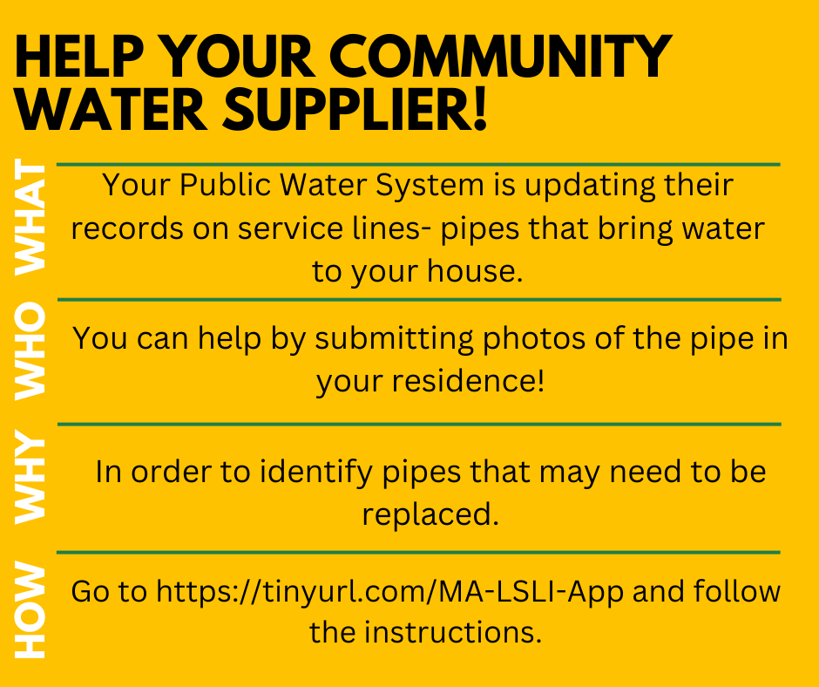
Instagram/Facebook Caption: Public Water Systems in Massachusetts are creating inventories of water service lines, in order to identify all lead service lines. To do this, they need your help to identify what materials make up your water service line. Read below to learn more about the Service Line Inventory and help to identify lead service lines in our community: https://tinyurl.com/MA-LSLI-App.
If a homeowner identifies their service line as a lead line, it does NOT mean you are required to replace it, however, MassDEP strongly encourages the removal of all lead service line! If a homeowner is concerned with the cost of replacement, they should reach out to their PWS and ask if they offer lead service line replacement financial incentives. Homeowners can also check with their homeowner’s insurance company to see if they cover lead service line replacement.
#lead #water #drinkingwater #free #safedrinkingwater #takeapic
X Caption: Public Water Systems in Massachusetts are working to identify all Lead Service Lines. They need your help to identify what material make up your water service line by taking a pic. See: https://tinyurl.com/MA-LSLI-App.
Homeowners are not required to replace lead service lines.
#lead #water #drinkingwater #free #takeapic #safedrinkingwater
Web App Introduction
Web App Design #1

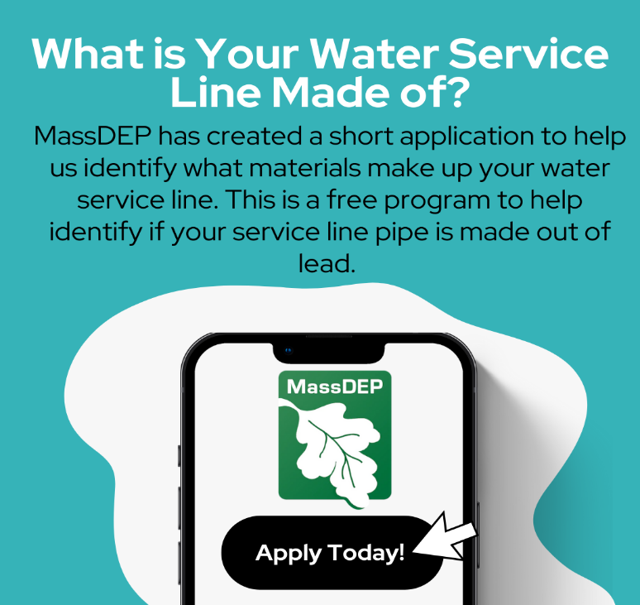
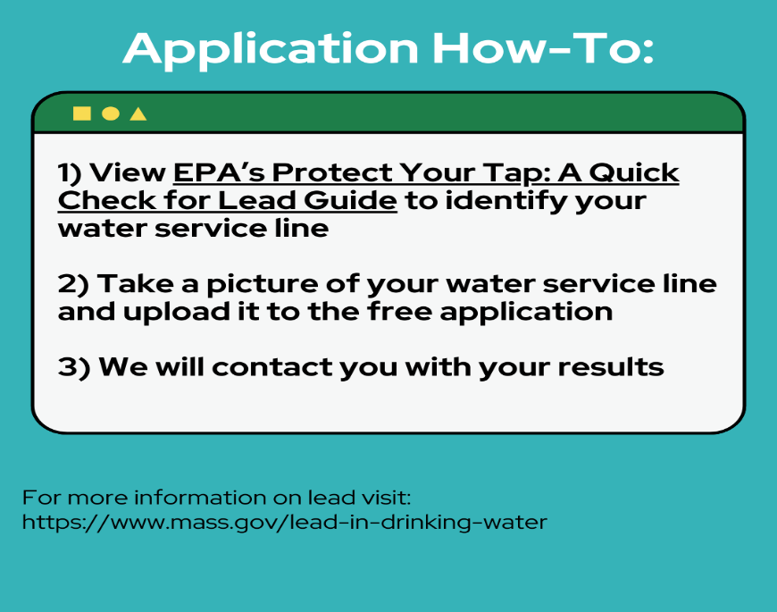
Instagram/Facebook Caption: Help your local Public Water System identify what your water service line is made of. The service line is the pipe that runs from the water main in the street to the home. As part of the Environmental Protection Agency’s (EPA) Lead and Copper Rule Revisions, water systems in Massachusetts are required to inventory service line materials by October 16th, 2024.
If a homeowner identifies their service line as a lead line, it does NOT mean you are required to replace it, however, MassDEP strongly encourages the removal of all lead service line! If a homeowner is concerned with the cost of replacement, they should reach out to their PWS and ask if they offer lead service line replacement financial incentives. Homeowners can also check with their homeowner’s insurance company to see if they cover lead service line replacement.
Read more about the program here: https://tinyurl.com/MA-LSLI-App. For more information on lead in water please visit: https://tinyurl.com/ProtectYourTap.
#lead #water #drinkingwater #free #takeapic #safedrinkingwater
X Caption: Help your local Water System identify what your service line is made of. Read more about the program here: https://tinyurl.com/MA-LSLI-App. For more information on lead in water please visit: https://tinyurl.com/ProtectYourTap.
#lead #water #drinkingwater #free #takeapic #safedrinkingwater
Web App Design #2
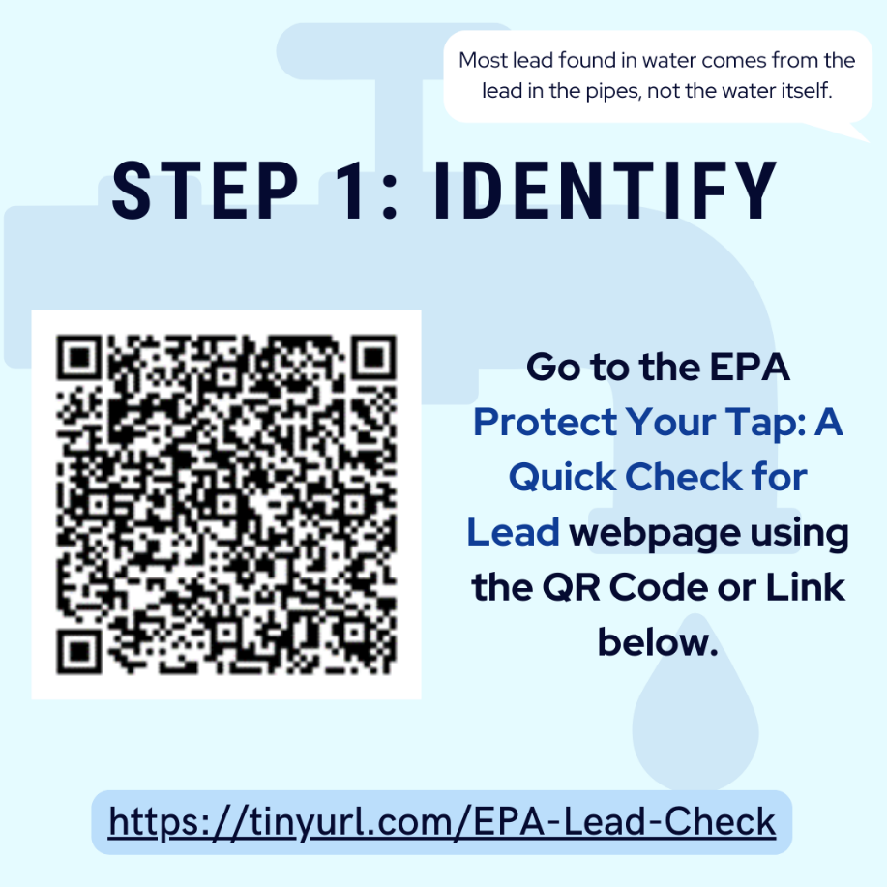
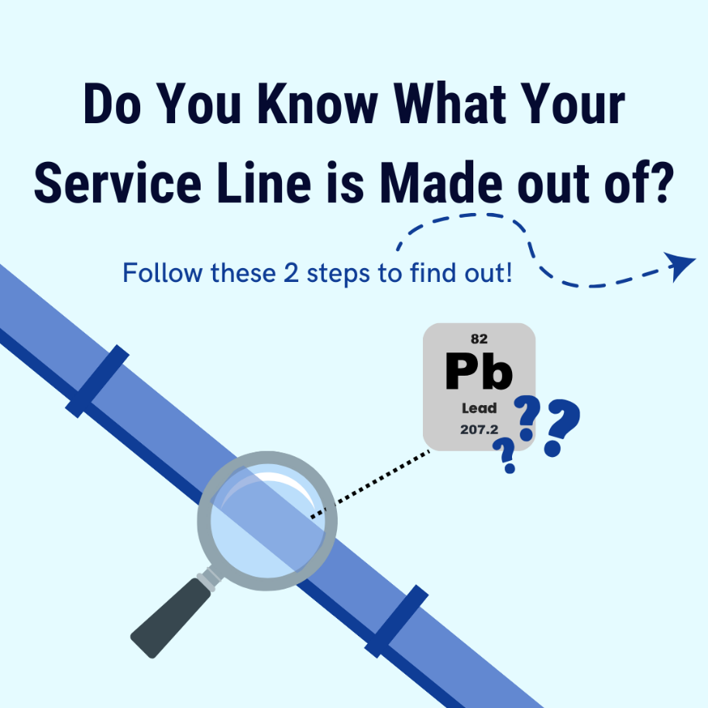
Instagram/Facebook Caption Option 1: Help your local Public Water System identify what your water service line is made of. The service line is the pipe that runs from the water main in the street to the home. As part of the Environmental Protection Agency’s EPA's Lead and Copper Rule Revisions, water systems in Massachusetts are required to inventory service line materials by October 16th, 2024. If your water system is participating with MassDEP, you can participate in the program here: https://tinyurl.com/MA-LSLI-App. For more information on lead in water please visit: https://tinyurl.com/ProtectYourTap.
If a homeowner identifies their service line as a lead line, it does NOT mean you are required to replace it, however, MassDEP strongly encourages the removal of all lead service line! If a homeowner is concerned with the cost of replacement, they should reach out to their PWS and ask if they offer lead service line replacement financial incentives. Homeowners can also check with their homeowner’s insurance company to see if they cover lead service line replacement.
#lead #water #drinkingwater #free #takeapic #safedrinkingwater
All 4 photos on pages 6 and 7 should be included in the post.

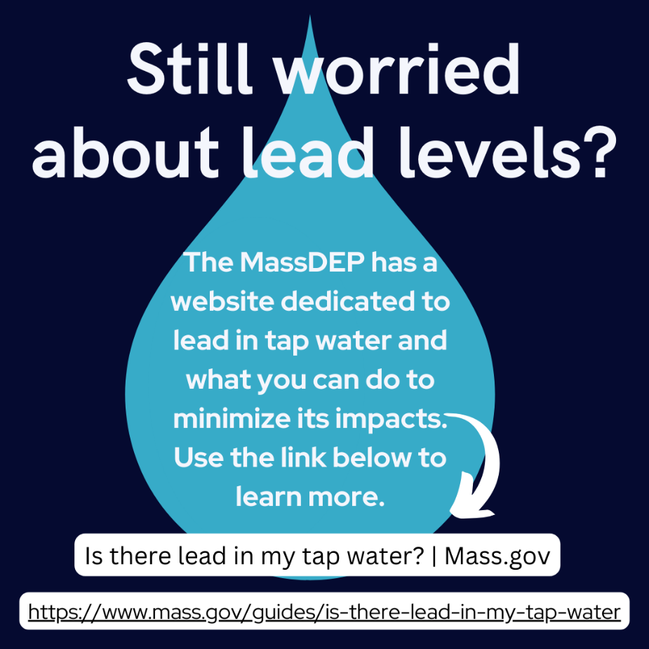
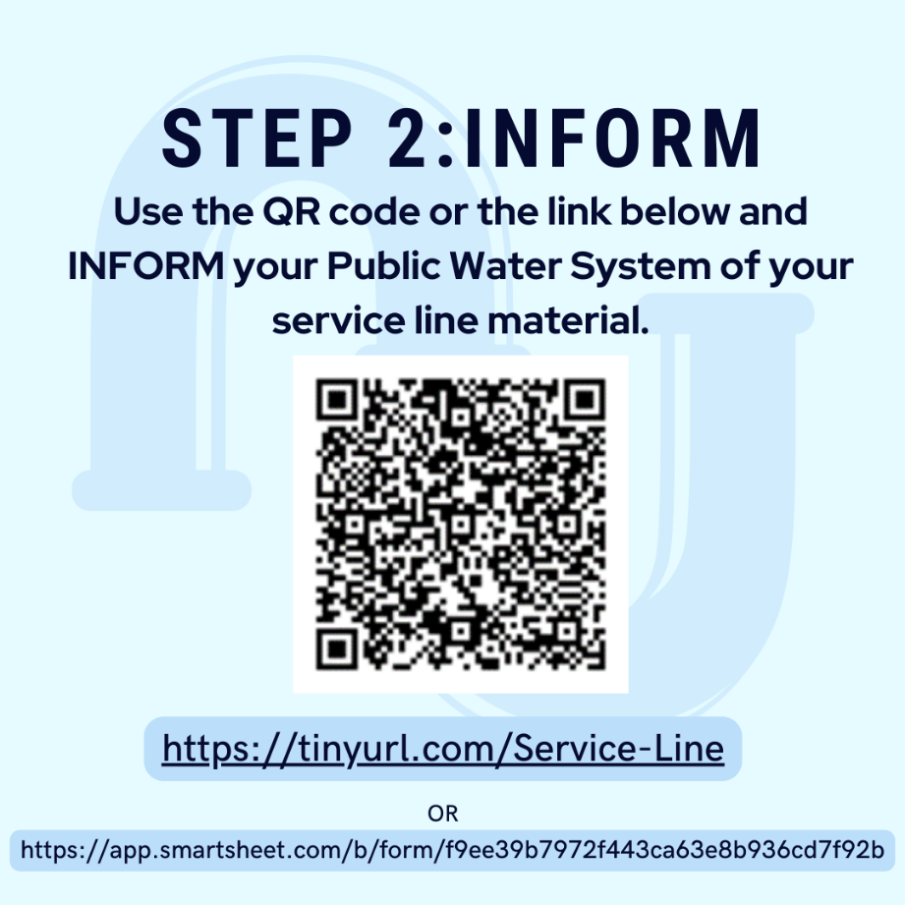
Instagram/Facebook Caption Option 2: Do you have children or plan to become pregnant in the near future? Are you worried about how they could be impacted by lead in your drinking water? Use this step-by-step guide (https://tinyurl.com/ProtectYourTap) provided by the Environmental Protection Agency’s EPA to find your service lines, and to test whether it may be made of lead. If your Public Water System is participating in this effort*, you can send a photo of your service lines along with the area you live in to our app here (https://tinyurl.com/MA-LSLI-App) to let your water supplier know!
If a homeowner identifies their service line as a lead line, it does NOT mean you are required to replace it, however, MassDEP strongly encourages the removal of all lead service line! If a homeowner is concerned with the cost of replacement, they should reach out to their PWS and ask if they offer lead service line replacement financial incentives. Homeowners can also check with their homeowner’s insurance company to see if they cover lead service line replacement.
#lead #water #drinkingwater #free #takeapic #safedrinkingwater

X Caption: Help your local Public Water System identify what your water service line is made of. Read more about the program here: https://tinyurl.com/MA-LSLI-App. For more information on lead in water please visit: https://tinyurl.com/ProtectYourTap.
#lead #water #drinkingwater #free #takeapic #safedrinkingwater

Lead Service Line 101 #1

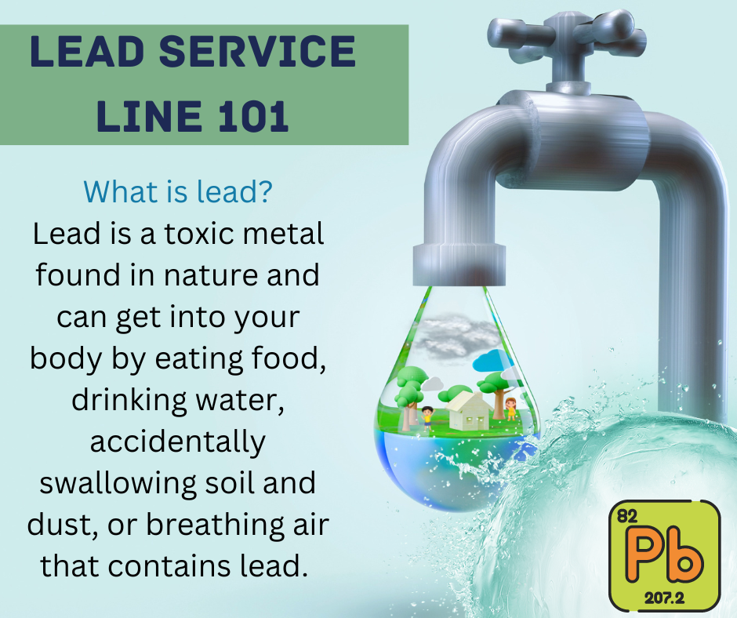

Instagram/Facebook Caption: If your home was built before 1986, you may have a lead service line. Read below for more information on what a lead service line is and how to know if you have one. Questions? Contact your local public water system!
If a homeowner identifies their service line as a lead line, it does NOT mean you are required to replace it, however, MassDEP strongly encourages the removal of all lead service line! If a homeowner is concerned with the cost of replacement, they should reach out to their PWS and ask if they offer lead service line replacement financial incentives. Homeowners can also check with their homeowner’s insurance company to see if they cover lead service line replacement.
#lead #water #drinkingwater #free #safedrinkingwater #takeapic
X Caption: If your home was built before 1986, you may have a lead service line. Questions? Contact your local public water system!
If a homeowner identifies their service line as a lead line, it does NOT mean you are required to replace it.
#lead #water #drinkingwater #free #takeapic #safedrinkingwater

Lead Service Line 101 #2

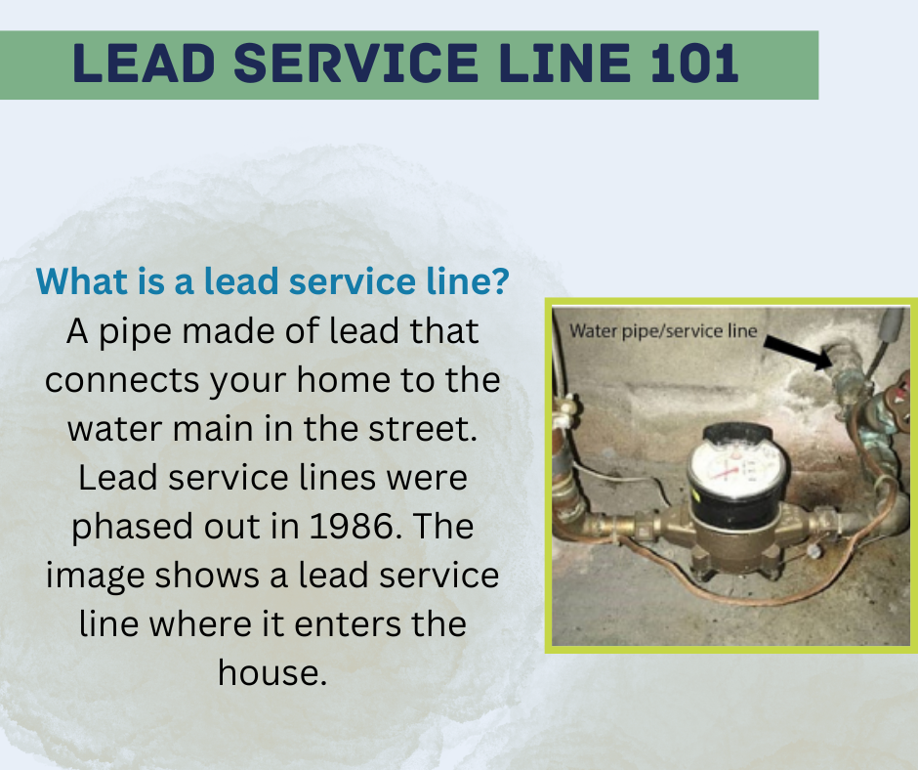

Instagram/Facebook Caption: If your home was built before 1986, you may have a lead service line. Read below for more information on what a lead service line is and how to know if you have one. Questions? Contact your local public water system!
If a homeowner identifies their service line as a lead line, it does NOT mean you are required to replace it, however, MassDEP strongly encourages the removal of all lead service line! If a homeowner is concerned with the cost of replacement, they should reach out to their PWS and ask if they offer lead service line replacement financial incentives. Homeowners can also check with their homeowner’s insurance company to see if they cover lead service line replacement.
#lead #water #drinkingwater #free #safedrinkingwater #takeapic
X Caption: If your home was built before 1986, you may have a lead service line. Questions? Contact your local public water system!
If a homeowner identifies their service line as a lead line, it does NOT mean you are required to replace it.
#lead #water #drinkingwater #free #takeapic #safedrinkingwater

Lead Service Line 101 #3

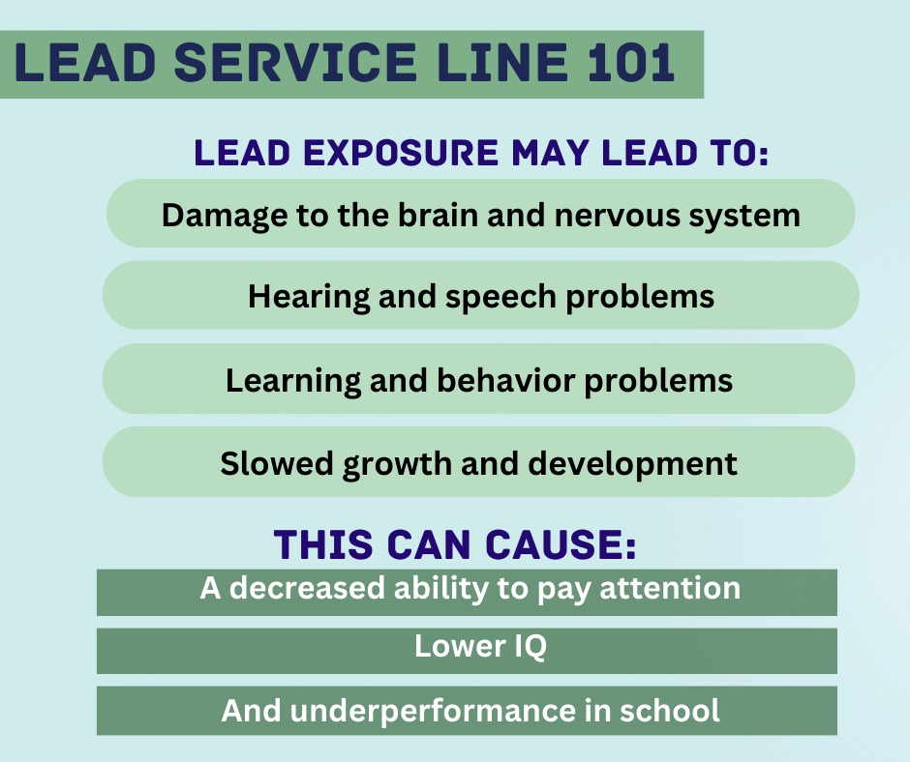
Instagram/Facebook Caption: If your home was built before 1986, you may have a lead service line. Read below for more information on what a lead service line is and how to know if you have one. Questions? Contact your local public water system!
If a homeowner identifies their service line as a lead line, it does NOT mean you are required to replace it, however, MassDEP strongly encourages the removal of all lead service line! If a homeowner is concerned with the cost of replacement, they should reach out to their PWS and ask if they offer lead service line replacement financial incentives. Homeowners can also check with their homeowner’s insurance company to see if they cover lead service line replacement.
#lead #water #drinkingwater #free #safedrinkingwater #takeapic
X Caption: If your home was built before 1986, you may have a lead service line. Questions? Contact your local public water system!
If a homeowner identifies their service line as a lead line, it does NOT mean you are required to replace it.
#lead #water #drinkingwater #free #takeapic #safedrinkingwater

Lead Service Line 101 #4

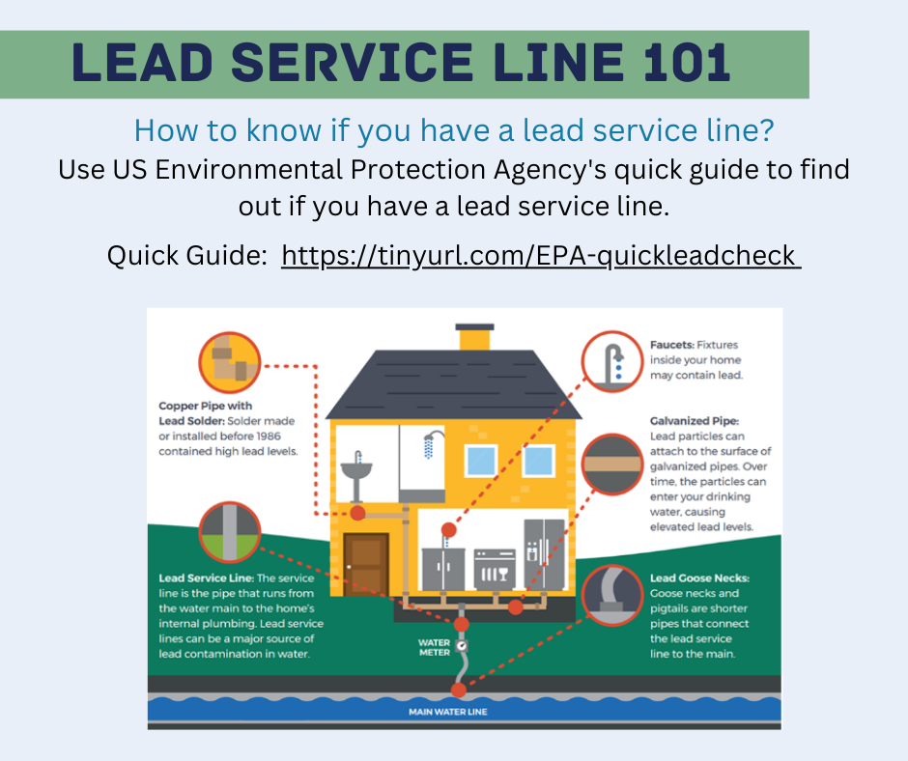

Instagram/Facebook Caption: If your home was built before 1986, you may have a lead service line. Read below for more information on what a lead service line is and how to know if you have one. Questions? Contact your local public water system!
If a homeowner identifies their service line as a lead line, it does NOT mean you are required to replace it, however, MassDEP strongly encourages the removal of all lead service line! If a homeowner is concerned with the cost of replacement, they should reach out to their PWS and ask if they offer lead service line replacement financial incentives. Homeowners can also check with their homeowner’s insurance company to see if they cover lead service line replacement.
#lead #water #drinkingwater #free #safedrinkingwater #takeapic
X Caption: If your home was built before 1986, you may have a lead service line. Questions? Contact your local public water system!
If a homeowner identifies their service line as a lead line, it does NOT mean you are required to replace it.
#lead #water #drinkingwater #free #takeapic #safedrinkingwater

How to Identify your Service Line Video


Video Description:
This video walks customers through how to use the Environmental Protection Agency’s EPA Quick Guide and the MSA-LI crowdsourcing web app to identify service lines.
The video is located at https://youtu.be/OcDSTNn4Ov0.

Power Point Materials for News Outlets

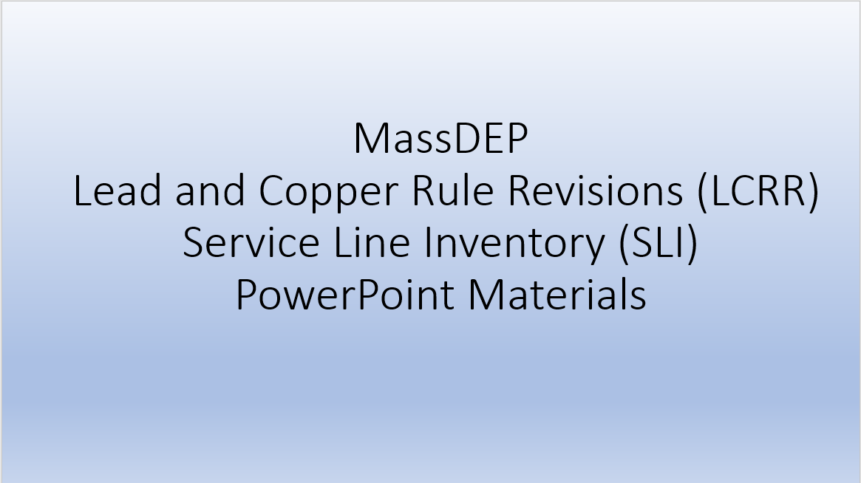
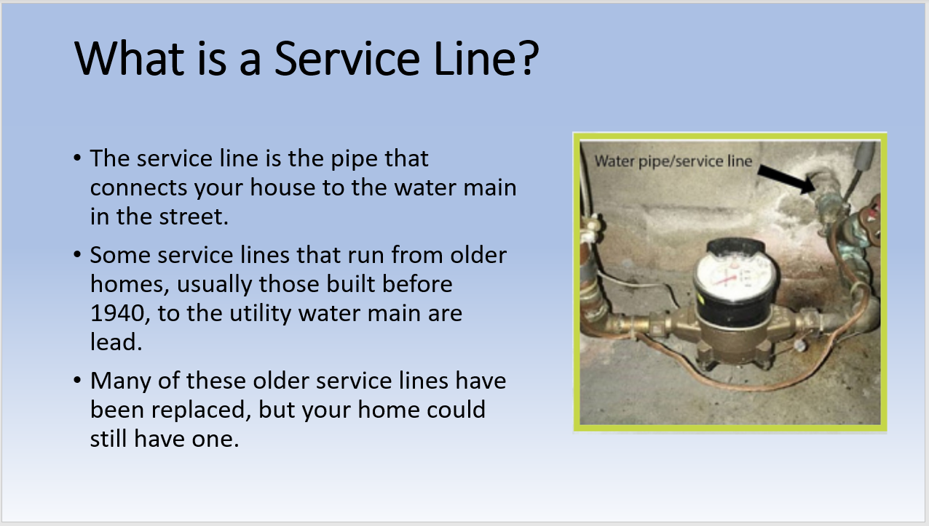
PowerPoint Description:
This PowerPoint Presentation goes through the main article points in an easier to digest manner, which news outlets may use as visuals as they describe why the public should get involved.

Article:
Did you know that right now, public water systems (PWS) in Massachusetts are trying to identify ALL service lines in their service area? Under the Lead and Copper Rule Revisions (LCRR), most public water systems are required to create a service line inventory (SLI) by October 16th, 2024, and submit it to the state. This is a federal requirement as part of an initiative to protect the health and safety of consumers on public water systems.
According to the National Survey of Lead Service Line Occurrence study developed by the American Waterworks Association (AWWA), there were approximately 220,000 lead service lines (LSL) in use in Massachusetts in 2016 (https://awwa.onlinelibrary.wiley.com/doi/abs/10.5942/jawwa.2016.108.0086). This is an estimated 12% of all service lines in Massachusetts.
What is a service line?
The service line is the pipe that connects your house to the water main in the street. Some service lines that run from older homes (usually those built before 1940) to the utility water main are lead. Many of these older service lines have been replaced, but your home could still have one.
Why is lead in your drinking water concerning?
Lead can cause serious health problems if too much enters your body from drinking water or other sources. Overexposure to lead may cause problems ranging from stomach distress to brain damage. It can cause damage to the kidneys and can interfere with the production of red blood cells that carry oxygen to all parts of your body.
The greatest risk of lead exposure is to infants, young children, and pregnant women. Scientists have linked the effects of lead on the brain with lowered IQ in children. Adults with kidney problems and high blood pressure can be affected by low levels of lead more than healthy adults. Our bones store lead and can release it later in life. During pregnancy, the child receives lead from the mother's bones, which may affect brain development.
What are PWS required to do?
All Community (COM) and Non-Transient Non-Community (NTNC) systems must inventory (identify) all service lines and make public the locations of lead service lines (LSLs), galvanized requiring replacement (GRR), and unknown service lines by October 16, 2024.
What can you do to help?
- You can find out what materials your service line is made of!
Using this link: https://www.epa.gov/ground-water-and-drinking-water/protect-your-tap-quick-check-lead, you will find a quick guide from the Environmental Protection Agency’s EPA which describes how to find your service line and how to check the material it is made of.
- Inform your PWS!
If your PWS is working with MassDEP, you may be able to send them a photo of your service line and your identification using the application here: https://app.smartsheet.com/b/form/f9ee39b7972f443ca63e8b936cd7f92b. This application is quick and easy to use, and only has customers fill in information found by using the Protect Your Tap Guide above! If your PWS is not working with MassDEP in this application, you can still reach out to them to let them know!
Are you Required to Replace your Service Line?
If a homeowner identifies their service line as a lead line, it does NOT mean you are required to replace it, however, MassDEP strongly encourages the removal of all lead service line! If a homeowner is concerned with the cost of replacement, they should reach out to their PWS and ask if they offer lead service line replacement financial incentives. Homeowners can also check with their homeowner’s insurance company to see if they cover lead service line replacement.
Don’t know who your PWS is?
That’s all right! You can go here: https://www.mass.gov/drinking-water-health-safety and look under additional resources for a list of all active PWS, there city/town of service, and contact information to confirm. This list is updated monthly. Use this contact information to let them know what your service line is made of.
Or check on their website first! They may already have a similar application or program to alert them. You may also find helpful information, like if they have a lead service line replacement program, or other programs you may benefit from!

Service Line Inventory Statistics
Community Public Water Systems: Massachusetts has 528 Community Public Water Systems, active as of Spring 2024. Community Public Water System means a public water system that serves at least 15 service connections used by year-round residents or regularly serves at least 25 year-round residents.
Estimated Lead Service Lines: According to the National Survey of Lead Service Line Occurrence study developed by the American Waterworks Association (AWWA), there were approximately 220,000 lead service lines (LSL) in use in Massachusetts in 2016 (https://awwa.onlinelibrary.wiley.com/doi/abs/10.5942/jawwa.2016.108.0086).

Service Line Statistics
Estimated Number of Service Line Connections in Massachusetts: 1,865,530
Estimated Number of Service Line Connections in Community Public Water Systems: 1,859,644
Estimated Number of Lead Service Lines in Massachusetts According to the AWWA 2016 Lead Service Line Occurrence Study (https://awwa.onlinelibrary.wiley.com/doi/abs/10.5942/jawwa.2016.108.0086): 220,000
Estimated Lead in Massachusetts: 12% of all Service Lines in Massachusetts.

COM PWS Concerns when developing a Service Line Inventory:
Legend:
NE – Northeastern Massachusetts
WE – Western Massachusetts
CE – Central Massachusetts
SE – Southeastern Massachusetts
COM PWS – Community Public Water System
- Lack of records.
- Lack of access and to customer owned service line segments.
- Lack of customer engagement to allow PWS staff into homes and onto properties to identify service lines.
- A high quantity of service lines to inventory.
- Age of records and concern over validity of much older records.

Helpful Tables and Graphs
 | WE | CE | NE | SE | TOTAL
# of Community Public Water Systems (COM PWS) | 135 | 148 | 111 | 134 | 528
# of COM PWS estimated to have less than 5,000 Service Lines | 122 | 135 | 54 | 88 | 399
# of COM PWS estimated to have 5,000 to 10,000 Service Lines | 8 | 8 | 28 | 28 | 72
# of COM PWS estimated to have over 10,000 Service Lines | 5 | 5 | 29 | 18 | 57

