LEAD AND COPPER RULE REVISIONS
SERVICE LINE INVENTORY PUBLIC OUTREACH TOOLKIT
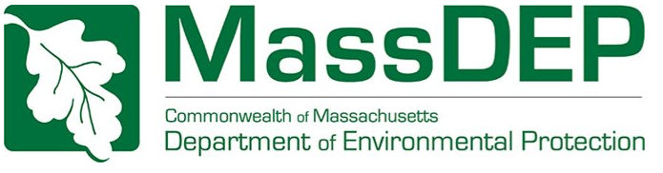

BACKGROUND

Under the Lead and Copper Rule Revisions (LCRR), all community and non-transient non-community systems are required to submit a service line inventory by October 16, 2024. To help these systems develop their inventories and encourage community involvement, the MassDEP Drinking Water Program developed this outreach toolkit that contains posters, infographics, social media images and other tools.

You can download all images at https://www.mass.gov/media/2587511/download.
Contents
MA LSLI – CROWDSOURCING WEB APPLICATION 4
Template Letter For Customers 4
Web App Introduction 5
Lead Service Line 101 #1 6
Lead Service Line 101 #2 7
Lead Service Line 101 #3 8
Web App Design #1 Part 1 9
Web App Design #1 Part 2 10
Web App Design #2 Part 1 11
Web App Design #2 Part 2 12
Web App Design #2 Part 3 13
Lead In Drinking Water Basics 14
How To Identify Servile Lines Materials Video 15
INFOGRAPHIC: Service Line inventory 16
INFOGRAPHIC: Service Line inventory Spanish 17
DOOR HANGER: LSL Identification 18
Postcards for Volunteer Resident Water Sampling 19
Homeowner incentives for LCR sampling 25
Examples of Incentives Previously Used by PWS in MA 26

 | MA LSLI – CROWDSOURCING WEB APPLICATION  - FIND THE APP AT https://app.smartsheet.com/b/form/f9ee39b7972f443ca63e8b936cd7f92b  INSTRUCTIONS CAN BE FOUND AT https://www.mass.gov/doc/instructions-mass-lead-service-line-identification-ma-lsli-web-app  - REACH OUT TO YOUR CUSTOMERS THROUGH SOCIAL MEDIA OR BY EMAIL/MAIL USING THE TEMPLATES PROVIDED IN THIS DOCUMENT.  - START BUILDING YOUR INVENTORY ONCE YOU START TO RECEIVE SUBMISSIONS!!! | MassDEP developed a “crowdsourcing application” (“the App”) to assist consumers and PWS identify service lines. The App is a web-based tool that allows customers to submit photos of their service line for identification. This can help PWS develop their service line inventories and prioritize lead service line replacements.  Using the App, customers upload photos of their service line and attempt to identify the service line material using EPA’s service line identification guide “Protect Your Tap: A Quick Check for Lead”.  PWS receive email notifications when customers make submissions and will have their own Smartsheet to keep track of submissions.

Template Letter For Customers

MassDEP has prepared an example letter that PWS can adapt and use when offering the App to their customers. You can download the template at https://www.mass.gov/doc/template-letter-for-pws-to-send-to-customers-for-ma-lsli-app-availability.

Infographics for PWS websites and social media accounts

On the following 20 pages, MassDEP is providing infographics and text that PWS can use on their websites and social media accounts to promote understanding of lead in drinking water and use of the App. Note that this includes several that can be used as a series.

Web App Introduction
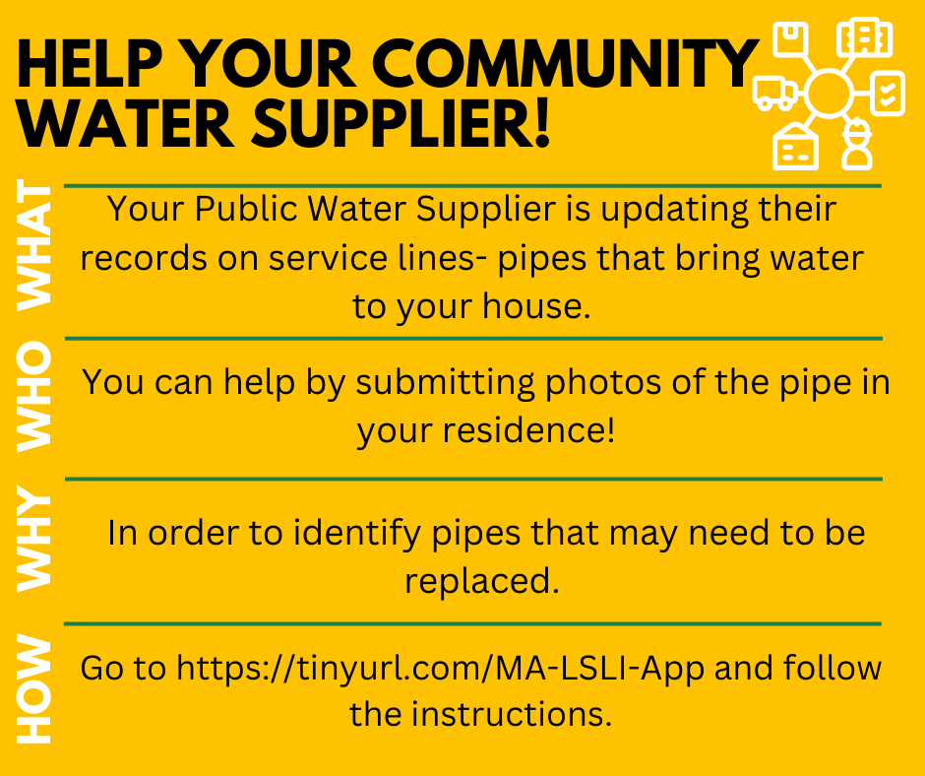
Instagram/Facebook Caption: Public Water Systems in Massachusetts are working to identify all Lead Service Lines. To do this, we need your help to identify what materials make up your water service line. Read below to learn more about the Service Line Inventory and help us to identify lead service lines in our community: https://tinyurl.com/MA-LSLI-App.
#lead #water #drinkingwater #free #safedrinkingwater #takeapic

Twitter Caption: Public Water Systems in Massachusetts are working to identify all Lead Service Lines. We need your help to identify what material make up your water service line by taking a pic. See: https://tinyurl.com/MA-LSLI-App.

#lead #water #drinkingwater #free #takeapic #safedrinkingwater

Lead Service Line 101 #1
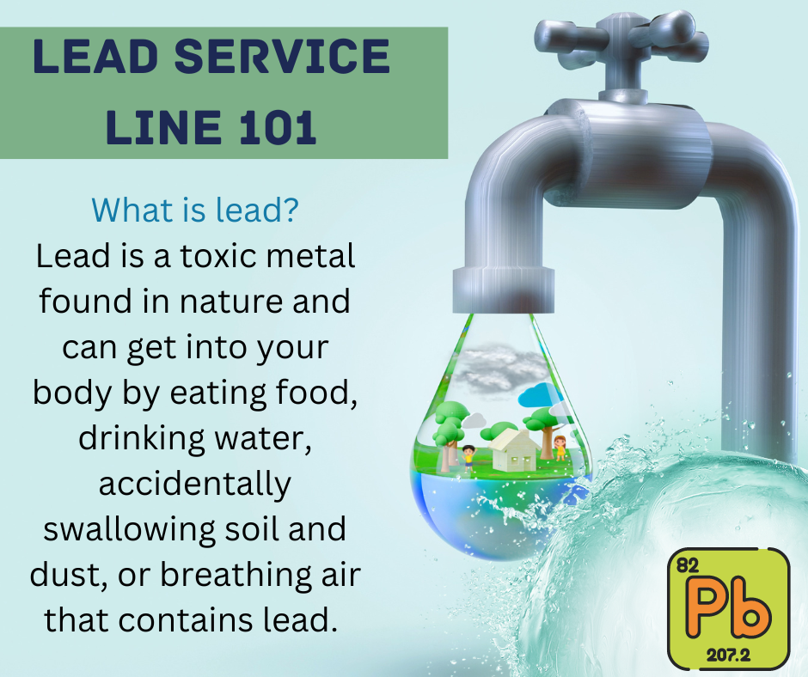
Instagram/Facebook Caption: If your home was built before 1986, you may have a lead service line. Read below for more information on what a lead service line is and how to know if you have one. Questions? Contact: ____

#lead #water #drinkingwater #free #safedrinkingwater #takeapic

Twitter Caption: If your home was built before 1986, you may have a lead service line. Read below for more information on what a lead service line is and how to know if you have one. Questions? Contact: ____
#lead #water #drinkingwater #free #takeapic #safedrinkingwater

Lead Service Line 101 #2
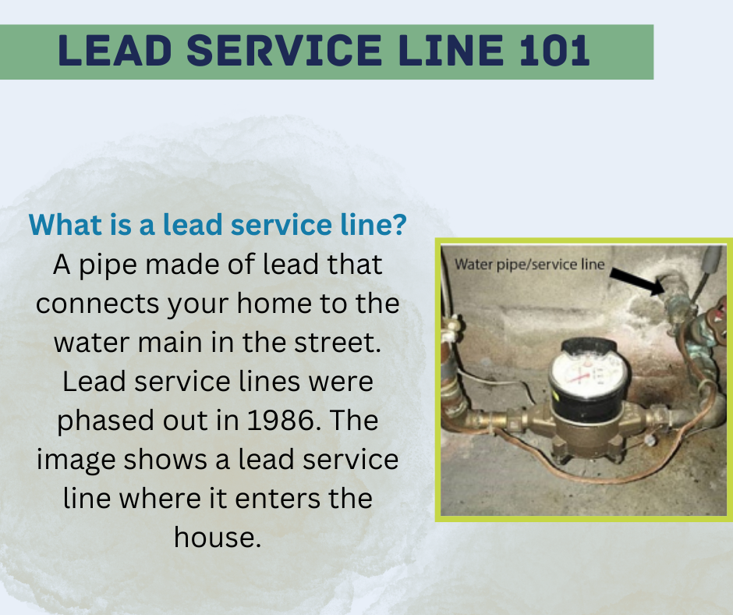
Instagram/Facebook Caption: If your home was built before 1986, you may have a lead service line. Read below for more information on what a lead service line is and how to know if you have one. Questions? Contact: ____
https://tinyurl.com/MA-LSLI-App.
#lead #water #drinkingwater #free #safedrinkingwater #takeapic

Twitter Caption: If your home was built before 1986, you may have a lead service line. Read below for more information on what a lead service line is and how to know if you have one. Questions? Contact: ____
#lead #water #drinkingwater #free #takeapic #safedrinkingwater

Lead Service Line 101 #3
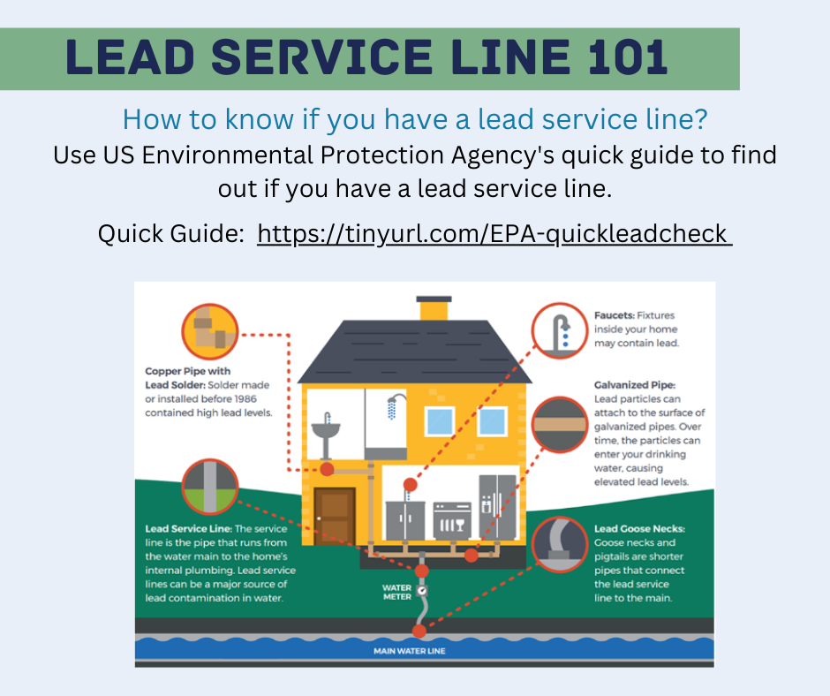
Instagram/Facebook Caption: If your home was built before 1986, you may have a lead service line. Read below for more information on what a lead service line is and how to know if you have one. Questions? Contact: ____
https://tinyurl.com/MA-LSLI-App.
#lead #water #drinkingwater #free #safedrinkingwater #takeapic

Twitter Caption: If your home was built before 1986, you may have a lead service line. Read below for more information on what a lead service line is and how to know if you have one. Questions? Contact: ____
#lead #water #drinkingwater #free #takeapic #safedrinkingwater

Web App Design #1 Part 1
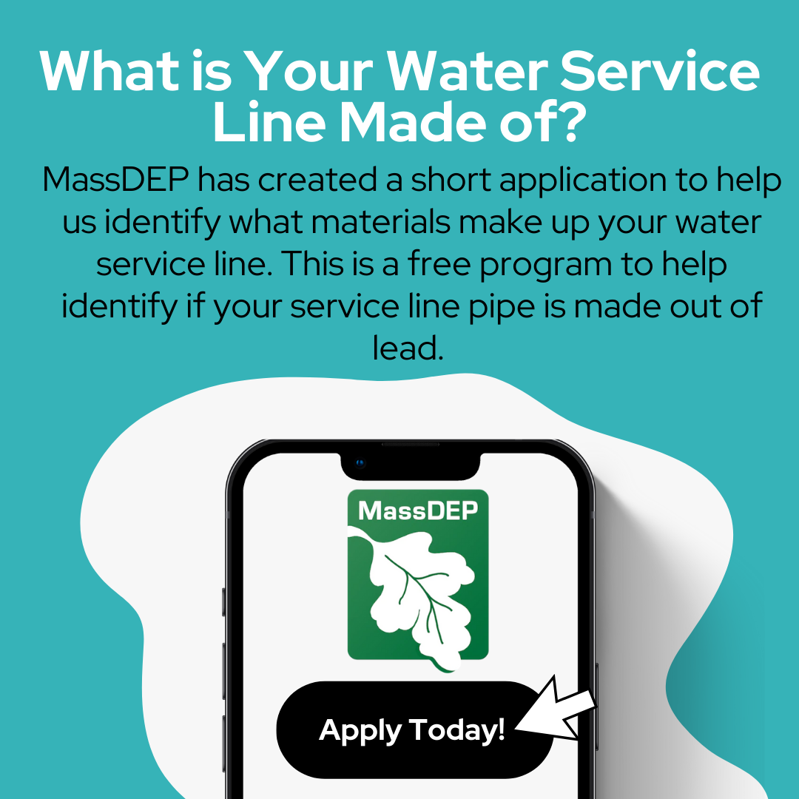
Instagram/Facebook Caption: Help us identify what your water service line is made of. The service line is the pipe that runs from the water main in the street to the home. As part of EPA's Lead and Copper Rule Revisions, water suppliers in Massachusetts are required to inventory service line materials by the end of 2024.
Read more about the program here: https://tinyurl.com/MA-LSLI-App. For more information on lead in water please visit: https://tinyurl.com/ProtectYourTap.
#lead #water #drinkingwater #free #takeapic #safedrinkingwater

Twitter Caption: Help us identify what your water service line is made of. Read more about the program here: https://tinyurl.com/MA-LSLI-App. For more information on lead in water please visit: https://tinyurl.com/ProtectYourTap.
#lead #water #drinkingwater #free #takeapic #safedrinkingwater

Web App Design #1 Part 2
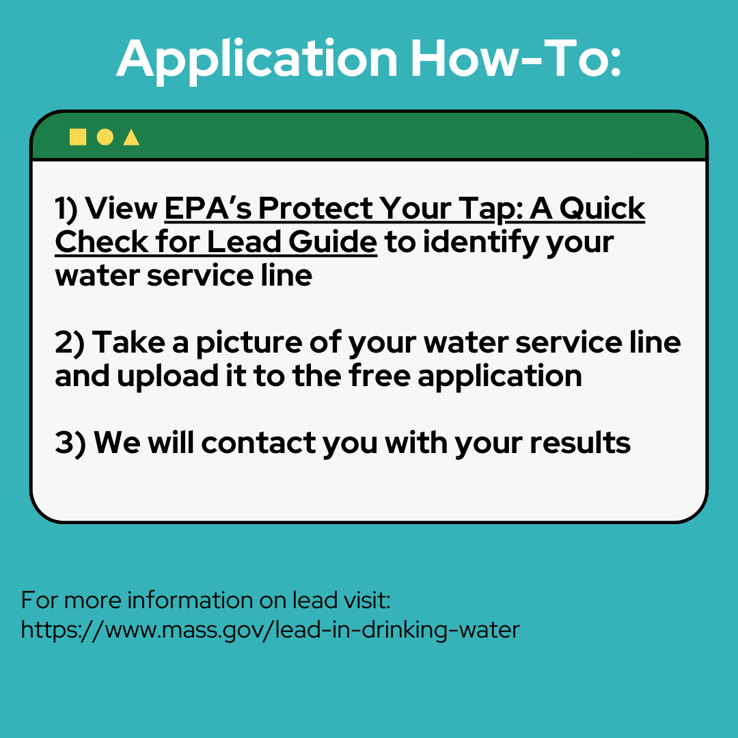
Instagram/Facebook Caption: Help us identify what your water service line is made of. The service line is the pipe that runs from the water main in the street to the home. As part of EPA's Lead and Copper Rule Revisions, water suppliers in Massachusetts are required to inventory service line materials by the end of 2024.
Read more about the program here: https://tinyurl.com/MA-LSLI-App. For more information on lead in water please visit: https://tinyurl.com/ProtectYourTap.
#lead #water #drinkingwater #free #takeapic #safedrinkingwater

Twitter Caption: Help us identify what your water service line is made of. Read more about the program here: https://tinyurl.com/MA-LSLI-App. For more information on lead in water please visit: https://tinyurl.com/ProtectYourTap.
#lead #water #drinkingwater #free #takeapic #safedrinkingwater

Web App Design #2 Part 1
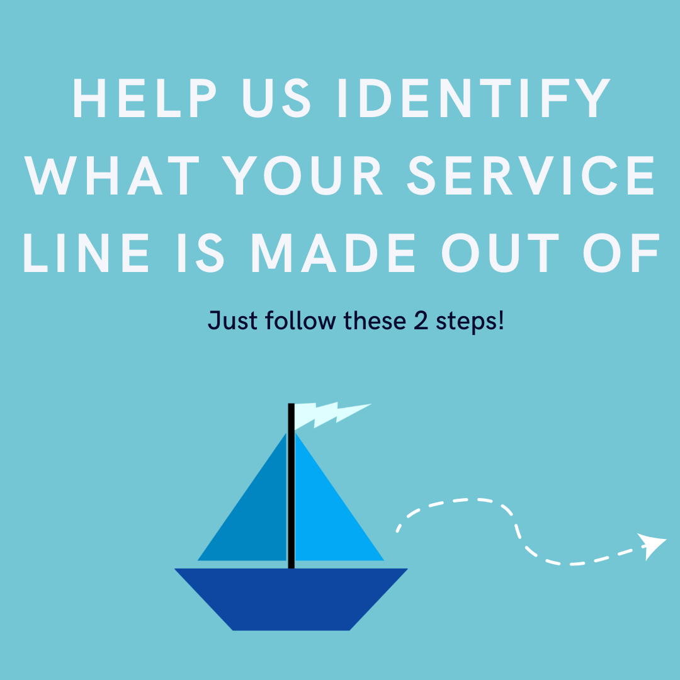
Instagram/Facebook Caption: Help us identify what your water service line is made of. The service line is the pipe that runs from the water main in the street to the home. As part of EPA's Lead and Copper Rule Revisions, water suppliers in Massachusetts are required to inventory service line materials by the end of 2024.
Read more about the program here: https://tinyurl.com/MA-LSLI-App. For more information on lead in water please visit: https://tinyurl.com/ProtectYourTap.
#lead #water #drinkingwater #free #takeapic #safedrinkingwater

Twitter Caption: Help us identify what your water service line is made of. Read more about the program here: https://tinyurl.com/MA-LSLI-App. For more information on lead in water please visit: https://tinyurl.com/ProtectYourTap.
#lead #water #drinkingwater #free #takeapic #safedrinkingwater

Web App Design #2 Part 2
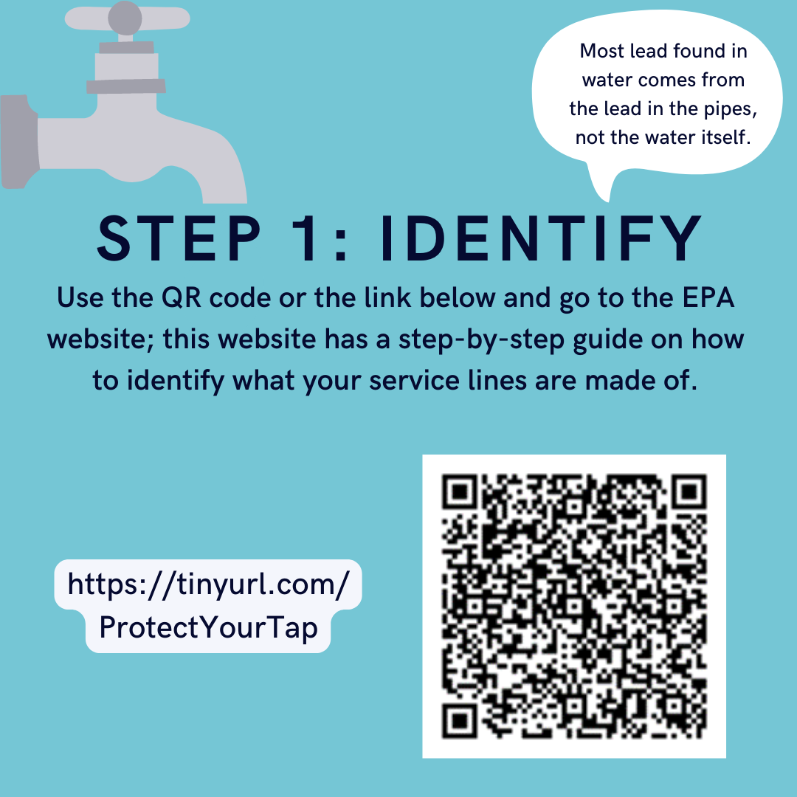
Instagram/Facebook Caption: Help your public water supplier get rid of lead pipes! Your water supply is monitored for lead levels often, but the lead in your pipes can still cause higher lead levels! Use this step-by-step guide to find out what your service line is made of, (https://tinyurl.com/ProtectYourTap.) and use our website (https://tinyurl.com/MA-LSLI-App) to let your water supplier know! Protect your family and your water by submitting your application today!
#lead #water #drinkingwater #free #takeapic #safedrinkingwater

Twitter Caption: Help us identify what your water service line is made of. Read more about the program here: https://tinyurl.com/MA-LSLI-App. For more information on lead in water please visit:
https://tinyurl.com/ProtectYourTap.
#lead #water #drinkingwater #free #takeapic #safedrinkingwater

Web App Design #2 Part 3
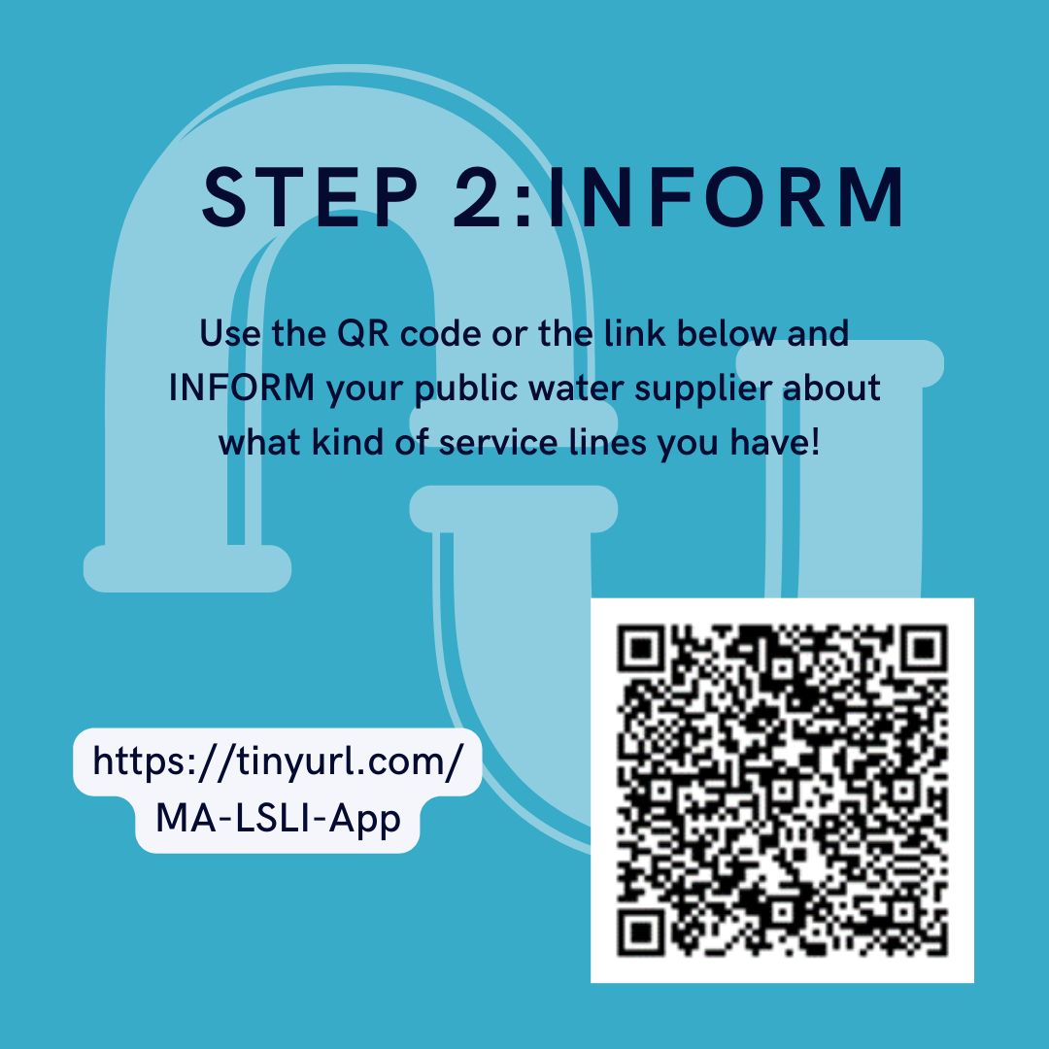
Instagram/Facebook Caption: Help us identify what your water service line is made of. The service line is the pipe that runs from the water main in the street to the home. As part of EPA's Lead and Copper Rule Revisions, water suppliers in Massachusetts are required to inventory service line materials by the end of 2024.
Read more about the program here: https://tinyurl.com/MA-LSLI-App. For more information on lead in water please visit: https://tinyurl.com/ProtectYourTap.
#lead #water #drinkingwater #free #takeapic #safedrinkingwater

Twitter Caption: Help us identify what your water service line is made of. Read more about the program here: https://tinyurl.com/MA-LSLI-App. For more information on lead in water please visit: https://tinyurl.com/ProtectYourTap.
#lead #water #drinkingwater #free #takeapic #safedrinkingwater

Lead In Drinking Water Basics
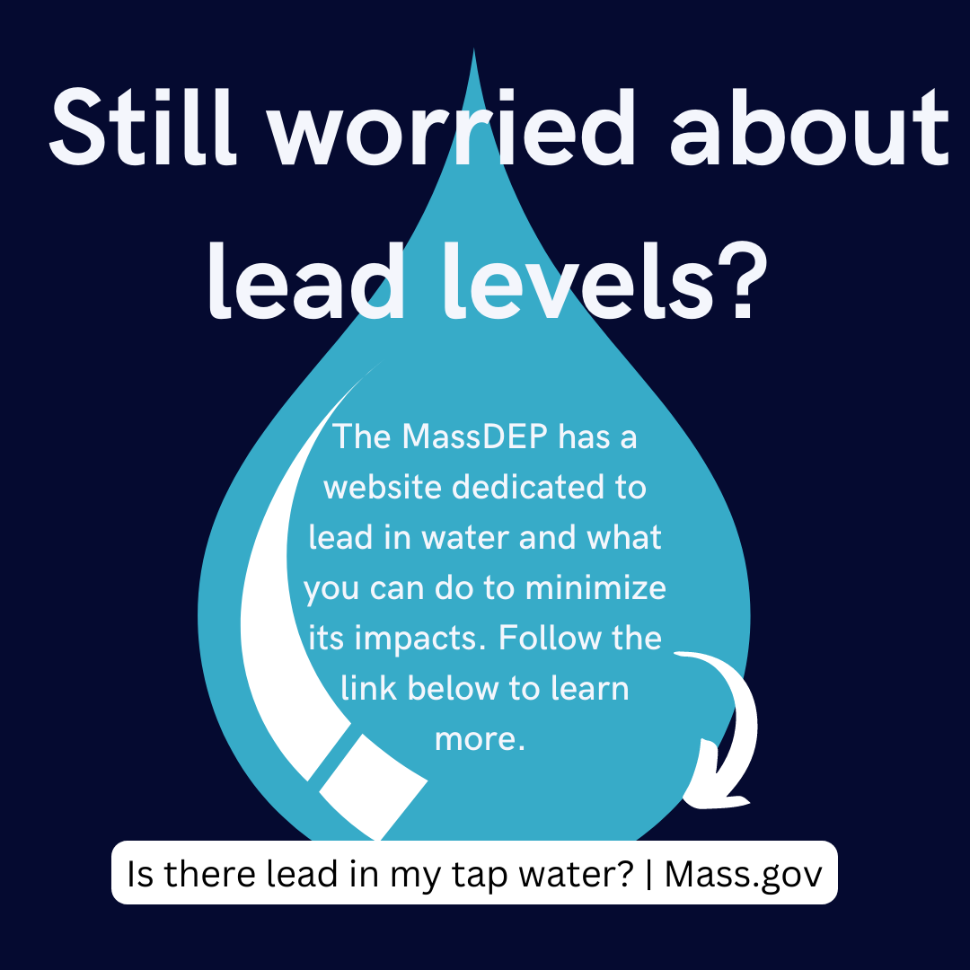
Instagram/Facebook Caption: Do you have children or plan to become pregnant in the near future? Are you worried about how they could be impacted by lead in your drinking water? Use this step-by-step guide ( https://tinyurl.com/ProtectYourTap) provided by the EPA to find your service lines, and to test whether it may be made out of lead. Send a photo of your service lines along with the area you live in to our app here ( https://tinyurl.com/MA-LSLI-App) to let your water supplier know!
#lead #water #drinkingwater #free #takeapic #safedrinkingwater

Twitter Caption: Help us identify what your water service line is made of. Read more about the program here: https://tinyurl.com/MA-LSLI-App. For more information on lead in water please visit: https://tinyurl.com/ProtectYourTap.
#lead #water #drinkingwater #free #takeapic #safedrinkingwater

How To Identify Servile Lines Materials Video
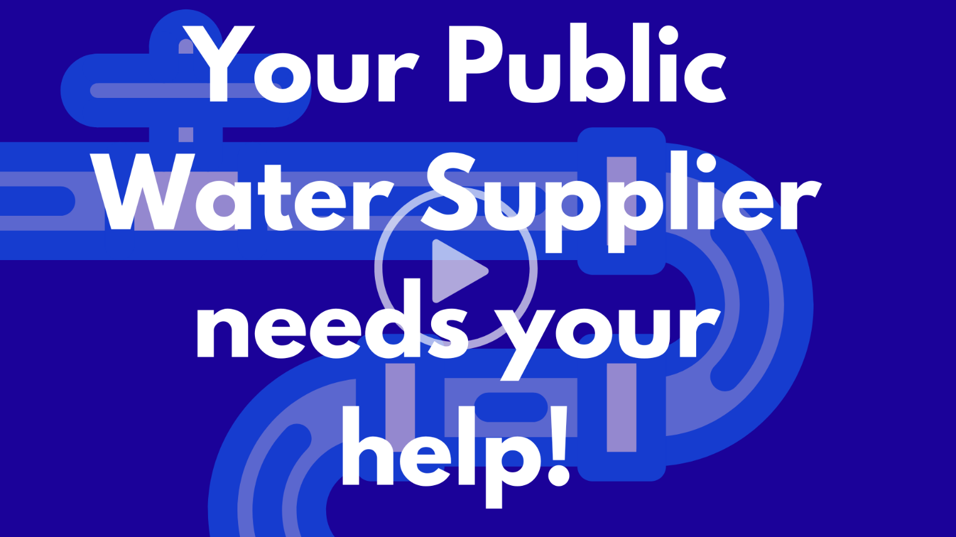
Video Description:
This video walks customers through how to use the EPA Quick Guide and the MSA-LI crowdsourcing web app to identify service lines.
The video is located at https://youtu.be/OcDSTNn4Ov0.

INFOGRAPHIC: Service Line inventory
Located at https://www.mass.gov/doc/how-to-identify-service-line-materials-an-infographic-for-customers-english/

INFOGRAPHIC: Service Line inventory Spanish
Located at https://www.mass.gov/doc/como-identificar-los-materiales-de-la-linea-de-servicio-infografia-para-clientes-espanol/

DOOR HANGER: LSL Identification
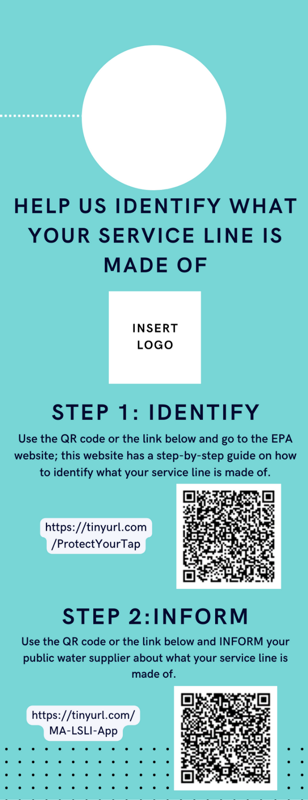

Postcards for Volunteer Resident Water Sampling
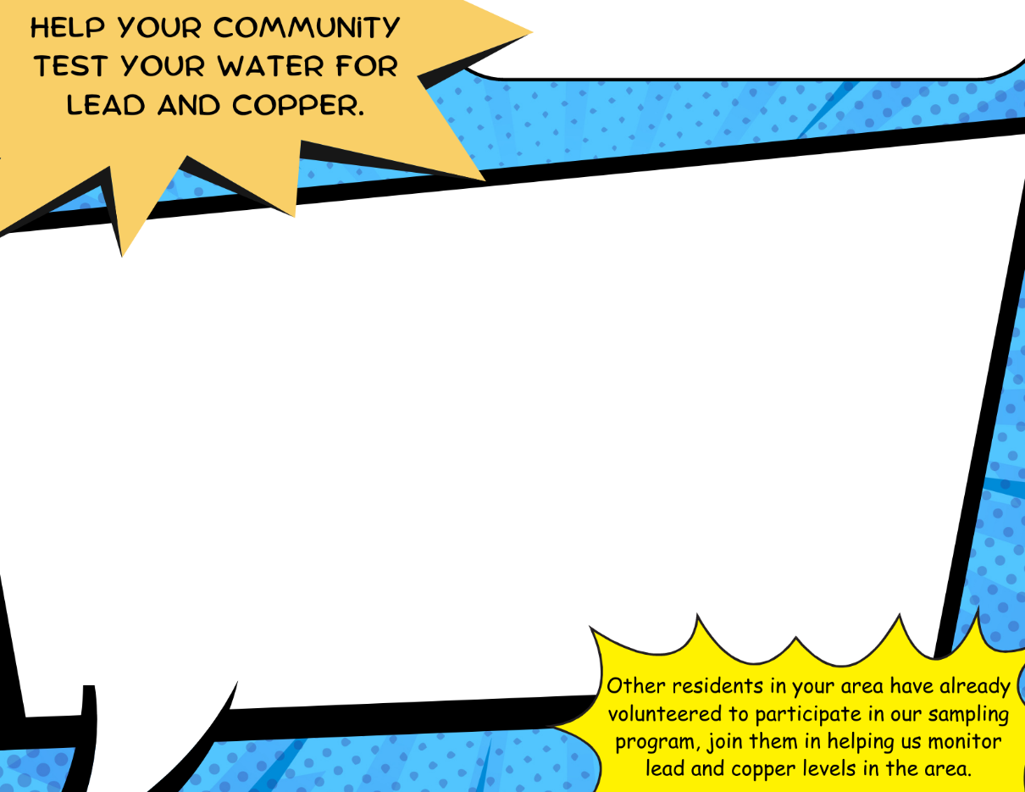
These samples help assess whether lead and copper are present at unsafe levels and, if so, what steps should be taken to minimize a customer’s exposure through drinking water. The public water system will analyze the water sample free of charge and notify you of the results within 30 days from receipt.

Your home has been selected to participate in our area wide sampling program to test for the presence of lead and copper in our drinking water. Lead and copper primarily enters drinking water systems through corrosion of household plumbing materials.

Periodically, all community water systems, including the ____insert PWS Name____________ are required by the U.S. Environmental Protection Agency and the Massachusetts Department of Environmental Protection, to measure lead and copper levels in their drinking water.

PWS Name Here
Option 1A: An eye-catching design to entice residents. This design features a description of why water sampling is important for residents and how to contact their PWS to volunteer for sampling. This design does not include a section to provide incentives.

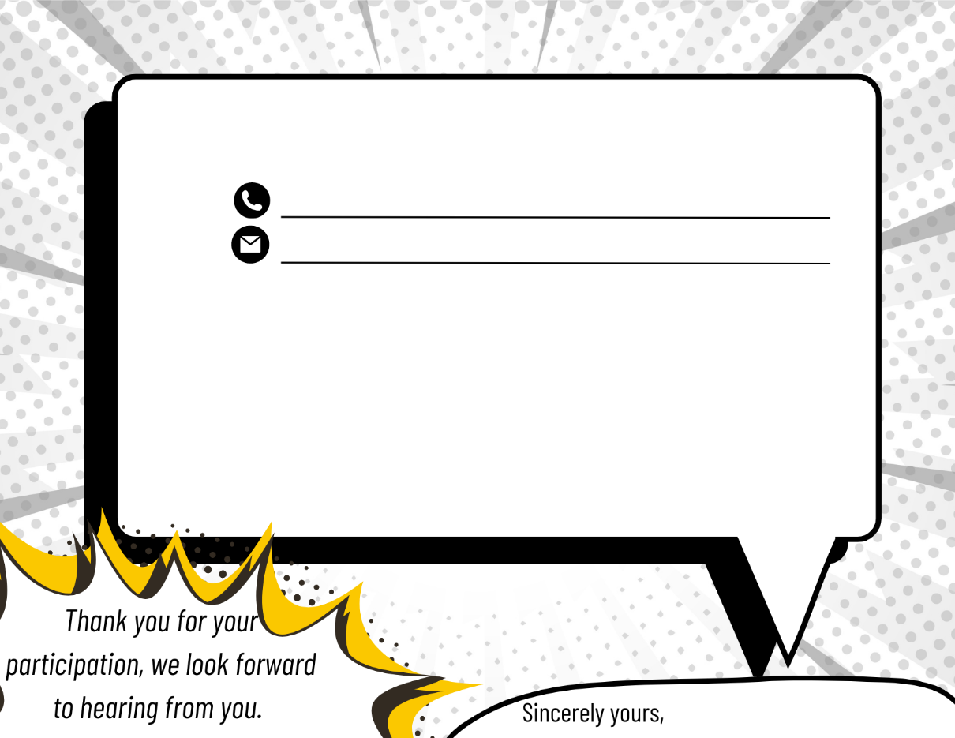
Having a general knowledge of your home’s water quality is important as it can directly impact you and your family's health. If you would like to volunteer to participate in this testing, please do so by contacting by email or calling us.
Phone Number
Email Address
Your Name Here
One of our employees will call and ask you a few questions from a brief survey before water samples can be collected. Sample bottles will be delivered to your home by ---PWS Name here--- personnel and the completed water samples will be collected the following day.

If you volunteer to participate detailed instructions regarding the sampling procedures will be provided when the sample bottles are delivered. The lead and copper results will be provided to you at the completion of the area wide testing.

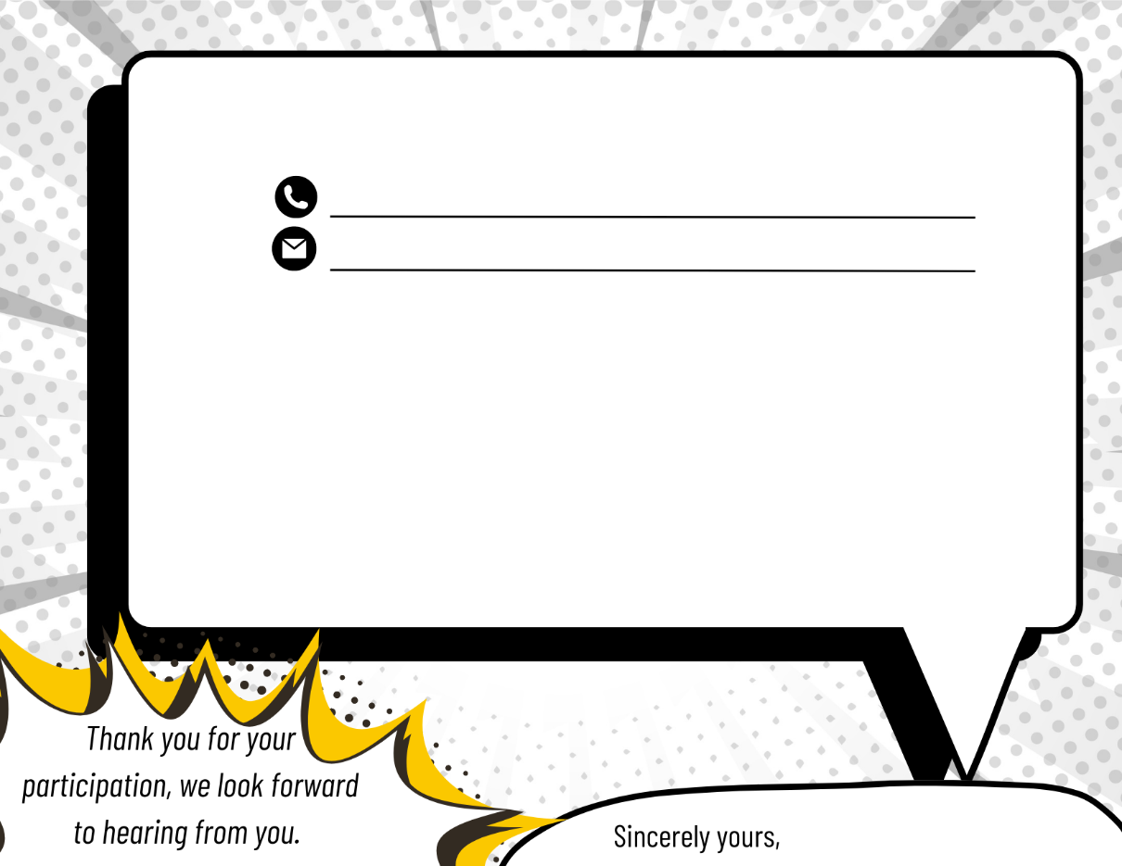
Your home has been selected to participate in our area wide sampling program to test for the presence of lead and copper in our drinking water. Lead and copper primarily enters drinking water systems through corrosion of household plumbing materials.

Periodically, all community water systems, including the ____insert PWS Name____________ are required by the U.S. Environmental Protection Agency and the Massachusetts Department of Environmental Protection, to measure lead and copper levels in their drinking water.

These samples help assess whether lead and copper are present at unsafe levels and, if so, what steps should be taken to minimize a customer’s exposure through drinking water. The public water system will analyze the water sample free of charge and notify you of the results within 30 days from receipt.

PWS Name Here
One of our employees will call and ask you a few questions from a brief survey before water samples can be collected. Sample bottles will be delivered to your home by ---PWS Name here--- personnel and the completed water samples will be collected the following day.

Having a general knowledge of your home’s water quality is important as it can directly impact you and your family's health. If you would like to volunteer to participate in this testing, please do so by contacting by email or calling us.
Phone Number
Email Address

Option 1B: An eye-catching design to entice residents. This design features a description of why water sampling is important for residents and how to contact their PWS to volunteer for sampling. This design includes a section to provide incentives for residents on the back.

As a thank you for your assistance to in our community safe drinking water program, all residents who volunteer to sample their drinking water will receive –Incentive here ---.

If you volunteer to participate detailed instructions regarding the sampling procedures will be provided when the sample bottles are delivered. The lead and copper results will be provided to you at the completion of the area wide testing.

Your Name Here

Option 2A: A simple design to entice residents. This design features a description of why water sampling is important for residents and how to contact their PWS to volunteer for sampling. This design does not include a section to provide incentives.
If you volunteer to participate detailed instructions regarding the sampling procedures will be provided when the sample bottles are delivered. The lead and copper results will be provided to you at the completion of the area wide testing.

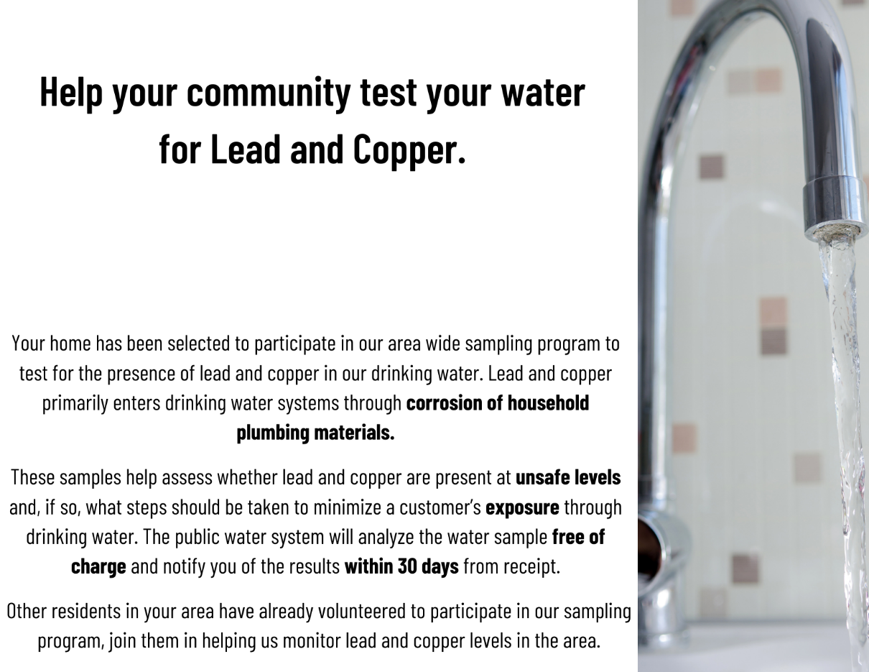

Periodically, all community water systems, including the ____insert PWS Name____________ are required by the U.S. Environmental Protection Agency and the Massachusetts Department of Environmental Protection, to measure lead and copper levels in their drinking water.

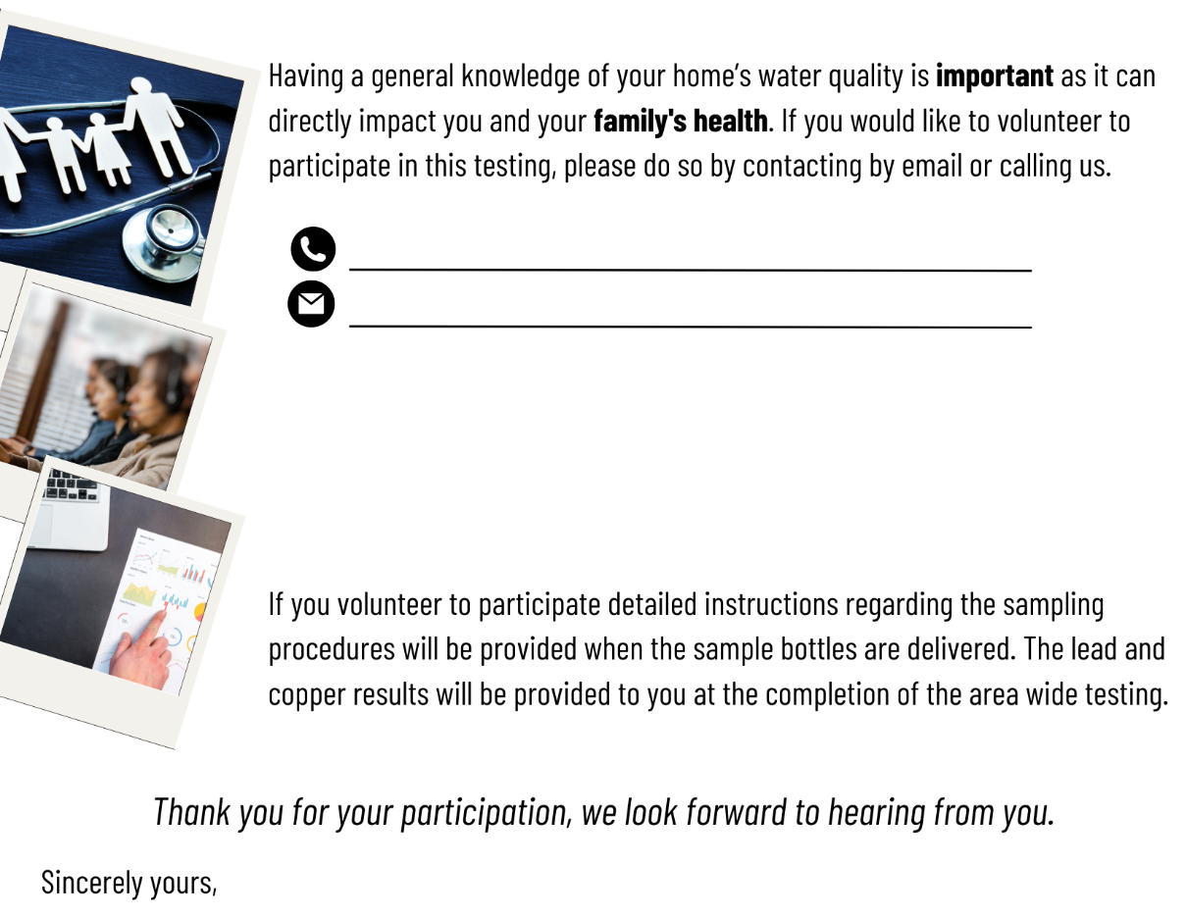
One of our employees will call and ask you a few questions from a brief survey before water samples can be collected. Sample bottles will be delivered to your home by ---PWS Name here--- personnel and the completed water samples will be collected the following day.

Your Name Here
Phone Number
Email Address
PWS Name Here

Option 2B: A simple design to entice residents. This design features a description of why water sampling is important for residents and how to contact their PWS to volunteer for sampling. This design includes a section to provide incentives for residents on the back.
PWS Name Here
Periodically, all community water systems, including the ____insert PWS Name____________ are required by the U.S. Environmental Protection Agency and the Massachusetts Department of Environmental Protection, to measure lead and copper levels in their drinking water.

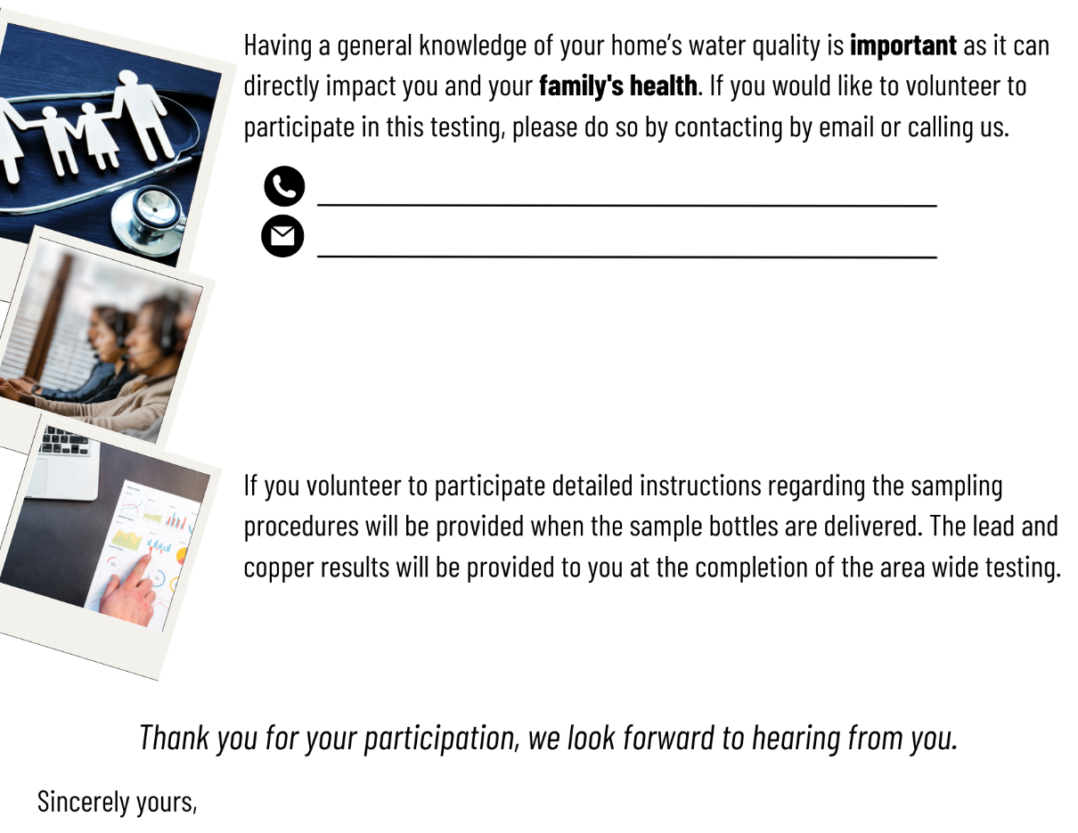

Phone Number
Your Name Here
As a thank you for your assistance to in our community safe drinking water program, all residents who volunteer to sample their drinking water will receive –Incentive here ---.
One of our employees will call and ask you a few questions from a brief survey before water samples can be collected. Sample bottles will be delivered to your home by ---PWS Name here--- personnel and the completed water samples will be collected the following day.

Email Address
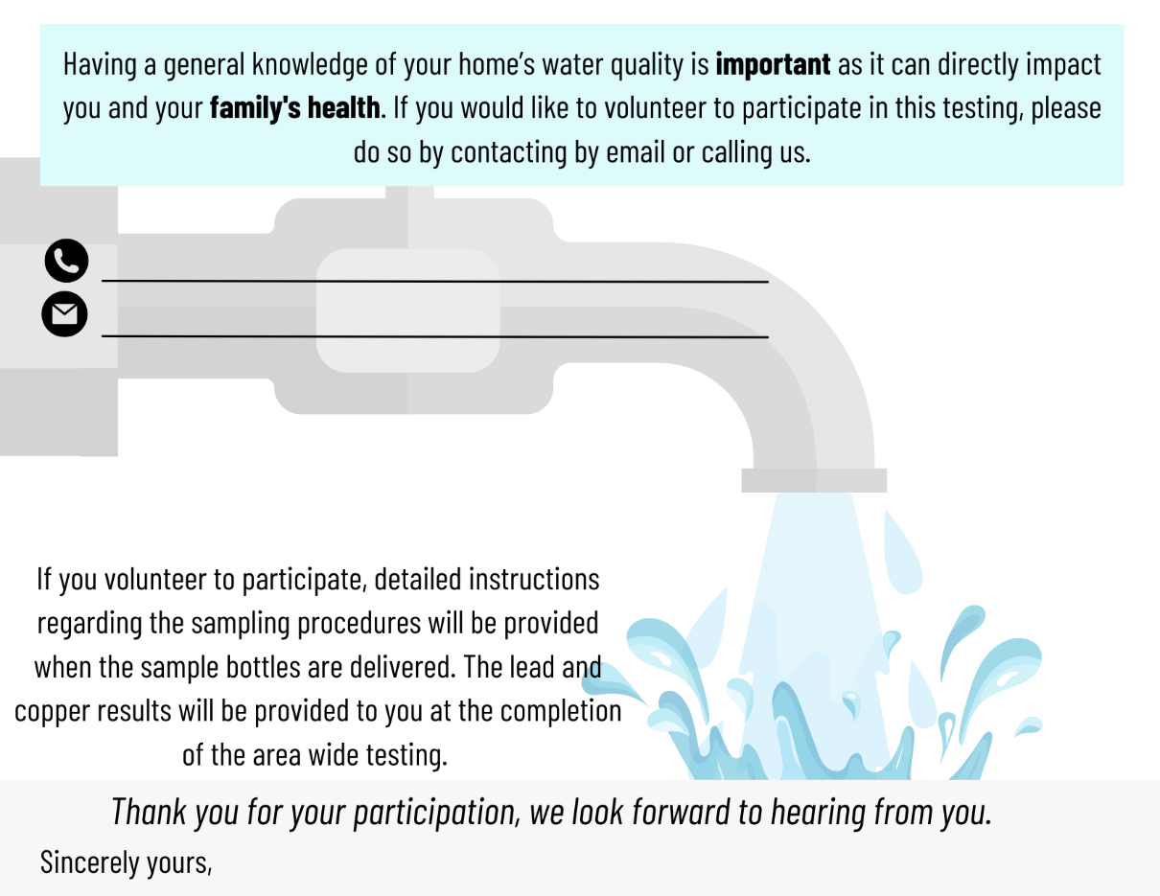
Email Address
Phone Number
Your Name Here
One of our employees will call and ask you a few questions from a brief survey before water samples can be collected. Sample bottles will be delivered to your home by ---PWS Name here--- personnel and the completed water samples will be collected the following day.

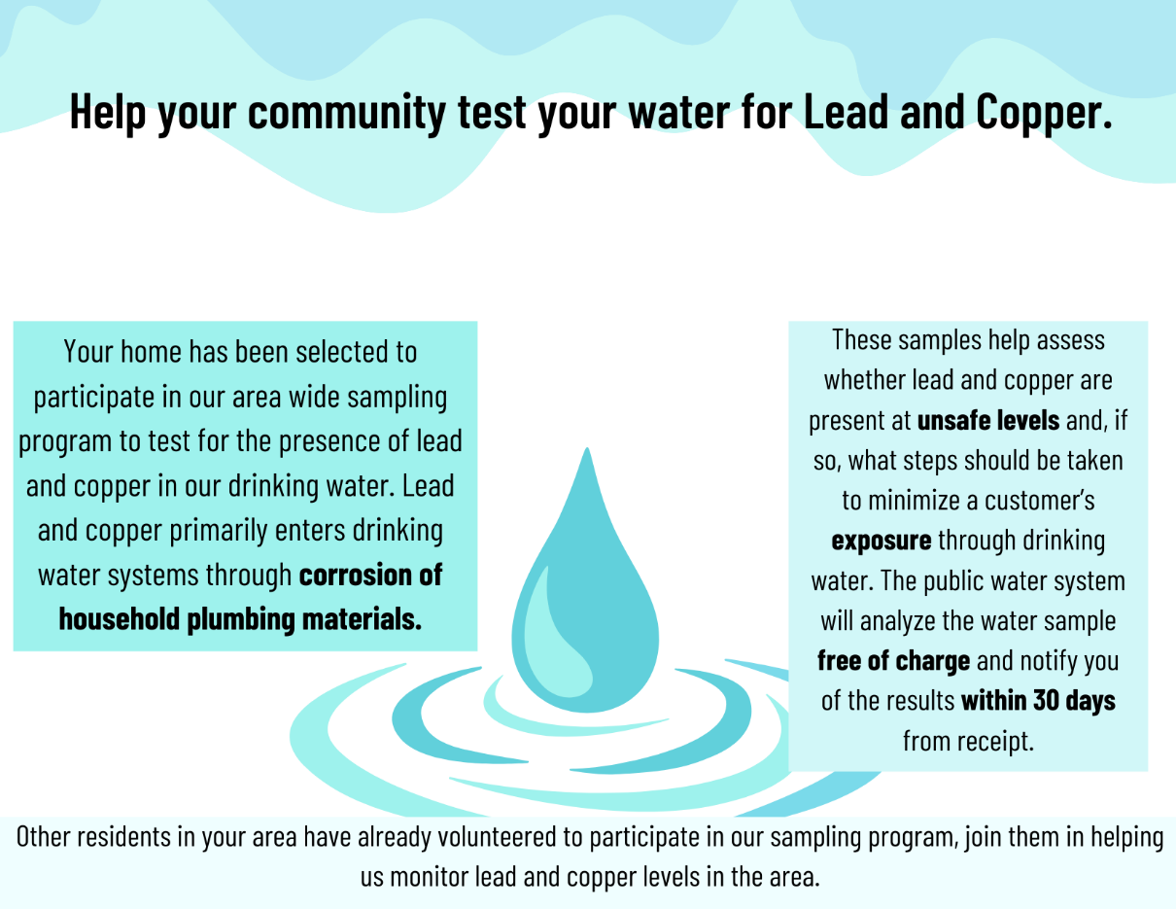
PWS Name Here

Option 3A: A water-themed design to entice residents. This design features a description of why water sampling is important for residents and how to contact their PWS to volunteer for sampling. This design does not include a section to provide incentives.
Periodically, all community water systems, including the ____insert PWS Name____________ are required by the U.S. Environmental Protection Agency and the Massachusetts Department of Environmental Protection, to measure lead and copper levels in their drinking water.

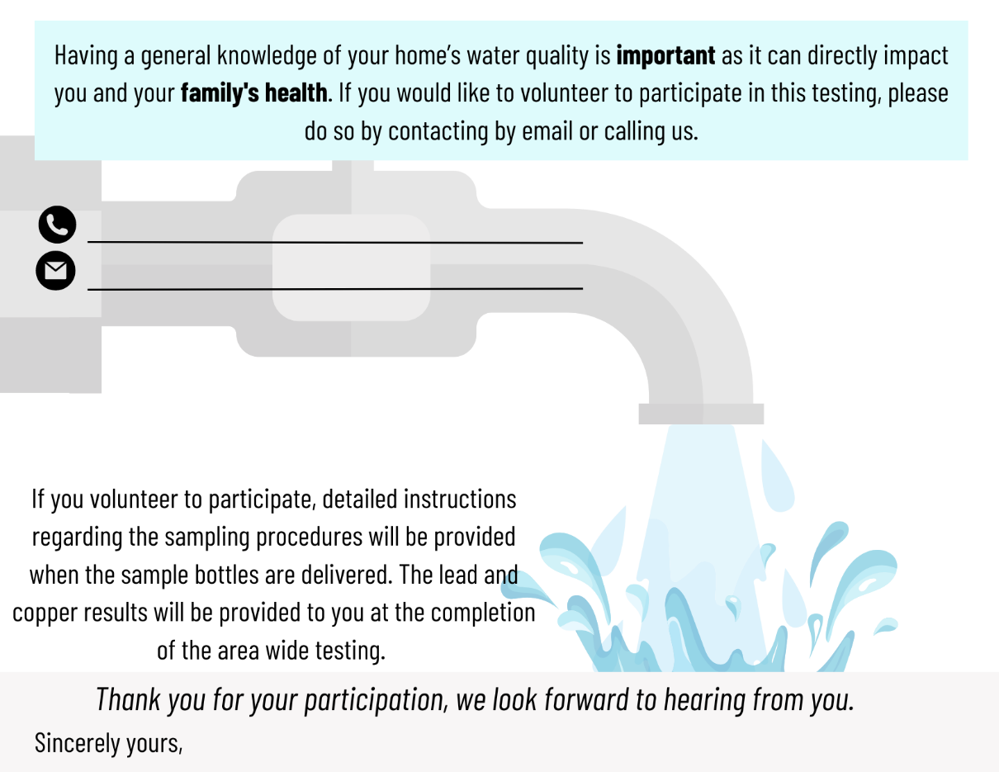
As a thank you for your assistance to in our community safe drinking water program, all residents who volunteer to sample their drinking water will receive --- incentive here--.
Option 3B: A water-themed design to entice residents. This design features a description of why water sampling is important for residents and how to contact their PWS to volunteer for sampling. This design includes a section to provide incentives for residents on the back.
Periodically, all community water systems, including the ____insert PWS Name____________ are required by the U.S. Environmental Protection Agency and the Massachusetts Department of Environmental Protection, to measure lead and copper levels in their drinking water.

PWS Name Here
Email Address
Phone Number
Your Name Here
One of our employees will call and ask you a few questions from a brief survey before water samples can be collected. Sample bottles will be delivered to your home by ---PWS Name here--- personnel and the completed water samples will be collected the following day.

Homeowner incentives for LCR sampling
MassDEP’s Drinking Water Program has collected examples of incentives Public Water Suppliers (PWS) have used nationally to encourage homeowners to participate in their local community lead and copper drinking water program. Listed below are incentives we have identified that some PWS have offered homeowners.

Incentives:

- A credit towards the homeowner’s water bill,
- A cash reward,
- A prize drawing with a variety of prizes to win,
- A gift card to a well-known business; businesses such as a coffee seller, a fast-food or other restaurant, a home improvement store, an ice cream store, and so on would all be great incentives. Giving a choice between multiple gift card options might entice the most homeowners.
- Tickets to a local event such as a sporting event, movie theater, a carnival, or a show.
- Small gifts or gift baskets based on a theme that may be of interest to homeowners.
For example, during the summer, a small kiddie pool for children, or accessories for their existing pools. During the fall or winter, items could be baskets of hot chocolate.
- A community BBQ or outdoor lunch; admission could be based on showing a participation card or by bringing their sampling bottles to the event.

Do you know of other incentives to add to this list? Please share your example with MassDEP Drinking Water Program at program.director-dwp@mass.gov.

Examples of Incentives Previously Used by PWS in MA
- One District offers a $10 credit towards the next water bill if the sample bottle is dropped off within the first ten days (the District tends to extend this deadline). This District reports that the incentive generally translates into a 50% improvement in response. The most recent sampling round they received 40 of their required 60 samples within the first 3 weeks.

- One PWS offers a drawing with three cash prizes: $500, $300, $100. Winners have option to accept the cash prize or have it applied as a credit on their water bill; cash prize requires W-9 state tax form to be completed by customer; utility creates vendor account for winner and submits invoice to Town Hall for payment. For participant to be eligible to receive the prize, paperwork must be complete and accurate and meet the deadline to submit sample. The PWS reports paperwork quality was much better with less back and forth with the customer. The PWS reported a vast improvement in response. Where it previously took 3 months to get 40 samples, with this incentive, 28 of the 40 required samples were returned in the first week and sampling was completed in 3-4 weeks. The PWS used bright gold paper in the sampling kit bringing attention to the “cash reward” available for participation. People called back inquiring about the drawing and its results. The PWS believes this will help retain targeted sites in the sampling program.

- One PWS offers $100 credit towards the next quarterly water bill. The incentive seems to attract interest. The system is able to collect 30 samples within 1-2 weeks.

- One PWS offers a $25 credit on water bill provided the sample and paperwork are completed properly.

- Beginning in 2023, one PWS will waive the unit charge for participants provided the sample and paperwork are completed properly. “Unit charge” is like a bond debt fee or minimum bill; so essentially this is a credit on water bill. The unit charge is currently $45. This way if the unit charge increases in the future, the incentive will automatically increase.

- One PWS offers $10 gift cards from a popular coffee seller to participants.

- Two PWS give money (at least $25) to each homeowner collecting samples.

