COMMONWEALTH OF MASSACHUSETTS
Executive Office of Health and Human Services
MASSHEALTH SCHOOL-BASED MEDICAID PROGRAM

LEA Instruction Guide for Direct Service Cost Report
Instructions for Submission of the
Annual Direct Service Claiming Cost Report
Effective for State Fiscal Year 2021
[ updated August 2021 ]

Contents

Executive Summary 3
Section 1: School-Based Medicaid Program (SBMP) Overview 4
1.1 How to Use School-Based Medicaid Guides 4
1.2 Applicable Laws, Regulations, and Published Guidance 4
Section 2: Direct Service Cost Report Overview and LEA Requirements 6
2.1 Filing Deadlines and Certification 8
2.2 Designating an LEA Cost Report Preparer 8
2.3 Requirements for Reporting Expenditures 9
2.4 Record Retention and Audit Preparedness 9
Section 3: LEA Contracted and Employed Staff Salary and Benefit Expenditures 11
3.1 Which Staff Members Can Be Claimed? 11
3.2 Allowable Personnel Expenditures 11
Section 4: Medicaid Penetration Factors 13
4.1 LEA Financial Responsibility for Students 13
4.2 Non-IEP (Expansion) Services Student Population 15
4.3 IEP Services Student Population 15
4.4 Medicaid Penetration Rates 15
Section 5: Out-of-District Tuition 16
5.1 Allowable Out-of-District Tuition Expenditures 16
5.2 Reporting Out-of-District Tuition Expenditures 17
5.3 Reporting “Cost Share” Tuition Expenditures 17
Section 6: Other Direct Medical Costs 18
6.1 Materials and Supplies 18
6.2 Purchased Services 18
6.3 Medical Equipment 19
6.4 Indirect Costs 19
Section 7: Application of RMTS Percentages 20
Section 8: Cost Report Amendments 21
Appendix A: Contact Information 22
Appendix B: Commonly Used SBMP Terms 23
Appendix C: SBMP Guides and Other Resources 24
Appendix D: Service Type Groupings 25
Appendix E: Certification of Public Expenditure Form 26
Appendix F: Certification of Public Expenditure Form for Amended Reports 27
Appendix G: Indirect Costs 28
Appendix H: Cost Share Supplemental Report 29

Executive Summary
This guide is intended to provide local education agencies (LEAs) with instructions and information needed to submit the required annual Direct Service Cost Report for the School-Based Medicaid Program (SBMP). As MassHealth-contracted providers, LEAs are expected to follow all MassHealth rules and regulations. LEAs should review the SBMP Program Guide for Local Education Agencies and the SBMP Direct Service Claiming Program Guide on the SBMP Resource Center before reviewing this guide.
The SBMP Program Guide offers a high-level overview of the entire program, including the administrative activity claiming (AAC) component, which complements the direct-service claiming (DSC) that is discussed in this document, and the RMTS, which is an integral component of the entire program.
The SBMP Direct Service Claiming Program Guide provides instructions related to interim claiming requirements, which are an integral part of the Direct Service Cost Report settlement determination. LEAs are required to submit interim claims whenever a reimbursable service is provided to an eligible MassHealth-enrolled student for whom the LEA seeks reimbursement. Interim claims demonstrate to MassHealth that reimbursable services are being provided and are required to allow costs for each provider type (e.g., nurses, speech therapists, etc.) and appropriate number of students to be included in the annual DSC cost report.
Additionally, MassHealth uses a method called the Random Moment Time Study (RMTS) to quantify the time that staff spends doing reimbursable activities. Participation in the RMTS is required under the SBMP Provider Contract as a condition for reimbursement. All employed and contracted practitioners for whom the LEA wishes to seek Direct Service (DSC) reimbursement must be included in the RMTS. For details about the RMTS, see the LEA RMTS Coordinator Guide for Random Moment Time Study (RMTS) available in the SBMP Resource Center.
LEAs are required to designate an individual from the LEA as the primary contact for all matters related to the submission of the annual Direct Service Cost Report. LEAs may also designate another LEA employee or contracted billing agent to assist with the report. Regardless of designation to an outside entity, as with all LEA contractual obligations, the LEA is ultimately responsible for ensuring compliance with SBMP program guidelines and deadlines.
This guide provides an overview of the key components of accurately reporting LEA expenditures that are eligible for Medicaid Direct Medical Service reimbursement. For step-by-step instructions, please refer to the Step-by-Step Manual: Direct Service Cost Report available by request from UMMS. The step-by-step guide must be used in conjunction with this guide.

Section 1:

School-Based Medicaid Program (SBMP) Overview
The school setting provides a unique opportunity for local communities to partner with MassHealth to enroll eligible children, and to assist enrolled children in accessing their benefits. Federal matching funds (called Federal Financial Participation or FFP) are available to contracted LEAs through participation in the SBMP. Final reimbursement for SBMP direct services and administrative activities is based on Medicaid- allowable actual incurred costs.
Massachusetts is authorized to claim federal dollars for direct services and administrative activities through its State Plan Amendment, which is approved by the Centers for Medicare & Medicaid Services (CMS).

1.1 How to Use School-Based Medicaid Guides
This guide provides an overview of the Direct Service Cost Reporting process and is designed for any staff involved in the gathering of allowable expenditure information or implementing SBMP program requirements related to Medicaid DSC reimbursement, including the LEA-designated “Cost Report Preparer(s)” and any contracted billing agents. For a general understanding of the SBMP, including Direct Service Claiming (DSC) and AAC, please refer to the SBMP Program Guide for Local Education Agencies, and other applicable guides, available on the SBMP Resource Center.
Other guides that are available on the Resource Center are referenced throughout this guide. This guide must be used in conjunction with the detailed Step-by-Step Manual: Direct Service Cost Report, available by request from UMMS, to ensure accurate and timely filing of the cost report as required by the provider contract.
Because SBMP guides and resources will be updated on an ongoing basis, it is critical to visit the SBMP Program website for the most up-to-date information. All program bulletins, training materials, and additional resources must be followed and are consistent with the scope of the School-Based Medicaid Program Provider Contract. Materials referenced in this guide, and their availability in the Resource Center, are listed in Appendix C. The SBMP distributes new and updated materials after they are posted online. To receive notification of new materials and other important communications, LEAs must update contacts by filling out the School District Contact Information Form on the SBMP Resource Center .

1.2 Applicable Laws, Regulations, and Published Guidance
Any LEA or subcontractor participating in the SBMP must comply with all applicable federal and state laws, regulations, published guidance, and the terms of the Provider Contract (a sample contract is available on the SBMP Resource Center), including, but not limited to
    - Section 1902(a) of the Social Security Act;

    - Code of Federal Regulation (C.F.R.) Titles 42 and 45;
    - OMB Uniform Administrative Requirements, Cost Principle, and Audit Requirements for Federal Awards (2 C.F.R. §200);
    - OMB Circular A-133 Audits of States, Local Governments, and Non-Profit Organizations;
    - Massachusetts School-Based Medicaid Program Provider Contract;
    - MassHealth School-Based Medicaid Program bulletins; and
    - MassHealth School-Based Medicaid Program instruction guides.
LEAs are responsible for keeping up to date on and complying with all applicable rules and regulations. LEAs should be aware that applicable regulations, contracts, and other program guidance may be updated from time to time; and such updates may not be reflected in this document.
LEAs may not claim reimbursement for, and staff must be excluded from the RMTS and any cost reports in, any of the following situations.
    - 100 percent of the staff person’s salary is paid through a federal grant or from other federal funds (including Individuals with Disabilities Education Act (IDEA) funds). As a reminder, this includes any state or local funds that were a required match to receive the federal grant, which are considered part of the federal funding percentage related to staff salary;
    - Medicaid billing vendors who are paid on a contingency fee (percent of claim) basis; or
    - Any staff member whose salary is included in the LEA’s Indirect Cost Rate. See Appendix G for additional details and excluded account object codes.

Section 2:

Direct Service Cost Report Overview and LEA Requirements
The Direct Service Claiming (DSC) Program is the mechanism through which LEAs seek federal reimbursement for the provision of medical services (as opposed to Medicaid administrative costs, which are captured in administrative activity claiming (AAC)). For more information about AAC, see the SBMP Program Guide for Local Education Agencies and the Administrative Activities Claiming Guide in the SBMP Resource Center.
The SBMP covers the provision of Medicaid-covered medical services delivered in a school setting that meet Medicaid’s definition of medical necessity and all other program requirements. Medicaid-covered medical services include speech-language pathology, occupational therapy, and physical therapy; mental/behavioral health services; skilled nursing services; audiology services; personal care services; applied behavior analysis (ABA) services for students with autism spectrum disorder; medical nutritional counseling; certain physical and behavioral health screenings; and fluoride varnish treatment.
For additional information on licensure requirements for covered services, review the Local Education Agencies Covered Services and Qualified Practitioners Document posted in the SBMP Resource Center.

Interim Claims and Cost Report Overview
Throughout the year, LEAs submit interim claims for reimbursable services provided to eligible MassHealth-enrolled members through MassHealth’s Medicaid Management Information System (MMIS). Providers must submit per-unit claims for all services for which they seek reimbursement in the annual DSC cost report due on December 31 each year. Interim claims are required to demonstrate that reimbursable services were provided to an eligible member. Interim claims that are adjudicated in MMIS and determined to be “paid” (regardless of interim billing fee) are the basis for which costs can be included in the annual Cost Report and the basis for the number of students that can be counted in the Medicaid Percentage Rate calculations. The annual DSC cost report calculates total gross Medicaid allowable expenditures based on each LEA’s actual incurred and allowable costs. Interim claims are paid quarterly.
After the conclusion of the fiscal year, LEAs submit an annual DSC cost report that includes costs to provide Medicaid-covered services and LEA-specific Medicaid eligibility statistics used to calculate Medicaid penetration factors. These inputs, and the statewide Random Moment Time Study (RMTS) results, are used to determine the gross Medicaid reimbursable amount, also referred to as the Certified Public Expenditure amount. This calculation is shown in Figure 1.
Figure 1: Annual DSC Cost Report Calculation to Determine Gross Expenditure Amount for Medicaid Covered Services
Allowable Costs for Covered Services times statewide RMTS Results times LEA-specific Medicaid Penetration Factor equals Gross Medicaid Allowable Expenditure.
This gross Medicaid allowable expenditure amount is reported to CMS, and the state receives partial federal reimbursement. The total of each LEA’s interim claims paid throughout the year is deducted from the LEA’s portion of federal reimbursement, and the remaining amount is paid to the LEA (“LEA’s total portion of federal reimbursement”). This is called the cost report reconciliation process. Figure 2 illustrates this process.
Figure 2: Annual DSC Cost Report Reconciliation Process
LEA’s total portion of federal reimbursement minus Interim Payment reimbursement previously received equals Cost Report Settlement or Liability.
If the cost report reconciliation is positive, then a payment will be issued to the LEA. If the cost report reconciliation is negative, then MassHealth will recoup the overpayment from the LEA. Cost reports are due by December 31 each year and generally paid or recouped by the end of the following June. For example, for FY19 (July 2018–June 2019), cost reports were due 12/31/19, and reconciliations are anticipated to be paid or recouped by 6/30/20. A helpful list of dates and deadlines is available in the SBMP Resource Center (the document is called SBMP Schedule SFY20XX).
LEAs can impact whether they receive a cost report reconciliation payment, or whether they end up owing MassHealth money from an overpayment. LEAs may bill any amount up to the maximum fee specified in the SBMP Procedure Codes and Maximum Fees document. Accordingly, to avoid a recoupment, when LEAs monitor interim claiming to ensure that all qualified services are submitted to MMIS, they should also track interim payments received throughout the year against total cost report projections, and adjust the interim fees charged accordingly throughout the year. Because LEA final reimbursement is paid based on cost allocation, setting conservative or low interim billing fees does not negatively impact annual revenue.
This Instruction Guide for Direct Service Cost Report provides instructions for the accurate reporting of allowable costs in the annual cost report. Please refer to the MassHealth School-Based Medicaid Program Direct Service Claiming (DSC) Program Guide, available in the SBMP Resource Center, for additional details about the direct service reimbursement program, with a focus on reimbursable service requirements for interim claiming and documentation of RMTS moments.

Allowable Medicaid Costs for DSC are reported annually and include
    - qualified employee salary and employer-paid benefit expenditures;
    - qualified contracted staff payments;
    - out-of-district tuition expenditures;
    - medical supplies, materials, purchased services, and equipment expenditures when used in the provision of Medicaid-covered direct medical services; and
    - indirect costs through the application of the Department of Elementary and Secondary Education (DESE)-approved indirect cost rate.

2.1 Filing Deadlines and Certification
Cost reports are due within six months of the close of the state fiscal year (December 31). LEAs must submit all cost reports electronically through the Cost Report System website. Details on how to use the system are available in the Step-by-Step Manual: Direct Service Cost Report, available by request from UMMS.
The December 31 deadline applies regardless of holidays and weekends. Exceptions to the December 31 deadline will be granted only for extraordinary circumstances. In such instances, the LEA must request approval from MassHealth, in writing, describing the circumstances at least 10 days before the submission deadline (i.e., no later than December 21).
Before the beginning of each school year, MassHealth posts all important program deadlines, including RMTS deadlines, in the SBMP Resource Center. For the current fiscal year deadlines, please see SBMP Dates & Deadlines SFY20XX.
The Certification of Public Expenditure (CPE) must be signed by an officer of the LEA, such as the school superintendent or the business manager. (See Appendix E and F for examples of original and amended certification form letters). The CPE will be prepopulated and must be downloaded from the Cost Report system following approval of the submitted report. LEAs must submit electronic copies of signed original CPE letters by midnight on April 20 to the University of Massachusetts Medical School (UMMS) on school district letterhead, at SchoolBasedClaiming@umassmed.edu.
Notes on Deadline and Certification of Negative Amendments (Overpayments)
    - Providers must file amendments that reduce the amount of the settlement in the case of an overpayment (“negatively amended reports”). Please refer to All Provider Bulletin 224 for all overpayment disclosure processes and requirements.
    - The Amended Certification of Public Expenditure (CPE) letter must be signed by an officer of the LEA, such as the school superintendent or the business manager. (See Appendix F for example of amended certification form letters).

2.2 Designating an LEA Cost Report Preparer
The LEA Cost Report Preparer oversees compliance with all reporting requirements on behalf of the LEA. LEAs may designate one or more LEA employees or a contracted billing agent to assist with these operations. Regardless of designation to an outside entity, as with all LEA contractual obligations, the LEA is ultimately responsible for ensuring compliance with SBMP program guidelines and deadlines as outlined in this guide. Accordingly, LEAs should monitor the cost report submission to ensure that it is submitted accurately and on time. To update the Cost Report Preparer designation as required, complete the School-Based Medicaid Program: Authorized Designee Information Form in the SBMP Resource Center. The completed and signed form should be scanned and sent to UMMS via email to schoolbasedclaiming@umassmed.edu or faxed to (508) 856-7643.

2.3 Requirements for Reporting Expenditures
LEAs must report all expenditures in the Direct Service cost report as actual expenditures during the period in which the expenditure occurred (i.e., the “check date” of the expenditure determines the reporting period, not the service date that the expenditure may have been for). The only exception to this rule is that prepaid expenditures must be claimed in the period in which the services were rendered.
Excluded Expenditures Applicable to ALL Expenditure Categories
    - LEAs must exclude restricted federal funding from the report of actual LEA expenses. Only state/local funding sources may be included.
    - LEAs must exclude expenditures that were used to satisfy a federal matching requirement
(2 C.F.R. 200.306).
    - Costs related to Medicaid billing contractors/vendors that are paid on a contingency fee (percent of claim) basis must be excluded.
    - Any expenditures (including staff salaries) included in the LEA’s Indirect Cost Rate must be excluded. See Appendix G for additional details and excluded account object codes.
    - Costs for service types without corresponding interim claims must be excluded. The LEA must have demonstrated that services were provided in order to seek reimbursement for each medical service category (IEP and non-IEP) and type of service. (Note: There is no requirement for an LEA to participant in both IEP and non-IEP reimbursement, as these two aspects of the program are measured, and reimbursement is calculated, separately.) Specifically, this means that there must be paid interim claims processed through MMIS for in-district services for each service type offered by the LEA per quarter to qualify for reimbursement. This applies to all costs, including health service or billing staff salary and benefits, supplies, materials, equipment, and purchased services. The staff job descriptions and other related costs associated with each service type grouping are detailed in Appendix D. (For information regarding allowable out-of-district costs, see Section 5.1.)
* Note: Medicaid billing costs may be included only in quarters where paid interim claims exist for at least one of the covered service types
    - Additional exclusions that are applicable to specific sections of the cost report are indicated in those sections to follow.

2.4 Record Retention and Audit Preparedness
LEAs are responsible for ensuring program compliance and must certify, under penalties of perjury, that cost reports are accurate. For reference, the Certification of Public Expenditure form and mandatory certification statements can be reviewed in Appendix E. The federal government regularly audits the SBMP, and all costs are subject to audit review by MassHealth and other state and federal agencies. LEAs are responsible for ensuring that the appropriate documentation can be produced in the event of an audit or other request by MassHealth or other state or federal compliance agency. Failure to do so may result in a recoupment or termination from the program as described in the Provider Contract. A model contract is available in the SBMP Resource Center.

Under the Provider Contract and 130 CMR 450.205, the provider agrees to make, keep, and maintain in a systematic and orderly manner, and have readily retrievable, such records as are necessary to fully disclose the type and extent of all Direct Services and Administrative Activities provided to members, including the records described in 130 CMR 450.205 and the records described in federal regulations at 42 C.F.R. 431.107. These records shall be created at the time Direct Services and Administrative Activities are delivered, and must be retained by the provider for the at least six years from the date of filing.

Section 3:

LEA Contracted and Employed Staff Salary and Benefit Expenditures
Personnel costs may be claimed in the cost report for staff who are involved in the delivery of medical service types for which the LEA has paid MMIS claims. The cost report may also include costs for staff conducting billing activities under the School-Based Medicaid Program. Information should be included only for staff members who were included in the appropriate DSC cost pool (pool 1, 2, or 3) within the Random Moment Time Study (RMTS) participant list. Contracted and directly employed staff are generally claimed the same way and are referred to as “staff” or “staff members” in this guide. When contractor claiming is treated differently, it is explicitly stated.

3.1 Which Staff Members Can Be Claimed?
Personnel costs may be included in the cost report only when all the following conditions have been met.
1. Staff were included as participants in an appropriate direct service pool (pool 1, 2, or 3) in the first possible RMTS participant list following their date of hire or change in job position (per the RMTS participant list submission deadlines described in the LEA RMTS Coordinator Guide for Random Moment Time Study available in the SBMP Resource Center).
2. Staff costs were at least 1% funded from state and/or local funds.
3. The staff member was working, or was not working but was using LEA-paid benefit time, during the claiming period. (Please note: Submission of a Change of Status (COS) request indicating that a staff member was terminated or out of work on unpaid time is equivalent to removal of that participant from the RMTS. Therefore, no costs may be included for those periods of time, even if the COS request was submitted in error.)
4. Staff met provider qualifications to perform Medicaid-covered direct services, including holding an active license for the time period claimed. (Refer to the Local Education Agencies Covered Services and Qualified Practitioners document in the SBMP Resource Center for a complete list of Direct-Service practitioners and their corresponding licensure requirements.)
Excluded Expenditures
- Please refer to the exclusions in Section 2.3, which apply to all expenditures reported, including personnel costs.

3.2 Allowable Personnel Expenditures
LEAs can include costs for staff who are involved in the delivery of a medical service type for which the LEA has paid MMIS claims.

Any personnel costs related to separate and unrelated duties must be excluded. For example:
- Stipends paid for supervision of extracurricular activities (such as an athletic coach or club advisor, etc.) should be excluded.
- For staff who hold two part-time job positions where only one is qualified for Medicaid participation, such as a part-time occupational therapy assistant (OTA) who also works part time in the cafeteria, only those costs attributable to the salaries and benefits earned as the OTA should be included.
For those LEAs that also participate in the Administrative Activity Claiming (AAC) portion of the SBMP, personnel expenditures reported in AAC will be prepopulated into the cost report. All prepopulated expenditure data should be reviewed and adjusted if necessary. Regardless of cost preparer designee, LEAs are responsible for ensuring accuracy of all reported data and compliance with all DSC program requirements.
LEA personnel costs must be actual (not allocated) and are reported and categorized as follows.
1. Actual Quarterly Salary—the staff member’s actual salary or contractual payment amount for the period before the federally funded percentage is applied. For expenditures paid to a contracted agency that included the costs of multiple contracted staff, the expenditures must accurately break out individual expenditure per contractor.
2. Federally Funded Percentage—the percentage of a staff member’s salary (or contractor’s quarterly payment) that is funded from federal grant(s) or any federal funding source. This includes any state or local funds that were a required match to receive the federal grant. These dollars should also be considered part of the federal funding percentage. A percentage between 0.00 and 100 must be reported. The field may not be left blank.
3. Salary Without Federal Funding—the staff member’s actual salary or contractual payment amount for the period, after the federally funded portion has been deducted. This is calculated by the AAC system if online data entry is used.
4. Unemployment—the actual employer-paid unemployment contribution for the staff member. This amount must be zero for contracted staff.
5. Health Insurance—the actual employer-paid health insurance amount for the staff member. This amount must be zero for contracted staff.
6. Medicare Tax—the actual employer-paid Medicare tax for the staff member. This amount must be zero for contracted staff.
7. Workers’ Compensation—the actual employer-paid workers’ compensation insurance contribution for the staff member. This amount must be zero for contracted staff.
8. Retirement—the actual employer-paid retirement contribution for the staff member. This amount must be zero for contracted staff.
9. Other Benefits—the total amount of any actual employer-paid benefits for the staff member not categorized above. This amount must be zero for contracted staff.

Section 4:

Medicaid Penetration Factors
Reimbursement is available only if provided to MassHealth-enrolled members between three and 21 years of age (until the student’s 22nd birthday) who are eligible for federal reimbursement for non-emergency services. In general, this includes most MassHealth Standard, CommonHealth, Family Assistance, or CarePlus members (not Limited or Children’s Medical Security Plan (CMSP)).
For the Direct Service cost report reimbursement calculation, two separate Medicaid Penetration Factors are used for IEP and non-IEP direct medical services. LEAs must report student statistics to determine the applicable Medicaid Penetration Factors (MPFs) for the category(s) of direct medical services for which the LEA is seeking reimbursement (IEP and/or non-IEP). For both factors, LEAs must report the applicable total student population of all students for whom the LEA was financially responsible at any point during the fiscal year of the cost report (see Section 4.2 and 4.3). Then, a count of unique students with paid claims in MMIS for each category (IEP and non-IEP) will be prepopulated, based on MMIS claims data.

4.1 LEA Financial Responsibility for Students
The School-Based Medicaid Program reimburses the public entity that has the financial responsibility for providing services to the student, regardless of where the student attends school. In general, if a student resides in one district (district A) and attends school in another (district B), and district A pays for the student to attend district B, then only district A may file a Medicaid claim or include that student in its enrollment roster for the IEP and Non-IEP Medicaid Penetration Factors.
The exception is if a student attends a regional vocational or technical school, agricultural school district, or charter school. In such cases, only the regional vocational or technical school, agricultural school district, or charter school is eligible to file a Medicaid claim on behalf of the student. The sending public school district cannot submit claims for any such student or include that student on their enrollment roster for the Medicaid Penetration Factor.
LEAs should refer to the guidance of the Department of Elementary and Secondary Education (DESE) for any questions regarding the determination of financial responsibility for a student as governed by 603 CMR 10 (http://www.doe.mass.edu/lawsregs/603cmr10.html?section=all).
The following table describes the financial responsibility situations that occur with student enrollment for the purpose of claiming costs under the School-Based Medicaid Program.

Table 3: Financial Responsibility Determination for Claiming Costs under the SBMP

Sending LEA | Receiving LEA | LEA with Financial Responsibility | LEA Claiming the Student under Medicaid (includes in Eligibility Statistics)
Public School District (SD) | Public SD  (school choice) | Sending Public SD | Sending Public SD
Public SD | Charter School * | Sending Public SD | Charter School
Public SD | Home School | Sending Public SD | Sending Public SD
Public SD | Private School  [Special Education (SPED) placement] | Sending Public SD | Sending Public SD
Public SD | Private School (parentally placed) | Private School ** | N/A
Public SD | Regional SD  (school choice) | Sending Public SD | Sending Public SD
Public SD | Regional Voc/Tech | Sending Public SD | Regional Voc/Tech
Regional SD | Public SD  (school choice) | Sending Regional SD | Sending Regional SD
Regional SD | Charter School ** | Sending Regional SD | Charter School
Regional SD | Home School | Sending Regional SD | Sending Regional SD
Regional SD | Private School (SPED placement) | Sending Regional SD | Sending Regional SD
Regional SD | Private School (parentally placed) | Private School * | N/A *
Regional SD | Regional SD  (school choice) | Sending Regional SD | Sending Regional SD
Regional SD | Regional Voc/Tech | Sending Regional SD | Regional Voc/Tech
Public SD | Any METCO | Receiving METCO SD | Receiving METCO SD
Regional SD | Any METCO | Receiving METCO SD | Receiving METCO SD
* Horace Mann charter schools are part of a public school district and can be considered part of an LEA for this table.
** Private schools are not eligible to participate in the School-Based Medicaid Program because there are no state costs.

4.2 Non-IEP (Expansion) Services Student Population
For LEAs participating in reimbursement for non-IEP (expansion) services, the total count of all students for whom the LEA was financially responsible at any point during the fiscal year and who received Medicaid-covered health care services that were not pursuant to an IEP will be reported as the non-IEP (expansion) student population. The count includes all students between three and 21 years of age (until the student’s 22nd birthday) for whom the LEA was financially responsible (see Section 4.1) district-wide at any point during the fiscal year of the cost report.

4.3 IEP Services Student Population
For LEAs participating in reimbursement for IEP services, the total count of all students between three and 21 years of age (until the student’s 22nd birthday) for whom the LEA was financially responsible (see Section 4.1) with Medicaid-covered health care services included in their IEP for which the LEA participates in reimbursement at any point during the fiscal year of the cost report is reported as the IEP services student population.

4.4 Medicaid Penetration Rates
The cost report system will be prepopulated (and not editable) with all other statistics required to calculate the two Medicaid Penetration Rates for IEP and non-IEP services as follows.

IEP Student Eligibility Statistics
Medicaid IEP Students: count of unique Medicaid (non-CHIP) students with a paid claim in MMIS for IEP services during the fiscal year
CHIP-MA Expansion IEP Students: count of unique CHIP-MA Expansion students with a paid claim in MMIS for IEP services during the fiscal year
CHIP-MA Stand-Alone IEP Students: count of unique CHIP-MA Stand-Alone students with a paid claim in MMIS for IEP services during the fiscal year

Non-IEP (District-wide) Student Eligibility Statistics
Medicaid Students: count of unique Medicaid (non-CHIP) students with a paid claim in MMIS for non-IEP services during the fiscal year
CHIP-MA Expansion Students: count of unique CHIP-MA Expansion students with a paid claim in MMIS for non-IEP services during the fiscal year
CHIP-MA Stand-Alone Students: count of unique CHIP-MA Stand-Alone students with a paid claim in MMIS for non-IEP services during the fiscal year
Note: Students can be reported in both categories (IEP and non-IEP) of services.

Section 5:

Out-of-District Tuition
LEAs may include expenditures for costs related to the IEP placement of students in out-of-district special education programs when those programs include the provision of Medicaid-covered services that meet reimbursement requirements under the SBMP. Generally, this includes expenditures to private special education school programs (sometimes called “Chapter 766″ schools; now under M.G.L. c. 71B) and special education collaborative programs. The Medicaid eligibility status of students should not be considered to determine whether the cost is allowable.
Even though the placement must be pursuant to an IEP, both IEP and non-IEP health costs are claimed.
For those LEAs who also participate in the AAC portion of the SBMP, tuition expenditures reported in AAC will be prepopulated into the cost report. All prepopulated expenditure data should be reviewed and adjusted, if necessary. Regardless of cost preparer designee, LEAs are responsible for ensuring accuracy of all reported data and compliance with all DSC program requirements.

5.1 Allowable Out-of-District Tuition Expenditures
Not all out-of-district tuition expenditures can be claimed. For expenditures to be claimable, the following criteria must be met.
1. The out-of-district special education placement must be included in the student’s IEP and include Medicaid-covered services in the service delivery grid. Expenditures for out-of-district placements for any reason other than an IEP (e.g., LEA election or court order) cannot be claimed.
Note: The services provided in the out-of-district placement must be covered and meet all requirements for reimbursement, the same as in-district services. Please refer to the MassHealth School-Based Medicaid Program Direct Service Claiming (DSC) Program Guide, available in the SBMP Resource Center, for additional details.
2. The LEA must be fully compliant with all direct-service program requirements for students in out-of-district placements for the quarter of the expenditure. Specifically, this means that there must be paid interim claims processed through MMIS for out-of-district services for the quarter to allow tuition costs to be included for the quarter.
3. The out-of-district expenditure was not paid to another public school district.
4. The out-of-district expenditure was not paid to the Pappas Rehabilitation Hospital for Children (formerly known as the Mass. Hospital School) or the Judge Rotenberg Center (see School-Based Medicaid Bulletin 23, April 2013).
5. The out-of-district program must be listed as an approved program by DESE or the LEA has been granted an Individual Student Program (formerly known as “sole source”) placement by DESE and a pricing authorization (under 808 CMR 1.06(7)(b)) has been approved by the Operational Services Division (OSD).

6. The tuition expenditure claimed must not exceed the amount authorized by OSD. Expenditures incurred by an LEA for an out-of-district placement that are more than the daily tuition rate (such as the cost of a 1:1 aide or private duty nurse) may not be claimed as a tuition cost. However, these costs may be eligible for reimbursement as “purchased services,” provided that all requirements are met (see Section 6.2).

5.2 Reporting Out-of-District Tuition Expenditures
Out-of-district tuition expenditures must be reported by organization, program type, program name, and Elementary and Secondary Education (ESE) Program Code. The list of DESE-approved organizations and programs is prepopulated in the cost report system, and the appropriate program must be selected from the dropdown list provided. For detailed instructions about entering out-of-district expenditure data, including how to report expenditures approved by DESE under the Individual Student Program, please see the Step-by-Step Manual: Direct Medical Services Cost Report available from UMMS.

5.3 Reporting “Cost Share” Tuition Expenditures
Tuition expenditures for students who are also clients of the Department of Children and Families (DCF), the Department of Mental Health (DMH), or the Department of Youth Services (DYS) are considered “Cost Shares” and must be identified and reported separately. See the Step-by-Step Manual: Direct Medical Services Cost Report for instructions. All DCF, DMH, and DYS students who are placed in a residential treatment facility, and for whom the LEA pays only a share of the student’s total tuition for that program, are considered cost shares, including students for whom the LEA pays a day-rate tuition.
Additionally, a Cost Share Supplemental Report must be submitted at the same time as the cost report if any cost-share tuition is included in the cost report. The Cost Share Supplemental Report details the tuition expenditure by program and student as required for matching this information to DCF, DMH, and DYS data for these students. The report must be completed using the template available from UMMS. See a sample report in Appendix H.
Note: There is no special reporting requirement relative to a tuition cost for a student that may be shared with another LEA.

Section 6:

Other Direct Medical Costs
LEAs may include other expenditures that are related to the cost of providing Medicaid-covered medical services, including materials and supplies, purchased services, medical equipment, and indirect costs. Reported expenditures must comply with all requirements outlined in Section 2.3 in addition to the requirements provided in this section.

6.1 Materials and Supplies
LEAs should enter the total actual annual material and supply expenditures related to the delivery of Medicaid-covered medical services. Materials and supply costs are allowable if used exclusively for the delivery of health care services for which the LEA is including allowable personnel (employed or contracted) costs. Consult Appendix D for a list of materials and supplies that may qualify.
Excluded Expenditures
    - The cost of materials and supplies used in the performance of Medicaid administrative activities should not be included in the cost report. These costs may be reimbursable through the Administrative Activity (AAC) reimbursement portion of the SBMP when all requirements for reimbursement are met. See the LEA Instruction Guide for Administrative Activity Claiming (AAC) for additional information.
    - Please refer to the exclusions in Section 2.3, which apply to all expenditures reported, including materials and supplies costs.

6.2 Purchased Services
LEAs should enter actual quarterly purchased services expenditures related to the delivery of Medicaid-covered medical services. Examples of costs that can be included are
    - an expenditure for a Medicaid-covered private duty nurse or personal care services provider that is incurred over and above the tuition cost for a student placed in an out-of-district program; and
    - costs incurred for the services of a contracted Medicaid-qualified optometrist to provide EPSDT-covered vision screenings in school over a brief period of a day or two that are not scheduled far enough in advance, which makes it unreasonable to include the optometrist in the RMTS.
Excluded Expenditures
    - The cost of materials and supplies used in the performance of Medicaid administrative activities should not be included in the cost report. These costs may be reimbursable through the Administrative Activity (AAC) reimbursement portion of the SBMP when all requirements for reimbursement are met. See the LEA Instruction Guide for Administrative Activity Claiming (AAC) for additional information.

    - Please refer to the exclusions in Section 2.3, which apply to all expenditures reported, including purchased services costs.

6.3 Medical Equipment
LEAs should enter the total actual expenditures for medical equipment related to the delivery of Medicaid-covered medical services. Medical equipment costs are allowable if used exclusively for the delivery of health care services for which the LEA is including personnel (employed or contracted) costs.
Excluded Expenditures
▪ Any item with a per unit cost in excess of $5,000 and a useful life of at least one year is considered a capital expense and should not be included in the cost report.
▪ Please refer to the exclusions in Section 2.3, which apply to all expenditures reported, including medical equipment costs.

6.4 Indirect Costs
LEA annual unrestricted indirect cost rates, as calculated by DESE, will be prepopulated in the Cost Report system. All expenditures reported in the annual cost report must comply with all guidance included in Appendix G related to indirect cost rates and exclusion of costs.

Section 7:

Application of RMTS Percentages
As described in Section 2, the annual DSC cost report calculates final reimbursement based on each LEA’s actual incurred and allowable costs multiplied by the RMTS percentage of time spent performing reimbursable work activities. Reimbursement is available for both the cost of providing Medicaid-covered services pursuant to an IEP, as well as for other medically necessary services outside of an IEP (expansion services). (Note: There is no requirement for an LEA to participate in both IEP and non-IEP reimbursement, as these two aspects of the program are measured, and reimbursement is calculated, separately). The RMTS quantifies these two percentages, IEP service time and non-IEP service time, separately; and the Cost Report system performs the calculations to apply the percentages to the reported costs from each LEA, as follows.
- On a quarterly basis, if MMIS records include paid interim claims for in-district IEP services for the quarter, then allowable in-district costs will be multiplied by the IEP RMTS percentage to determine the Medicaid-related portion of those costs for the quarter.
- On a quarterly basis, if MMIS records include paid interim claims for in-district non-IEP services for the quarter, then allowable in-district costs will be multiplied by the non-IEP RMTS percentage to determine the Medicaid-related portion of those costs for the quarter.

Section 8:

Cost Report Amendments
Positive amendments to prior-year cost reports may be filed within the two-year filing deadline for submission. For example, positive amendments (that increase the amount of the cost report) for FY19 (July 1, 2018, to June 30, 2019) must be filed by June 15, 2020. Negative amendments (that reduce the amount of the cost report in the case of an overpayment) must comply with all requirements outlined in MassHealth All Provider Bulletin 224 from March 2012 and are not subject to the two-year filing deadline. Negative amendments may be filed in any quarterly submission.
See the Step-by-Step Manual: Direct Medical Services Cost Report for instructions on how to amend a cost report in the system.

Appendix A:

Contact Information
For SBMP publications and other information, including where to find this and other guides, please visit
    - www.mass.gov/masshealth/schools.
For questions about the program, contact the UMMS Help Desk at
    - schoolbasedclaiming@umassmed.edu; or
    - (800) 535-6741, M–F, 7:30 a.m.–7:30 p.m.
To enroll as a School-Based Medicaid provider, as well as to get information about MMIS claims, please contact MassHealth Customer Service at
    - providersupport@mahealth.net (for non-member-specific questions only); or
    - (800) 841-2900, M–F, 8 a.m.–5 p.m.
For general MassHealth information, including regulations, please visit the MassHealth website at
    - www.mass.gov/masshealth.

Appendix B:

Commonly Used SBMP Terms

ABA—Applied Behavior Analysis; a service type covered for students with an autism spectrum diagnosis
AAC—Administrative Activity Claiming
CHIP—Children’s Health Insurance Program
CMS—Centers for Medicare & Medicaid Services, the federal agency that gives MassHealth, including the School-Based Medicaid Program, the authority to operate and claim federal dollars
Cost Report—the annual submission of an LEA’s actual incurred costs related to the provision of Medicaid-reimbursable services, which determines the total Medicaid-allowable costs that the LEA incurred that year
Covered Services—services for which there is an SBMP-corresponding procedure code, including direct medical services provided in the school setting. When a Covered Service is provided in a school setting and meets the requirements for reimbursement it is referred to as a “reimbursable service.”
CPE—certified public expenditure
DESE—Massachusetts Department of Elementary and Secondary Education
DSC—direct service claiming
FERPA—the Family Educational Rights and Privacy Act
HIPAA—the Health Insurance Portability and Accountability Act
IDEA—the Individuals with Disabilities Education Act
IEP—Individualized Education Program
LEA—Local Education Agency
MassHealth—the jointly administered Medicaid and the Children’s Health Insurance Program (CHIP) in Massachusetts
MMIS—Medicaid Management Information System
POSC—Provider Online Service Center
Reimbursable Service—a covered service that has been provided and that meets the requirements for reimbursement
RMTS—Random Moment Time Study
SBMP—School-Based Medicaid Program
UMMS—University of Massachusetts Medical School, which administers the School-Based Medicaid Program on behalf of MassHealth

Appendix C:

SBMP Guides and Other Resources
Please see the SBMP Resource Center for other SBMP publications. Documents available online as of the date of publication are indicated with an asterisk. The following documents were discussed in this guide.
    - All Provider Bulletin 224*
    - LEA Instruction Guide for Administrative Activity Claiming (AAC)*
    - RMTS Systems Requirements
    - SBMP Authorized Designee Information Form*
    - SBMP Direct Service Claiming (DSC) Program Guide*
    - SBMP Program Guide for Local Education Agencies*
    - Dates & Deadlines SFYXX*
    - School-Based Medicaid Bulletin 23*
    - School-Based Medicaid Provider Bulletin 28*
    - School District Contact Information Form*
    - LEA RMTS Coordinator Guide for Random Moment Time Study (RMTS)*
    - Local Education Agencies Covered Services and Qualified Practitioners*
    - School-Based Medicaid Program Provider Contract*
    - Step-by-Step Manual: RMTS Participant Management
    - Step-by-Step Manual: RMTS Work Schedules
    - Step-by-Step Manual: Student Medicaid Eligibility Matching
    - Step-by-Step Manual: Administrative Activity Claiming

Appendix D:

Service Type Groupings
This table identifies the staff and other related costs associated with each “service type” grouping:
Service Type | Staff Job Description(s) | Other Related Costs
Applied Behavior Analysis | Autism Specialist (incl. Assistant Applied Behavior Analyst)  Licensed Applied Behavior Analyst | Equipment, supplies, materials, purchased services used for ABA therapy
Behavioral Health | DESE Licensed School Psychologist  Licensed Clinical Social Worker  Licensed Educational Psychologist  Licensed Independent Clinical Social Worker  Licensed Marriage and Family Therapist  Licensed Mental Health Counselor  Licensed Psychologist  Licensed Psychiatrist | Equipment, supplies, materials, purchased services used for behavioral health services
Dental | Dental Hygienist | Equipment, supplies, materials, purchased services used for dental health services
Medical Nutritional Counseling | Licensed Nutritionist /Dietitian | Equipment, supplies, materials, purchased services used for medical nutritional counseling services
Nursing | Licensed Practical Nurse (LPN)  Registered Nurse (RN) | Equipment, supplies, materials, purchased services used for nursing services
Occupational Therapy | Licensed Occupational Therapist  Licensed Occupational Therapy  Assistant | Equipment, supplies, materials, purchased services used for occupational therapy
Personal Care Services | Personal Care Service Provider | Equipment, supplies, materials, purchased services used for personal care services
Physical Therapy | Licensed Physical Therapist  Licensed Physical Therapy Assistant | Equipment, supplies, materials, purchased services used for physical therapy
Speech-Language Therapy & Audiology | Licensed Audiologist  Licensed Speech-Language Pathologist  Licensed Speech-Language Pathology Assistant  Licensed Hearing Instrument Specialist | Equipment, supplies, materials, purchased services used for speech therapy and audiology
Medicaid Billing Services* | Medicaid Billing Personnel | Materials, supplies, and purchased services used for Medicaid billing

Appendix E:

Certification of Public Expenditure Form
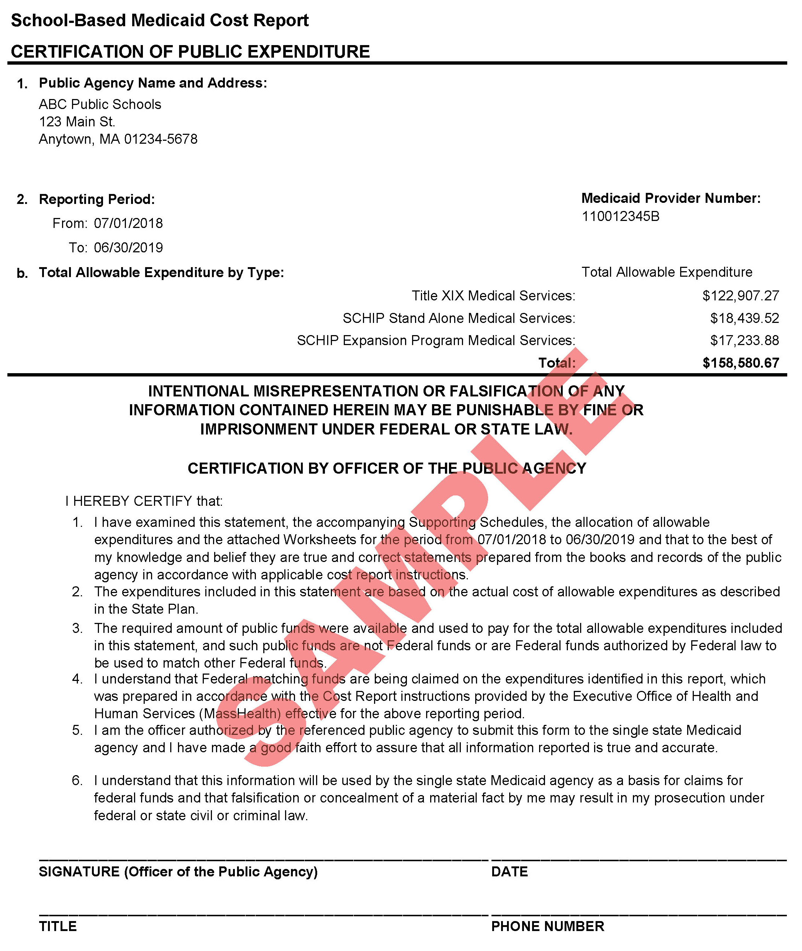

Appendix F:

Certification of Public Expenditure Form for Amended Reports
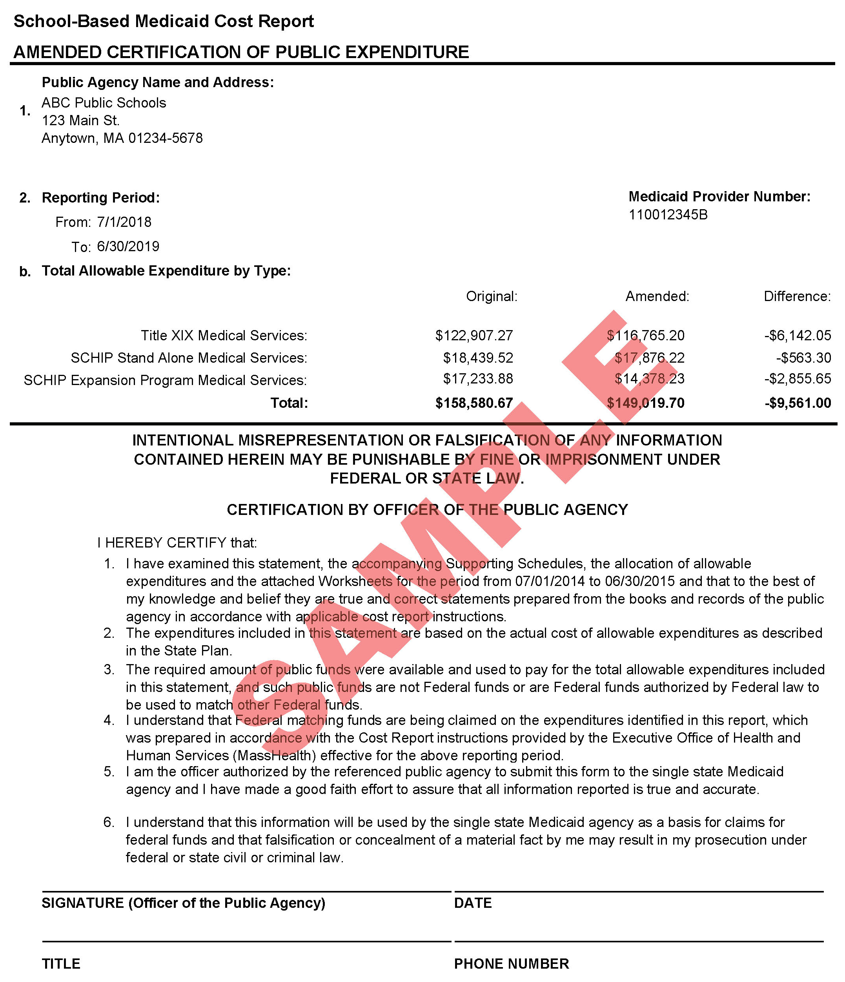

Appendix G:

Indirect Costs
The annual indirect cost rates for each LEA are calculated and published by DESE and prepopulated in the AAC system. LEAs must comply with the guidance in this appendix about indirect costs to ensure compliance with state and federal cost principles.
Exclusion of Expenditures from Administrative Activity Claims
LEA costs that are reported on the Chart of Accounts (COA) in the following object codes are included in the calculation of each LEA’s Indirect Cost Rate by DESE. Therefore, the LEA must exclude them from AAC and Direct Service Cost Reports.
- Administration—1000 series (specifically includes 1210, 1220, 1230, 1410, 1420, 1430, 1450);
- School Security (3600);
- Maintenance—4000 series (all);
- Employee insurance (5200)—( Exclude costs only when related to salaries in the excluded 1000 series codes);
- Retired-employee insurance (5250);
- Other insurance (5260);
- Rental lease (5300); and
- Other fixed charges (5500)
(DESE COA: http://www.doe.mass.edu/finance/accounting/eoy/chartofaccounts.docx).
Indirect Cost Rates for Charter Schools
AACs and Direct Service Cost Reports for charter schools will be processed using a 10% de minimis Indirect Cost Rate per 2 C.F.R. § 200 .414. Charter schools are instructed to follow the same guidelines as other SBMPs, and exclude from RMTS participation claims and cost reports costs related to staff who are part of central administration. These staff members include superintendent, assistant superintendent, professional and clerical support staff, grants manager, director of planning, school business manager or chief financial officer, director of human resources, districtwide information and technology staff, or any equivalent schoolwide administration staff.
- See also: School-Based Medicaid Provider Bulletin 28 (July 2015).

Appendix H:

Cost Share Supplemental Report
Below is a sample Cost Share Supplemental Report. LEAs must fully complete the required report using the Excel template available from UMMS if any cost share tuition expenditures are included in the annual cost report.
ABC Public Schools—FY19 Cost Report
Cost-Share Tuition Expenditures (DCF/DMH/DYS)
