


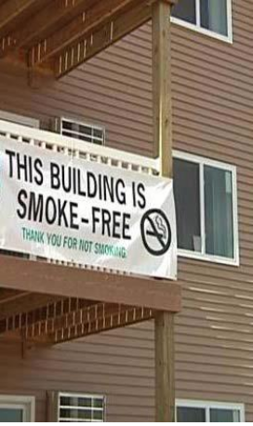



Massachusetts Partnership for Health Promotion
and Chronic Disease Prevention




Achieving Health Equity through Community-Clinical Linkages
January 16, 2014


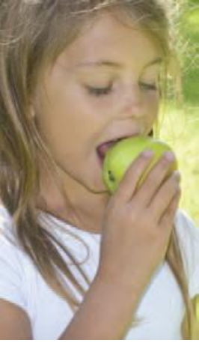



• Prevent 20,000 heart attacks and strokes (10% reduction in heart attack and strokes by 2017)
• Prevent 1,500 diabetes-related hospitalizations (1% decrease in diabetes related hospitalizations by 2017)
• Prevent 800 cancer deaths (6% decrease in cancer deaths by 2017)
• Prevent 1,000 asthma-related hospitalizations (1.5% decrease in asthma-
related hospitalizations by 2017)
• Decrease obesity among Massachusetts youth and adults by 5% by 2017
• Engage an additional 34,000 adults with arthritis in the recommended amount of physical activity (5% increase in adults with arthritis that are getting the recommended physical activity by 2017)

CoP Representatives
James Buszkiewecz, MDPH
Joanne Calista, Central MA AHEC
Kathy Cunningham, BPHC
Heather Drake, MassDOT/SRTS
Patti Henley, MDPH
Phyllis Kaplan, MassPRO
Steve Winslow, Mass in Motion Gloucester
At-large Members
Robyn Alie, Mass Medical Society
Rick Buckley, MassPRO
Carol Girard, MDPH
Lea Susan Ojamaa, MDPH
Ruth Palombo, Tufts Health Plan Foundation
Annette Peele, EOEA
Allyson Perron, AHA/ASA

Staff Support
Jennica Allen
Peggy Kocoras
Jean Zotter

Healthy Eating
Ruth Walsh, Tufts Health Plan and Cynthia Bayerl, MDPH
Physical Activity
Marybeth Allen, Tufts Health Plan and Chris Nordstrom, MDPH
Built Environment
David Watson, MassBIKE and Ben Wood, MDPH
Tobacco-Free Living
Chris Banthin, Public Health Advocacy Institute and Esmirna Damaso, MDPH
Clinical Preventive Services and Population Health Management
Phyllis Kaplan, MassPRO and Patricia Daly, MDPH
Community and Healthcare Linkages
Joanne Calista, Central MA AHEC and Gail Hirsch, MDPH
Improved Access to State and Local Data
Joshua Nyambose, MDPH

• Established under MGL Chapter 224

• How funds are allocated:

– $57 million in trust for 4 years

– No requirement for spending equal amounts annually

– At least 75% must be spent on grantee awards

– No more than 10% on worksite wellness programs

– No more than 15% on administration through MDPH

• Reduction in prevalence of preventable health conditions

• Reduction in health care costs and/or growth in health care
cost trends

• Beneficiaries from the health care cost reduction

• Employee health, productivity and recidivism through
workplace-based wellness or health management programs

• Outcomes in 4 years or less
Health Conditions Addressed

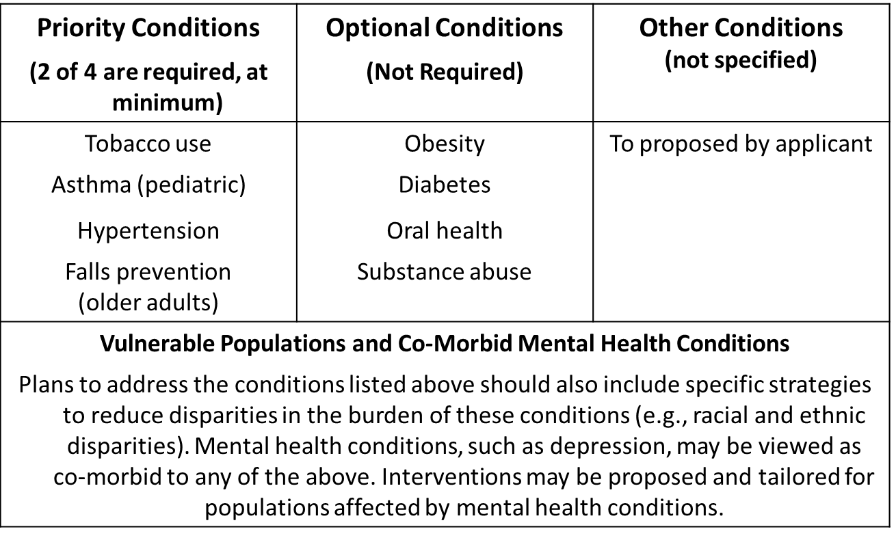
Interventions

Priority and Optional conditions proposed must include
interventions in each of 3 domains:

• Community – Supports behavioral change to improve health through individual, social and physical environments where people live and work

• Clinical – Improves clinical environment – delivery and access

• Community-Clinical Linkages – Strengthens connection between
community-based services and healthcare providers

Massachusetts Partnership for Health Promotion
and Chronic Disease Prevention

Activating Community Healthcare Linkages

CHWs: Synergies and Opportunities

Joanne L. Calista
Central MA AHEC, Inc.

Identified 3 Models of Practice
– The Engagement and Utilization of CHWs
– The Utilization of Evidence Based Practices
– The Utilization of Mobile Health/ Community Based Care

Impact
Prevention and Wellness Trust Fund: Model for the U.S.
Core Component: Community Healthcare Linkages
Includes CHWs as well as Mobile/ VNA Practices
Incorporation of 3 Models of Practice
CHWs—Pediatric Asthma
Evidence based programs-Geriatric Falls Prevention/Hypertension

Priority and Optional conditions proposed must include
interventions in each of 3 domains:

• Community – Supports behavioral change to improve health through individual, social and physical environments where people live and work

• Clinical – Improves clinical environment – delivery and access

• Community-Clinical Linkages – Strengthens connection between
community-based services and healthcare providers

• Surge in National Attention

– Agency for Healthcare Quality and Research (AHRQ)

– Centers for Disease Control and Prevention (CDC)

• Core Element>>>CHWs

• Emerging ROI Evidence

Sharpening Our Focus/
Broadening Our Partnerships

• Workforce Sustainability

• Further Integration of CHW Efforts with:
– ACA
– MA HCR
– MA Payment Reform *chapter 224”
– Triple Aim and….

• CMS Ruling

▪ MA Department of Public Health

▪ Tenacious Leadership, 2005 Study, Support of CHW Professional Association

▪ MACHW: Importance of a CHW Professional
Organization/ Network

▪ Allies: Legislators, Training Entities, Payers…

Section 110 of the Health Care Reform Law of 2006:
Legislative Mandate to MDPH

▪ Conduct investigation of the CHW workforce:
▪ Use and funding of CHWs
▪ CHW role in increasing access to health care
▪ CHW role in eliminating health disparities

▪ Convene a statewide CHW Advisory Council
▪ Inform the investigation & interpret the findings
▪ Develop recommendations for a sustainable CHW program in MA,
including training, certification and financing

▪ Submit a report of the findings and recommendations to the Legislature

Source: Gail Hirsch and Stephanie Anthony: Raising Awareness and Making Change through Public- Private Partnerships: Lessons Learned from a Statewide Community Health Worker Advisory Council in Massachusetts 10/4/09. 15

Strengthen Workforce Development:
Training and Certification

▪ Stabilize current funding for training of CHWs and
CHW supervisors;

▪ Expand statewide access to training;

▪ Establish a Board of Certification of CHWs.

Source: Gail Hirsch and Stephanie Anthony: Raising Awareness and Making Change through Public-Private Partnerships: Lessons Learned from a Statewide Community Health Worker Advisory Council in Massachusetts 10/4/09.
16

Chapter 322, Acts of 2010

▪ Resulted from CHW Advisory Committee policy
recommendations

▪ Intent: address provider, payer, and CHW needs for workforce standards

▪ 11 members, appointed by governor

▪ Chaired by DPH commissioner or designee

▪ MACHW nominates 4 members

▪ Also reps from CHW training, health plans, CHCs, employers, MPHA, public

▪ Statewide geographic representation
Geoff Wilkinson, Senior Policy Advisor to the Commissioners, MDPH, 5/1/12

Chapter 322, Acts of 2010: Summary
(continued)

§108 establishes the board’s powers and duties, some
of which include:
▪ to develop and administer a certification program and establish the education, training and qualifications for certification, the application requirements and standards of practice;
▪ to set standards to approve CHW education and training programs;
▪ to set continuing education standards and requirements for biennial
renewal of CHW certificates;
▪ to establish minimum qualifications for CHW trainers;
▪ to develop methods of evaluating CHW qualifications;
(“Grandparenting”).

Source: Gail Hirsch, Director, Office of Community Health Workers, MDPH: Summary of the Chapter 322, Acts of 2010 (2011).

Chapter 322, Acts of 2010: Summary
(continued)
to establish procedures to review applications for certification,
including renewals;

▪ to adopt, amend and enforce relevant rules and regulations;

▪ to collect fees and create a trust fund;

▪ to develop means to assess CHW competency;

▪ to establish tiered levels of certification;

▪ to certify CHWs already certified in other states; (reciprocity)

▪ to establish grounds for complaints; to establish disciplinary
actions;

▪ to develop rules for the mandatory certification of CHWs,
effective five years after the board’s inception.
Source: Gail Hirsch, Director, Office of Community Health Workers, MDPH: Summary of the Chapter 322, Acts of 2010 (2011).

Board of Certification of CHWs

• Review of the Field
• Created the CHW Advisory Workgroup
• Review and Determination of Core Competencies
• Determination of Hours of Training
• Development of a CHW Code of Ethics
• Design of “Grandparenting” Parameters
– Pathways to Certification

• Next Steps
– Draft Regulations to Legal Counsel
– Public Comment
– Revisions…

CMS created a new rule which allows state Medicaid agencies to
reimburse for preventive services provided by professionals that
may fall outside of a state's clinical licensure system, as long as
the services have been initially recommended by a physician or
other licensed practitioner. The new rule for the first time offers
state Medicaid agencies the option to reimburse for more
community-based preventive services, including those of CHWs.

The rule went effect on January 1, 2014.

Source: Adapted from: http://www.nhlbi.nih.gov/health/healthdisp

"(c) Preventive services means services recommended by a
physician or other licensed practitioner of the healing arts acting
within the scope of authorized practice under State law to…

1. Prevent disease, disability, and other health conditions or their
progression;
2. Prolong life; and
3. Promote physical and mental health and efficiency."

Centers for Medicare & Medicaid Services. 78 Fed Reg 42160 (July 15, 2013). Section is, "a. Diagnostic, Screening, Preventive, and Rehabilitative Services (Preventive Services) (§ 440.130)" (paragraph citation: 78 FR 42226)

State must file Medicaid State Plan Amendment
(in a few states this requires legislative authorization)

Must specify what non-licensed occupations are covered and qualifications (skill requirements) – not necessarily certification

Must specify what services will be paid for (CPT codes)

Opportunity to provide stability and funding mechanism to
CHW Workforce

Receiving significant attention on a national level.

Like other Massachusetts CHW initiatives—should be CHW
driven and proceed systematically.

Massachusetts Partnership for Health Promotion
and Chronic Disease Prevention

Community and Healthcare Linkages

CoP Meeting:

1:00 February 13, 2014 @ MDPH For more information contact: Joanne L. Calista jlcalista@cmahec.org.

