**Lead Service Line Replacement Program**

**[Add notice classification: First Notice, Second Notice, Final Notice]**

*This notice contains important information about your drinking water.*

*Have someone translate it for you or speak with someone who understands it.*

*Este aviso contiene información importante sobre su agua potable.*

*Pídele a alguien que te lo traduzca o habla con alguien que lo entienda.*

*Este aviso contém informacões importantes sobre sua agua potavel.*

*Pec̗a para alguém traduzir para você ou fale com alguém que entenda.*

Dear Water Customer,

As part of the Lead and Copper Rule Revisions (40 CFR Subpart I, January 2021) water systems are required to document all water service line materials in their system and identify any lead or lead containing materials that may be in the system.

Exposure to lead in drinking water can cause serious health effects in all age groups. Infants and children can have decreases in IQ and attention span. Lead exposure can lead to new learning and behavior problems or exacerbate existing learning and behavior problems. The children of women who are exposed to lead before or during pregnancy can have increased risk of these adverse health effects. Adults can have increased risks of heart disease, high blood pressure, kidney or nervous system problems.

The [System] is continuing the lead service line replacement program. As part of this program, we are investigating all services and notifying customers if and when a lead service line is encountered. If Applicable: Ownership of the service line varies by water system, but in [City/Town], per ordinance #, the full service line is the responsibility of the property owner (main to meter).

**Our most recent service line inventory indicates that some or all of the water service materials between the water main and your property may contain lead.** [System] will be entering into a series of construction contracts focused on replacing lead service lines (if present) at various locations throughout City/Town both within the roadway and on private property. To verify that your service line does or does not contain lead, [System] must be on the property to identify the service line.

**If applicable: [City/Town] has committed to a lead service line removal and replacement that does not put a burden on residents.** Funding sources for this work could vary by phase of the replacement program but will generally be sourced from [Source].

This work will require your consent, as well as access to the water meter in your basement. **Please fill out the attached investigation consent form with the required information** and email to [Email Address] or mail/drop off to [Address]. Investigation of your service line includes verifying the material by your water meter, which may be located in your home. If your service line is identified as lead, a replacement consent will be provided, which must be completed prior to a service line replacement taking place. The [System] staff member/Contractor on your property can discuss estimated replacement costs and the expected steps to replace your service line at the time of investigation.

Additional information pertaining to lead service lines including procedures for checking whether your home has a lead water service can be found untilizing the resources below:



MassDEP Lead Service Line Identification Tool <https://app.smartsheet.com/b/form/f9ee39b7972f443ca63e8b936cd7f92b>.

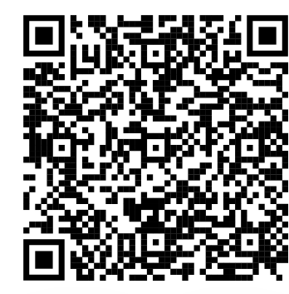

MassDEP Lead in Drinking Water Information <https://www.mass.gov/service-details/lead-in-drinking-water>



US EPA Protect Your Tap Tool [Protect Your Tap: A Quick Check for Lead](https://www.epa.gov/ground-water-and-drinking-water/protect-your-tap-quick-check-lead)

YOUR TOWN/PWS Drinking Water Information

*Thank you for prioritizing the health of our community.*