INDOOR AIR QUALITY ASSESSMENT

Lee Town Hall
32 Main Street
Lee, MA

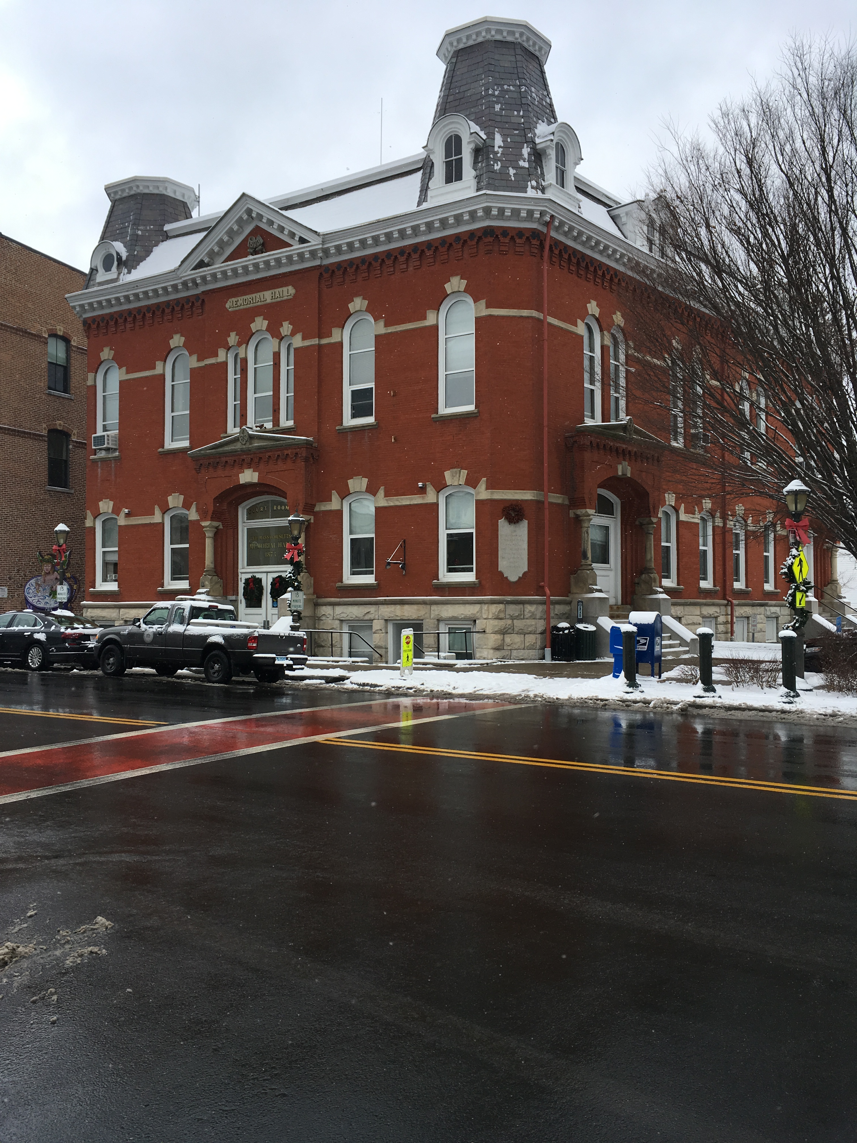

Prepared by:
Massachusetts Department of Public Health
Bureau of Environmental Health
Indoor Air Quality Program
January 2022

Background
Building: | Lee Town Hall (LTH)
Address: | 32 Main Street, Lee, MA
Assessment Requested By: | James J. Wilusz, Executive Director/Registered Sanitarian  Tri-Town Health Department  45 Railroad St., Lee, MA 01238
Reason for Request: | General indoor air quality (IAQ) assessment
Date of Assessment: | January 7, 2022
Massachusetts Department of Public Health/Bureau of Environmental Health (MDPH/BEH) Staff Conducting Assessment: | Michael Feeney, Director, IAQ  Program
Building Description: | This building was originally constructed in 1873 and renovated in 1991. The LTH has two stories with a basement, a brick exterior, and a peaked roof. Lee Police Department occupies parts of the first floor and basement.
Building Population: | Approximately 8 employees
Windows: | Openable

Methods
Please refer to the IAQ Manual for methods, sampling procedures, and interpretation of results (MDPH, 2015).

IAQ Testing Results
The following is a summary of indoor air testing results (Table 1).
- Carbon dioxide levels were below or very close to 800 parts per million (ppm) in all areas assessed.
- Temperature was within or slightly below the recommended range of 70°F to 78°F in areas assessed.
- Relative humidity was below the recommended range of 40% to 60% in all areas assessed, which typically occurs during the heating season.
- Carbon monoxide levels were non-detectable (ND) in all areas assessed.
- Fine particulate matter (PM2.5) concentrations measured were below the National Ambient Air Quality Standard (NAAQS) level of 35 μg/m³ in all areas assessed

Ventilation
A heating, ventilating, and air conditioning (HVAC) system has several functions. First, it provides heating and if equipped, cooling. Second, it is a source of fresh air. Finally, an HVAC system will dilute and remove normally occurring indoor environmental pollutants by not only introducing fresh air, but by filtering the airstream and ejecting stale air to the outdoors via exhaust ventilation. Even if an HVAC system is operating as designed, point sources of respiratory irritation may exist and cause symptoms in sensitive individuals. The following analysis examines and identifies components of the HVAC system and likely sources of respiratory irritant/allergen exposure due to water damage, aerosolized dust, and/or chemicals found in the indoor environment.
The LTH has no mechanical means to provide fresh air. Openable windows are the main source of fresh air in the building. Heat is provided by wall-mounted radiators and cooling is provided by window-mounted air conditioners. The assessment results indicate that the building is receiving adequate fresh air for the occupancy in the building, however, note that many areas had low occupancy, which can reduce the creation of carbon dioxide. Without a mechanical means of ventilation, it is difficult to dilute or remove normally occurring pollutants, allowing them to build up and lead to IAQ/comfort complaints.
In addition, the building appears to be originally designed to provide fresh air by opening windows and transoms during temperate weather. In the original configuration, windows are located on opposing exterior walls with transoms (hinged windows) located above hallway doors. The function of transoms is to allow airflow between windows and hallways even with the doors to each room closed. This design allows for airflow to enter an open window on the windward side, pass through a room, pass through the open transom, enter the hallway, pass through the opposing open transom, into the opposing room and exit the building on the leeward side (opposite the windward side) (Figure 1). With all windows and transoms open, airflow can be maintained in a building regardless of the direction of the wind. The system fails if the windows or transoms are closed (Figure 2). All transoms in the building were likely removed/sealed as part of the 1991 renovation.

Microbial/Moisture Concerns
During this assessment, the IAQ staff did not identify water-damaged building materials in occupied spaces. As noted above, the building does not possess a centralized HVAC system. Without such equipment, the LTH has a no centralized means to chill air, relying on window-mounted AC units. In addition, due to the age of the building, the basement floor likely has little or no insulation, which may make it prone to condensation during extended periods of hot, humid weather.
It is important to note that Massachusetts has experienced extended periods of relative humidity during the summer of 2021. July of 2021 was the wettest ever recorded in Massachusetts, and the three-month period from June through August, known as the meteorological summer, was the fourth wettest on record, according to the National Oceanic and Atmospheric Administration’s (NOAA) Centers for Environmental Information. The three-month period also was the third warmest ever in the state and was tied for the warmest on record across the United States (HG, 2021, NOAA, 2021).
The key to managing condensation in hot, humid weather indoors is understanding dew point. When warm, moist air passes over a cooler surface, condensation can form. Condensation is the collection of moisture on a surface at or below the dew point. The dew point is the temperature that air must reach for saturation to occur. If a building material/component has a temperature below the dew point, condensation will accumulate on that material. Over time, condensation can collect and moisten the material.
Since the building was originally constructed in the late 1800s, it is highly unlikely that the basement floor and wall have either insulation or a vapor barrier. Therefore, the floor and walls likely have temperatures similar to the material beneath (e.g., soil, sand, rock ledge, rock fill). If the temperature of the basement floor/walls is below or equal to the dew point, condensation will begin to accumulate. With a floor chilled through contact with soil/rock, and the infiltration of unconditioned hot, humid air during the warmer months, condensation on the floor is likely. This will then moisten materials that are on the floor, including furniture, carpeting and stored materials.
In addition, the presence of high relative humidity (>70%) alone for a significantly long period, can also cause water damage to susceptible materials. If these materials are porous, carbon-containing items (e.g., gypsum wallboard, carpeting, cloth, paper, and cardboard), mold can grow (ASHRAE, 2019).
The basement level of the building contains significant amounts of materials that can support mold growth if exposed to moisture. It is highly recommended that materials that can support mold growth including paper, cardboard, cloth, and leather, be removed from this area as these can all become mold-colonized if repeatedly exposed to moisture. Conditions conducive to mold growth may result in an indoor environment that could adversely affect the health of occupants with respiratory diseases such as asthma.
It is recommended that porous material be dried with fans and heating within 24 to 48 hours of becoming wet (US EPA, 2008, ACGIH, 1989). If porous materials are not dried within this time frame, mold growth may occur. Water-damaged porous materials cannot be adequately cleaned to remove mold growth.

Other Concerns
Significant gaps were noted in doors and around heating pipes between furnace room and other areas were noted, such as pipe holes in the basement ceiling (Picture 1). Such openings can allow for basement odors to enter occupied areas. They also provide pathways for pests.
Carpeting installed in hallways and other areas is at likely 20 years old. Carpeting should be vacuumed regularly with a high efficiency particulate arrestance (HEPA) filter equipped vacuum cleaner to avoid particulates from causing further irritation or serving as a reservoir for microbial colonization. Also, carpeting and rugs should be cleaned at least once per year according to IICRC recommendations (IICRC 2012). It should be noted that the usable life of carpeting in schools and similar buildings is approximately 10-11 years (IICRC, 2002). Aging carpet can produce fibers that can be irritating to the respiratory system. Non-porous (e.g., vinyl tile) flooring solutions should be considered instead of carpeting for areas subjected to condensation (e.g., on slab, below grade).
Note that prior to any carpet removal, it is important to determine if existing wall-to-wall carpeting is installed over floor tiling similar to that in the first-floor meeting (former court) room. Due to its age and configuration, such tile may contain asbestos. Intact asbestos-containing materials do not pose a health hazard. If wall-to-wall carpeting is adhered to asbestos-containing floor tile, it may become friable as the carpet is removed and become aerosolized. Friable asbestos is a chronic (long-term) health hazard but will not produce acute (short-term) health effects (e.g., headaches) typically associated with buildings believed to have indoor air quality problems. If asbestos-containing floor tile exists beneath existing carpeting, these materials should be removed or remediated in a manner consistent with Massachusetts asbestos remediation laws (MDLI, 1993).
Window-mounted air-conditioning units have filters that should be cleaned regularly to remove dust and debris.

Conclusions/Recommendations
Based on the observations made during this assessment, the BEH makes the following recommendations:

Ventilation Recommendations
- To increase fresh air exchange, windows can be opened during temperate weather. Where still possible, opening transoms can be used to create airflow if office doors need to be closed. However, if window-mounted air conditioners are activated, all windows should remain closed to prevent condensation from chilling of humid outdoor air.

Water Damage Recommendations
- Consideration should be given to removing the wall-to-wall carpet in the basement level. Use a floor covering that is non-porous. Have a licensed asbestos inspector assess whether carpet was installed over floor tile that may contain asbestos. If floor tile contains asbestos, carpet removal likely requires compliance with asbestos removal laws. Consult the Department of Labor Standards regarding safely handing materials with asbestos (https://www.mass.gov/asbestos-safety-program).
- Remove any porous materials such as paper, boxes, and cloth from the floor of the basement and consider storing no porous materials in the basement at all. Consider reducing the amount of materials in the basement overall.

Other Recommendations
- Seal around pipe holes in walls with fire-rated expanding foam.
- Seal holes in the basement ceiling to prevent basement pollutants from entering the building floor and wall cavities.
- Maintain window-mounted air conditions as recommended by the manufacturer. Clean or replace filters prior to initial use in the beginning of hot weather and periodically during the cooling season.
- Clean all carpeting in accordance with IICRC recommendations (IICRC 2012).
- Refer to resource manual and other related IAQ documents located on the MDPH’s website for further building-wide evaluations and advice on maintaining public buildings. These documents are available at: http://mass.gov/dph/iaq.

References
ACGIH. 1989. Guidelines for the Assessment of Bioaerosols in the Indoor Environment. American Conference of Governmental Industrial Hygienists, Cincinnati, OH.
ASHRAE, 2019. American Society of Heating, Refrigeration and Air Conditioning Engineers (ASHRAE) Ventilation for Acceptable Indoor Air Quality. ANSI/ASHRAE Standard 62.1-2019. Atlanta, GA.
HG. 2021. Mold keeps South Hadley High School shuttered. Hampshire Gazette. https://www.gazettenet.com/South-Hadley-High-School-still-closed-amid-mold-remediation-42413519.
IICRC. 2002. Institute of Inspection, Cleaning and Restoration Certification. A Life-Cycle Cost Analysis for Floor Coverings in School Facilities.
IICRC. 2012. Institute of Inspection, Cleaning and Restoration Certification. Carpet Cleaning: FAQ.
MDLI. 1993. Regulation of the Removal, Containment or Encapsulation of Asbestos, Appendix 2. 453 CMR 6,92(I)(i).
MDPH. 2015. Massachusetts Department of Public Health. Indoor Air Quality Manual: Chapters I-III. Available at: https://www.mass.gov/lists/indoor-air-quality-manual-and-appendices.
NOAA. 2021. Summer 2021 neck and neck with Dust Bowl summer for hottest on record. National Oceanic and Atmospheric Administration, 1401 Constitution Avenue NW, Room 5128, Washington, DC 20230 https://www.noaa.gov/news/summer-2021-neck-and-neck-with-dust-bowl-summer-for-hottest-on-record
US EPA. 2008. “Mold Remediation in Schools and Commercial Buildings”. Office of Air and Radiation, Indoor Environments Division, Washington, DC. EPA 402-K-01-001. September 2008. Available at: http://www.epa.gov/mold/mold-remediation-schools-and-commercial-buildings-guide.

Figure 1 Cross Ventilation in a Building Using Open Windows and Transoms

Leeward Windward
Side of Side of
Building Building

Wind Direction

Key

Open Window

Open Transom

Interior Path of Cross Ventilation

Drawing Not to Scale

Figure 2 Inhibition of Cross Ventilation in a Building with Several Windows and Transoms Closed

Leeward Windward
Side of Side of
Building Building

Wind Direction
Key

Open Window

Open Transom

Closed Window

Closed Transom

Interior Path of Cross Ventilation

Drawing Not to Scale
Picture 1
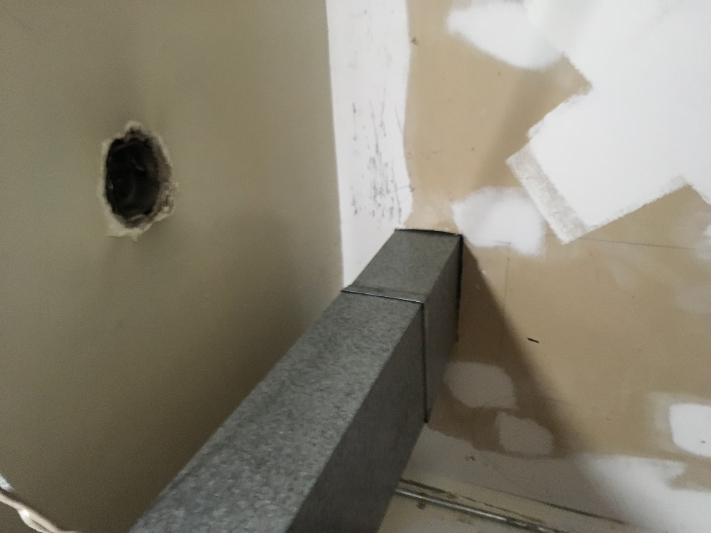
Opening in furnace room ceiling and around outside of duct

Location | Carbon  Dioxide  (ppm) | Carbon Monoxide  (ppm) | Temp  (°F) | Relative  Humidity  (%) | PM2.5  (µg/m³) | Occupants  in Room | Windows  Openable | Ventilation |  | Remarks
 |  |  |  |  |  |  |  | Supply | Exhaust
Background | 372 | ND | 30 | 44 | 21 |  |  |  |  | snow
Meeting room (former courtroom) | 481 | ND | 66 | 30 | 11 | 0 | Y | N | N
Furnace room | 479 | ND | 71 | 28 | 18 | 0 | N | N | N
Town collector | 807 | ND | 71 | 27 | 10 | 4 | Y | N | N | Ceiling-mounted air conditioner
Vault | 690 | ND | 71 | 27 | 10 | 0 | N | N | N
Vault foyer | 690 | ND | 71 | 27 | 10 | 0 | Y | N | N | Window-mounted air conditioner
Town manager | 511 | ND | 71 | 21 | 11 | 0 | Y | N | N | Window-mounted air conditioner
Selectmen’s office | 467 | ND | 71 | 24 | 9 | 0 | Y | N | N | Window-mounted air conditioner
Selectmen’s private office | 447 | ND | 72 | 22 | 9 | 0 | Y | N | N | Window-mounted air conditioner
Treasurer | 584 | ND | 71 | 23 | 10 | 2 | Y | N | N | Window-mounted air conditioner
Public works | 504 | ND | 71 | 23 | 9 | 0 | Y | N | N | Window-mounted air conditioner
Assessor’s | 416 | ND | 71 | 24 | 9 | 1 | Y | N | N | Window-mounted air conditioner
Building safety | 509 | ND | 71 | 23 | 9 | 3 | Y | N | N
Accounting | 434 | ND | 70 | 20 | 10 | 0 | Y | N | N
Kitchen | 500 | ND | 70 | 24 | 10 | 0 | Y | N | N
Police front desk | 589 | ND | 72 | 23 | 11 | 1 | Y | N | N | Window-mounted air conditioner
Police office area | 635 | ND | 72 | 25 | 11 | 1 | Y | N | N | Window-mounted air conditioner
Police chief | 587 | ND | 72 | 23 | 12 | 1 | Y | N | N | Window-mounted air conditioner

