Resource Guide
Legal Interview for Interpreters

40 Broad Street

Boston, MA 02109

Tel. (617) 740-1600

VP (617) 326-7546

TTY (617) 740-1700

Fax (617) 740-1880

http://www.mass.gov/mcdhh

The Commonwealth of Massachusetts
Executive Office of Health and Human Services
Massachusetts Commission for the Deaf and Hard of Hearing


Department of Communication Access Services
Opeloluwa Sotonwa, Commissioner
Sharon Harrison, Chief of Staff

Table of Contents
Introduction 3
Application 5
Legal Verification Form 7
Legal Interview Process 8
Retaking Screening 9
Common Important Terms Used in MA Court Settings 10
Recommended Reading Materials 13
The Department of Communication Access Services 14
Appendix A: The Massachusetts Court System 18
Appendix B: Criminal Justice Flow Chart 19
Appendix C: Arrest to Sentence DA 20
Appendix D: M.G.L Chapter 221, Section 92 21
Appendix E: M.G.L Chapter 221, Section 92A 22

Introduction
MCDHH is tasked with the provision of providing qualified interpreters as outlined in Massachusetts General Law (MGL Chapter 221 § 92A) which requires the Massachusetts Commission for the Deaf and Hard of Hearing to “coordinate all requests for qualified interpreters”.

For this reason, MCDHH determines whether or not an interpreter is qualified for legal settings. MCDHH provides approval to interpreters working in legal situations using the following criteria: credentials, training, experience, and mentorship.

The purpose of the Legal Interview is to determine your level of legal interpreting knowledge and experience.

We hope you find this information helpful and easy to use but do not hesitate to contact us at MCDHHScreening@mass.gov if you have any questions.

Application

Qualifications
Until it was sunset in 2016, MCDHH expected court and legal interpreters to obtain the RID “SC:L” certificate which stands for Specialist Certificate: Legal. Interpreters who possess this certificate have proven specialized knowledge of legal settings and the language used in courts and the legal system in general. Now we expect interpreters who want to work in court and legal settings in Massachusetts to demonstrate their qualifications in the following ways:

Possess SC:L/BEI: Legal or equivalent State Legal license
Those who possess the SC:L or the BEI: Legal must submit proof of these legal credentials.

For the equivalent State license interpreters must submit proof of their legal credentials and link to the state licensure requirement for legal credentialing.

Non-SC:L and/or non-BEI: Legal
For those who do not possess the SC:L or the BEI:Legal, the prerequisites are:

- Graduation from an Interpreter Training Program (preferably 2 –4 years Associate or Bachelor's Degree Program) or one of the Alternative Pathways as outlined in MCD Contract.

- ASL Interpreters must be Nationally Certified and/or MCDHH Approved as generalists with a minimum of 5 years’ experience in the community. Deaf Interpreters (CDI/SDI) must have minimum of 3 years’ experience in the community.

- Completion of specialized, intensive, legal interpreting training, plus mentoring and documentation of successful experiences in court/legal interpreting using the Legal Verification Form.

  - 80 hours of Foundations in Legal Interpreting and/or other equivalent legal trainings. (RID Transcript/Proof of trainings required)

  - Legal Field Experience (Mentorship) of 100 hours in court/legal settings with documentation from an interpreter holding the SC:L, the BEI: Legal, who is MCDHH Legal Approved, or who is a licensed court/legal interpreter in their state. Please provide proof of legal field experience hours on those topics.

  - 3 Letters of Recommendation. Please see below for letters of recommendation requirements.

Application Status
The applicant is responsible for checking in with MCDHH on the status of their paperwork, and to make sure all references have been received. To check on the status of paperwork, contact the Screening and Evaluation Coordinator at MCDHHScreening@mass.gov.

Once we receive all required paperwork, it will be reviewed and if approved, we’ll contact you to schedule a Legal Interpreting Interview.

Legal Verification Form

Training Topics Taken
Please select the training topics you have taken and if they were taken through a program, please state what program. Please indicate the number of hours for each training. If you studied specific topics with a mentor 1:1, please state their name and their certification. Please provide proof of legal field experience hours on those topics.

Interpreting Experience
Please check off the different settings you’ve had experience interpreting in the field. State your mentor's name and their certification/qualifications to provide court/legal field experience. Please provide proof of legal field experience hours on those topics.

Letter of Recommendations
The applicant must have three letters of recommendation:
- 2 Legal interpreters
  - The Legal interpreters must hold the SC:L or is MCDHH-Approved, or who can document that they are equivalently qualified in another state.
- 1 Professional
  - The professional recommendation can be from a case manager or a lawyer or other professional. They should have seen your work as an interpreter; it does not have to be in legal settings, however legal settings is preferred.

The letter should explain the candidate’s experience interpreting in legal settings. The letters should in a PDF format and be sent directly to MCDHHScreening@mass.gov.

Letter of Recommendation Guideline
In the letter, your reference should state:

Your role/relationship
  - What is or was your role with this candidate, such as mentor, supervisor, colleague, etc.?
  - How long have you known/worked with this candidate?

Context of work
  - In what legal settings did you observe or work with the candidate?
  - Approximately how many hours have you worked with this candidate in legal settings?
  - Explain what you have seen of the candidate’s legal interpreting skills and knowledge.
  - What areas do you think the candidate needs to work on?
  - Do you think this candidate is ready to take the Legal Interpreter Interview?

Legal Interview Process

Interview
The interview is an assessment of the Candidate’s skills, knowledge and ability to work within the field of legal interpreting. During the interview the panel will ask 4 questions and provide 3 ethical scenarios.

The interview panel includes three qualified MCDHH Legal Interpreters: Deaf and ASL/spoken English interpreters.

Candidates applying for the legal interview should be familiar with the following, but not limited in their scope of knowledge of:
- The Massachusetts Court System
- Laws applicable to Massachusetts
- Basic familiarity with the processing of a broad array of different kinds of Massachusetts legal cases
- Ethical decision making within the legal field
- Teaming Structures within legal settings

Candidates also should know some of the most important laws that govern court/legal interpreting in MA, such as Americans with Disabilities Act and several Massachusetts-specific laws (please see the laws in the recommended reading materials section and Appendix A&B).

Candidates have the option of receiving feedback from the Evaluation Team immediately following the screening.

Interview Results
The interview is pass/do not pass. A score of 70% or higher is required to pass.

All candidates will receive written results and a report that includes Evaluation team’s comments, where applicable.

Upon approval and based on the recommendations from the panel, the Court/Legal Referral Specialist will be able to refer and book you on assignments and cases as a newly qualified legal interpreter.

Retaking Screening

Re-taking the Screening
If a candidate does not pass the interview, they must follow through with the recommendations stated by the evaluators, prior to applying to re-take either portion of the screening. Prior to applying for a re-take, verification of completion of the recommended steps must be provided. Verification can be in the form of a letter from a mentor discussing what they have focused on and what progress the candidate has made, or a certificate of completion for a workshop that was attended. When the candidate has them all, they can proceed to apply for retake and attach the verification to their application. After such verification has been reviewed by MCDHH and the recommendations have been met, the Coordinator will reach out to schedule a Screening.
MCDHH Legal Interpreters are strongly encouraged to pursue further educational opportunities following the general guidelines of RID, Inc. for continuing education credits to upgrade their skills and ultimately obtain RID, Inc. national certification.

Common Important Terms Used in MA Court Settings
Pro Se – this means a person chooses to give up their 6th Amendment (or in Mass., Article 12) right to have an attorney and instead chooses to represent themself in court, for any discussions/negotiations with the district attorney/prosecutor, and for any proceedings. This happens a lot for criminal motor vehicle misdemeanor charges, misdemeanor drug possession (not sale or distribution) charges, and other charges where the judge determines there is no risk of jail time.
Sua Sponte – this is when the judge makes a ruling when there is no motion from an attorney or party before the court. The judge simply decides to do something (like exclude evidence, or remand to a different court, or set aside a jury’s verdict, etc.).
209A – in Mass., this means Restraining Order, also referred to commonly as an RO or TRO (temporary restraining order). You can read the whole law or just look at the most pertinent section which is Section 4.

258E – in Mass., this is a harassment prevention order. Similar to a Restraining Order but is available to anyone regardless of relationship status. This order prevents stalking, cyberstalking, neighbor to neighbor harassment, workplace harassment, etc.
51A and 51B – The 51A is a law mandating the report itself, the 51B is a law mandating the investigation that DCF engages in after the report has been “screened in” – deemed worthy of investigation (not frivolous, fabricated, or below the threshold of seriousness) is a law mandating the report itself, the 51B is a law mandating the investigation that DCF engages in after the report has been “screened in” – deemed worthy of investigation (not frivolous, fabricated, or below the threshold of seriousness).
Section 12: Sections 12A and 12B – are the laws that allow someone to be committed to a psychiatric facility for up to 3 days. You will often hear or see reference to a person being sectioned.
Mass specific: A hearing on the merits in juvenile court, or a summary process, in housing court, are trials. A hearing on the merits is a trial to determine whether or not a person's parental rights will be terminated, and a summary process is a trial to determine whether somebody will be evicted from their home.
In Mass: burglary is unlawfully entering a dwelling place or other structure at night for the purpose of committing a felony therein. The people being burgled don't necessarily need to be there. Robbery on the other hand requires that the robber be in physical contact or such close proximity to the person as to either commit violence or use the threat of violence in order to forcibly take the person's property.
Section 3: the law that allows a person committed on a Section 12 to be transferred to a different hospital for voluntary, conditional voluntary or involuntary commitment.
Section 35 (or “Section 35’ed) – the law that allows someone to be committed against their will for alcohol or drug addiction/abuse.
CWOF – Continued Without a Finding – This is a kind of alternative punishment/sentence the judge can give that would require the defendant to be on probation for a certain period, like 6 months, at the end of which – if the defendant followed all rules and didn’t get in any trouble during the set time period - , the judge would dismiss the case without ever entering a guilty finding. However, the CWOF stays on the defendant’s record.
Pre-trial Probation – a diversion program. This is mostly used for adolescents/young adults who’ve never been in trouble before as a kind of wake-up call. The defendant is put on probation without ever officially going before the court and at the end there would be no record of any kind. A case is never opened, and no docket number assigned.
CRA – Child Requiring Assistance – A parent whose child is considered unruly, truant, non-compliant or otherwise out of control can file a CRA in the Juvenile Court. If the judge adjudicates the child as A Child Requiring Assistance, a case gets opened with the Department of Children and Families and the parents are offered services as is the child. The goal of the CRA is to get the family the services they need so that the child can get back on track.
C and P – Care and Protection. This is a kind of court case – it is something DCF files in Juvenile Court in response to a substantiated 51A report and 51B investigation. It often involves the removal of a child/ren from the home and placing them in foster care.
CPCS – Committee for Public Counsel Services – the Mass. Defense Bar or public defenders (CPCS attorneys do criminal defense as well as represent people with mental illness in commitment proceedings and in termination of parental rights proceedings)
CPR – Committee for Public Representation – solely represent people with mental illness in commitment, guardianship and Roger’s Orders (forced medication) proceedings.
DLC – the Disability Law Center
MCAD (often pronounced “em-cad”) – The Mass. Commission Against Discrimination
Notice to Quit – legal document a landlord files that starts the 14 day clock running on eviction proceedings
151B – State law prohibiting discrimination
LOPC or LOPC’d – Lack of Probable Cause (mostly used in discrimination cases)

TERMS OF ART

Constructive: means when one party creates such an untenable situation that the other party must withdraw, as in constructive termination, or constructive eviction. With constructive termination, for example, the employer creates such a hostile environment for the worker that the worker is forced to resign. The argument the worker would make in court, is that he had no choice, that he was in essence fired.
Consideration: a bargained-for exchange, of something that the 2 parties perceive as valuable. The thing at issue can be an actual item, money, or a promise to do something or refrain from doing something (example: I will give you $1000 if you quit smoking for one year).
Discovery: Basically, means exchange of evidence between parties in a civil suit, and in general from prosecutor to defendant in a criminal case. Evidence can be documents, interrogatories, depositions, etc. Please refer to the Mass. law that explains exactly what evidence can and can’t be discovered.
Motion: A formal request to the judge asking him/her to do something/take some kind of action (as in a motion to suppress evidence – the attorney asks the judge to exclude certain evidence from a trial, so the jury may not consider it; or a motion for funds – often a court-appointed defense attorney will ask the judge for money to pay the interpreter for attorney/client meetings, etc.)
Hearsay: An out-of-court statement stated in court to try to prove the truth of the matter stated – inadmissible but for several exceptions.

Recommended Reading Materials
It is STRONGLY recommended that prior to sitting for the Legal Interview, you thoroughly study the materials below, ESPECIALLY the Codes of Professional Conduct and the NCIEC Best Practices.

Code of Professional Conduct

Available from RID, Inc. Publishing

Massachusetts Code of Professional Conduct for Court Interpreters of the Trial Court:

Section 4.00 of the Standards and Procedures - OCIS (mass.gov)

NCIEC Best Practices American Sign Language and English Interpretation Within Legal Settings

Communication with People who are Deaf or Hard of Hearing: ADA Guide for Law Enforcement Officers

Employment Rights of People with Disabilities (Massachusetts Law)

Discrimination in Admission to, or Treatment in Place of Public Accommodation; Punishment; Forfeiture; Civil Right (Massachusetts Law)

Project CLIMB’s website – Toolkit for Legal Interpreters

Deaf Interpreters in Court

Sign Language Interpreters in Court: Understanding Best Practices by Carla Mathers

Law Enforcement Interpreting for Deaf Persons Paperback – September 4, 2019 by Tara Potterveld (Author)

The Department of Communication Access Services

What is the MCDHH Communication Access Services Division?
The Communication Access Services (CAS) Division provides numerous services within MCDHH on behalf of the Commonwealth of Massachusetts, some of which are:

    - Managing the Statewide Interpreter & CART Referral Services.
    - Providing interpreter services to consumers through use of staff and contract interpreters.
    - Purchasing Interpreter and CART services when no other entity is legally mandated to do so.
    - Providing Interpreter, Transliterator and Deaf Interpreter Screening services to approved qualified interpreters as appropriate.
    - Establishing the standard for fees to be charged by freelance interpreters for state paid assignments.
    - Providing CART training periodically in cooperation with the Massachusetts Court Reporters Association and approve qualified applicants as CART captioners to receive referrals from MCDHH and to be paid for MCDHH-paid assignments.
    - Providing advocacy to agencies, businesses and consumers regarding interpreter and CART services and related policies.
    - Providing consultation and training to agencies, businesses and consumers regarding interpreter and CART services and related policies via the telephone or referral to the CATTS department for ‘on-site’ trainings.
    - Providing consultation, technical assistance, and recommended standards of qualification for working interpreters.
    - Providing consultation on interpreting or CART arrangements in educational settings, and at conferences, hearings, and similar events.
    - Providing advocacy on behalf of consumers and interpreters on communication access and billing issues.
    - Engaging in activities to increase the available pool of qualified interpreters and CART captioners in-state.
The Department of Communication Access Services is located at the administrative office of the Commission in Boston and serves as the central point of contact for the entire Commonwealth of Massachusetts.

The Department also provides communication access for MCDHH employees in accordance with the Americans with Disabilities Act (ADA).

What is the MCDHH Statewide Referral Service?
One of the most important functions of MCDHH is the statewide Interpreter and CART Referral Service. MCDHH provides referral services to meet the diverse communication needs of Deaf, Oral Deaf, Late-deafened, DeafBlind, and hard of hearing people in a variety of settings including medical, mental health, legal, education, employment, recreation, and social services. Although MCDHH employs staff interpreters, and a staff CART captioner, the majority of requests are filled by freelance Interpreters and CART captioners on statewide contract.

MCDHH-approved Interpreters in an effort to provide maximum quality interpreter services.

The Interpreters referred by MCDHH are either certified by the Registry of Interpreters for the Deaf, Inc. (RID), a nationally based professional organization, Board for Evaluation of Interpreters (BEI), or MCDHH approved. All Interpreters are required to adhere to a strict code of professional conduct established by RID in conjunction with the National Association of the Deaf (NAD). CART captioners are certified and approved by MCDHH to work as CART captioners. All CART captioners are required to adhere to strict standards of professional conduct.

Who uses the Interpreter/CART Referral Services?
    - Requestors (persons or entities who are paying for the service)
    - Consumers (Deaf, Hearing, Hard of Hearing, Late-deafened, DeafBlind, etc.)
    - Providers of services (Interpreters and CART captioners)

Staffing of the Interpreter/CART Referral Services
The Referral Services Supervisor oversees the referral service and reports directly to Director of Communication Access Services. The department has both Intake Specialists and regional Referral Specialists.

Intake Specialists handle all incoming requests and once the needed information has been compiled, they assign each request to a Referral Specialist.

Interpreter and CART requests are divided into geographical areas of the state and specialties with a Referral Specialist assigned to each area or specialty. The areas/specialties are:
    - Boston Metro
    - High Profile Statewide
    - Central Mass
    - Northeastern Mass
    - Southeastern Mass
    - Western Mass
    - Statewide CART
    - Statewide Court/Legal
    - Statewide SUD
    - Statewide Intake

Who should make a request for an Interpreter or CART captioner?
Deaf, Hard of Hearing, DeafBlind, late-deafened, and hearing individuals representing a group or agency such as a non-profit organization, school, employer, and business are all consumers of Interpreter or CART captioner services. The request for this service must come from the court, private doctor, individual or agency responsible for paying for the service.

How and where can the requester make a request?
Contact: Massachusetts Commission for the Deaf and Hard of Hearing
Interpreter/CART Referral Services
40 Broad Street
Boston, MA 02109

For medical, mental health, and legal emergencies please call 800-249-9949 TTY/Voice 24 hours a day/7 days a week.

Request should be made online and should include the following information.

During business hours the requester will be connected to an Intake Specialist who will ask for some information crucial to process the request.

    - Name, telephone number and organization (if applicable) of the requester.
    - Date and time an interpreter or CART captioner are needed and length of assignment.
    - Address of the assignment including specifics: the name of the building, court or clinic, which floor, room number, etc.
    - The nature and format of the meeting (e.g., medical appointment, platform lecture, staff meeting, civil or criminal court case, docket number, etc.)
    - Number and names of all participants.
    - Special equipment to be used (e.g., microphone, overhead projectors, video, etc.); for CART requests, specify if projection service will be required and what equipment, if any you will provide (e.g., monitor, overhead projector, LCD plate, projection screen, etc.)
    - Names of Deaf participants and their preferred mode of communication (e.g., American Sign Language, oral, signed English, etc.), if known, and names of participants who will be using CART services.
    - Names of preferred interpreters/CART captioners. Often Deaf, hard of hearing and late deafened people have a specific service provider they prefer. A requested interpreter/CART captioner will be contacted first in an attempt to honor these preferences. If there is an interpreter/CART captioner the consumer would prefer not to work with, please inform the Intake Specialist.
    - Name and telephone number of the contact person at the assignment.
    - Payment information: the name, address and telephone number of the person who is responsible for paying for the interpreter. Requests cannot be processed without confirmed billing.

Except for emergency mental health, medical and legal requests, no assignments are accepted with less than 48 hours advance notice. Requestors are advised that requests need to be called in as early as possible, because freelance interpreters/CART captioners often fill their schedule 3 weeks to 3 months in advance. Every attempt will be made to fill requests; however, all requests are subject to the availability of the service providers.

Priority will be given to those requests involving urgent mental health, medical and legal matters. Generally, MCDHH will notify the contact person as soon as an interpreter has been booked. A one-week notification period will be used for requests for conferences, certain meetings, and other events in which rescheduling are difficult or impossible. MCDHH will continue looking for interpreters/CART captioners until 2 business days prior to the assignment, giving the requester a 2-day notification if the job is unfilled unless otherwise stated.

Is there an emergency interpreter service?
MCDHH has an After Hours Emergency Services Program to handle medical, mental health, and legal emergencies requiring communication access Monday – Friday from 5:00 PM to 8:45 AM, weekends and holidays. Please call (800) 249-9949 TTY/Voice.

During regular daytime business hours, MCDHH will handle all emergency mental health, medical and legal requests through the same phone number (800) 249-9949.

Can people give feedback about the interpreters or CART captioners?
Yes. Deaf and hearing people can share feedback, compliments, and complaints with the Director of Communication Access Services at MCDHH. The complaints will be investigated to verify accuracy and share with interpreters when appropriate. Names will not be used without the complainant’s permission (please refer to page 19) but complaints filed anonymously will not be placed in the contractor’s file. Folks who’ve received interpreting or CART services can also provide feedback by videophone; to do this contact (617) 326-7546.

The MCDHH Compliment and complaint form can also be used by contractors, requesters, and other participants to provide feedback about MCDHH staff, including intake and referral specialists.

Appendix A: The Massachusetts Court System

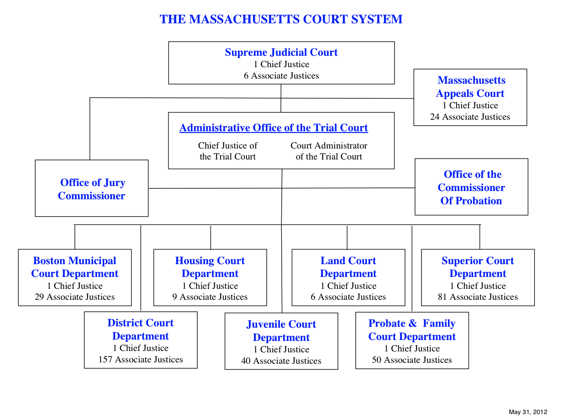

Appendix B: Criminal Justice Flow Chart
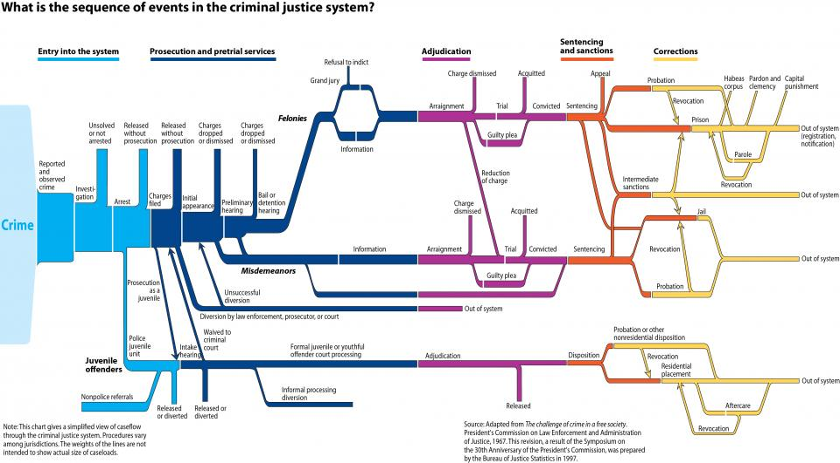

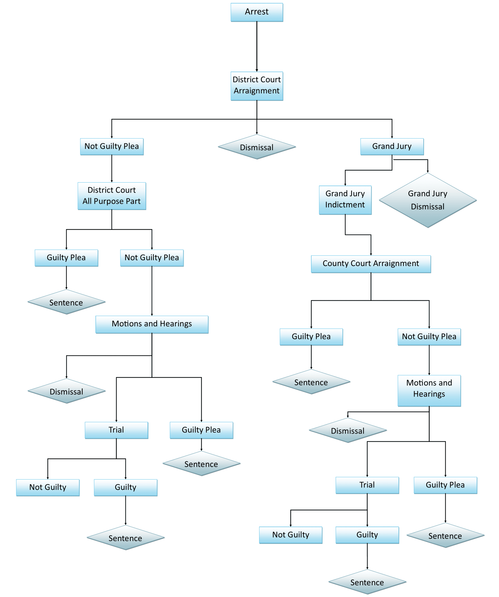
Appendix C: Arrest to Sentence DA

Appendix D: M.G.L Chapter 221, Section 92

General Laws of Massachusetts

Part III

Courts, Judicial Officers and Proceeding in Civil Cases

Title I

Courts and Judicial Officers

CHAPTER 221. CLERKS, ATTORNEYS AND OTHER OFFICERS OF JUDICIAL COURTS.

CHAPTER 221: Section 92. Interpreters; appointment; tenure; compensation.

Section 92. The justices of the superior court may appoint such official interpreters as they may deem necessary for the sessions of the court. Such interpreters shall hold their positions at the pleasure of the court, shall be paid by the commonwealth, and shall render such additional service as any justice of the court requires. No official interpreter shall request or receive, directly or indirectly, any gratuity, bonus or fee, in connection with any case pending, or in course of preparation for presentation to said court; provided, that upon request of the district attorney such interpreter may, in the discretion of the court, receive additional compensation from the county for his services as an interpreter at such hours or times as the courts are not in session, which shall be paid under section twenty-four of chapter twelve.

This section shall not prevent the justices from employing other interpreters when the services of the official interpreters are not available. Such expenses incurred shall be paid by the commonwealth.

What is a Qualified Legal Interpreter in the Commonwealth of Massachusetts?
A Qualified Legal Interpreter is a service provider who has been specifically qualified by MCDHH. Such individuals demonstrate specialized knowledge, training and expertise in legal interpreting/transliterating and knowledge of the Massachusetts legal system. Specialized training and mentorship are available through the Massachusetts Commission for the Deaf and Hard of Hearing in conjunction with the Administrative Office of the Trial Court (AOTC). Possession of Registry of Interpreters for the Deaf (RID) Specialist Certificate: Legal (SC:L) or Certified Legal Interpreter Provisional—Relay (CLIP-R) does not automatically qualify the Interpreter in Massachusetts.

“Unless MCDHH designates the Interpreter as appropriate for the performance of a particular assignment involving a legal proceeding, the Interpreter’s performance of any interpreter services whatsoever in any portion of any legal proceeding may constitute a failure to fulfill obligations under this contract and may give rise to MCDHH’s right to terminate without a corresponding right of cure. For purposes of this paragraph, ‘legal proceeding’ shall include all phases of any civil or criminal proceeding in any court or executive or legislative board, commission, agency, bureau, committee or other body or political subdivision of the state.”

Appendix E: M.G.L Chapter 221, Section 92A

General Laws of Massachusetts

Part III

Courts, Judicial Officers and Proceeding in Civil Cases

Title I

Courts and Judicial Officers

CHAPTER 221. CLERKS, ATTORNEYS AND OTHER OFFICERS OF JUDICIAL COURTS.

Chapter 221: Section 92A. Interpreters for the deaf or hearing-impaired; court proceeding; arrests; admissibility of evidence; fees and expenses; privileged communications.

Section 92A. In any proceeding in any court in which a deaf or hearing-impaired person is a party or a witness, or proceeding involves a juvenile whose parent, or parents, is deaf or hearing-impaired, or in any proceeding before an executive or legislative board, commission, agency, bureau committee or other body of the state or political subdivisions involving a hearing-impaired person, such court or body shall appoint a qualified interpreter to interpret the proceedings, unless such deaf or hearing-impaired person knowingly, voluntarily, and intelligently waives in writing, the appointment of such interpreter. Such waiver is subject to the written approval of counsel where such deaf or hearing-impaired person is being represented by counsel. In no event shall the failure of the deaf or hearing-impaired person to request an interpreter be deemed a waiver of such appointment.

Whenever a deaf or hearing-impaired person is arrested for an alleged violation of a criminal law, including a local ordinance, the arresting officer shall procure and arrange payment for a qualified interpreter to assist such person regarding any interrogation, warning, notification of rights, or taking of a statement. No answer, statement, or admission, written or oral, made by a deaf or hearing-impaired person in response to any question by a law enforcement officer or any prosecutor, in his official capacity, in any criminal proceeding may be used against such deaf or hearing-impaired person unless such statement was made or elicited through a qualified interpreter and was made knowingly, voluntarily and intelligently or, in the case of waiver of interpreter, unless the court makes a special finding that any statement made by such deaf or hearing-impaired person was made knowingly, voluntarily and intelligently. In any criminal proceeding wherein counsel has been appointed to represent an indigent defendant, the court shall also appoint a qualified interpreter for such defendant, whenever such defendant is deaf or hearing-impaired to assist in communication with counsel in all phases of the preparation and presentation of the case.

In all proceedings involving an interpreter under this section, no testimony shall be admitted as evidence until:
    - the interpreter is so situated as to assure effective communication between all persons having a substantial interest in the outcome of such proceedings,
    - the interpreter swears under oath, that he will provide a true and accurate interpretation of the proceedings to the best of his skill and judgment, and
    - the person conducting such proceedings determines, on the basis of testimony of the interpreter and the deaf or hearing-impaired person, that such interpreter is able in that particular proceeding, to communicate accurately with and translate information to and from such deaf or hearing-impaired person involved.

If, at any time during the proceeding, it is determined that the interpreter is no longer able to provide effective communication between the parties, the person conducting such proceeding shall appoint another qualified interpreter or an intermediary interpreter in accordance with the provisions of this section.

For the purposes of this section, the following words shall have the following meanings:

“Intermediary interpreter,” a person who, because of an intimate acquaintance with deaf or hearing-impaired persons who use mainly natural or unusual gestures for communicating, can act as a mediator between the hearing-impaired person and the qualified interpreter.

“Qualified interpreter,” a person skilled in sign language or oral interpretation and transliteration, has the ability to communicate accurately with a deaf or hearing-impaired person and is able to translate information to and from such hearing-impaired person, an interpreter shall be deemed qualified or intermediary as determined by the Office of Deafness, based upon the recommendations of the Massachusetts Registry of the Deaf, the Massachusetts State Association of the Deaf and other appropriate agencies. Said office of deafness shall coordinate all requests for qualified interpreters and shall maintain a list of all such interpreters from which is shall fill such requests.

An interpreter appointed pursuant to this section or section sixty-nine of chapter two hundred and thirty-four A, shall be reimbursed a reasonable fee by the commonwealth for his services, pursuant to a fee schedule established and promulgated by the chief administrative judge. Said schedule shall be based upon recommendations of the commission for the deaf and hard of hearing, established pursuant to the provisions of section one hundred and ninety-two of chapter six, the Massachusetts Registry of Interpreters for the Deaf, the Massachusetts State Association of the Deaf, and other appropriate agencies. Reimbursement for actual travel and ordinary living expenses shall be at the rates provided for employees of the commonwealth.

A client has a privilege to prevent a certified sign language interpreter from disclosing a confidential communication between one or more persons where the communication was facilitated by said interpreter. For purposes of this paragraph a client is a person rendered interpreting services by an interpreter; a communication is confidential if a client has a reasonable expectation or intent that it not be disclosed to persons other than those to whom such disclosure is made.

Nothing in this section shall be construed to prevent any department, board, commission, agency or licensing authority from employing a qualified interpreter, who is recommended by the office of deafness, on a full-time basis or under contract at a mutually agreed upon compensation rate.

Some situations that are defined as legal are:
    - Police arrests, interrogations, reports
    - Client/lawyer meetings
    - Court hearings/trials
    - Psychiatric commitment
    - Department of Children and Families
    - Administrative hearings (Social Security, Office of Transitional Assistance, etc.)
    - Some Medical treatment
    - House closings/final will and testaments
    - Situations in which an official record of proceedings is made

An Interpreter must be specifically qualified by the Massachusetts Commission for the Deaf and Hard of Hearing to perform legal interpreting/transliterating services in the state of Massachusetts. If an Interpreter arrives at an assignment and discovers it is legal in nature or if it becomes legal during the course of the assignment; the Interpreter is bound by the Code of Ethics and by state law (M.G.L. 221 §92A) to recluse himself/herself from the assignment. An effective justification for such withdrawal should include references to the law, professional codes of conduct as dictated by the RID Code of Ethics, and the rights of consumers to qualified legal transliterating services. In addition, any information communicated through a Interpreter who has not been qualified by MCDHH to provide legal services could be challenged as “inadmissible in court.”

