

Bureau of Climate and Environmental Health

Massachusetts Department of Public Health

May 2025

Leicester Elementary School,   
170 Paxton Street, Leicester:

Indoor Air Quality assessment

& response to Environmental Health concerns

**TABLE OF CONTENTS**

INDOOR AIR QUALITY ASSESSMENT REPORT 3

ENVIRONMENTAL HEALTH CONCERNS 58

Building and Acute (Short-Term) Health-Related Concerns……………………………………… 58

Cancer Concerns among Current and Former Staff 59

Appendix A Cancer Risk Factors, Exposure, Latency, and Incidence 61

Appendix B Breast Cancer Risk Factor Information 67

Appendix C Release of Oil from Subsurface Fuel Lines at Leicester Elementary School in 2021 77

INDOOR AIR QUALITY ASSESSMENT

**Leicester Elementary School**

170 Paxton Street

Leicester, MA

**May 2025**

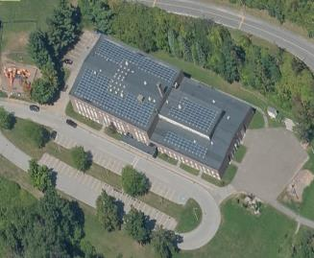

Prepared by:

Massachusetts Department of Public Health

Bureau of Climate and Environmental Health

Division of Environmental Health Regulations and Standards

Contents

EXECUTIVE SUMMARY 5

BACKGROUND 8

RESULTS AND DISCUSSION 8

Ventilation 9

HVAC System Maintenance 9

HVAC Types and Specific Conditions 10

Water Damage and Moisture Concerns 11

Water Damage Issues 12

Sources of Respiratory Irritants/Possible Asthma Triggers 13

Other IAQ Issues 16

CONCLUSIONS AND RECOMMENDATIONS 18

REFERENCES 23

FIGURES 25

PICTURES 26

Table 2A 49

Table 2B 50

Table 2C 51

Table 3 52

Table 4 54

# 

# EXECUTIVE SUMMARY

The Massachusetts Department of Public Health’s (MDPH) Division of Environmental Health Regulations and Standards (EHRS) conducted an Indoor Air Quality (IAQ) assessment of Leicester Elementary School (LES) located at 170 Paxton Street, Leicester, MA on February 7, 2025. This assessment was requested by LES staff through Dr. Brett Kustigian, Superintendent, Leicester Public Schools.

The LES*,* formerly the *Leicester Primary School*, has been visited by the MDPH several times over the years, most recently in 2011 ([Indoor air quality reports - cities and towns: L | Mass.gov](https://www.mass.gov/info-details/indoor-air-quality-reports-cities-and-towns-l#leicester-)). It is important to note that the 2011 report indicated:

* *The operational lifespan of heating, ventilating, and air conditioning (HVAC) equipment has long passed and given its age, continuing to maintain the balance of fresh air to exhaust air will be difficult at best.*
* *Without adequate supply and exhaust ventilation, excess heat and environmental pollutants can build up and lead to indoor air/comfort complaints.*

The 2011 report made twenty-four (24) short-term recommendations and three (3) long-term recommendations (listed below):

1. *Contact an HVAC engineering firm for a building-wide ventilation systems assessment. Based on historical issues with air exchange/indoor air quality complaints, age, physical deterioration and availability of parts for ventilation components, such an evaluation is necessary to determine the operability and feasibility of replacing the equipment.*
2. *Strong consideration should be given to replacing univents in classrooms. Consideration should also be given to replacing exhaust units.*
3. *Consider contacting a building envelope specialist to investigate settling of brick and efflorescence.*

The LES needs HVAC system replacement. Most of the HVAC equipment is original to the building (> 50 years old), well past its service life, with parts and components such as pneumatic controls being unavailable and/or difficult to repair. It was reported that in some cases, parts must be fabricated to keep units operating for ventilation/temperature control. These conditions make it difficult to control outside airflow, temperature, and relative humidity, particularly during hot humid summer conditions that can lead to widespread condensation and water damage/mold issues. Additionally, other building materials (e.g., carpeting, ceiling tiles, and windows) are mostly original to the building’s construction and are also past their service life and in need of replacement. As climate change and global warming intensifies, the urgent need for modern, energy-efficient solutions becomes clear. Without significant upgrade of HVAC equipment and other interior components, building conditions and indoor air quality will continue to degrade.

Any building can have indoor air quality (IAQ) issues. These issues can be made worse through conditions common to marginalized communities [i.e., environmental justice communities (EJ)] such as inequitable exposure to outdoor air pollution and a greater likelihood of poor building conditions leading to deterioration of IAQ and higher asthma rates. The Leicester Elementary School is within an EJ community, (<https://www.mass.gov/info-details/environmental-justice-populations-in-massachusetts#environmental-justice-maps-update-2022->). In addition, the pediatric asthma rate for this school as of 2023-2024 is 11.1%, although statistically not significantly different than the state average, it is higher than the statewide pediatric prevalence rate of 9.6% (MAEPHT, 2024).

The assessment was conducted by evaluating several key elements within the school; a visual inspection of the heating, cooling, and ventilating (HVAC) systems, water/microbial damage, cleanliness, point sources of respiratory irritants such as chemicals, and electronic measurement of carbon dioxide (CO2), carbon monoxide (CO), temperature, relative humidity (RH), total volatile organic compounds (TVOCs) and small particulate matter (PM2.5) all taken with a Qtrak XP monitor. Data is collected in this manner to identify potential asthma triggers, allergens, and other environmental factors that can cause indoor air quality symptoms. Please refer to the [Indoor Air Quality Manual](https://www.mass.gov/lists/indoor-air-quality-manual-and-appendices#indoor-air-quality-manual-) on the MDPH website for methods, sampling procedures, and interpretation of results.

As a result of this assessment, there are several findings: conditions in this school are typical of elementary schools of this age and type, water-damaged building materials were found from breaches in the building envelope, univents and other HVAC components may be beyond their lifespan, and there are occupant-induced issues such as clutter. (Results and Discussion)

(Conclusions)

Based on the results of the assessment, the following primary recommendations are made:

* Maintain the HVAC system, including regular filter changes and activating/repairing exhaust vents that are not working.
* Operate all functional ventilation systems throughout the building (e.g., cafeteria, classrooms) *continuously* during periods of occupancy for air exchange and filtration. An increase in the percentage of fresh air supply and/or increased exhaust capabilities is recommended.
* Address building envelope issues leading to water infiltration and damaged building materials in the building.
* Ensure portable/window-mounted air conditioners are thoroughly cleaned to remove accumulated dust/debris, which can become moldy if moistened during humid/summer conditions. If they cannot be cleaned adequately, replace.

Please note: this report contains a series of recommendations that should serve as Best Practices that apply to most public-school buildings across the Commonwealth and should be shared amongst other buildings in the school district.

(Conclusions and Recommendations)

# BACKGROUND

|  |  |
| --- | --- |
| Building: | Leicester Elementary School |
| Address: | 170 Paxton Street  Leicester, Massachusetts |
| Assessment Requested by: | Dr. Brett Kustigian, School Superintendent, Leicester |
| Reason for Request: | Mold, general IAQ, and chronic disease concerns |
| Date of Assessment: | February 7, 2024 |
| Massachusetts Department of Public Health/Bureau of Climate and Environmental Health (MDPH/BCEH) Staff Conducting Assessment: | Cory Holmes, Senior Advisor for Indoor Air Quality Inspections, Audits, Outreach and Training, and  Amy Riordan, Senior Advisor for Inspections, Audits, Outreach and Training, EHRS |
| Building Description: | The school is a two-story brick building completed in 1974. The second floor is primarily general classrooms. The first floor contains general classrooms configured around a centrally located gymnasium and library. A new roof was reportedly installed in 2009. |
| Windows: | Most windows in the building are openable. |

# RESULTS AND DISCUSSION

The following is a summary of indoor air testing results (Table 1)

|  |  |  |
| --- | --- | --- |
| * ***Carbon dioxide (CO2)*** | *a measure of the adequacy of ventilation* | Levels were above the MDPH guideline of 800 parts per million (ppm) in all but one area, which was unoccupied at the time of assessment. This is likely due to age, condition, and lack of operation of supply and exhaust ventilation in most areas of the school. |
| * ***Temperature*** | *a measure of comfort* | Was mostly within the MDPH recommended range of 70°F to 78°F in occupied areas. A few areas were slightly cooler than the recommended temperature range. |
| * ***Relative humidity*** | *a measure of comfort and, when in excess for an extended period, a way to reflect the potential for mold and fungal growth* | Was below the MDPH recommended range of 40 to 60% in all areas tested. This is reflective of outdoor conditions. Low relative humidity is common indoors during the heating season. Relative humidity would be expected to be higher during hot, humid weather. |
| * ***Carbon monoxide***   ***(CO)*** | *a product of combustion that can result in acute and long term cardiovascular, respiratory, and neurological symptoms* | Levels were non-detectible (ND) in all indoor areas assessed. |
| * ***Particulate matter (PM2.5)*** | *a way to measure inhalable particle distribution in the air* | Concentrations were below the National Ambient Air Quality Standard (NAAQS) of 35 micrograms per cubic meter (μg/m3) in all areas tested. |
| * ***Total Volatile Organic Compounds (TVOCs)*** | *VOCs are carbon-containing substances that can evaporate at room temperature. Frequently, exposure to low levels of total VOCs (TVOCs) may produce eye, nose, throat and/or respiratory irritation in some sensitive individuals.* | Levels were ND in all areas assessed. |

## Ventilation

Ventilation refers to both the supply of fresh air and the removal of stale air from a room. The introduction of fresh air into an occupied space will dilute normally occurring pollutants that are generated by occupancy and other activities. In addition, an HVAC system will remove pollutants from a building if operating appropriately. All ventilation systems throughout the building should operate continuously during periods of occupancy.

The LES has a combination of unit ventilators (univents) and rooftop air handing units. Univents (Picture 1) bring in fresh air from a vent on the outside of the building (Picture 2), filter it, heat it, and supply the air through a vent on the top. Some room air is recirculated along with the fresh air through a vent at the bottom (Figure 1). The air handling units bring in fresh air from the roof, filter it, heat it, and distribute to occupied areas through a wall or ceiling-mounted supply vent. Classrooms and offices are also equipped with exhaust vents that remove stale air from rooms (Picture 3) (Table 2B).

The various types of ventilation components as well as devices that can move/redirect airflow are listed in Table 2A, Table 2B and Table 2C.

### HVAC System Maintenance

* Univents are well beyond their service life According to the American Society of

Heating, Refrigeration, and Air-Conditioning Engineering (ASHRAE), the service life of

this type of unit is 15-20 years, assuming routine maintenance of the equipment

(ASHRAE, 1991).

### HVAC Types and Specific Conditions

**Balancing**

To have proper ventilation with a mechanical supply and exhaust system, a system must be balanced to provide an adequate amount of fresh air to the interior of a room while also removing stale air from the room.

It is recommended that HVAC systems be re-balanced every five years to ensure adequate air systems function (SMACNA, 1994).

(see HVAC pictures)

**Classroom Unit Ventilators**:

* Univents were deactivated throughout the building (Picture 4) and in some cases were blocked with furniture or items (Picture 5; Table 1).
* Some univents were reportedly turned off due to excessive noise, or lack of temperature control/regulation. The few univents that were found operating during the assessment were very weak and moving little air.
* A univent was opened and the filter examined was caked with dust/debris and dated August 2023 (Pictures 6a and 6b). MDPH recommends that filters of at least a Minimum Efficiency Rating Value (MERV) 8 be used as these are adequate to filter out pollen, mold, and similar particulates (ASHRAE, 2012). MDPH recommends that filters be changed two to four times a year or as per the manufacturers’ recommendations. It was reported that filters are MERV 13 and are replaced two to four times a year.

**Classroom Exhaust Vents:**

* All exhaust vents were found to be not operating in classrooms and other areas throughout the building, as judged by a lack of air draw (Table 1). It was not known whether these vents were not functional or just deactivated. Without proper supply and exhaust ventilation, normally occurring environmental pollutants can build up and lead to indoor air quality/comfort complaints. In addition, without proper exhaust ventilation, excess moisture cannot be removed from the building, which can lead to mold growth.
* Several exhaust vents were blocked by the installation of portable ACs (Picture 7) or sealed with plastic (Picture 8).

**Additional HVAC Conditions:**

* Most classrooms have openable windows. These can be used for additional fresh air during temperate weather. Windows should be kept closed during wet weather, when air conditioning is operating in the room, and at the end of the school day.
* As mentioned, portable and window-style air conditioners were installed in a number of rooms (Table 1). They are equipped with filters that need to be cleaned periodically. When any type of air conditioners are operating, the windows should be closed, and the room door should be kept closed.
* In a few areas, no provision for supply ventilation was observed (104A, 204A; Table 1). Long-term planning to install fresh air supply to these areas should be considered. However, as an interim measure, since these areas do not have windows, installing a passive supply vent or undercutting doors for make-up air should be done.
* Some thermostats are located near hallway doors (Picture 9). With hallway doors open, thermostats may not correctly sense classroom temperatures and may not activate when needed.

## Water Damage and Moisture Concerns

Please note that the IAQ Program does not recommend conducting mold testing in a typical water damage remediation. For details, please consult [Guidance Regarding Testing for Mold in Water-Damaged Public Buildings](https://www.mass.gov/info-details/guidance-regarding-testing-for-mold-in-water-damaged-public-buildings) | Mass.gov

The application of a mildewcide to moldy porous materials is not recommended.

Molds are found naturally in our environment both indoors and outdoors. Inside, mold growth may occur when items, particularly porous products such as paper or gypsum wallboard, are exposed to moisture. Typical water sources include leaks, floods, and condensation. To avoid mold growth, dry all water-damaged items and affected areas within 24-48 hours and reduce indoor humidity. Some people with chronic respiratory conditions, such as asthma, are more likely to experience health symptoms associated with molds, including allergic reactions and respiratory irritation. Controlling moisture is the key to preventing mold growth and potential health symptoms.

Hot humid summers are becoming more frequent due to climate change. Massachusetts has experienced hot, humid, and rainy summers in 2018, 2021, and 2023. July of 2021 was the wettest ever recorded in Massachusetts, and the three-month period from June through August, known as the meteorological summer, was the fourth wettest on record, according to the National Oceanic and Atmospheric Administration’s (NOAA) Centers for Environmental Information (NOAA, 2021). The summer of 2023 was also hot, and wet, being measured as the second rainiest on record (WBUR, 2023). These conditions are challenging for buildings, particularly those without air conditioning.

During these hot and wet summers, extended periods of outdoor relative humidity above 70% occurred. Under these weather periods, public buildings experienced extended periods of water vapor exposure from high relative humidity. When exposed to these conditions, porous materials such as gypsum wallboard, cardboard, and other materials may become prone to developing mold colonization, particularly if located in areas that are prone to developing condensation on floors and walls (e.g., below grade space).

### Water Damage Issues

(see Water Damage and Moisture Concern Pictures)

Many of the materials used in construction of schools of this age, such as concrete, hard wood, floor tile, and brick, are resistant to mold growth.

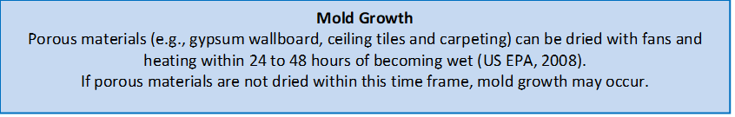

* Water-damaged ceiling tiles were found in a few locations (Pictures 10 and 11; Table 1). This water damage was most notable at the junction where the two and one-story sections of the building meet and where the exterior brick needs repointing (Pictures 12 and 13).
* Most classrooms are equipped with sinks; many of the backsplashes and countertops were damaged (Pictures 14 and 15). Damaged material around sinks can allow moisture to accumulate, prevent effective cleaning, and may lead to mold growth.
* Some occupants had concerns regarding the cleanliness of ACs throughout the building. Several of the ACs appeared to have been in use for many years. Since ACs are always moving air, dust and debris tend to collect and accumulate on surfaces inside and on the exterior of the units. Since typical airborne dust contains naturally occurring mold spores, if this material gets moistened repeatedly it can grow mold. Many of the units needed cleaning, and visible mold was observed on/around some of the units (Pictures 16 through 18).
* Visible mold growth was also observed on the corner of solid ceiling material in the hallway near exterior door/room 101. This surface mold likely occurred due to dust/debris accumulation and the introduction of hot/humid air infiltration beneath/around the exterior door in this area.
* Plants were noted in some classrooms and offices (Table 1). Plants can be a source of pollen or mold especially if overwatered or not well maintained.
* Bowed or sagging ceiling tiles and rust/corrosion on metal surfaces were noted in some classrooms (Table 1; Pictures 19 and 20). This is an indication that these rooms have been subject to an extended period of high humidity.
* To help combat elevated humidity/mold issues many classrooms are equipped with dehumidifiers. However, many of the household-style dehumidifiers have small reservoirs which require them to be emptied several times a day. When it is possible and safe to do so, dehumidifiers should be stationed on countertops so they can drain directly into sinks.
* A stained/water-damaged wooden shelving unit was noted in Room 219 (Picture 21). It was not clear what the source of moisture was, however, this unit should be cleaned and refinished, or be removed.
* Occupants had concerns about moldy carpet squares. Carpet squares in use at the LES are made with a rubber/vinyl backing that is non-porous and resistant to mold growth (Pictures 22a and 22b). These tiles are glued directly to the cement substrate (no layers/padding), and dry easily. However, the porous nature of carpeting in general can make the top of the carpet tiles susceptible to mold growth during summer months/periods of elevated relative humidity. Carpets should be vacuumed regularly with a high efficiency particulate arrestance (HEPA) filter equipped vacuum cleaner and cleaned annually (or semi-annually in soiled/high traffic areas) in accordance with Institute of Inspection, Cleaning and Restoration Certification (IICRC) recommendations (IICRC, 2012).

Several other conditions on the outside of the buildings were identified which can contribute to water issues, which are specified in Table 3.

## Sources of Respiratory Irritants/Possible Asthma Triggers

Asthma is a lung disease that can make breathing difficult. Without careful management of asthma, some people can have symptoms, like a tight feeling in the chest, shortness of breath, coughing, or wheezing. Although there is no cure for asthma, people with asthma can live healthy, active lives. A safe and healthy environment helps to reduce asthma symptoms.

**Comparison of Local and State-wide Asthma Rates**

**(2023-2024 school year/MAEPHT, 2024)**

11.9% of children

have asthma

**Leicester**

9.6% of children

have asthma

**Massachusetts**

11.1% of children

have asthma

**Leicester Elementary School**

* **Sometimes, learning tools and personal items in a classroom can be a source of irritants.** For example, a bird or insect nest is a great learning tool for students but may harbor microbes and allergens. Similarly, food-based projects can attract pests that carry disease or trigger allergies.
* **Personal products, particularly those with volatile organic compounds (VOCs) including scents, can also be a source of respiratory irritation.** VOCs are carbon-containing substances that have the ability to evaporate at room temperature. Frequently, exposure to low levels of total VOCs (TVOCs) may produce eye, nose, throat and/or respiratory irritation in some sensitive individuals.
* **Dust, a common respiratory and eye irritant, can collect on surfaces and items.** Although janitorial and maintenance staff perform routine cleaning in classrooms, they may not be able to clean as effectively if classroom items are not picked up or surfaces are cluttered. Even with a properly functioning ventilation system, it is necessary to either eliminate or reduce the use of materials that can be a source of respiratory irritants to prevent symptoms in individuals who have sensitivity to such pollutants.

For guidance on maintaining an asthma-friendly healthy school environment, please consult the MDPH Asthma Prevention and Control Program’s [Clearing the Air: An Asthma Toolkit for Healthy Schools](https://www.maasthma.org/schooltoolkit).

Possible asthma triggers and/or airborne pollutants exist in the building. These are listed below as well as in (Table 4).

(see Sources of Respiratory Irritant Pictures)

* It was reported that rodents were observed in the Library and several storage areas in the building. Note that rodent infestation, because of materials present in wastes, can produce indoor air quality-related symptoms. Mouse urine contains a protein that is a known sensitizer (US EPA, 1992). A sensitizer is a material that can produce symptoms in exposed individuals (e.g. running nose or skin rashes) after repeated exposures. To reduce issues related to rodents, the animals first need to be excluded from and removed from a building. Then thorough cleaning needs to be performed to remove wastes and dander. The district has currently has an integrated pest management (IPM) plan. Given the location near woodlands, removing and excluding rodents will be an ongoing process. Replacing or making repairs to damaged exterior doors or sealing spaces around doors with weather stripping will help to keep out pests, as well as drafts and moisture (Pictures 23 and 24). Occupants can assist by:
  + Keeping all food and food waste in tightly closed mouse-proof containers,
  + Removing accumulated items from the floor which can serve as harborage for rodents,
  + Cleaning crumbs and removing trash daily,
  + Ensuring doors are closed tightly and open windows are equipped with intact screens, and
  + Reporting pest sightings or new gaps in the building envelope to facility management.
* Many classrooms had an excess of items such as books, craft materials, papers, and other materials due to a lack of storage throughout the building. Excess items can accumulate dust and make it difficult for custodial staff to clean. Items should be relocated and/or be cleaned periodically to avoid excessive dust build up. In addition, dust and debris can accumulate on flat surfaces (e.g., desktops, shelving and carpets) in occupied areas and subsequently be re-aerosolized causing further irritation.
* Some areas are covered with wall-to-wall carpet that is damaged and past its service life (Picture 25). Occupants had concerns about carpet cleaning. Carpeting has a service life in schools of approximately 10-11 years (IICRC, 2002). Carpeting that is beyond its service life becomes increasingly difficult to clean and may release fibers which can be irritating if airborne. Carpets should be vacuumed regularly with a high efficiency particulate arrestance (HEPA) filter-equipped vacuum cleaner and cleaned annually (or semi-annually in soiled/high traffic areas) in accordance with Institute of Inspection, Cleaning and Restoration Certification (IICRC) recommendations (IICRC, 2012).
* Many classrooms had area rugs, pillows/cushions, and upholstered furniture (Picture 26). These need to be cleaned regularly to remove dust, debris, and odors. Area rugs should be stored off the floor in a climate-controlled area during the summer to prevent moistening by condensation. Used area rugs should not be brought into the school as they may harbor allergens such as pet dander.
* Air purifiers were noted in many classrooms, a number of which needed their filters cleaned/changed (Table 1; Picture 27). These appear to be units which use high efficiency particulate arrestance (HEPA) filters which are good choices for use in occupied areas. Air purifiers that may produce ozone should not be used (US EPA, 2003) All air purifiers should be cleaned and maintained in accordance with manufacturer’s instructions.
* Univent cabinets, supply, exhaust/return vents, and personal fans had accumulations of dust and debris (Table 1; Pictures 1, 4, 16, 17, 18, 28, and 29). This dust/debris can be aerosolized under certain conditions, and should be cleaned periodically (e.g., during regular filter changes).
* Classroom 204 had some vinyl or leather chairs that were delaminated (Picture 30). The damaged surface of these chairs would make them difficult to clean and they should be removed/replaced.
* A dead animal was reported to have been found during the previous school year above the ceiling in Room 201 and questions remained about what was above the ceiling tiles. DPH staff observed conditions above the ceiling tiles and found no evidence of current wildlife, debris, mold growth and/or associated odors (Pictures 31 and 32).
* Finally, it was reported during the site visit that a release of #2 fuel oil occurred on or about April 1, 2021, at Leicester Elementary School along the exterior of the north side of the building (Picture 33). The release was reported to the Massachusetts Department of Environmental Protection (MassDEP) and assigned Release Tracking Number (RTN) 2-21538. In response, the school was closed on April 26th and was not used for the remainder of the 2020-2021 school year. Contaminated soils were excavated and replaced with clean fill. A sub-slab depressurization system (SSDS) was installed to reduce levels of air-phase petroleum hydrocarbons (APH). Indoor air sampling has shown that levels have decreased over time. While it is likely that operation of the SSDS is no longer needed, it will continue for the remainder of the 2024-2025 school year. Additional sampling is planned for July 2025 with the system shut off to confirm that operation of the system is not necessary to maintain acceptable indoor air quality. For more details, see Appendix C.

## Other IAQ Issues

*Radon*

Radon is a naturally occurring radioactive gas that seeps into buildings from the surrounding soil and at elevated levels can increase the risk of lung cancer.

The Environmental Protection Agency (EPA) conducted a National School Radon Survey “in which it discovered nearly one in five schools has at least one schoolroom with a short-term radon level above the action level of 4pCi/L (picocuries per liter) – the level at which the EPA recommends that schools take action to reduce the level” (US EPA, 1993)

**The BCEH/IAQ Program therefore recommends that every school be tested for radon, and that this testing be conducted during the heating season while school is in session in a manner consistent with USEPA radon testing guidelines**. Radon measurement specialists and other information can be found at [www.nrsb.org](http://www.nrsb.org) and <http://aarst-nrpp.com/wp>, with additional information at: <http://www.mass.gov/eohhs/gov/departments/dph/programs/environmental-health/exposure-topics/iaq/radon>.

*Asbestos and Water Quality*

Building occupants also had concerns regarding asbestos containing material (ACM) and water quality.

No obvious sources of damaged ACM were observed during the assessment. However, it is important to note that schools are required by federal law called the *Asbestos Hazard Emergency Response Act (AHERA)*, passed in 1986, to maintain an asbestos management plan which requires districts to:

* conduct an initial inspection of their schools for asbestos-containing building material,
* prepare management plans and take action to prevent or reduce asbestos hazards,
* perform a certified inspection every 3 years, and
* keep reports at a central location for public access in the district.

It was reported by Leicester Department of Public Works Director, Kris Lauzon that the AHERA reports are readily accessible on line at <https://leicester.k12.ma.us/departments/facilities_and_transportation/asbestos_information>, that the most recent *3-year inspection* occurred the first week of February (2025), and that these reports will be uploaded when available.

These legal requirements are founded on the principle of "in-place" management of asbestos-containing material. Removal of these materials is not usually necessary unless the material is severely damaged or will be disturbed by a building demolition or renovation project. [Asbestos and School Buildings | US EPA](https://www.epa.gov/asbestos/asbestos-and-school-buildings#requirements).

For water quality issues/advice, contact the Massachusetts DEP [School Water Improvement Grants Program | Mass.gov](https://www.mass.gov/info-details/school-water-improvement-grants-program?_gl=1*u0dbe9*_ga*NTA2MjAzNDY1LjE3MTQwNzc0NDU.*_ga_MCLPEGW7WM*MTczODg1MDM0OC43MS4xLjE3Mzg4NTMyMzcuMC4wLjA.).

# CONCLUSIONS AND RECOMMENDATIONS

**Please note:** this report contains a series of recommendations that should serve as *Best Practices* that apply to most public-school buildings across the Commonwealth and should be shared amongst other buildings in the School District.

Issues typical to many schools were found in this building. The age of the HVAC equipment will make controlling temperature and airflow more difficult as time goes on. Water infiltration issues, particularly where the two and one-story sections of the building meet, are likely responsible for the water-damaged ceiling tiles observed in classrooms and in the hallway in this area. Other issues described can be mitigated with repairs to the exhaust system, improved maintenance/changing of filters, and with changes to occupant behaviors to prevent deactivation/blockage of univents and reduction of clutter.

**Short-term recommendations** can be implemented as soon as practicable, however **long-term measures** are more complex and will require planning and resources to adequately address overall indoor air quality concerns within the building.

|  |  |  |
| --- | --- | --- |
| **Short-term Recommendations** | | |
| **HVAC System** | | |
|  |  | **Helpful links** |
|  | Ensure all univents (and AHUs in common areas) are *on and operating* during occupied periods. |  |
|  | Remove blockages from the top and front of univents, including furniture and items. |  |
|  | Periodically check the function of all exhaust vents and repair as needed. |  |
|  | Close classroom (and cafeteria) doors for improved exhaust vent function. |  |
|  | Change HVAC filters 2-4 times a year using MERV 8 filters or the best MERV-rating that can work with current equipment. | [ANSI/ASHRAE Standard 52.2-2017](https://www.ashrae.org/File%20Library/Technical%20Resources/COVID-19/52_2_2017_COVID-19_20200401.pdf) |
|  | During filter changes, clean dust and debris from the inside of univent and HVAC system cabinets. |  |
|  | Use openable windows for additional fresh air during temperate weather when outdoor air quality is good. Tightly close windows at the end of the day and avoid opening windows when air conditioning is in use to prevent condensation and mold growth and during extreme cold to prevent freezing of pipes. | <https://www.airnow.gov/> |
|  | Air purifiers that use HEPA filters, with or without carbon filters, are good choices for occupied areas. Units that may produce ozone should not be used. Maintain all in accordance with manufacturers’ instructions. | <https://www.epa.gov/indoor-air-quality-iaq/ozone-generators-are-sold-air-cleaners> |
| **Water Damage** | | |
|  | Conduct a thorough building envelope evaluation to make repairs/repointing efforts to eliminate leaks. Building occupants should ensure they report active leaks to building management for investigation and repairs. |  |
|  | Replace water-damaged ceiling tiles. Repeated water damage to ceiling tiles indicates leaks from the roof or plumbing/HVAC system which should be repaired. | US EPA. 2008. “Mold Remediation in Schools and Commercial Buildings”. EPA 402-K-01-001. United States Environmental Protection Agency, Office of Air and Radiation, Indoor Environments Division, Washington, DC. September 2008. <http://www.epa.gov/mold/mold-remediation-schools-and-commercial-buildings-guide> |
|  | Repair or replace water-damaged countertops and backsplashes on sinks to prevent ongoing water exposure of the material beneath the veneer. |  |
|  | Thoroughly clean the inside and outside of window and portable air conditioners, if units cannot be cleaned adequately, replace. Clean/change filters in accordance with manufacturer’s instructions. Keep windows closed in rooms where air conditioners are operating to avoid condensation. |  |
|  | Clean surface mold from corner of solid ceiling material in the hallway near exterior door/room 101. |  |
|  | While bowed/sagging ceiling tiles and rusted/corroded metal fixtures are not a source of mold, this indicates extended exposure to high humidity. Therefore, care should be taken with storage of materials in these areas during hot, humid weather and over the summer. |  |
|  | Continue to use dehumidifiers during periods of elevated relative humidity. Clean and maintain units in accordance with manufacturers’ instructions. In cases where there are outlets available and *it is safe to do so*, dehumidifiers should be stationed on countertops to allow them to drain directly into sinks/floor drains to reduce daily maintenance. |  |
|  | Refinish or remove stained/water-damaged wooden shelving unit was noted in Room 219. |  |
|  | Inspect under classroom sinks periodically. If surface mold/debris found, clean with a wet cloth/wipe or antimicrobial solution. If wood/particleboard under sinks is damaged and cannot be cleaned adequately, remove and replace. |  |
|  | Properly maintain plants to avoid mold and odors. Keep plants away from airflow of HVAC equipment. |  |
|  | Use these guidelines to control moisture and increase comfort in a non-air-conditioned schools especially during heatwaves. | * Mold Growth Prevention During Hot, Humid Weather <https://www.mass.gov/service-details/preventing-mold-growth-in-massachusetts-schools-during-hot-humid-weather> * Remediation and Prevention of Mold Growth and Water Damage in Public Schools <https://www.mass.gov/service-details/remediation-and-prevention-of-mold-growth-and-water-damage-in-public-schools-and> * Methods for Increasing Comfort in Non-air-conditioned Schools <https://www.mass.gov/doc/methods-for-increasing-comfort-in-non-air-conditioned-schools/download> |
|  | Refinish/repaint or replace rusted/corroded metal fixtures in classrooms. |  |
|  | Do not store books, cardboard, or other porous items directly on ground-level floors or up against walls to prevent mold growth due to condensation on cool surfaces, Elevate items with pallets or store on shelving. |  |
| **Respiratory Irritants/Possible Asthma Triggers** | | |
|  | Ensure the principles of integrated pest management (IPM) are followed in accordance with state regulations. Continue with district-wide plans to work with a professional pest contractor to address rodent infestation issues, including:   * reducing harborages inside (i.e., library) and outside the building, * sealing breaches and pathways of entry, * centralizing food prep appliances to a central location, * reducing/eliminating eating in classrooms and improving cleaning protocols. |  |
|  | Reduce clutter. Periodically sort through classrooms/shelving, closets, and storage areas to remove unwanted items. Store remaining items neatly and off the floor. Where rooms have a history of moisture issues, consider storing items in waterproof totes. Consider ways to provide additional storage, if needed. |  |
|  | Replace old/worn outdated wall-to-wall carpeting with carpet squares or other non-porous material such as tile. Until carpet can be replaced, clean in accordance with IICRC recommendations (IICRC, 2012): annually (or semi-annually in soiled/high traffic areas). |  |
|  | Clean area rugs, pillows, and cushions annually (or semi-annually in soiled/high traffic areas) using a HEPA-equipped vacuum cleaner. Avoid bringing used area rugs into the school. |  |
|  | Supplement mechanical ventilation with portable air purifiers equipped with HEPA filters. While these do not supply fresh air, they can remove particles including mold spores and microbes. If used, ensure filters are changed and equipment is cleaned in accordance with manufacturers’ instructions. Avoid the use of air purifiers that may produce ozone. | <https://www.epa.gov/indoor-air-quality-iaq/ozone-generators-are-sold-air-cleaners> |
|  | Clean supply, return/exhaust vents and personal fans to regularly to remove accumulated dust/debris. |  |
|  | Remove chairs with delaminated leather from Room 204. |  |
|  | Continue to work with environmental consultant to monitor air quality in rooms affected by the oil spill until the site is closed by DEP. |  |
| **Other Recommendations to Improve Air Quality Conditions** | | |
|  | Test the school for radon by a certified radon measurement specialist during the heating season when school is in session. Radon measurement specialists and other information can be found at: [www.nrsb.org](http://www.nrsb.org), and <http://aarst-nrpp.com/wp>. | |
|  | To learn more about radon, review the MDPH’s Radon in Schools and Child Care Programs factsheet, with additional information at: <https://www.mass.gov/radon>. | |
|  | Include an IAQ component in the school’s Wellness Advisory Committee program. An IAQ plan should have an IAQ liaison/teacher representative, a member of maintenance/facilities and administration that conduct regular walk-throughs to identify on-going and/or potential environmental issues. | |
|  | Utilize the US EPA’s (2000), “Tools for Schools” as an instrument for maintaining a good IAQ environment in the building. <https://www.epa.gov/iaq-schools>. | |
|  | For guidance on maintaining an asthma-friendly healthy school environment, please consult the MDPH Asthma Prevention and Control Program’s Clearing the Air: An Asthma Toolkit for Healthy Schools. <https://www.maasthma.org/schooltoolkit> | |
| **Long-term Recommendations** | | |
|  | The age, physical deterioration, and availability of parts for mechanical ventilation system components and controls should be fully evaluated by an HVAC engineering firm to determine the feasibility of repair vs. replacement. | |
|  | Replace single-paned windows that are beyond their service life. | |
|  | Contact a building envelope specialist to investigate and make repairs to damaged brick and mortar. | |

**Other Recommendations**

|  |  |
| --- | --- |
| For questions and/or technical assistance on Water Quality contact the DEP:  **School Water Improvement Grants Program** | [School Water Improvement Grants Program | Mass.gov](https://www.mass.gov/info-details/school-water-improvement-grants-program?_gl=1*u0dbe9*_ga*NTA2MjAzNDY1LjE3MTQwNzc0NDU.*_ga_MCLPEGW7WM*MTczODg1MDM0OC43MS4xLjE3Mzg4NTMyMzcuMC4wLjA.) |
| For more information on asbestos consult the district/schools AHERA Plan and/or the following state and federal agencies that regulate asbestos:  US EPA  Asbestos and School Buildings, How Schools Comply with the Asbestos Hazard Emergency Response Act (AHERA)  Department of Labor Standards Information  Hotline: (617) 626-6960, Email: [DLSfeedback@state.ma.us](mailto:DLSfeedback@state.ma.us)  The Department of Labor Standards (DLS) regulates occupational asbestos exposure in Massachusetts. The agency also licenses asbestos removal contractors, analytical laboratories, and training providers.  MassDEP Asbestos, Construction & Demolition Notifications | [Asbestos and School Buildings | US EPA](https://www.epa.gov/asbestos/asbestos-and-school-buildings#requirements)  [Asbestos Safety Program | Mass.gov](https://www.mass.gov/asbestos-safety-program)  [MassDEP Asbestos, Construction & Demolition Notifications | Mass.gov](https://www.mass.gov/guides/massdep-asbestos-construction-demolition-notifications?_gl=1*jqyor8*_ga*NTA2MjAzNDY1LjE3MTQwNzc0NDU.*_ga_MCLPEGW7WM*MTczODg1MDM0OC43MS4xLjE3Mzg4NTE0ODUuMC4wLjA.) |

# REFERENCES

ASHRAE. 1991. ASHRAE Applications Handbook, Chapter 33 “Owning and Operating Costs”. American Society of Heating, Refrigeration and Air Conditioning Engineers, Atlanta, GA.

ASHRAE. 2012. American Society of Heating, Refrigeration and Air Conditioning Engineers (ASHRAE) Standard 52.2-2012 -- Method of Testing General Ventilation Air-Cleaning Devices for Removal Efficiency by Particle Size (ANSI Approved).

IICRC. 2002. Institute of Inspection, Cleaning and Restoration Certification. A Life-Cycle Cost Analysis for Floor Coverings in School Facilities.

IICRC. 2012. Institute of Inspection, Cleaning and Restoration Certification. Carpet Cleaning: FAQ.

MAEPHT. 2024. Massachusetts Environmental Public Health Tracking. Massachusetts Department of Public Health – Bureau of Climate and Environmental Health. <https://matracking.ehs.state.ma.us/>

MDPH. 2015. Massachusetts Department of Public Health. Indoor Air Quality Manual: Chapters I-III. Available at: <https://www.mass.gov/lists/indoor-air-quality-manual-and-appendices>.

NOAA. 2021. Summer 2021 neck and neck with Dust Bowl summer for hottest on record. National Oceanic and Atmospheric Administration, 1401 Constitution Avenue NW, Room 5128, Washington, DC 20230 <https://www.noaa.gov/news/summer-2021-neck-and-neck-with-dust-bowl-summer-for-hottest-on-record>

SMACNA. 1994. HVAC Systems Commissioning Manual. 1st ed. Sheet Metal and Air Conditioning Contractors’ National Association, Inc., Chantilly, VA.

US EPA. 1992. Indoor Biological Pollutants. US Environmental Protection Agency, Environmental Criteria and Assessment Office, Office of Health and Environmental Assessment, research Triangle Park, NC. EPA 600/8-91/202. January 1992.

US EPA. 1993. Radon Measurement in Schools, Revised Edition. Office of Air and Radiation, Office of Radiation and Indoor Air, Indoor Environments Division (6609J). EPA 402-R-92-014.

US EPA. 2000. Tools for Schools. Office of Air and Radiation, Office of Radiation and Indoor Air, Indoor Environments Division (6609J). EPA 402-K-95-001, Second Edition. <https://www.epa.gov/iaq-schools>.

US EPA. 2003. “Ozone Generators that are Sold as Air Cleaners: An Assessment of Effectiveness and Health Consequences”. United States Environmental Protection Agency, Office of Air and Radiation, Indoor Environments Division, Washington, DC. Last updated September, 2018. <https://www.epa.gov/indoor-air-quality-iaq/ozone-generators-are-sold-air-cleaners>.

US EPA. 2008. Mold Remediation in Schools and Commercial Buildings. US Environmental Protection Agency, Office of Air and Radiation, Indoor Environments Division, Washington, D.C. EPA 402-K-01-001. <http://www.epa.gov/mold/mold-remediation-schools-and-commercial-buildings-guide>.

US EPA. 2023. Indoor Air Quality (IAQ),<https://www.epa.gov/indoor-air-quality-iaq>.

WBUR. 2023. “It's been a summer of rain and flooding misery in Mass.” WBUR local news. September 12, 2023. <https://www.wbur.org/news/2023/09/12/summer-flooding-rain-massachusetts>.

# FIGURES

**Figure 1**

**Unit Ventilator (Univent)**

Mixed Air

Air Diffuser

**Outdoors Indoors**

Fan

Heating/Cooling Coil

Air Mixing Plenum

Filter

Outdoor Return

Air Air

Air

Flow

Control

Louvers

**Air Flow**

= Fresh Air/Return Air

= Mixed Air

# PICTURES

(Click to link back to report)

HVAC pictures

**Picture 1**

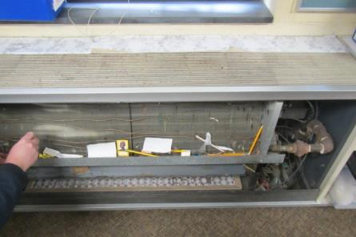

**1970’s vintage unit ventilator (univent) in classroom, Note: dust/debris inside unit**

**Picture 2**

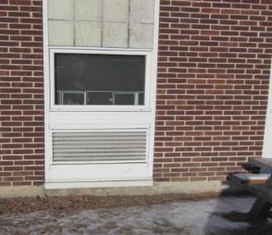

**Univent fresh air intake**

**Picture 3**

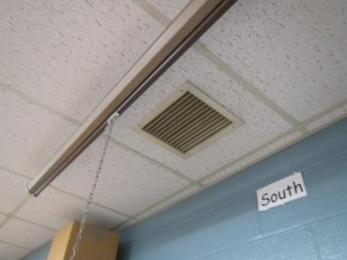

**Classroom exhaust vent**

**Picture 4**

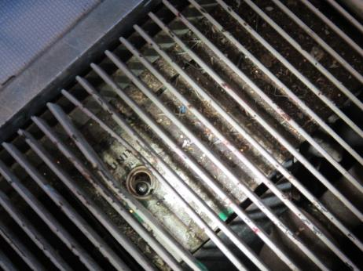

**Protective grate bent to allow access to univent controls (unit deactivated), also note dirt/dust/debris inside unit**

**Picture 5**

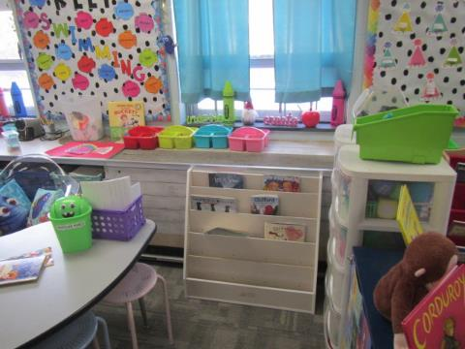

**Univent blocked by furniture and items**

**Pictures 6a and 6b**

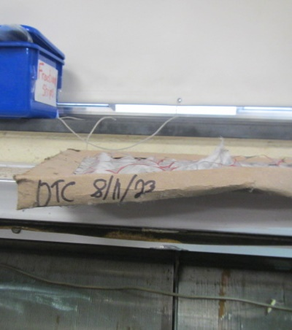 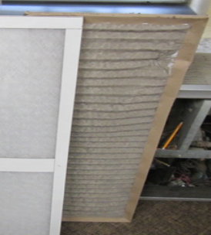

**Univent filter dated 8/11/2023, left, and clean filter on right**

**Picture 7**

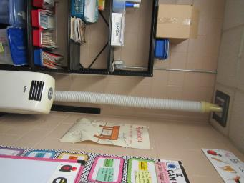

**Portable AC ducted into general exhaust vent; note: this configuration prevents full operation of exhaust vent**

**Picture 8**

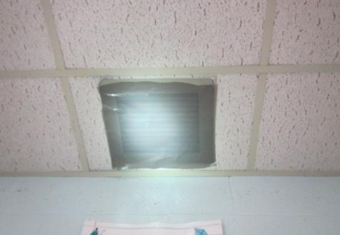

**Classroom exhaust vent sealed with plastic**

**Picture 9**

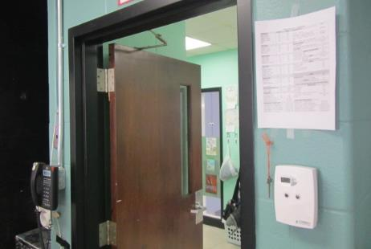

**Classroom thermostat near open hallway door**

Water Damage and Moisture Concern Pictures

(click to link back to report)

**Picture 10**

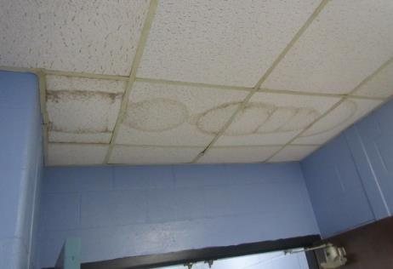

**Water-damaged ceiling tiles in first floor hallway**

**Picture 11**

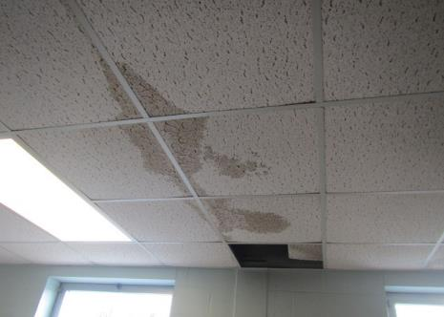

**Water-damaged ceiling tiles in first floor classroom**

**Picture 12**

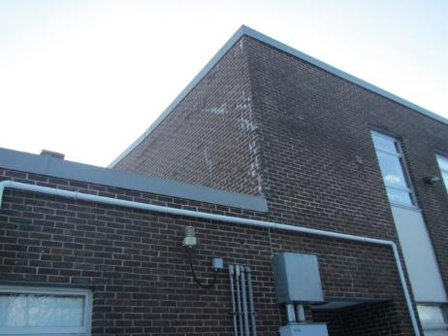

**Area where leaks are occurring due to water infiltration through masonry**

**Picture 13**

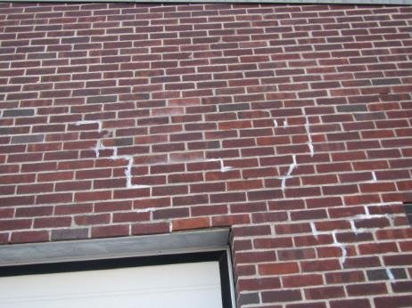

**Masonry that needs repointing**

**Picture 14**

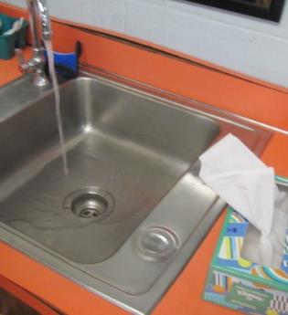

**Water-damaged particleboard sink countertop**

**Picture 15**

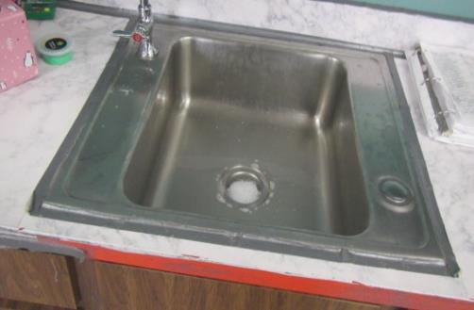

**Water-damaged particleboard sink countertop; note duct tape holding countertop/backsplash together**

**Picture 16**

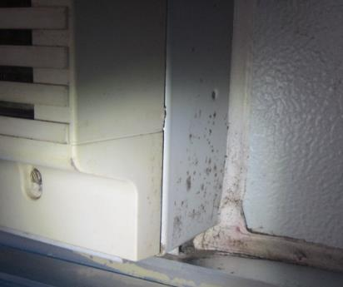

**Dust/debris/mold growth on corner of AC in classroom**

**Picture 17**

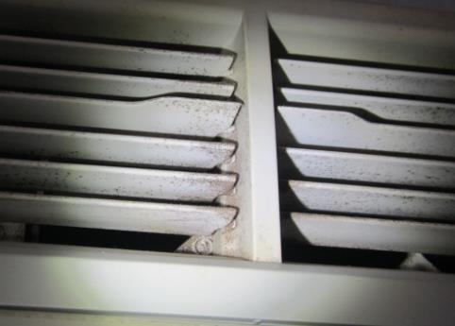

**Dust/debris/mold growth on louvers of AC in classroom**

**Picture 18**

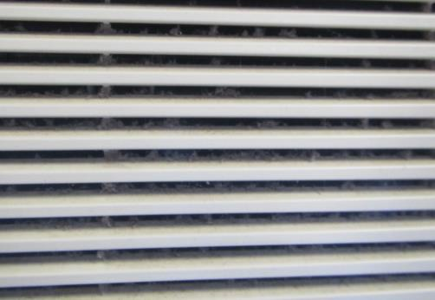

**Dust/debris on/between louvers of AC in classroom**

**Picture 19**

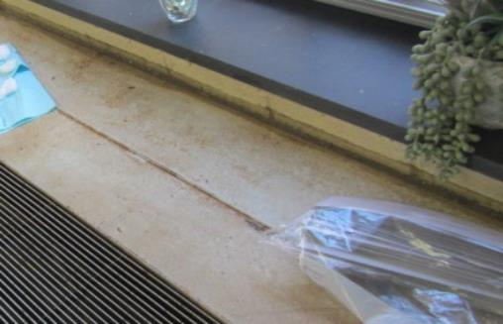

**Rusted/corroded metal univent housing in classroom from chronic moisture exposure**

**Picture 20**

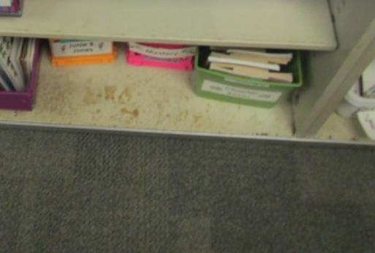

**Rusted/corroded metal cabinet/shelving in classroom from chronic moisture exposure**

**Picture 21**

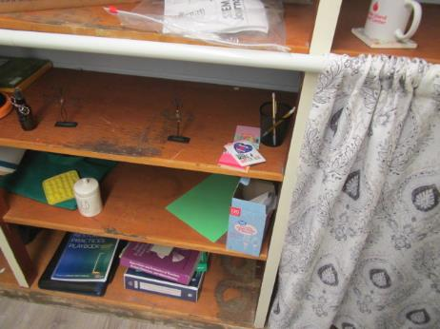

**Water-damaged/stained wooden shelving unit in Room 219**

**Pictures 22a and 22b**

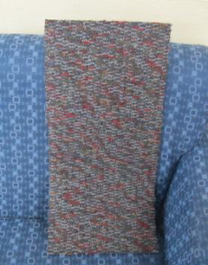

**Top and underneath of typical carpet square at LES**

Sources of Respiratory Irritant Pictures

(Click to link back to report)

**Picture 23**

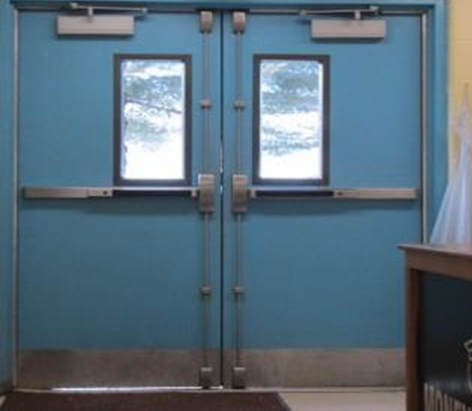

**Space/light seen penetrating beneath exterior door**

**Picture 24**

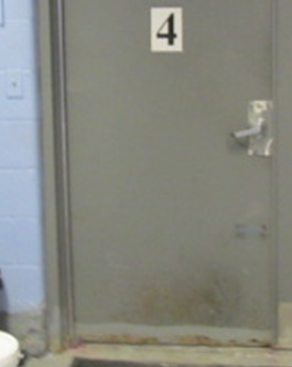

**Damaged/corroded exterior door in kitchen area; note steel wool in corner (arrow) to prevent rodent entry**

**Picture 25**

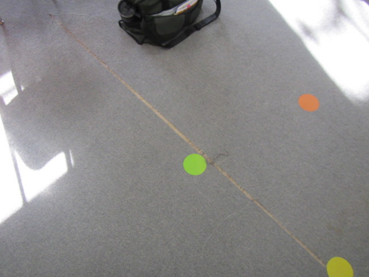

**Old worn wall-to-wall carpeting**

**Picture 26**



**Pillows and area rug on floor; note univent return vent blocked (bottom front)**

**Picture 27**

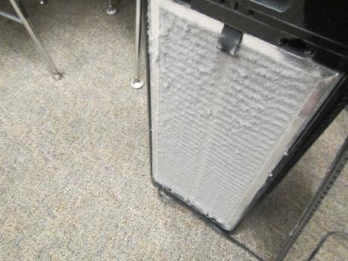

**Air purifier filter in need of changing/cleaning**

**Picture 28**

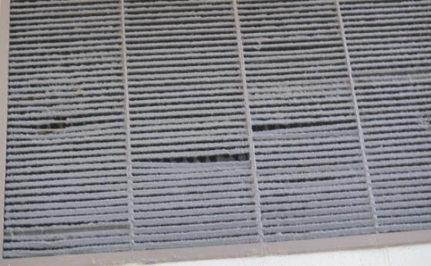

**Filter in gym clogged with dust/debris**

**Picture 29**

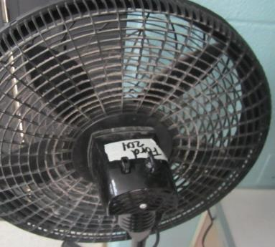

**Personal fan with accumulated dust/debris**

**Picture 30**

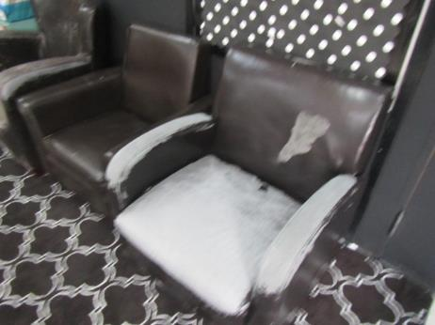

**Delaminating chairs in Room 204**

**Picture 31**

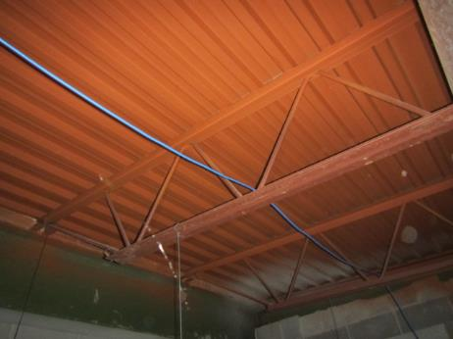

**Open space above ceiling tiles in Room 201**

**Picture 32**

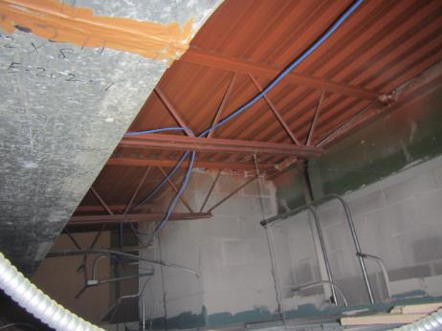

**Open space above ceiling tiles in Room 201**

**Picture 33**

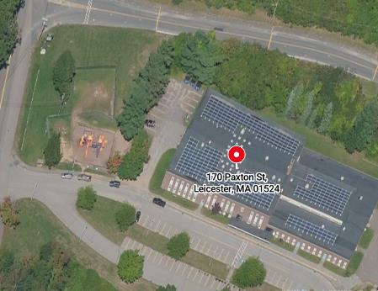

**Map courtesy of Google Maps, bracket indicates area of 2021 oil release and mitigation system**

**Picture 34**

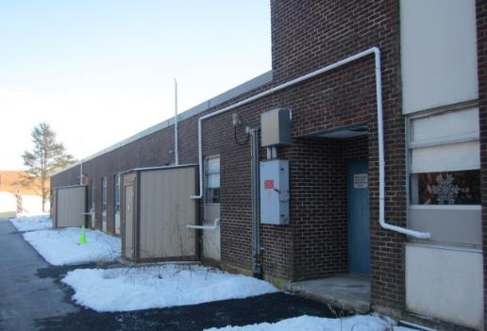

**Pump shacks (arrows) and piping for the Oil Spill Mitigation System along West side of building**

**Picture 35**

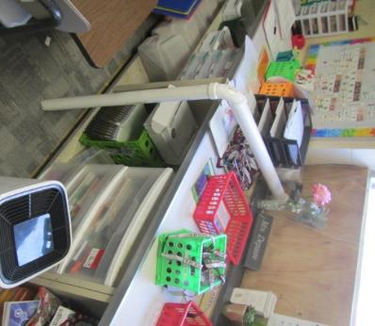

**Depressurization pipes in classroom along West side of building**



| **Location** | **Carbon**  **Dioxide**  **(ppm)** | **Carbon Monoxide**  **(ppm)** | **Temp**  **(°F)** | **Relative**  **Humidity**  **(%)** | **PM2.5**  **(µg/m3)** | **TVOCs**  **(ppm)** | **Occupants**  **in Room** | **Windows**  **Openable** | **Ventilation** | | **Remarks** |
| --- | --- | --- | --- | --- | --- | --- | --- | --- | --- | --- | --- |
| **Supply** | **Exhaust** |
| Background (outside) | 427 | ND-1 | 33 | 42 | 3 | ND |  |  |  |  | Cold and windy WNW 31-44 mph, snow the previous day |
| 101 | 2115 | ND | 73 | 30 | ND | ND | 17 | Y | Y  Off | Y  Off | Area rug, AP, WD CT above windows |
| Hallway near Exterior Door (Room 101) |  |  |  |  |  |  |  |  |  |  | Visible mold on surface of ceiling/corner |
| 102 | 2237 | ND | 70 | 35 | 2 | ND | 20 | Y | Y  Off | Y  Off | Area rug, AP, sink countertop damaged |
| 103 | 2874 | ND | 70 | 35 | ND | ND | 20 | Y | Y  Off | Y | Area rug, PF, bowed CTs |
| 104 | 2488 | ND | 68 | 38 | ND | ND | 25 | Y | Y  Off | Y | AC window-dust/debris, dark staining above on caulking (possible mold), bowed CTs, carpet squares, WD CT around exhaust vent |
| 104A | 2146 | ND | 71 | 30 | ND | ND | 4 | N | N | Y  Off | Recommend passive vent in door or undercut |
| 105 | 1753 | ND | 74 | 27 | ND | ND | 19 | Y | Y  Off | Y  Sealed | Area rug, AP (2), carpet squares |
| 106 | 1605 | ND | 71 | 26 | ND | ND | 17 | Y | Y  Off | Y  Sealed | 4 WD CTs, DO, AP, PF |
| 107 | 2034 | ND | 73 | 27 | ND | ND | 16 | Y | Y  On/weak | Y  Off/blocked | Carpet squares, AP (3), PF |
| 108 | 2230 | ND | 71 | 30 | ND | ND | 18 | Y | Y  Off | Y  Off/blocked | Carpet squares, AC, AP, damaged sink countertop |
| 109 | 2427 | ND | 73 | 31 | ND | ND | 15 | Y | Y | Y | AP, visible mold on AC-clean or replace, items hanging from ceiling tiles, area rug, damage to sink countertop |
| 110 | 1001 | ND | 71 | 23 | ND | ND | 0 | Y | Y | Y | Dirty AC, wall-to-wall carpeting |
| 114 | 1190 | ND | 73 | 24 | ND | ND | 1 | N | N | N | Carpet squares, CF, AC duct connected to exhaust vent |
| 118 | 1115 | ND | 74 | 23 | ND | ND | 0 | Y | Y  Noisy | Y  Off | Dust/mold around AC, items hanging from CTs, carpet old/worn, plants, aquarium, rust/corrosion on metal around univent |
| 119 | 1202 | ND | 72 | 24 | ND | ND | 0 | Y | Y | Y  Off | Area rug, univent return blocked |
| 120 | 1107 | ND | 69 | 25 | ND | ND | 2 | Y | Y | Y  Off | 16 WD CTs, rust/corrosion on metal surfaces from chronic moisture exposure |
| 121 | 970 | ND | 67 | 25 | ND | ND | 0 | Y | Y  Off | Y  Off | 2 WD CT, wall-to-wall carpeting, dirty AC filter |
| 122 | 787 | ND | 73 | 21 | ND | ND | 0 | Y | Y | Y | Items hanging from CTs, AP, dirty AC |
| Hallway Exterior Door #10 |  |  |  |  |  |  |  |  |  |  | Light around/beneath exterior door #10 |
| Gym | 1248 | ND | 74 | 22 | ND | ND | 22 | N | Y | Y | Exhaust vent dust/debris, vent needs to be cleaned (drips/stains), wall-to-wall carpet |
| Library | 1118 | ND | 72 | 23 | ND | ND | 20 | N | Y | Y | Carpet squares, reports of rodents, various items stored along floor/wall |
| Cafeteria | 1478 | ND | 72 | 26 | ND | ND | ~80 | Y | Y  2/3 off | Y  Off | PF, DO, ceiling exhaust near open hallway doors-rec shutting, 2 of 3 univents off |
| Kitchen |  |  |  |  |  |  |  |  |  |  | Back storage area – spaces bottom of door-damaged/corroded |
| Nurse | 1470 | ND | 73 | 26 | ND | ND | 3 | N | Y  Off | Y  Off | AP (2) |
| 201 | 1945 | ND | 69 | 34 | ND | ND | 4 | Y | Y  Off | Y  Off | Carpet tile, univent filter dirty (dated 8/23: changed on-site by Fac Dir), accumulated items, microwave, AP -unplugged, WD sink countertop, PF, observed above ceiling tiles – no visible water damage/mold, dead animals or associated odors |
| 202 | 1851 | ND | 69 | 30 | ND | ND | 18 | Y | Y  Off | Y  Off | Area rug, PF, plants, dehumidifier, accumulated items, AP |
| 203 | 1909 | ND | 70 | 32 | ND | ND | 21 | Y | Y  Off | Y  Off | DO, upholstered furniture, sink countertop damaged-duct tape, PF, WD CT, AP |
| 204 | 1568 | ND | 73 | 25 | ND | ND | 20 | Y | Y | Y  Off | PF-dusty (2), area rug, leather/vinyl chairs delaminating - difficult to clean, plants, AP, dehumidifier, damaged sink countertop-duct tape, paint cans under sink |
| 204A | 1623 | ND | 72 | 27 | ND | ND | 1 | N | N | Y  Off | Dehumidifier, AP-near door, door undercut |
| 208 | 1660 | ND | 72 | 27 | ND | ND | 20 | Y | Y  Off | Y  Off | Area rug, univent return partially blocked, cushions |
| 209 | 1646 | ND | 69 | 28 | ND | ND | 1 | Y | Y  Off | Y  Off | 21 occupants gone ~15 mins, noise complaints (univent deactivated), area rug, paint cans under sink, AP |
| 210 | 2423 | ND | 70 | 32 | ND | ND | 1 | Y | Y  Off | Y  Off | Area rug, 19 occupants gone~25 mins, sink countertop damaged, PF |
| 211 | 886 | ND | 68 | 19 | ND | ND | 0 | Y  Open | Y  Off | Y  Off | Area rug, AP, PF |
| 212 | 1145 | ND | 73 | 21 | ND | ND | 2 | Y | Y  Off | Y  Blocked | Items hanging from CTs, DO, carpet squares, WD CT |
| 213 | 1543 | ND | 72 | 26 | ND | ND | 5 | Y | Y  Passive | Y  Blocked | Exhaust vent blocked with AC flex hose, wall-to-wall carpeting, AP-filter dirty (changed on-site by Fac Dir) |

(Click to link back to report)

# Table 2A

|  |  |  |  |  |  |
| --- | --- | --- | --- | --- | --- |
| **Equipment Present in Building**  **(X = Yes)** | **Type of Heating/Cooling Ventilation**  **Equipment** | **Fresh**  **Air**  **Supply**  **(X = Yes)** | **Type of Location(s)** | **Air Filters Installed**  **MERV Rating**  **(1-15, U*)**  **(X = Yes)** | **Comments** |
| X | Univents | X | classrooms | X 13 | Need to change 2-4 times a year |
| X | Rooftop Air Handling Units | X | common areas | X 11-13 | Need to change 2-4 times a year |
|  | Outdoor, Ground-Installed Air Handling Units |  |  |  |  |
|  | Attic/Crawlspace Air Handling Units |  |  |  |  |
| X | Ceiling-Mounted Air Handling Units (including inside plenum) |  | Kitchen |  |  |
|  | Basement/Crawlspace-Installed Air Handling Units |  |  |  |  |
|  | Mechanical Room-installed Air Handling Units |  |  |  |  |
|  | Fan Coil Units |  |  |  |  |
| X | Window-Mounted Air Conditioners |  | classrooms |  | Filters need cleaning |
|  | Wall Louver-Controlled Gravity Air Supply |  |  |  |  |
| X | Windows |  | School-wide |  |  |
|  | Fan in window (blowing in) |  |  |  |  |
|  | Built in wall fan (switched) |  |  |  |  |
|  | Heat recovery ventilator unit |  |  |  |  |
|  | Energy recovery ventilator unit |  |  |  |  |
|  | Chilled Beam |  |  |  |  |
|  | Passive combustion supply vent in basement/boiler room |  |  |  |  |

(Click to link back to report)

# Table 2B

|  |  |  |  |  |
| --- | --- | --- | --- | --- |
| **Equipment Present in Building**  **(X = Yes)** | **Type of Exhaust Ventilation**  **Equipment** | **Ducted**  **To Outdoors**  **(X = Yes)** | **Type of Location(s)** | **Comments** |
| X | Rooftop Motors/Fans |  | Classrooms and common areas | Not functioning |
|  | Unit Exhaust |  |  |  |
| X | Ceiling Return Vent |  |  | Not functioning |
|  | Ceiling Return Vent, Plenum |  |  |  |
|  | Wall Return Vent |  |  |  |
|  | Kitchen Stove Hood |  |  |  |
| X | Restroom Exhaust Vent |  |  |  |
|  | Photocopier Exhaust Vent |  |  |  |
|  | Garage |  |  |  |
|  | Chemical Hood(s) |  |  |  |
|  | Locker Rooms |  |  |  |
|  | Showers |  |  |  |
|  | Clothes Dryers |  |  |  |
|  | Gas Water Heaters |  |  |  |
|  | Furnace-Flue to Chimney |  |  |  |
|  | Furnace/Boiler direct vent or power vent (no combustion air supply) |  |  |  |
|  | Kiln, Pottery |  |  |  |
|  | Dark Room |  |  |  |
|  | Generator Room |  |  |  |
|  | Wood Shop Dust Collector |  |  |  |
|  | Spray Paint Booths |  |  |  |
|  | Fan in window (blowing out) |  |  |  |
| X | Other | Y | Rooms 105, 106, 107 and 109 | Sub slab depressurizing system |

# Table 2C

|  |  |  |  |
| --- | --- | --- | --- |
| **Equipment Present in Building**  **(X = Yes)** | **Type of Equipment** | **Type of Location(s)** | **Comments** |
| X | Floor Fans, pedestal |  |  |
| X | Floor Fans, portable |  |  |
| X | Air Purifier (HEPA, other) |  |  |
|  | Floor heaters, portable |  |  |
| X | Refrigerators, Cold Beverage Vending Machines |  |  |
|  | Radiator, wall-mounted |  |  |
|  | Radiator, floor-mounted |  |  |
| X | Passive Vents (Wall/Door) | Offices and specialty areas |  |
| X | Window or portable ACs | Classrooms and offices |  |

(Click to link back to report)

# Table 3

| **Found in Building**  **X = Yes** | **Water-Damaged Materials, Building Components or Stored Materials** | **Location** | **Visible Microbial Growth?**  **X = Yes** | **Musty odor detected?**  **X = Yes** | **Comments** |
| --- | --- | --- | --- | --- | --- |
|  | Books-other bound materials |  |  |  |  |
| X | Brick walls – broken, missing mortar | Exterior |  |  |  |
|  | Brick walls – blocked weep holes |  |  |  |  |
|  | Cardboard boxes |  |  |  |  |
|  | Carpet tiles |  |  |  |  |
|  | Carpet - Area rugs |  |  |  |  |
|  | Carpet wall-to-wall |  |  |  |  |
|  | Ceiling tiles - affixed directly to ceiling surface |  |  |  |  |
| X | Ceiling tiles - bowing-in suspended ceiling | classrooms |  |  |  |
|  | Ceiling tiles - water-stained in splined ceiling |  |  |  |  |
| X | Ceiling tiles - water-stained in suspended ceiling | Classrooms and hallways |  |  |  |
|  | Chairs - laminated |  |  |  |  |
|  | Cloth |  |  |  |  |
| X | Countertops (around sinks) |  |  |  |  |
|  | Curtains |  |  |  |  |
|  | Dust/debris within AHU, uninvent, HVAC, chilled beam units, etc. (WD through condensation, humidity, or leaks) |  |  |  |  |
| X | Efflorescence (i.e., mineral deposits) | exterior |  |  |  |
| X | Engineered woods - particleboard, plywood, Masonite | Sink countertops |  |  |  |
|  | Flooring – loosened tiles |  |  |  |  |
|  | Flooring - wooden |  |  |  |  |
|  | Furniture - laminated |  |  |  |  |
|  | Furniture - upholstered |  |  |  |  |
|  | Gypsum wallboard - ceiling |  |  |  |  |
|  | Gypsum wallboard - restroom wall |  |  |  |  |
|  | Gypsum wallboard - interior wall |  |  |  |  |
|  | Gypsum wallboard – located on exterior wall |  |  |  |  |
|  | HVAC drain pan – lack of draining |  |  |  |  |
|  | HVAC filters |  |  |  |  |
|  | Insulation- attic (paper-backed) |  |  |  |  |
|  | Insulation - inside air handling unit |  |  |  |  |
|  | Insulation - on pipe(s) fiberglass |  |  |  |  |
|  | Insulation - on pipe(s) other/plaster-like material |  |  |  |  |
|  | Insulation - wall cavity |  |  |  |  |
|  | Insulation – ceiling plenum |  |  |  |  |
|  | Modular furniture – walls/cloth partitions |  |  |  |  |
|  | Musical instrument cases |  |  |  |  |
|  | Plaster ceilings |  |  |  |  |
|  | Records/files |  |  |  |  |
|  | Refrigerator - door gasket |  |  |  |  |
|  | Refrigerator - drip pan |  |  |  |  |
|  | Refrigerator - Interior surfaces |  |  |  |  |
|  | Room divider - ceiling-mounted, sliding |  |  |  |  |
| X | Sink backsplash | multiple classrooms |  |  |  |
|  | Tables – laminated |  |  |  |  |
|  | Wallpaper |  |  |  |  |
|  | Wood - attic/roof materials |  |  |  |  |
|  | Wood - floor joists in basement ceiling |  |  |  |  |
|  | Wood - wall framing |  |  |  |  |
|  | Wood - window sills |  |  |  |  |
|  | Wood - window-mounted air conditioner framing |  |  |  |  |
| X | OTHER (Air Conditioners) |  | X |  |  |

WHAT ARE ENVIRONMENTAL ASTHMA TRIGGERS?

Asthma triggers are any chemical, pollutant, or allergen that can make your asthma worse. Asthma triggers can also be strong chemical smells, dust, or pets. Your asthma triggers may be different from those of other people. Not all asthma triggers affect people the same way. Environmental asthma triggers are found both indoors and outdoors. DPH link: [Asthma and Your Environment (mass.gov)](https://www.mass.gov/doc/asthma-and-your-environment-english/download)

(click to link back to report)

# Table 4

| **Condition Present**  **X = Yes** | **Possible asthma symptom-inducing environmental pollutant** | **Recommendation to reduce or eliminate the pollutant** |
| --- | --- | --- |
| X | Water Damage and/or Mold  (allergen) | Identify water source and repair to eliminate.  Clean non-porous materials.  Remove and replace porous materials susceptible to mold growth.  Perform regular water damage assessments as a tool to ensure timely mitigation as needed.  Use NIOSH water damage assessment protocol as a guide: [NIOSH water damage assessment guideline](https://www.cdc.gov/niosh/docs/2019-115/pdfs/2019-115.pdf?id=10.26616/NIOSHPUB2019115&inf_contact_key=241b5c2ed98c27d94b530dedc36f1623f651f238aa2edbb9c8b7cff03e0b16a0). |
| X | Moistening of building components during hot, humid weather (>2 days in length) (mold, allergen) | Remove materials not dried in <2 days in a manner consistent with [US EPA Mold Removal in Commercial Buildings guideline](https://www.epa.gov/mold/pdf-version-checklist-mold-remediation-mold-remediation-schools-and-commercial-buildings).  Use dehumidification in occupied basement areas and other areas with chronic dampness. |
|  | Vegetation against exterior of building (water damage-mold) | Remove all vegetation preventing building exterior drying.  Remove all vegetation capable of falling onto a building or depositing debris onto the roof. |
|  | Personal humidifiers (lack of proper maintenance)  (pollutant and allergen) | Clean and maintain properly.  Use distilled water to eliminate metal and water treatment odors.  Maintain hydration by increasing water consumption. |
| X | Drains: Floor drains, Sink drains (abandoned use)  Water bubblers (abandoned use) | If in use, pour water into drain at least twice a week.  If not in use, seal the drain with an appropriate material in accordance with Massachusetts Plumbing Code (248 CMR 10.00). |
|  | Live Animals (turtles, gerbils, birds, rabbits, etc.) | Ensure cleanliness or remove animals from the location. |
|  | Improperly maintained aquariums and terrariums (allergen) | Maintain such equipment properly to eliminate odor.  Discontinue use. |
| X | Plants and flowers  (allergen and mold) | Keep indoor plants well maintained and not overwatered. Monitor for signs of mold and pests.  Ensure water for cut flowers does not become stagnant.  Ensure dried plant material is free of odors, mold, and pests and handled carefully  If asthma risks are high, eliminate plants and flowers. |
| X | HVAC system moisture issues  (mold, allergen) | Consult ASHRAE’s minimum standards for HVAC maintenance and inspection of commercial HVAC systems (<https://www.ashrae.org/technical-resources/bookstore/standards-180-and-211>). |
|  | HVAC system contaminant issues (allergen) | Consult ASHRAE’s minimum standards for HVAC maintenance and inspection of commercial HVAC systems (<https://www.ashrae.org/technical-resources/bookstore/standards-180-and-211>). |
|  | Indoor swimming pool odors outside of swimming pool (mold, chemical) | Maintain and operate pool HVAC systems to vent odors from building.  Ensure locker room exhaust vents are operating during building hours.  All doors leading to pool should be rendered airtight and be closed. |
|  | Pollen (allergen) | Recommend installation of MERV 8 or better filters if HVAC engineer confirms HVAC system can be so equipped without adversely affecting function.  Cut grass after hours.  Cut grass in a pattern to direct clippings away from exterior wall.  Remove trees and shrubs from in front of windows and air intakes. |
| X | Dry air | Maintain hydration.  Avoid overheating of air. |
| X | Dust mites  (allergen) | Recommendation to remove non-official upholstered furniture, area rugs, pillows, cushions, etc.  Cleaning with use of HEPA-filtered vacuum cleaner.  Eliminating clutter, storing items in dust and moisture-proof containers, and regularly removing dust through wet wiping. |
| X | Pests, including rodents and cockroaches  (allergen) | Use of integrated pest management guidelines, including:   * Proper disposal of food containers * Proper storage of food products in airtight containers * Elimination of use of food as art projects * Remove pest harborages/clutter * Regular monitoring for pests   [EPA IPM guideline link](https://www.epa.gov/ipm/introduction-integrated-pest-management) |
|  | Latex-containing materials | Remove tennis balls from furniture legs. |
|  | Fragrances  (chemical) | Eliminate point sources, such as:   * Plug-in air fresheners * Aroma/oil reed diffusers * Scented sprays * Discontinue use of other scented materials * Consult DPH fragrance guideline: [*Clean air is odor-free*](https://www.mass.gov/doc/clean-air-is-odor-free-removing-fragrances-to-improve-indoor-air-quality-in-schools-and-0/download) |
|  | Strong smells from /use of Chemicals (such as cleaning products)  (chemical) | Use building-issued cleaning products.  Use products in accordance with manufacturer’s instructions including dilution, application, and ventilation.  Avoid using products that are stronger than needed for the situation. |
|  | Strong odors from new building materials (carpeting/furniture)  (chemical) | Use low VOC-emitting materials.  Air out materials (outside or in unoccupied area) prior to installation. |
|  | Tobacco smoke  Secondhand Smoke  (pollutant) | Eliminate tobacco smoking.  Seal all shared wall penetrations. |
| X | Products with a strong odor such as paint, perfume, hairspray, air fresheners, bug-spray, laminators, candles, wax melters, dry erase markers and other VOC-containing products  (chemical) | If essential:   * Provide proper exhaust ventilation to eject aerosolized product directly outdoors. * Avoid/reduce use during occupied hours.   If not necessary, remove and eliminate. |
|  | Vehicle exhaust  (pollutant) | Enforce anti-idling regulations and post signs to give notice.  Relocate vehicles away from fresh air intakes.  Require cars to park face-in at building walls.  <https://www.mass.gov/files/documents/2018/02/20/idling-faq.pdf> |
|  | Vapors and or fumes from gas, oil, or kerosene stoves  (pollutant) | Operate stove hood when stove in use.  Install stove hood if not present.  Ensure equipment is in good working order. |
|  | Ozone (pollutant) | Eliminate use of ozone generating equipment. |
| X | Window Air Conditioners (if not properly maintained) (allergen) | Equip with proper filter and clean periodically.  Clean drip pans.  Install in window with weathertight, non-mold-growth sustaining material. |
|  | Pottery (pollutant) | Do not operate kiln during occupied hours.  Operate kiln with exhaust system activated.  Seal all seams and holes in kiln vent.  Ensure kiln exhaust discharge terminates outdoors. |
| X | Carpeting (allergen) | Clean carpeting in a manner consistent with IICRC standards, including regular vacuuming with a high efficiency particulate air (HEPA) filtered vacuum in combination with annual cleaning or semi-annual cleaning in soiled high traffic areas. |
|  | Sweeping/dusting vs HEPA vacuuming/wet wiping  (allergen or pollutant) | Refrain from using feather dusters or brooms.  Utilize HEPA vacuums and wet wiping to minimize aerosolizing particulate matter. |
| X | Lack of adequate air exchange/mechanical ventilation | Make repairs as necessary and ensure all HVAC system components are operating continuously when building is occupied. |
|  | Lack of local exhaust at source of pollution (vocational shop activities, kitchen exhaust hood) (all) | Recommend installation of exhaust ventilation to direct pollutants directly outdoors. |
|  | Renovating buildings while occupied  (chemical) | Use all SMACNA guidelines for Renovation While Buildings Are Occupied. For information, visit <https://www.mass.gov/service-details/construction-and-renovation-generated-pollutants-in-occupied-buildings>. |
|  | Chemistry program chemical storage  (chemical) | Repair (if needed) and operate chemical storeroom vents appropriately.  Reduce or eliminate unneeded or overstocked chemicals.  Store all chemicals in a manner to separate incompatible chemicals.  Keep chemical storerooms clean. |
| X | Photocopiers/duplicating machines | All machines should have dedicated exhaust vents. |

**ENVIRONMENTAL HEALTH CONCERNS**

**Leicester Elementary School**

**170 Paxton Street**

**Leicester, MA**

The Superintendent of Leicester Public Schools contacted the BCEH Division of Environmental Epidemiology in November 2024 to request assistance responding to health concerns raised by staff at Leicester Elementary School about diagnoses of cancer among current and former staff over approximately the last three years. School staff had also expressed some acute health-related concerns, such as respiratory conditions. In response, staff were offered the opportunity to participate in individual interviews with BCEH staff.

The interviews included the administration of a questionnaire by BCEH staff to obtain information on the type and frequency of symptoms experienced by employees. The questionnaire was closely modeled on surveys used previously by BCEH as well as those used by the National Institute of Occupational Safety and Health (NIOSH) and the U.S. Environmental Protection Agency (US EPA). The questionnaire elicited information on specific symptoms that have been reported in the scientific literature as commonly experienced by occupants of buildings with indoor air quality problems as well as information on perceived air quality and personal health factors. These types of questionnaires are used to systematically collect building-related health concerns and environmental complaints. The information collected, in conjunction with the assessment of the indoor environment, is used to evaluate possible associations between indoor air quality and health and to recommend appropriate follow-up, if warranted.

Leicester Elementary School has an employee population of approximately 100 individuals. Fewer than five individuals chose to participate in an interview with BCEH staff. All responses were reviewed to identify the types of diseases and symptoms that were reported, their frequency of occurrence, and whether any unusual patterns emerged suggestive of a possible association with indoor environmental conditions at the school. Under both state and federal regulations, personally identifying information shared by employees is confidential; therefore, the following discussion provides summary information only.

**Building and Acute (Short-Term) Health-Related Concerns**

Based on the limited information received, the symptoms most experienced by staff while in the building consist of respiratory issues, primarily coughing and a sore, hoarse, or dry throat. Respondents were asked if there was a particular time of day or week when their symptoms became worse or occurred more frequently. Overall, there did not appear to be a consistent pattern among respondents. BCEH staff also asked employees several questions about their perceptions of environmental conditions in their work surroundings. The most common condition reported by staff is that the temperature is too cold. Employees who participated in the interviews were asked if they had any other building-related concerns at Leicester Elementary School that had not yet been discussed. A variety of concerns were raised, including the following:

* Ceiling leaks
* Infrequent cleaning of classrooms, especially rugs
* Mold on carpets, floors/walls, and ceiling tiles
* Musty smell
* Oil odor
* Mice droppings
* Quality and cleanliness of ventilation units
* Peeling paint
* Sinks and toilets do not always function
* Radon levels in indoor air
* Loose railing on outside stairs.

Most of the building concerns shared by staff coincide with the findings of the IAQ assessment. The respiratory/irritant symptoms reported by participants are among those commonly experienced in buildings with indoor air quality problems and are commonly associated with ventilation problems; although other factors (e.g., odors, microbiological contamination) may also contribute (Passarelli, 2009; Norbäck, 2009; Burge, 2004; Stolwijk, 1991). Results from the IAQ assessment also indicate several opportunities for exposure to allergens (i.e., dust and potential mold growth from water damage). Given that exposure to excessive dust and mold can exacerbate pre-existing symptoms (e.g., asthma, allergies), it is possible that some individuals in the building may react differently than the general population. It is important to note that the onset of allergic reaction to triggers such as mold can be either immediate or delayed.

**Concerns of Cancer among Current and Former Staff**

BCEH staff reviewed limited information shared by interview participants on cancer diagnoses among current and former staff of Leicester Elementary School. It is important to note that cancer is a general term used to describe a group of different diseases -- different types of cancer have different causes, risk factors, characteristics, and age patterns. To protect patient privacy, no specific details are provided about any of the particular diagnoses.

Breast cancer was the most reported cancer type among staff. Because a school’s workforce is often primarily composed of women, it is not unusual for breast cancer to be the most frequently diagnosed cancer type in the school population. Researchers suspect that established risk factors for breast cancer such as later maternal age at first birth and lower parity (the number of times a woman has given birth) may be more prevalent in women working in a professional setting. Women with more education are also more likely to undergo regular mammograms, increasing the likelihood of earlier detection for breast cancer (NIOSH 2010).

Appendix A provides information that offers a greater context in which to understand the incidence of and risk factors for cancer, with additional information specific to breast cancer.

Appendix B provides a more detailed discussion of risk factors for breast cancer, also available on the Massachusetts Environmental Public Health Tracking website at <https://matracking.ehs.state.ma.us/Health-Data/Cancer/Risk_Factor_Summaries.html>.

**REFERENCES**

Burge, PS. 2004. Sick building syndrome. Occupational and Environmental Medicine 61:185-190.

NIOSH. 2010. Letter to Dawn McCarthy from Elena Page concerning cancer incidence in a Transportation Security Administration facility. Cincinnati, OH. May 17, 2010.

Norbäck, D. 2009. An update on sick building syndrome. Current Opinion in Allergy and Immunology 9:55-59.

Passarelli, GR. 2009. Sick building syndrome: an overview to raise awareness. Journal of Building Appraisal 5(1):55-66.

Stolwijk, J. 1991. Sick-building syndrome. Environmental Health Perspectives 95:99-100.

# 

# Appendix A Cancer Risk Factors, Exposure, Latency, and Incidence

**Cancer Risk Factors, Exposure, and Latency**

While all cancers have the characteristic of abnormal and invasive cell growth, “cancer” is a general term that describes a group of different diseases with different causes, risk factors, characteristics, and age patterns. A risk factor is anything that increases a person's chance of developing cancer and can include hereditary conditions, medical conditions or treatments, infections, lifestyle factors, or environmental exposures. An individual's risk of developing cancer may change over time and may depend on a complex interaction between their genetic makeup and exposure to a cancer-causing agent (i.e., carcinogen). It is likely that multiple risk factors influence the development of most cancers.

* Risk factor summaries for several cancer types are available on the Massachusetts Environmental Public Health Tracking website at [www.mass.gov/dph/matracking](http://www.mass.gov/dph/matracking).
* Additional risk factor information by cancer type is available from the American Cancer Society at [www.cancer.org](http://www.cancer.org).

Many cancers occur because of changes to cells that happen by random chance. Referred to as sporadic or spontaneous mutations, they are not due to any particular exposure to a cancer-causing agent. Other times, exposure may be an initiating or contributing factor to the development of cancer in an individual. If a person is exposed to something, it does not necessarily mean that their health will be affected. Any potential health risk depends on:

* whether you contact the chemical (e.g., drink contaminated water or touch contaminated soil),
* the amount of the chemical that gets into your body, and
* how toxic that chemical is.

The latency period is the time interval between an initiating event (such as a random mutation or exposure to a carcinogen) and the appearance of symptoms of the disease or its diagnosis. Cancer, in general, has a long latency period but it may vary depending on the type, magnitude, and timing of when the exposure or mutation occurred. Cancers that are solid tumors are believed to have a long latency period, estimated to be no shorter than 10 years and possibly as long as 50 years or more. For hematopoietic or blood-related cancers, such as lymphoma, experts think that the general latency period may be shorter, most commonly on the order of 5 to 10 years (Hall 2006; NRC 2005; UNSCEAR 2000; Bang 1996; Frumkin 1995). Due to the long latency period for most types of cancer, it is difficult to identify exactly what may have contributed to an individual’s cancer development.

**Cancer Incidence**

According to the American Cancer Society, one out of three individuals develop cancer in their lifetime (ACS 2025a). For this reason, cancers often appear to occur in “clusters,” and it is understandable that someone may perceive that there is an unusually high number of cancer diagnoses in their neighborhood, workplace, or town. Upon close examination, many of these “clusters” are not unusual increases, as first thought, but are related to such factors as local population density or a concentration of individuals who possess related behaviors or risk factors for cancer. Some, however, are unusual; that is, they represent a true excess of cancer in a workplace, a community, or among a subgroup of people. A suspected cluster is more likely to warrant further public health investigation if it involves a high number of diagnoses of one type of cancer in a relatively short time period rather than several different types diagnosed over a long period of time (i.e., 20 years), a rare type of cancer rather than common types, and/or a large number of diagnoses among individuals in age groups not usually affected by that cancer.

The Massachusetts Cancer Registry (MCR), a division in the MDPH Office of Population Health, is a population-based surveillance system that has been monitoring cancer incidence in the Commonwealth since 1982. Although the MCR can be used to evaluate cancer incidence in some cases, calculating an expected rate of cancer for a place of employment is difficult at best because data reported to the MCR is based on the individual’s place of residence at diagnosis, not their workplace. Therefore, the most practical first step in evaluating cancer in a workplace is to determine the types of cancer reported and whether they appear to represent an unusual pattern. An information sheet on cancer in Massachusetts is available online at <https://www.mass.gov/info-details/cancer-in-massachusetts>.

**Breast Cancer**

Nationally and statewide, breast cancer is the most common cancer diagnosed among women, except for skin cancers, accounting for about 30% of all newly diagnosed cancers among females (ACS 2025b; MCR 2024). For more than two decades, breast cancer has been the most common type of cancer diagnosed among females in Massachusetts and in the United States (except for skin cancers) (MCR 2008, 2014, 2018, 2024; ACS 2007-2024, 2025c). The chance of developing invasive breast cancer at some time in a woman’s life is about 1 in 8 (13%). A woman’s risk of developing breast cancer increases with age, with most women diagnosed at age 55 and older (ACS 2025b,d).

The risk of developing breast cancer is influenced by several factors. The most well-established risk factors for breast cancer are related to genetics and specific reproductive events in a woman’s life that impact exposure of the breast tissue to estrogen and progesterone, such as age at first pregnancy, number of births, and age at menopause. Other factors such as drinking alcohol, being overweight, some medical conditions, and demographic characteristics (e.g., socioeconomic status) are known to also influence breast cancer risk (ACS 2025b,d).

It should be noted that because a school’s workforce is often primarily composed of women, it is not unusual for breast cancer to be the most frequently diagnosed cancer type in the school population. Several studies have found that women who work in professional jobs tend to have an increased risk of developing breast cancer (Ruben et al. 1993; Threlfall et al. 1985; MacArthur et al. 2007; King et al. 1994; Pollan and Gustavsson 1999) while other studies have not (Calle et al. 1998; Petralia et al. 1999). No occupational exposures have been identified in these studies. Rather, researchers suspect that established risk factors for breast cancer such as later maternal age at first birth and lower parity (the number of times a woman has given birth) may be more prevalent in women working in a professional setting. Women with more education are also more likely to undergo regular mammograms, increasing the likelihood of earlier detection for breast cancer (NIOSH 2010).

**REFERENCES**

American Cancer Society (ACS). 2007-2024. Cancer Facts & Figures, *Annual Reports 2007 through 2024*. Available at <https://www.cancer.org/research/cancer-facts-statistics/all-cancer-facts-figures.html>.

ACS. 2025a. Lifetime Risk of Developing or Dying from Cancer. Available at [https://www.cancer.org/cancer/risk-prevention/understanding-cancer-risk/lifetime-probability-of-developing-or-dying-from-cancer.html.](https://www.cancer.org/cancer/risk-prevention/understanding-cancer-risk/lifetime-probability-of-developing-or-dying-from-cancer.html.%20%20)

ACS. 2025b. Breast Cancer. Available at [www.cancer.org/cancer/breast-cancer.html.](https://www.cancer.org/cancer/breast-cancer.html)

ACS. 2025c. Cancer Facts & Figures 2025. Available at [www.cancer.org/content/dam/cancer-org/research/cancer-facts-and-statistics/annual-cancer-facts-and-figures/2025/2025-cancer-facts-and-figures-acs.pdf.](http://www.cancer.org/content/dam/cancer-org/research/cancer-facts-and-statistics/annual-cancer-facts-and-figures/2025/2025-cancer-facts-and-figures-acs.pdf.%20%20)

ACS. 2025d. Breast Cancer Facts & Figures 2024-2025. Available at <https://www.cancer.org/content/dam/cancer-org/research/cancer-facts-and-statistics/breast-cancer-facts-and-figures/2024/breast-cancer-facts-and-figures-2024.pdf>

Bang KM. 1996. Epidemiology of Occupational Cancer. Occupational Medicine. 11(3) :467-485.

Calle, E.E. et al. 1998. Occupation and breast cancer mortality in a prospective cohort of US women. American Journal of Epidemiology 148(2):191-197.

Frumkin H. 1995. Carcinogens. In: Levy BS and Wegman DH, editors. Occupational Health- Recognizing and Preventing Work-Related Disease. 3rd ed. Boston: Little, Brown and Company. p.293

Hall EJ. 2006. Radiobiology for the radiologist. 6th ed. Philadelphia: Lippincott Williams & Wilkins; p. 138

King, A.S. et al. 1994. Mortality among female registered nurses and school teachers in British Columbia. American Journal of Industrial Medicine 26(1):125-132.

MacArthur, A.C. et al. 2007. Occupational female breast cancer and reproductive cancer mortality in British Columbia, Canada, 1950-94. Occupational Medicine 57:246-253.

Massachusetts Cancer Registry (MCR). 2008. Cancer Incidence and Mortality in Massachusetts 2001-2005: Statewide Report.

MCR. 2014. Cancer Incidence and Mortality in Massachusetts 2006-2010: Statewide Report (Revised November).

MCR. 2018. Cancer Incidence and Mortality in Massachusetts 2011-2015: Statewide Report. Available at [www.mass.gov/lists/cancer-incidence-statewide-reports](https://www.mass.gov/lists/cancer-incidence-statewide-reports).

MCR. 2024. Cancer Incidence and Mortality in Massachusetts 2016-2020: Statewide Report. Available at [www.mass.gov/lists/cancer-incidence-statewide-reports](https://www.mass.gov/lists/cancer-incidence-statewide-reports).

National Research Council (NRC). 2005. Health risks from exposure to low levels of ionizing radiation. BEIR VII Phase 2. Washington, DC: National Academies Press.

National Institute for Occupational Safety and Health (NIOSH). Letter to Dawn McCarthy from Elena Page concerning cancer incidence in a Transportation Security Administration facility. Cincinnati, OH. May 17, 2010.

Petralia, S.A. et al. 1999. Risk of premenopausal breast cancer and patterns of established breast cancer risk factors among teachers and nurses. American Journal of Industrial Medicine 35(2):137-141.

Pollan, M. and Gustavsson, P. 1999. High-risk occupations for breast cancer in the Swedish female working population. American Journal of Public Health 89(6):875-881.

Ruben, C.H. et al. 1993. Occupation as a risk identifier for breast cancer. American Journal of Public Health 83(9):1311-1315.

Threlfall, W.J. et al. 1985. Reproductive variables as possible confounders in occupational studies of breast and ovarian cancer in females. Journal of Occupational Medicine 27(6):448-450.

United Nations Scientific Committee on the Effects of Atomic Radiation (UNSCEAR). 2000. Sources and Effects of Ionizing Radiation. Volume I. New York: United Nations Scientific Committee on the Effects of Atomic Radiation.

# Appendix B Breast Cancer Risk Factor Information

**Massachusetts Department of Public Health | Bureau of Environmental Health**

Breast Cancer

Risk Factor Information

MASSACHUSETTS DEPARTMENT OF PUBLIC HEALTH | BUREAU OF ENVIRONMENTAL HEALTH

This document gives a general overview of risk factors. The document covers:

* About Cancer and Risk Factors
* About Breast Cancer
* Types of Breast Cancer
* Known Risk Factors
* Possible Risk Factors
* Other Risk Factors That Have Been Investigated
* References / More Information

**About Cancer and Risk Factors**

**Cancer is not just one disease.**

Cancer is a group of over 100 different diseases. Cancer occurs when abnormal cells grow out of control and crowd out the normal cells. It can start anywhere in the body and can spread (metastasize) to other parts of the body. Cancer types are named for the original location in the body and the type of cell or tissue. Different types of cancer have different causes and risk factors.

**Cancer can take a long time to develop.**

The cause of cancer is sometimes related to events that happened many years ago. Most cancer types are thought to take anywhere from 10 to over 50 years to develop. A few types, such as leukemia or lymphoma, are thought to take less than 10 years.

**A risk factor is anything that increases your chance of getting cancer.**

Some risk factors can be controlled while others cannot. Risk factors can include:

* Hereditary conditions (e.g., genes passed down from parents)
* Medical conditions or treatments (e.g., a previous cancer diagnosis)
* Infections (e.g., human papilloma virus)
* Lifestyle factors (e.g., smoking cigarettes)
* Environmental exposures (e.g., certain air pollutants)

**Most risk factors do not directly cause cancer.**

A risk factor influences the development of cancer but usually does not directly cause cancer.Instead, a combination of risk factors likely drives cancer development. For example, genetic factors can make individuals more likely to get cancer when they are exposed to a cancer-causing chemical.

**Environmental risk factors depend on how, how much, and how long you are exposed.**

Your risk from exposure to certain chemicals or radiation depends on the type, extent, and duration of exposure. For example, inhaling a certain chemical may increase your risk of getting cancer. However, touching the same chemical may not. In addition, some substances may increase your risk only if you are exposed to high amounts over a long time.

**It is difficult to identify the exact causes of cancer.**

* Many cancers can develop due to random chance.
* Multiple risk factors can act in combination.
* Risk factors can change over time.
* Cancer might not develop or get diagnosed for a long time after an initiating event (such as exposure or random cell mutation).

**Knowing your risk factors can help you make more informed choices.**

Discuss your risk factors with your health care provider to make more informed decisions on lifestyle and health care.

**About Breast Cancer**

**Breast cancer is the most common cancer in women in the United States.**

Breast cancer accounts for about 1 in 3 cancer diagnoses in women in the United States. A woman has about a 1 in 8 chance of developing breast cancer in her life.2, 9 The American Cancer Society estimates that 287,850 women in the U.S. and 6,710 women in Massachusetts will be diagnosed with invasive breast cancer in 2022.1 Since the mid-2000s, incidence rates of invasive breast cancer have increased by 0.5% each year.1, 2, 6

**Breast cancer is rare for men.**

Men can develop breast cancer, but it accounts for less than 1% of male cancer diagnoses.1, 7 White men are about 100 times less likely than white women to develop this cancer, and black men are about 70 times less likely than black women to develop it.5 For more information on breast cancer in men, visit the American Cancer Society website at [www.cancer.org](http://www.cancer.org).5

**Most breast cancers occur in women age 55 or older.**

The risk of developing breast cancer increases with age. About 70% of women diagnosed with breast cancer are age 55 and older.2, 6, 10, 11 A very small number of women diagnosed with breast cancer are younger than 45.2

**Although white women are more likely to develop breast cancer, black women are more likely to die from it.**

Before age 40, non-Hispanic Black women have a higher chance of developing breast cancer than non-Hispanic white women.2, 3, 6 Between the ages of 65 to 84, non-Hispanic white women are most likely to be diagnosed with breast cancer followed closely by non-Hispanic black women.3 Hispanic, Asian/Pacific Islander, and American Indian/Alaskan Native women are less likely to develop breast cancer.2, 3, 6

At any age, non-Hispanic black women are more likely to die from breast cancer than any other race or ethnic group.2, 3

**Types of Breast Cancer**

**Breast cancers are either *in situ* or invasive.**

* An *in situ* breast cancer is considered the earliest stage of cancer. It has not invaded the breast’s deeper tissues or spread to other organs. *In situ* breast cancers are also referred to as non-invasive breast cancers.2
* An invasive breast cancer has spread beyond the layer of cells where it started into surrounding tissues and can spread (metastasize) to other parts of the body.2

The remainder of this risk factor summary will focus on invasive breast cancers. For more information on *in situ* breast cancers and other benign (non-cancerous) breast conditions, visit the American Cancer Society website at [www.cancer.org](http://www.cancer.org).2, 4

**Most breast cancers are invasive (or infiltrating).**

The two most common types of breast cancer are invasive ductal carcinoma and invasive lobular carcinoma.2, 6

* Invasive ductal carcinoma begins in cells that line the milk duct of the breast. It makes up about 70-80% of all invasive breast cancers.
* Invasive lobular carcinoma begins in the milk-producing glands (lobules) of the breast. It accounts for 10% of invasive breast cancers. Invasive lobular carcinoma may be harder to detect by a mammogram.

Less common types of breast cancer include inflammatory breast cancer, Paget’s disease of the breast, angiosarcoma, and Phyllodes tumor.2

**Certain properties of breast cancer cells inform treatment decisions.**

Breast cancer cells are tested for two hormone receptors and a certain protein. Breast cancer tumors can be:

* Hormone receptor-positive: These breast cancer cells have either an estrogen receptor (ER), progesterone receptor (PR), or both. About 66% of breast cancers are ER and/or PR positive and are more common after menopause. They can be treated with hormone therapy.
* Human epidermal growth factor receptor 2 (HER2)-positive: These breast cancer cells have high levels of the HER2 protein, making them grow quickly. About 10-20% of breast cancers are HER2-positive and can be treated with drugs that target the HER2 protein. They can also be hormone receptor-positive.
* Triple-negative: These breast cancer cells do not have an estrogen receptor, progesterone receptor, or excess HER2 protein. They grow and spread faster than most other types of breast cancers. These breast cancers tend to be more common in women younger than 40 and can be difficult to treat.2, 6, 10

**Known Risk Factors**

*Medical Conditions*

**Non-cancer breast conditions:**

Certain benign (non-cancerous) breast conditions may increase breast cancer risk, including:

* Lobular neoplasia (a change in the cells of the milk-producing glands)2, 6
* Proliferative lesions with atypia (abnormal cells in the ducts or milk-producing glands that grow excessively)2
* Dense breast tissue (as seen on a mammogram)2, 6

**Previous breast cancer diagnosis:**

A woman with cancer in one breast has a higher risk of developing a new cancer in the other breast or in another part of the same breast. This is different from a recurrence or return of the first cancer2, 6

**High lifetime exposure to estrogen and progesterone:**

A longer lifetime exposure of the breast tissue to estrogen and progesterone can increase breast cancer risk. Several factors can increase risk, including:

* Starting menstruation before age 11 or 12
* Going through menopause after age 55
* Having a first pregnancy after age 30, or never having a full-term pregnancy2, 6

**Menopausal hormone therapy:**

Use of menopausal hormone therapy (also called post-menopausal hormone therapy or hormone replacement therapy) may affect breast cancer risk.

* Combined hormone therapy with both estrogen and progesterone increases the risk of breast cancer. The risk seems to decrease within 5 years of stopping treatment but does not disappear completely.
* Estrogen-only therapy does not appear to increase the risk of breast cancer.2, 6, 11

If you are considering menopausal hormone therapy, discuss the possible risks and benefits with your health care provider. In general, if a woman decides to use hormone therapy, it is usually best to use it at the lowest dose for as short a time as possible.2

**Previous radiation therapy to chest:**

Women who have had radiation therapy to the chest as treatment for another cancer (e.g., Hodgkin or non-Hodgkin lymphoma) have a higher risk for breast cancer.2, 11 The risk is highest if the radiation occurs as a teen or young adult, when the breasts are still developing. Radiation treatment after age 40 to 45 does not seem to increase breast cancer risk.2

**Prior use of diethylstilbestrol (DES) drug:**

From the 1940s to the early 1970s, some pregnant women were given DES because it was thought to lower their chances of miscarriage. Use of DES slightly increases breast cancer risk. A woman whose mother took DES while pregnant may also have a slightly higher risk of breast cancer.2

*Hereditary Conditions*

**Family history of breast cancer:**

Having a family history of breast cancer increases a woman’s risk of developing the disease. A woman has a higher risk if she has:

* Several close blood relatives (e.g., grandparents, aunts, cousins) diagnosed with breast and/or ovarian cancer.6
* A first-degree relative (i.e., mother, sister, or daughter) diagnosed with breast cancer. This almost doubles the risk. Having two first-degree relatives with breast cancer increases the risk by about 3 times.2
* A father or brother with breast cancer.2, 6

It is important to note that most women with breast cancer do not have a family history of the disease.2

**Inherited gene mutations:**

About 5-10% of breast cancers likely result from a genetic mutation passed down from a parent.2 Most of these mutations occur in the *BRCA1* and *BRCA2* genes. On average, women with *BRCA1* mutations have a 65% chance of developing breast cancer by age 70 and women with BRCA2 mutations have about a 45% chance. In the United States, BRCA mutations are more common in Jewish people of Ashkenazi (Eastern Europe) origin. Other less common gene mutations can increase the risk of breast cancer, including *ATM*, *CHEK2*, *NF1,* *TP53*, *PTEN, CDH1, STK11,* and *PALB2*.2, 11

*Lifestyle Factors*

**Drinking alcohol:**

Drinking alcohol is clearly linked to increased risk of breast cancer. The risk goes up with higher amounts of alcohol consumed.2, 6

* Women who drink one alcoholic drink per day have a small increase in risk.2
* Women who have 2 to 3 alcoholic drinks per day have about a 20% higher risk compared to non-drinkers.2

**Being overweight or obese:**

After menopause (when the ovaries stop making estrogen), most estrogen comes from fat tissue. Being overweight or obese after menopause increases a woman’s risk of breast cancer.2, 6, 11  Similarly, women who are less physically active may have an increased risk of breast cancer, especially in women past menopause.2, 6

**Higher socioeconomic status:**

The risk of breast cancer is higher in women of higher socioeconomic status (e.g., higher income, education), but is not due to socioeconomic status itself. Instead, this may be due to multiple reproductive and lifestyle risk factors (e.g., later age at first pregnancy, fewer children, greater use of menopausal hormone therapy, easier access to screening, etc.).6, 11

**Possible Risk Factors**

*Medical Conditions*

**Birth control use:**

Use of birth control may affect breast cancer risk.

* Women using birth control pills (oral contraceptives) have a slightly greater risk of breast cancer. However, the risk seems to return to normal within 10 years after stopping.
* Some studies suggest women using long-acting progesterone birth control shots (such as Depo-Provera) every 3 months may have an increase in breast cancer risk, but not all studies have found this.
* Some studies suggest women using a hormone-releasing intrauterine device (IUD) may have an increased risk.

Few studies have looked at breast cancer risk from birth control implants, skin patches, and vaginal rings. If you are considering hormonal birth control, discuss your breast cancer risk factors with your health care provider.2

*Height*

Many studies have found that taller women have a higher risk of breast cancer than shorter women. The reasons for this aren’t exactly clear, but it may have something to do with factors that affect early growth, such as nutrition early in life, as well as hormonal or genetic factors.2

*Lifestyle Factors*

**Smoking:**

Recent research suggests that long-term heavy smokers may have a slightly higher risk of breast cancer, with risk increasing for certain groups, such as women who started smoking before having their first child.2 Information about quitting smoking and related services is available from the Massachusetts DPH Tobacco Cessation and Prevention Program at 1-800-Quit-Now or 1-800-784-8669.

**Secondhand smoke:**

Some studies suggest a possible connection between secondhand smoke and an increased risk for breast cancer, particularly in premenopausal women. However, this is still being studied.2, 11

**No history of breastfeeding:**

Women who have breastfed (especially for 1 year or more) might have a lower risk for breast cancer. Experts think this might be because breastfeeding reduces the number of menstrual cycles in a woman’s lifetime, lowering exposure to estrogen and progesterone.2, 11

**Working the night shift:**

Some recent studies have suggested that working the night shift may increase the risk for breast cancer. The light-sensitive hormone melatonin may play a role in this link. Further research is looking into this possibility.2, 8

*Environmental Exposures*

**Exposure to chemicals with estrogen-like properties:**

A great deal of research has been done trying to understand possible environmental risk factors for breast cancer. Some environmental chemicals, such as endocrine disruptors, elicit hormonal responses or have estrogen-like properties. 2, 11 In theory, estrogen-like chemicals could affect breast cancer risk. These chemicals can be found in certain:

* Plastics
* Cosmetics and personal care products
* Pesticides
* PCBs (polychlorinated biphenyls) 2

One research program found that exposure to endocrine disrupting chemicals during prenatal development, puberty, pregnancy, and menopausal transition was associated with an increased risk for breast cancer.12 However, there is no clear link between exposure to these substances and breast cancer risk.2

**Other Risk Factors That Have Been Investigated**

*Medical Conditions*

**Miscarriages and pregnancy terminations?**

Several studies have found that miscarriages and pregnancy terminations (either induced or spontaneous abortions) do not affect breast cancer risk.2, 111

*Lifestyle Factors*

**Antiperspirants?**

Use of antiperspirants has been investigated as a possible risk factor for breast cancer. Based on the available evidence, no associations or scientific basis have been found linking breast cancer risk with use of antiperspirants.2, 111

**Bras?**

No scientific or clinical evidence indicates that bras can cause breast cancer.2, 11

**Breast implants?**

Breast implants have not been linked to an increased risk for the most common types of breast cancer. However, breast implants with a textured surface have been linked to a rare cancer, [breast implant-associated anaplastic large cell lymphoma (BIA-ALCL)](https://www.cancer.org/cancer/breast-cancer/reconstruction-surgery/breast-reconstruction-options/breast-reconstruction-using-implants.html), which can form in the scar tissue around the implant.2

**Dietary fat intake?**

Studies of women in the United States have not found a consistent link between high-fat diets and breast cancer risk. One large study found a high-fat diet during adolescence was associated with a moderate increase in premenopausal breast cancer risk. Studies have found breast cancer is less common in other countries where the typical diet is lower in total, polysaturated, and saturated fats, but this association is complicated by other factors (such as activity level, intake of other nutrients, and genetic factors).2, 11

**References / More Information**

*This information sheet should not be considered exhaustive. For more information on other possible risk factors and health effects being researched, please see the resources below. Much of the information contained in this summary has been taken directly from these sources. This material is provided for informational purposes only and should not be considered as medical advice. Consult your physician if you have questions regarding a specific medical problem or condition.*

American Cancer Society (ACS). <http://www.cancer.org>

1. ACS. 2022. Cancer Facts & Figures 2022.
2. ACS. 2022. Breast Cancer.
3. ACS. 2019. Breast Cancer Facts & Figures 2019-2020.
4. ACS. 2022. Non-Cancerous Breast Conditions.
5. ACS. 2022. Breast Cancer in Men.

American Society of Clinical Oncology (ASCO). <http://www.cancer.net>

1. ASCO. 2020. Breast Cancer.
2. ASCO. 2020. Breast Cancer in Men.

International Agency for Research on Cancer (IARC). <http://www.iarc.fr/>

1. IARC. 2010. IARC Monographs on the Evaluation of Carcinogenic Risks to Humans, Volume 98: Painting, Firefighting and Shiftwork. Available at: <http://monographs.iarc.fr/ENG/Monographs/vol98/index.php>

Massachusetts Cancer Registry (MCR), Massachusetts Department of Public Health.

1. MCR. 2021. Cancer Incidence and Mortality in Massachusetts 2013-2017: Statewide Report. Available at: <https://www.mass.gov/doc/cancer-incidence-and-mortality-in-massachusetts-2013-2017-statewide-report/download>

National Cancer Institute (NCI). [http://www.cancer.gov](http://www.cancer.gov/)

1. NCI. 2021. Breast Cancer.

Schottenfeld D and JF Fraumeni.

1. Brinton LA, Gaudet MM, and Gierach GL. 2018. Breast Cancer. In: Cancer Epidemiology and Prevention. 4th Ed, edited by Thun MJ, Linet MS, Cerhan JR, Haiman CA, and Schottenfeld D, New York: Oxford University Press.

National Institute of Environmental Health Sciences (NIEHS). <https://www.niehs.nih.gov/>

1. NIEHS. 2022. Breast Cancer.

**The Seal of the State of Massachusetts**

**Massachusetts Department of Public Health**

**Bureau of Environmental Health**

250 Washington Street

Boston, MA 02108

Phone: 617-624-5757 | Fax: 617-624-5777 | TTY: 617-624-5286

[www.mass.gov/dph/environmental_health](http://www.mass.gov/dph/environmental_health)

**September 2022**

# 

# Appendix C Release of Oil from Subsurface Fuel Lines at Leicester Elementary School in 2021

On or about April 1, 2021, several large tents were set up outside the north wall of Leicester Elementary School in anticipation of the school reopening after the COVID-19 shutdown. Oil odors were reported over the next several weeks in classroom 106. On April 15th, school maintenance staff hand-dug a small pit where the fuel lines for the aboveground storage tank (AST) leave the school building. The 10,000-gallon AST is located about 70 feet northeast of the building and contains No. 2 fuel oil for the school’s boiler. No evidence of separated oil was observed. A storm with mixed precipitation occurred that night and a small amount of water with and oil floating in a separate layer was observed in the pit on April 16th. School staff realized that some of the tents had been installed along the path of the subsurface fuel lines and a tent stake may have damaged one of the fuel lines. An environmental consultant was contacted, and the Massachusetts Department of Environmental Protection (MassDEP) was notified. The school was shut down on April 26th and the elementary school was not used for the remainder of the 2020-2021 school year.

Remediation activities were conducted under the Massachusetts Contingency Plan (MCP), the statewide cleanup program for releases of oil and hazardous materials per Massachusetts General Laws. Excavation activities to remove the oil-contaminated soil occurred in April through July 2021. This included careful removal of contaminated subsurface soils located below the foundation of the building in sections using a process called sequential underpinning. The excavated areas were backfilled with clean soil. Post-excavation soil samples were analyzed for volatile petroleum hydrocarbons (VPH) and extractable petroleum hydrocarbons (EPH). Concentrations were either not detected or below applicable standards except for two detections of C9-C10 Aromatic in subsurface soil (one from a sample collected north of the building, just west of the door where the first story becomes two stories, and the other from a sample collected east of the building, just south of the original fire hydrant location).

Sorbent booms and pads were used to collect oil that had entered a nearby catch basin. The storm drain was cleaned from the catch basin to the outfall and the waste fluids were recovered for proper disposal. Oil that had traveled through the storm drain system was excavated along 175 feet of the drainage channel where the outfall empties about 450 feet south of the school.

Three groundwater monitoring wells were installed in November 2021 and samples were collected in December 2021, March 2022, and June 2022. Concentrations of EPH and VPH were either not detected or below applicable standards. It should be noted that Leicester Elementary School is provided with municipal drinking water and there are no irrigation wells or other uses of groundwater on the site.

Initial indoor air sampling from July and August 2021 showed concentrations of air-phase petroleum hydrocarbon (APH) analytes that exceeded residential and commercial/industrial threshold values, likely due to vapor migration from residual soil contamination along the building foundation. In response, a pilot sub-slab depressurization system (SSDS) was installed in August 2021 and showed that such a system could be effective. The full SSDS was installed in October 2021 to create a vacuum field below classrooms 106 through 109 and along the exterior foundation wall below classroom 105. The SSDS includes extraction points and vapor pins in classrooms 105, 106, 107 and 109 and two vacuum blowers housed in separate sheds outside the north wall of the building. The SSDS has operated continuously since installation except for short periods to allow for assessment of indoor air concentrations with the system shut off. Air sampling from October 2021 to present indicates APH concentrations have decreased over time. Indoor air sampling from July 2024, November 2024, and January 2025 showed APH analytes were either not detected or below residential threshold values (except for the November 2024 sample from classroom 109, which could not be analyzed due to an equipment failure). Although operation of the SSDS no longer appears to be necessary, it will be kept on for the remainder of the 2024-2025 school year. Additional sampling is planned for July 2025 with the system shut off to confirm that operation of the system is not necessary to maintain acceptable indoor air quality.

For more information about the release of oil at the Leicester Elementary School and subsequent remediation, visit the MassDEP website for waste sites and reportable releases at <https://eeaonline.eea.state.ma.us/portal/dep/wastesite/detailviewer/2-0021538/> or contact the MassDEP’s Central Regional Office at 508-792-7650.

**REFERENCES**

Hydro-Environmental Technologies, Inc. (HETI). 2025. Immediate Response Status Report #8, Leicester Elementary School, 170 Paxton Street, Leicester, Massachusetts, MADEP Release Tracking Number 2-21538. Available at <https://fileservice.eea.comacloud.net/V3.1.0/FileService.Api/file/aeaffedhj?HqzyvNhiCaLDxuh4ZUd0lYStf/RKJTc4I2os0lAYHKoqCpwVxk1+tpMPHb8lCrlGhw9n2DMQtaHHS8OoO0G8nNFtH/B4Sj29osGCJoyxZdiAF1d3emfm/098KH3RzsLl>.

HETI. 2022. Phase I Initial Site Investigation and Tier Classification Submittal, Leicester Elementary School, 170 Paxton Street, Leicester, Massachusetts, MADEP Release Tracking Number 2-21538. Available at <https://eeaonline.eea.state.ma.us/DEP/WscNBApi/documents/get-file/gcgadgjj?fileSource=EDEP>.

HETI. 2022. Immediate Response Status Report #2, Leicester Elementary School, 170 Paxton Street, Leicester, Massachusetts, MADEP Release Tracking Number 2-21538. Available at <https://fileservice.eea.comacloud.net/V3.1.0/FileService.Api/file/gbfjhifj?lmCTHeatk77gq74Wl0N+tCRT7bnT2/KpNYN8mZaiYxY6JIUFZ5IDr5f6e601JN4i1mMCc5t2kMHlBznG8TWbSZk7rGFzTrMmfKURZOriP23RjyEeVQyPS2BVE/jiFQtr>.

HETI. 2021. Immediate Response Status Report #1, Leicester Elementary School, 170 Paxton Street, Leicester, Massachusetts, MADEP Release Tracking Number 2-21538. Available at <https://fileservice.eea.comacloud.net/V3.1.0/FileService.Api/file/ficgbbgj?3L0qTNMRpn7HvkVT379BMyRT7bnT2/KpNYN8mZaiYxY6JIUFZ5IDr5f6e601JN4i1mMCc5t2kMHlBznG8TWbSZk7rGFzTrMmfKURZOriP23RjyEeVQyPS2BVE/jiFQtr>.

*Appendix C was made possible by a cooperative agreement [program # CDC-RFA-TS-23-0001] from the Agency for Toxic Substances and Disease Registry (ATSDR). Its contents are solely the responsibility of the Massachusetts Department of Public Health and do not necessarily represent the official views of the ATSDR, or the U.S. Department of Health and Human Services.*