# BACKGROUND

**INDOOR AIR QUALITY**

**ASSESSMENT**

**Leicester High School**

**Borger Building**

**964 Main Street**

**Leicester, MA**

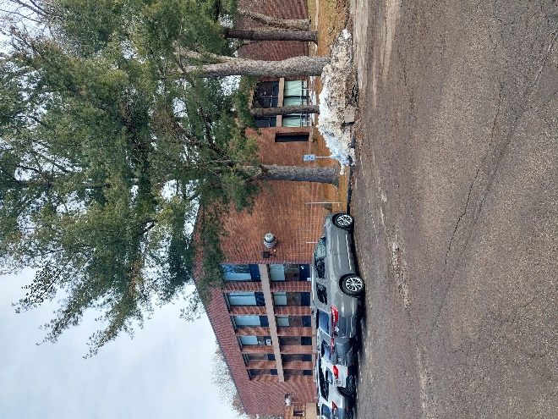

Prepared by:

Massachusetts Department of Public Health

Bureau of Climate and Environmental Health

Indoor Air Quality Program

March 2024

|  |  |
| --- | --- |
| Building: | Borger Building (BB), Leicester High School (LHS) (formerly part of Becker College) |
| Address: | 174 Paxton Street, Leicester, MA |
| Assessment Requested by: | Dr. Brett Kustigian, Superintendent, Leicester Public Schools (LPS) |
| Date of Assessment: | February 9, 2024 |
| Massachusetts Department of Public Health/Bureau of Climate and Environmental Health (MDPH/BCEH) Staff Conducting Assessment: | Michael Feeney, Director, Indoor Air  Quality (IAQ) Program |
| Date of Building Construction/Renovation: | Constructed in 1995 |
| Building Description: | The BB is a two-story brown brick and cement building that contains general classrooms, science classrooms, an auditorium, and office space. At the time of this assessment, the first floor was used for classrooms. |
| Windows: | Openable |

# The IAQ Program initially assessed the building to identify possible causes of mold growth from condensation and to make recommendations regarding methods that may be used to limit such water damage during hot, humid conditions. IAQ staff returned to BB to conduct air testing. At the time of this assessment, the first floor was occupied by students as classrooms. The second floor was not in use as classrooms due to accessibility issues.

# METHODS

Please refer to the IAQ Manual for methods, sampling procedures, and interpretation of results (MDPH, 2015).

# RESULTS AND DISCUSSION

The following is a summary of testing results (Table 1):

* ***Carbon dioxide*** was above the MDPH guideline of 800 parts per million (ppm) in most spaces measured. Higher levels of carbon dioxide were found in more heavily occupied areas.
* ***Temperature*** was below recommended comfort range of 70°F to 78°F in half the rooms tested. Some occupants reported rooms that were frequently too hot or too cold.
* ***Relative humidity*** ranged from below to above the recommended range of 40% to 60%. Low relative humidity is typical of the heating season in New England. Elevated relative humidity may be caused by open windows during wet weather, or high occupancy.
* ***Carbon monoxide*** (CO) levels were detected in a range of 1-4 ppm. Outdoor CO levels were measured at 4 ppm. Indoor air CO measurements would be expected to be equal or below outdoor measurements.
* ***Fine particulate matter (PM2.5)*** concentrations were below the National Ambient Air Quality Standard (NAAQS) level of 35 μg/m3.

## Ventilation

A heating, ventilating, and air conditioning (HVAC) system has several functions. First it provides heating and, if equipped, cooling. Second, it is a source of fresh air. Finally, an HVAC system will dilute and remove normally occurring indoor environmental pollutants by not only introducing fresh air, but by filtering the airstream and ejecting stale air to the outdoors via exhaust ventilation. Even if an HVAC system is operating as designed, point sources of respiratory irritation may exist and cause symptoms in sensitive individuals.

Fresh air in the majority of classrooms is supplied by unit ventilators (univents) installed when the BB was constructed (Picture 1). Univents draw air from the outdoors through a fresh air intake located on the exterior wall of the building and return air through an air intake located at the base of the unit. Fresh and return air are mixed, filtered, heated, or cooled and provided to rooms through an air diffuser located in the top of the unit (Figure 1). Univents were found deactivated in several classrooms.

Mechanical exhaust ventilation in classrooms is provided by wall-mounted exhaust vents (Picture 2) connected to air handling units (AHU) located indoors in the building. The MDPH IAQ Program recommends that supply and exhaust ventilation operate *continuously* during occupied periods to provide air exchange and filtration. Without sufficient supply and exhaust ventilation, normally occurring environmental pollutants can build-up and lead to IAQ/comfort complaints.

Some classrooms do not have a univent. As an example, Room B1 has openable windows and a heating register, but does not have a univent or exhaust vent connected to the main HVAC system. It is possible this room was designed for a film-based photography program. One indication of this design is the existence of a large adjacent room that appears to have been constructed as a photography dark room. The adjacent room has one entrance and appears to have a vent. To develop film, dark rooms are equipped with a water source, and drains. In order to remove film developing odors and water vapor, darkrooms would also have a mechanical exhaust vent.

Room B4 did not have a readily identifiable exhaust vent. The exhaust vent exists in a closed wood cabinet (Picture 3). Due to this, Room B4 has limited means to vent air from the room. This configuration also may also allow draw of pollutants and water vapor from the foundation of the building. The space around the pipe also has the potential to be a pathway for radon gas to enter the building.

To maximize air exchange, the IAQ program recommends that both supply and exhaust ventilation operate continuously during periods of occupancy. To have proper ventilation with a mechanical ventilation system, the systems must be balanced after installation to provide an adequate amount of fresh air to the interior of a room while removing stale air from the room. It is recommended that HVAC systems be re-balanced every five years to ensure adequate air systems function (SMACNA, 1994).

Of note, is the construction of the building’s exterior walls. The building has large, sloped cement ledges (Picture 4). The window systems for rooms are recessed exterior walls that have windows that open at floor level instead of above the top of the classroom univent. These window systems appear to be original to the building and the gaskets appear to no longer completely seal. This allows outdoor air to be drawn into the room by operation of the univent and/or exhaust vent. In this configuration, individuals sitting near windows or in the airflow of the univent may report feeling cold. If the building is operating during hot, humid weather, such window gaps may make air-conditioning control more difficult and result in elevated relative humidity indoors.

It is also important to note that HVAC units are at the end of their life cycle. Efficient function of equipment of this age (> 29 years old) is difficult to maintain, since compatible replacement parts are often unavailable. According to the American Society of Heating, Refrigeration, and Air-Conditioning Engineering (ASHRAE), the service life[1] of this type of unit is 15-20 years, assuming routine maintenance of the equipment (ASHRAE, 1991).

## Microbial/Moisture Concerns

As noted, the building has recessed window systems that are above sloped ledges. A sealant compound is installed in the junction between the window frames and cement ledge. Sealants can shrink and become eroded by weather, which can open gaps for wind-driven rain to enter the building. If materials that are prone to mold growth (e.g., carpeting) are on or close to the window system, such materials may become moistened by rainwater or outdoor water vapor during hot, humid weather.

### Building material prone to water vapor absorption in high humidity environments

According to the American Society of Heating, Refrigerating and Air-Conditioning Engineers (ASHRAE), if relative humidity exceeds 70% for extended periods of time, mold growth may occur due to wetting of building materials even in the absence of liquid water (ASHRAE, 2019). In these conditions, porous materials such as ceiling tiles, gypsum wallboard, cardboard and other items may develop mold colonization.

It is recommended that porous material be dried with fans and heating within 24 to 48 hours of becoming wet (US EPA, 2008, ACGIH, 1989). If porous materials are not dried within this time frame, mold growth may occur. If mold-colonized, they should be removed and discarded. Water-damaged porous materials cannot be adequately cleaned to remove mold growth.

### Dry drain traps

The BB has science labs that contain sinks and drains, some abandoned and some in use. It is highly likely that sinks that are not used have dry traps, which can result in significant backflow of water vapor into the building from the drainage system, particularly during times of heavy rains. The purpose of a drain trap is to prevent sewer gases from entering the building by having water fill the P-trap beneath the drain. This creates an airtight seal to also prevent excess water vapor from entering the building. All drains should be wet with water at least once a week. Drains that are no longer needed should be sealed or permanently abandoned.

### Extreme weather conditions

Hot humid summers are becoming more frequent due to climate change. Massachusetts has experienced hot, humid, and rainy summers in 2018, 2021, and 2023. Extended periods of hot, humid weather were experienced in the summer of 2021. July of 2021 was the wettest ever recorded in Massachusetts, and the three-month period from June through August, known as the meteorological summer, was the fourth wettest on record, according to the National Oceanic and Atmospheric Administration’s (NOAA) Centers for Environmental Information (HG, 2021, NOAA, 2021). The summer of 2023 was also hot, and wet, being measured as the second rainiest on record (WBUR, 2023). These conditions are challenging for buildings, particularly those without air conditioning.

During the summers of 2018, 2021 and 2023, extended periods of outdoor relative humidity above 70% occurred. Under these excessively moist weather periods, public buildings experienced extended periods of water vapor exposure from high relative humidity. When exposed to these conditions, porous materials such as gypsum wallboard, cardboard, and other materials may become prone to developing mold colonization, particularly if located in areas that are prone to developing condensation on floors and walls (e.g., below grade space). According to the American Society of Heating, Refrigerating and Air-Conditioning Engineers (ASHRAE); if relative humidity exceeds 70%, mold growth may occur due to wetting of building materials (ASHRAE, 2022) even in the absence of liquid water.

The BB has a waffle cement ceiling (Picture 5). A sound absorbent tile is installed inside each indentation to absorb noise. IAQ did not observe any water damage to these sound absorbent panels.

### Building exterior

IAQ staff examined the building envelope to identify possible sources of water damage, breaches, and/or other conditions that could provide a source of moisture that can adversely affect indoor air quality. The ledge has a lip into which the window system is installed. The configuration of the window systems above ledges is an example of a design that may allow for wind-driven rain to enter the building through gaps in sealant and/or worn window system gaskets over time. In this condition, flooring may become moistened. In addition to rainwater penetration, the use of window ledges in this manner may serve as a thermal bridge to lower the temperature of the floor. During extended periods of below freezing weather, the temperature of the cement slab as well as metal window frames may go below the dew point inside the building. If this occurs, condensation may accumulate on surfaces and moisten porous materials that are prone to mold growth. Using flooring materials in place of carpeting is recommended for at least the nearest three feet from exterior window systems to prevent repeated moistening.

Plants were observed in contact with and near the foundation (Picture 4). Plants near the building can cause water damage to brickwork and mortar. In addition, plants shading exterior walls can slow drying. Water can eventually penetrate the brick, subsequently freezing and thawing during the winter. This freezing/thawing action can weaken and damage bricks and mortar. Plants near air intakes can also be a source of pollen and odors to the interior. The building is also surrounded by many large trees (Pictures 7 and 8). The presence of large trees is likely enhancing water retention and affecting drainage as well as overhanging the roof. These trees pose several hazards to the BB:

* Leaves, pine needles and other debris accumulate around roof drains, which inhibits rainwater drainage from the roof. Ineffective drains can lead to water running off the roof to moisten exterior walls.
* Trees prevent sunlight from drying courtyard walls and soil.
* The trees are a possible danger to the BB due to the closeness to exterior walls.
  + The recommended safe distance that any tree should be planted is the minimum of the expected maximum growth height of the species from the exterior of a building (BI, 2015).
* Soil subsidence may also be caused by tree roots which can undermine the structure of a building to cause wall and floor cracking and related damage. To prevent subsidence, a sufficient distance appropriate for the tree species is recommended.
* Severe weather may result in the tree falling onto the BB or the tree roots damaging the foundation/slab. Due to the height of the trees, each is likely located closer than recommended distances.
* In general, a tree root system will spread out in all directions from its trunk. In some cases, tree roots can extend for over 100 feet from its trunk. Any structure disrupting the root structure may make the tree unstable if subjected to high winds from a certain direction. Based on the location, the foundation walls may likely disrupt the roots of several trees.

The Department of Homeland Security’s (DHS’s) READY.GOV website provides several recommendations in order to prepare for severe thunderstorms. Of note, DHS recommends “Cut down or trim trees that may be in danger of falling on your [building]” (DHS, 2023). Given the proximity to exterior walls, removal of trees from the exterior of the building including the courtyard should be strongly considered.

Some exterior doors had light visible beneath them indicating that the weatherstripping was missing or worn out. Doors to the exterior should be made weather tight.

## Radon

The Environmental Protection Agency (EPA) conducted a National School Radon Survey in which it discovered nearly one in five schools had “…at least one frequently occupied ground contact room with short-term radon levels above 4 [picocuries per liter] pCi/L” (US EPA, 1993). The BCEH/IAQ Program therefore recommends that every school be tested for radon, and that this testing be conducted during the heating season while school is in session in a manner consistent with USEPA radon testing guidelines. Radon measurement specialists and other information can be found at [www.nrsb.org](http://www.nrsb.org) and <http://aarst-nrpp.com/wp>, with additional information at: <http://www.mass.gov/eohhs/gov/departments/dph/programs/environmental-health/exposure-topics/iaq/radon>.

# RECOMMENDATIONS

The purpose of these recommendations is to assist LPS with the building conditions prior to planned refurbishment of the building. As reported by LPS staff, the BB is intended to undergo renovations to the window systems and HVAC.

In addition, Massachusetts buildings are experiencing more frequent and large volume rainstorms. Some recommendations in this report are related to the weather patterns in New England related to rain and drainage that are exacerbated by climate change. There exist potential issues related to moisture in the building including rooms located on cement slab in direct contact with soil and the use of cement ledges with recessed window systems. Central Massachusetts experiences winter storms that can produce several feet of snow which can accumulate on the cement ledges, and which may affect those window systems and block univent fresh air intakes. Removal of accumulated snow from slope cement ledges would be difficult. Snow may damage windows systems and HVAC components.

Based on these observations LPS should explore making changes to the window systems to make a flat exterior wall plane. If feasible, such a placement would eliminate snow accumulations on the ledges, improve rainwater shedding to the BB exterior walls, and provide space for installation of new HVAC equipment in classrooms.

Moisture-related problems during hot, humid weather may occur given the extreme relative humidity and rain within the past several summers. Management of buildings in such weather without air conditioning and/or dehumidification can be challenging. The following documents can provide guidance that can be used to reduce the impact of hot, humid weather in buildings.

* Preventing mold growth in Massachusetts schools during hot, humid weather: <https://www.mass.gov/service-details/preventing-mold-growth-in-massachusetts-schools-during-hot-humid-weather>
* Remediation and prevention of mold growth and water damage in public schools and buildings to maintain air quality: <https://www.mass.gov/service-details/remediation-and-prevention-of-mold-growth-and-water-damage-in-public-schools-and>
* Methods for increasing comfort in non-air-conditioned schools: <https://www.mass.gov/doc/methods-for-increasing-comfort-in-non-air-conditioned-schools/download>

Recommendations are divided into short-term and long-term recommendations. Short-term recommendations are strategies that can be implemented to improve IAQ by changing various activities in a building that would be included in the usual facility maintenance and operations. Long-Term recommendations are related to alterations in the building that may include replacement of building equipment, renovations or other activities that require planning, funding, or alteration to the building due to design/constructions.

## Short-term recommendations

### Ventilation Recommendations

1. Operate supply and exhaust systems continuously when the school is occupied.
2. Avoid blocking supply and exhaust system vents with furniture and items.
3. Periodically check exhaust vents for draw of air and repair when needed.
4. Continue with regular filter changes for HVAC equipment using a minimum efficiency rating value (MERV) 8 or the best quality/highest MERV-rated filter that can be used without effecting airflow. During filter changes, vacuum debris from univent and AHU cabinets.
5. Use openable windows for additional fresh air during temperate weather. Tightly close windows at the end of the day and avoid opening windows during freezing temperatures or when air conditioning is in use.
6. Have the HVAC system balanced if it has been more than 5 years since the last balancing.

### Water damage recommendations

1. Remove water damaged wood from the cabinet in Room B4. Remove materials in accordance with the EPA Guidance “Mold Remediation in Schools and Commercial Buildings” (US EPA, 2008). Identify the purpose of the pipe in the cabinet inside the cabinet. The following activities are recommended regarding the pipe in this cabinet.
   1. If this pipe is in service:
      1. consider sealing the space between the pipe and the slab/foundation to render airtight,
      2. insulate the pipe with insulating material with an appropriate R value to prevent condensation. Insulation ends should be properly sealed to be rendered watertight.
   2. If pipe is not in service:
      1. consider removal and then sealing all pipe-related openings to prevent moisture migration into the building.
2. Replace water-damaged ceiling tiles once leaks from plumbing, HVAC or building envelope have been resolved. Repair water-damaged plaster and paint.
3. Ensure that all sink and floor drains have sufficiently wetted traps. Pour water into each drain a minimum of once a week to maintain trap integrity. Consider sealing or properly abandoning any sinks and drains that are no longer needed.
4. Because classrooms may have high humidity in the summer months, particularly when the school is closed, the following steps should be taken:
   1. avoid storage of large amounts of porous materials over the summer. Take all porous items, such as area rugs, boxes, and decorative items, off the floors before the end of the school year.
   2. Put other porous items in water resistant totes or store in a climate-controlled area until the following autumn.
   3. Move furniture away from walls (1 to 2-inches) to allow for airflow behind items.
   4. Remove any impermeable materials such as laminated posters off walls.
5. Regularly remove debris from in and around roof drains and inspect the condition of the roof. Repair roof membrane as needed.
6. Trim plants and tree branches at least 5 feet away from the building.
7. Add or repair weatherstripping on exterior doors to maintain weathertightness.

### Other recommendations

1. Clean area rugs and carpets in accordance with IIRC recommendations. Store area rugs rolled up and off the floor in a dry area during summer break.
2. The school should be tested for radon by a certified radon measurement specialist during the heating season when school is in session. Radon measurement specialists and other information can be found at: www.nrsb.org, and <http://aarst-nrpp.com/wp> .
3. To learn more about radon, review the MDPH’s Radon in Schools and Child Care Programs factsheet, with additional information at: <https://www.mass.gov/radon> .
4. Include an IAQ component in the school’s Wellness Advisory Committee program. An IAQ plan should have an IAQ liaison/teacher representative, a member of maintenance/facilities and administration that conduct regular walk-throughs to identify on-going and/or potential environmental issues.
5. Utilize the US EPA’s (2000), “Tools for Schools”, as an instrument for maintaining a good IAQ environment in the building available at: https://www.epa.gov/iaq-schools.
6. For guidance on maintaining an asthma-friendly healthy school environment, please consult the MDPH Asthma Prevention and Control Program’s Clearing the Air: An Asthma Toolkit for Healthy Schools.
7. Refer to resource manual and other related IAQ documents located on the MDPH’s website for further building-wide evaluations and advice on maintaining public buildings. These documents are available at: <http://mass.gov/dph/iaq> .

## Long Term Recommendations

1. If the window systems are to be replaced, consideration should be given to redesigning the exterior walls to eliminate the cement ledges by installing the new window system at the outer edge of the cement ledges.
2. If the window system is to be replaced, redesign windows to be at least three feet above the floor level.
3. Consider removing trees from close proximity of the building (within their maximum growth height). All tree limbs should be a minimum of 5 feet from exterior walls with no branches overhanging the BB roof.
4. Since the HVAC system is likely beyond its service life contact a building engineering firm for advice regarding conditions noted at the AMS, including a building-wide HVAC equipment assessment to determine:
   1. Whether the existing HVAC system can be balanced as recommended.
   2. The operability and feasibility of repairing the existing equipment.
   3. If the equipment should be replaced due to age, physical deterioration, and availability of parts for ventilation components.

# REFERENCES

ACGIH. 1989. Guidelines for the Assessment of Bioaerosols in the Indoor Environment. American Conference of Governmental Industrial Hygienists, Cincinnati, OH.

ASHRAE, 2019. American Society of Heating, Refrigeration and Air Conditioning Engineers (ASHRAE) Ventilation for Acceptable Indoor Air Quality. ANSI/ASHRAE Standard 62.1-2019. Atlanta, GA.

BI. 2015. A List of Trees and the Recommended Safe Distance from Buildings. Bickers Insurance, Littlehampton, West Sussex, UK. <https://www.bickersinsurance.co.uk/about-us/latest-news/property-owners-news/a-list-of-trees-and-the-recommended-safe-distance-from-buildings/>

DHS. 2023. Thunderstorms & Lightning. Department of Homeland Security, READY.GOV. August 8. 2023. <https://www.ready.gov/thunderstorms-lightning>.

HG. 2021. Mold Keeps South Hadley High School Shuttered. Hampshire Gazette. <https://www.gazettenet.com/South-Hadley-High-School-still-closed-amid-mold-remediation-42413519>

MDPH. 2015. Massachusetts Department of Public Health. Indoor Air Quality Manual: Chapters I-III. Available at: <https://www.mass.gov/lists/indoor-air-quality-manual-and-appendices#indoor-air-quality-manual->.

NOAA. 2021. Summer 2021 Neck and Neck with Dust Bowl Summer for Hottest on Record. National Oceanic and Atmospheric Administration, 1401 Constitution Avenue NW, Room 5128, Washington, DC 20230 <https://www.noaa.gov/news/summer-2021-neck-and-neck-with-dust-bowl-summer-for-hottest-on-record>

SMACNA. 1994. HVAC Systems Commissioning Manual. 1st ed. Sheet Metal and Air Conditioning Contractors’ National Association, Inc., Chantilly, VA.

US EPA. 2000. Tools for Schools. Office of Air and Radiation, Office of Radiation and Indoor Air, Indoor Environments Division (6609J). EPA 402-K-95-001, Second Edition. <https://www.epa.gov/iaq-schools>.

US EPA. 2008. “Mold Remediation in Schools and Commercial Buildings”. Office of Air and Radiation, Indoor Environments Division, Washington, DC. EPA 402-K-01-001. September 2008. Available at: <http://www.epa.gov/mold/mold-remediation-schools-and-commercial-buildings-guide>

**Figure 1**

**Unit Ventilator (Univent)**

Mixed Air

Air Diffuser

**Outdoors Indoors**

Fan

Heating/Cooling Coil

Air Mixing Plenum

Filter

Outdoor Return

Air Air

Air

Flow

Control

Louvers

**Air Flow**

= Fresh Air/Return Air

= Mixed Air

**Picture 1**

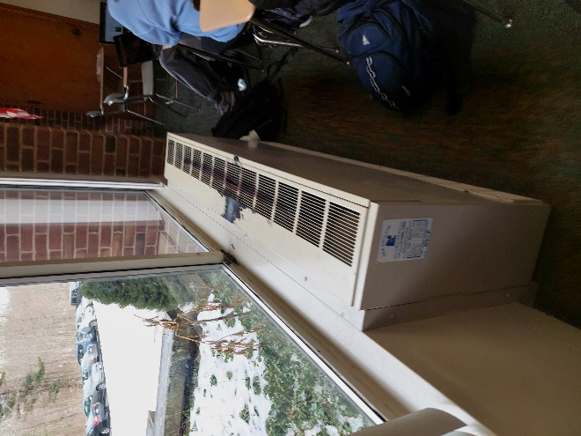

**Unit ventilator (univent)**

**Picture 2**

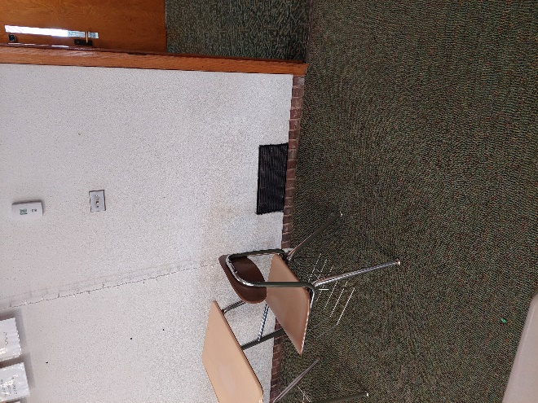

**Exhaust vent**

**Picture 3**

**Exhaust vent in cabinet, possibly drawing air 
and water vapor from foundation when cabinet door is closed
**

**Exhaust vent in cabinet, possibly drawing air**

**and water vapor from foundation when cabinet door is closed**

**Picture 4**

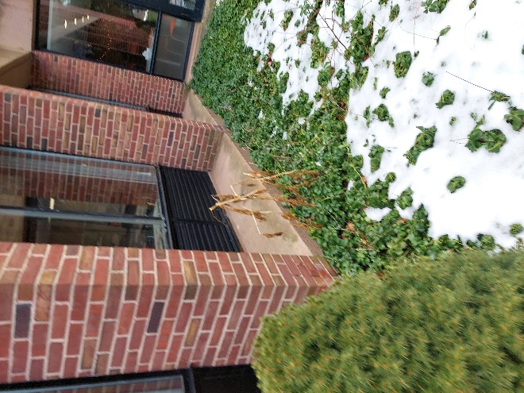

**Cement ledges of the exterior wall, note plants in contact with cement ledges**

**Picture 5**

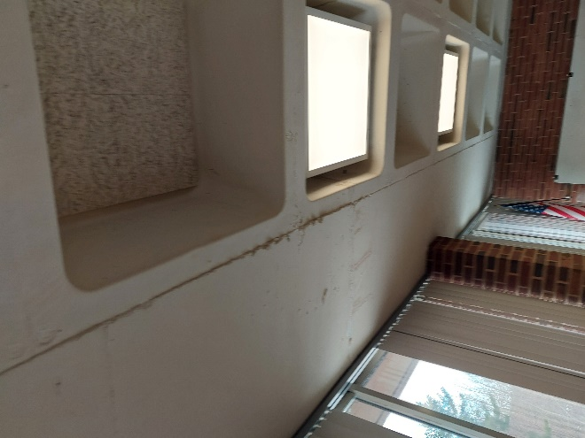

**Waffle ceiling**

**Picture 6**

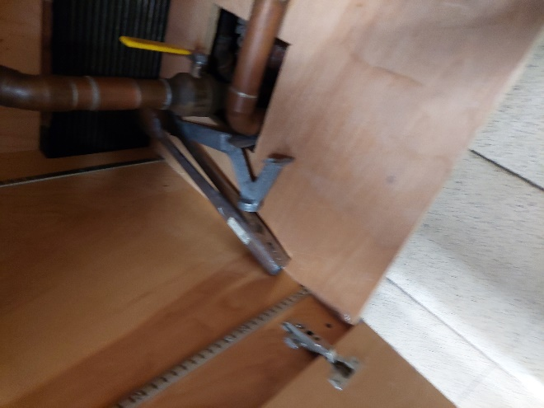

**Opening into floor in B4**

**Picture 7**

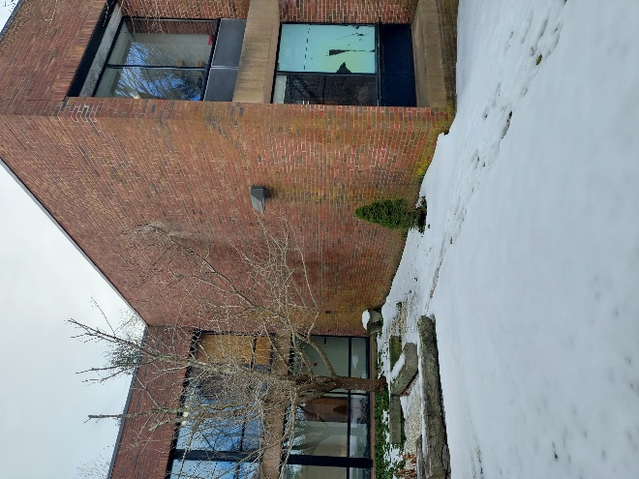

**Tree in courtyard on north side of building**

**Picture 8**



**Pine trees overhanging south side of building**

| Location | **Carbon**  **Dioxide**  **(ppm)** | **Carbon Monoxide**  **(ppm)** | **Temp**  **(°F)** | **Relative**  **Humidity**  **(%)** | **PM2.5**  **(µg/m3)** | **Occupants**  **in Room** | **Windows**  **Openable** | **Ventilation** | | **Remarks** |
| --- | --- | --- | --- | --- | --- | --- | --- | --- | --- | --- |
| **Supply** | **Exhaust** |
| Background (outside) | 358 | 4 | 41 | 76 | 13 |  |  |  |  |  |
| Lobby | 700 | 3 | 66 | 40 | 3 | 3 | Y | Y | Y |  |
| B5 | 919 | 4 | 68 | 68 | 1 | 12 | Y | Y | Y | Fresh air supply off |
| B7 | 1897 | 4 | 67 | 46 | 1 | 20 | Y | Y | Y | Fresh air supply off |
| B9 | 1332 | 4 | 67 | 41 | 3 | 1 | Y | Y | Y | Fresh air supply off |
| B8 | 868 | 4 | 67 | 40 | 2 | 1 | Y | Y | Y | Fresh air supply off |
| B6 | 2216 | 4 | 67 | 50 | 2 | 21 | Y | Y | Y | Fresh air supply off |
| B2 | 738 | 4 | 72 | 34 | ND | 21 | N | Y | Y |  |
| B3 | 812 | 4 | 71 | 36 | 2 | 18 | N | N | Y | Carpeted, clutter |
| B4 | 854 | 3 | 71 | 36 | 2 | 19 | Y | Y | Y | Exhaust inside cabinet. cabinet wood water-damaged, pipe into foundation serves as possible moisture source, exhaust draws from pipe access hole |
| B1 | 1262 | 2 | 72 | 41 | 1 | 18 | Y | N | Y | Exhaust vent in former dark room for wet film development |
| Auditorium | 825 | 2 | 71 | 34 | 1 | 20 | N | Y | Y |  |

1. The service life is the median time during which a particular system or component of … [an HVAC] … system remains in its original service application and then is replaced. Replacement may occur for any reason, including, but not limited to, failure, general obsolescence, reduced reliability, excessive maintenance cost, and changed system requirements due to such influences as building characteristics or energy prices (ASHRAE, 1991).