Background

INDOOR AIR QUALITY
ASSESSMENT

Leicester Middle School
70 Winslow Avenue
Leicester, Massachusetts

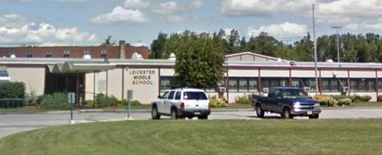

Prepared by:
Massachusetts Department of Public Health
Bureau of Environmental Health
Indoor Air Quality Program
October 2021
Building: | Leicester Middle School (LMS)
Address: | 70 Winslow Avenue, Leicester, MA
Assessment Requested by: | Marilyn Tencza, Ed. D., Superintendent, Leicester Public Schools
Date of Assessment: | July 9, 2021
Massachusetts Department of Public Health/Bureau of Environmental Health (MDPH/BEH) Staff Conducting Assessment: | Michael Feeney, Director, Indoor Air Quality (IAQ) Program
Date of Building Construction/Renovation: | Constructed in 1961, with addition in 1978, and renovation in 1995
Building Description: | The LMS is a one-story steel beam and cinder block building constructed around a central courtyard. The building contains general classrooms, science classrooms, an auditorium, gymnasium, cafeteria, kitchen, library, computer room, art room, teachers’ room, music room, office space and technology room.
Windows: | Openable

METHODS
MDPH IAQ staff conducted a series of visual assessments, temperature, and relative humidity measurements to identify likely areas that could be prone to condensation in hot, humid weather. Please refer to the IAQ Manual for methods, sampling procedures, and interpretation of results (MDPH, 2015).

RESULTS AND DISCUSSION
The following is a summary of testing results (Table 1):
- Temperature was within or close to the lower end of the MDPH recommended range of 70°F to 78°F in areas tested. It is important to note that although the LMS is not an air-conditioned building, most areas are equipped with window-mounted units for comfort control.
- Relative Humidity was above the MDPH recommended range of 40 to 60% in all areas on the day of assessment due to outside weather conditions.

Ventilation
A heating, ventilating and air conditioning (HVAC) system has several functions. First it provides heating and, if equipped, cooling. Second, it is a source of fresh air. Finally, an HVAC system will dilute and remove normally occurring indoor environmental pollutants by not only introducing fresh air, but by filtering the airstream and ejecting stale air to the outdoors via exhaust ventilation. Even if an HVAC system is operating as designed, point sources of respiratory irritation may exist and cause symptoms in sensitive individuals.
Fresh air in the majority of classrooms is supplied by unit ventilators (univents) installed when the LMS was constructed as a high school in 1961. Univents draw air from the outdoors through a fresh air intake located on the exterior wall of the building and return air through an air intake located at the base of the unit. Fresh and return air are mixed, filtered, heated, or cooled and provided to rooms through an air diffuser located in the top of the unit (Figure 1).
Mechanical exhaust ventilation in classrooms is provided by wall-mounted exhaust vents connected to rooftop motors. The MDPH IAQ Program recommends that supply and exhaust ventilation operate continuously during occupied periods to provide air exchange and filtration. Without sufficient supply and exhaust ventilation, normally occurring environmental pollutants can build-up and lead to indoor air quality/comfort complaints.
It is also important to note that despite ongoing maintenance and replacement of parts/components by Leicester Public Schools facilities staff, many of the HVAC units are at the end of their life cycle. Efficient function of equipment of this age (> 60 years old) is difficult to maintain, since compatible replacement parts are often unavailable. According to the American Society of Heating, Refrigeration, and Air-Conditioning Engineering (ASHRAE), the service life of this type of unit is 15-20 years, assuming routine maintenance of the equipment (ASHRAE, 1991). It was reported that currently two univents were on a repair list.
To maximize air exchange, the IAQ program recommends that both supply and exhaust ventilation operate continuously during periods of occupancy. To have proper ventilation with a mechanical ventilation system, the systems must be balanced after installation to provide an adequate amount of fresh air to the interior of a room while removing stale air from the room. It is recommended that HVAC systems be re-balanced every five years to ensure adequate air systems function (SMACNA, 1994). Based on the age and condition of the univents. Re-balancing of the HVAC system may not be possible.
Univent cabinets exhibit signs of long-term exposure to moisture. Both univent interior and exteriors have rust (Pictures 1 and 2, Table 1). A number of univents have the original fresh air supply vent louvers replaced with a steel fitting (Picture 3), which alters the amount of air expelled from its original design. IAQ staff believes the louvers in these univents had broken due to extreme corrosion from water vapor intake via the fresh air supply located on the exterior wall (Picture 4).

Microbial/Moisture Concerns
The LMS has experienced water damage from the following sources:
- Condensation on classroom floors during hot, humid weather
- Poor drainage of ground along the exterior walls
- Poor drainage in the courtyard
- Failure of the exterior wall/slab
- Failure of exterior wall fenestration
- Leaks from radiator valves
- Dry drain traps

Building Materials Prone to Condensation

It is important to note that Massachusetts has experienced extended periods of relative humidity during the summer of 2021. This July was the wettest ever recorded in Massachusetts, and the three-month period from June through August, known as the meteorological summer, was the fourth wettest on record, according to the National Oceanic and Atmospheric Administration’s Centers for Environmental Information. The three-month period also was the third warmest ever in the state and was tied for the warmest on record across the United States. (HG, 2021, NOAA, 2021).

The LMS was assessed to determine if floors (cement on soil) were subject to developing condensation during extended (> 24 hours) hot, humid weather. The key to managing condensation in hot, humid weather indoors is understanding dew point. When warm, moist air passes over a cooler surface, condensation can form. Condensation is the collection of moisture on a surface at or below the dew point. The dew point is the temperature that air must reach for saturation to occur. If a building material/component has a temperature below the dew point, condensation will accumulate on that material. Over time, condensation can collect and form water droplets. Floor tiles show signs of chronic condensation exposure (Picture 5).

A method to locate areas in a building prone to condensation is to measure air and building material temperatures using a laser thermometer (Table 1). If a wide temperature range exists between measurements (>5°F), the building materials at the colder end of the range may be prone to becoming moistened with condensation if exposed to hot, humid weather for extended periods of time. According to the test results in Table 1, all floors in the building would appear to be prone to condensation under high-humidity conditions.

According to American Society of Heating, Refrigerating and Air-Conditioning Engineers (ASHRAE), if relative humidity exceeds 70%, mold growth may occur due to wetting of building materials even in the absence of liquid water (ASHRAE, 1989). Relative humidity measured in the building was near or exceeded 70% in all but one location during this assessment (Table 1). In these condition, porous materials such as gypsum wallboard, cardboard and other materials may develop mold colonization. It is recommended that porous material be dried with fans and heating within 24 to 48 hours of becoming wet (US EPA, 2008, ACGIH, 1989). If porous materials are not dried within this time frame, mold growth may occur. If porous materials are not dried within this time frame, they should be removed and discarded. Water-damaged porous materials cannot be adequately cleaned to remove mold growth

Poor drainage of ground along the exterior walls
The LMS was visited during a rainstorm that resulted in flash flood warnings. Water was seen pooled against the building slab around the exterior wall. Over time, rainwater runoff from the exterior wall can compress soil to produce a furrow-like depression of ground adjacent to the building slab (Picture 6), which can, in turn, result in water puddling. This condition can result in univents drawing of water vapor from these pools, which can corrode the univent cabinet, wet filters to cause mold growth, and increase relative humidity inside the building, particularly if exhaust ventilation is not working as designed. The building was originally designed to have exterior doors, with a cement slab to serve as a step. These doors were removed, but the cement steps were left. Over time with exposure to various weather conditions, the cement steps have sunk into the ground as the soil was compressed. As the step sank, the soil around these objects now gathers pooling water, which in turn, increases the amount of pooling water along the exterior wall.

Poor drainage in the courtyard
The LMS was originally constructed in a U-shape footprint on sloped land. The rear of the building is located at a higher level than the front of the building (Picture 7). The construction of an addition enclosing the courtyard forms a partially cement-surfaced pitched ground with its terminus as the exterior wall of the library at the bottom of the slope. Due to weather conditions, topography, design, and other conditions, an environment exists for water pooling and damage to exterior walls and floor slab:
- Due to the slope, water pools directly against the library wall (Picture 8). The sill above the pooled water is covered with carpeting. If water seeps through the exterior wall/slab junction, this carpeting can become water-damaged and result in mold growth.
- One drain of the courtyard appeared to be dammed up using bricks to prevent rainwater removal from the courtyard (Picture 9).
- A metal plate exists in the courtyard which covers a sink hole (Picture 10), as reported by LMS staff.
- Cement slabs have subsided or have been lifted/damaged by plant roots, resulting in poor damage flow, and creating soil depressions that can result in pooling water.
- Univent fresh air intakes are only about 4 inches above ground level and possible pooling rainwater (Picture 4).

Leakage through the exterior wall/slab/lack of wall flashing

The LMS has an exterior wall-cladding system that consists of thousands of individual-glued/cemented into place 1” x 2” ceramic tiles (Picture 11). The tile wall system appears to be missing in a number of places where the exterior wall and foundation meet (Picture 12). In addition, no flashing could be observed beneath the tile/slab junction, unlike the newer constructed rear section of the building (Picture 13). Without flashing or a continuous exterior wall system, rainwater and water vapor likely readily enters the building interior through the wall/slab joint. In some locations, the exterior wall/slab junction appears below ground/buried beneath mulch. The wall and slab junction should not be buried.

Leakage though the exterior wall fenestration

During this assessment, clear water was noted on windowsill (Picture 14) and floor, which likely indicates water penetration through the exterior fenestration (windows and doors). As previously noted, the original wall fenestration was altered during renovation by removal of exterior classroom doors. Given the heavy rain of the day of the assessment and lack of water-stained ceiling tiles/observable leaks, the most likely source of this water would be leaks through fenestration under wind-driven rain condition.

Leaks from radiator valves

Some classrooms have a wood covering over heating pipes (Picture 15). Water staining was noted beneath radiator valves, which may leak and moisten building materials. The wood coverings may also be exposed to moisture due to water penetration through the exterior wall/slab junction. If repeatedly moistened, wood may become colonized by mold.

Dry drain traps

The LMS has a large, currently unused, locker room and showering facility with a large number of floor drains. The chemistry lab area also contains a number of sink drains, both abandoned and in use. It is highly likely that each of these drains have a dry trap, which can result in significant backflow of water vapor into the building from the sewer system, particularly during times of heavy rains. The purpose of a drain trap is to prevent sewer gasses from entering the building by having water fill the U-bend beneath the drain. Such an airtight seal also prevents water vapor from readily entering into the building. All drains should be wet with water at least once a week or if not used, sealed.

Other Conditions
Note that the Environmental Protection Agency (EPA) conducted a National School Radon Survey in which it discovered nearly one in five schools had “…at least one frequently occupied ground contact room with short-term radon levels above 4 [picocuries per liter] pCi/L” (US EPA, 1993). The BEH/IAQ Program therefore recommends that every school be tested for radon, and that this testing be conducted during the heating season while school is in session in a manner consistent with USEPA radon testing guidelines. Radon measurement specialists and other information can be found at www.nrsb.org and http://aarst-nrpp.com/wp, with additional information at: http://www.mass.gov/eohhs/gov/departments/dph/programs/environmental-health/exposure-topics/iaq/radon.

RECOMMENDATIONS
The LMS has a number of issues related to moisture in the building in addition to HVAC system issues denoted in previous IAQ assessments that are included as Appendix A and Appendix B of this report. The capacity of mechanical ventilation equipment to provide adequate fresh air and exhaust to classrooms is limited, as evidenced by previous indoor air testing (i.e., carbon dioxide levels above 800 ppm). Since the previous visit, the LMS has experienced significant water exposure.
One issue that is a significant problem given the extreme relative humidity and rain of this summer, management of building in such weather without air condition can be challenging. The following documents can provide guidance that can be used to reduce the impact of hot, humid weather in buildings.

- Preventing mold growth in Massachusetts schools during hot, humid weather: https://www.mass.gov/service-details/preventing-mold-growth-in-massachusetts-schools-during-hot-humid-weather
- Remediation and prevention of mold growth and water damage in public schools and buildings to maintain air quality: https://www.mass.gov/service-details/remediation-and-prevention-of-mold-growth-and-water-damage-in-public-schools-and
- Methods for Increasing Comfort in Non-Air-Conditioned Schools: https://www.mass.gov/doc/methods-for-increasing-comfort-in-non-air-conditioned-schools/download

To remedy building problems, two sets of recommendations are made: short-term measures that may be implemented as soon as practicable and long-term measures that will require planning and resources to address overall IAQ concerns. This building was previously visited in February 1999 and November 1999 and reports with recommendations were written in March 1999 and 2000, respectively, included as Appendices A and B.

In view of the findings at the time of the visit, the following recommendations are provided:

Short Term Recommendations

Implement recommendations made in previous reports.

Ensure that all plumbing drains are wetted at least once a week or permanent sealed if not to be used. Temporarily sealing shower drains with an appropriate material should be considered if used in the future.
- Consider removing all former cement slab steps from the building exterior walls.
- Remove all accumulated equipment, debris and other materials along the building exterior wall that is compressing soil to lead to rainwater pooling.
- Remove all soil and mulch that has buried the exterior wall/slab joint from the entire exterior wall system.
- Remove all water-damaged wood coverings in classrooms and replace with appropriate material.
- Examine the feasibility preventing rainwater pooling along the exterior walls by regrading soil. In general, a water-resistant material in a configuration of 1 foot in height and 5’ in length is recommended to increase drainage of rainwater.
- Remove carpeting from the library windowsill. Also consider removing carpet at least 3 feet from the library exterior wall to prevent mold growth.
- Consider removing all plants in the interior courtyard to reduce water accumulation.
- Un-dam the drain in the courtyard.
- Examine whether cement blocks in the courtyard can be repaired and repositioned to aid water drainage.
- The U.S. Department of Education has released new guidance encouraging the use of American Rescue Plan (ARP) funds to improve ventilation systems and make other indoor air quality improvements in schools. More information can be found at this link https://www.ed.gov/coronavirus/improving-ventilation. The school should be tested for radon by a certified radon measurement specialist during the heating season when school is in session. Radon measurement specialists and other information can be found at: www.nrsb.org, and http://aarst-nrpp.com/wp.
- To learn more about radon, review the MDPH’s Radon in Schools and Child Care Programs factsheet, with additional information at: http://www.mass.gov/eohhs/gov/departments/dph/programs/environmental-health/exposure-topics/iaq/radon.
- Consider forming an IAQ committee in each school building district-wide. Committees should have an IAQ liaison/teacher representative, a member of maintenance/facilities and administration that conduct regular walk-throughs to identify on-going and/or potential environmental issues.
- Consider adopting the US EPA (2000) document, “Tools for Schools”, as an instrument for maintaining a good IAQ environment in the building available at: https://www.epa.gov/iaq-schools/indoor-air-quality-tools-schools-action-kit

Long Term Recommendations
Contact a building engineering firm for advice regarding the following conditions noted at the LMS:
- Examine the sinkhole in the courtyard to determine its short- and long-term impact on the building’s structure. Examine best practice to repair the sinkhole, if feasible.
- Examine whether exterior wall/slab junction can be repaired to render watertight.
- Repair or replace the exterior wall cladding.
- Improve drainage through installation of a drain system or further regrading of ground around the LMS.
- Repair or replace the exterior fenestration system.
- Conduct a building-wide ventilation systems assessment. Based on historical issues with air exchange/indoor air quality complaints, age, physical deterioration, and availability of parts for ventilation components, such an evaluation is necessary to determine the operability and feasibility of replacing the equipment.

REFERENCES
ACGIH. 1989. Guidelines for the Assessment of Bioaerosols in the Indoor Environment. American Conference of Governmental Industrial Hygienists, Cincinnati, OH.
ASHRAE. 1989. Ventilation for Acceptable Indoor Air Quality. American Society of Heating, Refrigeration and Air Conditioning Engineers. ANSI/ASHRAE 62-1989.
ASHRAE. 1991. ASHRAE Applications Handbook, Chapter 33 “Owning and Operating Costs”. American Society of Heating, Refrigeration and Air Conditioning Engineers, Atlanta, GA.
HG. 2021. Mold Keeps South Hadley High School Shuttered. Hampshire Gazette. https://www.gazettenet.com/South-Hadley-High-School-still-closed-amid-mold-remediation-42413519
MDPH. 2015. Massachusetts Department of Public Health. Indoor Air Quality Manual: Chapters I-III. Available at: https://www.mass.gov/lists/indoor-air-quality-manual-and-appendices#indoor-air-quality-manual-.
NOAA. 2021. Summer 2021 Neck and Neck with Dust Bowl Summer for Hottest on Record. National Oceanic and Atmospheric Administration, 1401 Constitution Avenue NW, Room 5128, Washington, DC 20230 https://www.noaa.gov/news/summer-2021-neck-and-neck-with-dust-bowl-summer-for-hottest-on-record
SMACNA. 1994. HVAC Systems Commissioning Manual. 1st ed. Sheet Metal and Air Conditioning Contractors’ National Association, Inc., Chantilly, VA.
US EPA. 1993. Radon Measurement in Schools, Revised Edition. Office of Air and Radiation, Office of Radiation and Indoor Air, Indoor Environments Division (6609J). EPA 402-R-92-014. https://archive.epa.gov/epa/iaq-schools/radon-measurement-schools-revised-edition.html.
US EPA. 2000. Tools for Schools. Office of Air and Radiation, Office of Radiation and Indoor Air, Indoor Environments Division (6609J). EPA 402-K-95-001, Second Edition. http://www.epa.gov/iaq/schools/index.html.
US EPA. 2008. “Mold Remediation in Schools and Commercial Buildings”. Office of Air and Radiation, Indoor Environments Division, Washington, DC. EPA 402-K-01-001. September 2008. Available at: http://www.epa.gov/mold/mold-remediation-schools-and-commercial-buildings-guide
Figure 1

Unit Ventilator (Univent)

Mixed Air

Air Diffuser

Outdoors Indoors

Fan

Heating/Cooling Coil

Air Mixing Plenum

Filter

Outdoor Return
Air Air

Air
Flow
Control
Louvers

Air Flow

= Fresh Air/Return Air

= Mixed Air

Picture 1

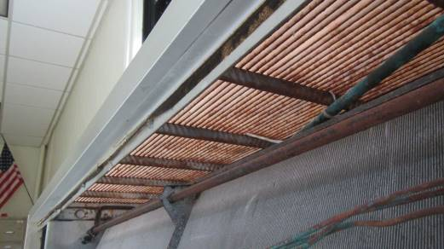

Univent corrosion, interior

Picture 2

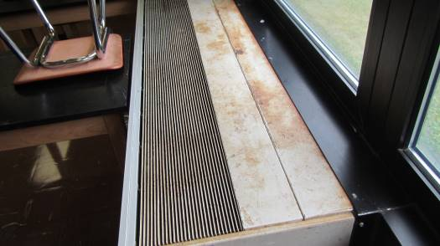

Univent corrosion, exterior

Picture 3

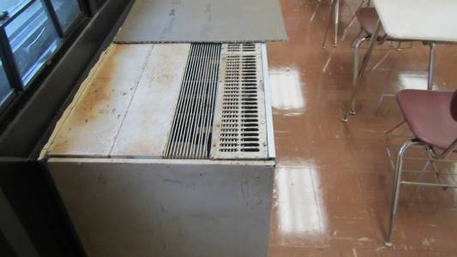

Steel grate over univent

Picture 4

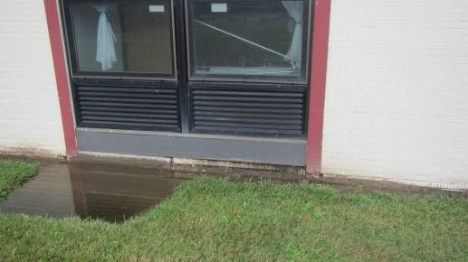

Univent fresh air intake, note pooling water

Picture 5

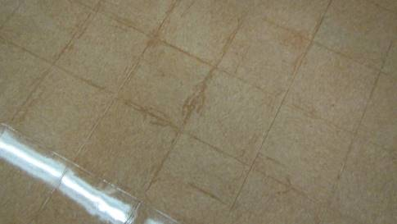

Staining of floor tile edges can be a sign of repeated
condensation exposure

Picture 6

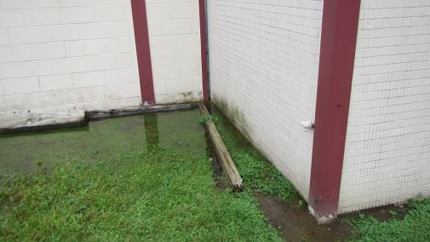

Furrow-like depression of exposed dirt adjacent to the building
slab, note pooled water

Picture 7

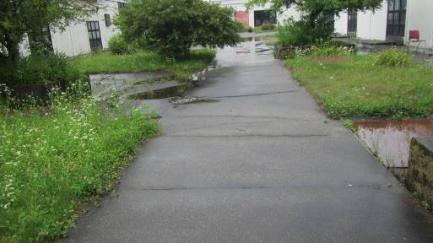

The rear of the building is located at a higher level than
the front of the building

Picture 8

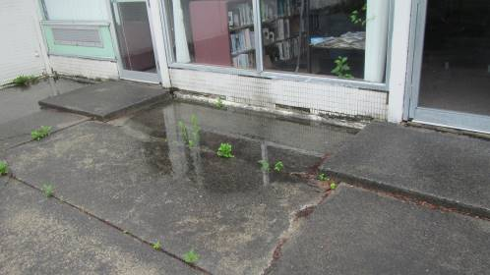

Water pooling against library exterior courtyard wall

Picture 9

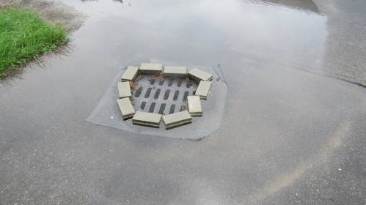

Brick dammed drain in courtyard

Picture 10

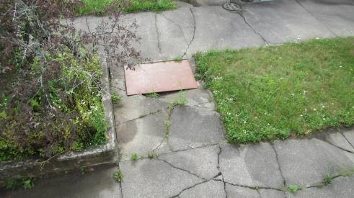

Metal plate covering sink hole

Picture 11

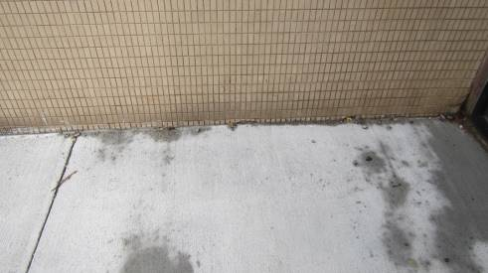

Exterior wall covering consisting of 1” x 2” ceramic tiles

Picture 12

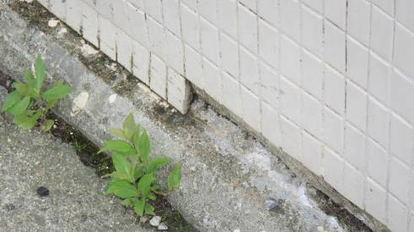

Damage at the exterior wall/slab junction; note no flashing
at this joint

Picture 13

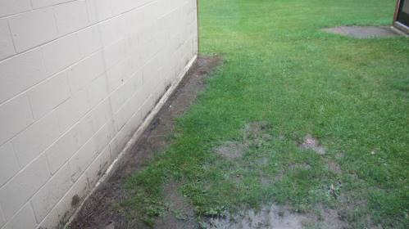

Example of flashing on other exterior walls of LMS

Picture 14

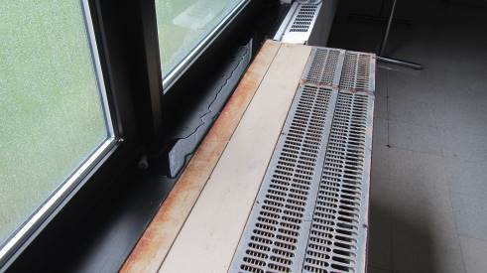

Rainwater on windowsill

Picture 15

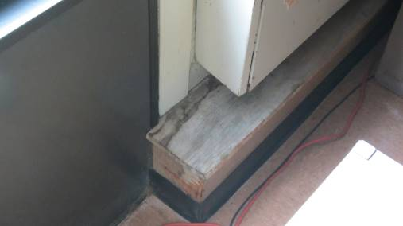

Water-damaged wood beneath radiator valves

Location | Air Temp  (ºF) | Relative Humidity  (%) | Dew Point  (ºF) | Floor Temp  (ºF) | Water-damaged Wood pipe coverings | Water-damaged  Univent louvers cabinets | Ventilation |  |  | Floor to Air Temp  Difference  (ºF) | Comments
 |  |  |  |  |  |  | Windows openable | Supply | Exhaust
Background (outdoors) | 68 | 88 | 64 |  |  |  |  |  |  |  | Weather- post rainstorm with flash flood warnings
Storage | 70 | 72 | 61 | 61 | Y | N | Y | Y | N | -9 | Temperature of gypsum wallboard in contact with floor = 61℉
Cafeteria | 71 | 77 | 64 | 64 | N | N | Y | Y | Y | -7
Band | 72 | 72 | 63 | 67 | Y | N | N | Y | Y | -5
Auditorium | 73 | 70 | 62 | 68 | N | N | N | Y | Y | -5
Gym | 73 | 65 | 61 | 66 | N | N | Y | Y | Y | -7
Nurse’s office | 71 | 76 | 63 | 63 | N |  | Y | N | Y | -8 | Window-mounted air-conditioner  Water-damaged window frame
Library | 72 | 73 | 62 | 62 | Y |  | Y | Y | Y | -10 | Wall-to wall carpeting  Pooling outdoor water against carpeted courtyard windowsill
2 | 71 | 73 | 62 | 63 | Y | Y rust | Y | Y | Y | -8
4 | 71 | 71 | 61 | 63 | Y | Y louvers | Y | Y | Y | -8
5 | 71 | 70 | 61 | 62 | Y | N | Y | Y | Y | -9
6 | 71 | 70 | 61 | 62 | Y | N | Y | Y | Y | -9
7 | 71 | 73 | 62 | 62 | N | Y louvers | Y | Y | Y | -9
8 | 71 | 72 | 62 | 62 | N | Y rust | Y | Y | Y | -9
9 | 71 | 71 | 61 | 62 | Y | Y louvers &  Rust | Y | Y | Y | -9
10 | 71 | 73 | 62 | 62 | N | Y louvers &  Rust | Y | Y | Y | -9
11 | 71 | 73 | 62 | 62 | Y |  | Y | Y | Y | -9
12 | 71 | 74 | 62 | 61 | N | Y rust | Y | Y | Y | -10
13 | 70 | 74 | 62 | 61 | N | Y rust | Y | Y | Y | -9
14 | 70 | 75 | 62 | 60 | N | Y rust | Y | Y | Y | -10
15 | 69 | 71 | 62 | 61 | N | Y louvers & rust | Y | Y | Y | -8
16 | 70 | 74 | 61 | 62 | N |  | Y | Y | N | -8 | Window-mounted air conditioner
18 | 70 | 72 | 61 | 63 | N | N | Y | Y | N | -7 | Temperature of gypsum wallboard in contact with floor = 62℉
19 | 71 | 73 | 62 | 62 | Y | Y louvers | Y | Y | Y | -9
20 | 71 | 73 | 62 | 62 | N |  | Y | Y | Y | -9
21 | 71 | 74 | 62 | 62 | Y | Y louvers | Y | Y | Y | -9
23 | 71 | 75 | 63 | 63 | Y | Y louvers | Y | Y | Y | -8
24 | 71 | 71 | 62 | 64 | Y | Y louvers | Y | Y | Y | -7
25 | 71 | 71 | 61 | 61 | N |  | Y | Y | Y | -10 | Crawlspace hatch near univent return air vent
26 | 71 | 71 | 61 | 63 | N |  | Y | Y | Y | -8
27 | 71 | 71 | 61 | 61 | N | Y louvers & rust | Y | Y | Y | -10
28 | 71 | 72 | 62 | 62 | Y |  | Y | Y | Y | -9
29 | 71 | 71 | 62 | 61 | N |  |  | Y | Y | -10
30 | 71 | 72 | 62 | 63 | N | Y louvers | Y | Y | Y | -8
31 | 71 | 72 | 62 | 63 | N |  | Y | Y | Y | -8
32 | 73 | 72 | 63 | 64 | N | Y louvers | y | y | Y | -9
33 | 72 | 69 | 65 | 65 | N | Y louvers | Y | Y | Y | -7
34 | 73 | 69 | 62 | 68 | N |  | Y | Y | Y | -5
36 | 73 | 69 | 62 | 64 | N | Y louvers | Y | Y | Y | -9
38 | 73 | 69 | 62 | 65 | Y | N | Y | Y | Y | -8

INDOOR AIR QUALITY ASSESSMENT

Leicester Middle School
Leicester, Massachusetts

Prepared by:
Massachusetts Department of Public Health
Bureau of Environmental Health Assessment
March 1999

Background/Introduction

At the request of the Leicester Board of Health, an indoor quality assessment was conducted at the Leicester Middle School in Leicester, Massachusetts. This assessment was conducted by the Massachusetts Department of Public Health (MDPH), Bureau of Environmental Health Assessment (BEHA).
On February 10, 1999, a visit was made to this school by Cory Holmes, an Environmental Analyst, in BEHA’s Emergency Response/ Indoor Air Quality Program. Mr. Holmes was accompanied by Carl Wickland, Facilities Manager.
The school is a one-story steel beam and cinder block building built in 1961. Seven classrooms were added in 1978 and bathrooms were renovated in 1995. The school is constructed around a central courtyard and contains general classrooms, science classrooms, an auditorium, gymnasium, cafeteria, kitchen, library, computer room, art room, teacher’s room, music room, office space and, located in the former woodshop, is the technology room.

Methods
Air tests for carbon dioxide were taken with the Telaire, Carbon Dioxide Monitor and tests for temperature and relative humidity were taken with the Mannix, TH Pen PTH8708 Thermo-Hygrometer.

Results
This school houses grades 6 through 8 with a student population of 482 and a staff of approximately 50. The tests were taken during normal operations at the school. Test results appear in Tables 1-4.

Discussion
Ventilation
It can be seen from the tables that carbon dioxide levels were elevated above 800 ppm in twenty-three out of thirty-eight areas surveyed, indicating a ventilation problem in these areas of the school.
Fresh air in classrooms is supplied by a unit ventilator (univent) system. These univents were functioning in the majority of classrooms surveyed. In classroom 14 the univent was off due to a malfunctioning motor. The univent in classroom 21 was operating, however, very little air movement was noted from the diffuser. Both units were repaired by maintenance staff and restored to working order during the assessment. Obstructions to airflow, such as objects stored on univents were also seen in a number of classrooms. In order for univents to provide fresh air as designed, fresh air vents must remain free of obstructions.
Mechanical exhaust vents for the 1961 addition are located on the outside of closets. The mechanical exhaust ventilation system in the 1978 addition consists of ceiling mounted exhaust vents. The 1961 system appeared to be off in the majority of classrooms; therefore, no mechanical exhaust was being provided. BEHA staff and Mr. Wickland determined that the fan belts that drive the motors were broken.
Also noted in several classrooms were exhaust vents found obstructed by boxes, crates and in classroom six, an open door. The exhaust vent for classroom six is located on the wall behind the hallway door. When this door is shut, the vent is clear. In an effort to improve airflow, some individuals will leave the hallway door open. However, when the door is open, the exhaust vent is blocked, therefore interfering with the proper function of the system. Ceiling mounted exhaust vents in the seven new classrooms are located approximately three feet above storage cabinets. Items were seen stored on top of these cabinets in many classrooms, blocking these vents. Care should be taken to avoid the blockage of these vents by items stored on top of these cabinets.
In order to have proper ventilation with a univent and exhaust system, the systems must be balanced to provide an adequate amount of fresh air to the interior of a room while removing stale air. Information regarding the date of the last servicing and balancing of these systems was not available at the time of the assessment.
The Massachusetts Building Code requires a minimum ventilation rate of 15 cubic feet per minute (cfm) per occupant of fresh outside air or have openable windows in each room. The ventilation must be on at all times that the room is occupied. Providing adequate fresh air ventilation with open windows and maintaining the temperature in the comfort range during the cold weather season is impractical. Mechanical ventilation is usually required to provide adequate fresh air ventilation.
Carbon dioxide is not a problem in and of itself. It is used as an indicator of the adequacy of the fresh air ventilation. As carbon dioxide levels rise, it indicates that the ventilating system is malfunctioning, or the design occupancy of the room is being exceeded. When this happens a buildup of common indoor air pollutants can occur, leading to discomfort or health complaints. The Occupational Safety and Health Administration (OSHA) standard for carbon dioxide is 5,000 parts per million parts of air (ppm). Workers may be exposed to this level for 40 hours/week.
The Department of Public Health uses a guideline of 800 ppm for publicly occupied buildings. A guideline of 600 ppm or less is preferred in schools due to the fact that the majority of occupants are young and considered to be a more sensitive population in the evaluation of environmental health status. Inadequate ventilation and/or elevated temperatures are major causes of complaints such as respiratory, eye, nose and throat irritation, lethargy, and headaches.

Temperature and Relative Humidity
Temperature readings were within a range of 68º F to 79 º F. The BEHA recommends that indoor air temperatures be maintained in a range between 70 º F to
78 º F in order to provide for the comfort of building occupants. In many cases concerning indoor air quality, fluctuations of temperature in occupied spaces are typically experienced, even in a building with an adequate fresh air supply.
The relative humidity in this building was below the BEHA recommended comfort range in the majority of areas sampled. Relative humidity measurements ranged from 11 percent to 20 percent. The BEHA recommends that indoor air relative humidity is comfortable in a range of 40-60 percent. The sensation of dryness and irritation is common in a low relative humidity environment. Low relative humidity is a very common problem during the heating season in the northeast part of the United States.

Microbial/Moisture Concerns
Several classrooms had a number of plants. Moistened plant soil and drip pans can be a source of mold growth. Plants are also a source of pollen. Plants should be located away from the air stream of ventilation sources to prevent the aerosolization of mold, pollen, or particulate matter throughout the classroom.

Other Concerns
Several conditions that can potentially affect indoor air quality were also identified. Cleaning products were found in several classrooms. Cleaning products contain chemicals, which can be irritating to the eyes, nose, and throat. These items should be stored properly and out of reach of children.
Utility holes in ceilings and walls were noted in several classrooms. Holes in ceilings and walls can provide pathways for the movement of odors, fumes, dusts and vapors between rooms and floors.
The teacher’s workroom contains photocopiers and a lamination machine. Lamination machines can give off excess heat and odors. Ozone can be produced by photocopiers, particularly if the equipment is older and in frequent use. This room has no mechanical exhaust ventilation to help remove odors.
The gymnasium and faculty lounge contained pipes with damaged insulation, exposing a fiberglass material. Fiberglass can be an eye, skin, and respiratory irritant to certain individuals.
A fish-like odor was noted in science classroom ten. This room contained six aquariums. Also noted in this classroom was a wall mounted exhaust fan, which was deactivated. Aquariums should be properly maintained and be located away from univents to prevent the distribution of odors.
The mechanical exhaust vent, in the chemical storage room located in classroom ten was not operating. Exhaust ventilation should be activated and kept on at all times to prevent the infiltration of chemical odors into occupied areas.

Conclusions/Recommendations
In view of the findings at the time of the visit, the following recommendations are made:
- Examine each univent for function. Survey classrooms for univent function to ascertain if an adequate air supply exists for each room; an increase of fresh air intake may be necessary. Operate univents while classrooms are occupied.
- Have exhaust ventilation operate during occupancy. Inspect exhaust motors and belts for proper function, repair and replace as necessary.
- Remove all blockages from univents and exhaust vents.
- Once both the fresh air supply and the exhaust ventilation are functioning, the ventilation system should be balanced.
- Move plants away from univents in classrooms. Examine drip pans for mold growth and disinfect areas of water leaks with an appropriate antimicrobial where necessary. Remove extra potting soil from underneath sinks.
- Store cleaning products properly and out of reach of children.
- Repair or fill holes and cracks in ceilings and walls, to prevent the egress of odors, fumes, vapors, and particulate matter into classrooms.
- Consider installing local exhaust ventilation in the teacher’s workroom to help reduce lamination machine and photocopier odors. If not feasible, consider relocating odor-producing machinery to an area with local exhaust ventilation.
- Repair or replace insulation around pipe in the special needs room to prevent fiberglass exposure.
- Restore exhaust ventilation in the chemical storeroom to prevent the infiltration of chemical odors into occupied areas.
- Maintain aquariums properly and utilize wall-mounted exhaust fan to remove odors from classroom ten.

References
OSHA. 1997. Limits for Air Contaminants. Occupational Safety and Health Administration. Code of Federal Regulations. 29 C.F.R 1910.1000 Table Z-1-A.

SBBRS. 1997. Mechanical Ventilation. State Board of Building Regulations and Standards. Code of Massachusetts Regulations. 780 CMR 1209.0

TABLES

Indoor Air Test Results - Leicester Middle School, Leicester - February 10, 1999

Remarks | Carbon | Temp. | Relative | Occupants | Windows | Ventilation |  | Remarks
 | Dioxide  *ppm | °F | Humidity  % | in Room | Openable | Intake | Exhaust
Outside  (Background) | 396 | 46 | 33
Main Office | 738 | 73 | 17 | 2 | yes | yes |  | HVAC A/C, burning candle
Teacher’s Workroom | 607 | 76 | 15 | 0 | yes | no | no | photocopiers, risograph, lamination machine
Nurse’s Office | 712 | 78 | 19 | 2 | yes | no | yes | exhaust off, wall-mounted exhaust fan
Library | 499 | 76 | 11 | 2 | yes | yes | yes | exhaust off, photocopier, plants (3)
Room #20 | 1200 | 77 | 19 | 22 | yes | yes | yes | exhaust partially blocked, door open
Room #19 | 1523 | 77 | 19 | 25 | yes | yes | yes | window open
Room #21 | 1328 | 76 | 17 | 23 | yes | yes | yes | window and door open, univent operating - little air movement
Room #23 | 1150 | 77 | 14 | 21 | yes | yes | yes | door open
Room #25 | 944 | 77 | 15 | 3 | yes | yes | yes | exhaust off, door open
Room #24 | 794 | 75 | 13 | 1 | yes | yes | yes | occupants gone ~10 minutes, window open
Room #26 | 1014 | 75 | 16 | 24 | yes | yes | yes | exhaust off, book on univent
Room #27  (Computer Room ) | 1098 | 76 | 16 | 25 | yes | yes | yes | exhaust off, holes around pipes,  24 computers
Room #29 | 1385 | 77 | 17 | 25 | yes | yes | yes | exhaust off, holes around pipes, hole through wall
Room #28 | 1277 | 76 | 18 | 18 | yes | yes | yes | exhaust off, door open
Room #31 | 928 | 76 | 14 | 1 | yes | yes | yes | exhaust off, posters on univent,  (15) occupants gone ~25 minutes
Room #30 | 778 | 76 | 12 | 1 | yes | yes | yes | (23) occupants gone ~ 30 minutes, exhaust off, exterior door open, items on univent
Room #34 | 682 | 68 | 14 | 24 | no | yes | yes | exhaust off, books on univent, exterior door open, degreaser spray product
Art Room | 925 | 72 | 20 | 25 | no | yes | yes | exhaust blocked by file cabinets,  plants (10+)
Gym | 594 | 70 | 15 | 21 | no | yes | yes | damaged fiberglass insulation
Auditorium |  | 70 | 16 | 0 | no | yes | yes | exhaust off, ceiling supply
Cafeteria | 853 | 71 | 22 | 100+ | no | yes | yes | door open
Technology Room | 1041 | 74 | 18 | 22 | yes | yes | yes | supply and exhaust off, wall mounted fan exhaust, former wood shop
Faculty Lounge | 876 | 75 | 17 | 13 | yes | yes | yes | wall mounted exhaust, damaged fiberglass insulation, plaster damage on walls, recyclables (cans)
Room #14 | 922 | 74 | 17 | 21 | yes | yes | yes | supply and exhaust off, door open
Room #15 | 1360 | 79 | 18 | 23 | no | yes | yes | exhaust off, univent - heat
Room #13 | 1142 | 78 | 18 | 26 | no | yes | yes | exhaust off
Room #12 | 653 | 77 | 13 | 0 | yes | yes | yes | exhaust off
Room #10 | 1196 | 76 | 23 | 16 | yes | yes | yes | exhaust off, stuffed owl near univent, aquariums (6), plants
Chemical Storage Room |  |  |  |  |  | yes | yes | wall mounted exhaust fan - off, passive supply, buckets of formaldehyde
Room #11 | 985 | 76 | 17 | 24 | no | yes | yes | exhaust off, exterior door open
Room #9 | 1010 | 77 | 20 | 20 | no | yes | yes | exterior door open
Room #8 | 1040 | 74 | 18 | 20 | yes | yes | yes | exhaust off
Room #7 | 517 | 74 | 14 | 6 | no | yes | yes | exhaust off, door open
Room #5 | 551 | 75 | 13 | 21 | no | yes | yes | exhaust off, plant over univent, door open
Room #6 | 781 | 79 | 14 | 18 | yes | yes | yes | exhaust off, closet vent behind door
Room #4 | 768 | 76 | 14 | 23 | yes | yes | yes | exhaust off, door open
Room #2 | 736 | 75 | 15 | 14 | yes | yes | yes | exhaust off
Room #32 | 945 | 77 | 14 | 20 | no | yes | yes | exhaust off and blocked
Room #32b | 1268 | 78 | 17 | 9 | no | no | no | dry erase board`
Room #33 | 740 | 76 | 13 | 2 | yes | yes | yes | exhaust off, plant/papers on univent
* ppm = parts per million parts of air
Comfort Guidelines CT = water-damaged ceiling tiles
Carbon Dioxide - | < 600 ppm = preferred
 | 600 - 800 ppm = acceptable
 | > 800 ppm = indicative of ventilation problems
Temperature - | 70 - 78 °F
Relative Humidity - | 40 - 60%

INDOOR AIR QUALITY ASSESSMENT

Leicester Middle School
70 Winslow Avenue
Leicester, Massachusetts

Prepared by:
Massachusetts Department of Public Health
Bureau of Environmental Health Assessment
February 2000

Background/Introduction
At the request of Mr. Carl Wickland, Facilities Manager of the Leicester School Department, an indoor air quality assessment was conducted at the Leicester Middle School (the school) in Leicester, Massachusetts. This assessment was conducted by the Massachusetts Department of Public Health (MDPH), Bureau of Environmental Health Assessment (BEHA).
The school was originally visited by Cory Holmes, Environmental Analyst of BEHA’s Emergency Response/ Indoor Air Quality Program, on February10, 1999 to conduct an indoor air assessment and a report was issued (MDPH, 1999). The report showed that there were problems identified and gave recommendations on how to correct those problems. On November 4, 1999, the school was re-visited by Mr. Holmes to conduct a follow-up indoor air quality assessment. Mr. Holmes was accompanied during the evaluation by Archie Suprenant, Supervisor of Grounds Maintenance, Leicester School Department.
The school is a one-story, steel beam and cinder block building built in 1961. Seven classrooms were added in 1978 and bathrooms were renovated in 1995. The school is constructed around a central courtyard and contains general classrooms, science classrooms, an auditorium, gymnasium, cafeteria, kitchen, library, computer room, art room, teacher’s room, music room, and office space. The woodshop was converted into the technology classroom.
Actions on Previous Recommendations
BEHA had previously made 11 recommendations to improve indoor air quality at the Middle School, many of these recommendations had been implemented. Several school faculty and staff members reported to BEHA staff that they believe indoor air quality was improved compared to the previous school year. The following is an update on actions taken in response to BEHA recommendations, based on reports from the Leicester School Department and/or direct observation by BEHA personnel during this re-evaluation.
- A number of inactive univents noted during the previous visit were repaired. A number of other univents, found operating during the previous assessment, had broken down since the previous visit (see Tables). All broken univents are on a work list for repair by the Leicester School Department.
- School personnel were instructed to allow univents to operate during classroom occupation. Several classrooms had deactivated univents even though these units were operational.
- Rooftop exhaust ventilation motors that were inoperative and/or missing fan belts during the previous visit were restored to working order. Exhaust ventilation was operating during classroom occupation.
- Exhaust ventilation for the chemical storage areas had not been repaired.
- School personnel were instructed to remove all blockages from univents and exhaust vents. While univents throughout the school were free from obstructions, some exhaust vents were still blocked in a number of classrooms.
- School personnel were instructed to re-locate plants away from univents in classrooms. No plants were observed on univent fresh air diffusers.
- School personnel have been instructed to store cleaning products properly and out of the reach of students. No cleaning products were observed to be stored improperly.
- Insulation around pipe in the special needs area had been repaired.
- School personnel were instructed to properly maintain aquariums to prevent unpleasant odors and/or the growth of bacteria and mold. Aquariums were being maintained and no unpleasant odors were noted during the assessment.

Methods
In addition to evaluating the status of a number of remedial measures taken by the Leicester School Department, BEHA staff also conducted a series of follow up tests. Air tests for carbon dioxide were taken with the Telaire, Carbon Dioxide Monitor and tests for temperature and relative humidity were taken with a Mannix, TH Pen PTH 8708 Thermo-Hygrometer. Wind speed and direction were measured with a Davis, Wind Wizard, Wind Speed Indicator.

Results
This school houses grades 6 through 8 with a student population of 448 and a staff of approximately 50. The tests were taken during normal operations at the school. Test results appear in Tables 1-3.
Discussion
Ventilation
It can be seen from the tables that carbon dioxide levels were elevated above 800 ppm in eighteen of twenty-seven areas surveyed, indicating a ventilation problem in these areas of the school. It is important to note that in almost all areas where carbon dioxide levels were above 800 ppm, the ventilation systems were either off or obstructed.
Fresh air in classrooms is supplied by a unit ventilator (univent) system (see Figure 1). These univents were functioning in the majority of classrooms surveyed. Univents in classrooms that were not operating were in the process of being repaired or were on a repair list awaiting motors and/or other mechanical components. Several univents were found deactivated; these univents were re-activated by Mr. Suprenant during the assessment.
Mechanical ventilation in the art room is provided by an air-handling unit (AHU) located in an adjacent mechanical room. The system was deactivated by request of the occupant, therefore providing no mechanical ventilation. In addition, ventilation grilles were noted to be blocked by various items (see Picture 1). Mr. Suprenant re-activated the system during the assessment, which BEHA staff verified. The door to the mechanical room is equipped with louvers to provide fresh “make-up” air to the mechanical room. These louvers were blocked with sheet metal which prevents airflow, interfering with the proper function of the system (see Pictures 2 & 3). It is important that the system remains “on” and be allowed to operate un-obstructed to provide mechanical ventilation to the area.
Mechanical exhaust vents for the 1961 addition are located on the outside of closets. The mechanical exhaust ventilation system for the 1978 addition consists of ceiling mounted exhaust vents. Mechanical exhaust ventilation was operating in all classrooms surveyed, with the exception of room 25. Exhaust ventilation in room 25 is supplied by a ceiling-mounted exhaust vent. The fire damper to this vent was shut, which blocks the exhaust vent draw.
Exhaust ventilation for science classrooms 8 and 10 is provided by ceiling-mounted exhaust vents located in a chemical storeroom for each of the science classrooms (see Pictures 4 & 5). Passive grills are mounted on the wall adjacent to the drop ceiling to draw classroom air into the storerooms and out of the building through the exhaust vents (see Picture 6). These systems were not operating during the assessment. Cool air was noted backdrafting through these vents indicating that the system was off or that motors on the roof were inoperable. The assessment occurred on a cold day with moderate wind conditions (10-15 mph). The combination of the inactive ventilation system and wind would explain the occurrence of backdrafting noted on the day of the assessment.
Also noted in several classrooms were exhaust vents found obstructed by boxes, crates, and other items. Ceiling mounted exhaust vents in the seven new classrooms are located approximately three feet above storage cabinets. Items were seen stored on top of the cabinets in many classrooms, blocking the vents (see Picture 7). As noted in the previous report, care should be taken to avoid the blockage of these vents by items stored on top of cabinets. Exhaust ventilation in the cafeteria was drawing weakly.
In order to have proper ventilation with a univent and exhaust system, the systems must be balanced to provide an adequate amount of fresh air to the interior of a room while removing stale air. Information regarding the date of the last servicing and balancing of these systems was not available at the time of the assessment.
The Massachusetts Building Code requires a minimum ventilation rate of 15 cubic feet per minute (cfm) per occupant of fresh outside air or have openable windows in each room (SBBRS, 1997). The ventilation must be on at all times that the room is occupied. Providing adequate fresh air ventilation with open windows and maintaining the temperature in the comfort range during the cold weather season is impractical. Mechanical ventilation is usually required to provide adequate fresh air ventilation.
Carbon dioxide is not a problem in and of itself at levels measured in this building. It is used as an indicator of the adequacy of the fresh air ventilation. As carbon dioxide levels rise, it indicates that the ventilating system is malfunctioning, or the design occupancy of the room is being exceeded. When this occurs a buildup of common indoor air pollutants can occur, leading to discomfort or health complaints. The Occupational Safety and Health Administration (OSHA) standard for carbon dioxide is 5,000 parts per million parts of air (ppm). Workers may be exposed to this level for 40 hours/week, based on a time-weighted average (OSHA, 1997).
The Department of Public Health uses a guideline of 800 ppm for publicly occupied buildings. A guideline of 600 ppm or less is preferred in schools due to the fact that the majority of occupants are young and considered to be a more sensitive population in the evaluation of environmental health status. Inadequate ventilation and/or elevated temperatures are major causes of complaints such as respiratory, eye, nose and throat irritation, lethargy, and headaches.
Temperature readings were within a range of 66º F to 77 º F, which is slightly below the lower end of the BEHA recommended range. The BEHA recommends that indoor air temperatures be maintained in a range of 70 º F to 78 º F in order to provide for the comfort of building occupants. In many cases concerning indoor air quality, fluctuations of temperature in occupied spaces are typically experienced, even in a building with an adequate fresh air supply. Complaints of excessive heat were reported in classroom 24, which serves as the computer room. No additional ventilation or air conditioning has been installed in this classroom to help remove heat generated by the
30 + computers located in this area. In addition, the univent in this classroom was inoperable, therefore no fresh outside air was being provided, which can exacerbate heat build up.
The relative humidity in this building was below the BEHA recommended comfort range in the majority of areas sampled. Relative humidity measurements ranged from 11 to 20 percent. The BEHA recommends that indoor air relative humidity is comfortable in a range of 40-60 percent. The sensation of dryness and irritation is common in a low relative humidity environment. Low relative humidity is a very common problem during the heating season in the northeast part of the United States.

Microbial/Moisture Concerns
Several classrooms still had a number of plants. Moistened plant soil and drip pans can be a source of mold growth. Plants are also a source of pollen. Plants were re-located away from the air stream of univents and should remain as such, to prevent the aerosolization of mold, pollen, or particulate matter.
Along the perimeter of the building, shrubbery and flowering plants were noted in close proximity to a univent fresh air intake outside of one of the classrooms (see Picture 8). Shrubbery and flowering plants can be a source of mold and pollen and should be placed and/or maintained to ensure that fresh air intakes remain clear of obstructions.

Other Concerns
Several conditions that can potentially affect indoor air quality were also identified. As noted in the previous report, the teacher’s workroom contains photocopiers and a lamination machine. Lamination machines can give off excess heat and odors. Ozone can be produced by photocopiers, particularly if the equipment is older and in frequent use. This room has no mechanical exhaust ventilation to help remove odors.
Several classrooms contained aquariums and hamsters/gerbils. Animal wastes and dander can be a source of irritants to the nose and throat. Animals should be properly maintained, and their cages cleaned regularly (NIOSH, 1998). Aquariums must be properly maintained to prevent bacterial and microbial growth.
Several classrooms contained dry erase boards and dry erase board markers. Materials such as dry erase markers and dry erase board cleaners may contain volatile organic compounds (VOCs), such as methyl isobutyl ketone, n-butyl acetate and butyl-cellusolve (Sanford, 1999), which can be irritating to the eyes, nose, and throat. Several classrooms contained excessive chalk dust. Chalk can become easily aerosolized and also serve as an eye and respiratory irritant.
As noted in the previous report, mechanical exhaust ventilation in the chemical storage rooms located in classrooms eight and ten were not operating. Exhaust ventilation should be activated and kept on at all times to prevent the infiltration of chemical odors into occupied areas.

Conclusions/Recommendations
In view of the findings at the time of the visit, the following recommendations are made:
- Continue with activities to improve the building's ventilation system. Continue to operate exhaust ventilation and univents while classrooms are occupied.
- Inspect exhaust system that services the science rooms and chemical storage areas for proper function. Repair and replace motors and belts as necessary. Once operable, run the system continuously to prevent the infiltration of chemical odors into occupied areas.
- Remove all blockages from univents and exhaust vents. Inspect periodically to ensure these areas remain free from obstructions.
- Once univents and exhaust ventilation are running properly, the systems should be balanced.
- Avoid over-watering and examine plants and drip pans periodically for mold growth. Disinfect areas of water leaks with an appropriate antimicrobial where necessary. Continue to locate plants away from the air stream of univents.
- Continue to store cleaning products properly and out of reach of students.
- Examine the feasibility of installing local exhaust ventilation in the teacher’s workroom to help reduce lamination machine and photocopier odors. If not feasible, consider relocating odor-producing machinery to an area with local exhaust ventilation.
- Continue to maintain aquariums properly.
- Clean chalk boards and chalk trays regularly to avoid the excessive build-up of chalk dust.
- Inspect shrubbery along outside perimeter of building periodically; trim away from fresh air intakes as needed.
- Examine the feasibility of providing air conditioning and/or additional ventilation to computer classroom 24 to remove excess heat generated by computer equipment.

References
NIOSH. 1998. NIOSH Alert Preventing Asthma in Animal Handlers; US Department of Health and Human Services, Public Health Service, Centers for Disease Control, National Institute for Occupational Safety; DHHS/NIOSH Publication no. 97-116; January 1998.

OSHA. 1997. Limits for Air Contaminants. Occupational Safety and Health Administration. Code of Federal Regulations. 29 C.F.R 1910.1000 Table Z-1-A.

Sanford. 1999. Material Safety Data Sheet (MSDS No: 198-17). Expo® Dry Erase Markers Bullet, Chisel, and Ultra Fine Tip. Sanford Corporation. Bellwood, IL.

SBBRS. 1997. Mechanical Ventilation. State Board of Building Regulations and Standards. Code of Massachusetts Regulations. 780 CMR 1209.0

Schmidt Etkin, D. 1992. Office Furnishings/Equipment & IAQ Health Impacts, Prevention & Mitigation. Cutter Information Corporation, Indoor Air Quality Update, Arlington, MA.
Figure 1 Unit Ventilator (Univent)

Mixed Air

Air Diffuser

Outdoors Indoors

Fan

Heating/Cooling Coil

Air Mixing Plenum

Filter

Outdoor Return
Air Air

Air
Flow
Control
Louvers

Air Flow

= Fresh Air/Return Air

= Mixed Air

The service life is the median time during which a particular system or component of … [an HVAC] … system remains in its original service application and then is replaced. Replacement may occur for any reason, including, but not limited to, failure, general obsolescence, reduced reliability, excessive maintenance cost, and changed system requirements due to such influences as building characteristics or energy prices (ASHRAE, 1991).
Flashing is a thin metal material that is installed at wall/slab joint to prevent water penetrating into a structure.

