INDOOR AIR QUALITY ASSESSMENT

Leicester School Department
Administration Building
1078 Main Street
Leicester, Massachusetts

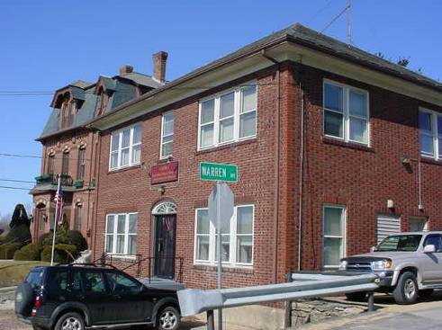

Prepared by:
Massachusetts Department of Public Health
Center for Environmental Health
Emergency Response/Indoor Air Quality Program
April 2007

Background/Introduction
At the request of Mr. Carl Wicklund, Facilities Director for the Leicester School Department, the Massachusetts Department of Public Health (MDPH), Center for Environmental Health (CEH), provided assistance and consultation regarding indoor air quality concerns at the Leicester School Department Administration Building (LSDAB), 1078 Main Street, Leicester, MA. The request was prompted by illness among staff (i.e., pneumonia, strep throat, sinus irritation) as well as concerns of mold growth in the basement.
On March 6, 2007, a visit to the LSDAB to conduct an indoor air quality assessment was made by Cory Holmes, an Environmental Analyst in CEH’s Emergency Response/Indoor Air Quality (ER/IAQ) Program.
The LSDAB is a two-story, red brick building reportedly constructed in the 1930s. The building contains administration offices and storage rooms. The basement of the building is unoccupied and used for storage. Windows are openable throughout the building.

Methods
Air tests for carbon monoxide, carbon dioxide, temperature and relative humidity were conducted with the TSI, Q-Trak, IAQ Monitor, Model 8551. Moisture content of basement materials prone to moistening were measured with a Delmhorst, BD-2000 Model, Moisture Detector equipped with a Delmhorst Standard Probe. CEH staff also performed visual inspection of building materials for water damage and/or microbial growth.

Results
The LSDAB has an employee population of approximately 10 and is visited by staff and members of the public daily. The tests were taken during normal operations. Test results appear in Table 1.

Discussion
Ventilation
It can be seen from Table 1 that carbon dioxide levels were below 800 parts per million (ppm) in all areas surveyed, indicating adequate ventilation in the building. However, it is important to note that the building is not equipped with a modern mechanical ventilation system but relies on openable windows for air circulation.
The Massachusetts Building Code requires that each room have a minimum ventilation rate of 20 cubic feet per minute (cfm) per occupant of fresh outside air or openable windows (SBBRS, 1997; BOCA, 1993). The ventilation must be on at all times that the room is occupied. Providing adequate fresh air ventilation with open windows and maintaining the temperature in the comfort range during the cold weather season is impractical. Mechanical ventilation is usually required to provide adequate fresh air ventilation.
Carbon dioxide is not a problem in and of itself. It is used as an indicator of the adequacy of the fresh air ventilation. As carbon dioxide levels rise, it indicates that the ventilating system is malfunctioning or the design occupancy of the room is being exceeded. When this happens, a buildup of common indoor air pollutants can occur, leading to discomfort or health complaints. The Occupational Safety and Health Administration (OSHA) standard for carbon dioxide is 5,000 parts per million parts of air (ppm). Workers may be exposed to this level for 40 hours/week, based on a time-weighted average (OSHA, 1997).
The Department of Public Health uses a guideline of 800 ppm for publicly occupied buildings. A guideline of 600 ppm or less is preferred in schools due to the fact that the majority of occupants are young and considered to be a more sensitive population in the evaluation of environmental health status. Inadequate ventilation and/or elevated temperatures are major causes of complaints such as respiratory, eye, nose and throat irritation, lethargy and headaches. For more information concerning carbon dioxide, please see Appendix A.
Temperature readings ranged from 68º F to 72 º F, which were below or near the lower end of the MDPH recommended comfort guidelines. The MDPH recommends that indoor air temperatures be maintained in a range of 70 º F to 78 º F in order to provide for the comfort of building occupants. In many cases concerning indoor air quality, fluctuations of temperature in occupied spaces are typically experienced, even in a building with an adequate fresh air supply. Occupants reported difficulty controlling temperature due to drafts around windows. In many cases large gaps/seams were observed around window frames (Pictures 1 and 2), which can allow uncontrollable drafts into the building. In some cases, staff placed towels or wrapped up newspaper along window frames to reduce drafts (Picture 3). Spaces around windows can also serve as pathways for moisture penetration and pests into the building.
The relative humidity measured in the building ranged from 14 to 22 percent, which were below the MDPH recommended comfort range in all areas surveyed. The MDPH recommends a comfort range of 40 to 60 percent for indoor air relative humidity. Relative humidity levels in the building would be expected to drop during the winter months due to heating. The sensation of dryness and irritation is common in a low relative humidity environment. Low relative humidity is a very common problem during the heating season in the northeast part of the United States. As indicated previously, the assessment was prompted in part due to several cases of pneumonia reported by occupants, thus it is important to mention that some studies have indicated that the incidence of respiratory infections increases in the winter when people are exposed to long periods of time to low indoor humidity levels (Arundel, A.V., Sterling, E.M., Biggin, J.H., Sterling, T.D.; 1986).

Microbial/Moisture Concerns
In order for building materials to support mold growth, a source of water exposure is necessary. Identification and elimination of the source of water moistening building materials is necessary to control mold growth. Several days prior to the assessment the New England region experienced a tremendous amount of rain, which resulted in flooding in a number of areas. Mr. Wicklund reported that several inches of rain water had to be removed from the basement of the LSDAB. At the time of the assessment, most of the water had been removed, however small areas of standing water and moistened concrete were observed along exterior walls (Pictures 4 through 7). Although a dehumidifier was in use to help dry the basement, musty odors were detected. The main source of the odors appeared to be moistened wooden trim along the floor of the basement and stairs (Pictures 4 through 7).
Identification and elimination of water moistening building materials is necessary to control mold growth. Building materials with increased moisture content over normal concentrations may indicate the possible presence of mold growth. Identification of the location of materials with increased moisture levels can also provide clues concerning the source of water supporting mold growth. In this case the source of water appears to be through the building envelope.
In an effort to ascertain moisture content of wood trim in the basement moisture readings were taken in materials that appeared to be water damaged. As indicated, moisture content was measured with a Delmhorst Moisture Detector equipped with a Delmhorst Standard Probe. The Delmhorst probe is equipped with three lights that function as visual aids that indicate moisture level. Readings that activate the green light indicate a sufficiently dry or low moisture level, those that activate the yellow light indicate borderline conditions and those that activate the red light indicate elevated moisture content. Moisture readings of wooden trim in several areas were found to have high (i.e., saturated) moisture content (Table 1).
The US Environmental Protection Agency (US EPA) and the American Conference of Governmental Industrial Hygienists (ACGIH) recommends that porous materials be dried with fans and heating within 24 to 48 hours of becoming wet (US EPA, 2001; ACGIH, 1989). If porous materials are not dried within this time frame, mold growth may occur. Cleaning cannot adequately remove mold growth from water-damaged porous materials. The application of a mildewcide to mold contaminated, porous materials is not recommended.
CEH staff examined the outside perimeter of the building to identify breaches in the building envelope that could provide a source of water penetration. A number of exterior sources for moisture were identified:
- A damaged/missing downspout (Picture 8).
- Missing/damaged mortar and cracks in exterior brick (Pictures 9 though 11).
- Spaces were also noted around flashing and in masonry around windows (Pictures 1, 2 and 11 and 12).
- Open holes in basement wooden window plug (Pictures 13 and 14).
Over time, these conditions can undermine the integrity of the building envelope and provide a means of water entry by capillary action into the building through exterior walls, foundation concrete and masonry (Lstiburek & Brennan, 2001). In addition these breaches in the exterior can provide a means of drafts and pest entry into the building.
As previously mentioned, the basement is not occupied but rather is used for storage. Several areas contained a large number of cardboard boxes, records and other porous items, some located directly on the cement floor (Picture 15). It is important to note that this area is not equipped with mechanical ventilation or air conditioning. One dehumidifier was operating in the basement apparently to help remove moisture. Without mechanical ventilation and/or an adequate means to remove moisture, porous items can be subjected to prolonged periods of elevated moisture (e.g., >70%), which can create conditions conducive to mold growth.
The US Environmental Protection Agency and the American Conference of Governmental Industrial Hygienists (ACGIH) recommends that porous materials (carpeting, ceiling tiles, etc.) be dried with fans and heating within 24 to 48 hours of becoming wet (US EPA, 2001; ACGIH, 1989). If porous materials are not dried within this time frame, mold growth may occur. Water-damaged porous materials cannot be adequately cleaned to remove mold growth. The application of a mildewcide to moldy porous materials is not recommended.
A bundle of what appeared to be paper bags colonized with mold was observed in the Food Service Director’s office (Picture 16). No signs of water damage or active leaks were reported in this area so it is presumed they became damaged while being stored in another area. These items should be discarded.
Water coolers were installed over carpeting in a few areas. Water spillage or overflow of cooler catch basins can result in the wetting of the carpet. Water stained ceiling tiles were observed in the main office and the men’s room, which were reported to be from historic plumbing leaks. Water stained ceiling tiles can provide a source of mold and should be replaced after a water leak is discovered and repaired.
Plants were observed in several areas. Plants, soil and drip pans can serve as sources of mold growth, and thus should be properly maintained. Over-watering of plants should be avoided and drip pans should be inspected periodically for mold growth.

Other IAQ Evaluations
Several other conditions that can potentially affect indoor air quality were identified. CEH staff observed exposed pipe insulation in the basement near the oil burner, which was labeled as asbestos containing material (Picture 17). This finding was reported to Mr. Wicklund upon discovery. CEH staff recommended that the material be encapsulated by a licensed member of the Leicester Public Schools maintenance staff, or a professional remediation firm.
Also of note was the amount of materials stored inside offices. In areas throughout the building, items were observed on windowsills, tabletops, counters, bookcases and desks. The large number of items stored provides a source for dusts to accumulate. These items, (e.g., papers, folders, boxes) make it difficult for custodial staff to clean. Dust can be irritating to eyes, nose and respiratory tract. Items should be relocated and/or be cleaned periodically to avoid excessive dust build up. Compounding this issue is the condition of spaces around window frames and the building’s proximity to Route 9, which travels directly in front of the building. Occupants reported an excessive amount of infiltration of road dirt and sand during winter months on flat surfaces around window sills.
Finally, a damaged ceiling tile was observed in the main office area. Damaged/dislodged ceiling tiles can provide a pathway for dusts and particulates that accumulate in the ceiling plenum and subsequently released into occupied areas.

Conclusions/Recommendations
The conditions related to indoor air quality problems at the LSDAB raise a number of issues. The general building conditions, stored materials, and breaches in the building envelope, if considered individually, present conditions that could degrade indoor air quality. When combined, these conditions can serve to further degrade indoor air quality. Some of these conditions can be remedied by actions of building occupants. Other remediation efforts will require alteration to the building structure and equipment. For these reasons, a two-phase approach is required for remediation. The first consists of short-term measures to improve air quality and the second consists of long-term measures that will require planning and resources to adequately address the overall indoor air quality concerns.

The following short-term measures should be considered for implementation:
- Remediate exposed pipe insulation in basement in conformance with Massachusetts asbestos remediation and hazardous waste disposal laws.
- Remove water damaged wooden trim from along the base of walls in the basement that are susceptible to water penetration. Clean behind/around these areas with a mild detergent followed by soap and water.
- Consider consult with an architect, masonry firm or general contractor regarding the integrity of the building envelope, primarily concerning water penetration through exterior walls. Examine the feasibility of repointing brickwork.
- Continue to remove water from basement after heavy rains, employ the use of fans such as the one in Picture 18, (which was found in the basement). Consider using an additional dehumidifier in the SPED storage room.
- Do not store cardboard boxes or other porous materials directly on the cement floor. Items should be elevated (e.g., on pallets or shelves).
- Seal holes in the basement ceilings for pipes and cables to prevent the egress of odors and particulates into occupied areas.
- Discard moldy paper products in the Food Service Director’s office (Picture 16).
- In order to control the spread of germs frequent hand washing is recommended.
- Discard stored materials and building materials that appear to be water damaged or colonized with mold. This measure will remove actively growing mold colonies that may be present.
- Keep both the basement door and second door at landing shut to prevent the egress of basement odors into occupied areas.
- Seal holes in basement wooden window plug (Picture 13).
- Replace missing/damaged elbows to downspouts in a manner to direct rainwater away from the building.
- Ensure plants have drip pans and are not placed on porous materials (e.g., paper towels/plates). Avoid over-watering of plants and examine drip pans periodically for mold growth. Disinfect with an appropriate antimicrobial where necessary.
- Place tile or rubber matting underneath water coolers in carpeted areas.
- For buildings in New England, periods of low relative humidity during the winter are often unavoidable. Therefore, scrupulous cleaning practices should be adopted to minimize common indoor air contaminants whose irritant effects can be enhanced when the relative humidity is low. To control for dusts, a high efficiency particulate arrestance (HEPA) filter equipped vacuum cleaner in conjunction with wet wiping of all surfaces is recommended. Drinking water during the day can help ease some symptoms associated with a dry environment (e.g. throat and sinus irritations).
- Relocate or consider reducing the amount of materials stored in common areas to allow for more thorough cleaning. Clean items regularly with a wet cloth or sponge to prevent excessive dust build-up.
- Replace damaged ceiling tiles.
- For more information on mold consult with “Mold Remediation in Schools and Commercial Buildings” published by the US Environmental Protection Agency (US EPA, 2001). Copies of this document can be downloaded from the US EPA website at: http://www.epa.gov/iaq/molds/mold_remediation.html.
- For further building-wide evaluations and advice on maintaining public buildings, see the resource manual and other related indoor air quality documents located on the MDPH’s website at http://mass.gov/dph/indoor_air.

The following long-term recommendations are made.
- Consider having exterior walls re-pointed and waterproofed to prevent water intrusion. This measure should include a full building envelope evaluation.
- Repair/replace loose windowpanes throughout the building.

References
ACGIH. 1989. Guidelines for the Assessment of Bioaerosols in the Indoor Environment. American Conference of Governmental Industrial Hygienists, Cincinnati, OH.
Arundel, A.V., Sterling, E.M., Biggin, J.H., Sterling, T.D. 1986. Indirect Health Effects of Relative Humidity in Indoor Environments. Env. Health Perspectives. 65:351-361.
BOCA. 1993. The BOCA National Mechanical Code/1993. 8th ed. Building Officials and Code Administrators International, Inc., Country Club Hill, IL. Section M-308.1.1.

OSHA. 1997. Limits for Air Contaminants. Occupational Safety and Health Administration. Code of Federal Regulations. 29 C.F.R 1910.1000 Table Z-1-A.

SBBRS. 1997. Mechanical Ventilation. State Board of Building Regulations and Standards. Code of Massachusetts Regulations. 780 CMR 1209.0

US EPA. 2001. “Mold Remediation in Schools and Commercial Buildings”. Office of Air and Radiation, Indoor Environments Division, Washington, DC. EPA 402-K-01-001. March 2001. Available at: http://www.epa.gov/iaq/molds/mold_remediation.html
Picture 1

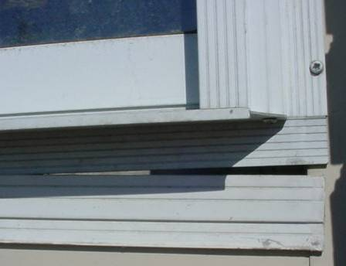

Exterior View of Spaces around Window Frames

Picture 2

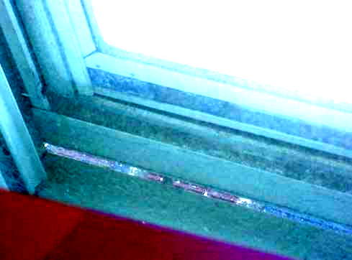

Interior View of Spaces around Window Frames
Picture 3

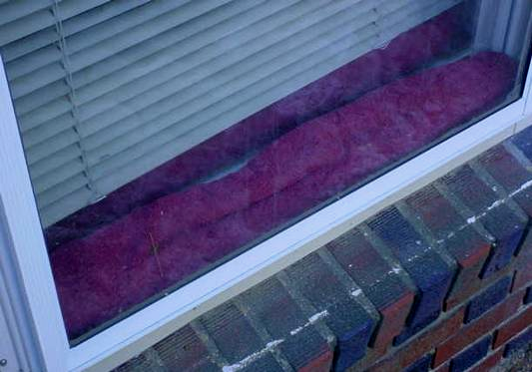

Towels Used to Help Reduce Drafts around Window Frames

Picture 4

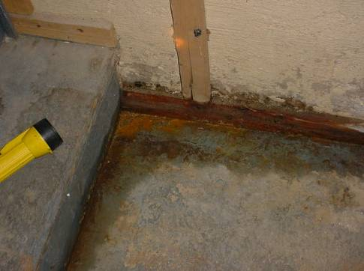

Moisture Accumulation (Dark Staining) at Landing of Basement Stairwell, Note Bottom of Wooden Stairs had High (i.e., Elevated Moisture Content)

Picture 5

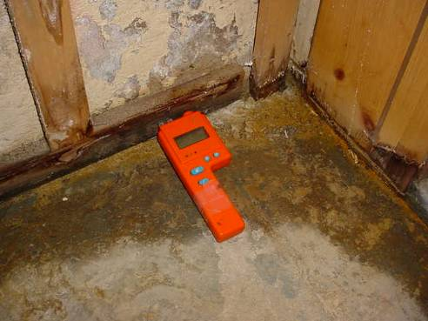

Moisture Accumulation (Dark Staining) at Landing of Basement Stairwell, Note Wooden Trim
had High (i.e., Elevated Moisture Content)

Picture 6

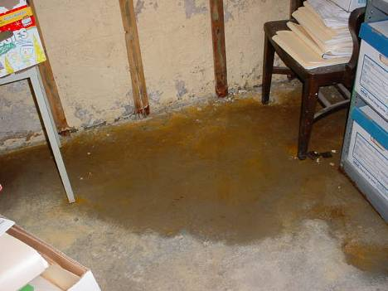

Moisture Accumulation (Dark Staining) in SPED Storage Area, Note Bottom of Wooden Slats
had High (i.e., Elevated Moisture Content)
Picture 7

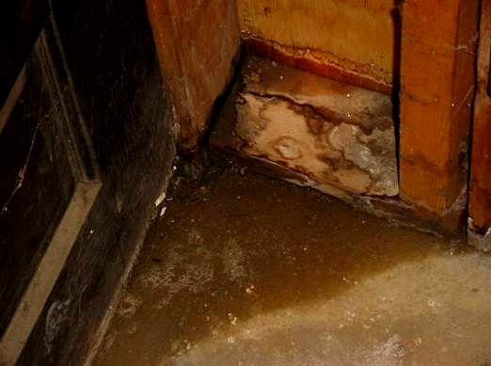

Moisture Accumulation (Dark Staining) near Custodial Closet, Note Wooden Trim along Floor
had High (i.e., Elevated Moisture Content)

Picture 8

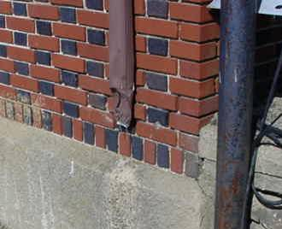

Damaged Downspout and Missing Elbow Extension
Picture 9

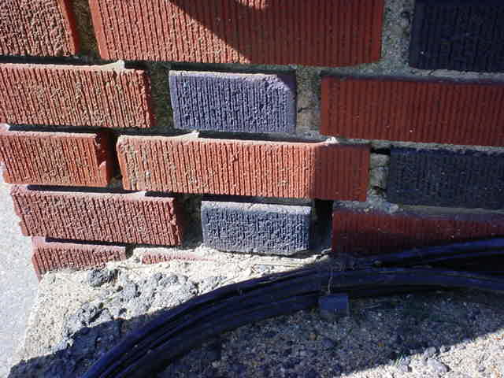

Missing/Damaged Mortar around Exterior Brick

Picture 10

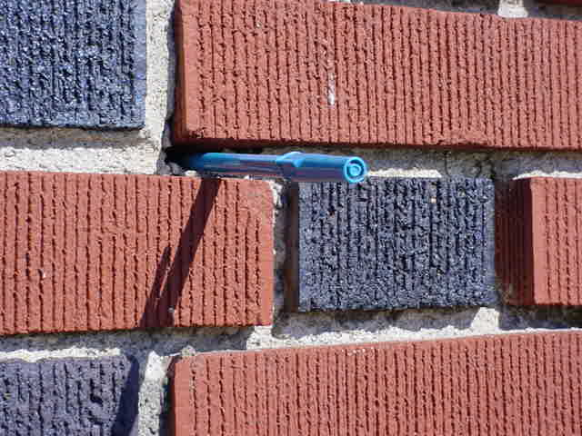

Missing/Damaged Mortar around Exterior Brick, Pen Inserted by CEH Staff to Show Depth
Picture 11

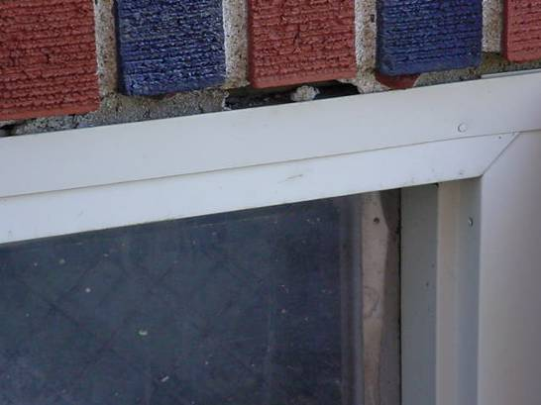

Missing/Damaged Mortar around Exterior Brick/Basement Window Frame

Picture 12

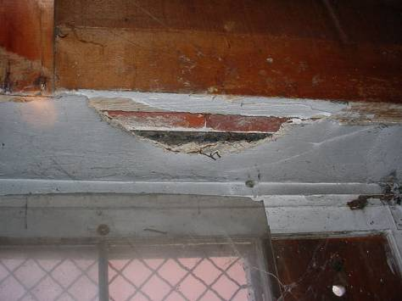

Interior Shot of Damaged Plaster around Basement Window Shown in Preceding Picture
Picture 13

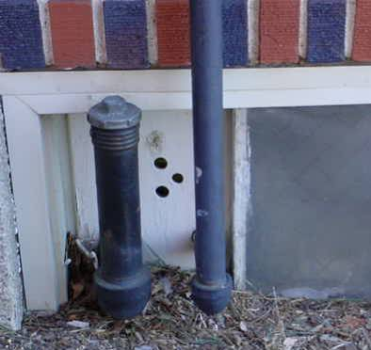

Holes in Plywood Plug for Basement Window

Picture 14
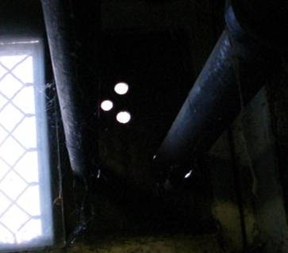

Interior View of Holes in Plywood Plug for Basement Window Shown in Preceding Picture
Picture 15

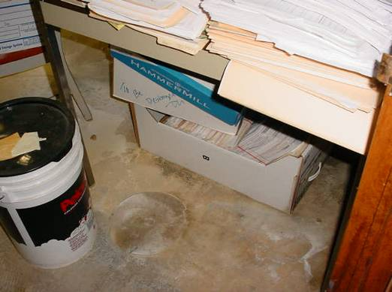

Cardboard Box Stored Directly on Cement Floor

Picture 16

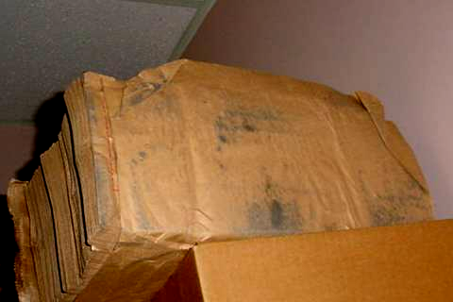

Mold Colonized Paper Products in Food Service Director’s Office
Picture 17

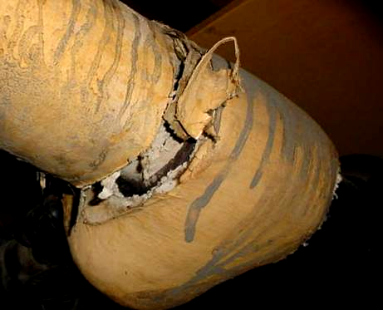

Exposed Pipe Insulation in Basement

Picture 18

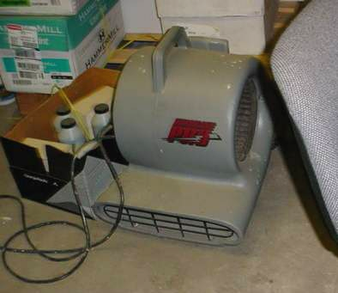

Industrial Floor Fan Found in the Basement
Location | Carbon  Dioxide  (*ppm) | Temp  (°F) | Relative  Humidity  (%) | Occupants  in Room | Windows  Openable | Ventilation |  | Remarks
 |  |  |  |  |  | Supply | Exhaust | Remarks
Outside  (Background) | 336 | 4 | 10 |  |  |  |  | Extremely cold, WNW winds 20-40 mph, wind chill - 20 °F
Facilities Director | 792 | 68 | 22 | 1 | Y | N | N
Business Manger | 750 | 69 | 19 | 0 | Y | N | N | Plant
Business/SPED Office | 675 | 72 | 19 | 3 | Y | N | N | Plant, water cooler on carpet, drafty windows reported
Special Ed Admin | 725 | 72 | 17 | 2 | Y | N | N | Plants
Storeroom |  |  |  | 0 | Y | N | N | Storm windows-open-drafts
Main Office | 545 | 70 | 15 | 3 | Y | N | N | 1 damaged ceiling tile
Men’s Restroom |  |  |  |  | Y | N | N | 2 water stained ceiling tiles-historic plumbing leak-repaired
Woman’s Restroom |  |  |  |  | N | N | Y
Food Service Director | 521 | 70 | 15 | 3 | Y | N | N | Towels on window sill to reduce drafts, visible mold on paper products stored on cabinet
Basement Lower Landing |  |  |  |  | N | N | N | Moistened concrete floor along base of wall, Elevated (high=saturated) moisture content wooden trim along base of wall, musty odors
Basement SPED Storeroom |  |  |  |  | N | N | N | Standing water on concrete floor along base of wall, Elevated (high=saturated) moisture content wooden wall slats near floor, musty odors, cardboard boxes stored directly on floor
Basement Main Storeroom |  |  |  |  | N | N | N | Standing water on concrete floor along base of wall, dehumidifier, cardboard boxes on cement
Basement Furnace Area |  |  |  |  | N | N | N | Open holes in wooden window plug, exposed insulation material on ceiling-mounted pipes, reported to Facilities Director for remediation
Superintendent’s Office | 530 | 72 | 14 | 1 | Y | N | N | Spaces around windows-dust accumulation/drafts

