INDOOR AIR QUALITY ASSESSMENT

Leicester Town Hall
3 Washburn Square
Leicester, Massachusetts

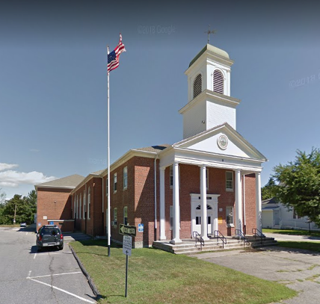

Prepared by:
Massachusetts Department of Public Health
Bureau of Environmental Health
Indoor Air Quality Program
November 2022

BACKGROUND
Building: | Leicester Town Hall (LTH)
Address: | 3 Washburn Square, Leicester, MA
Assessment Requested by: | Leicester Board of Health (LBOH)
Reason for Request: | Mold growth concerns due to water accumulation on lower-level floors during hot, humid weather
Date of Assessment: | August 25, 2022
Massachusetts Department of Public Health/Bureau of Environmental Health (MDPH/BEH) Staff Conducting Assessment: | Michael Feeney, Director, Indoor Air Quality (IAQ) Program and Stefanie Santora, Environmental Analyst, IAQ Program
Building Description: | LTH is a two-story brick building constructed in the 1930’s as Leicester High School. The LBOH offices are located in the basement, with additional town offices on the second and third floors.
Windows: | Windows are openable.

METHODS
Please refer to the IAQ Manual for methods, sampling procedures, and interpretation of results (MDPH, 2015).

RESULTS AND DISCUSSION
The following is a summary of indoor air testing results (Table 1).
- Carbon dioxide levels were below the MDPH guideline of 800 parts per million (ppm) in most of the areas assessed, apart from several rooms on the third floor.
- Temperature was within or slightly above the MDPH recommended range of 70°F to 78°F in all areas. The meeting room had a temperature measurement of 83°F with the air conditioner (AC) deactivated at the time of assessment.
- Relative humidity was within the MDPH recommended range of 40% to 60% in most of the areas tested and slightly above in a few locations where ACs were deactivated.
- Carbon monoxide levels were non-detectable (ND) in all indoor areas assessed.
- Fine particulate matter (PM2.5) concentrations measured were ND, below the National Ambient Air Quality Standard (NAAQS) limit of 35 μg/m³ in all areas tested.

Ventilation
It can be seen from Table 1 that carbon dioxide levels were below 800 parts per million of air (ppm) in most areas tested, indicating adequate air exchange. Each room has a radiator beneath the window which provides heat. The sole source of fresh air in most rooms is the openable windows.
It is important to note that the LTH was originally constructed as a school and was not intended to be occupied during hot, humid weather that occurs in summer months. Classrooms had been equipped with a unit ventilator (univent) (Picture 1) that was installed in 1939. When operating, univents draw air from the outdoors through a fresh air intake located on the exterior wall of the building (Picture 2) and return air through an air intake located at the base of the unit. Fresh and return air are mixed, filtered, heated, or cooled and provided to rooms through an air diffuser located in the top of the unit (Figure 1). In order for univents to provide fresh air as designed, intakes/returns must remain free of obstructions. Importantly, these units must remain on and be allowed to operate while rooms are occupied. However, the mechanical portions of most of the univents in the LTH were non-functional, so the univents only serve as a source of radiant heat.
An exhaust vent system in the form of a wall opening connected to an air shaft exists in each former classroom (Picture 3). None of these systems were operating at the time of the assessment. An exhaust fan also exists in the doorframe of the rear basement level entrance (Picture 4).
It is also important to note that despite ongoing maintenance, these univents are at the end of their life cycle. Efficient function of equipment of this age (> 80 years old) is difficult to maintain, since compatible replacement parts are often unavailable. According to the American Society of Heating, Refrigeration, and Air-Conditioning Engineering (ASHRAE), the service life of this type of unit is 15-20 years, assuming routine maintenance of the equipment (ASHRAE, 1991). Also note that even if all the systems in the building were operational, none are designed to provide mechanical chilled air (air conditioning).
In an effort to improve comfort during year-round operation, many areas have been retrofitted with devices to chill air to increase comfort, including:
- Window-mounted ACs (Picture 5).
- Wall-mounted mini-splits; these are connected to chillers installed in the LTH attic.
- The auditorium appears to be equipped with an air handling unit (AHU) that is installed in the attic (Picture 6).
- However, some areas do not have any cooling, including hallways.

Based on the equipment, its function, and location, LTH does not have the means to provide cooling throughout the entire building.
It is important to note that heating, ventilating, and air conditioning (HVAC) systems are designed to heat and cool a predetermined maximum volume of air by AHUs. If the volume of air is exceeded by the introduction of unconditioned air, the ability of the HVAC system equipment to maintain heating and cooling consistently will be impaired, resulting in increased indoor relative humidity. Such conditions exist at the LTH.
There are many places in the LTH where unconditioned air can be drawn into air-conditioned spaces and be a source of heat and humidity. As an example, various room and hallway doors are open to non-conditioned areas such as hallways. These hallways can become a source of hot, moist air from opening exterior doors. During this visit, some exterior doors were propped open or continuously used (Picture 7). In this configuration/use, a significant amount of unconditioned air is likely to enter LTH hallways and is then captured by the HVAC system and is redistributed throughout the building, resulting in poor air chilling control during hot, humid weather. If the same use pattern of the exterior doors exists during cold weather months, heat control would also become difficult due to the introduction of a large volume of cold, unconditioned air.
Offices and restrooms do not have mechanical exhaust ventilation. With the lack of exhaust ventilation, pollutants that exist in the interior space can build up and remain inside the building, subsequently leading to indoor air complaints.
The Massachusetts Building Code requires a minimum ventilation rate of 20 cubic feet per minute (cfm) per occupant of fresh outside air or openable windows in each room (SBBRS, 1997, BOCA, 1993). The ventilation must be on at all times when the room is occupied. Providing adequate fresh air ventilation with open windows and maintaining the temperature in the comfort range during the cold weather season is impractical. Mechanical ventilation is usually required to provide adequate fresh air ventilation.

Microbial/Moisture Concerns
All rooms were assessed for the presence of either mold or visible water damage (Table 1). IAQ staff did not observe any materials that had visible mold growth or had musty odors during this assessment. Water-damaged plaster was noted in the auditorium, which is likely from a historic roof leak. Due to weather conditions/patterns of the past decade, IAQ staff assessed whether the LTH may be prone to developing condensation on building materials.
As reported by LTH officials, flooring and stairs leading to the basement level are prone to becoming wet during hot, humid weather conditions (Picture 8). It is important to note that Massachusetts experienced extended periods of high relative humidity during the summer of 2021. July 2021 was the wettest ever recorded in Massachusetts, and the three-month period from June through August 2021, known as the meteorological summer, was the fourth wettest on record, according to the National Oceanic and Atmospheric Administration’s (NOAA) Centers for Environmental Information. That three-month period also was the third warmest ever in the state and was tied for the warmest on record across the United States (HG, 2021, NOAA, 2021). Although the summer of 2022 was dryer, periods of hot, humid weather occurred as well.
Based on reports from LTH staff as well as type of floor construction (cement on soil), the floors develop condensation during extended (> 24 hours) hot, humid weather. The key to managing condensation in hot, humid weather indoors is understanding dew point. When warm, moist air passes over a cooler surface, condensation can form. Condensation is the collection of moisture on a surface at or below the dew point. The dew point is the temperature that air must reach for saturation to occur. If a building material/component has a temperature below the dew point, condensation will accumulate on that material. Over time, condensation can collect and form water droplets.
Relative humidity in the building was measured in the mid-50s (%), which was similar to outdoor measurements at the time of the assessment, which was not particularly hot, humid weather (Table 1). Given the construction of the building, lack of HVAC chilling in halls, and exterior door use, relative humidity indoors would also be expected to match outdoor measurements during extended periods of hot, humid weather.
According to American Society of Heating, Refrigerating and Air-Conditioning Engineers (ASHRAE), if relative humidity exceeds 70% for an extended period of time, mold growth in porous materials (e.g., carpeting, cardboard) may occur due to wetting of building materials even in the absence of liquid water (ASHRAE, 1989). It is recommended that porous material be dried with fans and heating within 24 to 48 hours of becoming wet (US EPA, 2008, ACGIH, 1989). If porous materials are not dried within this time frame, mold growth may occur. Water-damaged porous materials cannot be adequately cleaned to remove mold growth.
IAQ staff examined the exterior to identify water sources, breaches in the building envelope, and/or other conditions that could provide a source of moisture that can adversely affect IAQ. A number of conditions related to moisture were identified:
- Plants were observed in direct contact with or growing near the foundation and/or building exterior. Plants near the building envelope can cause water damage to brickwork and mortar. In addition, plants shading exterior walls can slow drying and lead to damage to brick and mortar, wood rot, and water infiltration into the building.
- The exterior wall outside the basement offices has grass-covered soil and a cement access ramp. Foundation walls below grade can allow rainwater to accumulate against the foundation. Sealant on the seam between the ramp and exterior wall has eroded, which can allow pooled rainwater to come into extended contact with the basement foundation, which can in turn enter the building to cause water damage. Such water damage is noted on the office wall near windows (Picture 9).
- As noted above, an exhaust fan of undetermined function exists in the doorframe of the rear basement level entrance (Picture 4). If this fan is not in use, moist outdoor air may enter the basement level through the fan.

In addition to water entry, these breaches in the exterior can provide a means for drafts and pest entry into the building.
As noted previously, the building is configured in a manner where significant hot, moist air can readily pass into the interior of the building. Other access points for hot, humid air include spaces around the exterior basement doors, spaces in exterior walls, and spaces in other parts of the building envelope around windows/doors as well as outdoor exterior doors.
Floors and walls in contact with the ground are particularly vulnerable to condensation, as they are in contact with soil that is at a lower temperature than the indoor air during the summer. This, combined with the presence of thermal bridges, and possible water penetration through the cement floor from poorly draining rainwater make materials on or near the floor and walls in the lower level susceptible to moistening and mold growth during hot, humid summer weather conditions.

Other Issues
Window mounted ACs have filters that accumulate dust and debris. The purpose of air conditioner filters is to remove particulate matter from air drawn into the units. AC filters need to be cleaned on a regular basis in order to maximize the efficiency of the filter. If not cleaned regularly, the filter can become saturated with dust and become a source of aerosolized particulates and odors when the AC is operating.

CONCLUSIONS/RECOMMENDATIONS
The LTH has a number of issues related to moisture in the building. One issue that is of significance is that management of the building without AC can be challenging. The following documents can provide guidance that can be used to reduce the impact of hot, humid weather in buildings:
- Preventing mold growth in Massachusetts schools during hot, humid weather: https://www.mass.gov/service-details/preventing-mold-growth-in-massachusetts-schools-during-hot-humid-weather
- Remediation and prevention of mold growth and water damage in public schools and buildings to maintain air quality: https://www.mass.gov/service-details/remediation-and-prevention-of-mold-growth-and-water-damage-in-public-schools-and-buildings-to-maintain-air-quality
- Methods for increasing comfort in non-air-conditioned schools: https://www.mass.gov/doc/methods-for-increasing-comfort-in-non-air-conditioned-schools/download

To remedy building problems, the following recommendations are provided:

Ventilation Recommendations
- The building’s univent system has been abandoned and is not functional to introduce fresh air into rooms. The building was designed to also use windows to provide fresh air. Since no mechanical ventilation is available, the opening of windows is recommended to provide fresh air. Windows should not be opened during wet weather, or when a form of air conditioning (e.g. mini-split or window air conditioner) is operating. Ensure windows have intact screens to prevent pest entry, and that windows are tightly closed at the end of the day or when rooms are not in use.
- Due to the age/condition of HVAC system/components, consider developing a plan for replacement or overhaul of the HVAC systems and controls.
- To prevent air transfer between rooms and wall/floor cavities, seal wall/floor spaces in univents (Picture 1) with a fire-related expandable foam. In addition, seal holes in the floors, walls, and ceilings for pipes and cables to prevent infiltration of pollutants from wall cavities.
- Clean or replace filters in window-mounted ACs in a manner consistent with the manufacturer’s recommendations. To reduce airborne particulates, consider operating the ACs in “fan-only” setting during cold weather. The operation of the window-mounted ACss without activating the air-cooling capacity of the equipment will provide particulate removal and increase air circulation in office space.

Water Damage Recommendations
- Keep all exterior doors closed during hot, humid weather to promote airflow.
- Keep all doors closed in each AC zone to maintain air temperature and prevent condensation in adjoining uncooled areas.
- Consider replacing carpets in basement with a flooring resistant to water damage/mold growth.
- Do not store any porous material on the basement level floor.
- Ensure that the ramp drain outside basement offices is regularly cleaned of accumulated debris.
- Determine the use of the fan in Picture 4. If useful in ejecting water vapor, operate during hot, humid weather.
- Reseal the joint between the ramp and exterior wall.
- Trim plants away from the building a minimum of five feet.
- Any water-damaged material should be removed in a manner consistent with recommendations listed in the US EPA’s “Mold Remediation in Schools and Commercial Buildings” (US EPA, 2008). This work should be performed when the building is unoccupied. In addition, due to the age of the building and the presence of asbestos-containing floor tiles, all work should be done in accordance with state and federal regulations.
- Refer to the resource manual and other related indoor air quality documents located on the MDPH’s website for further building-wide evaluations and advice on maintaining public buildings. These documents are available at http://mass.gov/dph/iaq.
REFERENCES
ACGIH. 1989. Guidelines for the Assessment of Bioaerosols in the Indoor Environment. American Conference of Governmental Industrial Hygienists, Cincinnati, OH.
ASHRAE. 1989. Ventilation for Acceptable Indoor Air Quality. American Society of Heating, Refrigeration and Air Conditioning Engineers. ANSI/ASHRAE 62-1989.

ASHRAE. 1991. ASHRAE Applications Handbook, Chapter 33 “Owning and Operating Costs”. American Society of Heating, Refrigeration and Air Conditioning Engineers, Atlanta, GA.

BOCA. 1993. The BOCA National Mechanical Code-1993. 8th ed. Building Officials & Code Administrators International, Inc., Country Club Hills, IL. M-308.1

HG. 2021. Mold Keeps South Hadley High School Shuttered. Hampshire Gazette. https://www.gazettenet.com/South-Hadley-High-School-still-closed-amid-mold-remediation-42413519
MDPH. 2015. Massachusetts Department of Public Health. Indoor Air Quality Manual: Chapters I-III. Available at: https://www.mass.gov/lists/indoor-air-quality-manual-and-appendices.
NOAA. 2021. Summer 2021 neck and neck with Dust Bowl summer for hottest on record. National Oceanic and Atmospheric Administration, 1401 Constitution Avenue NW, Room 5128, Washington, DC 20230 https://www.noaa.gov/news/summer-2021-neck-and-neck-with-dust-bowl-summer-for-hottest-on-record
SBBRS. 1997. Mechanical Ventilation. State Board of Building Regulations and Standards. Code of Massachusetts Regulations. 780 CMR 1209.0

US EPA. 2008. “Mold Remediation in Schools and Commercial Buildings”. Office of Air and Radiation, Indoor Environments Division, Washington, DC. EPA 402-K-01-001. September 2008. Available at: http://www.epa.gov/mold/mold-remediation-schools-and-commercial-buildings-guide

Figure 1

Unit Ventilator (Univent)

Mixed Air

Air Diffuser

Outdoors Indoors

Fan

Heating/Cooling Coil

Air Mixing Plenum

Filter

Outdoor Return
Air Air

Air
Flow
Control
Louvers

Air Flow

= Fresh Air/Return Air

= Mixed Air

Picture 1
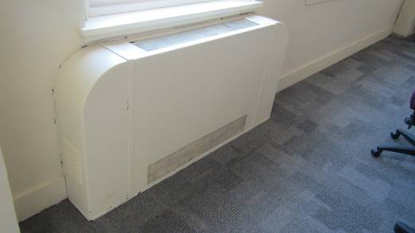
Univent
Picture 2
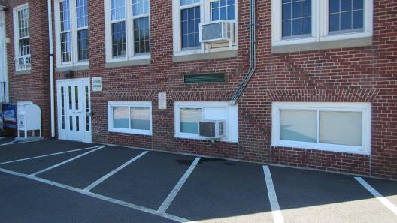
Univent fresh air intake

Picture 3
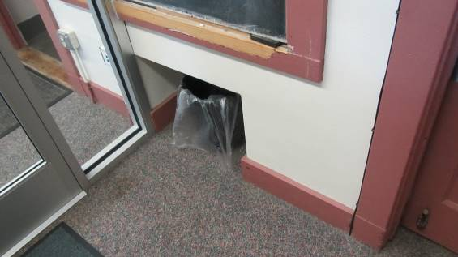
Exhaust vent
Picture 4
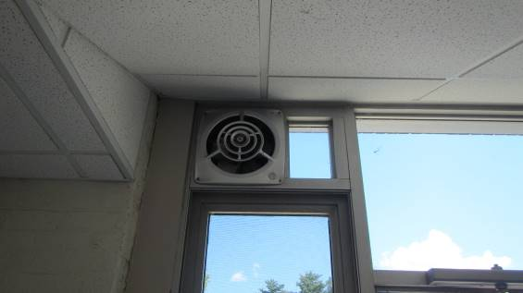
Fan in basement hallway
Picture 5
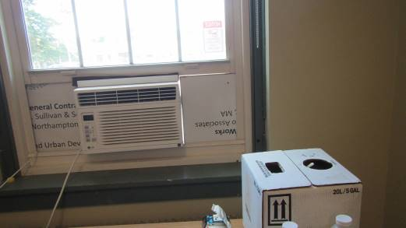
Window-mounted air conditioner
Picture 6
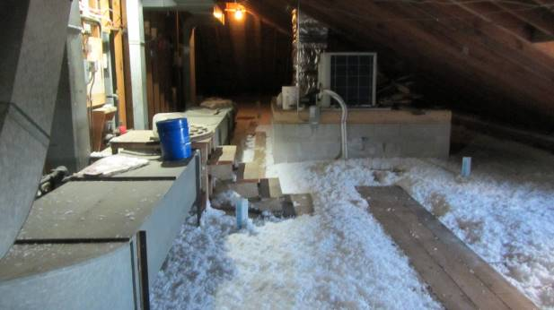
Auditorium attic AHU (arrow)
Picture 7
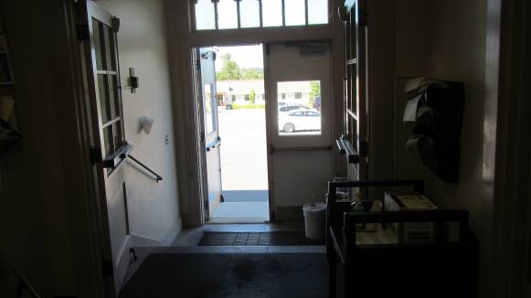
Propped open exterior door
Picture 8
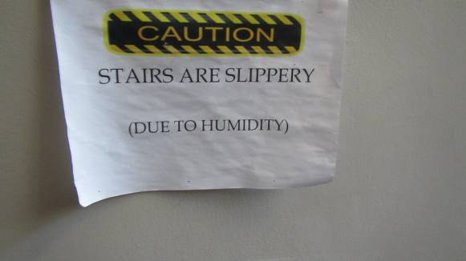
Paper wrinkled by water exposure, presumably during hot, humid conditions
Picture 9
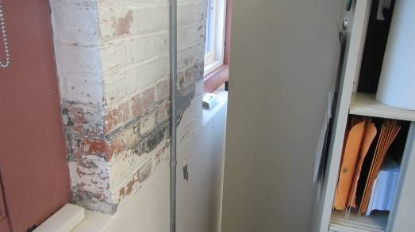
Water-damaged wall in basement

Location | Carbon  Dioxide  (ppm) | Carbon Monoxide  (ppm) | Temp  (°F) | Relative  Humidity  (%) | PM2.5  (µg/m³) | Dew  Point  (°F) | Occupants  in Room | Windows  Openable | Ventilation |  | Remarks
 |  |  |  |  |  |  |  |  | Supply | Exhaust
Background  (Outdoors) | 308 | ND | 79 | 56 | ND | 62
Basement
BOH Meeting Rm | 457 | ND | 79 | 50 | ND | 59 | 0 | Y | N | N | Portable AC running, carpeting, cardboard boxes on floor
BOH offices | 612 | ND | 76 | 55 | ND | 59 | 4 | Y | N | N | Portable AC running, carpeting
Town Admin. | 613 | ND | 71 | 50 | ND |  | 1 | Y | N | N
Town Admin. Office | 615 | ND | 69 | 52 | ND | 50 | 1 | N/A | N | N | Window AC unit, Minisplit
Front Lobby | 339 | ND | 78 | 57 | ND |  | 0 |  |  |  | Peeling paint
Accounting | 391 | ND | 77 | 55 | ND |  | 1 | Y | N | N | Window AC unit, plants, rippled carpet
Additional Office | 329 | ND | 78 | 56 | ND | 62 | 0 | Y | Y | Y | Ceiling fans
Copy Room | 336 | ND | 77 | 57 | ND | 60 | 0 | N | N | N | Window AC unit
Assessor | 349 | ND | 77 | 56 | ND | 56 | 0 | N | N | N | Window AC unit
Building Department | 357 | ND | 79 | 55 | ND | 61 | 1 | Y | N | N | Windows open, air freshener, water-damaged, plants
Building Manager | 368 | ND | 80 | 55 | ND | 63 | 1 | Y | N | N | Water-damaged wall, carpeting
Additional Office | 379 | ND | 78 | 54 | ND | 60 | 1 | Y | N | N | Water-damaged wall, carpeting
Second Floor
Tax Collector/Treasurer | 581 | ND | 78 | 47 | ND | 55 | 2 | Y | N | N | Window AC running
Room adjacent to tax collector | 591 | ND | 80 | 48 | ND | 59 | 0 | Y | N | N
Clerk | 512 | ND | 76 | 52 | ND | 57 | 1 | Y | N | N | Window AC running
Room adjacent to clerk | 520 | ND | 76 | 56 | ND | 55 | 3 | Y | N | N
Third Floor
Superintendent Lobby | 840 | ND | 76 | 61 | ND | 61 | 2 | Y | N | N | Minisplit not running
Superintendent’s Office | 844 | ND | 74 | 51 | ND | 55 | 0 | Y | N | N
Technology Facilities Offices | 623 | ND | 73 | 65 | ND | 61 | 2 | N/A | N | N | Minisplit not running
Special Education/Business Offices | 1000 | ND | 78 | 61 | ND | 64 | 0 | N/A | N | N | Minisplit not running
Meeting Room | 409 | ND | 83 | 53 | ND | 64 | 1 | Y | N | N | Minisplit not running

The service life is the median time during which a particular system or component of …[an HVAC]… system remains in its original service application and then is replaced. Replacement may occur for any reason, including, but not limited to, failure, general obsolescence, reduced reliability, excessive maintenance cost, and changed system requirements due to such influences as building characteristics or energy prices (ASHRAE, 1991).

