**INDOOR AIR QUALITY**

**ASSESSMENT**

**Leicester Vocational Education Program**

**at the Winslow School**

**70 Winslow Avenue**

**Leicester, Massachusetts**

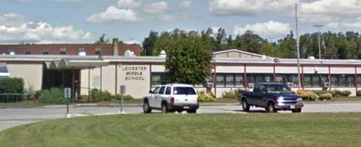

Prepared by:

Massachusetts Department of Public Health

Bureau of Climate and Environmental Health

Indoor Air Quality Program

March 2024

# BACKGROUND

|  |  |
| --- | --- |
| Building: | Leicester Vocational Technical High School (LVTHS) at the Winslow School (WS) |
| Address: | 70 Winslow Avenue, Leicester, MA |
| Assessment Requested by: | Dr. Brett M. Kustigian, Superintendent, Leicester Public Schools |
| Date of Assessment: | January 19, 2024 |
| Massachusetts Department of Public Health/Bureau of Environmental Health (MDPH/BEH) Staff Conducting Assessment: | Michael Feeney, Director, Indoor Air  Quality (IAQ) Program |
| Date of Building Construction/Renovation: | Constructed in 1978 |
| Building Description: | The LVTHS is located in the section of the building originally constructed for vocational education when the building was Leicester High School. This section of this building complex is one-story steel beam and cement block building built around 1978. The building contains a general classroom, two shop areas and storerooms. |
| Windows: | Openable |

**METHODS**

Please refer to the IAQ Manual for methods, sampling procedures, and interpretation of results (MDPH, 2015).

On August 25, 2023, the IAQ Program conducted a pre-occupancy assessment of the proposed LVTHS space at 70 Winslow Avenue, including recommendations. This report is attached as Appendix A. This report is based on a return visit to the building to conduct indoor air testing while the spaces were occupied.

# RESULTS AND DISCUSSION

The following is a summary of testing results (Table 1):

* ***Carbon dioxide*** was below the MDPH guideline of 800 parts per million (ppm) in all areas tested.
* ***Temperature*** was below the recommended comfort range of 70°F to 78°F in all areas.
* ***Relative humidity*** was below the recommended range of 40% to 60% in all areas. This is typical of the heating season in New England.
* ***Carbon monoxide*** levels were non-detectable (ND) in all areas.
* ***Fine particulate matter (PM2.5)*** concentrations were below the National Ambient Air Quality Standard (NAAQS) level of 35 μg/m3 in all areas.
* ***Volatile Organic Compounds*** were non-detectable in all areas assessed.

## Ventilation

A heating, ventilating and air conditioning (HVAC) system has several functions. First it provides heating and, if equipped, cooling. Second, it is a source of fresh air. Finally, an HVAC system will dilute and remove normally occurring indoor environmental pollutants by not only introducing fresh air, but by filtering the airstream and ejecting stale air to the outdoors via exhaust ventilation. Even if an HVAC system is operating as designed, point sources of respiratory irritation may exist and cause symptoms in sensitive individuals.

Fresh air in classrooms is supplied by unit ventilators (univents) installed when the LVTHS was constructed as a high school in 1978. Univents draw air from the outdoors through a fresh air intake located on the exterior wall of the building and return air through an air intake located at the base of the unit. Fresh and return air are mixed, filtered, heated, or cooled and provided to rooms through an air diffuser located in the top of the unit (Figure 1).

Mechanical exhaust ventilation in classrooms is provided by wall-mounted exhaust fans connected to motors. The MDPH IAQ Program recommends that supply and exhaust ventilation operate continuously during occupied periods to provide air exchange and filtration. Without sufficient supply and exhaust ventilation, normally occurring environmental pollutants can build-up and lead to indoor air quality/comfort complaints.

It is also important to note that despite ongoing maintenance and replacement of parts/components by Leicester Public Schools facilities staff, HVAC units are at the end of their life cycle. Efficient function of equipment of this age (> 40 years old) is difficult to maintain, since compatible replacement parts are often unavailable. According to the American Society of Heating, Refrigeration, and Air-Conditioning Engineering (ASHRAE), the service life[1] of this type of unit is 15-20 years, assuming routine maintenance of the equipment (ASHRAE, 1991). It was reported that currently two univents were on a repair list.

To maximize air exchange, the IAQ program recommends that both supply and exhaust ventilation operate continuously during periods of occupancy. To have proper ventilation with a mechanical ventilation system, the systems must be balanced after installation to provide an adequate amount of fresh air to the interior of a room while removing stale air from the room. It is recommended that HVAC systems be re-balanced every five years to ensure adequate air systems function (SMACNA, 1994). Based on the age and condition of the univents. Re-balancing of the HVAC system may not be possible.

## Microbial/Moisture Concerns

Of note is the windows in the LVTHS classrooms are not configured in the same manner as the wall/window systems that exist in the now unused 1962 section of the building that is described in previous reports. The unused 1962 section windows experienced water leaks as described in the 2021 Leicester Middle School reports ([Indoor air quality reports - cities and towns: L | Mass.gov](https://www.mass.gov/info-details/indoor-air-quality-reports-cities-and-towns-l#leicester-)). Unlike the Leicester Middle School, LVTHS classrooms do not have:

* Water-damaged wood cabinets encasing heating pipes,
* fresh air intakes located at ground level, with the exception of Room 16, or
* exhaust vent systems connected to below floor/slab ductwork.

IAQ staff examined each classroom and did not find any water damage to ceilings, walls, or floors that were intended for use for LVTHS activities. Signs of pooling water was noted along exterior walls; however, no water penetration was note in LVTHS classrooms.

Standing water was noted in the garage area used by maintenance staff. The garage is located at the bottom of a large-sloped hill. Materials stored along the garage exterior wall may have caused to soil to compress, resulting in significant water pooling along this wall. This garage is not intended for use by LVTHS students and is separated from classrooms by a closeable door.

## Other Conditions

Leicester Public Schools officials report that the classrooms examined are intended to be used for vocational education activities that may produce pollutants. This equipment may produce unwanted heat, dust, fumes, vapor and gases, including products of combustion. Such pollutants and activities can adversely affect IAQ if produced indoors without appropriate exhaust ventilation equipment. Exhaust ventilation for these activities should be designed by individuals with experience in industrial hygiene practice to properly vent all pollutants from the building.

## Radon

Note that the Environmental Protection Agency (EPA) conducted a National School Radon Survey in which it discovered nearly one in five schools had “…at least one frequently occupied ground contact room with short-term radon levels above 4 [picocuries per liter] pCi/L” (US EPA, 1993). The BEH/IAQ Program therefore recommends that every school be tested for radon, and that this testing be conducted during the heating season while school is in session in a manner consistent with USEPA radon testing guidelines. Radon measurement specialists and other information can be found at [www.nrsb.org](http://www.nrsb.org) and <http://aarst-nrpp.com/wp>, with additional information at: <http://www.mass.gov/eohhs/gov/departments/dph/programs/environmental-health/exposure-topics/iaq/radon>.

# CONCLUSIONS AND RECOMMENDATIONS

In view of the findings at the time of the visit, the following recommendations are provided:

***Short Term Recommendations***

### Implement recommendations made in previous reports in building areas to be used by LVTHS staff and students.

### Consulting with a certified industrial hygienist regarding the venting of pollution-generating vocational education activities.

1. To learn more about radon, review the MDPH’s [Radon in Schools and Child Care Programs](https://www.mass.gov/info-details/radon-in-schools-and-child-care-programs?utm_source=IAQP&utm_medium=reports) factsheet, with additional information at: <https://www.mass.gov/radon>.
2. Include an IAQ component in the school’s Wellness Advisory Committee program. An IAQ plan should have an IAQ liaison/teacher representative, a member of maintenance/facilities and administration that conduct regular walk-throughs to identify on-going and/or potential environmental issues.
3. Utilize the US EPA’s (2000), “Tools for Schools”, as an instrument for maintaining a good IAQ environment in the building available at: <https://www.epa.gov/iaq-schools>.
4. For guidance on maintaining an asthma-friendly healthy school environment, please consult the MDPH Asthma Prevention and Control Program’s [Clearing the Air: An Asthma Toolkit for Healthy Schools](https://www.maasthma.org/schooltoolkit).
5. Refer to resource manual and other related IAQ documents located on the MDPH’s website for further building-wide evaluations and advice on maintaining public buildings. These documents are available at: <http://mass.gov/dph/iaq>.

### **Long Term Recommendations**

1. Conduct a building-wide ventilation systems assessment. Based on historical issues with air exchange/indoor air quality complaints, age, physical deterioration, and availability of parts for ventilation components, such an evaluation is necessary to determine the operability and feasibility of replacing the equipment.

# REFERENCES

MDPH. 2015. Massachusetts Department of Public Health. Indoor Air Quality Manual: Chapters I-III. Available at: <https://www.mass.gov/lists/indoor-air-quality-manual-and-appendices#indoor-air-quality-manual->.

SMACNA. 1994. HVAC Systems Commissioning Manual. 1st ed. Sheet Metal and Air Conditioning Contractors’ National Association, Inc., Chantilly, VA.

US EPA. 1993. Radon Measurement in Schools, Revised Edition. Office of Air and Radiation, Office of Radiation and Indoor Air, Indoor Environments Division (6609J). EPA 402-R-92-014. <https://archive.epa.gov/epa/iaq-schools/radon-measurement-schools-revised-edition.html>.

US EPA. 2000. Tools for Schools. Office of Air and Radiation, Office of Radiation and Indoor Air, Indoor Environments Division (6609J). EPA 402-K-95-001, Second Edition. <http://www.epa.gov/iaq/schools/index.html>.

**Figure 1**

**Unit Ventilator (Univent)**

Mixed Air

Air Diffuser

**Outdoors Indoors**

Fan

Heating/Cooling Coil

Air Mixing Plenum

Filter

Outdoor Return

Air Air

Air

Flow

Control

Louvers

**Air Flow**

= Fresh Air/Return Air

= Mixed Air

| **Location** | **Carbon**  **Dioxide**  **(ppm)** | **Carbon Monoxide**  **(ppm)** | **Temp**  **(°F)** | **Relative**  **Humidity**  **(%)** | **PM2.5**  **(µg/m3)** | **TVOC (ppm)** | **Occupants**  **in Room** | **Windows**  **Openable** | **Ventilation** | | **Remarks** |
| --- | --- | --- | --- | --- | --- | --- | --- | --- | --- | --- | --- |
| **Supply** | **Exhaust** |
| Background (outdoors) | 358 | ND | 41 | 74 | 1 |  |  |  |  |  |  |
| 16 | 628 | ND | 67 | 36 | 2 | ND | 2 | Y | Y | Y | Wall exhaust fan off, window-mounted air conditioner, exterior wall fresh air intake grill broken |
| 18 | 541 | ND | 66 | 37 | 1 | ND | 5 | Y | Y | N |  |
| Tool storage | 477 | ND | 67 | 34 | 1 | ND | 0 | N | N | N |  |
| Shop rear room with garage door | 468 | ND | 64 | 37 | 1 | ND | 0 | N | N | Y | Wall exhaust fan off |
| Product storage off Room 18 | 584 | ND | 66 | 37 | 1 | ND | 0 | N | N | Y |  |

# BACKGROUND

**INDOOR AIR QUALITY**

**PRE-OCCUPANCY ASSESSMENT**

**Proposed Leicester Vocational Educational Program Building**

**70 Winslow Avenue**

**Leicester, MA**

Proposed Leicester Vocational Educational Program Building
70 Winslow Avenue
Leicester, MA


Prepared by:

Massachusetts Department of Public Health

Bureau of Climate and Environmental Health

Indoor Air Quality Program

October 2023

|  |  |
| --- | --- |
| Building: | Proposed Leicester Vocational Education Program building, former Leicester Middle School (LMS) |
| Address: | 70 Winslow Avenue, Leicester, MA |
| Assessment Requested by: | Dr. Brett Kustigian, Superintendent, Leicester Public Schools |
| Date of Pre-Occupancy Assessment: | August 25, 2023 |
| Massachusetts Department of Public Health/Bureau of Climate and Environmental Health (MDPH/BCEH) Staff Conducting Assessment: | Michael Feeney, Director, Indoor Air Quality (IAQ) Program |

# Introduction/Building Description

The LMS was originally constructed in 1962 as Leicester High School. An addition for the original structure was added to the uphill, north section of the original building. This wing contains classrooms that were designed for vocational education programs including a garage. This wing also contains a gymnasium, cafeteria/kitchen, and other classrooms. This assessment was limited to classrooms and areas that are intended for use for the newly established vocational technical (VocTech) educational program, which includes the garage, classrooms 16 to 18, as well as hallways.

# Previous Relevant Environmental History

No current/active Massachusetts Contingency Plan projects for this building or property were found in the Massachusetts Department of Environmental Protection database.

# The IAQ Program assessed the entire LMS complex in 2021, at which time recommendations were made regarding the entire building. The report from that assessment can be found at: <https://www.mass.gov/info-details/indoor-air-quality-reports-cities-and-towns-l#leicester->.

# METHODS

Please refer to the IAQ Manual for methods, sampling procedures, and interpretation of results (MDPH, 2015). The following table is a summary of indoor air testing results. BCEH/IAQ staff also performed visual inspection of building materials for water damage and/or microbial growth and examined the space for the presence of odors or other environmental concerns.

# RESULTS AND DISCUSSION

| **Media sampled** | | **MDPH Guideline/**  **Comparison Value** | | **Measured Range** | | | **Comments** | |
| --- | --- | --- | --- | --- | --- | --- | --- | --- |
| **Outdoors/**  **Background** | | **Indoors** |
| Carbon Dioxide (CO2) | | < 800 parts per million (ppm) is preferred | | 353 | | 363-406 | HVAC operating, unoccupied | |
| Total Volatile Organic Compounds (TVOCs) | | Equal to or below background level measured | | ND | | ND | New carpeting and painting, no odors detected | |
| Carbon Monoxide (CO) | | Non-detectable (ND) or equal to or below background level measured | | ND | | ND |  | |
| Particulate Matter 2.5 (PM2.5) | | US EPA National Ambient Air Quality Standards (NAAQS) 35 μg/m3 or less | | 5 | | 5-6 | Areas were clean and free of dust and debris | |
| Temperature | | 70 to 78ºF | | 65 | | 71-81 | Garage had high temperature | |
| Relative Humidity (RH) | | 40% to 60% | | 93 | | 70-81 | Garage had highest relative humidity standing water on floor.  no temperature controls | |
| ppm = parts per million | µg/m3 = microgram per cubic meter | | ND = non-detectable | |  | | |

The northwest portion of the LMS contained former shop classrooms and a garage currently used by the Town of Leicester. These classrooms and garage were added to ground that is uphill from the original building (Picture 1). The heating, ventilation, and air-conditioning (HVAC) system is configured in a different manner than the original building since air intakes are located above ground level except in one location (Picture 2). In addition, unlike classrooms in the original building, water-damaged wood covering heating pipes is not present in these areas.

Walls are constructed from painted cement block (Picture 3). The wall construction and HVAC system intakes are configured in a manner to limit water vapor intake from pooling water, unlike many locations (e.g., the garage doors).

At the time of assessment, interior renovations were in progress. New flooring was being installed. The MDPH typically recommends wet-wiping surfaces and high-efficiency particulate arrestance (HEPA) vacuuming multiple times prior to occupancy. Additional cleaning once files, materials, and furniture have been transported into the building will help remove any dust, debris and moisture brought in from outside during the move.

No water-damaged or moist materials were observed in any proposed classrooms during the assessment. However, the garage contains walls that are constructed from gypsum wallboard, which had visible mold (Picture 4). The use of gypsum wallboard in an unconditioned space is not recommended, particularly in a location that appears to experience standing water.

Standing water was also noted along some areas along the exterior walls of the proposed VocTech classrooms. Standing water may cause damage to cement slab/foundation over time.

# RECOMMENDATIONS

Based on the observations made during this assessment, use of the areas examined would be appropriate for the proposed VocTech Program. Management of buildings that do not have the means to provide air conditioning during hot, humid weather can be challenging. The following documents can provide guidance that can be used to reduce the impact of hot, humid weather in buildings.

* Preventing mold growth in Massachusetts schools during hot, humid weather: <https://www.mass.gov/service-details/preventing-mold-growth-in-massachusetts-schools-during-hot-humid-weather>
* Remediation and prevention of mold growth and water damage in public schools and buildings to maintain air quality: <https://www.mass.gov/service-details/remediation-and-prevention-of-mold-growth-and-water-damage-in-public-schools-and-buildings-to-maintain-air-quality>.
* Methods for increasing comfort in non-air-conditioned schools: <https://www.mass.gov/doc/methods-for-increasing-comfort-in-non-air-conditioned-schools/download>.

In view of the findings at the time of the visit, the following recommendations are provided:

1. Remove water-damaged gypsum wallboard in the garage in a manner consistent with the US EPA guidelines, Mold Remediation in Schools and Commercial Buildings. Available at: <http://www.epa.gov/mold/mold-remediation-schools-and-commercial-buildings-guide>
2. For any activity that may produce dust, fumes, vapor or gas, ensure there is an appropriate exhaust ventilation system installed and maintained.
3. Improve drainage on the garage to prevent standing water.
4. Improve water drainage around exterior walls of the proposed VocTech classrooms. Prevention of standing water near the fresh air intake in Picture 2 is highly recommended. Consider reconfiguring the air intake to draw air at least one foot above the ground.
5. Change filters for HVAC equipment prior to occupancy, and additionally 2-4 times a year using the highest Minimum Efficiency Reporting Value (MERV) rating the building’s ventilation system can accommodate to improve air filtration as much as possible without significantly reducing airflow.
6. If the HVAC system has not been balanced prior to this assessment, consider balancing the system after move-in and every five years (SMACNA, 1994).
7. Upon completion of renovations and moving, perform a final, thorough cleaning of the space including wet wiping of all surfaces and use of a HEPA vacuum of all carpeting prior to staff moving into the space.
8. Consistent with previously established protocol, once the space has been occupied for a minimum of three weeks, contact the BEH/IAQ Program to conduct a follow-up assessment of the space.

# REFERENCES

SMACNA. 1994. HVAC Systems Commissioning Manual. 1st ed. Sheet Metal and Air Conditioning Contractors’ National Association, Inc., Chantilly, VA.

MDPH. 2015. Massachusetts Department of Public Health. “Indoor Air Quality Manual: Chapters I-III”. Available at: [Indoor air quality - manual and appendices | Mass.gov](https://www.mass.gov/lists/indoor-air-quality-manual-and-appendices)

**Picture 1**

LMS section reported to contain proposed vocational education programs
(northwest portion of LMS complex)


**LMS section reported to contain proposed vocational education programs**

**(northwest portion of LMS complex)**

**Picture 2**

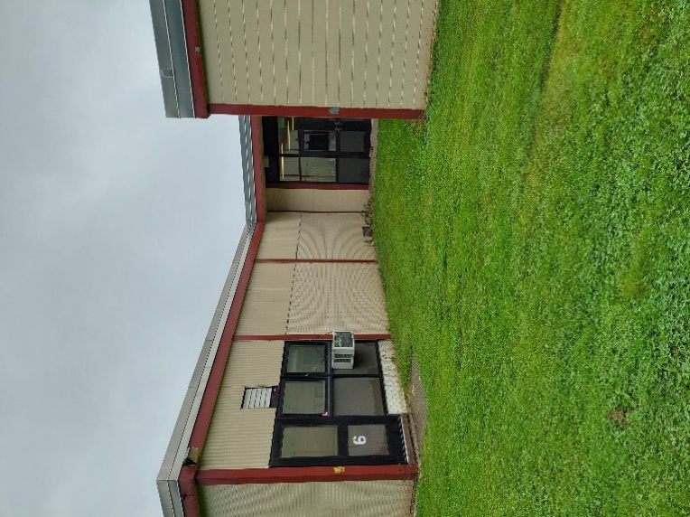

**Ground level fresh air intake (arrow)**

**Picture 3**

Exterior walls are painted cement block
Note standing water


**Exterior walls are painted cement block, note standing water**

**Picture 4**

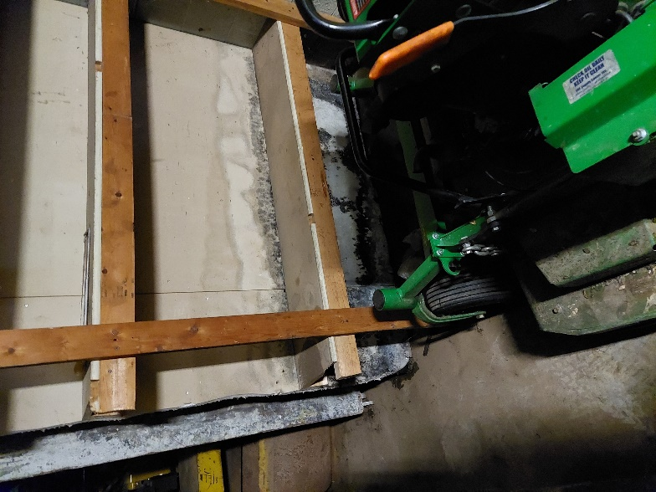

**Mold-colonized gypsum wallboard in garage**

1. The service life is the median time during which a particular system or component of … [an HVAC] … system remains in its original service application and then is replaced. Replacement may occur for any reason, including, but not limited to, failure, general obsolescence, reduced reliability, excessive maintenance cost, and changed system requirements due to such influences as building characteristics or energy prices (ASHRAE, 1991).