ODOR ASSESSMENT

Lenox High School
197 East Street
Lenox, Massachusetts

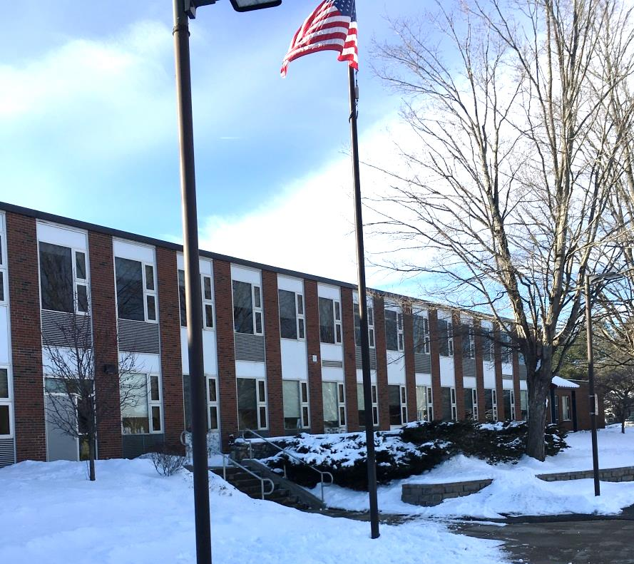

Prepared by:
Massachusetts Department of Public Health
Bureau of Environmental Health
Indoor Air Quality Program
March 2019

Background
Building: | Lenox High School (LHS)
Address: | 197 East Street, Lenox, MA
Assessment Requested by: | Kimberly Merrick, Ed.D., Superintendent Lenox School District
Date of Assessment: | February 1, 2019
Bureau of Environmental Health/Indoor Air Quality (BEH/IAQ) Program Staff Conducting Assessment: | Mike Feeney, Director, IAQ Program
Date of Building Construction: | 1966
Reason for Request: | Odor concerns

The Lenox Middle School and Lenox High School share a single brick building. This assessment examined the LHS section of the building.
Some of the wall surface veneer tiles (Picture 1) in the hallway on the LHS first and second floor were crushed, creating jagged edges. In order to provide a barrier between the wall and hallway, painter’s tarps were installed from floor to ceiling over the damaged hallway walls (Picture 2). Complaints concerning odors associated with the painter’s tarps were made by building staff.

Methods
Please refer to the IAQ Manual for methods, sampling procedures, and interpretation of results (MDPH, 2015).

Discussion

Odor
In general, painter’s tarps are a heavy, plain, woven cotton/canvas fabric that is used in many applications, including: hammocks, sandbags, heavy work clothes, clothes bags, and shower curtains. In general, cotton appears to not be associated with hypersensitivity. Cotton/canvas fabric can have an odor, which some individuals may find irritating.

Ventilation

Configuration and Draw of Air from Hallway
Of note is the configuration of the heating, ventilating and air-conditioning (HVAC) system in the building. Hallways do not appear to have fresh air supply or exhaust vents. Without this equipment, the only air movement in hallways would be created by the passage of building occupants, opening of exterior doors and/or the operation of classroom HVAC systems with hallway doors open. Based on observations, it is likely that odors associated with the cotton/canvas fabric are drawn into classrooms when hallway doors are open.
Fresh air is supplied to classrooms by unit ventilator (univent) systems (Picture 3). A univent draws air from the outdoors through a fresh air intake located on the exterior wall of the building and returns air through an air intake located at the base of the unit (Figure 1). Fresh and return air are mixed, filtered, heated, and provided to classrooms through an air diffuser located in the top of the unit.
Each room has exhaust ventilation provided by either a vent located inside of the closet (Picture 4) or by a unit exhaust ventilator (Picture 5). At the time of this assessment, neither exhaust vents nor the unit exhaust ventilators were functioning, which means that no means existed to vent odors from classrooms. As noted previously, univents recirculate a portion of air from classrooms, which would then draw air from the hallways if classroom doors are open. Once captured by the univent, the odor would then be heated and redistributed to the classroom via the fan.

Other Ventilation Issues
Univents and unit exhaust ventilators were also found obstructed by various items on top and along the front. In order to operate as designed, intakes/returns must remain free of obstructions. Importantly, these units must remain “on” and be allowed to operate while rooms are occupied.
In addition, univents and univent exhausts are original to the building’s construction, which makes them over 50 years old. Efficient function of such aged equipment is difficult, since compatible replacement parts are often unavailable. According to the American Society of Heating, Refrigeration, and Air-Conditioning Engineering (ASHRAE), the service life for a unit heater (hot water or steam) is 20 years, assuming routine maintenance of the equipment (ASHRAE, 1991). Despite attempts to maintain the equipment, the operational lifespan of this equipment has been exceeded.
To maximize air exchange, we recommend that both supply and exhaust ventilation operate continuously during periods of occupancy. Thermostats should be set to the fan “on” setting during occupied hours to provide a continuous source of fresh air and filtration.

Conclusions/Recommendations
The conditions related to IAQ problems at the LHS raise a number of issues. If the univents and exhaust systems operate with classroom hallway doors open, odors associated with the cotton/canvas can be drawn into classrooms. These odors will tend to accumulate since hallways do not appear to have any vents that are part of the building HVAC system, nor was there functional exhaust ventilation in classrooms.
- Address odors directly using these three methods in order of priority:
  - Use large fans of sufficient capacity to ventilate the hallways in areas with tarps when weather becomes temperate. At minimum one fan should be placed in an exterior door/open window to eject air from the building with another window or door open on an opposite side of the building to provide make-up airflow. As needed, more fans can be placed to direct airflow to the exterior door fan.
  - Consider laundering each sheet of fabric to help reduce odors. Ensure that all sheets are completely dry prior to re-hanging to prevent mold growth. Use scent-free detergents and avoid fabric softeners or other additives that may have an odor.
  - If laundering does not reduce odors, consideration should be given to replacing the cotton/canvas fabric with an alternative material, such as house wrap, that is water resistant. Please note that newly hung house wrap may have a residual plastic odor. If installed, using fans to air out hallways is recommended.
- Improve the function of various components of the HVAC system so it can function as designed, including:
  - Survey classrooms to determine if an adequate air supply exists for each room, including a functional univent. Consider consulting an HVAC engineer concerning the calibration of univent fresh air control dampers throughout the school.
  - Activate exhaust ventilation in each classroom. Make repairs as needed to restore exhaust ventilation.
  - Inspect unit exhaust motors and belts for proper function. Repair and replace as necessary.
  - Operate all ventilation systems throughout the building (e.g., gym, locker rooms, cafeteria, classrooms) continuously during periods of school occupancy and independent of thermostat control. To increase airflow in classrooms, set univent controls to “high.”
  - Remove all blockages from univents and exhaust vents to ensure adequate airflow.
  - Close classroom doors to maximize air exchange.
- Use openable windows in conjunction with classroom univents and exhaust vents to increase air exchange during temperate weather. Care should be taken to ensure windows are properly closed at night and weekends to avoid the freezing of pipes and potential flooding.
- Consider adopting the US EPA (2000) document, “Tools for Schools”, as an instrument for maintaining a good IAQ environment in the building. This document is available at: http://www.epa.gov/iaq/schools/index.html.
- Refer to resource manual and other related IAQ documents located on the MDPH’s website for further building-wide evaluations and advice on maintaining public buildings. These documents are available at: www.mass.gov/dph/iaq.

References
ASHRAE. 1991. ASHRAE Applications Handbook, Chapter 33 “Owning and Operating Costs”. American Society of Heating, Refrigeration and Air Conditioning Engineers, Atlanta, GA.
MDPH. 2015. Massachusetts Department of Public Health. “Indoor Air Quality Manual: Chapters I-III”. Available from http://www.mass.gov/eohhs/gov/departments/dph/programs/environmental-health/exposure-topics/iaq/iaq-manual/
US EPA. 2000. Tools for Schools. Office of Air and Radiation, Office of Radiation and Indoor Air, Indoor Environments Division (6609J). EPA 402-K-95-001, Second Edition. http://www.epa.gov/iaq/schools/index.html.
Picture 1
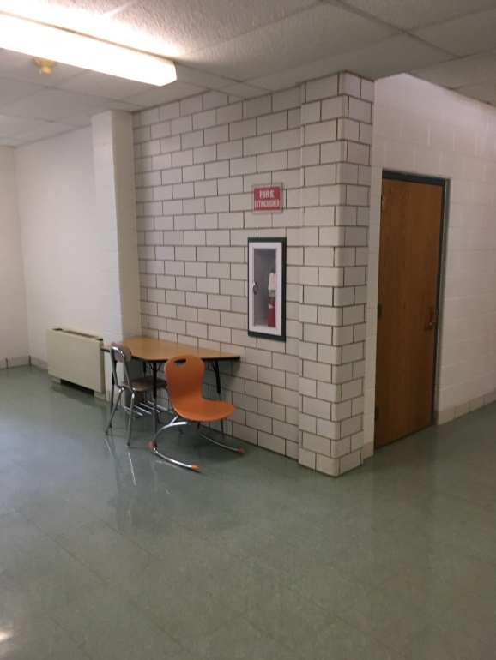
Example of intact surface veneer tiles
Picture 2
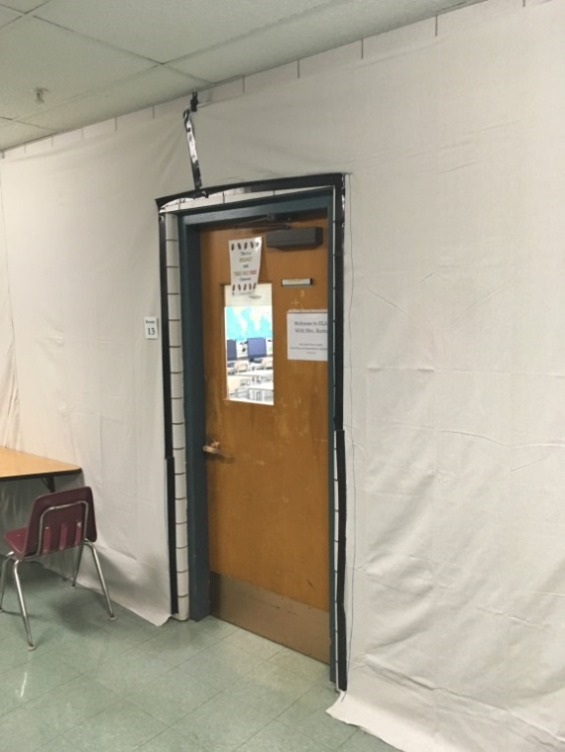
Floor-to-ceiling cotton/canvas fabric sheet
Picture 3
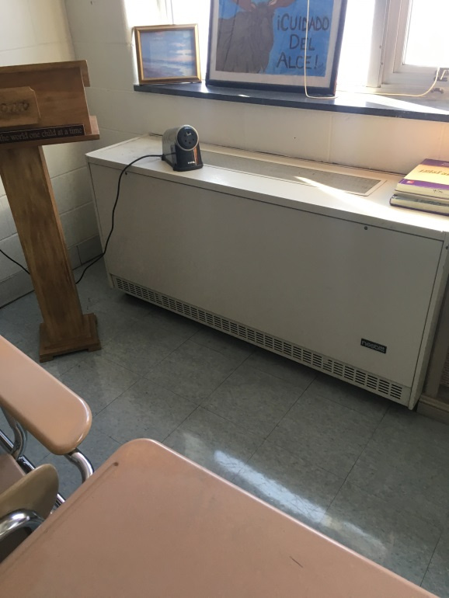
Unit ventilator (univent)
Picture 4
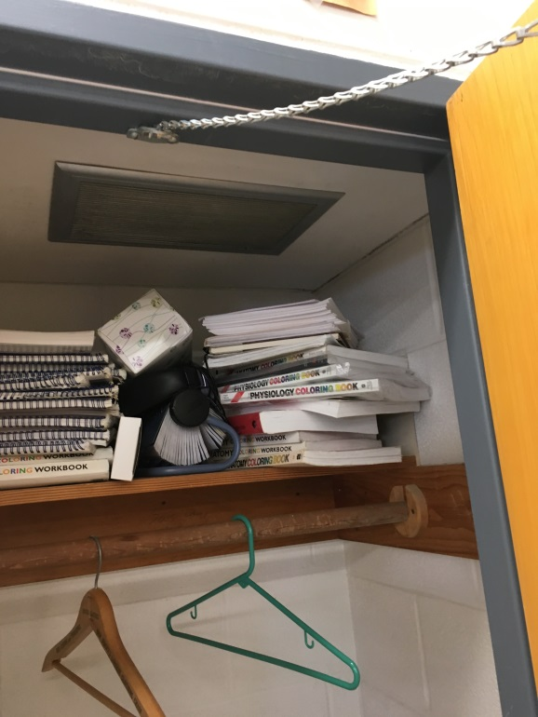
Closet exhaust vent
Picture 5
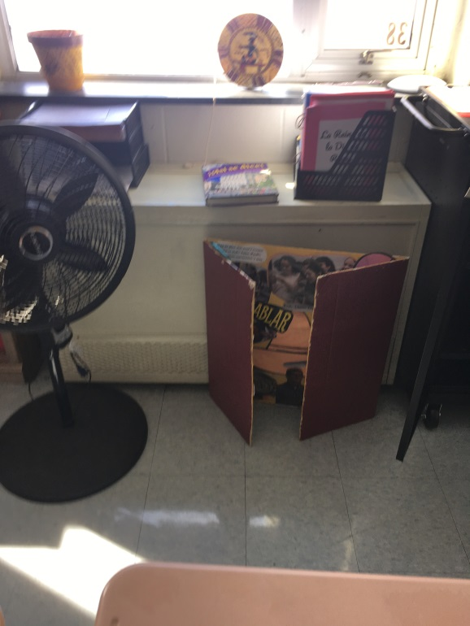
Unit exhaust ventilator

The service life is the median time during which a particular system or component of …[an HVAC]… system remains in its original service application and then is replaced. Replacement may occur for any reason, including, but not limited to, failure, general obsolescence, reduced reliability, excessive maintenance cost, and changed system requirements due to such influences as building characteristics or energy prices (ASHRAE, 1991).

