**WATER DAMAGE ASSESSMENT**

**Leominster City Hall**

**Basement floor**

**25 West Street**

**Leominster, Massachusetts**

Leominster City Hall
25 West Street
Leominster, Massachusetts


Prepared by:

Massachusetts Department of Public Health

Bureau of Environmental Health

Indoor Air Quality Program

July, 2021

# BACKGROUND

|  |  |
| --- | --- |
| **Building:** | Leominster City Hall (LCH)  Basement Office |
| **Address:** | 25 West Street, Leominster, MA |
| Assessment Requested by: | Christopher Knuth, Director, Leominster Health Department |
| **Reason for Request:** | Water damage assessment in basement offices and meeting room |
| **Date of Assessment:** | June 11, 2021 |
| **Massachusetts Department of Public Health/Bureau of Environmental Health (MDPH/BEH) Staff Conducting Assessment:** | Mike Feeney, Director, Indoor Air Quality (IAQ) Program |
| **Building Description:** | The LCH is a two-story, brick building with an occupied basement constructed in 1915. The interior of the building was renovated in the 1970s, which created offices in the basement and installation of a heating, ventilation and air-conditioning (HVAC) system. |
| **Windows:** | Openable |

# METHODS

DPH staff conducted a visual assessment of water-damaged materials. Please refer to the IAQ Manual for methods, sampling procedures, and interpretation of results (MDPH, 2015).

# RESULTS and DISCUSSION

## Previous IAQ Program Recommendations

## The IAQ Program previously evaluated the LCH in 2006. The report of that visit is included as Appendix A.

## Ventilation

## Mechanical ventilation in office space is provided by ceiling or floor-mounted fan coil units (FCUs). It is important to note that FCUs do not draw fresh air from outdoors through an air intake, rather they recirculate existing air. The sole source of fresh air is via opening windows. However, the use of windows in the basement office at the front of the building is limited due to reports of vehicle exhaust from traffic. During the visit, FCUs were found deactivated throughout the building. The operation of FCUs will aid in air movement, which may increase comfort in basement offices.

## As noted in the previous report (Appendix A), the building was originally designed to use openable windows to create cross-ventilation to provide comfort for building occupants using windows on opposing exterior walls and transoms. The basement appears to have been designed mainly as a single, open space, which facilitated airflow. Offices were later constructed with doors that do not have transoms, obstructing airflow.

## Microbial Concerns

Conditions noted in the LCH may have been influenced by previous extended periods of hot, humid weather. During the summer of 2018, the Boston area experienced an unprecedented period of extended hot, humid weather. According to the Washington Post (WP), “[d]ata…show[s]…cities in the Northeast have witnessed such humidity levels for record-challenging duration...[i]ncluding Albany, Boston, Burlington Portland and Providence” during the summer of 2018 (WP, 2018). “Boston and nearby locations… [saw]…historic numbers of those warm nights with low temperatures at or above 70 degrees…Providence and Blue Hill Observatory have already broken their annual records” (WP, 2018).

During the summer of 2021, several periods of extended hot, humid weather have occurred, in conjunction with extended periods of heavy rain, which can lead to excessive amounts of water vapor into the LCH via air infiltration through windows, leaks around exterior doors and frames and/or through exterior doors opening.

If a building does not have adequate exhaust ventilation and air chilling capacity to remove/reduce relative humidity, then hot/moist air can linger to increase discomfort as well as possibly wet materials that may lead to mold growth. With the subdivision of the basement offices (Suite 10) located in the front of the building, they were not provided with a means to exhaust air via ductwork or passive vents. As reported by LCH staff, the main door to the basement office Suite 10 is kept open to allow air circulation and prevent the buildup of humidity in the corner office that contains a ceiling-mounted FCU. Suite 10 does not have a transom. The only means to provide airflow would be to keep the Suite 10 main door open.

Water-damaged ceiling tiles were noted in Suite 10 (Picture 1) as well as the City Council meeting room (Picture 2). The likely source of moisture wetting ceiling tiles is condensation dripping from the HVAC system chilled water pipes that have either no or water-damaged insulation (Picture 3). The ability of insulation to prevent temperature transfer is expressed with an R-value rating. The materials of the insulation as well the thickness of the batt determine the R-value. Water exposure to insulation will reduce the ability of insulation to prevent temperature transfer, which may cause the outer surface of insulation to have a temperature at or below the dew point. The key to managing condensation in hot, humid weather indoors is understanding dew point. When warm, moist air passes over a cooler surface, condensation can form. Condensation is the collection of moisture on a surface at or below the dew point. The dew point is the temperature that air must reach for saturation to occur. If a building material/component has a temperature *below the dew point*, condensation will accumulate on that material. Over time, condensation can collect and form water droplets.

According to American Society of Heating, Refrigerating and Air-Conditioning Engineers (ASHRAE), if relative humidity exceeds 70%, mold growth may occur due to wetting of building materials (ASHRAE, 1989). It is recommended that porous material be dried with fans and heating within *24 to 48 hours of becoming wet* (US EPA, 2008, ACGIH, 1989). Based on observations made in the basement of the LCH, water-damaged ceiling tiles should be removed in a manner consist with the United States Environmental Protection Agency (US EPA) recommendations. In order to prevent building components from becoming wet, it is likely necessary to replace water-damaged chilled water pipe insulation. It is important to note that porous building materials, once mold-colonized, cannot be adequately cleaned to remove mold growth.

# CONCLUSIONS AND RECOMMENDATIONS

The conditions related to IAQ at the LCH raise a number of issues regarding condensation. A combination of the following conditions likely resulted in water damage of ceiling tiles and pipe insulation:

* The unusually hot, humid weather experienced in New England during the summers of 2018 and 2021 caused hot humid air to accumulate in the basement.
* Chilled water pipes above the suspended ceiling had a temperature at or below the dew point, which in turn accumulated condensation to chronically wet insulation and ceiling tiles.
* Suite 10 does not have a transom, which requires the door to be open to create airflow and reduce water vapor accumulation.

In general, eliminating/limiting the source of water damage is the preferred method for preventing mold growth inside of buildings. In view of the findings at the time of the visit, the following recommendations are made:

1. Keep the door to Suite 10 open during hot, humid weather to promote airflow.
2. All water-damaged material should be removed in a manner consistent with recommendations listed in the US EPA’s “Mold Remediation in Schools and Commercial Buildings” (US EPA, 2008). This work should be performed when the building is unoccupied. In addition, due to the age of the building and the presence of asbestos-containing floor tiles, all work should be done in accordance with state and federal regulations.
3. Consult a building engineer to ascertain the best method(s) to insulate chilled water pipes.
4. Consider using the methods described in the document “Preventing Mold Growth in Massachusetts Schools During Hot, Humid Weather” to help reduce the impact of hot, humid weather in the balcony space. This guideline is attached as Appendix B and can be found online at: <https://www.mass.gov/service-details/preventing-mold-growth-in-massachusetts-schools-during-hot-humid-weather>
   * As noted in this document, according to ASHRAE, if relative humidity exceeds 70%, mold growth may occur due to wetting of building materials (ASHRAE, 1989).
   * Monitoring weather for predicted outdoor relative humidity over 70% for over 2 consecutive days is recommended to implement the guidelines is highly recommended. This is mostly likely to occur during summer heatwave conditions in New England.
5. Refer to the resource manual and other related indoor air quality documents located on the MDPH’s website for further building-wide evaluations and advice on maintaining public buildings. These documents are available at <http://mass.gov/dph/iaq>.

# REFERENCES

ACGIH. 1989. Guidelines for the Assessment of Bioaerosols in the Indoor Environment. American Conference of Governmental Industrial Hygienists, Cincinnati, OH.

ASHRAE. 1989. Ventilation for Acceptable Indoor Air Quality. American Society of Heating, Refrigeration and Air Conditioning Engineers. ANSI/ASHRAE 62-1989.

MDPH. 2015. Massachusetts Department of Public Health. Indoor Air Quality Manual: Chapters I-III. Available at: <https://www.mass.gov/lists/indoor-air-quality-manual-and-appendices#indoor-air-quality-manual->

US EPA. 2008. “Mold Remediation in Schools and Commercial Buildings”. Office of Air and Radiation, Indoor Environments Division, Washington, DC. EPA 402-K-01-001. September 2008. Available at: <http://www.epa.gov/mold/mold-remediation-schools-and-commercial-buildings-guide>.

WP. 2018. ‘It’s been relentless’: Smothering summer humidity in the Northeast has crushed records. Washington Post, Washington, DC. <https://www.washingtonpost.com/news/capital-weather-gang/wp/2018/08/30/its-been-relentless-smothering-summer-humidity-in-the-northeast-has-crushed-records/>

**Picture 1**

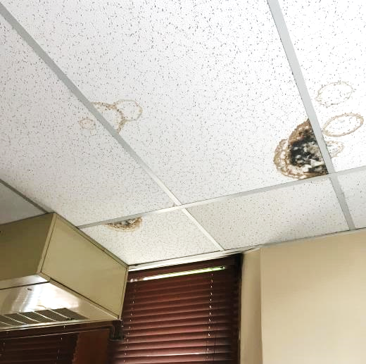

**Water-damaged (and mold-colonized) ceiling tiles**

**Picture 2**

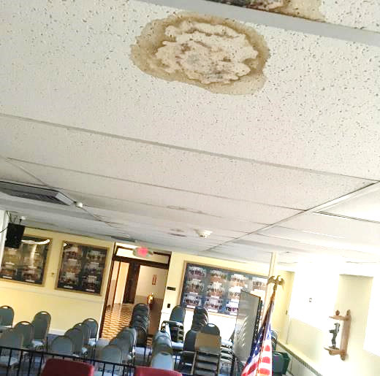

**Water-damaged ceiling tiles in City Council room. Note stains appear in a straight pattern (dashed line), indicating that the chilled water pipe of the HVAC system is the likely source of condensation**

**Picture 3**

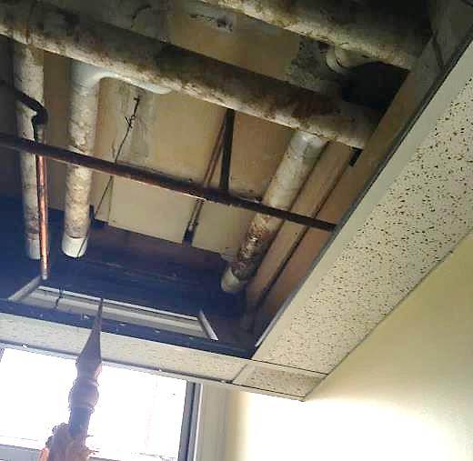

**Water-damaged pipe insulation, likely due to condensation**

**INDOOR AIR QUALITY ASSESSMENT**

**Leominster City Hall**

**25 West Street**

**Leominster, Massachusetts**

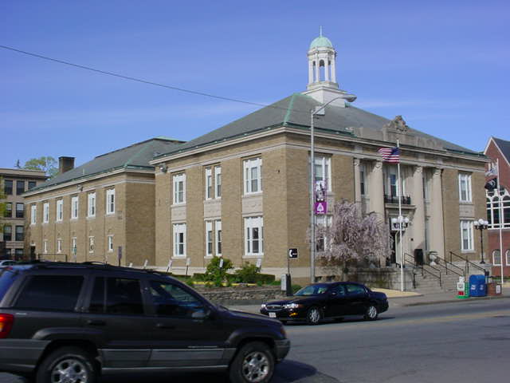

Prepared by:

Massachusetts Department of Public Health

Center for Environmental Health

Emergency Response/Indoor Air Quality Program

October 2006

**Background/Introduction**

At the request of Christopher Knute, Director of the Leominster Health Department, an indoor air quality assessment was conducted at the Leominster City Hall (LCH),25 West Street, Leominster, Massachusetts. The assessment was conducted by the Massachusetts Department of Public Health (MDPH), Center for Environmental Health (CEH). On April 21, 2006, Michael Feeney, Director of CEH’s Emergency Response/Indoor Air Quality (ER/IAQ) Program, made a visit to this building.

The LCH is a two-story, brick building with an occupied basement constructed in 1915. The interior of the building was renovated in the 1970s, which created offices in the basement and installation of a heating, ventilation, and air-conditioning system. Windows in the building are openable.

# Methods

Air tests for carbon dioxide, temperature and relative humidity were taken with the TSI, Q-Trak, IAQ Monitor, Model 8551.

# Results

The building has an employee population of 25 and can be visited by several hundred members of the public daily. The tests were taken under normal operating conditions. Test results appear in Table 1.

**Discussion**

**Ventilation**

It can be seen from Table 1 that the carbon dioxide levels were below 800 parts per million (ppm) of air in the majority of areas surveyed indicating adequate air exchange. The exception was in the Health Department offices located in the basement, which had carbon dioxide levels above 800 ppm, indicating poor air exchange. Please note that many offices were not occupied during the assessment, which can greatly reduce carbon dioxide. Carbon dioxide levels would be expected to be higher with increased occupancy.

Mechanical ventilation in office space is provided by ceiling or floor-mounted fan coil units (FCUs) (Picture 1). However, the FCUs do not draw fresh air from outdoors through an air intake, rather they recirculate existing air. The sole source of fresh air is via opening windows. The use of the windows in basement office at the front of the building is limited due to reports of vehicle exhaust from traffic near the building. During the visit, FCUs were found deactivated throughout the building. The operation of FCUs will aid in air movement, which may increase comfort in basement offices.

The building was originally designed to use openable windows to create cross-ventilation to provide comfort for building occupants using windows on opposing exterior walls. In addition, the building has hinged windows located above the hallway doors. The hinged window (called a transom) (Picture 2) enables occupants to close hallway doors while maintaining a pathway for airflow into the room. This design allows for airflow to enter an open window, pass through a room, pass through the open transom, enter the hallway, pass through the opposing open room transom, into the opposing room and exit the building on the leeward side (opposite the windward side) (Figure 1). With all windows and transoms open, airflow can be maintained in a building regardless of the direction of the wind. This system fails if the windows or transoms are closed (Figure 2). Most transoms were closed and rendered redundant since the FCUs also provide cooling during summer months.

Large meeting areas are equipped with ceiling or wall mounted fresh air diffusers and return vents connected to air handling units (AHUs) with fresh air intakes and exhausts, located in the boiler room. Of note is the fresh air supply ductwork above the ceiling in the City Council Meeting room, which has a large breach, allowing air to escape and pressurize the ceiling plenum above the room (Picture 3). Airflow in the ceiling plenum would disturb dust and dirt and have the potential to migrate into the room through the ceiling system.

The Massachusetts Building Code requires a minimum ventilation rate of 20 cubic feet per minute (cfm) per occupant of fresh outside air or have openable windows in each room (SBBRS, 1997; BOCA, 1993). The ventilation must be on at all times that the room is occupied. Providing adequate fresh air ventilation with open windows and maintaining the temperature in the comfort range during the cold weather season is impractical. Mechanical ventilation is usually required to provide adequate fresh air ventilation.

Carbon dioxide is not a problem in and of itself. It is used as an indicator of the adequacy

of the fresh air ventilation. As carbon dioxide levels rise, it indicates that the ventilating system is malfunctioning or the design occupancy of the room is being exceeded. When this happens a buildup of common indoor air pollutants can occur, leading to discomfort or health complaints. The Occupational Safety and Health Administration (OSHA) standard for carbon dioxide is 5,000 parts per million parts of air (ppm). Workers may be exposed to this level for 40 hours/week based on a time weighted average (OSHA, 1997).

The MDPH uses a guideline of 800 ppm for publicly occupied buildings. A guideline of 600 ppm or less is preferred in schools due to the fact that the majority of occupants are young and considered to be a more sensitive population in the evaluation of environmental health status. Inadequate ventilation and/or elevated temperatures are major causes of complaints such as respiratory, eye, nose and throat irritation, lethargy, and headaches. For more information on carbon dioxide see Appendix A.

Temperature readings ranged from 69º F to 75º F, which were within or very close to the lower end of the MDPH recommended comfort range the day of the assessment. The MDPH recommends that indoor air temperatures be maintained in a range of 70º F to 78º F in order to provide for the comfort of building occupants. In many cases concerning indoor air quality, fluctuations of temperature in occupied spaces are typically experienced, even in a building with an adequate fresh air supply.

The relative humidity measured in the building ranged from 26 to 36 percent, which was below the MDPH recommended comfort range on the day of the assessment. The MDPH recommends a comfort range of 40 to 60 percent for indoor air relative humidity. It is important to note however, that relative humidity measured indoors exceeded outdoor measurements (range +3 to 13 percent). Without the aid of mechanical ventilation or dehumidification, moisture removal is difficult. Moisture removal is important since the sensation of heat increases as relative humidity increases (the relationship between temperature and relative humidity is called the heat index). If moisture is removed, the comfort of the individuals is increased. Removal of moisture from the air, however, can have some negative effects. Relative humidity levels in the building would be expected to drop during the winter months due to heating. The sensation of dryness and irritation is common in a low relative humidity environment. Low relative humidity is a very common problem during the heating season in the northeast part of the United States.

**Microbial/Moisture Concerns**

Building occupants reported odors from the elevator carpet. Sometime after the 1970s renovation, an elevator was added to the west wall of the LCH. A room containing the elevator motor was constructed on the basement level, with a passive vent installed in the exterior wall of the building (Picture 4). A corresponding vent exists in the elevator shaft wall (Picture 5). The purpose of these vents is to equalize air pressure in the elevator shaft as the car moves. Since this room is open to the outdoors, the room and elevator shaft likely becomes extremely cold in the winter, as confirmed by employees in the office that contains the elevator room entrance. Cold air would then be drawn into the elevator shaft. Under these circumstances the elevator car floor can be prone to condensation.

If cold air penetrates into the elevator shaft, it may come in contact with warm building materials (e.g., elevator shaft), and result in condensation. Condensation is the collection of moisture on a surface that has a temperature below the dew point. The dew point is a temperature that is determined by air temperature and relative humidity. As an example, at a temperature of 70o F and relative humidity of 25 percent indoors, the dew point for water to collect on a surface is approximately 32 o F (IICR, 2000). Therefore, any surface that has a temperature below 32 o F (e.g., elevator room and likely the floor of the elevator car) would be prone to condensation generation under these temperature and relative humidity conditions. Therefore, the carpet can become repeatedly moistened, which can subsequently lead to mold growth and/or associated odors.

It appears that the designer of the elevator system was concerned with the possibility of cold air affecting the elevator motor and condensation, since an electric baseboard heater was installed in the elevator room. The heater should be activated during cold weather to heat the room and decrease condensation. In addition, a sump pump exists in the floor of the elevator room (Picture 6). The cover for the pump was off, exposing the sump pump which had standing water in it. The cover should be replaced to minimize the drawing of odors into the elevator/shaft.

Some areas had water-damaged ceiling tiles which can indicate leaks through window frames (Table 1). Water-damaged ceiling tiles can provide a medium for mold and growth and should be replaced after a water leak is discovered and repaired.

A restroom in the basement had mold colonized pipe insulation (Picture 7). This condition may indicate that the restroom does not have adequate exhaust ventilation to remove water vapor. Another restroom in the basement had a disconnected flexible duct, allowing for restroom odors and water vapor to vent into the ceiling plenum (Picture 8). Restroom vents should vent directly outdoors.

The US Environmental Protection Agency (US EPA) and the American Conference of Governmental Industrial Hygienists (ACGIH) recommends that porous materials be dried with fans and heating within 24 to 48 hours of becoming wet (US EPA, 2001; ACGIH, 1989). If porous materials are not dried within this time frame, mold growth may occur. Water-damaged porous materials (e.g., ceiling tiles, carpeting, insulation) cannot be adequately cleaned to remove mold growth. The application of a mildewcide to moldy porous materials is not recommended.

During the assessment, BOH staff indicated that mold odors existed in the office space beneath the front of the LCH. A bookcase with a pungent mold odor was identified by CEH staff as the likely source. The bookcase was removed the day of the visit, eliminating the musty odor.

Several rooms also had a number of plants. Plant soil and drip pans can serve as source of mold growth. A number of these plants did not have drip pans or were in outdoor type planters with no drainage. The lack of drip pans and drainage can lead to water pooling and mold growth on windowsills when used indoors. Wooden sills can be potentially colonized by mold growth and serve as a source of mold odor. Plants should also be located away from FCUs to prevent the aerosolization of dirt, pollen, or mold.

# Other Concerns

FCUs are normally equipped with filters that strain particulates from airflow. Filters found inside the FCUs were not of sufficient size (Picture 9). With smaller filters, particulates/debris can be drawn into and accumulate inside the FCUs. Accumulated debris

inside the FCU can obstruct airflow and may serve as a reservoir of particulates that can be re-aerosolized and distributed to occupied areas. In order to decrease aerosolized particulates, properly sized, disposable filters with an adequate dust spot efficiency should be installed. The dust spot efficiency is the ability of a filter to remove particulates of a certain diameter from air passing through the filter. Filters that have been determined by ASHRAE to meet its standard for a dust spot efficiency of a minimum of 40 percent would be sufficient to reduce airborne particulates (Thornburg, 2000; MEHRC, 1997; ASHRAE, 1992). Note that increasing filtration can reduce airflow, a condition known as pressure drop, which can reduce efficiency due to increased resistance. Prior to any increase of filtration, a ventilation engineer should be consulted as to whether the FCUs can maintain function with more efficient filters.

A number of areas contained window-mounted air conditioners. This equipment is also typically equipped with filters, which should be cleaned or changed per the manufacturer’s instructions to avoid the build-up and re-aerosolization of dirt, dust, and particulate matter.

Finally scented candles were observed in work areas. Scents and burning candles can produce aerosolized particulates and odors that can be irritating to the eyes, nose, and throat.

## Conclusions/Recommendations

In view of the findings at the time of this visit, the following recommendations are made:

1. Ensure FCUs are activated during business hours year-round. This will help to increase air circulation, particularly in the Health Department offices.
2. Remove carpet from elevator floor. Replace with a non-porous material (e.g., tile) to limit possible mold growth.
3. Replace cover on sump pump in elevator room. Install a hose in the cover to draw air from outdoors when the pump operates. Render the sump pump cover airtight with a sealant compound.
4. Use the heater in the elevator room during cold weather to prevent/limit condensation.
5. Seal the breach in the fresh air supply ductwork above the City Council Meeting Room.
6. Ensure that all FCUs have filters of sufficient size.
7. Service FCUs on a regular basis. This includes changing filters and cleaning drip pans.
8. Replace mold colonized pipe insulation in basement restroom. This material should be examined by a licensed asbestos inspector to ensure that remediation does not create an asbestos hazard.
9. Replace water-damaged ceiling tiles. Identify source of water causing water-damaged ceiling tiles (e.g., window frames) and make repairs as needed. Examine the area above and around these areas for mold growth. Disinfect areas of water leaks with an appropriate antimicrobial.
10. Ensure plants have drip pans and avoid over-watering. Examine drip pans periodically for mold growth and disinfect with an appropriate antimicrobial where necessary.
11. Avoid using candles in the building.
12. For buildings in New England, periods of low relative humidity during the winter are often unavoidable. Therefore, scrupulous cleaning practices should be adopted to minimize common indoor air contaminants whose irritant effects can be enhanced when the relative humidity is low. To control for dusts, a high efficiency particulate arrestance (HEPA) filter equipped vacuum cleaner in conjunction with wet wiping of all surfaces is recommended. Avoid the use of feather dusters. Drinking water during the day can help ease some symptoms associated with a dry environment (throat and sinus irritations).
13. Refer to resource manuals and other related indoor air quality documents for further building-wide evaluations and advice on maintaining public buildings. Materials are available on the MDPH’s website: <http://mass.gov/dph/indoor_air>.

**References**

ACGIH. 1989. Guidelines for the Assessment of Bioaerosols in the Indoor Environment. American Conference of Governmental Industrial Hygienists, Cincinnati, OH.

ASHRAE. 1992. Gravimetric and Dust-Spot Procedures for Testing Air-Cleaning Devices Used in General Ventilation for Removing Particulate Matter. American Society of Heating, Refrigeration and Air Conditioning Engineers. ANSI/ASHRAE 52.1-1992.

BOCA. 1993. The BOCA National Mechanical Code-1993. 8th ed. Building Officials & Code Administrators International, Inc., Country Club Hills, IL. M-308.1

MEHRC. 1997. Indoor Air Quality for HVAC Operators & Contractors Workbook. MidAtlantic Environmental Hygiene Resource Center, Philadelphia, PA.

OSHA. 1997. Limits for Air Contaminants. Occupational Safety and Health Administration. Code of Federal Regulations. 29 C.F.R. 1910.1000 Table Z-1-A.

SBBRS. 1997. Mechanical Ventilation. State Board of Building Regulations and Standards. Code of Massachusetts Regulations. 780 CMR 1209.0

Thornburg, D. 2000. Filter Selection: a Standard Solution. *Engineering Systems* 17:6 pp. 74-80.

US EPA. 2001. Mold Remediation in Schools and Commercial Buildings. US Environmental Protection Agency, Office of Air and Radiation, Indoor Environments Division, Washington, D.C. EPA 402-K-01-001. March 2001.







**Picture 1**

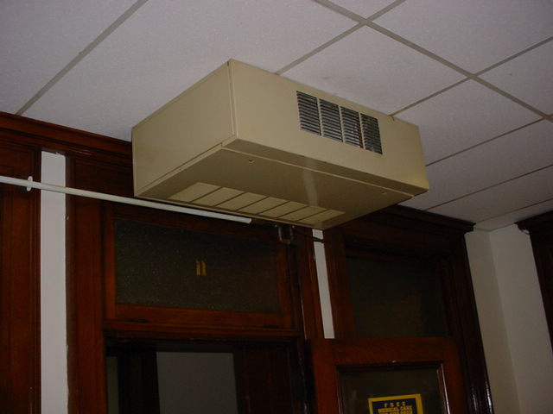

**FCU**

**Picture 2**

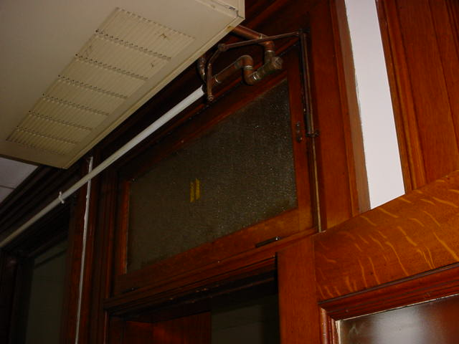

**Transom**

**Picture 3**

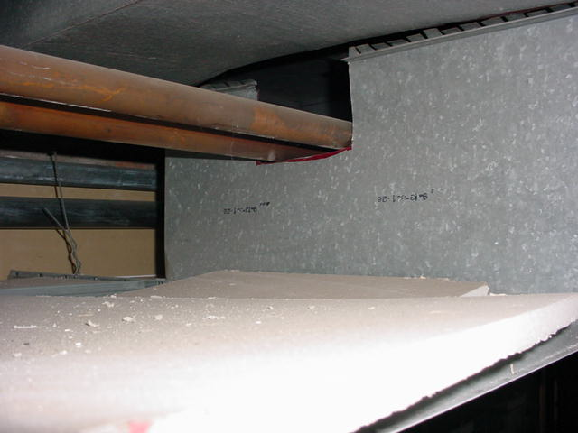

**Ductwork above City Council Meeting Room, note hole**

**Picture 4**

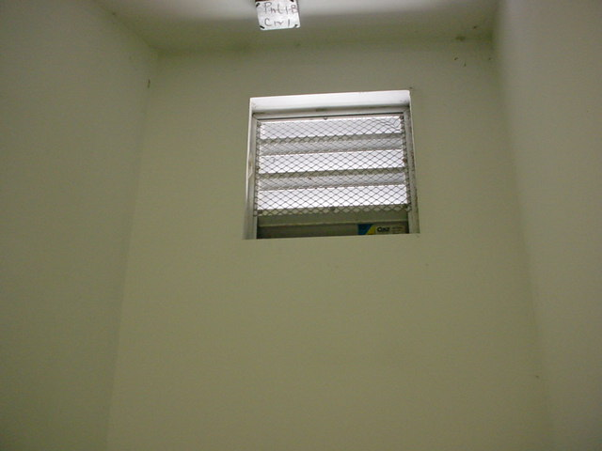

**Elevator pressure equalization vent, exterior wall**

**Picture 5**

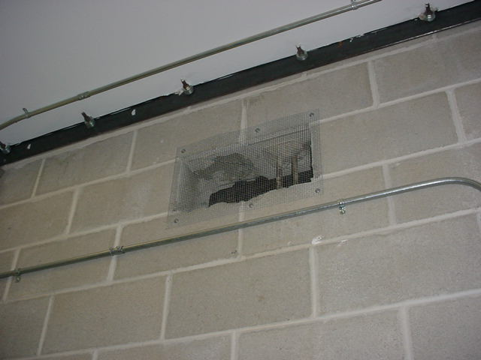

**Elevator pressure equalization vent, elevator shaft wall**

**Picture 6**

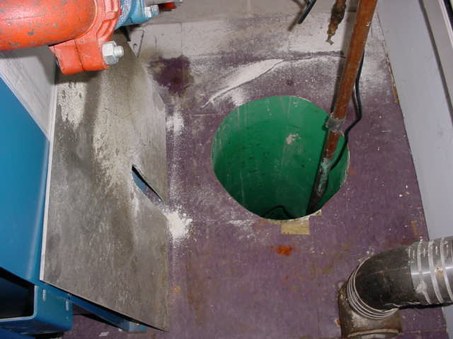

**Sump pump, note cover on floor**

**Picture 7**

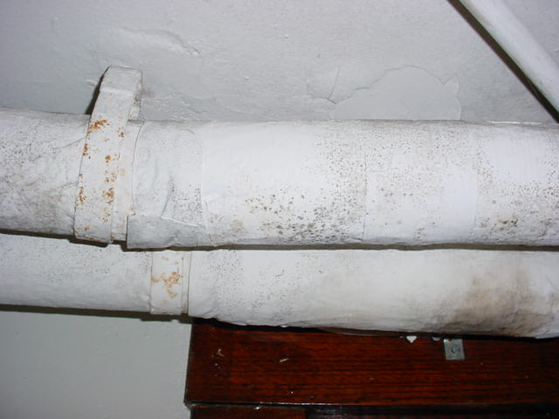

**Mold colonized pipe insulation**

**Picture 8**

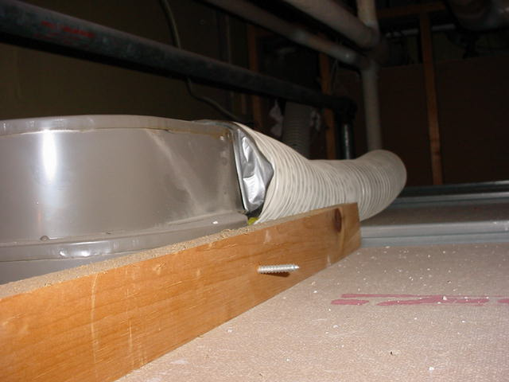

**Hose detached from rest room fan**

**Picture 9**

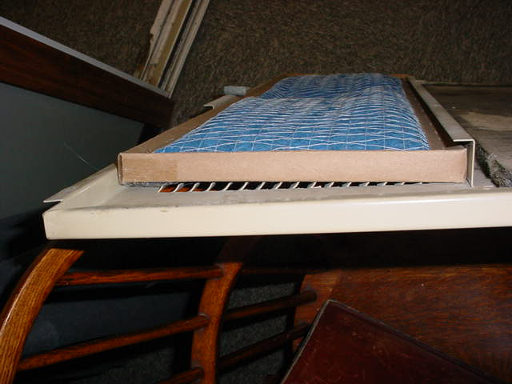

**Undersized filter in FCU**

| Location | **Carbon**  **Dioxide**  **(*ppm)** | **Temp**  **(°F)** | **Relative**  **Humidity**  **(%)** | **Occupants**  **in Room** | **Windows**  **Openable** | **Ventilation** | | **Remarks** |
| --- | --- | --- | --- | --- | --- | --- | --- | --- |
| **Supply** | **Exhaust** |
| Outside  (Background) | 381 | 68 | 23 |  |  |  |  |  |
| 11 Health Department | 827 | 69 | 35 | 1 | Y | N | N | FCU  Door open |
| 12 Health Department | 952 | 69 | 35 | 3 | Y | N | N | Moldy bookshelf  Door open |
| 12 private office | 955 | 69 | 36 | 0 | Y | N | N | Perfume odor  Door open |
| 10 reception | 654 | 70 | 31 | 1 | N | N | N | 4 water-damaged ceiling tiles  Door open |
| 10 private office | 586 | 70 | 33 | 0 | N | N | N | Plants  3 water-damaged ceiling tiles  Door open |
| 10 private office | 589 | 71 | 34 | 0 | N | N | N | Door open |
| 10 blueprint room | 549 | 71 | 34 | 0 | Y | N | N |  |
| 10 ticket office | 602 | 71 | 32 | 0 | Y | N | N | Door open |
| 15 | 590 | 70 | 30 | 3 | Y | N | N | Photocopier  Door open |
| City Council Meeting Room | 498 | 69 | 29 | 0 | Y | Y | Y | Musty odor traceable to elevator shaft  Door open |
| 9 | 640 | 71 | 29 | 1 | Y | N | N | Door open |
| 9 inner office | 569 | 73 | 27 | 2 | Y | N | N | Plants  Door open |
| 9 server room | 587 | 73 | 27 | 0 | Y | N | N | Door open |
| 10 reception | 707 | 74 | 29 | 3 | Y | N | N | Door open |
| 10 records | 688 | 75 | 28 | 0 | Y | N | N | Door open |
| 10 private office | 728 | 75 | 28 | 1 | Y | N | N | Door open |
| Meeting room | 676 | 74 | 27 | 0 | Y | N | N | Door open |
| 12 | 656 | 73 | 27 | 1 | Y | N | N | Door open  Candle on hot plate |
| 12 private office | 671 | 73 | 28 | 1 | N | N | N |  |
| Mayor’s office reception | 571 | 72 | 26 | 1 | Y | N | N |  |
| Mayor’s office | 543 | 71 | 26 | 0 | Y | N | N | 1 water-damaged ceiling tile |
| Treasurer reception | 708 | 74 | 33 | 2 | Y | N | N | Door open |
| Treasurer | 692 | 74 | 33 | 0 | Y | N | N | 1 water-damaged ceiling tile  Door open |
| 3 | 730 | 73 | 31 | 2 | Y | N | N | 1 water-damaged ceiling tile  Door open |
| 4 | 699 | 74 | 28 | 2 | Y | N | N | Door open |
| 4 comptroller | 791 | 74 | 29 | 1 | Y | N | N | Door open |
| 5 | 567 | 73 | 26 | 2 | Y | N | N | Door open |
| 6 | 682 | 73 | 28 | 1 | Y | N | N | Door open |



**BUREAU OF ENVIRONMENTAL HEALTH**

**Indoor Air Quality Program**

**Preventing Mold Growth in Massachusetts Schools**

**During Hot, Humid Weather**

June 2004

**Background/Statement of the Problem**

During the summers of 2002 and 2003, schools and other municipal buildings experienced significant mold problems. As a result, at least thirty school systems have experienced delayed school openings and/or have spent substantial funds on cleaning and remediating mold growth in schools. These mold growth problems are directly related to unusual weather patterns in New England (e.g., extended periods of hot, humid weather).

Mold growth in a building can produce eye, nose, throat, and respiratory irritation. Mold may also exacerbate pre-existing respiratory problems (e.g., asthma) and cause symptoms in hypersensitive individuals. For these reasons, it is recommended that mold contaminated materials be removed or cleaned, where feasible (US EPA, 2001).

This document provides guidance on preventing or minimizing mold growth within a building. Most mold prevention steps can be employed in any building. However, certain steps involving dehumidification can only be achieved with dehumidifiers and/or heating, ventilating, and air-conditioning (HVAC) equipment

**Understanding Dew Point**

In general, two water phases - liquid and vapor - can create conditions conducive to fungal colonization of vulnerable materials. Leaks through the building envelope (e.g., roof, exterior wall components, foundation) or plumbing problems are obvious water sources. If the indoor environment is improperly managed, high relative humidity combined with hot weather can also cause damage. Under certain conditions, condensation can accumulate and moisten materials, especially porous, carbon-containing items (e.g., gypsum wallboard, carpeting, cloth, paper, cardboard).

The key to managing condensation within a building is understanding dew point. When warm, moist air passes over a cooler surface, condensation can form. Condensation is the collection of moisture on a surface at or below the dew point. The dew point is the temperature that air must reach for saturation to occur. If a building material/component has a temperature **below the dew point**, condensation will accumulate on that material. Over time, condensation can collect and form water droplets.

For example, at a temperature of 76oF and relative humidity of 30%, the dew point temperature at which condensation can collect on a surface is approximately 42oF. At temperatures less than 43oF, water vapor can condense and form droplets on a surface. During humid weather, when the temperature is 85oF and relative humidity is 90%, the dew point is approximately 82oF. Therefore, surfaces with a temperature below 83oF are prone to condensation formation.

According to American Society of Heating, Refrigerating and Air-Conditioning Engineers (ASHRAE), if relative humidity exceeds 70%, mold growth may occur due to wetting of building materials (ASHRAE, 1989). It is recommended that porous material be dried with fans and heating within **24 to 48 hours of becoming wet** (US EPA, 2001, ACGIH, 1989). If porous materials are not dried within this time frame, mold growth may occur. Water damaged porous materials cannot be adequately cleaned to remove mold growth. To prevent condensation formation, the following points are recommended:

**Action Step:** Monitor weather through extended weathercasts to determine if hot, humid weather for more than 2 days is predicted. Many web-based weather services will provide a dew point listing.

**Action Step:** Monitor temperature of condensation prone building components with a laser thermometer. If the temperature of the building component is below the dew point during hot, humid weather, steps should be taken to decrease humidity levels.

**Reducing Relative Humidity through Mechanical Means**

***Cooling***

Cooling air is the easiest method to reducing airborne water vapor. Window-mounted air conditioners and most HVAC systems are equipped with cooling coils. Each of these cooling efforts operates by drawing air over cooling coils that are set to a temperature below the dew point. As a result, condensation forms. In this manner, moisture is removed, before air is provided to a room. Although this method is the easiest for reducing indoor relative humidity, two disadvantages exist. First, drainage for condensation must be adequate to remove water at a sufficient rate. If a significant amount of water accumulates and lingers in the drip pan, the operation of HVAC system fans can reintroduce the moisture into the air stream. In addition, stagnant water can provide a medium for mold growth and associated odors.

**Action Step:** If systems equipped with cooling coils are used to remove moisture, ensure drain pans are operating as designed. Drain pans should not rely on evaporation to remove condensation; rather, water should drain rapidly. If pans are draining improperly, the drainage should be repaired. If proper drainage cannot be provided, this method of relative humidity reduction should be avoided.

Another problem associated with using cooling coils to reduce relative humidity is the potential for condensation generation on building components. This occurs when the HVAC system chills building components below the dew point. Most problems experienced in schools occurred in August 2003, when the buildings were unoccupied. HVAC systems are typically configured for occupied rooms, where room occupants generate heat. However, lack of building occupancy reduces the waste heat in a room. If the HVAC system operates at settings for occupied rooms during extended periods of vacancy, the chilling system operates at a temperature below the design. In this manner, building components are chilled below the dew point, causing condensation to form. Under these circumstances, monitoring of building component temperatures is vital to preventing/ minimizing condensation development.

**Action Step:** Monitor temperature of condensation prone building components with a laser thermometer. If the temperature of building components is below the dew point, raise the HVAC system set point to elevate the temperature of building materials above the dew point. The temperature of insulated chilled water pipes and HVAC components in contact with chilled air should also be monitored.

***Dehumidifying***

As with window-mounted air conditioners and HVAC systems, dehumidifiers also remove moisture from an indoor environment by cooling air drawn into the system. Although this method is effective, the dehumidification process also has limitations. Condensation usually drips into a collection well. If the water in the collection well becomes stagnant, it can provide the potential for mold growth.

**Action Step:** Clean and maintain dehumidifiers as per manufacturer’s instructions. Some dehumidifiers are also equipped with condensation drain hoses. Measures should be taken to ensure water is draining out of hoses when dehumidifiers are operating.

**Action Step:** Ensure drain hoses are pointed downwards into a suitable receptacle (e.g., sink) and away from porous materials. Monitor draining when the dehumidifier is actively operating.

***Heating***

Although counterintuitive, the application of heat to building components (e.g., slab floors and foundation in contact with soil, below grade areas) can reduce condensation generation and prevent mold growth. This method is typically employed in areas lacking mechanical ventilation (e.g., storage rooms).

**Action Step:** Use carpet-drying fans to apply heat to slab floors with carpeting and below grade occupied areas with carpeting, gypsum wallboard, particleboard, plywood, or ceiling tiles.

***Increasing airflow***

By increasing the airflow of a building, accumulation of hot, moist air can be reduced, decreasing the opportunity for porous materials to become wet. Areas particularly prone to elevated moisture include storage closets and occupied spaces without mechanical ventilation.

**Action Step:** Implement the following methods to promote increased airflow:

1. Open all interior doors between rooms and closets.
2. Operate HVAC systems not equipped with chilling components (e.g., unit ventilators, or univents) with the fresh air intake vents closed.
3. Operate general exhaust ventilation system normally.
4. Arrange floor fans in hallways to circulate air.

***Operating specialized exhaust ventilation***

Activities in some non-classroom areas can generate water vapor. These areas include pools, kitchens, restrooms, and locker rooms/showers. Specially designed exhaust ventilation systems in these areas should be provided to remove both odors and water vapor. This equipment is designed to prevent migration of odors and water vapor to other areas of a building.

**Action Step:** Operate exhaust vents in restrooms and locker rooms/showers during hot, humid weather to remove water vapor. The pool exhaust ventilation should be operating at all times.

**Removing Porous Materials from Exposure to Water Vapor**

To prevent mold growth in buildings, a number of mitigation steps can be taken. Measures may include the removal of porous materials from areas likely to be in contact with surfaces that have a temperature below the dew point, or removal of porous materials from hot, humid areas.

**Action Step:** The following measures can be used to reduce fungal growth of porous materials.

1. Avoid placing wall-to-wall carpeting or other porous materials on slab in contact with soil or on floors in below grade areas.
2. Avoid placing porous materials on temperature bridges. A temperature bridge is a structure that allows cooler temperatures to transfer between two areas. Furniture made of metal is more likely to be susceptible to temperature fluctuations. Avoid storing porous materials on metal objects that are low and in contact with floor or foundation walls.
3. Store porous materials in airtight, hard plastic containers.
4. Avoid placing porous materials between fresh air supply vents and exhaust vents. The air between this equipment is likely to hold moisture since these systems are used to remove water vapor from a building interior.

**Preventing Moisture Intrusion**

***Separating occupied areas from unoccupied areas***

A crawlspace is an unoccupied area that typically consists of a dirt floor, which holds moisture. As a result, this area is prone to high relative humidity and mold growth. The crawlspace is often used as a chase way to run pipes and electrical services to rooms through a building. Crawlspaces are usually present in schools that are equipped with univents connected to heating pipes. Spaces and holes in walls and floors provide a pathway for crawlspace air to penetrate classrooms. Breaches around pipes also provide a means for crawlspace air and associated odors/particles to be drawn and distributed to classrooms via univents. In order to prevent moisture and potential fungal pollutant migration from the crawlspace to occupied areas, penetrations should be rendered airtight.

**Action Step:** Seal holes/breaches with an appropriate fire-rated sealant compound to prevent air draw from the crawlspace.

***Reducing the Water Load on the Building Envelope***

Breaches in the building envelope or water pooling on/against a building structure can also result in water penetration and subsequent mold growth. Buildings are typically designed for minimal water impingement via building envelope components, including the roof, exterior walls, foundation, and other penetration points through the structures. For example, exterior wall systems should be designed weep holes and drainage plans to prevent moisture accumulation penetration.

An exterior wall system of many buildings contains an exterior curtain wall. Behind the curtain wall is an air space that allows for water to drain downward and for the exterior cladding system to dry. At the base of the curtain wall should be weep holes that allow for water drainage. Opposite the exterior wall and across the air space is a continuous, water-resistant material adhered to the back up wall that forms the drainage plane.

The purpose of the drainage plane is to prevent moisture that crosses the air space from penetrating the interior building system. The plane also directs moisture downwards toward the weep holes. The drainage plane can consist of a number of water-resistant materials, such as tarpaper or, in newer buildings, plastic wraps. The drainage plane should be continuous. Where breaks exist in the drainage plane (e.g., window systems, door systems and univent fresh air intakes), additional materials (e.g., copper flashing) are installed as transitional surfaces to direct water to weep holes. If the drainage plane is discontinuous, missing flashing or lacking air space, rainwater may accumulate inside the wall cavity and lead to water vapor/moisture penetration into the building.

In order to allow water to drain from the exterior brick wall system, a series of weep holes is customarily installed at or near the foundation slab/exterior wall system junction. Weep holes allow for accumulated water to drain from a wall system (Dalzell, 1955). Lack of weep holes in brickwork or burial of weep holes below grade will allow water to accumulate in the base of walls, resulting in seepage and possible moistening of building components.

Unless a structure is **designed** to be in contact with pooling water, efforts should be made to prevent water from pooling for extended periods. For example, standing water on flat roofs as well as water in contact with foundations and floor slabs should be removed. Mitigation efforts may include modifications to the building design and construction.

**Action Step:** Reduce pooling water around the building envelope and around the exterior wall system through the following methods:

1. Install gutters and downspouts to direct rainwater at least five feet away from the foundation. Gutters should extend along the entire roof edge.
2. Remove foliage and wood chips to no less than five feet from the foundation.
3. Improve the grading of the ground away from the foundation at a rate of 6 inches per every 10 feet (Lstiburek & Brennan, 2001).
4. Install a water impermeable layer (e.g., clay cap) on ground surface to prevent water saturation of ground near foundation (Lstiburek & Brennan, 2001).
5. Remove trees in close proximity to building to increase drying of exterior walls.
6. Ensure weep holes in exterior walls are not blocked with wicks or buried below grade. Weep holes must be free of blockage and located above grade to allow water to drain and air to penetrate and aid in drying into the drainage plane. Configure the weep hole opening to prevent insect entry into the drainage plane.

**Questions**

If you have any questions concerning these guidelines, please contact:

Massachusetts Department of Public Health

Bureau of Environmental Health

Indoor Air Quality Program

250 Washington Street, 7th Floor

Boston, MA 02108

Phone: (617) 624-5757

Fax: (617) 624-5777

*Document Reviewed: August 2008*

**References**

ACGIH. 1989. Guidelines for the Assessment of Bioaerosols in the Indoor Environment. American Conference of Governmental Industrial Hygienists, Cincinnati, OH.

ASHRAE. 1989. Ventilation for Acceptable Indoor Air Quality. American Society of Heating, Refrigerating, and Air-Conditioning Engineers, Atlanta, GA. ANSI/ASHRAE 62-1989.

Dalzell, J.R. 1955. *Simplified Masonry Planning and Building*. McGraw-Hill Book Company, Inc. New York, NY.

Lstiburek, J. & Brennan, T. 2001. Read This Before You Design, Build or Renovate. Building Science Corporation, Westford, MA. U.S. Department of Housing and Urban Development, Region I, Boston, MA

US EPA. 2001. Mold Remediation in Schools and Commercial Buildings. US Environmental Protection Agency, Office of Air and Radiation, Indoor Environments Division, Washington, D.C. EPA 402-K-01-001. March 2001. <http://www.epa.gov/iaq/molds/mold_remediation.html>