INDOOR AIR QUALITY ASSESSMENT

Lester J. Gates Intermediate School
327 1st Parish Road
Scituate, Massachusetts

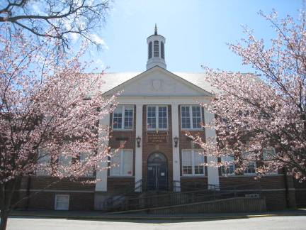

Prepared by:
Massachusetts Department of Public Health
Bureau of Environmental Health
Indoor Air Quality Program
June 2013

Background/Introduction
At the request of a parent, the Massachusetts Department of Public Health’s (MDPH), Bureau of Environmental Health (BEH) conducted an indoor air quality (IAQ) assessment at the Lester J. Gates Intermediate School (GIS), 327 1st Parish Road, Scituate, Massachusetts. On April 25, 2013, a visit was made to the GIS by Cory Holmes, Environmental Analyst/Inspector for BEH’s IAQ Program, and Ruth Alfasso, Environmental Engineer/Inspector for BEH’s IAQ Program. The request was in response to general building/IAQ concerns. The assessment was coordinated through Mr. Paul Donlan, Business Manager for Scituate Public Schools.
The GIS is a multi-level building with wings built at different times. The original portion of the building (B-wing) was constructed in the late 1920s, has three stories and contains the main office suite, classrooms, media center, storage, boiler/maintenance areas and the kitchen/cafeteria. The B-wing has a slate roof. The A-wing is two-story structure that was built in the early 1950s which has a rubber membrane/asphalt-shingled roof and contains the gym, locker rooms, nurse’s office and classrooms. The C-wing is a one-story addition with a gravel roof that was built in the mid-1950s. Windows are openable throughout the school.
It was reported to BEH/IAQ staff that the Town of Scituate is currently examining the feasibility of various options for a new school that will replace the GIS. However, since the construction of a new school building, if approved, may be several years off, Mr. Donlan reported that a number of upgrades/maintenance projects have been made to improve conditions in the building including: boiler plant upgrades, roof repairs, exterior brick re-pointing and a thorough inspection/repair/balancing of mechanical ventilation components and controls.

Methods
Air tests for carbon dioxide, carbon monoxide, temperature and relative humidity were conducted with the TSI, Q-Trak, IAQ Monitor, Model 7565. Air tests for airborne particle matter with a diameter less than 2.5 micrometers were taken with the TSI, DUSTTRAK™ Aerosol Monitor Model 8520. BEH/IAQ staff also performed a visual inspection of building materials for water damage and/or microbial growth.

Results
The school houses approximately 535 students in seventh and eighth grade with approximately 70-75 staff members. Tests were taken during normal operations, and results appear in Table 1.

Discussion

Ventilation
It can be seen from Table 1 that carbon dioxide levels were above 800 parts per million (ppm) in 22 of 57 areas (Table 1), indicating less than optimal air exchange in more than a third of the areas surveyed at the time of assessment. Many areas were unoccupied or were sparsely populated; carbon dioxide levels would be expected to be higher with increased occupancy. In several areas, ventilation equipment was found deactivated, therefore no means of mechanical ventilation was being provided to these areas at the time of testing (Table 1).
Fresh air to the majority of classrooms is supplied by unit ventilator (univent) systems (Pictures 1 and 2). A univent draws air from the outdoors through a fresh air intake located on the exterior wall of the building (Pictures 3 and 4). Return air from the classroom is drawn through an air intake located at the base of the unit (Figure 1). Fresh and return air are mixed, filtered, heated and provided to classrooms through an air diffuser located in the top of the unit. As mentioned, a number of univents were found deactivated at the time of assessment (Table 1). In addition, some univents were found obstructed by furniture and other items on top of air diffusers and/or in front of return vents along the bottom of the units. In order for univents to provide fresh air as designed, they must remain “on” and operating while rooms are occupied and remain free of obstructions.
It was reported to BEH/IAQ staff that filters are only changed once a year. In the experience of BEH/IAQ staff, univent filters are typically replaced two to four times a year in other school districts across the state. Univents examined had filters occluded with dust and debris (Pictures 5 and 6). In addition, accumulated dust/debris was noted on the inside of cabinets, radiator fins and other components (Pictures 7 and 8). This material should be cleaned/removed during regular filter changes.
Note that the univents are original equipment and thus more than 50 years old. Function of equipment of this age is difficult to maintain, since compatible replacement parts are often unavailable. According to the American Society of Heating, Refrigeration and Air-Conditioning Engineers (ASHRAE), the service life for a unit heater, hot water or steam is 20 years, assuming routine maintenance of the equipment (ASHRAE, 1991). Despite attempts to maintain the univents, the operational lifespan of the equipment has been exceeded. Maintaining the balance of fresh air to exhaust air will become more difficult as the equipment ages and as replacement parts become increasingly difficult to obtain.
Exhaust ventilation for classrooms with univents is provided by wall-mounted exhaust vents ducted to rooftop motors. Some of the wall-mounted exhaust vents were obstructed at the time of assessment. As with supply ventilation, exhaust ventilation must be free of blockages and allowed to operate while the building is occupied.
Mechanical ventilation for interior classrooms and common areas (e.g., auditorium, gymnasium) is provided by rooftop air handling units (AHUs). Fresh air is distributed via ceiling or wall-mounted air diffusers or supply grills and ducted back to the AHUs via ceiling or wall-mounted return vents. In some of these interior rooms, the ventilation system was not operating.
To maximize air exchange, the MDPH recommends that both supply and exhaust ventilation operate continuously during periods of occupancy. In order to have proper ventilation with a mechanical supply and exhaust system, the systems must be balanced to provide an adequate amount of fresh air to the interior of a room while removing stale air from the room. It is recommended HVAC systems be re-balanced every five years to ensure adequate air systems function (SMACNA, 1994). It was reported that the systems were balanced within the last year as a part of an overall maintenance effort for the school’s physical systems.
Minimum design ventilation rates are mandated by the Massachusetts State Building Code (MSBC). Until 2011, the minimum ventilation rate in Massachusetts was higher for both occupied office spaces and general classrooms, with similar requirements for other occupied spaces (BOCA, 1993). The current version of the MSBC, promulgated in 2011 by the State Board of Building Regulations and Standards (SBBRS), adopted the 2009 International Mechanical Code (IMC) to set minimum ventilation rates. Please note that the MSBC is a minimum standard that is not health-based. At lower rates of cubic feet per minute (cfm) per occupant of fresh air, carbon dioxide levels would be expected to rise significantly. A ventilation rate of 20 cfm per occupant of fresh air provides optimal air exchange resulting in carbon dioxide levels at or below 800 ppm in the indoor environment in each area measured. MDPH recommends that carbon dioxide levels be maintained at 800 ppm or below. This is because most environmental and occupational health scientists involved with research on IAQ and health effects have documented significant increases in indoor air quality complaints and/or health effects when carbon dioxide levels rise above the MDPH guidelines of 800 ppm for schools, office buildings and other occupied spaces (Sundell et al., 2011). The ventilation must be on at all times that the room is occupied. Providing adequate fresh air ventilation with open windows and maintaining the temperature in the comfort range during the cold weather season is impractical. Mechanical ventilation is usually required to provide adequate fresh air ventilation.
Carbon dioxide is not a problem in and of itself. It is used as an indicator of the adequacy of the fresh air ventilation. As carbon dioxide levels rise, it indicates that the ventilating system is malfunctioning or the design occupancy of the room is being exceeded. When this happens, a buildup of common indoor air pollutants can occur, leading to discomfort or health complaints. The Occupational Safety and Health Administration (OSHA) standard for carbon dioxide is 5,000 parts per million parts of air (ppm). Workers may be exposed to this level for 40 hours/week, based on a time-weighted average (OSHA, 1997).
The MDPH uses a guideline of 800 ppm for publicly occupied buildings. A guideline of 600 ppm or less is preferred in schools due to the fact that the majority of occupants are young and considered to be a more sensitive population in the evaluation of environmental health status. Inadequate ventilation and/or elevated temperatures are major causes of complaints such as respiratory, eye, nose and throat irritation, lethargy and headaches. For more information concerning carbon dioxide, consult Appendix A.
Temperatures ranged from 67°F to 75°F, which were within or slightly below the MDPH recommended guidelines (Table 1). The MDPH recommends that indoor air temperatures be maintained in a range of 70°F to 78°F in order to provide for the comfort of building occupants. In many cases concerning indoor air quality, fluctuations of temperature in occupied spaces are typically experienced, even in a building with an adequate fresh air supply. In addition, it is difficult to control temperature and maintain comfort without operating the ventilation equipment as designed (e.g., univents/exhaust vents deactivated/obstructed).
Relative humidity measurements in the building ranged from 29 to 48 percent at the time of the assessment, which were below the MDPH recommended comfort range in some areas surveyed (Table 1). The MDPH recommends a comfort range of 40 to 60 percent for indoor air relative humidity. Relative humidity levels in the building would be expected to drop during the winter months due to heating. The sensation of dryness and irritation is common in a low relative humidity environment. Low relative humidity is a very common problem during the heating season in the northeast part of the United States.

Microbial/Moisture Concerns
Water-stained ceiling tiles were observed in several classrooms (Table 1; Picture 9). These reportedly stemmed from historic roof leaks; since the most recent roof repairs have reportedly decreased leaks significantly. Water-damaged ceiling tiles should be replaced once a leak has been detected and repaired.
Plants were observed in some areas, including on top of univents (Table 1; Picture 10). Plants should be properly maintained and equipped with drip pans. Plants should also be located away from ventilation sources to prevent aerosolization of dirt, pollen or mold. Plants should also not be placed on porous materials, since water damage to porous materials may lead to microbial growth.
Several aquariums were located in one of the science classrooms, including one which appeared to have a large quantity of algal growth (Picture 11). Aquariums need to be properly maintained and cleaned so as not to emit odors; they should not be placed on or near univents.
In some areas, refrigerators and water-dispensing equipment (e.g., sinks, drinking fountains) were observed to be located directly on carpeting (Table 1; Pictures 12 and 13). These appliances can leak or spill, which can moisten carpet. It is recommended that these items be located on a non-porous surface. Areas under sinks were examined and some were found to contain porous materials, which can become moistened due to leaks or condensation.
The US Environmental Protection Agency (US EPA) and the American Conference of Governmental Industrial Hygienists (ACGIH) recommend that porous materials be dried with fans and heating within 24 to 48 hours of becoming wet (US EPA, 2001; ACGIH, 1989). If not dried within this time frame, mold growth may occur. Once mold has colonized porous materials, they are difficult to clean and should be removed/discarded.
During an examination of the exterior of the building, BEH/IAQ staff observed plants and shrubs in close proximity to the building in some areas, including directly adjacent to univent air intakes (Picture 4). Shrubs/trees in close proximity to the building hold moisture against the building exterior and prevent drying. The growth of roots against exterior walls can bring moisture in contact with the foundation. Plant roots can eventually penetrate the wall, leading to cracks and/or fissures in the sublevel foundation. Over time, these conditions can undermine the integrity of the building envelope and provide a means of water entry into the building via capillary action through exterior walls, foundation concrete and masonry (Lstiburek & Brennan, 2001). The freezing and thawing action of water during the winter months can create cracks and fissures in the foundation that can result in additional penetration points for both water and pests. Trees and shrubs can also be a source of pollen, debris and mold into univents and windows. Consideration should be given to removing landscaping in close proximity to the building so as to maintain a space of 5 feet between shrubbery and the building.
Light was visible beneath/around some exterior doors, showing that they were lacking weather-stripping or otherwise not tightly sealed. Spaces around doors can allow moisture, unconditioned air, and pests into the building.
Some of the splash pads for gutter downspouts were found to be missing or had been moved away from the end of the downspout, allowing stormwater to impinge on and accumulate next to the building foundation (Picture 14). These pads should be replaced/put back to direct rainwater away from the building.

Other IAQ Evaluations
Indoor air quality can be negatively influenced by the presence of respiratory irritants, such as products of combustion. The process of combustion produces a number of pollutants. Common combustion emissions include carbon monoxide, carbon dioxide, water vapor and smoke (fine airborne particle material). Of these materials, exposure to carbon monoxide and particulate matter with a diameter of 2.5 micrometers (μm) or less (PM2.5) can produce immediate, acute health effects upon exposure. To determine whether combustion products were present in the indoor environment, BEH/IAQ staff obtained measurements for carbon monoxide and PM2.5.

Carbon Monoxide
Carbon monoxide is a by-product of incomplete combustion of organic matter (e.g., gasoline, wood and tobacco). Exposure to carbon monoxide can produce immediate and acute health affects. Several air quality standards have been established to address carbon monoxide and prevent symptoms from exposure to these substances. The MDPH established a corrective action level concerning carbon monoxide in ice skating rinks that use fossil-fueled ice resurfacing equipment. If an operator of an indoor ice rink measures a carbon monoxide level over 30 ppm, taken 20 minutes after resurfacing within a rink, that operator must take actions to reduce carbon monoxide levels (MDPH, 1997).
The American Society of Heating Refrigeration and Air-Conditioning Engineers (ASHRAE) has adopted the National Ambient Air Quality Standards (NAAQS) as one set of criteria for assessing indoor air quality and monitoring of fresh air introduced by HVAC systems (ASHRAE, 1989). The NAAQS are standards established by the US EPA to protect the public health from six criteria pollutants, including carbon monoxide and particulate matter (US EPA, 2006). As recommended by ASHRAE, pollutant levels of fresh air introduced to a building should not exceed the NAAQS levels (ASHRAE, 1989). The NAAQS were adopted by reference in the Building Officials & Code Administrators (BOCA) National Mechanical Code of 1993 (BOCA, 1993), which is now an HVAC standard included in the MSBC (SBBRS, 2011). According to the NAAQS, carbon monoxide levels in outdoor air should not exceed 9 ppm in an eight-hour average (US EPA, 2006).
Carbon monoxide should not be present in a typical, indoor environment. If it is present, indoor carbon monoxide levels should be less than or equal to outdoor levels. Outdoor carbon monoxide concentrations were non-detect (ND) at the time of the assessment (Table 1). No measureable levels of carbon monoxide were detected inside the building during the assessment (Table 1).

Particulate Matter
The US EPA has established NAAQS limits for exposure to particulate matter. Particulate matter is airborne solids that can be irritating to the eyes, nose and throat. The NAAQS originally established exposure limits to particulate matter with a diameter of 10 μm or less (PM10). According to the NAAQS, PM10 levels should not exceed 150 micrograms per cubic meter (μg/m³) in a 24-hour average (US EPA, 2006). These standards were adopted by both ASHRAE and BOCA. Since the issuance of the ASHRAE standard and BOCA Code, US EPA established a more protective standard for fine airborne particles. This more stringent PM2.5 standard requires outdoor air particle levels be maintained below 35 μg/m³ over a 24-hour average (US EPA, 2006). Although both the ASHRAE standard and BOCA Code adopted the PM10 standard for evaluating air quality, MDPH uses the more protective PM2.5 standard for evaluating airborne particulate matter concentrations in the indoor environment.
Outdoor PM2.5 concentrations the day of the assessment were measured at 14 μg/m³. PM2.5 levels measured inside the building ranged from 5 to 14 μg/m³ (Table 1). Both indoor and outdoor PM 2.5 levels were below the NAAQS PM2.5 level of 35 μg/m³. Frequently, indoor air levels of particulates (including PM2.5) can be at higher levels than those measured outdoors. A number of activities that occur indoors and/or mechanical devices can generate particulate during normal operations. Sources of indoor airborne particulates may include but are not limited to particles generated during the operation of fan belts in the HVAC system, use of stoves and/or microwave ovens in kitchen areas; use of photocopiers, fax machines and computer printing devices; operation of an ordinary vacuum cleaner and heavy foot traffic indoors.

Volatile Organic Compounds
Indoor air concentrations can be greatly impacted by the use of products containing volatile organic compounds (VOCs). VOCs are carbon-containing substances that have the ability to evaporate at room temperature. Frequently, exposure to low levels of total VOCs (TVOCs) may produce eye, nose, throat and/or respiratory irritation in some sensitive individuals. For example, chemicals evaporating from a paint can stored at room temperature would most likely contain VOCs. In an effort to identify materials that can potentially increase indoor VOC concentrations, BEH/IAQ staff examined rooms for products containing these respiratory irritants.
Cleaning products were found in a number of rooms throughout the building (Table 1). Cleaning products contain chemicals that can be irritating to the eyes, nose and throat of sensitive individuals. These products should be properly labeled and stored in an area inaccessible to children. In addition, Material Safety Data Sheets (MSDS) should be available at a central location for each product in the event of an emergency. Consideration should be given to providing teaching staff with school issued cleaning products and supplies to prevent any potential for adverse chemical interactions between residues left from cleaners used by the facilities staff and those left by cleaners brought in by others.
In an effort to reduce noise, tennis balls had been sliced open and placed on the base of desk/chair legs in some classrooms (Picture 15). Tennis balls are made of a number of materials that are a source of respiratory irritants. Constant wearing of tennis balls can produce fibers and cause VOCs to off-gas. Tennis balls are made with a natural rubber latex bladder, which becomes abraded when used as a chair leg pad. Use of tennis balls in this manner may introduce latex dust into the school environment. Some individuals are highly allergic to latex (e.g., spina bifida patients) (SBAA, 2001). It is recommended that the use of materials containing latex be limited in buildings to reduce the likelihood of symptoms in sensitive individuals (NIOSH, 1997).
There are several rooms in the building containing photocopiers and lamination machines. Photocopiers and lamination machines can be sources of pollutants such as VOCs, ozone, heat and odors, particularly if the equipment is older and in frequent use. Both VOCs and ozone are respiratory irritants (Schmidt Etkin, 1992). Photocopiers should be kept in well ventilated rooms, and should be located near windows or exhaust vents.
Air fresheners, deodorizing materials and other scented products were observed in some areas (Table 1; Picture 16). Air deodorizers contain chemicals that can be irritating to the eyes, nose and throat of sensitive individuals. Many air fresheners contain 1,4-dichlorobenzene, a VOC which may cause reductions in lung function (NIH, 2006). Furthermore, deodorizing agents do not remove materials causing odors, but rather mask odors that may be present in the area.
Many classrooms contained dry erase boards and related materials. In some areas, dry erase debris was accumulated on the marker tray (Picture 17). Materials such as dry erase markers and dry erase board cleaners may contain VOCs, such as methyl isobutyl ketone, n-butyl acetate and butyl-cellusolve (Sanford, 1999), which can be irritating to the eyes, nose and throat.

Other Conditions
Other conditions that can affect indoor air quality were observed during the assessment. A pottery kiln was observed in room C102 (Picture 18). Pottery kilns can be a significant source of water vapor, particulate and other related pollutants when operating. In addition, a pottery kiln is a source of waste heat that can present a safety/fire hazard. The kiln appeared to be electrically operated with an exhaust vent from the back of the unit. Kilns should be vented directly outdoors and kept away from students. If possible, limit operation of the kiln to periods when the room will be unoccupied for the entire cycle. It was reported that the kiln is professionally inspected every year to ensure proper/safe functioning. Bottles of pottery glazing materials were examined and they were labeled as “lead free”, which is appropriate and recommended to protect the safety and health of staff and students.
In some classrooms and offices, items were observed on windowsills, tabletops, counters, bookcases and desks (Table 1). Items were also found hanging from the ceiling in several classrooms. The large number of items stored in classrooms provides a source for dusts to accumulate. These items make it difficult for custodial staff to clean. Items should be reduced, relocated and/or be cleaned periodically to avoid excessive dust build up. In addition, these materials can accumulate on flat surfaces (e.g., desktops, shelving and carpets) in occupied areas and subsequently be re-aerosolized causing further irritation.
Dust was also observed accumulated on the blades of personal fans, univent diffusers and exhaust vents (Picture 19). Univents, exhaust vents and fans should be cleaned periodically in order to prevent them from serving as a source of aerosolized particulates.
Exposed fiberglass insulation was observed in the B-wing hallway (Picture 20). Fiberglass can be a source of irritation to the skin, eyes and respiratory system. Pipe wrapping should be examined, and exposed insulation should be re-wrapped to prevent aerosolization of fiberglass materials.
Carpeting in many areas was found to be worn, wrinkled, stained or otherwise damaged; some of it appears to be original to the building. The Institute of Inspection, Cleaning and Restoration Certification (IICRC), recommends that carpeting be cleaned annually (or semi-annually in soiled high traffic areas) (IICRC, 2005). Since the average service time of carpeting in a school environment is approximately eleven years (Bishop, 2002), consideration should be given to planning for the replacement of carpeting with new flooring.

Conclusions/Recommendations
It was reported to BEH/IAQ staff that there may be plans for a new school replacing the GIS in the near future; however even if this plan goes forward, a new school would not be available until approximately 2016. If the plan for a new school moves forward, the resources available to make repairs to the existing school may understandably be limited. As a result, the BEH/IAQ program recommends a two-phase approach. The first consists of short-term measures to improve air quality and the second consists of long-term measures that will require planning and resources to adequately address the overall indoor air quality/building concerns, particularly if no new school is planned in the near future.

Short-Term Recommendations
- Operate all ventilation systems throughout the building including univents and interior classroom HVAC systems continuously during periods of occupancy to maximize air exchange. Continue to work with an HVAC engineering firm to adjust/repair univents and exhaust vents to improve air exchange in classrooms.
- Remove all blockages/items from the surface of univent air diffusers and return vents (along front/bottom) to ensure adequate airflow. Remove all blockages from exhaust vents.
- Increase the frequency of univent filter changes to at least twice a year (preferably three to four times a year). At each filter change, the cabinets of the univent should be cleaned of dust and debris using the wand attachment of a vacuum cleaner, pressurized air and/or a microfiber cleaning cloth.
- Consider adopting a balancing schedule of every 5 years for all mechanical ventilation systems, as recommended by ventilation industrial standards (SMACNA, 1994).
- Use openable windows to supplement fresh air in the classrooms during occupancy. If thermal comfort is a concern, consider opening windows between classes and during unoccupied periods. Care should be taken to ensure windows are closed at the day’s end.
- For buildings in New England, periods of low relative humidity during the winter are often unavoidable. Therefore, scrupulous cleaning practices should be adopted to minimize common indoor air contaminants whose irritant effects can be enhanced when the relative humidity is low. To control dusts, a high efficiency particulate arrestance (HEPA) filter equipped vacuum cleaner in conjunction with wet wiping of all surfaces is recommended. Avoid the use of feather dusters. Drinking water during the day can help ease some symptoms associated with a dry environment (throat and sinus irritations).
- Replace any remaining water-damaged ceiling tiles. Examine the area above these tiles for mold growth. Disinfect areas of water leaks with an appropriate antimicrobial, as needed.
- Ensure plants, trees and shrubs are located at least five feet away from exterior walls/foundation of the building and inspect univent air intakes for plant intrusion.
- Ensure indoor plants are equipped with drip pans. Examine drip pans periodically for mold growth and disinfect with an appropriate antimicrobial, as needed. Move plants away from the air stream of mechanical ventilation equipment.
- Clean and maintain aquariums regularly to prevent microbial growth and odors.
- Consider relocating portable refrigerators and water dispensing equipment away from carpeted areas or using a waterproof mat to prevent spills from moistening carpet. Consider replacing carpeting with non-porous floor tiles in the vicinity of built-in sinks and drinking fountains.
- Refrain from storing porous items under sinks.
- Repair weather-stripping on exterior doors to prevent infiltration of moisture, unconditioned air, and pests. Monitor for weather-tightness by looking for light visible around doors.
- Replace the splash footings beneath gutter downspouts to direct rainwater away from the foundation.
- Store cleaning products properly and out of reach of students. All cleaning products used at the facility should be approved by the school department with MSDS’ available at a central location.
- Refrain from using air fresheners and deodorizers to prevent exposure to VOCs.
- Ensure that the exhaust ventilation is operating every time the kiln is in use and for a period of time afterward to remove heat, particulates and other pollutants.
- Relocate or consider reducing the amount of materials stored in classrooms to allow for more thorough cleaning of classrooms. Clean items regularly with a wet cloth or sponge to prevent excessive dust build-up.
- Clean air diffusers, exhaust/return vents and personal fans periodically of accumulated dust.
- Clean chalk and dry-erase marker trays of accumulated dust and debris regularly using a damp cloth.
- Consider replacing tennis balls with latex-free tennis balls or glides.
- Ensure local exhaust is operating in areas with photocopiers and lamination machines; if not feasible consider relocating to areas with local exhaust ventilation or install local exhaust ventilation in areas where this equipment is used to reduce excess heat and odors.
- Encapsulate exposed fiberglass insulation (e.g., damaged pipes).
- Clean carpeting annually or semi-annually in soiled high traffic areas as per the recommendations of the Institute of Inspection, Cleaning and Restoration Certification (IICRC). Copies of the IICRC fact sheet can be downloaded at: http://1.cleancareseminars.net/?page_id=185 (IICRC, 2005).
- Consider adopting the US EPA (2000) document, “Tools for Schools”, as an instrument for maintaining a good indoor air quality environment in the building. This document is available at: http://www.epa.gov/iaq/schools/index.html
- Refer to resource manual and other related indoor air quality documents located on the MDPH’s website for further building-wide evaluations and advice on maintaining public buildings. These documents are available at: http://mass.gov/dph/iaq

Long-Term Recommendations
- Consult with an HVAC engineering firm for a plan to replace ventilation system components. Take into consideration the current and likely future uses of spaces to determine the placement of supply and exhaust ventilation to maximize airflow and removal of pollutants and odors, including dedicated exhaust ventilation in areas where copy machines, laminators, kilns, chemicals, and food preparation equipment are used.
- Consider replacing old carpeting in the school with either carpet squares for ease of maintenance, or non-porous flooring materials depending on the use of each area.

References
ACGIH. 1989. Guidelines for the Assessment of Bioaerosols in the Indoor Environment. American Conference of Governmental Industrial Hygienists, Cincinnati, OH.
ASHRAE. 1989. Ventilation for Acceptable Indoor Air Quality. American Society of Heating, Refrigeration and Air Conditioning Engineers. ANSI/ASHRAE 62-1989.
ASHRAE. 1991. ASHRAE Applications Handbook, Chapter 33 “Owning and Operating Costs”. American Society of Heating, Refrigeration and Air Conditioning Engineers, Atlanta, GA.
Bishop. 2002. Bishop, J. & Institute of Inspection, Cleaning and Restoration Certification. A Life Cycle Cost Analysis for Floor Coverings in School Facilities.
BOCA. 1993. The BOCA National Mechanical Code/1993. 8th ed. Building Officials & Code Administrators International, Inc., Country Club Hills, IL.
IICRC. 2005. Carpet Cleaning FAQ 4 Institute of Inspection, Cleaning and Restoration Certification. Institute of Inspection Cleaning and Restoration, Vancouver, WA.
IMC, 2009. 2009 International Mechanical Code. International Code Council Inc., Country Club Hills, IL.
Lstiburek, J. & Brennan, T. 2001. Read This Before You Design, Build or Renovate. Building Science Corporation, Westford, MA. U.S. Department of Housing and Urban Development, Region I, Boston, MA.
MDPH. 1997. Requirements to Maintain Air Quality in Indoor Skating Rinks (State Sanitary Code, Chapter XI). 105 CMR 675.000. Massachusetts Department of Public Health, Boston, MA.
NIH. 2006. Chemical in Many Air Fresheners May Reduce Lung Function. NIH News. National Institute of Health. July 27, 2006. http://www.nih.gov/news/pr/jul2006/niehs-27.htm
NIOSH. 1997. NIOSH Alert Preventing Allergic Reactions to Natural Rubber latex in the Workplace. National Institute for Occupational Safety and Health, Atlanta, GA.
OSHA. 1997. Limits for Air Contaminants. Occupational Safety and Health Administration. Code of Federal Regulations. 29 C.F.R 1910.1000 Table Z-1-A.
Sanford. 1999. Material Safety Data Sheet (MSDS No: 198-17). Expo Dry Erase Markers Bullet, Chisel, and Ultra Fine Tip. Sanford Corporation. Bellwood, IL.
SBAA. 2001. Latex In the Home And Community Updated Spring 2001. Spina Bifida Association of America, Washington, DC.
SBBRS. 2011. Mechanical Ventilation. State Board of Building Regulations and Standards. Code of Massachusetts Regulations, 8th edition. 780 CMR 1209.0.
Schmidt Etkin, D. 1992. Office Furnishings/Equipment & IAQ Health Impacts, Prevention & Mitigation. Cutter Information Corporation, Indoor Air Quality Update, Arlington, MA.
SMACNA. 1994. HVAC Systems Commissioning Manual. 1st ed. Sheet Metal and Air Conditioning Contractors’ National Association, Inc., Chantilly, VA.
Sundell. 2011. Sundell, J., H. Levin, W. W. Nazaroff, W. S. Cain, W. J. Fisk, D. T. Grimsrud, F. Gyntelberg, Y. Li, A. K. Persily, A. C. Pickering, J. M. Samet, J. D. Spengler, S. T. Taylor, and C. J. Weschler. Ventilation rates and health: multidisciplinary review of the scientific literature. Indoor Air, Volume 21: pp 191–204.
US EPA. 2000. Tools for Schools. Office of Air and Radiation, Office of Radiation and Indoor Air, Indoor Environments Division (6609J). EPA 402-K-95-001, Second Edition. http://www.epa.gov/iaq/schools/tools4s2.html
US EPA. 2001. Mold Remediation in Schools and Commercial Buildings. US Environmental Protection Agency, Office of Air and Radiation, Indoor Environments Division, Washington, D.C. EPA 402-K-01-001. March 2001.
US EPA. 2006. National Ambient Air Quality Standards (NAAQS). US Environmental Protection Agency, Office of Air Quality Planning and Standards, Washington, DC. http://www.epa.gov/air/criteria.html
Picture 1

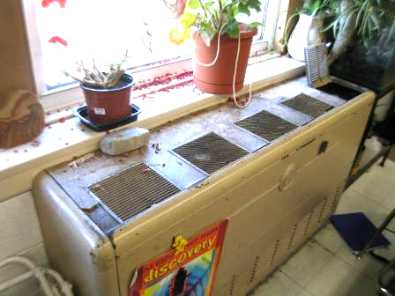

Early 1950s vintage univent, note plants/plant debris near unit and on flat surfaces

Picture 2

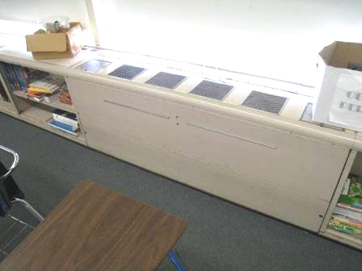

Mid 1950s vintage univent

Picture 3

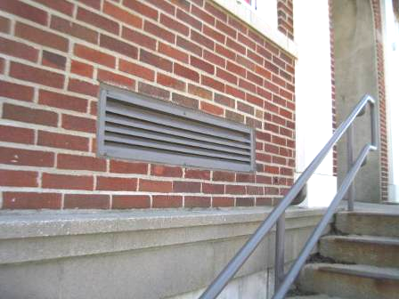

Univent fresh air intake

Picture 4

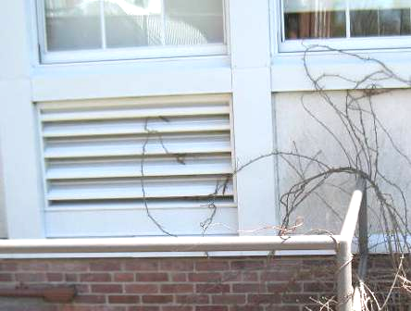

Univent fresh air intake, note plant growth near/on intake

Picture 5

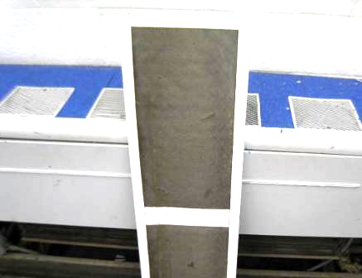

Univent filter occluded with dust/debris

Picture 6

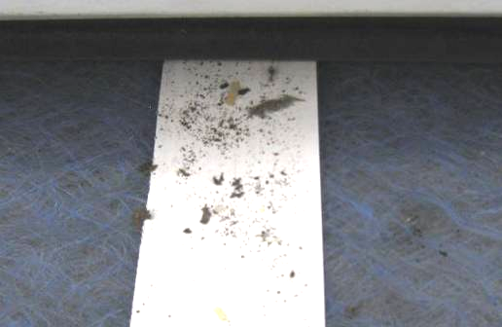

Loose dust/debris on filter inside univent

Picture 7

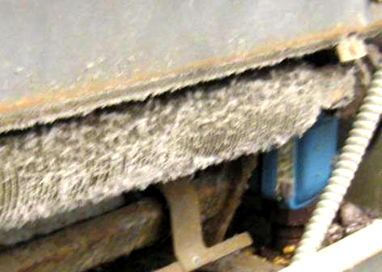

Dust/debris accumulation inside univent

Picture 8

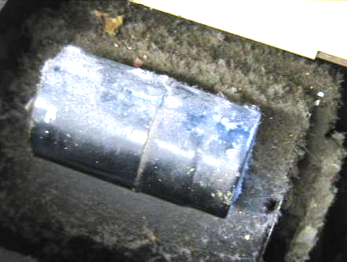

Dust/debris accumulation inside univent

Picture 9

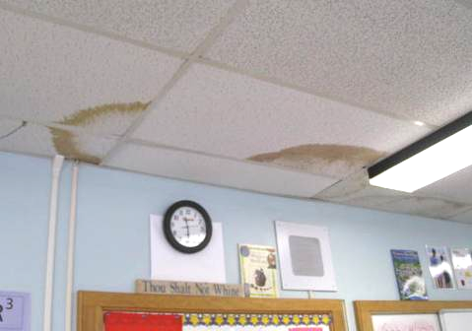

Water-damaged ceiling tiles

Picture 10

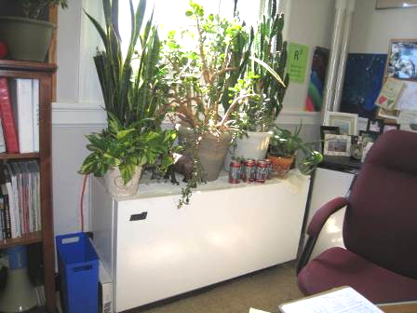

Plants on univent

Picture 11

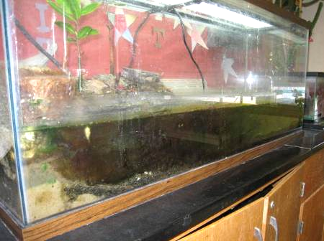

Aquarium with algal growth

Picture 12

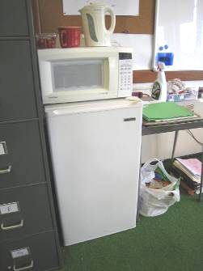

Refrigerator on carpet

Picture 13

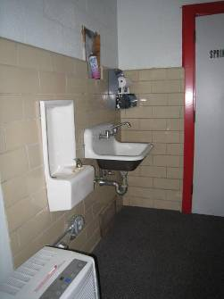

Sink and drinking fountain over carpeted area in weight room

Picture 14

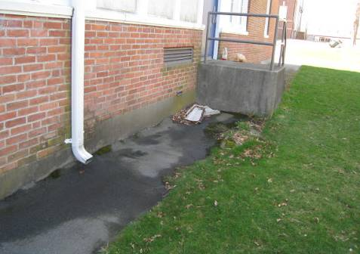

Downspout splash footer moved from end of downspout (arrow)

Picture 15

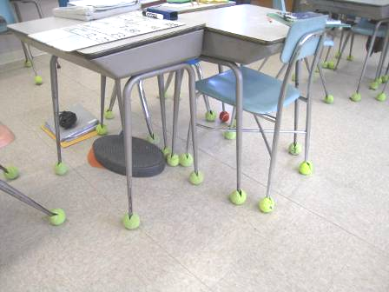

Tennis balls being used as glides

Picture 16

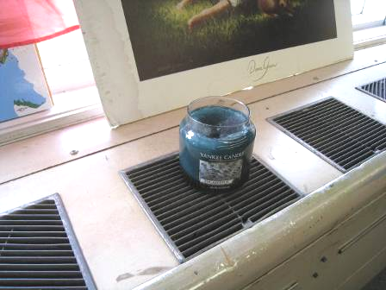

Scented candle on univent

Picture 17

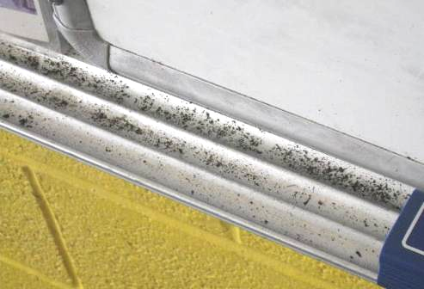

Accumulation of dry erase debris

Picture 18

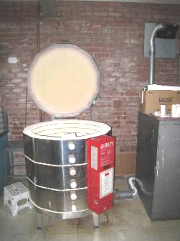

Pottery kiln

Picture 19

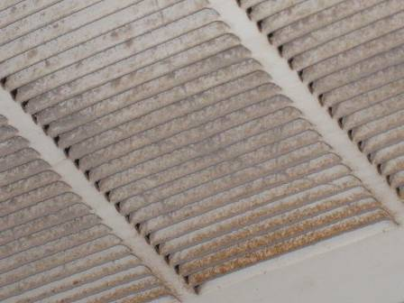

Dusty exhaust vent

Picture 20

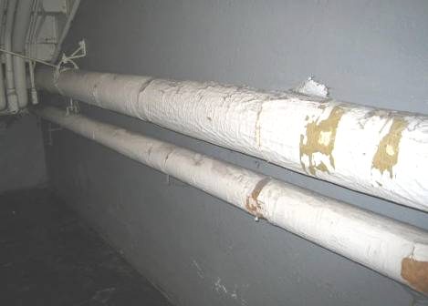

Exposed fiberglass insulation around pipes in the lower level of B wing
Location/ Room | Carbon Dioxide (ppm) | Carbon Monoxide  (ppm) | Temp  (°F) | Relative  Humidity  (%) | PM2.5  (ug/m³) | Occupants in Room | Windows Openable | Ventilation |  | Remarks
 |  |  |  |  |  |  |  | supply | exhaust | Remarks
Background | 478 | ND | 57 | 41 | 14 |  |  |  |  | Mostly cloudy, recent light rain
3rd floor women’s room |  |  |  |  |  |  |  |  | Y  on | WD CT
A100 | 644 | ND | 70 | 42 | 10 | 0 | Y | N |  | carpet, plants, CP
A101 | 1000 | ND | 72 | 46 | 11 | 21 | Y | Y  UV off | Y  on | 3 aquariums, terrarium, items, non carpeted
A103 | 809 | ND | 71 | 44 | 7 | 21 | Y | Y | Y  weak | Items on UV
A110 office (120C) | 530 | ND | 67 | 46 | 9 | 1 | N | N | N | DO, area rug
A110 weight room | 572 | ND | 67 | 46 | 9 | 0 | Y | Y  UV on |  | Carpet in good condition, doors to outside, sink/drinking fountain on carpet, AP
A112 engineering | 741 | ND | 67 | 44 | 11 | 2 | Y | Y  UV off, dusty | Y  off | Drinking fountain on carpet tools, UV filter dirty
A112 inner office | 879 | ND | 67 | 44 | 11 | 0 | Y | N | Y | Microwave, full size fridge on carpet
A203 | 791 | ND | 68 | 43 | 10 | 4 | Y | Y  on high | Y | DEM, carpet
A203 | 860 | ND | 70 | 39 | 12 | 21 | Y | Y  UV off | Y obstructed | DO, plants/debris on UV
A204 | 885 | ND | 70 | 38 | 14 | 22 | Y | Y | Y  on | DEM, DO
A204 | 760 | ND | 69 | 39 | 11 | 2 | Y | Y  UV on | Y | TB (a few), DEM, no carpet
A205 | 874 | ND | 70 | 40 | 12 | 20 | Y | Y  UV off | Y  on | DEM, no carpet, PF, sink, items and CP under sink, potential dry sink drains
A205 storage | 855 | ND | 71 | 40 | 11 | 0 | Y | N | Y | Sink, CP, microwave
A207 | 1213 | ND | 71 | 46 | 10 | 24 | Y | Y  UV off | Y | 2 WD CT
Admin office | 767 | ND | 73 | 39 | 9 | 0 | Y | Y  UV |  | Plants on UV, area carpet, DO
B101 | 753 | ND | 73 | 42 | 6 | 23 | Y | Y | Y | Carpet, DO, dust/debris on UV
B102 | 795 | ND | 72 | 44 | 7 | 16 | Y | Y  UV | Y | Carpet
B104 | 674 | ND | 69 | 39 | 9 | 1 | Y | Y | Y  on | Area rug on tile
B201 | 626 | ND | 71 | 34 | 9 | 4 | Y | Y  UV on | Y  partly obstructed | WD CT, along window area, plants on UV, chalk dust, DEM, fridge, TBs
B202 | 928 | ND | 71 | 40 | 8 | 17 | Y | Y  UV on | Y  on | Carpet, items, PF, DEM, 1 WD CT
B203 |  | ND | 72 | 42 | 10 | 16 | Y | Y  UV on | Y  weak, partly obstructed | Carpet old/damaged/wrinkled, MT, DEM
B205 | 1739 | ND | 75 | 45 | 9 | 0  (20 just left) | Y | Y  UV on | Y | Carpet, DEM
B301 | 1085 | ND | 73 | 34 | 11 | 24 | Y | Y  UV on | Y  on | Exhaust dusty, carpet, MT, WD CT, CP, fridge and microwave on carpet, items
B302 | 1257 | ND | 73 | 41 | 13 | 17 | Y | Y  UV on | Y  on obstructed | Plants, MT
B303 | 1003 | ND | 73 | 35 | 11 | 21 | Y | Y  UV on | Y | Carpet, fridge on carpet, DEM, items hanging from ceiling
B305 | 1106 | ND | 72 | 39 | 12 | 0 | Y | Y  UV off | Y | Carpet, DEM
B305A | 635 | ND | 71 | 32 | 11 | 1 | Y | N |  | Carpet, attached bathroom has MT
B306 | 1319 | ND | 72 | 42 | 11 | 20 | Y | Y  UV off | Y  on | UV cover ajar, DO, carpet, DEM
B307 | 595 | ND | 71 | 30 | 9 | just left | Y | Y | Y  off | MT, carpet, WD CT, dusty CT
B308 computers | 505 | ND | 74 | 29 | 7 | 0 | N | Y | Y | Dusty vents
B310 | 545 | ND | 74 | 31 | 7 | 0 | Y | Y | Y  off | 3 WD CT
B311 | 578 | ND | 73 | 33 | 6 | 1 | Y | Y  UV off | Y  off | 16 students just left, 4 WD CT
Basement Hallway |  |  |  |  |  |  |  |  |  | Exposed fiberglass insulation on pipes
Boys locker room | 602 | ND | 70 | 43 | 8 | 0 | Y | Y  UV off | Y  off
C101 music | 591 | ND | 70 | 42 | 7 | 0 | Y | Y  UV off | Y
C102 Art | 961 | ND | 71 | 38 | 9 | 11 | Y | Y  UV on | Y | Computers, art materials, microwave, no carpet, kiln (exhaust not tested)
C103 | 953 | ND | 71 | 42 | 9 | 14 | Y | Y  UV off | Y  partly obstructed | DO, worn/damaged carpet, DEM tray particulates
C104 Art | 1176 | ND | 71 | 44 | 14 | 15 | Y | Y  UV off | Y  on | Paints, pencil sharpener over UV
C105 | 499 | ND | 68 | 35 | 6 | 1 | Y open | Y  UV off | Y  partly obstructed | 8 students gone ~25 minutes, plants on UV, old carpet (worn/damaged)
C106 | 1046 | ND | 71 | 38 | 11 | 0 | Y | Y  UV off | Y  on | Carpet, DEM
C107 | 1096 | ND | 72 | 45 | 8 | 1 | Y | Y  UV off | Y | PF, 23 students gone 10 minutes, DO, carpet old
C108 robotics | 1453 | ND | 72 | 44 | 8 | 10 | Y | Y  UV on | Y | plants, 2 PF, DEM, chalk, carpet, tools
C109 | 750 | ND | 70 | 48 | 6 | 1 | Y | Y | Y | 22 students gone ~20 minutes, wall to wall carpet ~ 2 years old, DO
C110 | 1223 | ND | 71 | 42 | 10 | 15  just left | Y | Y  UV | Y  on | Scented candle on UV, carpet, DEM, chalk
Cafeteria | 653 | ND | 69 | 35 | 8 | 27 | Y | Y | Y | DEM, WD CT
Copy room | 735 | ND | 71 | 42 | 8 | 1 | Y | N | N | 3 PCs, sink, fridge, 3 WD CT
Faculty women’s room near gym |  |  |  |  |  |  |  |  | Y  on | Broken sink (covered in plastic)
Girls locker room | 702 | ND | 68 | 43 | 10 | 0 | Y | Y  UV off | Y  off | Potential dry drains
Guidance office | 550 | ND | 75 | 36 | 7 | 1 | N | N | Y | Carpet, DO
Gym, left side | 663 | ND | 67 | 38 | 8 | 0 | N | Y |  | Doors to outside
Gym, right side, | 676 | ND | 67 | 36 | 9 | 7 | N | Y | Y  off | DEM, doors to outside
Library | 457 | ND | 71 | 30 | 6 | 12 | Y | Y | Y | Plants, laminator, WD CT damaged CT, dusty vents
Main office | 705 | ND | 71 | 39 | 9 | 5 | Y | Y | Y | Carpet
Music room E | 688 | ND | 70 | 41 | 9 | 0 | N | Y  off |  | Stored items
Music room L | 717 | ND | 70 | 42 | 9 | 0 | N | Y  off |  | MT, use of tile on wall for sound-proofing
Nurse back office | 593 | ND | 71 | 37 | 10 | 0 | Y | N | N | WAC, DO, floor tile
Nurse copy room | 586 | ND | 71 | 36 | 10 | 0 | N | N | N | All DO, PC, floor tile
Nurse main room | 614 | ND | 71 | 36 | 10 | 1 | Y |  |  | Carpet, PF, shredder, water dispenser on carpet
Nurse’s bathroom |  |  |  |  |  |  |  |  | Y  on
Principal | 577 | ND | 74 | 33 | 9 | 0 | Y open | Y  UV | Y | Items on UV
Teacher’s lounge | 432 | ND | 71 | 31 | 5 | 2 | Y | Y | Y | Dust/debris on vents, holes in wall, fiberglass insulation, old, worn carpet

The service life is the median time during which a particular system or component of …[an HVAC]… system remains in its original service application and then is replaced. Replacement may occur for any reason, including, but not limited to, failure, general obsolescence, reduced reliability, excessive maintenance cost, and changed system requirements due to such influences as building characteristics or energy prices (ASHRAE, 1991).

