INDOOR AIR QUALITY WALKTHROUGH

Alfred S. Letourneau Elementary School
323 Anthony Street
Fall River, MA

May 2026



Prepared by:
Massachusetts Department of Public Health
Bureau of Climate and Environmental Health
Division of Environmental Health Regulations and Standards
Contents
EXECUTIVE SUMMARY 3
BACKGROUND 5
RESULTS AND DISCUSSION 5
Ventilation 5
Water Damage and Moisture Concerns 7
Sources of Respiratory Irritants/Possible Asthma Triggers 9
Other IAQ Issues 11
CONCLUSIONS AND RECOMMENDATIONS 12
REFERENCES 17
FIGURES 19
PICTURES 20
Ventilation Pictures 20
Water Damage Pictures 26
Sources of Respiratory Irritation Pictures 32
Table 1 35
Table 2A 39
Table 2B 40
Table 2C 41
Table 3 42
Table 4 44

EXECUTIVE SUMMARY
The Massachusetts Department of Public Health’s (MDPH), Division of Environmental Health Regulations and Standards (EHRS) conducted an Indoor Air Quality (IAQ) walkthrough of the Alfred S. Letourneau Elementary School located at 323 Anthony Street Fall River, MA, on April 30, 2026. This walkthrough was in conjunction with the “Asthma in Schools: Data to Action Project” - a collaboration between Massachusetts Department of Public Health programs, local health departments, and local school health and administration officials to support asthma prevention and intervention efforts in school settings, see https://www.mass.gov/asthma-in-schools-data-to-action-project.
Any building can have IAQ issues. These issues can be made worse through conditions common to marginalized communities (Environmental Justice communities or EJ) such as inequitable exposure to outdoor air pollution and a greater likelihood of poor building conditions leading to deterioration of IAQ resulting in higher asthma rates. The Letourneau Elementary School is located within an EJ community. Note that the pediatric asthma rate for this school as of 2024-2025 is 10.8%, which is not statistically significantly different from the statewide pediatric prevalence rate of 9.6% (MAEPHT, 2025).
The assessment was conducted by evaluating several key elements within the school; a visual inspection of the heating, cooling, and ventilating (HVAC) systems, water/microbial damage, exterior building envelope evaluation, cleanliness, and point sources of respiratory irritants such as chemicals. Data is collected in this manner to identify potential asthma triggers, allergens, and other environmental factors that can cause indoor air quality symptoms. Observed
As a result of this walkthrough, there are several findings: at approximately 20 years old, this school is generally in excellent condition. As building systems age, appropriate preventive and regular maintenance will help to keep school systems operating well into the future. Note that some water-stained ceilings were found, and there are occupant-induced issues including storage/clutter and use of scented products. The location of the school near busy big box stores provides additional challenges for maintaining good IAQ. (Results and Discussion), (Conclusions)
Based on the results of the assessment, the following primary recommendations are made:
- Operate supply and exhaust ventilation continuously when the building is occupied. Check fan coil units, air handling units, and exhaust vents during occupied periods to ensure they are on and operating to their full capacity.
- Address building envelope issues leading to water infiltration and damaged building materials in the building. Replace water-damaged ceiling tiles and clean/repair other water-damaged materials.
- Reduce clutter and sort stored materials regularly to remove items that are outdated or no longer needed. Store items neatly and off the floor.

Note that this building was visited by the IAQ unit previously to address water damage concerns in the building. The report from that visit can be found at https://www.mass.gov/info-details/indoor-air-quality-reports-cities-and-towns-f#fall-river along with other IAQ reports for the city of Fall River. Furthermore, this report contains a series of recommendations that should serve as Best Practices that apply to most public-school buildings across the Commonwealth and should be shared amongst other buildings in the school district.

BACKGROUND

Building: | Alfred E. Letourneau Elementary School (LES)
Address: | 323 Anthony Street, Fall River, MA
Coordinated Via: | Sean Sibson, Principal, Letourneau Elementary School
Reason for Request: | Pediatric Asthma Project and General IAQ
Date of Assessment: | April 30, 2026
Massachusetts Department of Public Health/Bureau of Climate and Environmental Health/Division of Environmental Health Regulations and Standards (MDPH/BCEH/EHRS) staff | Ruth Alfasso and Bharathi Patimalla-Dipali, IAQ Outreach and Education Unit, EHRS
Building Description: | The LES is a two-story, red-brick building constructed in 2008.
Windows: | Most windows in the school are openable.

RESULTS AND DISCUSSION
A summary of conditions observed during the IAQ walkthrough can be found in (Table 1).

Ventilation
Ventilation refers to both the supply of fresh air and the removal of stale air from a room. The introduction of fresh air into an occupied space will dilute normally occurring pollutants that are generated by occupancy and other activities. In addition, an HVAC system will remove pollutants from a building if operating appropriately. All ventilation systems throughout the building should operate continuously during periods of occupancy.
Fresh air ventilation for the LES comes from air handling units (AHUs) located on the roof (Picture 1). This air is filtered and heated/cooled and supplied to rooms via ceiling-mounted vents (Pictures 2 and 3). Fan coil units (FCUs) are present in many classrooms that provide air circulation, filtration, and heating/cooling (Picture 4 and 5). These look like unit ventilators (univents), but they do not have a corresponding vent on the outside to supply fresh air. Some rooms have an FCU on the ceiling. Like a univent, FCU vents should not be blocked by furniture or items, because this will impede the flow of air to and from the unit (Figure 1).
Classrooms and other rooms are also equipped with exhaust vents located on the ceiling or walls that remove stale air from rooms via rooftop exhaust motors (Pictures 6 and 7).
The HVAC equipment in the building is controlled by a centralized energy management system. There are sensors in each room (Picture 8) which feed into this system. The IAQ Outreach and Education unit recommends that occupied rooms be supplied with continuous fresh air rather than only supplying fresh air when temperature changes are called for by the system.
The various types of ventilation components as well as devices that can move/redirect airflow are listed in Table 2A, Table 2B and Table 2C.

HVAC System Maintenance
- According to the American Society of Heating, Refrigeration, and Air-Conditioning Engineering (ASHRAE), the service life of the types of HVAC equipment is 15-20 years, assuming routine maintenance of the equipment (ASHRAE, 1991). The equipment in this school is beginning to reach its service life, so ensuring that routine maintenance is conducted as recommended by the manufacturer will keep the systems running well for as long as possible.
Balancing
To have proper ventilation with a mechanical supply and exhaust system, a system must be balanced to provide an adequate amount of fresh air to the interior of a room while also removing stale air from the room.
It is recommended that HVAC systems be re-balanced every five years to ensure adequate air systems function (SMACNA, 1994).

HVAC Types and Specific Conditions
(see Ventilation Pictures)

Fresh Air Ventilation:
- Signs had been placed on classroom fan coil units and above wall-mounted exhaust vents to remind occupants not to block them with furniture or items (Pictures 4 and 6). Signs appear effective, as few fan coil units were found blocked, (Picture 9; Table 1).
- The IAQ Outreach and Education Unit recommends that filters of at least a minimum efficiency reporting value (MERV) 8 or better be used, if an HVAC engineer confirms the system can be so equipped without adversely affecting function, as these are adequate to filter out pollen, mold, and similar particulates (ASHRAE, 2012).
Exhaust vents:
- Most of the wall-mounted exhaust vents that were tested were on and operating strongly (Picture 10). However, a few units were underperforming, with minimal to no draw (Table 1).
- Some ceiling-mounted exhaust vents were partly blocked by items up near the ceiling (Picture 11). This can limit the flow of exhaust air. It may also be a violation of the fire code.

Additional HVAC Conditions:
- Most classrooms have openable windows (Table 1). Windows can potentially be used for additional fresh air during temperate weather.
  - Windows should be kept closed during wet weather to prevent water infiltration.
  - They should also be kept closed when air conditioning is operating to prevent condensation and mold growth during periods of elevated relative humidity.
  - Occupants should be aware of outdoor air quality and avoid opening windows during days with poor air quality, high pollen, outdoor noise, or when gas-fired equipment is operating near the windows.
  - When not in use, windows should be closed tightly and locked.
- In a set of rooms near the library for small-group assistance or testing (rooms 234-245), many of the rooms had no supply or return/exhaust ventilation. It appears the rooms are designed to use an exhaust vent in the hallway via an undercut in the door. However, these rooms also felt stuffy, too warm, and less comfortable than other areas of the building. This suggests that insufficient fresh air and exhaust ventilation is being supplied to these areas.
- Units were noted on the ceilings of some rooms (Picture 12). An internet image search suggests these may be ceiling-mounted air purifiers that use filtration and UV-C (ultraviolet light of a wavelength found to be able to kill germs).
  - Product literature for a visually-similar product reports that these units draw in air, filter the air with a MERV 6 filter, and expose the air to ultraviolet light (Armstrong, 2025).
  - Air purifiers that may produce ozone should not be used in occupied areas. The California Air Resources Board (CARB) tests and certifies air purifier products, including this type, for ozone emissions. The information here: https://ww2.arb.ca.gov/list-carb-certified-air-cleaning-devices should be used to ensure products meet minimum safety standards. The product that visually matches is on this list.
  - The manufacturers’ instructions should be followed regarding changing filters and UV lamps, and other maintenance/cleaning.

Water Damage and Moisture Concerns

Molds are found naturally in our environment both indoors and outdoors. Inside, mold growth may occur when items, particularly porous products such as paper or gypsum wallboard, are exposed to moisture. Typical water sources include leaks, floods, and condensation. To avoid mold growth, dry all water-damaged items and affected areas within 24-48 hours and reduce indoor humidity. Some people with chronic respiratory conditions, such as asthma, are more likely to experience health symptoms associated with molds, including allergic reactions and respiratory irritation. Controlling moisture is the key to preventing mold growth and potential health symptoms.Hot humid summers are becoming more frequent due to climate change. Massachusetts has experienced hot, humid, and rainy summers in 2018, 2021, and 2023. July of 2021 was the wettest ever recorded in Massachusetts, and the three-month period from June through August, known as the meteorological summer, was the fourth wettest on record, according to the National Oceanic and Atmospheric Administration’s (NOAA) Centers for Environmental Information (NOAA, 2021). The summer of 2023 was measured as the second rainiest on record (WBUR, 2023). The summers of 2024 and 2025 also had significant stretches of hot, humid weather. These conditions are challenging for buildings, even those with central air conditioning.
Extended periods of outdoor relative humidity exceeding 70% were recorded during these hot, humid summers. Public buildings experienced extended periods of water vapor exposure from high relative humidity. When exposed to these conditions, porous materials such as gypsum wallboard, cardboard, and other materials may become mold colonized, particularly if located in areas that are prone to developing condensation (e.g., floors and walls in below grade space).
Mold Growth
Porous materials (e.g., gypsum wallboard, ceiling tiles and carpeting) can be dried with fans and heating within 24 to 48 hours of becoming wet (US EPA, 2008).
If porous materials are not dried within this time frame, mold growth may occur.

(see Water Damage and Moisture Concern Pictures)
- Water-damaged ceiling tiles were found in a few locations (Pictures 13 and 14; Table 1), which can indicate plumbing, HVAC, or building envelope leaks. Water-damaged ceiling tiles can provide a source of mold and should be replaced after a water leak is discovered and repaired. Staff are encouraged to report any active leaks to the Facilities Department for prompt remediation.
- Plants and cut flowers were noted in some classrooms and offices (Pictures 15 and 16; Table 1). Plants can be a source of pollen or mold especially if overwatered or not well maintained. Plants without drip pans can damage porous surfaces they are placed on. Plants should be kept away from the airstream of ventilation equipment to prevent the spread of pollen or mold.
- An aquarium was noted in a classroom (Picture 16). Aquariums should be well aerated and kept clean to prevent algae growth, bacteria, and associated odors.
- There are sinks in classrooms, offices, and other areas (Table 1).
  - Some sinks may not be used often, Sinks and floor drains (e.g., for eye wash stations) that are not used often can have the plumbing trap dry out, which allows sewer gases into occupied areas. Pouring water down seldom-used sinks every few weeks will keep the trap seal intact.
  - One sink was marked “closed” (Picture 17); it may be out of order. Broken plumbing fixtures should be repaired to prevent leaks.
  - The design of sinks encloses the pipes (Picture 18). This design prevents use of the moist area in a typical sink cabinet for storage of porous materials. However, occupants should avoid crowding the area adjacent to the sink with storage.
- A water fountain was broken (Picture 19). Broken plumbing should be repaired or removed if repair is not possible.
- Dehumidifiers were in use in the building. Large units were present in some hallways (Picture 20), and smaller units were present in many classrooms (Pictures 17 and 18). Dehumidifiers are helpful to remove excess humidity before it can lead to comfort issues or condensation.
  - Most classroom units were placed next to sinks with the drain hoses emptying into the sink drains (e.g., Picture 18). Draining them this way removes the necessity to empty the bucket on a frequent basis.
  - Both the large and the small units need to be cleaned periodically to remove stagnant water and any build-up that can lead to odors.
  - Units that were turned on had displays reading close to 40, indicating 40% relative humidity. The guidance used by the IAQ unit is that relative humidity between 40% and 60% is most likely to be comfortable. Reducing humidity too low can cause discomfort due to dry air.
- In some classrooms and hallways, ceiling tiles were found to be bowed or sagging slightly in the ceiling tile grid. This is a sign of exposure to high humidity over a long period of time. While bowed ceiling tiles are not themselves an air quality issue, so long as the tiles are still secure in the ceiling, it is an indication that humidity issues may occur.
- Additional humidity measuring devices were found were found on the door frames of some classrooms. If these units are operable, they can be helpful to assess the potential for condensation during hot, humid weather as well as determine if air conditioning and dehumidification is effective at reducing humidity. The Guidance Preventing Mold Growth in Hot Humid Weather and Remediation and prevention of mold growth and water damage in public schools and buildings to maintain air quality can be used for help with excess humidity.
Please note that the IAQ Outreach and Education Unit does not recommend conducting mold testing in a typical water damage remediation. For details, please consult Guidance Regarding Testing for Mold in Water-Damaged Public Buildings | Mass.gov
The application of a mildewcide to moldy porous materials is not recommended.
An exterior evaluation was also conducted to identify potential pathways for water penetration and pest entry. The following issues were found:

- Some exterior doors had light visible beneath them (Picture 21), indicating gaps which can allow unconditioned air, moisture, or pests inside.
- Plants and trees were close to the building, including in the courtyard (Pictures 22 through 24). Plants next to the building can hold moisture against the exterior, encourage pests, and be a source of pollen and odors through open windows.
- A pile of wooden pallets was noted near the building exterior. Debris next to the building can become harborage for pests such as rodents.

A list of water damage issues identified and included as Table 3.

Sources of Respiratory Irritants/Possible Asthma Triggers

Asthma is a lung disease that can make breathing difficult. Without careful management of asthma, some individuals can have symptoms, like a tight feeling in the chest, shortness of breath, coughing, or wheezing. Although there is no cure for asthma, individuals with asthma can live healthy, active lives. A safe and healthy environment helps to reduce asthma symptoms.

Comparison of Local and State-wide Asthma Rates (2024-2025 school year/MAEPHT, 2026)
13.5% of children
have asthma
Fall River
9.6% of children
have asthma
Massachusetts
10.8% of children
have asthma
Kuss Middle School

- Sometimes, learning tools and personal items in a classroom can be a source of irritation. For example, a bird or insect nest is a great learning tool for students but may harbor microbes and allergens. Similarly, food-based projects can attract pests that carry disease or trigger allergies.
- Personal products, particularly those with volatile organic compounds (VOCs) including scents, can also be a source of respiratory irritation. VOCs are carbon-containing substances that have the ability to evaporate at room temperature. Frequently, exposure to low levels of total VOCs (TVOCs) may produce eye, nose, throat and/or respiratory irritation in some sensitive individuals. Products noted were dry erase markers, hand sanitizers, and other cleaning/sanitizing products (Picture 25; Table 1). Consult “Clean Air Is Odor Free” for more information on fragrances in schools and other buildings. Note that no scented air fresheners such as plug-ins or reed diffusers were observed during the visit.
- Dust, a common respiratory and eye irritant, can collect on surfaces and items. Although janitorial and maintenance staff perform routine cleaning in classrooms, they may not be able to clean as effectively if classroom items are not picked up or surfaces are cluttered. Even with a properly functioning ventilation system, it is necessary to either eliminate or reduce the use of materials that can be a source of respiratory irritants to prevent symptoms in individuals who have sensitivity to such pollutants.

For guidance on maintaining an asthma-friendly healthy school environment, please consult the MDPH Asthma Prevention and Control Program’s Clearing the Air: An Asthma Toolkit for Healthy Schools.
Possible asthma triggers and/or airborne pollutants exist in the building. These are listed below as well as in (Table 4).
(see Sources of Respiratory Irritant Pictures)

- A few classrooms and storage areas had an excess of items such as books, craft materials, papers, boxes, and miscellaneous materials (Picture 26). Excess items can accumulate dust and make it difficult for custodial staff to clean. Items should be relocated and/or be cleaned periodically to avoid excessive dust build up. In addition, dust and debris can accumulate on flat surfaces (e.g., desktops, shelving and carpets) in occupied areas and subsequently be re-aerosolized causing further irritation.
- Break rooms around the school and some classrooms and offices have food storage and preparation equipment such as refrigerators, microwaves, and toasters. Some of this equipment was dirty (Picture 27; Table 1). Food spills and crumbs can be a source of odors, especially when heated, and can attract pests.
  - While these refrigerators are not covered by the food code, it is good practice to have a thermometer in each refrigerator that is visible to ensure refrigerated food temperatures are kept at 5ºC (41ºF) or less (US FDA, 2022).
  - All food should be stored in closed, pest-proof containers (e.g., glass or hard plastic) when not in use. Open food containers were found in the school (Picture 28).
- A number of classrooms had area rugs, pillows/cushions, upholstered furniture, and wall hangings (Pictures 29 and 30). These need to be cleaned regularly to remove dust, debris, and odors. Area rugs should be stored off the floor in a climate-controlled area during the summer to prevent moistening by condensation. Used area rugs should not be brought into the school as they may harbor allergens such as pet dander. Any cloth coverings should be laundered periodically and removed during summer break.
- Of note was the proximity of the school to sources of diesel fumes. Behind and slightly below the schoolyard is a set of big box stores including a supermarket. Trucks were visible supplying the supermarket. Exhaust emissions, including particulate matter and carbon monoxide from cars, buses, trucks, and other motor vehicles, are higher where these vehicles are operating. Therefore, care should be taken when opening classroom windows during periods of heavy traffic.

Other IAQ Issues

Radon

Radon is a naturally occurring radioactive gas that seeps into buildings from the surrounding soil and can increase the risk of lung cancer at elevated levels.

The Environmental Protection Agency (EPA) conducted a National School Radon Survey “in which it discovered nearly one in five schools has at least one schoolroom with a short-term radon level above the action level of 4pCi/L (picocuries per liter) – the level at which the EPA recommends that schools take action to reduce the level” (US EPA, 1993).

The MDPH therefore recommends that every school be tested for radon, and that this testing be conducted during the heating season while school is in session in a manner consistent with US EPA radon testing guidelines. Radon measurement specialists and other information can be found at www.nrsb.org and http://aarst-nrpp.com/wp, with additional information at: https://www.mass.gov/radon and fact sheet on radon in schools and child care programs.

CONCLUSIONS AND RECOMMENDATIONS
Please note: this report contains a series of recommendations that should serve as Best Practices that apply to most public-school buildings across the Commonwealth and should be shared amongst other buildings in the School District.

As this is a modern school and in very good condition, fewer issues, compared to older schools, were noted. The goal for this school should be to maintain good air quality by maintaining the systems that exist, performing routine maintenance and cleaning, and controlling storage and clutter.

Recommendations

HVAC System Helpful Links
- 1. | Ensure proper operation of all AHUs, fan coil units, and other HVAC systems. If fan-coil fan operation is linked to thermostats, work with HVAC vendor to operate independently as to not “cycle” off/on during the school day.
- 2. | Remove blockages from the top/front of fan coil units, exhaust vents, and radiators. including furniture and items.
- 3. | Periodically check the function of all classroom and restroom exhaust vents. Repair as needed.
- 5. | Continue with regular filter changes for HVAC equipment using a minimum efficiency rating value (MERV) 8 or the best quality/highest MERV-rated filter that can be used without effecting airflow.  Ensure filters fit flush within their racks to prevent filter bypass. | ANSI/ASHRAE Standard 52.2-2017
- 6. | During filter changes, clean dust and debris from the inside of FCU and AHU cabinets.
- 7. | Develop and communicate a policy on when openable windows can be used. Tightly close windows at the end of the day and avoid opening windows during extreme cold to prevent freezing of pipes. Keep windows closed when it is hot and humid, outdoor air quality unhealthy, during heavy traffic conditions, or when the generator is operating. | https://www.airnow.gov/
 | Consider adding additional supply and return/exhaust ventilation to the small group rooms near the library
 | Ensure the units shown in Picture 12 have been certified by the California Air Resources Board for safety.  Portable air purifiers may also be used to supplement mechanical ventilation filtration. | https://ww2.arb.ca.gov/list-carb-certified-air-cleaning-devices  https://www.epa.gov/indoor-air-quality-iaq/ozone-generators-are-sold-air-cleaners
Water Damage Sources
- 9. | Replace water-damaged ceiling tiles. Repeated water damage to ceiling tiles indicates leaks from the roof or plumbing/HVAC system which should be repaired. | http://www.epa.gov/mold/mold-remediation-schools-and-commercial-buildings-guide
- 10. | Properly maintain plants to avoid mold and odors. Keep plants away from airflow of HVAC equipment.
 | Keep aquariums in good condition to reduce odors.
 | Pour water periodically (every week or two) down sinks and floor drains that are not often used to maintain the trap seal and prevent sewer gases from entering occupied areas.
 | Repair damaged plumbing to prevent leaks.
 | Continue to use dehumidifiers when indoor humidity is high. Clean and maintain the units to prevent stagnant water and odors. Ensure units do no reduce humidity too far, especially during cold weather.
 | Use information from humidity measuring devices to help manage the potential for condensation during humid weather. | https://www.mass.gov/info-details/preventing-mold-growth-in-massachusetts-schools-during-hot-humid-weather and  Remediation and prevention of mold growth and water damage in public schools and buildings to maintain air quality
- 20. | During summer months, pull furniture away (1 to 2 inches) from walls to prevent mold growth due to lack of airflow and remove impermeable wall coverings that can trap moisture such as laminated posters.
 | Ensure exterior doors fit tightly with no gaps. Repair or replace weatherstripping where needed.
 | Trim plants and trees from the building exterior.
 | Remove any piles of items near the building.
Respiratory Irritants/Possible Asthma Triggers
- 23. | Reduce use of products and equipment that create irritating volatile organic compounds (VOCs) and only use in well-ventilated areas. Minimize the use of air fresheners (e.g., plug-ins), deodorizers and scented products. | https://www.mass.gov/cleaner-greener-healthier-schools  and  Clean Air Is Odor Free
- 33. | Use only District-approved cleaning products. Keep spray bottles properly labeled and out of the reach of children.
- 34. | Provide exhaust ventilation or move copiers and laminators to a well-ventilated area with an exhaust vent.
- 26. | Clean area carpets, upholstered furniture, cushions/pillows frequently using a HEPA-equipped vacuum cleaner. Avoid bringing used area rugs into the school.
 | Clean carpeting regularly in accordance with IICRC recommendations (IICRC, 2012).
 | Replace old carpeting that is beyond its service life.
- 27. | Periodically, sort classroom and other storage areas for removal of unwanted items. Store the remaining items neatly and off the floor.
- 28. | Clean personal fans, supply, and exhaust/return vents periodically to remove dust and debris.
- 31. | Ensure the principles of integrated pest management (IPM) are followed in accordance with state regulations. | https://massnrc.org/ipm/docs/ipmkitforbuildingmanagers.pdf
 | Ensure food preparation equipment is kept clean to prevent smoke, odors, and pests
 | Keep all food in tightly-closed pest-proof containers.
 | Clean upholstered furniture, plush items, and wall hangings regularly to remove dust and odors.
 | For rooms on the side of the building adjacent to the big box stores, and avoid opening windows when traffic including trucks is heavy.

Other Recommendations to Improve Air Quality Conditions
- 35. | Test the school for radon by a certified radon measurement specialist during the heating season when school is in session. | Radon measurement specialists and other information can be found at: www.nrsb.org, and http://aarst-nrpp.com/wp
- 36. | To learn more about radon, review the MDPH’s Radon in Schools and Child Care Programs factsheet. | https://www.mass.gov/info-details/radon-in-schools.
- 37. | Utilize the US EPA’s (2000), “Tools for Schools” as an instrument for maintaining a good IAQ environment in the building. | https://www.epa.gov/iaq-schools.
- 38. | For guidance on maintaining an asthma-friendly healthy school environment, please consult the MDPH Asthma Prevention and Control Program’s Clearing the Air: An Asthma Toolkit for Healthy Schools. | https://www.maasthma.org/schooltoolkit
- 39. | Include an IAQ component in the school’s Wellness Advisory Committee program. An IAQ plan should have an IAQ liaison/teacher representative, a member of maintenance/facilities and administration that conduct regular walk-throughs to identify on-going and/or potential environmental issues.
 | Consider installing sensor technology in classrooms to provide continuous monitoring of the following indoor air parameters (particularly temperature and relative humidity). Sensors should be re-calibrated quarterly or according to manufacturers’ specifications and building management software updated as per manufacturers’ instructions, industrial standards, and/or change in operating systems. As an example, the link to the right illustrates how this technology is serving Boston Public Schools to improve air quality (i.e., carbon dioxide, temperature, relative humidity, carbon monoxide, and particulate matter). | COVID-19 Health & Safety Information / Indoor Air Quality Sensor Dashboard (bostonpublicschools.org)

REFERENCES
Armstrong, Inc. 2025. VIDASHIELD UV24™ Air Purification System Data Sheet. Distributed by Armstrong World Industries, Chatsworth, CA. https://www.armstrongceilings.com/content/dam/armstrongceilings/commercial/north-america/data-sheets/vidashield-uv24-air-purification-system-data-sheet.pdf
ASHRAE. 1991. ASHRAE Applications Handbook, Chapter 33 “Owning and Operating Costs”. American Society of Heating, Refrigeration and Air Conditioning Engineers, Atlanta, GA.
ASHRAE. 2012. American Society of Heating, Refrigeration and Air Conditioning Engineers (ASHRAE) Standard 52.2-2012 -- Method of Testing General Ventilation Air-Cleaning Devices for Removal Efficiency by Particle Size (ANSI Approved).
IICRC. 2012. Institute of Inspection, Cleaning and Restoration Certification. Carpet Cleaning: FAQ.
MAEPHT. 2025. Massachusetts Environmental Public Health Tracking. Massachusetts Department of Public Health – Bureau of Climate and Environmental Health. https://matracking.ehs.state.ma.us/
NOAA. 2021. Summer 2021 neck and neck with Dust Bowl summer for hottest on record. National Oceanic and Atmospheric Administration, 1401 Constitution Avenue NW, Room 5128, Washington, DC 20230 https://www.noaa.gov/news/summer-2021-neck-and-neck-with-dust-bowl-summer-for-hottest-on-record
SMACNA. 1994. HVAC Systems Commissioning Manual. 1st ed. Sheet Metal and Air Conditioning Contractors’ National Association, Inc., Chantilly, VA.
US EPA. 1993. Radon Measurement in Schools, Revised Edition. Office of Air and Radiation, Office of Radiation and Indoor Air, Indoor Environments Division (6609J). EPA 402-R-92-014.
US EPA. 2000. Tools for Schools. Office of Air and Radiation, Office of Radiation and Indoor Air, Indoor Environments Division (6609J). EPA 402-K-95-001, Second Edition. https://www.epa.gov/iaq-schools.
US EPA. 2008. Mold Remediation in Schools and Commercial Buildings. US Environmental Protection Agency, Office of Air and Radiation, Indoor Environments Division, Washington, D.C. EPA 402-K-01-001. http://www.epa.gov/mold/mold-remediation-schools-and-commercial-buildings-guide.
US FDA. 2022. 2022 Food Code. U.S. Department of Health and Human Services. U.S. Food and Drug Administration. College Park, MD January 18, 2023 Version. https://www.fda.gov/media/164194/download
WBUR. 2023. “It's been a summer of rain and flooding misery in Mass.” WBUR local news. September 12, 2023. https://www.wbur.org/news/2023/09/12/summer-flooding-rain-massachusetts.

FIGURES
Figure 1

Fan Coil Unit (FCU)

Air Diffuser

Outdoors Indoors

Fan

Heating/Cooling Coil

Air Mixing Plenum

Filter

Return
Air

PICTURES
(Click to link back to report)

Ventilation Pictures

Picture 1
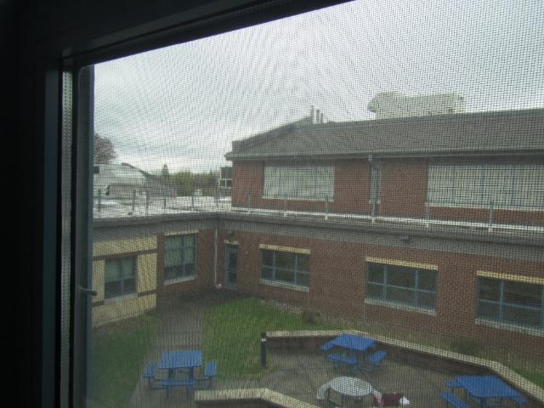
View of air-handling units on the roof from a second-story window
Picture 2
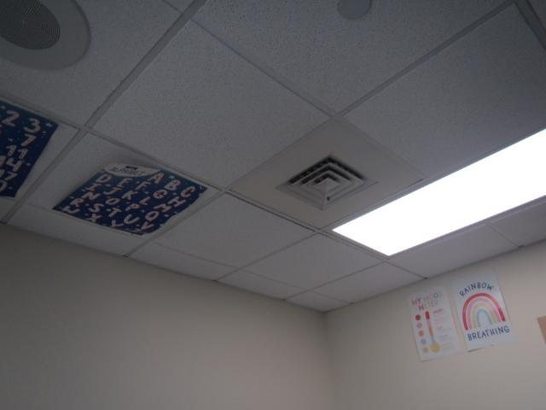
Ceiling-mounted supply vent
Picture 3
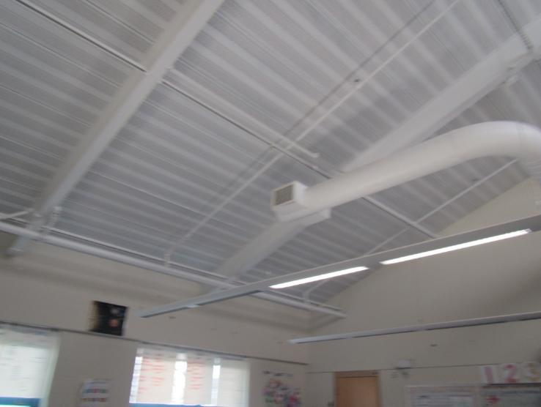
Supply vent from a visible duct near the ceiling
Picture 4
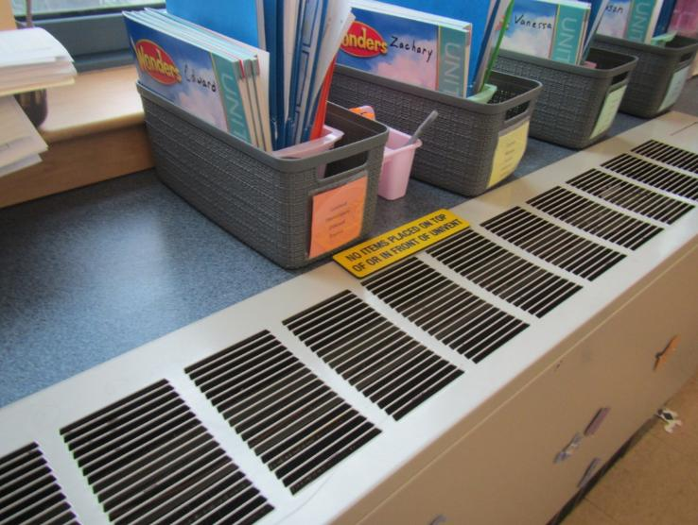
Fan coil unit in a classroom, note sign reminding occupants not to block unit

Picture 5
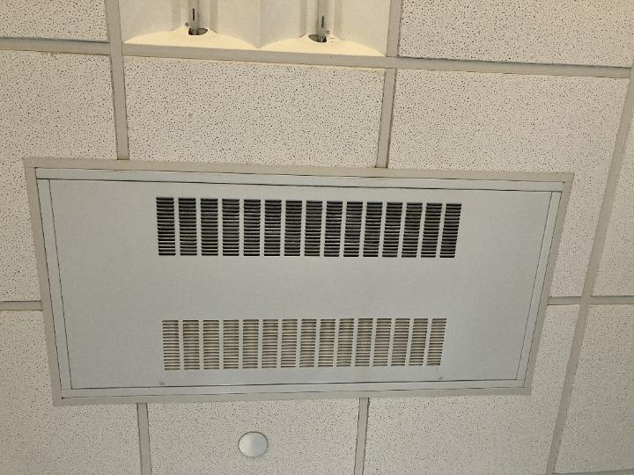
Ceiling-mounted fan coil unit
Picture 6
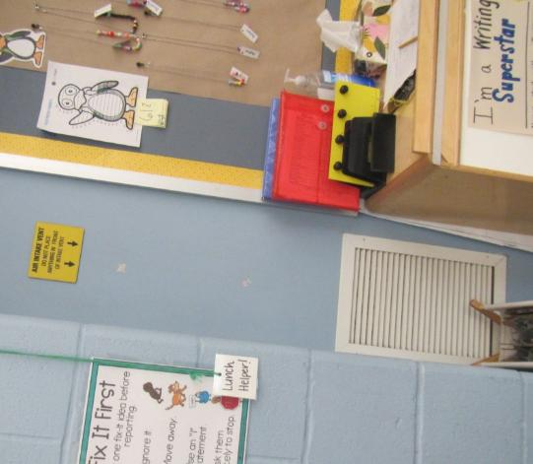
Wall-mounted exhaust vent, note sign above vent reminding occupants not to block

Picture 7
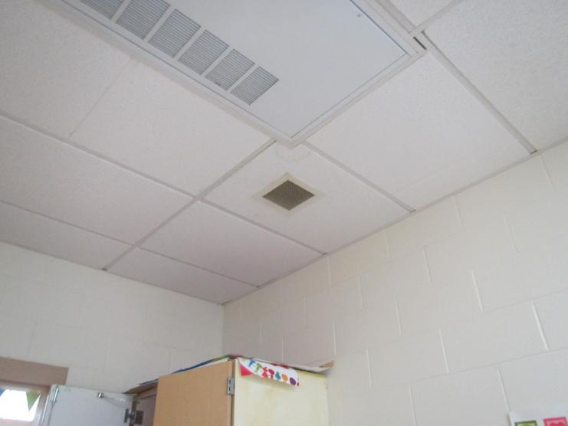
Ceiling-mounted exhaust vent (arrow)
Picture 8
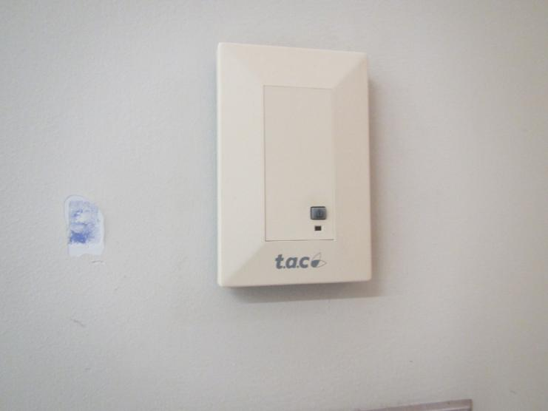
Building management system sensor in a classroom

Picture 9
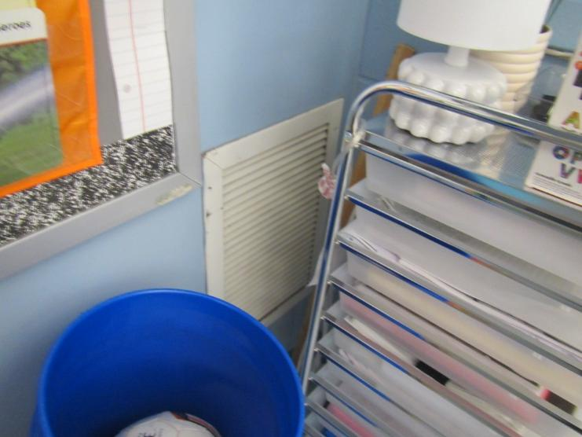
Partly blocked exhaust vent
Picture 10
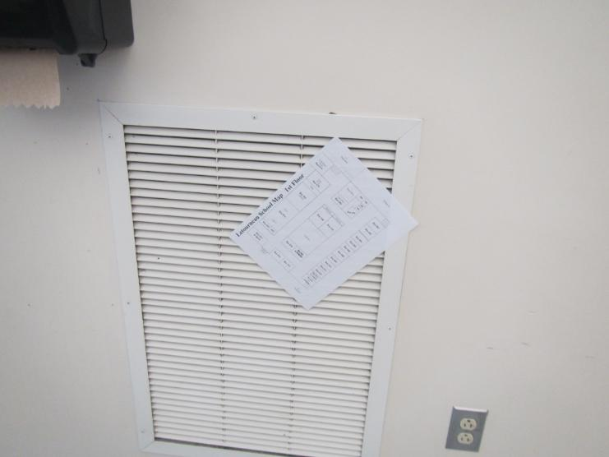
Paper drawn into exhaust vent showing strong flow of exhaust air

Picture 11
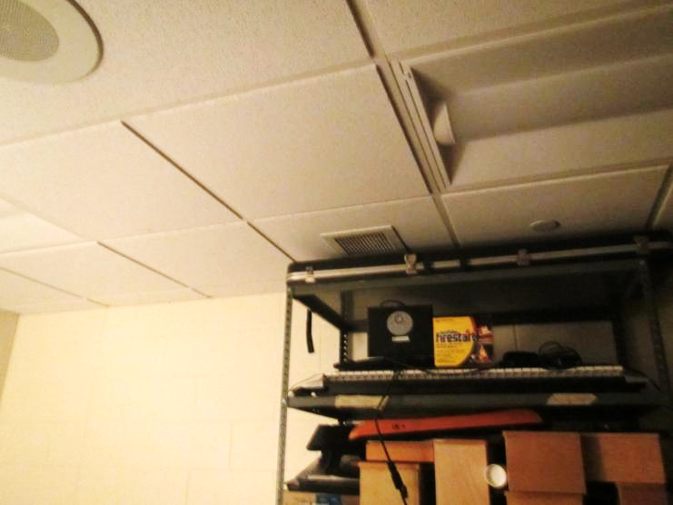
Items near the ceiling partly obstructing a ceiling-mounted exhaust/return vent
Picture 12
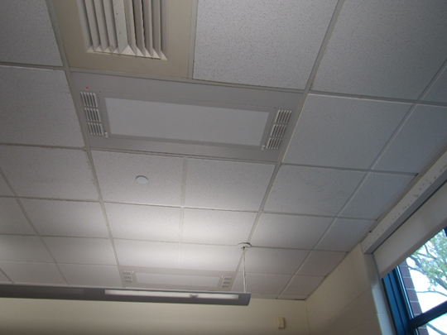
Two ceiling-mounted units that may be air purification systems (arrows)

Water Damage Pictures

Picture 13
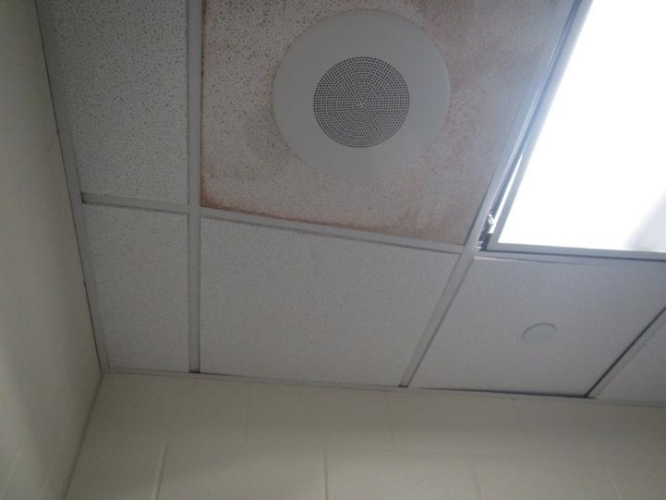
Water-damaged ceiling tile
Picture 14
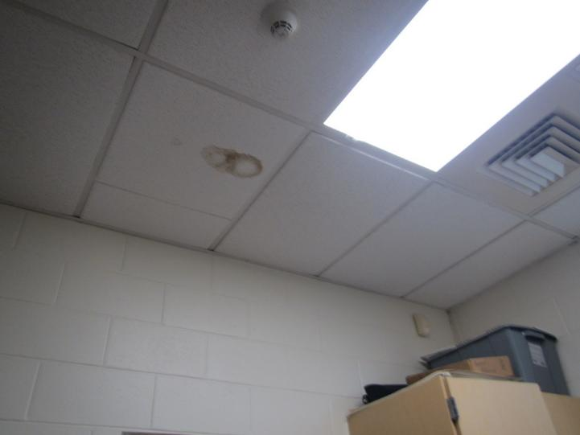
Water-damaged ceiling tile
Picture 15
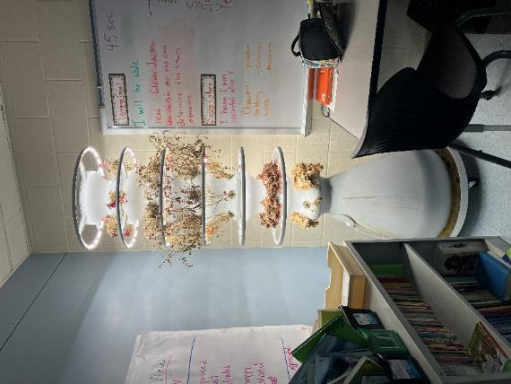
A planter in a classroom
Picture 16
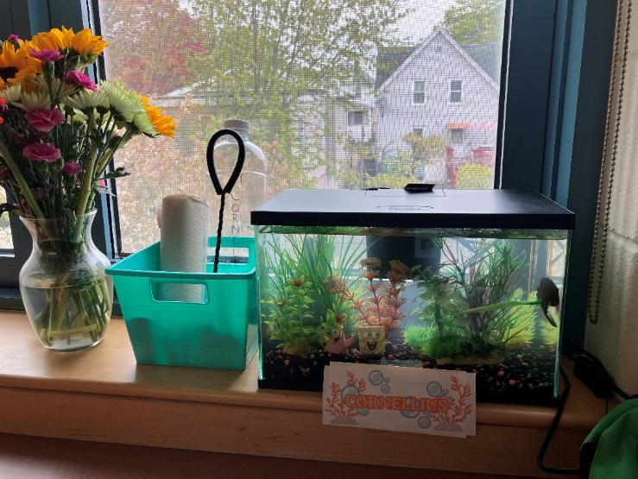
Aquarium in a classroom

Picture 17
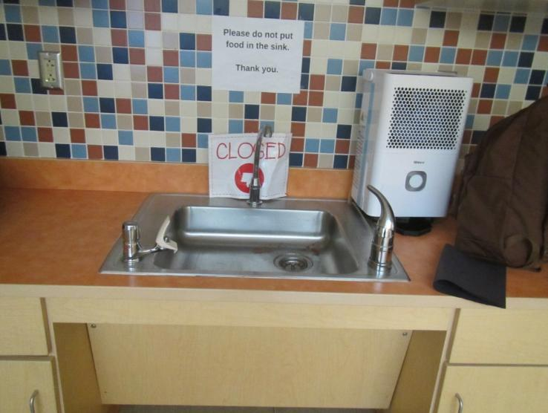
Sink that may be out of order, note dehumidifier unit to the right of sink
Picture 18
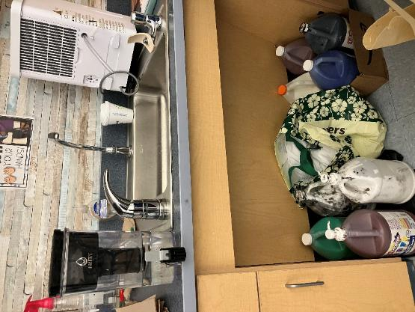
Under sink area, pipes walled off, used for storage, also note dehumidifier to right of sink

Picture 19
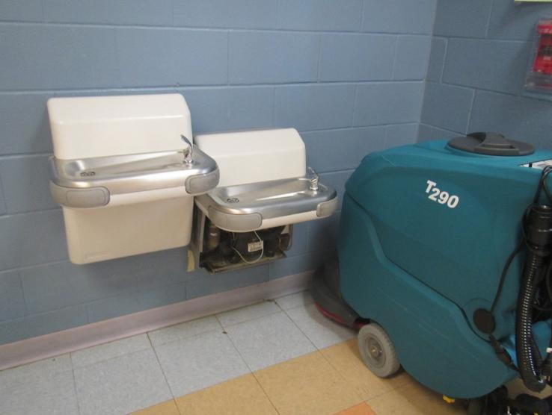
Broken water fountain
Picture 20
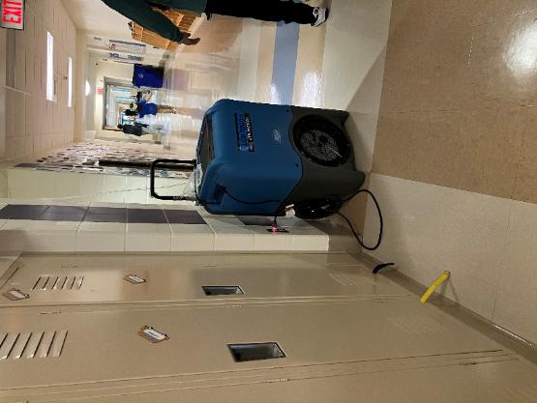
Large dehumidifier in a hallway

Picture 21
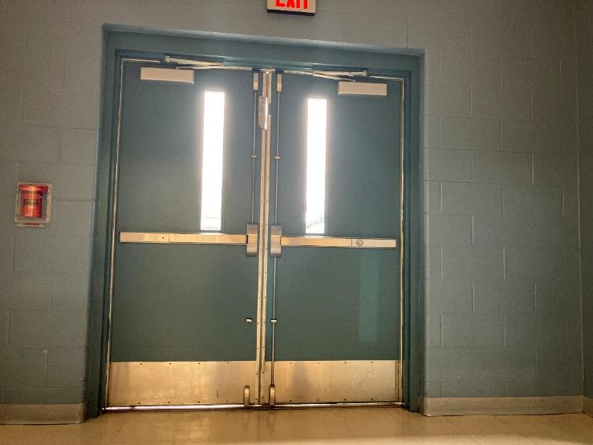
Gaps underneath exterior door
Picture 22
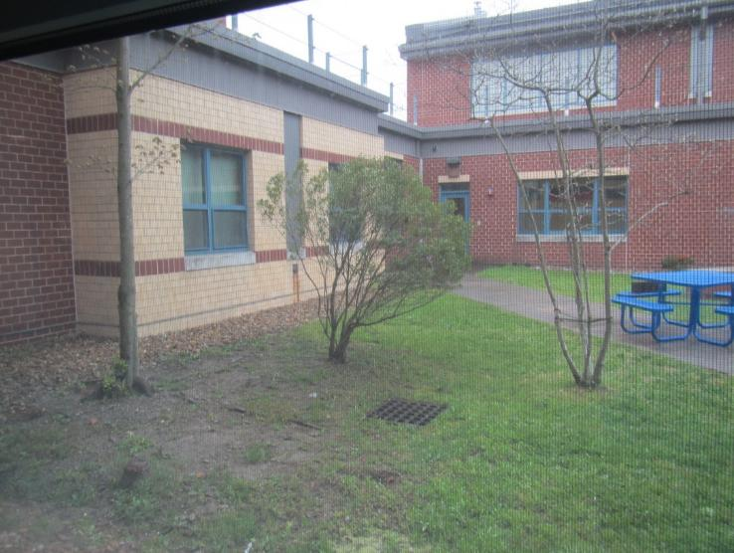
Plants/trees in the courtyard

Picture 23
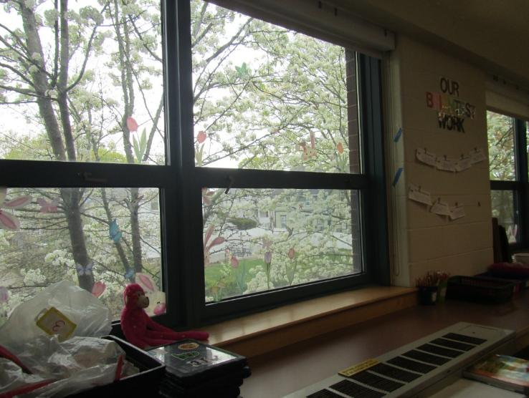
Trees up against window
Picture 24
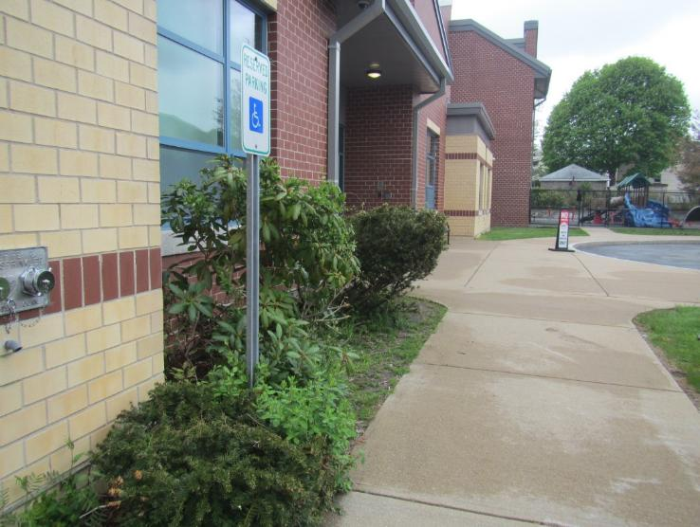
Plants against exterior of building

Sources of Respiratory Irritation Pictures

Picture 25
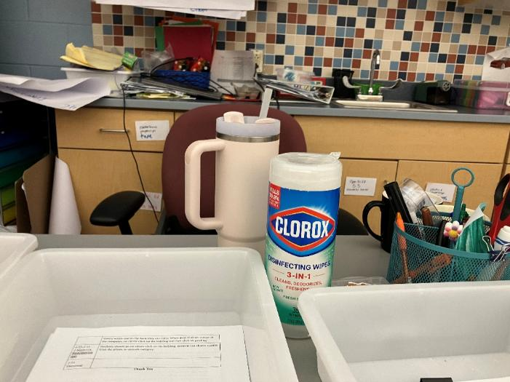
Sanitizer
Picture 26
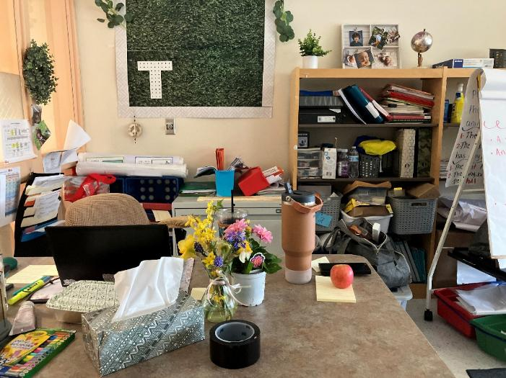
A variety of items on surfaces

Picture 27
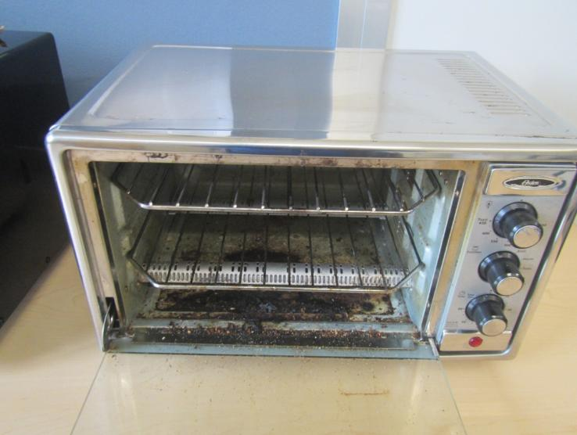
Dirty toaster oven
Picture 28
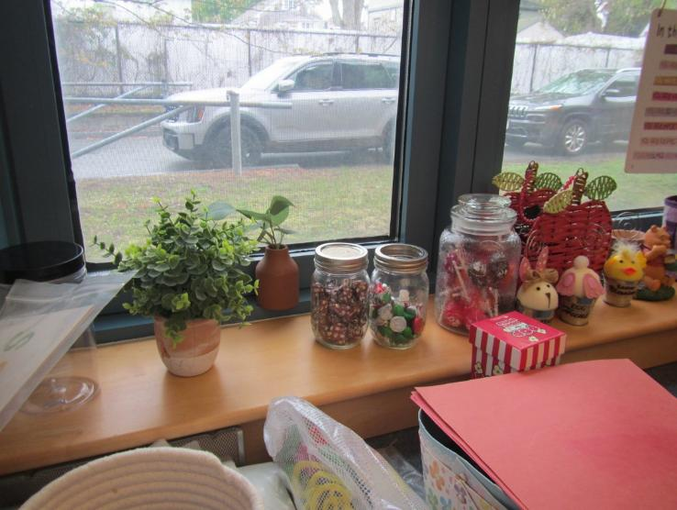
Food in uncovered container (arrow)

Picture 29
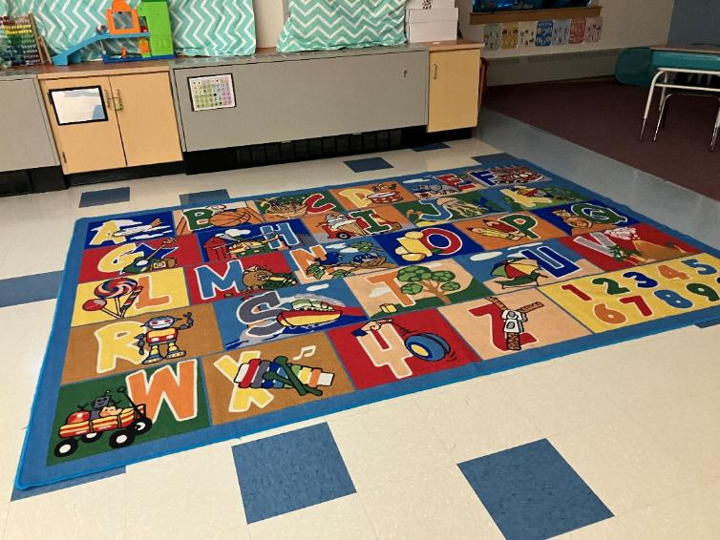
Area rug in a classroom
Picture 30
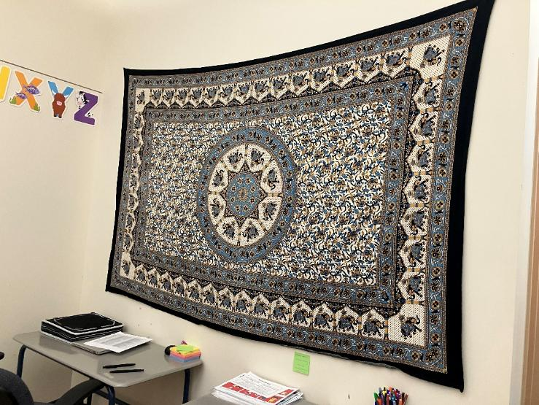
Cloth wall hanging

Click to link back to report

Table 1
Room | Openable Windows | HVAC | Ventilation |  | Ceiling Tiles/Staining (Y or N)  B = Bowed | Comments
Room | Openable Windows | HVAC | Supply | Exhaust | Ceiling Tiles/Staining (Y or N)  B = Bowed | Comments
Community Room | Y |  | Y | Y |  | HS
Community Room back | Y |  | Y | Y |  | Fridge (dirty), microwave, dishwasher, sink, DEM, food pantry, door to the exterior rusty at the bottom.
Student restroom in community room | N |  | Y | Y | Y, B
Music room |  | Y | Y | Y |  | DEM, carpet
074 music storage | Y | Y |  |  |  | Instruments
072 practice | N | Y | N |  |  | Storage of items
073 practice | N | Y | N |  |  | Clothing storge, room was locked but view through window showed items on floor
087 office | Locked | Y | N
094 storage | N | Y | Y
089 | Y | Y | Y | Y | Y | DEM, HS
090 storage | Y | Y | Y | N | Y | Clothing items on floor
097 | N | Y | Y | Y | Y | Area rug
098 | Y | Y | Y | Y | Y | Supply vent ajar
Nurses’ office | N | Y | Y | Y | N | Accessory rooms, mostly occupied, fridge, sink, microwave
002 | Y | Y | Y | Y | N | DEM, scented item, sink, dehumidifier, carpet, cardboard on floor, exhaust vent blocked
003 |  |  |  |  | Y | Area rug, plants, sink, dehumidifier
004 |  |  |  |  |  | Area rug, sink, dehumidifier, DEM
005 small group | Y | Y | Y | Y |  | Food, mostly contained in pest-proof containers, DEM, sink
008 | Y | Y | Y | Y |  | Area rug, pencil sharpener, DEM, sink, dehumidifier
010 | Y | Y | Y | Y | B | Area rug, sink, dehumidifier
012 | Y | Y | Y | Y | B | Mats, sink, dehumidifier
018 | Y | Y | Y | Y | B | Area rug, sink, dehumidifier, toilet rooms between classrooms
026 | Y | Y | Y | Y |  | Area rug, sink, dehumidifier, toilet rooms between classrooms
030 | Y | Y | Y | Y |  | Sink, dehumidifier, area rug, printer
033 | Y | Y | Y | Y |  | Area rug, sink – not in service, dehumidifier
Gym 054 | Doors | Y | Y | Y |  | One of the storage room has a missing ceiling tile, door to the exterior not weather proof, exhaust vent dusty
051 gym office | N | Y | Y | Y | 2 | FCU on ceiling, HS
Boys restroom/locker | N | Y | Y | Y |  | FCU on ceiling
Cafetorium | N | Y | Y | Y
ART | Y | Y | Y | Y |  | Area rug, sinks, dehumidifier, eyewash station
006 | Y | Y | Y | Y |  | DEM, sink, dehumidifier
110 | Y | Y | Y | Y |  | DEM, sink, dehumidifier, carpet, sunroom storage area door not weather tight
009 | Y | Y | Y | Y | 1 | DEM, sink, carpet, cushions on floor, dehumidifier
011 | Y | Y | Y | Y | 1 | Tapestry on the wall
014 | Y | Y | Y | Y | N | DEM, sink, dehumidifier
021 | Y | Y | Y | Y | N | DEM, sink, dehumidifier, door to the exterior not weather tight
025 | Y | Y | Y | Y | N | Exhaust vent blocked, DEM, sink, wall damaged
042 |  |  |  |  |  | Storage room
233 | Y | Y | Y | Y | 1 | DEM, sink, dehumidifier
Library (multiple rooms) | Y | Y | Y | Y | 2 | DEM, plants (real and fake), rusted ceiling vent in the main hallway, no air exchange
234 small | Y | Y | Y | Y |  | DEM
235 planning | Y | Y | Y | Y |  | Sink, HS, food, fridge – empty
Hallway near 234 |  | Y | Y | Y |  | Damaged/lifted carpet tiles
247 | N | Y | Y | Y |  | Carpet
237 workroom | N | Y | Y | Y |  | Sink, food
Social skills room | N | Y | Y | N |  | DEM, carpet
245 speech | N | Y | Y | N |  | Carpet
244 testing | N | Y | Y | N |  | Carpet, DEM
201 | Y | Y | Y | Y |  | Sink and dehumidifier, area rug
202 | Y | Y | Y | Y |  | Very weak exhaust draw, DEM, sink, dehumidifier
204 small | Y | Y | Y | Y |  | Sink, DEM
205 small | Y | Y | Y | Y |  | Sink, DEM, fridge – full and clean, microwaves, toaster ovens – dirty
209 | Y | Y | Y | Y |  | Sink and dehumidifier, DEM, area rug
239 | N | Y | Y | Y |  | DEM, sink, dusty PF, hydroponic plant tank with dead plants, cushions
221 | Y | Y | Y | Y |  | Sink, dehumidifier, area rug
220 small | Y | Y | Y | Y |  | Sink, plants
217 | Y | Y | Y | Y |  | Sink, dehumidifier, DEM, exhaust vent not drawing and rusty
225 | Y | Y | Y | Y |  | Area rugs, sink, fridge
203 | Y | Y | Y | Y |  | DEM, sink, carpet, dehumidifier
207 | Y | Y | Y | Y |  | DEM, sink, carpet, dehumidifier
208 | Y | Y | Y | Y |  | DEM, sink, carpet, dehumidifier
210 | Y | Y | Y | Y |  | DEM, personal fridge and microwave, floor seating with cushions, rugs, blankets, and teepee tent.
212 | Y | Y | Y | Y |  | DEM, sink, carpet, dehumidifier, terrarium
213
214 | Y | Y | Y | Y |  | DEM, sink, dehumidifier, fragrance
224 | Y | Y | Y | Y |  | DEM, sink, dehumidifier,
Main office conference room | N | Y | Y | Y |  | NC
Main office | Y | Y | Y | Y |  | NC, plants, PC
Main office break area | N | Y | Y | Y |  | Fridge, microwave, food
036 |  | Y | Y | Y
090 |  |  |  |  |  | Storage room
089 |  |  |  |  |  | Principal’s office

Table 2A
Equipment Present in Building  (X = Yes) | Type of Heating/Cooling Ventilation  Equipment | Fresh  Air  Supply  (X = Yes) | Type of Location(s) | Air Filters Installed  MERV Rating  (1-15, U*)  (X = Yes) | Comments
 | Univents
X | Rooftop Air Handling Units | X | Most areas | X
 | Outdoor, Ground-Installed Air Handling Units
 | Attic/Crawlspace Air Handling Units
X | Ceiling-Mounted Air Handling Units (including inside plenum) | No | some areas
 | Basement/Crawlspace-Installed Air Handling Units
 | Mechanical Room-installed Air Handling Units
X | Fan Coil Units | No | classrooms and other rooms | X
 | Window-Mounted Air Conditioners
 | Wall Louver-Controlled Gravity Air Supply
X | Windows |  | Classrooms, offices
 | Fan in window (blowing in)
 | Built in wall fan (switched)
 | Heat recovery ventilator unit
 | Energy recovery ventilator unit
 | Chilled Beam

*U = Filter Rating underdetermined due to inaccessibility during building visit

Table 2B
Equipment Present in Building  (X = Yes) | Type of Exhaust Ventilation  Equipment | Ducted  To Outdoors  (X = Yes) | Type of Location(s) | Comments
X | Rooftop Motors/Fans | X | Classrooms and offices
 | Unit Exhaust
X | Ceiling Return Vent | X
 | Ceiling Return Vent, Plenum
X | Wall Return Vent | X | Some rooms
 | Kitchen Stove Hood
X | Restroom Exhaust Vent | X
 | Photocopier Exhaust Vent
 | Garage
 | Chemical Hood(s)
X | Locker Rooms | X
 | Showers
 | Clothes Dryers
 | Gas Water Heaters
 | Furnace-Flue to Chimney
 | Furnace/Boiler direct vent or power vent (no combustion air supply)
 | Kiln, Pottery
 | Dark Room
 | Generator Room
 | Wood Shop Dust Collector
 | Spray Paint Booths
 | Fan in window (blowing out)

Table 2C
Equipment Present in Building  (X = Yes) | Type of Equipment | Type of Location(s) | Comments
 | Floor Fans, pedestal
X | Floor Fans, portable | Classrooms
 | Air Purifier (HEPA, other)
 | Floor heaters, portable
X | Refrigerators, Cold Beverage Vending Machines
 | Radiator, wall-mounted
 | Radiator, floor-mounted
 | Passive Vents (Wall/Door)

Table 3
Found in Building  X = Yes | Water-Damaged Materials, Building Components or Stored Materials | Location | Visible Microbial Growth?  X = Yes | Musty odor detected?  X = Yes | Comments
 | Books-other bound materials
 | Brick walls – broken, missing mortar
 | Brick walls – blocked weep holes
 | Cardboard boxes
 | Carpet tiles
 | Carpet - Area rugs
 | Carpet wall-to-wall
 | Ceiling tiles - affixed directly to ceiling surface
 | Ceiling tiles - bowing-in suspended ceiling
 | Ceiling tiles - water-stained in splined ceiling
X | Ceiling tiles - water-stained in suspended ceiling | Classrooms, offices, common areas
 | Chairs - laminated
 | Cloth
 | Countertops (around sinks)
 | Curtains
 | Dust/debris within AHU, uninvent, HVAC, chilled beam units, etc. (WD through condensation, humidity, or leaks)
 | Efflorescence (i.e., mineral deposits)
 | Engineered woods - particleboard, plywood, Masonite
 | Flooring – loosened tiles
 | Flooring - wooden
 | Furniture - laminated
 | Furniture - upholstered
 | Gypsum wallboard - ceiling
 | Gypsum wallboard - restroom wall
 | Gypsum wallboard - interior wall
 | Gypsum wallboard – located on exterior wall
 | HVAC drain pan – lack of draining
 | HVAC filters
 | Insulation- attic (paper-backed)
 | Insulation - inside air handling unit
 | Insulation - on pipe(s) fiberglass
 | Insulation - on pipe(s) other/plaster-like material
 | Insulation - wall cavity
 | Insulation – ceiling plenum
 | Modular furniture – walls/cloth partitions
 | Musical instrument cases
 | Plaster ceilings
 | Records/files
 | Refrigerator - door gasket |  | X
 | Refrigerator - drip pan
 | Refrigerator - Interior surfaces
 | Room divider - ceiling-mounted, sliding
 | Sink backsplash
 | Sink under cabinet
 | Tables – laminated
 | Wallpaper
 | Wood - attic/roof materials
 | Wood - floor joists in basement ceiling
 | Wood - wall framing
 | Wood – windowsills
 | Wood - window-mounted air conditioner framing
 | OTHER

WHAT ARE ENVIRONMENTAL ASTHMA TRIGGERS?
Asthma triggers are any chemical, pollutant, or allergen that can make your asthma worse. Asthma triggers can also be strong chemical smells, dust, or pets. Your asthma triggers may be different from those of other people. Not all asthma triggers affect people the same way. Environmental asthma triggers are found both indoors and outdoors. MDPH link: Asthma and Your Environment (mass.gov)

(click to link back to report)

Table 4
Condition Present  X = Yes | Possible asthma symptom-inducing environmental pollutant | Recommendation to reduce or eliminate the pollutant
X | Water Damage and/or Mold  (allergen) | Identify water source and repair to eliminate.  Clean non-porous materials.  Remove and replace porous materials susceptible to mold growth.  Perform regular water damage assessments as a tool to ensure timely mitigation as needed.  Use NIOSH water damage assessment protocol as a guide: NIOSH water damage assessment guideline.
X | Moistening of building components during hot, humid weather (>2 days in length) (mold, allergen) | Remove materials not dried in <2 days in a manner consistent with US EPA Mold Removal in Commercial Buildings guideline.  Use dehumidification in occupied basement areas and other areas with chronic dampness.
 | Vegetation against exterior of building (water damage-mold) | Remove all vegetation preventing building exterior drying.  Remove all vegetation capable of falling onto a building or depositing debris onto the roof.
 | Personal humidifiers (lack of proper maintenance)  (pollutant and allergen) | Clean and maintain properly.  Use distilled water to eliminate metal and water treatment odors.  Maintain hydration by increasing water consumption.
X | Drains: Floor drains, Sink drains (abandoned use)  Water bubblers (abandoned use) | If in use, pour water into drain at least twice a week.  If not in use, seal the drain with an appropriate material in accordance with Massachusetts Plumbing Code (248 CMR 10.00).
 | Live Animals (turtles, gerbils, birds, rabbits, etc.) | Ensure cleanliness or remove animals from the location.
 | Improperly maintained aquariums and terrariums (allergen) | Maintain such equipment properly to eliminate odor.  Discontinue use.
X | Plants and flowers  (allergen and mold) | Keep indoor plants well maintained and not overwatered. Monitor for signs of mold and pests.  Ensure water for cut flowers does not become stagnant.  Ensure dried plant material is free of odors, mold, and pests and handled carefully  If asthma risks are high, eliminate plants and flowers.
 | HVAC system moisture issues  (mold, allergen) | Consult ASHRAE’s minimum standards for HVAC maintenance and inspection of commercial HVAC systems (https://www.ashrae.org/technical-resources/bookstore/standards-180-and-211).
 | HVAC system contaminant issues (allergen) | Consult ASHRAE’s minimum standards for HVAC maintenance and inspection of commercial HVAC systems (https://www.ashrae.org/technical-resources/bookstore/standards-180-and-211).
 | Indoor swimming pool odors outside of swimming pool (mold, chemical) | Maintain and operate pool HVAC systems to vent odors from building.  Ensure locker room exhaust vents are operating during building hours.  All doors leading to pool should be rendered airtight and be closed.
X | Pollen (allergen) | Recommend installation of MERV 8 or better filters if HVAC engineer confirms HVAC system can be so equipped without adversely affecting function.  Cut grass after hours.  Cut grass in a pattern to direct clippings away from exterior wall.  Remove trees and shrubs from in front of windows and air intakes.
 | Dry air | Maintain hydration.  Avoid overheating of air.
X | Dust mites  (allergen) | Recommendation to remove non-official upholstered furniture, area rugs, pillows, cushions, etc.  Cleaning with use of HEPA-filtered vacuum cleaner.  Eliminating clutter, storing items in dust and moisture-proof containers, and regularly removing dust through wet wiping.
 | Pests, including rodents and cockroaches  (allergen) | Use of integrated pest management guidelines, including:  - Proper disposal of food containers  - Proper storage of food products in airtight containers  - Elimination of use of food as art projects  - Remove pest harborages/clutter  - Regular monitoring for pests  EPA IPM guideline link
 | Latex-containing materials | Remove tennis balls from furniture legs or replace with latex free ones.
X | Fragrances  (chemical) | Eliminate point sources, such as:  - Plug-in air fresheners  - Aroma/oil reed diffusers  - Scented sprays  - Discontinue use of other scented materials  - Consult MDPH fragrance guideline: Clean air is odor-free
 | Strong smells from /use of Chemicals (such as cleaning products)  (chemical) | Use building-issued cleaning products.  Use products in accordance with manufacturer’s instructions including dilution, application, and ventilation.  Avoid using products that are stronger than needed for the situation.
 | Strong odors from new building materials (carpeting/furniture)  (chemical) | Use low VOC-emitting materials.  Air out materials (outside or in unoccupied area) prior to installation.
 | Tobacco smoke  Secondhand Smoke  (pollutant) | Eliminate tobacco smoking.  Seal all shared wall penetrations.
X | Products with strong odor such as paint, perfume, hairspray, air fresheners, bug-spray, laminators, candles, wax melters, dry erase markers and other VOC-containing products  (chemical) | If essential:  - Provide proper exhaust ventilation to eject aerosolized product directly outdoors.  - Avoid/reduce use during occupied hours.  If not necessary, remove and eliminate.
 | Vehicle exhaust  (pollutant) | Enforce anti-idling regulations and post signs to give notice.  Relocate vehicles away from fresh air intakes.  Require cars to park face-in at building walls.  idling-faq
 | Vapors and or fumes from gas, oil, or kerosene stoves  (pollutant) | Operate stove hood when stove in use.  Install stove hood if not present.  Ensure equipment is in good working order.
 | Ozone (pollutant) | Eliminate use of ozone generating equipment.
 | Window Air Conditioners (if not properly maintained) (allergen) | Equip with proper filter and clean periodically.  Clean drip pans.  Install in window with weathertight, non-mold-growth sustaining material.
 | Pottery (pollutant) | Do not operate kiln during occupied hours.  Operate kiln with exhaust system activated.  Seal all seams and holes in kiln vent.  Ensure kiln exhaust discharge terminates outdoors.
X | Carpeting (allergen) | Clean carpeting in a manner consistent with IICRC standards, including regular vacuuming with a high efficiency particulate air (HEPA) filtered vacuum in combination with annual cleaning or semi-annual cleaning in soiled high traffic areas.
 | Sweeping/dusting vs HEPA vacuuming/wet wiping  (allergen or pollutant) | Refrain from using feather dusters or brooms.  Utilize HEPA vacuums and wet wiping to minimize aerosolizing particulate matter.
 | Lack of adequate air exchange/mechanical ventilation | Make repairs as necessary and ensure all HVAC system components are operating continuously when building is occupied.
 | Lack of local exhaust at source of pollution (vocational shop activities, kitchen exhaust hood) (all) | Recommend installation of exhaust ventilation to direct pollutants directly outdoors.
 | Renovating buildings while occupied  (chemical) | Use all SMACNA guidelines for Renovation While Buildings Are Occupied. For information, visit https://www.mass.gov/service-details/construction-and-renovation-generated-pollutants-in-occupied-buildings.
 | Chemistry program chemical storage  (chemical) | Repair (if needed) and operate chemical storeroom vents appropriately. Reduce or eliminate unneeded or overstocked chemicals. Store all chemicals in a manner to separate incompatible chemicals.  Keep chemical storerooms clean.
X | Photocopiers/duplicating machines | All machines should have dedicated exhaust vents.

