**WATER DAMAGE ASSESSMENT**

**Letourneau Elementary School**

**323 Anthony Street**

**Fall River**

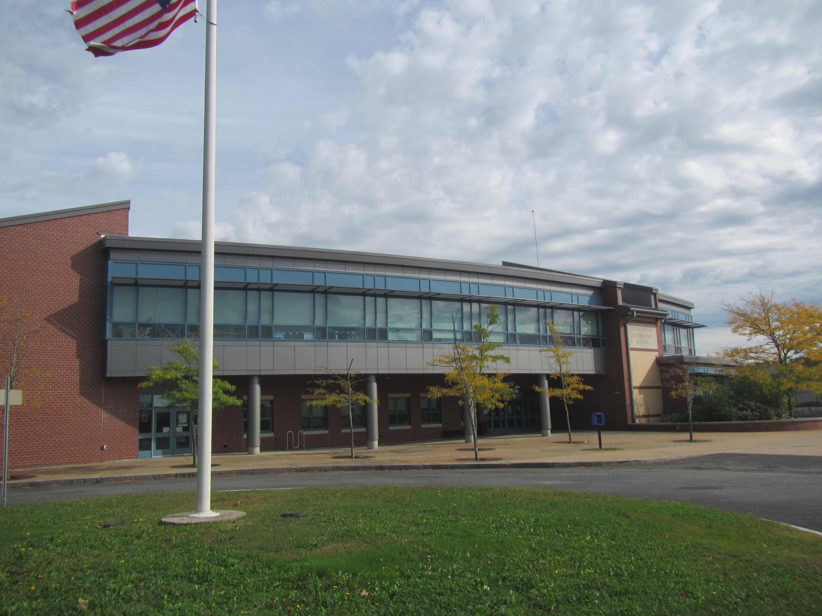

Prepared by:

Massachusetts Department of Public Health

Bureau of Climate and Environmental Health

December 2024

# BACKGROUND

|  |  |
| --- | --- |
| Building: | Letourneau Elementary School (LES) |
| Address: | 323 Anthony Street, Fall River, MA |
| Requestor: | Superintendent Tracy Curley |
| Reason for Request: | Concerns about mold in the school |
| Dates of Assessment: | September 27, 2024, and October 4, 2024 |
| Massachusetts Department of Public Health/Bureau of Climate and Environmental Health (MDPH/BCEH) Staff Conducting Assessment: | Michael Feeney, Senior Bureau Advisor and Thomas Murphy, Environmental Analyst, BCEH |
| Building Description: | LES is a two-story, red-brick building constructed in 2008. |
| Windows: | Openable in most areas |

# EXECUTIVE SUMMARY

The MDPH/BCEH received a complaint of water damage/mold growth at LES. No visible mold or musty odors were observed in classroom 008 or other areas. Air sampling for relative humidity and temperature were conducted throughout the school and the results can be found in Table 1.

Based on the observations made during this assessment, several recommendations were made; the highlights include:

* Sealing soffit vents under the roof ledge.
* Any necessary mold remediation should be conducted following the US EPA’s “Mold Remediation in Schools and Commercial Buildings” <http://www.epa.gov/mold/mold-remediation-schools-and-commercial-buildings-guide>.
* Refer to the following document “Preventing Mold Growth In Schools During Hot, Humid Weather” <https://www.mass.gov/info-details/preventing-mold-growth-in-massachusetts-schools-during-hot-humid-weather> which can be used to minimize the impact of such weather on classroom materials in the future.

In addition, the BCEH has offered to conduct a general IAQ assessment of LES to identify any other conditions that impact the indoor environment.

# METHODS

Please refer to the IAQ Manual for methods, sampling procedures, and interpretation of results (MDPH, 2015).

**RESULTS AND DISCUSSION**

The following is a summary of indoor air testing results (Table 1):

* ***Temperature*** was within or close to the MDPH recommended range of 70°F to 78°F in most areas tested on the day of the assessment.
* ***Relative Humidity*** was above the MDPH recommended comfort range of 40 to 60% in all areas tested. Relative humidity outdoors was 73%. Some indoor relative humidity measurements were equal to or above the outdoor measurement which is unusual in a building that has an HVAC system designed to provide cooling during hot weather. The US Environmental Protection Agency (US EPA) recommends keeping indoor relative humidity between 30 and 50% to prevent mold growth, which presents a unique challenge in regions with high relative humidity in the outdoor environment (Center for Green Schools, 2024).

## Ventilation

A heating, ventilating, and air conditioning (HVAC) system has several functions. First it provides heating and, if equipped, cooling. Second, it is a source of fresh air. Finally, an HVAC system will dilute and remove normally occurring indoor environmental pollutants by not only introducing fresh air, but by filtering the airstream and ejecting stale air to the outdoors via exhaust ventilation. Even if an HVAC system is operating as designed, point sources of respiratory irritation may exist and cause symptoms in sensitive individuals.

Fresh air in the areas assessed is provided by air-handling units (AHUs) located on the roof (Picture 1). Air is drawn into the AHUs from outside, it is then heated, or cooled, and delivered to occupied space via supply diffusers (Picture 2). Exhaust vents remove stale air from classrooms.

Heating, cooling, filtration, and recirculation is provided by fan coil units (FCUs) (Picture 3). FCUs do not provide fresh air. FCUs also chill air in each classroom, which produces condensation which is collected in a drip pan below the cooling coils (Pictures 4 and 5) and then drained outdoors by a pipe that passes through the exterior wall (Picture 6).

To have proper ventilation with a mechanical ventilation system, the systems must be balanced after installation to provide an adequate amount of fresh air to the interior of a room while removing stale air from the room. It is recommended that HVAC systems be re-balanced every five years to ensure adequate air systems function (SMACNA, 1994). Information regarding balancing was not available at the time of this visit.

### Indoor Humidity

The LES is equipped with multiple AHUs which provide cooling. In general, AHUs operating in chill mode will reduce indoor relative humidity. All AHUs appeared to be operating normally during this site assessment. In the experience of BCEH staff, indoor relative humidity is routinely measured to be roughly 20% below outdoor relative humidity when AHUs are operating in cooling mode. Note that rooms with dehumidifiers did not have notably different relative humidity levels to those without (Table 1).

Based on these measurements, a significant source of unconditioned outdoor air appears to be entering LES, independent of the HVAC system. One significant source may be opening windows, which may allow for large amounts of unconditioned outdoor air to enter a building, which will increase humidity during hot, humid weather. However, windows were closed during this assessment, indicating another possible source of unconditioned air independent of opening windows.

BCEH staff believe the unconditioned outdoor air is entering through the roof system which is equipped with soffit vents (Picture 7). Peaked roofs are commonly equipped with both soffit vents and ridge/gable vents to prevent ice dams from developing along the roof edge; ice dams can lead to water damage to indoor ceiling and walls. The purpose of ridge/gable vents is to provide a means to release hot air that may accumulate under the roof, keeping the underside of the roof cold enough to prevent snow from melting. If the roof becomes heated, accumulated snow melts on the roof, and can then freeze into ice along the roof edge where it is colder, creating a dam. This ice dam then prevents meltwater from draining, which may allow water to enter the building. To properly work, a building must have both soffit and roof ridge/gable vents.

BCEH staff observed that no roof section of the LES has any ridge or gable vents (Pictures 8 and 9) but do have soffit vents. The soffit vent likely opens to a space formed by the underside of the roof decking and insulation above the ceiling. In this configuration, outdoor particulate debris (pollen and other organic debris) can enter this space during windy conditions to settle on the bottom of the soffit space. During hot, humid weather, such materials may become moistened which can then lead to microbial growth.

The ceiling below the peaked roof section of the second floor has metal sheets with holes (Picture 10). If hot, moist air penetrates the roof system by the soffit vents, it is feasible that the LES HVAC system is drawing this moisture through seams and holes in the ceiling metal system. This condition would result in difficulty in heating the building in winter months as well as be a source of increased indoor relative humidity in the summer.

With unconditioned humid air entering the building interior, building materials in proximity to classroom FCUs can be cooled to temperatures at or below the dew point. Building materials that have a temperature at or below the dew point can become moistened by condensation. Porous, carbon-containing materials, which may include accumulated dust/debris and wood blocks installed beneath each FCU (Picture 11), may become mold-colonized if moistened.

As an HVAC system operates, outdoor air passes across coils chilled with coolant. This not only cools the air but removes water vapor in the form of condensation on the coils. Condensation forms water droplets, which then fall into a pan connected to a drain. In general, an HVAC system can reduce some, but not all humidity in the air during normal operations in an occupied building.

During extremely hot, humid weather, water vapor remaining in the supply air can moisten materials that are in the stream of air. These materials may include ceiling tiles, gypsum wallboard, cardboard, paper, dust, and other debris on top of cabinets. If moistened materials are notdried within 24 hours, such materials may become media for growing mold.

One of the FCUs in classroom 008 was opened and examined. Filters were found to be a pleated type with a minimum efficiency reporting value (MERV) of at least 10. Facility staff report that filters had been changed recently. In general, HVAC system filters should be changed at least twice a year.

## Water Damage Issues

### Moisture issues due to high humidity

BCEH staff identified potential moisture issues due to the configuration of the filter bracket in relation to the coils inside an FCU. This is particularly important because during the process of air chilling, condensation is created that needs to be drained. If extended periods of continuous hot, humid weather occur (e.g., a heat wave), increased atmospheric water vapor can overwhelm the drainage capacity of various components of the HVAC system. This may result in wetting of building components that are too close to the drain pan.

Hot humid summers are becoming more frequent due to climate change. Massachusetts has experienced hot, humid, and rainy summers in 2018, 2021, 2023, and August 2024. July of 2021 was the wettest ever recorded in Massachusetts, and the three-month period from June through August, known as the meteorological summer, was the fourth wettest on record, according to the National Oceanic and Atmospheric Administration’s (NOAA) Centers for Environmental Information (NOAA, 2021). The summer of 2023 was also hot, and wet, being measured as the second rainiest on record (WBUR, 2023). And the summer of 2024 also had significant stretches of hot, humid weather. These conditions are challenging for buildings, particularly those without central air conditioning.

Under these weather conditions, public buildings such as schools experienced extended periods of water vapor exposure from high relative humidity. When exposed to these conditions, porous materials such as gypsum wallboard, cardboard, and other materials may become moistened and colonized with mold, particularly if located in areas that are prone to developing condensation, such as floors and walls in contact with the ground (e.g., below grade space).

A key concept in dealing with condensation-related water damage is that of “dew point”, which was mentioned in the previous section. The dew point temperature is the temperature at which air with a given amount of water becomes saturated with water and water begins to condense out as a liquid. For example, at 75°F and 70% relative humidity, the dew point temperature would be 64°F. That means that any surface at or below that temperature in contact with that air will start to generate condensation. In very humid conditions, surfaces do not have to be cooled much below ambient temperature to go below the dew point. Dehumidification, either through air conditioning or through stand-alone dehumidifiers, can reduce the chances of condensation. Monitoring areas of the building that may be colder than the rest of the room (e.g., floors, exterior walls in shade, and chilled plumbing and HVAC components) can lead to discovery of the areas that are most likely to be a problem during humid weather.

One of the reasons for this visit was reports of mold in first floor classrooms, including classroom 008. While no visible evidence of mold or odors were detected by BCEH staff during the visit, potential sources of odors were identified during the visit, including the FCU configuration issue described above. Odors reportedly were noted early in the day and later dissipated. This may occur because the ventilation system is turned off overnight, leading to a buildup of stale air.

One sign of long periods of high relative humidity in the LES is the presence of bowed ceiling tiles (Picture 12). If a building experiences high relative humidity indoors over an extended period, moisture exposure may cause ceiling tiles to bow. Bowed ceiling tiles without discoloration/stains are not mold colonized, but are a sign of long-term water vapor exposure, which causes sagging due to the weight of water in the ceiling tile and its effect on binders that hold the tile intact.

Bowing ceiling tiles are often found in classrooms and cafeterias with sink or floor drains where the trap has dried out. A trap is a section of pipe below the drain opening that fills with water to form an airtight seal. The airtight seal prevents combustible sewer gas, odors, and water vapor from the drain systems from backing up the drain to enter occupied space. Water evaporates from the trap if plumbing is not used for several days, or weeks, depending on ambient conditions. Wetting of all drain traps regularly to maintain the airtight water seal is particularly important when heavy rains occur, which may pressurize combined storm/sanitary sewer systems and force sewer gas and water vapor/odors/pollutants up the drainpipe. Schools are particularly vulnerable to dry drain traps due to the extended summer vacation.

### Mold testing recommendations

BCEH does not recommend testing for mold in buildings such as this one. The presence of mold found by a test does not necessarily indicate a problem. Visual evidence of mold growth and/or the presence of musty odors are reliable indicators of mold problems that are correlated with health risks in buildings where indoor environmental complaints have been made. Mold spores waft through the indoor and outdoor air continually There is no practical way to eliminate all mold and mold spores in the indoor environment; the way to control indoor mold growth is to control moisture (US EPA, 2024).

There is no means by which to determine whether an individual’s symptoms or reactions were caused by mold by conducting environmental air testing for mold. While mold, spores, and other associated materials can make allergies and asthma symptoms worse, different people react differently to mold and mold spores. In addition to mold, reactions experienced by individuals could be caused by bacteria, other compounds in the air caused by the breakdown of wet building materials, or something different altogether (NIOSH, 2024; California DPH, unknown; Mendell, M. J., Mirer, A. G., Cheung, K., & Douwes, J. 2011; WHO. 2009).

The U.S. Environmental Protection Agency (EPA) does not recommend testing. DPH follows the guidelines contained in the U.S. EPA Mold Remediation in Schools and Commercial Buildings report for cleaning and removing water-damaged materials. US EPA’s guidelines recommend, in most cases, that if visible mold growth is present, mold sampling is not necessary. A number of international, US Federal, and state agencies either do not have or recommend against conducting mold testing as part of mold remediation (see **REFERENCES** headings: **Agencies with guidelines recommending against mold testing,** and **Reference from government agencies, industrial hygiene groups and or other environmental professional guidelines that denote that no mold exposure limits have been established for mold in workplace, government buildings or residences).** Forexample, the U.S. Department of Housing and Urban Development (HUD) does not recommend conducting environmental mold testing:

*“No matter what kind of mold you have, you need to get rid of it and fix the moisture problems that made it grow. Most experts think it’s better to spend your time and money on cleaning up the problem than testing” (HUD. 2024).*

Multiple worker safety agencies and organizations have no worker safety air levels established for exposure to species of mold. The following agencies and professional industrial hygiene agencies have not established mold exposure levels in the workplace that would justify air testing. The following industrial safety guidelines do not list any mold species and air level concentrations:

* US Occupational Safety and Health Administration (OSHA) has not established any mold Permissible Exposure Limits (PELs) for mold air levels.
* American Conference of Governmental Industrial Hygienists (ACGIH) has no established Threshold Limit Values (TLVs) for mold air levels.
* National Institute of Occupational Safety and Health (NIOSH) has no established Recommended Exposure Limits (RELs) for mold air levels.
* American Industrial Hygiene Association (AIHA) has no established Workplace Environmental Exposure Levels (WEELs) for mold air levels.

Additionally, even if worker safety exposure limits existed for mold, such guidelines **would not apply** to non-employees in a building. These individuals include: students in primary education schools; students in secondary education facilities; adults outside worker ages as defined by OSHA; individuals with chronic health conditions; patients in any medical facility; adults who are invitees, customers, or visitors to the workplace and other members of the general public.

For non-employees, there are **no established mold exposure limits** (international, Federal, or state regulations, building standards or guidelines) on how much mold can exist in air before health impacts are expected for the general population. In addition, the international, Federal, state or building standards agency have not established mold remediation clean-up levels that must be achieved after mold remediation efforts are completed.

This means that even if tests are conducted, there is no way to compare results or determine whether the measured level could cause health effects or meet clean up levels. Multiple Federal agencies, including the US EPA, US Department of Housing and Urban Development and the US Federal Emergency Management Agency (FEMA) have not established mold exposure standard or recommend environmental mold testing in any water damage/flood recovery guidelines. With no established workers or general public safety exposure limits, air testing will not influence how mold remediation efforts would be conducted.

To remove mold from buildings, of primary importance is to identify, repair and/or limit the moisture source. Once all moisture sources have been reduced or removed, then discarding and/or cleaning of mold-contaminated materials can be completed.

**CONCLUSIONS/RECOMMENDATIONS**

The LES has several issues related to moisture in the building. As noted, soffit vents without ridge/gable vents may be a source of unconditioned outdoor air that may result in condensation on building surfaces that are chilled to a temperature below the dew point.

The capacity of mechanical ventilation equipment to provide adequate chilled air and reduce relative humidity indoors is limited if unconditioned outdoor air enters the building. It is important to note that with extreme relative humidity and rain of this past summer, management of the building in such weather can be challenging. The following documents can provide guidance that can be used to reduce the impact of hot, humid weather in buildings, even ones equipped with an HVAC system that provides chilled air:

* Mold Growth Prevention during Hot, Humid Weather <https://www.mass.gov/service-details/preventing-mold-growth-in-massachusetts-schools-during-hot-humid-weather>
* Remediation and Prevention of Mold Growth and Water Damage in Public Schools <https://www.mass.gov/service-details/remediation-and-prevention-of-mold-growth-and-water-damage-in-public-schools-and>
* Methods for Increasing Comfort in Non-air-conditioned Schools <https://www.mass.gov/doc/methods-for-increasing-comfort-in-non-air-conditioned-schools/download>

To address the building’s problems, two sets of recommendations are made: **short-term** measures that may be implemented as soon as practicable and **long-term** measures that will require planning and resources to address overall IAQ concerns. In view of the findings at the time of the visit, the following recommendations are provided:

## Short Term Recommendations

### Ventilation recommendations

1. Continue to adjust the set point for chilling, it should be raised to avoid condensation in concert with limiting the introduction of unconditioned air into the building.
2. Have the HVAC system balanced every 5 years in accordance with SMACNA recommendations (SMACNA, 1994).

### Water damage recommendations

1. Sealing of all soffit vents beneath roof edges should be considered with the absence of any functioning ridge or gable vents. Monitor the building for the development of ice dams after soffit vents are sealed. Consider retrofitting an appropriate vent system when the roof is planned for replacement.
2. Clean debris on the floor beneath FCU cabinets prior to operating the HVAC system in chilling mode.
3. Continue to work with an HVAC contractor to determine if the HVAC system can be operated or modified to provide additional dehumidification while in chilling mode.
4. Replace wood installed inside FCUs with a material that is not capable of mold colonization.
5. Use dehumidifiers in the building until outdoor conditions are cooler, drier, and the building’s heating system is being used.
6. Maintain all dehumidifiers and regularly remove water and clean receptacles to avoid stagnant water, odors, and the potential for leaks.
7. Avoid storing porous materials on the floor, particularly on the lower level, to avoid moistening through condensation.
8. If mold reoccurs, continue to conduct remediation in a manner consistent with the EPA guideline “Mold Remediation in Schools and Commercial Buildings” (US EPA, 2008) <http://www.epa.gov/mold/mold-remediation-schools-and-commercial-buildings-guide>.
9. Refer to resource manuals and other related documents for further building-wide evaluations and advice on maintaining public buildings. Copies of these materials are located on the MDPH’s website: <http://mass.gov/dph/iaq>.

# Long Term Recommendations

1. Consideration should be given to consulting a building engineering firm to conduct a building-wide ventilation systems assessment and provide recommendations. Based on historical issues with air exchange, indoor air quality complaints, age, physical deterioration, and availability of parts for ventilation components, such an evaluation is necessary to determine the operability and feasibility of repairing or replacing the equipment.

# REFERENCES

## General References

ACGIH.1989. Guidelines for the Assessment of Bioaerosols in the Indoor Environment. American Conference of Governmental Industrial Hygienists, Cincinnati, OH.

Center for Green Schools. 2024. U.S. Green Building Council, Inc. [School mold prevention programs help keep schools healthy | U.S. Green Building Council (usgbc.org)](https://www.usgbc.org/articles/school-mold-prevention-programs-help-keep-schools-healthy). Lauren Bolton, Aug 22, 2024.

NOAA. 2021. Summer 2021 neck and neck with Dust Bowl summer for hottest on record. National Oceanic and Atmospheric Administration, 1401 Constitution Avenue NW, Room 5128, Washington, DC 20230<https://www.noaa.gov/news/summer-2021-neck-and-neck-with-dust-bowl-summer-for-hottest-on-record>.

MDPH. 2015. Massachusetts Department of Public Health. Indoor Air Quality Manual: Chapters I-III. Available at: <https://www.mass.gov/lists/indoor-air-quality-manual-and-appendices#indoor-air-quality-manual->.

SMACNA. 1994. HVAC Systems Commissioning Manual. 1st ed. Sheet Metal and Air Conditioning Contractors’ National Association, Inc., Chantilly, VA.

US EPA. 2008. “Mold Remediation in Schools and Commercial Buildings”. Office of Air and Radiation, Indoor Environments Division, Washington, DC. EPA 402-K-01-001. September 2008. Available at: <http://www.epa.gov/mold/mold-remediation-schools-and-commercial-buildings-guide>.

WBUR. 2023. “It's been a summer of rain and flooding misery in Mass.” WBUR local news. September 12, 2023. <https://www.wbur.org/news/2023/09/12/summer-flooding-rain-massachusetts>.

## Mold Testing References

### Agencies with guidelines recommending against mold testing

APHC. Residential Indoor Mold and Residential Mold Air Sample Results What Do They Mean? FACT SHEET 55-026-0319. U.S. Army Public Health Center, Industrial Hygiene Field Services Program, Aberdeen Proving Ground, Maryland.

CA HESIS. 2005. Molds in Indoor Workplaces. California Hazard Evaluation System and Information Service. P.2 Molds in Indoor Workplaces: Fact Sheet for Workers and Employers (ca.gov) Nov. 2005

CDC. 2024. Mold. Centers for Disease Control. Atlanta, GA. [Mold | Mold | CDC](https://www.cdc.gov/mold-health/about/index.html).

CTDPH. 2012. Get The Mold Out: Mold Clean-Up Guidance for Residences Fact Sheet. Connecticut Department of Public Health Environmental & Occupational Health Assessment Program Environmental Health Secon 410 Capitol Avenue, MS # 11EOH. [Get The Mold Out_ fact sheet082012](https://portal.ct.gov/-/media/departments-and-agencies/dph/dph/environmental_health/eoha/pdf/getthemoldoutpdf.pdf)

FEMA, unk. Homeowner’s and Renter’s Guide to Mold Cleanup after Disasters. <https://www.fema.gov/sites/default/files/documents/fema_hm-cdc-homeowners-and-renters-mold-guide_english.pdf>

Health Canada. Guide to addressing moisture and mould indoors. <https://www.canada.ca/en/health-canada/services/publications/healthy-living/addressing-moisture-mould-your-home.html>

MDHHS. 2010. Mold Fact Sheet. Maine Department of Health and Human Services, Bangor, ME. <https://www.maine.gov/dhhs/mecdc/infectious-disease/epi/disease/documents/pdf/mold.pdf>

MNDPH. 2024. Testing For Mold. [Testing For Mold - MN Dept. of Health (state.mn.us)](https://www.health.state.mn.us/communities/environment/air/mold/moldtest.html)

NHDHHS. 2013.. Mold and moisture. New Hampshire Department of Health and Human Services, Concord, NH. [https://www.dhhs.nh.gov/sites/g/files/ehbemt476/files/documents/2021-11/holu-dphs-mold-policy-letter.pdf](https://www.dhhs.nh.gov/sites/g/files/ehbemt476/files/documents/2021-11/holu-dphs-mold-policy-letter.pdf#:~:text=Although%20a%20handful%20of%20states%20have%20passed%20their,when%20ever%20you%20see%20mold%20or%20smell%20mildew.)

NIOSH. 2024. Mold, Testing, and Remediation. National Institute of Occupational Safety and Health, Cincinnati, OH.

NYDOL. Mold Assessment and Remediation in New York State. Mold Assessment and Remediation in New York State. New York Department of Labor. [p227.pdf (ny.gov)](https://dol.ny.gov/system/files/documents/2021/03/p227.pdf)

ODHS. Unk. FAST FACTs: Household Mold. Oregon Department of Human Services, Public Health Division, Office of Environmental Public Health: Toxicology Consulting Services. [Moldfactsheet.pdf (oregon.gov)](https://www.oregon.gov/oha/ph/HealthyEnvironments/TrackingAssessment/EnvironmentalHealthAssessment/Documents/Moldfactsheet.pdf)

OSHA. Mold. US Occupational Safety and Health Administration. [Mold - Recognize Mold Hazards | Occupational Safety and Health Administration (osha.gov)](https://www.osha.gov/mold/hazards)

USAPHC. 2018. Technical Guide 278 Industrial Hygiene Public Health Mold Assessment Guide. US Army Public Health Center, Public Health 6582 Magrath Ave BLDG 2059 Fort Carson, Colorado. <https://ph.health.mil/PHC%20Resource%20Library/TG278.pdf> .

VTDH. 2024. Mold Inside Home and Other Buildings. <https://www.healthvermont.gov/sites/default/files/document/env-hh-mold-indoors.pdf>

WSDH. Unk. Mold. Washington State Department of Health, [Mold | Washington State Department of Health](https://doh.wa.gov/community-and-environment/contaminants/mold)

### References from government agencies, industrial hygiene groups and or other environmental professional guidelines that report no mold exposure limits have been established for mold in workplace, government buildings or residences.

AIHA. 2019. FAQs About Spore Trap Air Sampling for Mold for Direct Microscopical Examination Mold Analysis Document. American Industrial Hygiene Association, Falls Church, VA. <https://aiha-assets.sfo2.digitaloceanspaces.com/AIHA/resources/FAQs-About-Spore-Trap-Air-Sampling-for-Mold-for-Direct-Examination-Guidance-Document.pdf>

APHC. Residential Indoor Mold and Residential Mold Air Sample Results What Do They Mean? FACT SHEET 55-026-0319. U.S. Army Public Health Center, Industrial Hygiene Field Services Program, Aberdeen Proving Ground, Maryland.

FEMA, unk. Homeowner’s and Renter’s Guide to Mold Cleanup after Disasters. <https://www.fema.gov/sites/default/files/documents/fema_hm-cdc-homeowners-and-renters-mold-guide_english.pdf>

MDHHS. 2010. Mold Fact Sheet. Maine Department of Health and Human Services, Bangor, ME. <https://www.maine.gov/dhhs/mecdc/infectious-disease/epi/disease/documents/pdf/mold.pdf>

OHHN. 2023. Mold Basics. Ohio Healthy Homes Network, Columbus, Ohio. [Mold Basics | Ohio Healthy Homes Network (ohhn.org)](https://www.ohhn.org/mold-basics/)

WDHS. 2021. Controlling Mold and Moisture Household Mold Guidance for Local Health Professionals Wisconsin Department of Health Services, Indoor Air and Radon Program Division of Public Health, Bureau of Environmental and Occupational Health. <https://www.dhs.wisconsin.gov/publications/p02069.pdf>

WHO, 2009. WHO Guidelines for Indoor Air Quality: Dampness and Mould. World Health Organization Copenhagen: WHO Europe. WHO guidelines for indoor air quality: dampness and mould <https://www.who.int/publications/i/item/9789289041683>

**Picture 1**

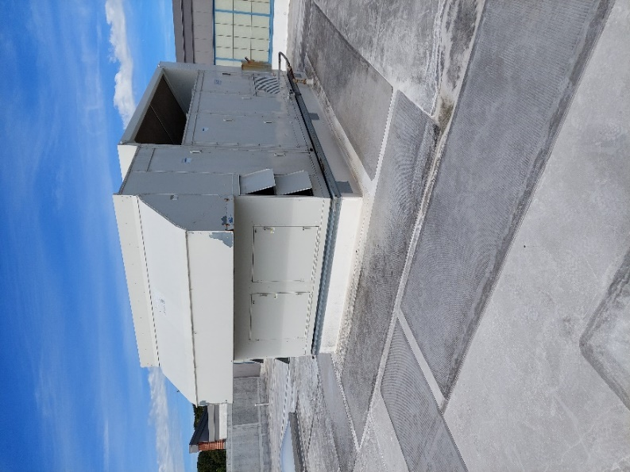

**Rooftop air handling unit**

**Picture 2**

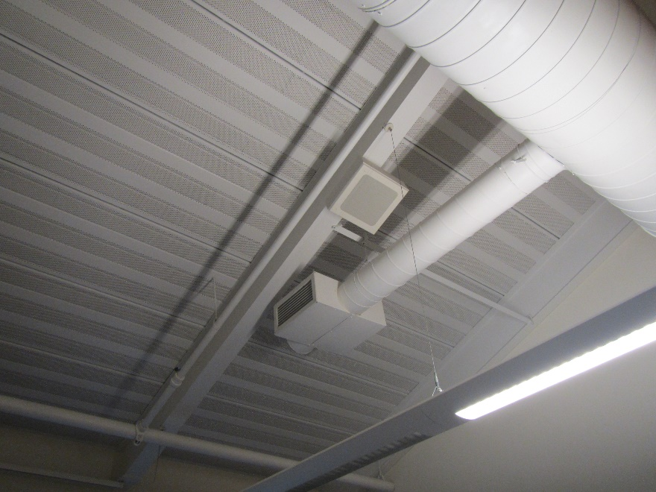

**Fresh air supply in classroom**

**Picture 3**

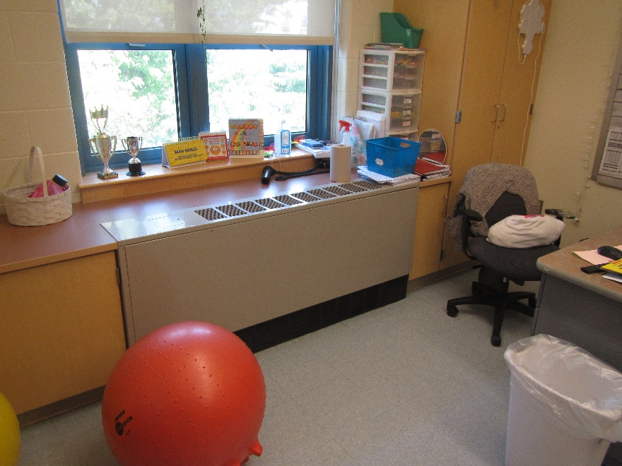

**Fan coil unit**

**Picture 4**

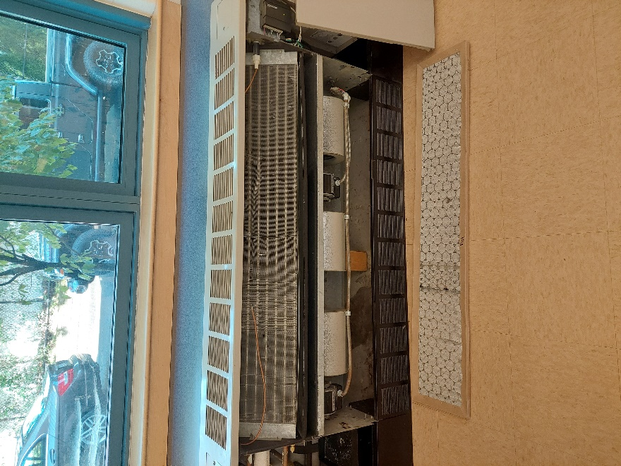

**Fan coil unit with front cover removed, arrow pointing to drip pan beneath coils**

**Picture 5**

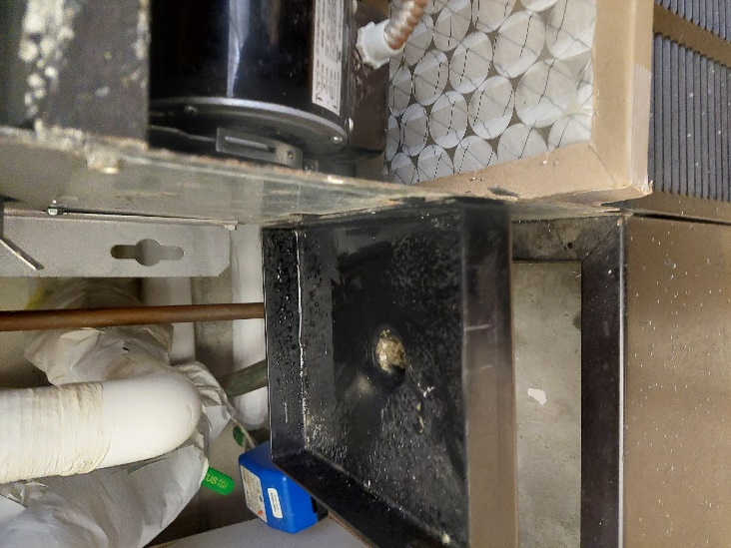

**Condensation collector attached to condensation drain in FCU**

**Picture 6**

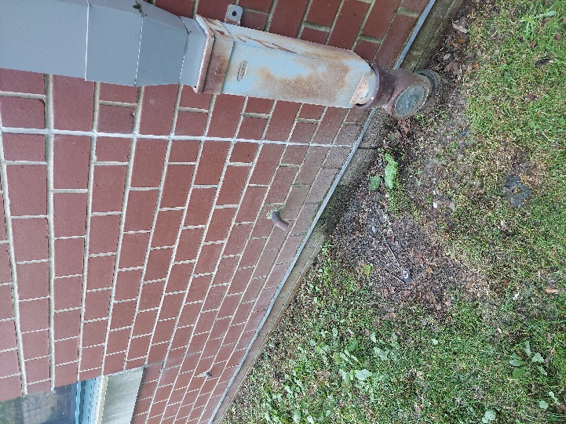

**FCU condensation drainpipe**

**Picture 7**

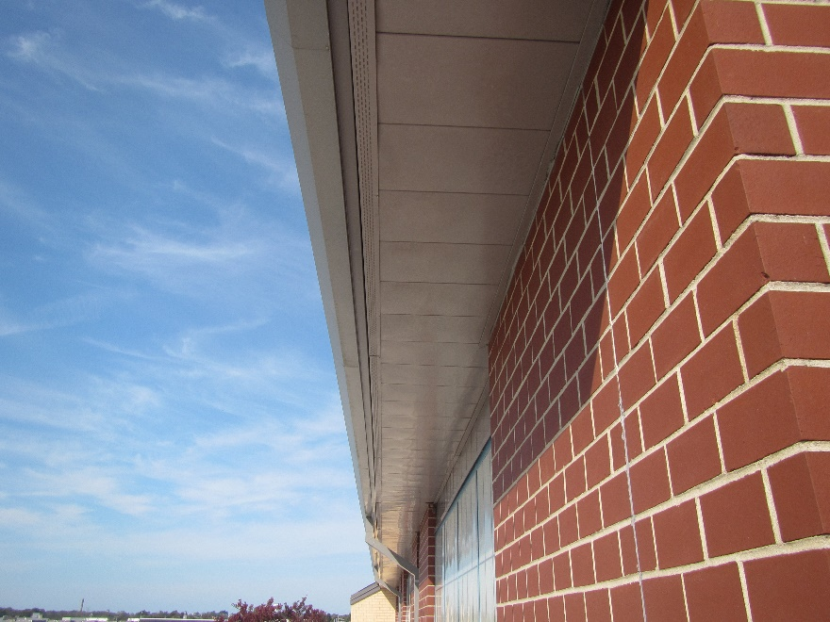

**Soffit vent (arrow)**

**Picture 8**

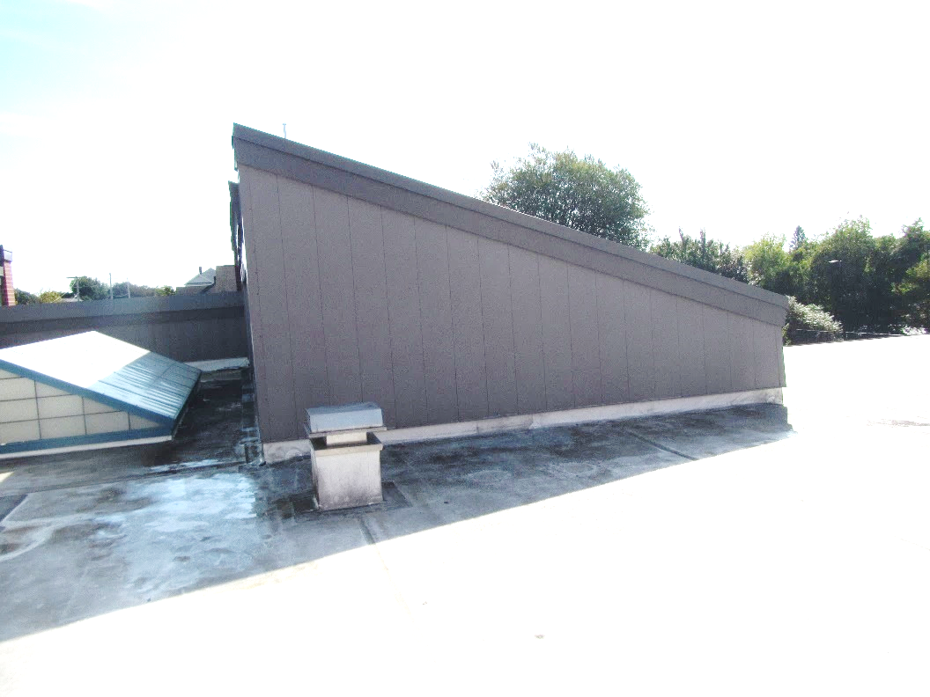

**Roof peak with neither ridge vents nor gable vents**

**Picture 9**

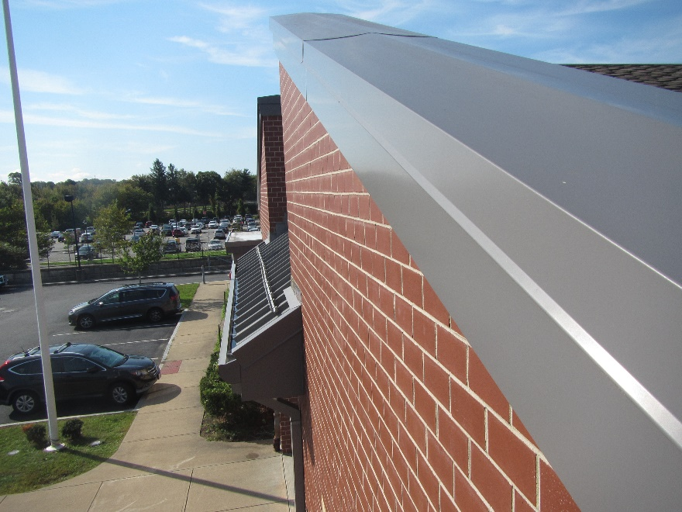

**Roof peak with neither ridge vents nor gable vents**

**Picture 10**

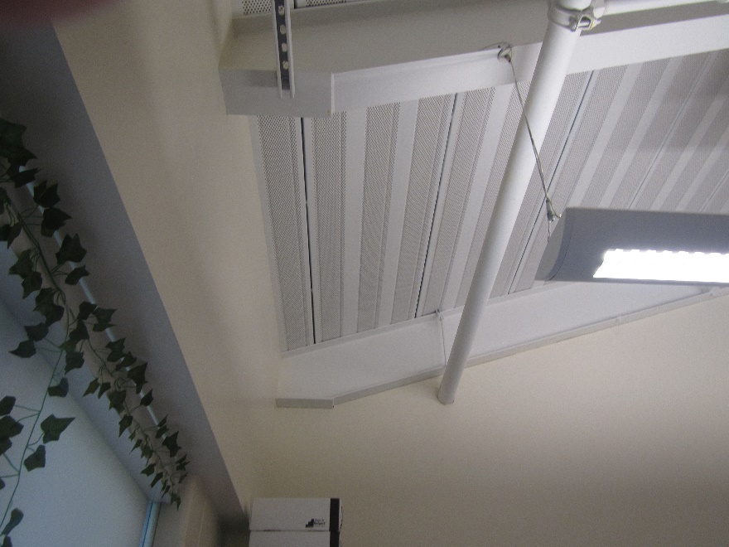

**Metal ceiling in LES, note holes and seams between metal ceiling sections which are likely not airtight**

**Picture 11**

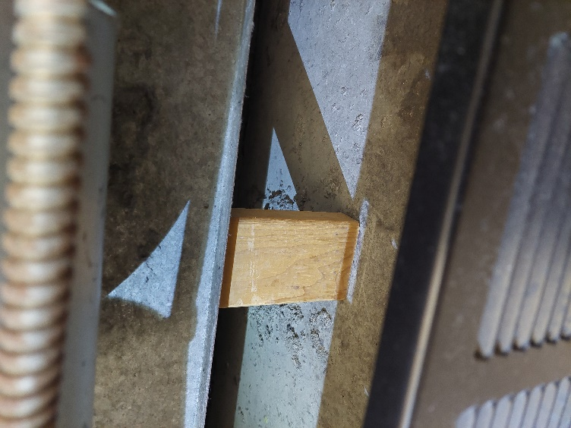

**Wood block wedged beneath FCU**

**Picture 12**

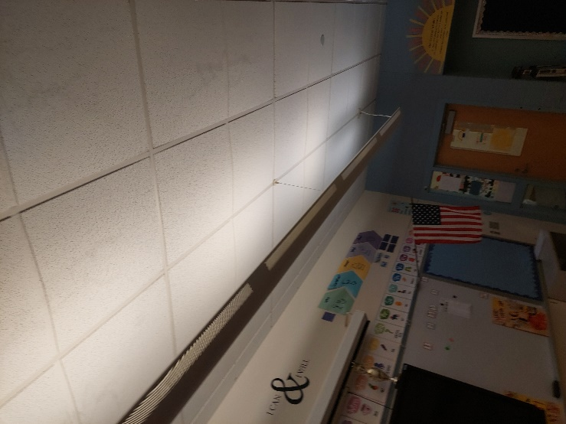

**Bowed ceiling tiles**

| **Table 1**  **Temperature and Relative Humidity Air Testing Results**  **Location: Letourneau Elementary School, 323 Anthony Street, Fall River, MA**  **Date: September 27, 2024** | | | | | | |
| --- | --- | --- | --- | --- | --- | --- |
| Location | **Temp**  **(°F)** | **Relative**  **Humidity (RH)**  **(%)** | **RH Difference compared to outdoors** | **Bowing ceiling tiles** | **Remarks** | |
|
| Background (Outdoors) 11:00 AM | 71 | 73 |  |  | Overcast | |
| 002 | 74 | 68 | -5 | Y |  | |
| 003 | 74 | 70 | -3 | Y | Dehumidifier | |
| 004 | 74 | 69 | -4 | Y | Dehumidifier | |
| 005 | 77 | 67 | -6 | N |  | |
| 006 | 73 | 68 | -5 | Y |  | |
| 007 | 72 | 62 | -11 | N |  | |
| 008 | 69 | 76 | 3 | Y |  | |
| 009 | 70 | 75 | 2 | Y |  | |
| 010 | 70 | 73 | 0 | Y |  | |
| 011 | 71 | 72 | -1 | N | Dehumidifier | |
| 012 | 70 | 73 | 0 | N | Dehumidifier | |
| 014 | 72 | 72 | -1 | N | Dehumidifier | |
| 018 | 71 | 72 | -1 | N | Dehumidifier | |
| 020 | 70 | 74 | 1 | Y |  | |
| 021 | 70 | 73 | 0 | Y |  | |
| 025 | 71 | 73 | 0 | Y |  | |
| 030 | 71 | 72 | -1 | Y |  | |
| 033 | 71 | 62 | -11 | Y |  | |
| 042 | 71 | 71 | -2 | Y |  | |
| 043 | 72 | 70 | -3 | Y |  | |
| 051 | 73 | 70 | -3 | Y |  | |
| 078 | 72 | 65 | -8 | N | Dehumidifier | |
| 087 | 72 | 63 | -10 | Y |  | |
| 093 | 72 | 63 | -10 | Y | Dehumidifier | |
| 094 | 72 | 65 | -8 | Y |  | |
| 095 | 72 | 65 | -8 | Y |  | |
| 096 | 72 | 64 | -9 | Y |  | |
| 101 | 72 | 70 | -3 | Y |  | |
| 108 | 71 | 71 | -2 | Y | Water-damaged ceiling tile | |
| 110 | 72 | 70 | -3 | Y | Dehumidifier | |
| 201 | 71 | 72 | -1 | N | Dehumidifier | |
| 202 | 72 | 73 | 0 | N | Dehumidifier | |
| 203 | 72 | 73 | 0 | N | Dehumidifier | |
| 204 | 72 | 72 | -1 | N |  | |
| 205 | 72 | 71 | -2 | N |  | |
| 206 | 73 | 72 | -1 | N | Dehumidifier | |
| 207 | 73 | 72 | -1 | N | Dehumidifier | |
| 209 | 72 | 74 | 1 | N | Dehumidifier | |
| 210 | 71 | 75 | 2 | N |  | |
| 212 | 73 | 73 | 0 | N | Univent partially blocked | |
| 213 | 73 | 69 | -4 | N | Dehumidifier | |
| 214 | 74 | 70 | -3 | N | Dehumidifier | |
| 217 | 74 | 70 | -3 | N |  | |
| 220 | 72 | 70 | -3 | N |  | |
| 221 | 72 | 73 | 0 | N | Dehumidifier | |
| 224 | 73 | 73 | 0 | N |  | |
| 225 | 72 | 72 | -1 | N |  | |
| 233 | 71 | 72 | -1 | Y |  | |
| 234 | 72 | 73 | 0 | Y |  | |
| 235 | 71 | 74 | 1 | Y |  | |
| 236 | 70 | 66 | -7 | Y |  | |
| 237 | 68 | 69 | -4 | Y |  | |
| 238 | 69 | 67 | -6 | Y |  | |
| 239 | 70 | 61 | -12 | N | Dehumidifier | |
| 240 | 68 | 67 | -6 | Y |  | |
| 242 | 68 | 68 | -5 | Y |  | |
| 244 | 68 | 68 | -5 | Y |  | |
| 246 | 68 | 69 | -4 | N |  | |
| 248 | 68 | 68 | -5 | N |  | |
| 250 | 68 | 68 | -5 | Y |  | |
| Auditorium/ Cafeteria | 71 | 66 | -7 | N | Microbial growth on exhaust vent | |
| Community Room | 70 | 73 | 0 | Y |  | |
| Conference Room | 71 | 66 | -7 | Y | Missing ceiling tile | |
| Gym | 73 | 69 | -4 | N |  | |
| Main Office | 71 | 66 | -7 | Y |  | |