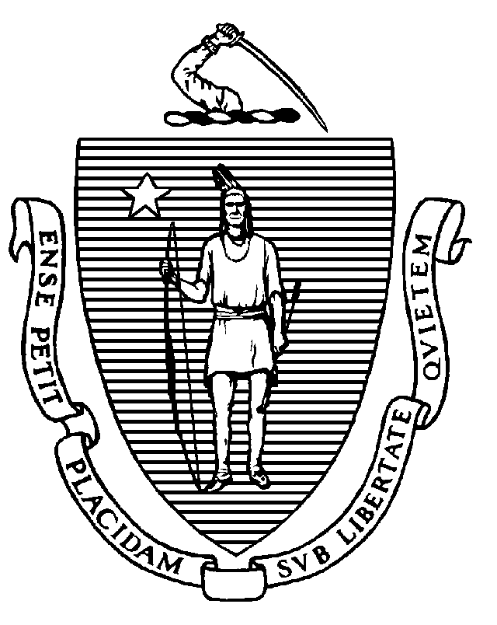
The Commonwealth of Massachusetts
Executive Office of Health and Human Services
Department of Public Health
250 Washington Street, Boston, MA 02108-4619

CHARLES D. BAKER
Governor
KARYN E. POLITO
Lieutenant Governor

MARYLOU SUDDERS
Secretary
MONICA BHAREL, MD, MPH Commissioner

April 17, 2020

Dear Newborn Hearing Screening Program Directors,

We appreciate your efforts during this time and recognize the extraordinary circumstances under which you are currently working. Hearing screenings prior to discharge continue to be mandated. However, temporary changes in policy regarding follow up after discharge are warranted as outlined below.
- Birth hospitals are still required to make appointments for babies that do not pass hearing screening. However, the availability of the centers has changed. An up-to-date list can be found on our website https://www.mass.gov/info-details/find-a-place-to-have-your-babys-hearing-tested. This list will be updated as needed. In some cases, follow-up testing will occur outside of the typical three-week window.
- Birth hospitals that are capable of offering audiological testing prior to discharge have been encouraged to do so to minimize the number of families having to return for testing after discharge.
- If a baby misses newborn hearing screening, it remains the responsibility of the birth hospital to ensure that hearing screening occurs. Record in the birth certificate that the baby was not screened and the reason why (early discharge, etc.). We have extended the time for returning to the hospital for a screen from 10 days to 2 months after discharge. If the baby does not return, the hospital must work with the child’s pediatrician to arrange for screening.
- Detailed lists of babies that missed their screens, or otherwise need follow up, must be kept and shared with staff from the Universal Newborn Hearing Screening Program. UNHSP staff will assist your hospital with outreach to families.
- The Department of Public Health is the payer of last resort for hearing screenings and audiological diagnostic testing for babies who do not pass newborn hearing screening. This policy is limited to Massachusetts residents only.

Thank you for your continued dedication to providing hearing screenings to all babies in the Commonwealth. If you have questions, please do not hesitate to contact me at sarah.stone@state.ma.us.

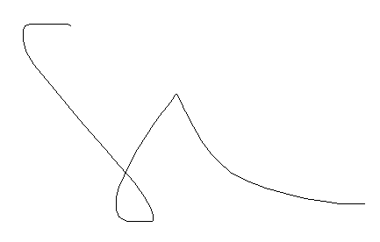

Sarah Stone
Director, Universal Newborn Hearing Screening Program

