INDOOR AIR QUALITY ASSESSMENT

Lexington Public Library
East Branch
795 Massachusetts Avenue
Lexington, Massachusetts



Prepared by:
Massachusetts Department of Public Health
Center for Environmental Health
Emergency Response/Indoor Air Quality Program
February 2007

Background/Introduction
At the request of the Derek Fullerton, Director of the Lexington Health Department, (LHD), the Massachusetts Department of Public Health (MDPH) Center for Environmental Health (CEH) provided assistance and consultation regarding indoor air quality concerns at the East Branch of the Lexington Public Library (EBL), 795 Massachusetts Ave, Lexington, Massachusetts. On January 10, 2007, a visit to the EBL to conduct an indoor air quality assessment was made by Cory Holmes, an Environmental Analyst in CEH’s Emergency Response/Indoor Air Quality (ER/IAQ) Program. Mr. Holmes was accompanied by Tom Fullen, Building Maintenance Foreman and Mr. Fullerton for portions of the assessment. The assessment was prompted by concerns regarding musty odors and potential mold growth in the basement.
The EBL is a two-story, wood-framed building (with attic and basement) constructed in 1833 as a lecture hall and residence. The building has served as a library since 1883 and has undergone minor interior renovations over the years. The ground floor contains the adult library and circulation desk. The second floor consists of a study room, staff office and children’s library. The attic is used for storage and houses air conditioning (AC) equipment. The unfinished basement contains the furnace, an AC unit for the ground floor and is used for storage. Many windows are reportedly unopenable or difficult to open.

Methods
In addition to taking various IAQ tests, CEH staff performed a visual inspection of building materials for water damage and/or microbial growth. Moisture content of porous building materials (e.g., carpeting, wood, ceiling tiles) was measured with Delmhorst, BD-2000 Model, Moisture Detector with a Delmhorst Standard Probe. Air tests for carbon dioxide, temperature and relative humidity were taken with the TSI, Q-TRAK™ IAQ Monitor, Model 8551.

Results
The EBL has a staff of 2 and can be visited by up to 50 individuals daily. The tests were taken during normal operations. Test results appear in Table 1.

Discussion
Ventilation
It can be seen from Table 1 that carbon dioxide levels were below 800 parts per million (ppm) in all areas surveyed at the time of the assessment, indicating adequate ventilation. However, it is important to note that a number of areas were unoccupied or sparsely populated, which can greatly reduce carbon dioxide levels. The building was originally designed to be heated by steam radiators and to introduce fresh air through windows.
A modern air conditioning (AC) system was later retro-fitted. According to building occupants, the system is only activated during the cooling season; therefore it was deactivated during the assessment. The system consists of two air handling units (one in the basement and one in the attic) that deliver conditioned air throughout the building via ducted air diffusers (Pictures 1 through 3). Fresh air in introduced into the system via vents located on the exterior of the building (Picture 4). Air is returned back to the AHUs via ceiling mounted grills.
Thermostats that control the AC system have fan settings of “on” and “automatic” (Picture 5). When thermostats are set to the fan “on” setting they provide continuous airflow, which is recommended by the MDPH. The “automatic” setting on the thermostat activates the HVAC system at a preset temperature; once the preset temperature is reached, the HVAC system deactivates.
The Massachusetts Building Code requires that each room have a minimum ventilation rate of 20 cubic feet per minute (cfm) per occupant of fresh outside air or openable windows (SBBRS, 1997; BOCA, 1993). The ventilation must be on at all times that the room is occupied. Providing adequate fresh air ventilation with open windows and maintaining the temperature in the comfort range during the cold weather season is impractical. Mechanical ventilation is usually required to provide adequate fresh air ventilation.
Carbon dioxide is not a problem in and of itself. It is used as an indicator of the adequacy of the fresh air ventilation. As carbon dioxide levels rise, it indicates that the ventilating system is malfunctioning or the design occupancy of the room is being exceeded. When this happens, a buildup of common indoor air pollutants can occur, leading to discomfort or health complaints. The Occupational Safety and Health Administration (OSHA) standard for carbon dioxide is 5,000 parts per million parts of air (ppm). Workers may be exposed to this level for 40 hours/week, based on a time-weighted average (OSHA, 1997).
The MDPH uses a guideline of 800 ppm for publicly occupied buildings. A guideline of 600 ppm or less is preferred in schools due to the fact that the majority of occupants are young and considered to be a more sensitive population in the evaluation of environmental health status. Inadequate ventilation and/or elevated temperatures are major causes of complaints such as respiratory, eye, nose and throat irritation, lethargy and headaches. For more information concerning carbon dioxide, please see Appendix A.
Temperature readings in occupied areas ranged from 68º F to 74 º F, which were either within or just below the lower end of the MDPH recommended comfort guidelines the day of the assessment. The MDPH recommends that indoor air temperatures be maintained in a range of 70 º F to 78 º F in order to provide for the comfort of building occupants. In many cases concerning indoor air quality, fluctuations of temperature in occupied spaces are typically experienced, even in a building with an adequate fresh air supply.
The relative humidity measured in occupied areas ranged from 22 to 30 percent, which was below the MDPH recommended comfort range the day of the assessment. The MDPH recommends a comfort range of 40 to 60 percent for indoor air relative humidity. Relative humidity levels in the building would be expected to drop during the winter months due to heating. The sensation of dryness and irritation is common in a low relative humidity environment. Low relative humidity is a very common problem during the heating season in the northeast part of the United States.

Microbial/Moisture Concerns
As mentioned, the primary concern prompting the request for an IAQ assessment was related to musty odors and potential mold growth in the basement. CEH staff examined the basement and detected a number of odors related to stored materials and stagnant air. The basement has no means of mechanical ventilation to remove odors. The basement is below grade, making it prone to moisture accumulation. A number of water damaged porous materials were observed in the basement including cardboard boxes, paper and sections of carpeting (Pictures 6 through 9). Porous materials like cardboard and carpeting can provide a medium for microbial growth, especially if moistened repeatedly.
Several potential pathways exist for basement odors and particulates to migrate into occupied areas of the building; including spaces around the basement door and utility holes in the ceiling (Pictures 10 and 11). Airflow tends to rise from lower to upper floors, a condition known as the stack effect. The basement door and utility holes should be sealed to minimize airflow into occupied areas.
In order for building materials to support mold growth, a source of water exposure is necessary. Identification and elimination of the source of water moistening building materials is necessary to control mold growth. In the case of the EBLPL, several likely sources of moisture were identified including chronic dampness, humidity and condensation from water vapor condensing on cold surfaces (e.g., concrete floors). MDPH staff examined the outside perimeter of the building and identified breaches in the building envelope that could also provide a source of water penetration:
- Damaged/rotted woodwork and exterior doors (Pictures 12 and 13);
- Missing/damaged gutters and downspouts (Picture 14); and
- Damaged foundation masonry (Pictures 15 and 16).
The aforementioned conditions represent water penetration sources. Over time, these conditions can undermine the integrity of the building envelope and provide a means of water entry into the building via capillary action through foundation concrete and masonry (Lstiburek & Brennan, 2001). In addition, these breaches may provide a means of egress for pests/rodents into the building.
As previously mentioned, for building materials to support mold growth, a source of water exposure is necessary. To determine moisture content, CEH staff conducted testing of porous building materials in occupied areas (i.e., ceiling tiles, carpeting, wood). Materials with increased moisture content over normal concentrations may indicate the possible presence of mold growth. All materials tested were found to have low (i.e., normal) moisture content (Table 1) at the time of the assessment. The areas sampled also appeared to be free of visible mold colonization.
Several areas also had water stained ceiling tiles (Picture 16), which were reportedly due to historic roof leaks. Water-damaged ceiling tiles can provide a source for mold growth and should be replaced after a water leak is discovered and repaired.
It is important to note that moisture content of materials measured is a real-time measurement of the conditions present in the building at the time of the assessment. Repeated water damage to porous building materials (i.e., wood, ceiling tiles and carpeting) can result in microbial growth. The US Environmental Protection Agency (US EPA) and the American Conference of Governmental Industrial Hygienists (ACGIH) recommend that porous materials be dried with fans and heating within 24 to 48 hours of becoming wet (US EPA, 2001; ACGIH, 1989). If not dried within this time frame, mold growth may occur. Once mold has colonized porous materials, they are difficult to clean and should be removed.

Other IAQ Evaluations
Several other conditions that can affect indoor air quality were noted during the assessment. Libraries in general have a large number of flat and irregular surfaces (e.g., book shelves, books) that provide a source for dusts to accumulate and are difficult for custodial staff to clean. Dust can be irritating to eyes, nose and respiratory tract. Items should be removed and/or be cleaned periodically to avoid excessive dust build up.
Carpeting in several areas was extremely worn, damaged and soiled (Pictures 18 and 19). Disintegrating textiles can be a source of particulates, which can be irritating to the eyes, nose and throat. Carpet fibers/particulate matter can also be entrained and suspended in air by the mechanical ventilation system.
Several containers of paints and polyurethanes were stored on open shelves in the upstairs study room adjacent to the children’s library. These products contain VOCs and other chemicals, which can be irritating to the eyes, nose and throat and should be stored properly and kept out of reach of children.
Finally, CEH staff observed the exhaust ductwork to the boiler plant to be corroded (Picture 20). If breaches form in the ductwork exhaust emissions such as carbon monoxide can be released in the indoor environment.

Conclusions/Recommendations
The conditions related to indoor air quality problems at the EBLPL raise a number of issues. The general building conditions and storage of porous materials in the basement can present conditions that could degrade indoor air quality. Some of these issues can be remedied by actions of building occupants. Other remediation efforts will require alteration to the building structure and equipment. For these reasons, a two-phase approach is required for remediation. The first consists of short-term measures to improve air quality and the second consists of long-term measures that will require planning and resources to adequately address the overall indoor air quality concerns.

The following short-term measures should be considered for immediate implementation:
- Refrain from storing porous materials in basement storage room. Inspect and discard any water damaged/mold colonized materials. Disinfect any areas of microbial growth with a mild detergent or antimicrobial, wipe clean surfaces with soap and water after disinfection.
- Utilize dehumidifiers in below grade areas to reduce relative humidity. Ensure dehumidifiers are cleaned and maintained as per the manufacture’s instruction to prevent microbial growth.
- Seal utility holes that allow air to travel between the basement and first floor (e.g., around radiator pipes, electrical conduits) to eliminate paths of odor/particulate migration into occupied areas.
- Seal basement door on all sides with foam tape, and/or weather-stripping. Ensure tightness of door by monitoring for light penetration and drafts.
- Work with staff to determine which windows are unopenable/difficult to operate and make repairs.
- Use windows in combination with radiators to provide air exchange and heat. Care should be taken to ensure windows are properly closed at night and weekends to avoid the freezing of pipes and potential flooding.
- Contact the town’s HVAC vendor to determine if the AC system can be operated year-round to provide air exchange. Operate the system in the fan “on" mode (as opposed to the fan “auto” setting) to provide continuous air circulation and supplement the use of windows.
- For buildings in New England, periods of low relative humidity during the winter are often unavoidable. Therefore, scrupulous cleaning practices should be adopted to minimize common indoor air contaminants whose irritant effects can be enhanced when the relative humidity is low. To control for dusts, a high efficiency particulate arrestance (HEPA) filter equipped vacuum cleaner in conjunction with wet wiping of all surfaces is recommended. Drinking water during the day can help ease some symptoms associated with a dry environment (e.g. throat and sinus irritations).
- Have boiler plant/furnace inspected annually or as per the manufacture’s instructions to ensure proper operation. Make repairs to corroded exhaust ductwork to prevent the escape of exhaust emissions into the building.
- Clean/change filters for air handling equipment as per the manufactures’ instructions or more frequently if needed. Prior to activation, vacuum interior of units to prevent the aerosolization of dirt, dust and particulates.
- Store paints and polyurethanes properly and out of the reach of children.
- Consult “Mold Remediation in Schools and Commercial Buildings” published by the US EPA (US EPA, 2001) for further information on mold and/or mold clean up. Copies of this document are available from the US EPA: http://www.epa.gov/iaq/molds/mold_remediation.html.
- Refer to the resource manual and other related indoor air quality documents for further building-wide evaluations and advice on maintaining public buildings. These documents are available on the MDPH’s website: http://www.state.ma.us/dph/beha/iaq/iaqhome.htm.

The following long-term measures should be considered:
- Consider consulting with an architect, masonry firm or general contractor regarding the integrity of the building envelope, primarily concerning water penetration through exterior walls. This measure should include a full building envelope evaluation.
- Consider replacing damaged/worn carpeting throughout the library to prevent the aerosolization of carpet fibers.
- Repair/replace missing/damaged gutters and downspouts to direct water away from the building.
- Repair/replace damaged exterior wooden doors and moldings.
- Consider local exhaust ventilation (e.g., exhaust vent and passive make up vent), in the basement to prevent the infiltration of odors into occupied areas.

References
ACGIH. 1998. American Conference of Governmental Industrial Hygienists. Industrial Ventilation A manual of Recommended Practice. 23rd Edition.

BOCA. 1993. The BOCA National Mechanical Code/1993. 8th ed. Building Officials and Code Administrators International, Inc., Country Club Hill, IL. Section M-308.1.1.

Lstiburek, J. & Brennan, T. 2001. Read This Before You Design, Build or Renovate. Building Science Corporation, Westford, MA. U.S. Department of Housing and Urban

OSHA. 1997. Limits for Air Contaminants. Occupational Safety and Health Administration. Code of Federal Regulations. 29 C.F.R 1910.1000 Table Z-1-A.

SBBRS. 1997. Mechanical Ventilation. State Board of Building Regulations and Standards. Code of Massachusetts Regulations. 780 CMR 1209.0

US EPA. 2001. “Mold Remediation in Schools and Commercial Buildings”. Office of Air and Radiation, Indoor Environments Division, Washington, DC. EPA 402-K-01-001. March 2001. Available at: http://www.epa.gov/iaq/molds/mold_remediation.html
Picture 1

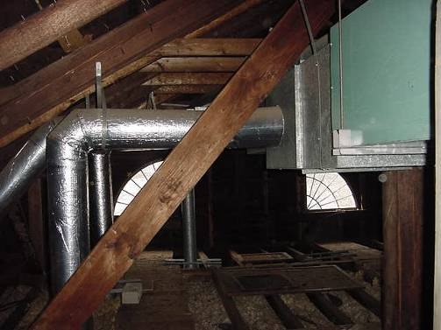

Air Handling Unit and Ductwork in Attic

Picture 2

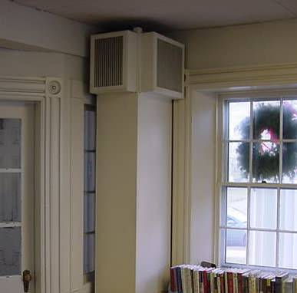

Ducted Supply Vents Flanking Front Entrance
Picture 3

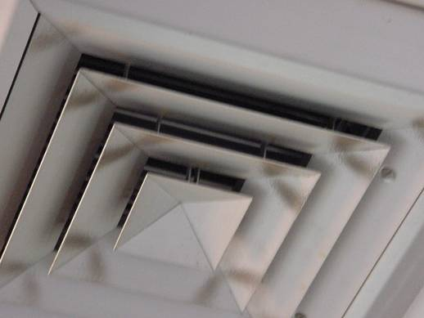

Ceiling-Mounted Supply Diffuser, Note Dust Accumulation

Picture 4

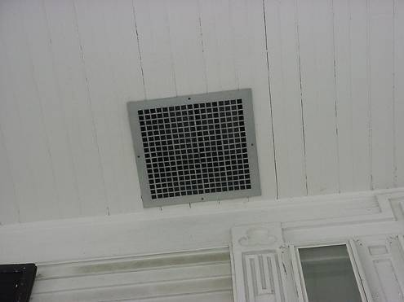

Fresh Air Intake for HVAC System (Front Entrance)
Picture 5

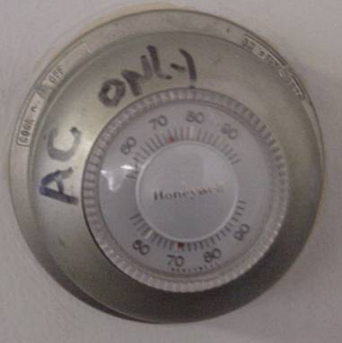

HVAC Thermostat, Fan Switch at Right/Top

Picture 6

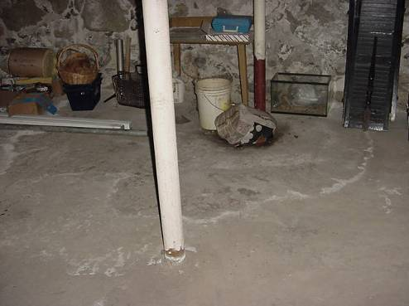

Water Damaged Porous Materials Stored on Basement Floor, Note Water Mark Indicating Historic Water Penetration
Picture 7

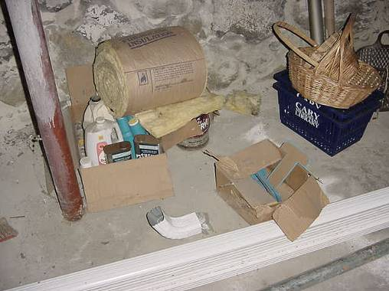

Water Damaged Porous Materials Stored on Basement Floor

Picture 8

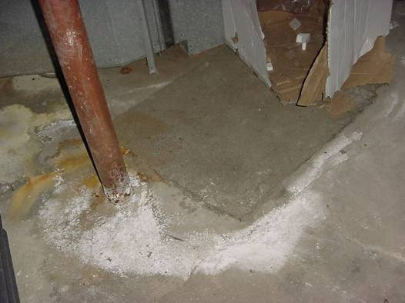

Water Damaged Porous Materials (Carpet Square and Cardboard) Stored on Basement Floor
Picture 9

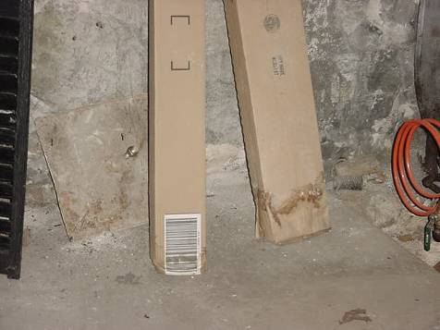

Water Damaged Porous Materials Stored on Basement Floor, Note Water Mark on Cardboard Indicating Historic Water Penetration

Picture 10

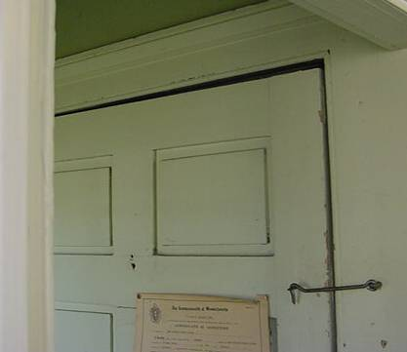

Spaces around Basement Door
Picture 11

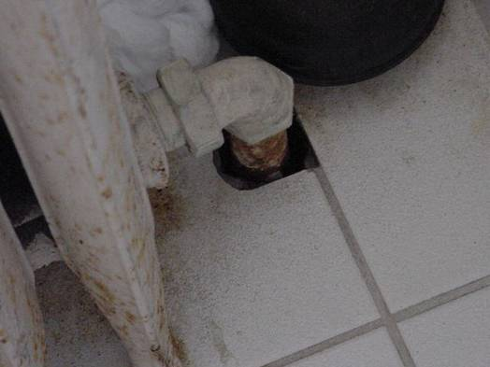

Utility Hole around Pipe in Restroom

Picture 12

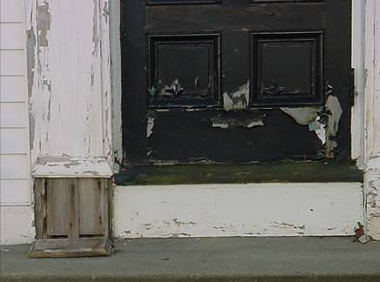

Water Damaged/Wood Rot, Side Entrance
Picture 13

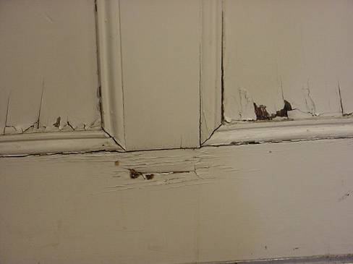

Interior View of Water Damaged/Wood Rotted Side Entrance Door in Previous Picture

Picture 14

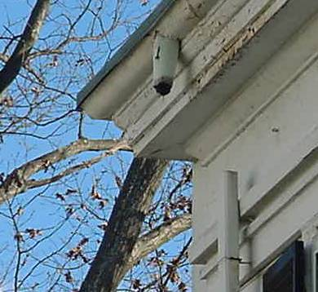

Missing/Damaged Gutter/Downspout System
Picture 15

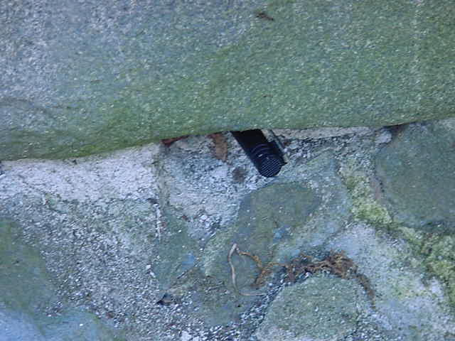

Missing/Damaged Mortar around Flagstone Foundation, Pen Inserted to Show Depth

Picture 16

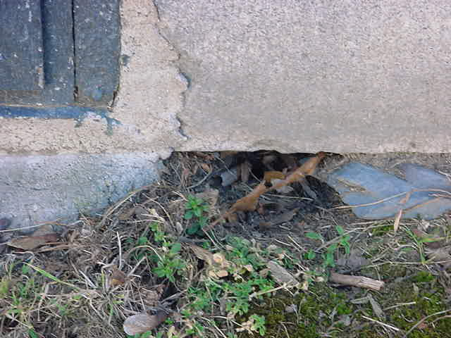

Missing/Damaged Mortar around Flagstone Foundation
Picture 17

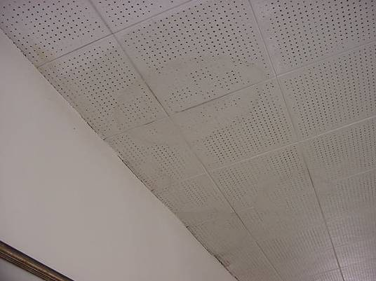

Water Stained Ceiling Tiles

Picture 18

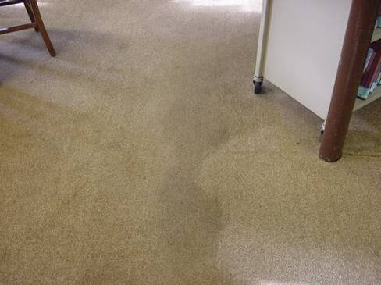

Stained/Soiled Carpeting
Picture 19

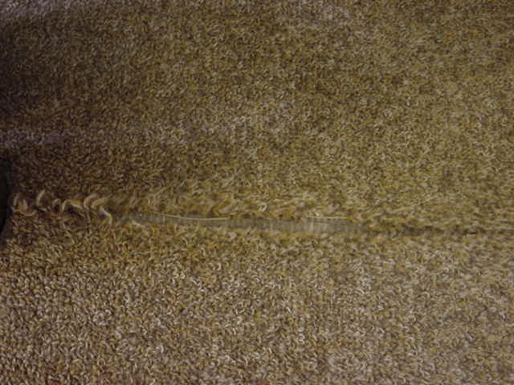

Worn/Damaged Carpeting

Picture 20

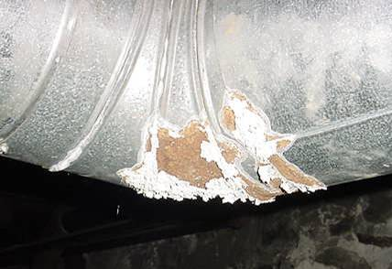

Corroded Section of Exhaust Ductwork for Boiler Plant
Location | Carbon  Dioxide  (*ppm) | Temp  (°F) | Relative  Humidity  (%) | Occupants  in Room | Windows  Openable | Ventilation |  | Remarks
 |  |  |  |  |  | Supply | Exhaust | Remarks
Outside  (Background) | 336 | 32 | 22 |  |  |  |  | Cold, mostly sunny, NW winds 5-10 mph
Adult Room NW | 692 | 68 | 30 | 3 | Y |  |  | Plants, 13 water damaged ceiling tiles along exterior wall-low (normal) moisture, carpeting -low (normal) moisture
Adult Room SW | 593 | 71 | 28 | 1 | Y |  |  | Wood rot, side entrance door-low (normal) moisture, 1 water damaged ceiling tile-low (normal) moisture, carpeting inside door-low (normal) moisture
Circulation Desk | 567 | 68 | 25 | 0 | N |  |  | carpeting inside door-low (normal) moisture
Adult Room NE | 490 | 69 | 25 | 0 | Y |  |  | Carpeting inside door-low (normal) moisture
Adult Room SE | 487 | 71 | 25 | 1 | Y |  |  | Carpeting inside door-low (normal) moisture
Restroom | 490 | 72 | 25 | 0 | Y |  |  | Utility holes-floor
Study Room | 546 | 73 | 22 | 0 | Y |  |  | Paint/polyurethane
Staff Office | 627 | 74 | 26 | 1 | Y
Children’s Room | 557 | 73 | 24 | 0 | Y
Basement | 512 | 65 | 37 | 0 | Y |  |  | Musty odors, water damaged porous materials, corroded exhaust ductwork, spaces around basement door

