INDOOR AIR QUALITY REASSESSMENT

Lillian M. Jacobs Elementary School
180 Harbor View Road
Hull, Massachusetts 02405

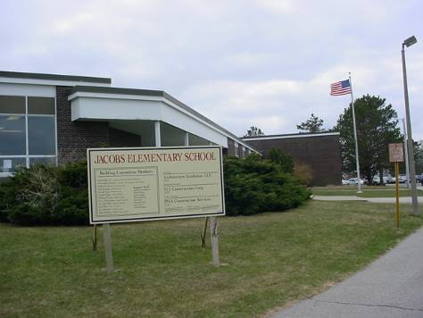

Prepared by:
Massachusetts Department of Public Health
Bureau of Environmental Health
Emergency Response/Indoor Air Quality Program
June 2007

Background/Introduction
At the request of a parent and David Twombly, Director of Operations, Hull Public Schools (HPS), the Massachusetts Department of Public Health (MDPH), Bureau of Environmental Health (BEH) provided assistance and consultation regarding indoor air quality at the Jacobs Elementary School (JES) in Hull, Massachusetts.
On April 10, 2007, a visit to conduct a follow-up assessment at the JES was made by Cory Holmes an Environmental Analyst in BEH’s Emergency Response/Indoor Air Quality (ER/IAQ) Program. Previous IAQ assessments were conducted at the JES in September and December, 2006 and reports were issued by BEH that described conditions observed in the building at that time (MDPH, 2006a: MDPH, 2006b). These assessments were requested due to concerns of mold growth, construction and general IAQ conditions. The April, 2007 assessment was prompted due to symptoms (headaches, dizziness and difficulty breathing) reported by a student in a second floor classroom (room 30). As with the two previous assessments, the JES is undergoing renovations while the building is occupied.

Methods
Air tests for carbon dioxide, carbon monoxide, temperature and relative humidity were conducted with the TSI, Q-TRAK™ IAQ Monitor, Model 8551. Air tests for airborne particulate matter with a diameter less than 2.5 micrometers were taken with the TSI, DUSTTRAK™ Aerosol Monitor Model 8520. Screening for total volatile organic compounds (TVOCs) was conducted using an HNu, Model 102 Snap-on Photo Ionization Detector (PID).

Results
The JES houses approximately 500 pre-kindergarten through grade 5 students and approximately 55 staff. Tests were taken under normal operating conditions and results appear in Table 1.

Discussion
Ventilation
It can be seen from Table 1 that carbon dioxide levels were elevated above 800 parts per million (ppm) in twenty-one of thirty areas surveyed, indicating less than optimal air exchange in the majority of areas. Univents were not functioning in several of these areas, including classroom 30. The univent fan in classroom 30 was found deactivated resulting in the unit emitting uncontrolled heat. In addition, a “hissing” sound was detected by BEH staff, which could indicate a pneumatic/air leak resulting in a lack of temperature/damper control. It is also important to note that several exhaust vents, particularly in classrooms near construction areas were not operating, which would inhibit air circulation and removal of environmental pollutants. Upon discovery these findings were reported to Mr. Twombly, Principal Kathleen Tyrell and Jim Griffin, Facilities Manager. Elevated carbon dioxide measurements were also recorded in the gymnasium, most likely due to the mechanical ventilation system also found to be deactivated at the time of the assessment.
The Massachusetts Building Code requires a minimum ventilation rate of 15 cubic feet per minute (cfm) per occupant of fresh outside air or have openable windows in each room (BOCA, 1993; SBBRS, 1997). The ventilation must be on at all times that the room is occupied. Providing adequate fresh air ventilation with open windows and maintaining the temperature in the comfort range during the cold weather season is impractical. Mechanical ventilation is usually required to provide adequate fresh air ventilation.
Carbon dioxide is not a problem in and of itself. It is used as an indicator of the adequacy of the fresh air ventilation. As carbon dioxide levels rise, it indicates that the ventilating system is malfunctioning or the design occupancy of the room is being exceeded. When this happens a buildup of common indoor air pollutants can occur, leading to discomfort or health complaints. The Occupational Safety and Health Administration (OSHA) standard for carbon dioxide is 5,000 parts per million parts of air (ppm). Workers may be exposed to this level for 40 hours/week based on a time-weighted average (OSHA, 1997).
The MDPH uses a guideline of 800 ppm for publicly occupied buildings. A guideline of 600 ppm or less is preferred in schools due to the fact that the majority of occupants are young and considered to be a more sensitive population in the evaluation of environmental health status. Inadequate ventilation and/or elevated temperatures are major causes of complaints such as respiratory, eye, nose and throat irritation, lethargy and headaches. For more information concerning carbon dioxide, please see Appendix A.
Temperature readings during the assessment ranged from 68º F to 76 º F, which were within or slightly below the MDPH comfort guidelines. The MDPH recommends that indoor air temperatures be maintained in a range of 70 º F to 78 º F in order to provide for the comfort of building occupants. As mentioned previously, several univents and exhaust vents were not operating, which can make it difficult to control temperature and lead to heat complaints.
Relative humidity measurements in the areas surveyed during the assessment ranged from 21 to 32 percent, which were below the MDPH recommended comfort range. The MDPH recommends that indoor air relative humidity is comfortable in a range of 40 to 60 percent. Relative humidity levels in the building would be expected to drop during the winter months due to heating. The sensation of dryness and irritation is common in a low relative humidity environment. Low relative humidity is a very common problem during the heating season in the northeast part of the United States.

Microbial/Moisture Concerns
It was reported by Mr. Twombly that occupants had previously raised concerns of potential mold growth in a crawlspace located beneath the kitchen. BEH staff examined the access hatch to the crawlspace and found that it was sealed and that no discernable pathways were identified for mold spores or associated odors to migrate into occupied areas (Picture 1).

Renovations and Other IAQ Evaluations
BEH staff inspected construction barriers to identify and reduce/prevent pollutant pathways. The plastic barrier in classroom 33 was observed to be “bowed” towards the occupied classroom, which would indicate that the pressurization is not performing appropriately (Picture 2). BEH staff examined the room directly adjacent to classroom 33 and found that the room was pressurized due to the removal of a portion of the exterior wall near this door allowing uncontrolled outside air into the space (Picture 3). It appeared likely that the section of wall was removed so that construction personnel could discard materials into a dumpster, which was stationed outside, directly below this area. The pressurization of construction areas directly adjacent to occupied areas can force airborne odors and pollutants through any breaches in containment. In several other areas plastic sheeting on the construction side had areas that were loose or torn (Pictures 4 and 5). These findings were also reported to school officials at the time of the assessment with the recommendation to relocate the dumpster.
Indoor air quality can be negatively influenced by the presence of respiratory irritants, such as products of combustion. The process of combustion produces a number of pollutants. Common combustion emissions include carbon monoxide, carbon dioxide, water vapor and smoke (fine airborne particle material). Of these materials, exposure to carbon monoxide and particulate matter with a diameter of 2.5 micrometers (μm) or less (PM2.5) can produce immediate, acute health effects upon exposure. To determine whether combustion products were present in the school environment, BEH staff obtained measurements for carbon monoxide and PM2.5.
Carbon monoxide is a by-product of incomplete combustion of organic matter (e.g., gasoline, wood and tobacco). Exposure to carbon monoxide can produce immediate and acute health affects. Several air quality standards have been established to address carbon monoxide and prevent symptoms from exposure to these substances. The MDPH established a corrective action level concerning carbon monoxide in ice skating rinks that use fossil-fueled ice resurfacing equipment. If an operator of an indoor ice rink measures a carbon monoxide level over 30 ppm, taken 20 minutes after resurfacing within a rink, that operator must take actions to reduce carbon monoxide levels (MDPH, 1997).
The American Society of Heating Refrigeration and Air-Conditioning Engineers (ASHRAE) has adopted the National Ambient Air Quality Standards (NAAQS) as one set of criteria for assessing indoor air quality and monitoring of fresh air introduced by HVAC systems (ASHRAE, 1989). The NAAQS are standards established by the US EPA to protect the public health from six criteria pollutants, including carbon monoxide and particulate matter (US EPA, 2000a). As recommended by ASHRAE, pollutant levels of fresh air introduced to a building should not exceed the NAAQS levels (ASHRAE, 1989). The NAAQS were adopted by reference in the Building Officials & Code Administrators (BOCA) National Mechanical Code of 1993 (BOCA, 1993), which is now an HVAC standard included in the Massachusetts State Building Code (SBBRS, 1997). According to the NAAQS, carbon monoxide levels in outdoor air should not exceed 9 ppm in an eight-hour average (US EPA, 2000a).
Carbon monoxide should not be present in a typical, indoor environment. If it is present, indoor carbon monoxide levels should be less than or equal to outdoor levels. On the day of assessment, outdoor carbon monoxide concentrations were non-detect (ND) (Table 1). Carbon monoxide levels measured in the school were also ND (Table 1). In response to previous concerns regarding carbon monoxide, battery operated detectors are used in several areas. Carbon monoxide alarms should be tested and replaced as per the manufactures recommendations to ensure proper working order.
The US EPA has established NAAQS limits for exposure to particulate matter. Particulate matter is airborne solids that can be irritating to the eyes, nose and throat. The NAAQS originally established exposure limits to particulate matter with a diameter of 10 μm or less (PM10). According to the NAAQS, PM10 levels should not exceed 150 microgram per cubic meter (μg/m³) in a 24-hour average (US EPA, 2006). These standards were adopted by both ASHRAE and BOCA. Since the issuance of the ASHRAE standard and BOCA Code, US EPA proposed a more protective standard for fine airborne particles. This more stringent PM2.5 standard requires outdoor air particle levels be maintained below 35 μg/m³ over a 24-hour average (US EPA, 2006). Although both the ASHRAE standard and BOCA Code adopted the PM10 standard for evaluating air quality, MDPH uses the more protective proposed PM2.5 standard for evaluating airborne particulate matter concentrations in the indoor environment.
Outdoor PM2.5 concentrations were measured at 6 μg/m³ (Table 1). PM2.5 levels measured in occupied areas of the school ranged from 19 to 65 μg/m³, which were above the NAAQS of 35 μg/m³ in areas in close proximity to construction barriers indicating that the pressurization of construction areas appeared to be forcing airborne particulates into occupied areas (Table 1). As a comparison PM 2.5 in the construction area was measured at 97 μg/m³. It is also important to note that frequently, indoor air levels of particulates can be at higher levels than those measured outdoors. A number of mechanical devices and/or activities that occur in schools can generate particulates during normal operation. Sources of indoor airborne particulate may include but are not limited to particles generated during the operation of fan belts in the HVAC system, cooking in the cafeteria stoves and microwave ovens; use of photocopiers, fax machines and computer printing devices, operating an ordinary vacuum cleaner and heavy foot traffic indoors.
Indoor air quality can also be negatively influenced by the presence of materials containing volatile organic compounds (VOCs). VOCs are carbon-containing substances that have the ability to evaporate at room temperature. Frequently, exposure to low levels of total VOCs (TVOCs) may produce eye, nose, throat and/or respiratory irritation in some sensitive individuals. For example, chemicals evaporating from a paint can stored at room temperature would most likely contain VOCs. In an effort to determine whether VOCs were present in the building, air monitoring for TVOCs was conducted. Indoor TVOC concentrations were ND (Table 1). An outdoor air sample was taken for comparison. Outdoor TVOC concentrations were also ND. Please note, TVOC air measurements are only reflective of the indoor air concentrations present at the time of sampling.
Portable air purifiers were in use in several areas. This equipment has air filters that should be cleaned or changed as per the manufacturer’s instructions to avoid the reaerosolization of dusts and particulates.
Lastly, damaged floor tiles containing asbestos were observed in several areas of the building. Mr. Twombly reported that at the recommendation of their remediation contractor, these tiles were identified and sealed with plastic and duct tape until they can be physically removed during subsequent phases of construction (Pictures 5 and 6).

Conclusions/Recommendations

The symptoms that prompted the assessment (headaches, dizziness and difficulty breathing) were reported by an occupant in classroom 30. These symptoms appeared likely related to a combination of the lack of air exchange and uncontrolled heat due to malfunctions with the univent system in this room. As mentioned, during the assessment BEH staff identified a “hissing” sound coming from the unit and found the room to be warm and uncomfortable. In addition, no windows were opened further limiting air exchange.
The building remains under construction, which can lead to potential exposures to construction/renovation-generated pollutants if control/containment measures are not adequate. Observations and testing conducted at the time of the assessment demonstrated this problem. As a reminder, renovation efforts require continued diligence by all parties involved with daily/routine maintenance, observation and reporting by building occupants involving construction and renovations.
In view of the findings at the time of the reassessment, the following recommendations are made to further improve indoor air quality:
- Work with HPS facilities and their HVAC vendor to determine whether mechanical ventilation issues observed in classroom 30 warrant repairs. Use openable windows as much as practicable to introduce fresh outside air.
- Relocate dumpster and seal exterior wall in construction area adjacent to classroom 33 if this has not already been done.
- Test and replace carbon monoxide detectors as per the manufacture’s recommendations to ensure proper working order.
- Clean/change filters for portable air purifiers as per the manufacturer’s instructions or more frequently if needed.
- Remediate damaged asbestos with Massachusetts asbestos remediation and hazardous waste disposal laws. For further questions regarding the proper remediation of asbestos-containing materials contact the Massachusetts Division of Occupational Safety's Asbestos Program at http://www.mass.gov/dos/asbestos/index.htm or by calling (617) 969-7177.
- Continue to implement all applicable recommendations listed in the previous MDPH reports particularly those regarding the integrity of construction barriers and depressurization of construction areas in relation to occupied areas (MDPH, 2006a; MDPH, 2006b).

References
ACGIH. 1989. Guidelines for the Assessment of Bioaerosols in the Indoor Environment. American Conference of Governmental Industrial Hygienists, Cincinnati, OH.

BOCA. 1993. The BOCA National Mechanical Code/1993. 8th ed. Building Officials & Code Administrators International, Inc., Country Club Hills, IL.

MDPH. 2006a. Indoor Air Quality Assessment Lillian Jacobs Elementary School, MA. Massachusetts Department of Public Health, Executive Office of Human Services, Boston, MA. October 2006.

MDPH. 2006b. Indoor Air Quality Reassessment Lillian Jacobs Elementary School, MA. Massachusetts Department of Public Health, Executive Office of Human Services, Boston, MA. December 2006.

OSHA. 1997. Limits for Air Contaminants. Occupational Safety and Health Administration. Code of Federal Regulations. 29 C.F.R 1910.1000 Table Z-1-A.

SBBRS. 1997. Mechanical Ventilation. State Board of Building Regulations and Standards. Code of Massachusetts Regulations. 780 CMR 1209.0

US EPA. 2001. “Mold Remediation in Schools and Commercial Buildings”. Office of Air and Radiation, Indoor Environments Division, Washington, DC. EPA 402-K-01-001. March 2001. Available at: http://www.epa.gov/iaq/molds/mold_remediation.html
US EPA. 2006. National Ambient Air Quality Standards (NAAQS). . US Environmental Protection Agency, Office of Air Quality Planning and Standards, Washington, DC. http://www.epa.gov/air/criteria.html.
Picture 1

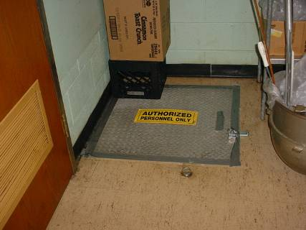

Crawlspace Access Hatch in Kitchen Sealed with Duct Tape

Picture 2

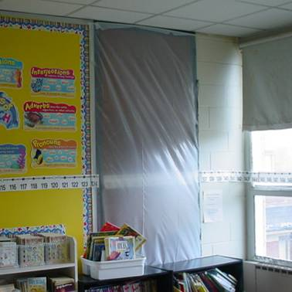

“Bowed” Plastic on Door in Classroom 33 Indicating that Construction area is
Pressurized in Relation to Classroom

Picture 3

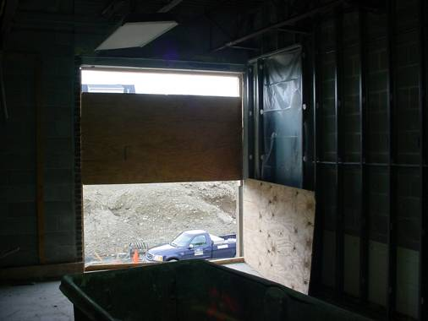

Section of Wall Removed in Construction Area Directly Adjacent to
Classroom 33 Door Shown in Preceding Picture

Picture 4

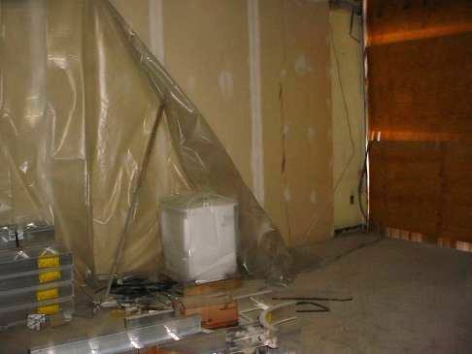

Failing Plastic Sheeting on Construction Side of Barriers
Picture 5

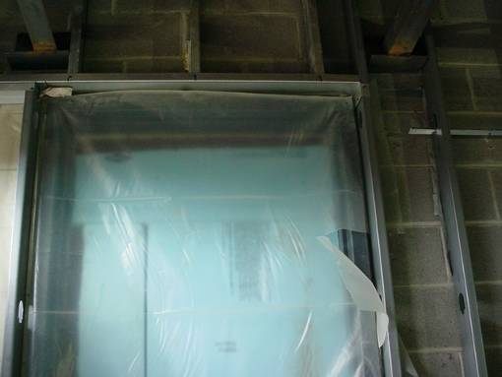

Torn Plastic Sheeting on Construction Side of Classroom Door

Picture 6

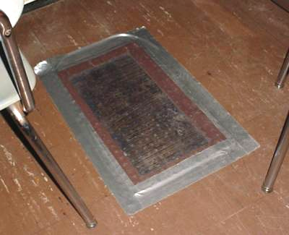

Damaged Asbestos-Containing Floor Tiles Sealed with Plastic and Duct Tape
Picture 7

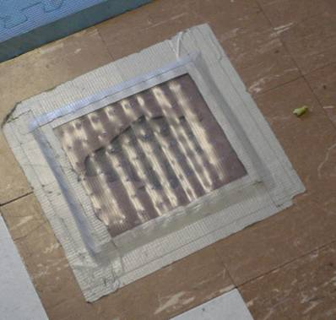

Damaged Asbestos-Containing Floor Tiles Sealed with Plastic and Duct Tape

Location/ Room | Occupants  in Room | Temp  (°F) | Relative  Humidity  (%) | Carbon  Dioxide  (ppm) | Carbon Monoxide  (ppm) | TVOCs  (ppm) | PM2.5  (µg/m3) | Windows  Openable | Ventilation |  | Remarks
 |  |  |  |  |  |  |  |  | Supply | Exhaust | Remarks
Background |  | 45 | 33 | 366 | ND | ND | 6 |  |  |  | Partly cloudy
19 | 19 | 69 | 32 | 1006 | ND | ND | 39 | Y | Y | Y | Dust/grit accumulation on windowsills and flat surfaces, 4 CTs, cleaning products
17 | 1 | 71 | 26 | 706 | ND | ND | 19 | Y | Y | Y | 19 occupants gone ~ 30 mins
18 | 2 | 69 | 26 | 872 | ND | ND | 25 | Y | Y | Y | Exhaust off-backdrafting, 17 occupants gone ~ 20 mins
15 | 19 | 72 | 29 | 1420 | ND | ND | 14 | Y | Y | Y | Exhaust off-backdrafting, UV-off (reportedly serviced/belt replaced)
16 | 15 | 73 | 25 | 1042 | ND | ND | 22 | Y | Y | Y | Exhaust off-backdrafting, cleaning products
13 | 16 | 72 | 24 | 1085 | ND | ND | 16 | Y | Y | Y
14 | 18 | 76 | 24 | 975 | ND | ND | 12 | Y | Y | Y | Occasional leaks along floor/wall junction-attempts to seal with foam, AP
11 | 15 | 75 | 23 | 1040 | ND | ND | 15 | Y | Y | Y
12 | 19 | 71 | 22 | 985 | ND | ND | 12 | Y | Y | Y | Floor tiles taped, AP
10 | 1 | 69 | 24 | 805 | ND | ND | 12 | Y | Y | Y | UV-off
33 | 15 | 70 | 24 | 1722 | ND | ND | 65 | Y | Y | Y | DO, room adjacent to construction, exhaust off-back drafting
34 | 15 | 75 | 30 | 1588 | ND | ND | 49 | Y | Y | Y | Plastic barrier on inter-room door bowed in towards classroom-open wall to the outside in adjacent construction area, CO monitor
31 | 1 | 72 | 27 | 1584 | ND | ND | 27 | Y | Y | Y | UV-off, exhaust-off, 16 occupants gone ~ 25 mins
29 | 0 | 71 | 27 | 1613 | ND | ND | 32 | Y | Y | Y | UV-off, exhaust-off, DO
32 | 18 | 76 | 30 | 1654 | ND | ND | 34 | Y | Y | Y | Exhaust-off
30 | 5 | 74 | 27 | 1430 | ND | ND | 31 | Y | Y | Y | UV-off/hissing noise-possible pneumatic air leak, tiles sealed with duct tape
27 | 18 | 73 | 24 | 1286 | ND | ND | 12 | Y | Y | Y
25 | 19 | 72 | 26 | 1464 | ND | ND | 12 | Y | Y | Y | DO, AP
28 | 16 | 72 | 26 | 1305 | ND | ND | 23 | Y | Y | Y
26 | 12 | 71 | 25 | 1074 | ND | ND | 17 | Y | Y | Y | DO
24 | 13 | 71 | 27 | 1226 | ND | ND | 9 | Y | Y | Y | UV-off, AP
23 | 4 | 71 | 21 | 602 | ND | ND | 7 | Y | Y | Y
Computer Lab | 0 | 72 | 25 | 782 | ND | ND | 10 | N | Y | Y | DO, exhaust-off
Library | 1 | 71 | 22 | 739 | ND | ND | 13 | Y | Y | Y | 20 occupants gone ~ 5 mins
Cafeteria A | 14 | 70 | 23 | 684 | ND | ND | 7 | Y | Y | Y | DO
Stage | 4 | 69 | 24 | 681 | ND | ND | 6 | N | N | Y | DO
Cafeteria B | 19 | 69 | 24 | 690 | ND | ND | 6 | Y | Y | Y | Ceiling fan-on
Cafeteria D | 18 | 69 | 25 | 736 | ND | ND | 6 | N | Y | N | DO, AP
Cafeteria C | 14 | 69 | 25 | 763 | ND | ND | 5 | N | Y | N | AP
Gym | 0 | 68 | 28 | 998 | ND | ND | 25 | N | Y | Y | Mechanical ventilation-off
Construction Area |  | 50 | 33 | 377 | ND | ND | 97 | N | N | N | Section of wall removed, area pressurized in relation to occupied areas

