INDOOR AIR QUALITY ASSESSMENT

Lillian M. Jacobs Elementary School
180 Harbor View Road
Hull, Massachusetts 02045

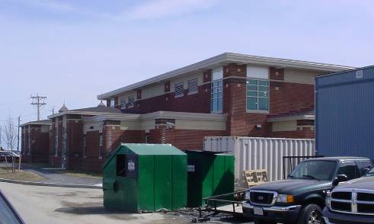

Prepared by:
Massachusetts Department of Public Health
Bureau of Environmental Health
Indoor Air Quality Program
April 2008

Background/Introduction
At the request of David Twombly, Director of Operations, Hull Public Schools (HPS), the Massachusetts Department of Public Health (MDPH), Bureau of Environmental Health (BEH) provided assistance and consultation regarding indoor air quality at the Lillian M. Jacobs Elementary School (JES) in Hull, Massachusetts.
On March 18, 2008, a visit to conduct an assessment at the JES was made by Cory Holmes and James Tobin, Environmental Analysts in BEH’s Indoor Air Quality (IAQ) Program. Previous IAQ assessments were conducted at the JES in 2006 and 2007. BEH issued reports describing conditions observed in the building at that time (MDPH, 2006a; MDPH, 2006b; MDPH 2007). These assessments were requested due to concerns of mold growth, construction and general IAQ conditions. The current assessment was prompted due to concerns related to entrainment of combustion products produced by the schools emergency generator located outside the building. At the time of the assessment JES students and staff were occupying the new addition (Picture 1), while the original building was undergoing renovations (Picture 2).

Methods
Air tests for carbon dioxide, carbon monoxide, temperature and relative humidity were conducted with the TSI, Q-TRAK™ IAQ Monitor, Model 8551. Air tests for airborne particulate matter with a diameter less than 2.5 micrometers were taken with the TSI, DUSTTRAK™ Aerosol Monitor Model 8520. Screening for total volatile organic compounds (TVOCs) was conducted using Thermo Environmental Instruments Inc., Model 580 Series Photo Ionization Detector (PID).
Results
The JES houses approximately 500 pre-kindergarten through grade 5 students and approximately 55 staff. Tests were taken under normal operating conditions and results appear in Table 1.

Discussion
Ventilation
It can be seen from Table 1 that carbon dioxide levels were elevated above 800 parts per million (ppm) in two of thirty-three areas surveyed, indicating adequate air exchange in the large majority of areas. Despite previous recommendations by MDPH in previous reports, univents in several areas remained blocked by furniture and/or had items on air diffusers, obstructing airflow in these areas.
The Massachusetts Building Code requires a minimum ventilation rate of 15 cubic feet per minute (cfm) per occupant of fresh outside air or have openable windows in each room (BOCA, 1993; SBBRS, 1997). The ventilation must be on at all times that the room is occupied. Providing adequate fresh air ventilation with open windows and maintaining the temperature in the comfort range during the cold weather season is impractical. Mechanical ventilation is usually required to provide adequate fresh air ventilation.
Carbon dioxide is not a problem in and of itself. It is used as an indicator of the adequacy of the fresh air ventilation. As carbon dioxide levels rise, it indicates that the ventilating system is malfunctioning or the design occupancy of the room is being exceeded. When this happens a buildup of common indoor air pollutants can occur, leading to discomfort or health complaints. The Occupational Safety and Health Administration (OSHA) standard for carbon dioxide is 5,000 parts per million parts of air (ppm). Workers may be exposed to this level for 40 hours/week based on a time-weighted average (OSHA, 1997).
The MDPH uses a guideline of 800 ppm for publicly occupied buildings. A guideline of 600 ppm or less is preferred in schools due to the fact that the majority of occupants are young and considered to be a more sensitive population in the evaluation of environmental health status. Inadequate ventilation and/or elevated temperatures are major causes of complaints such as respiratory, eye, nose and throat irritation, lethargy and headaches. For more information concerning carbon dioxide, consult Appendix A.
Temperature measurements in the building ranged from 68º F to 74 º F, which were within or slightly below the MDPH comfort guidelines. The MDPH recommends that indoor air temperatures be maintained in a range of 70 º F to 78 º F in order to provide for the comfort of building occupants. In many cases concerning indoor air quality, fluctuations of temperature in occupied spaces are typically experienced, even in a building with an adequate fresh air supply.
Relative humidity measurements in the building ranged from 15 to 20 percent, which were below the MDPH recommended comfort range. The MDPH recommends that indoor air relative humidity is comfortable in a range of 40 to 60 percent. Relative humidity levels in the building would be expected to drop during the winter months due to heating. The sensation of dryness and irritation is common in a low relative humidity environment. Low relative humidity is a very common problem during the heating season in the northeast part of the United States.

Emergency Generator and Products of Combustion
As discussed, concerns regarding the entrainment of exhaust emissions from the emergency generator (Picture 3) prompted the request for an IAQ assessment. As reported by Mr. Twombly, the generator was set on a timer to activate once a week to ensure proper function. The timer was previously set to test the generator on Monday mornings; it has since been re-programmed to test after school hours to prevent/reduce potential exposure to exhaust emissions. In addition, carbon monoxide detectors were installed in classrooms adjacent to the area where the generator is located (Picture 4). Carbon monoxide detectors should be tested and replaced as per the manufactures recommendations to ensure proper working order.
Indoor air quality can be negatively influenced by the presence of respiratory irritants, such as products of combustion. The process of combustion produces a number of pollutants. Common combustion emissions include carbon monoxide, carbon dioxide, water vapor and smoke (fine airborne particle material). Of these materials, exposure to carbon monoxide and particulate matter with a diameter of 2.5 micrometers (μm) or less (PM2.5) can produce immediate, acute health effects upon exposure. To determine whether combustion products were present in the school environment, BEH staff obtained measurements for carbon monoxide and PM2.5.
Carbon monoxide is a by-product of incomplete combustion of organic matter (e.g., gasoline, wood and tobacco). Exposure to carbon monoxide can produce immediate and acute health affects. Several air quality standards have been established to address carbon monoxide and prevent symptoms from exposure to these substances. The MDPH established a corrective action level concerning carbon monoxide in ice skating rinks that use fossil-fueled ice resurfacing equipment. If an operator of an indoor ice rink measures a carbon monoxide level over 30 ppm, taken 20 minutes after resurfacing within a rink, that operator must take actions to reduce carbon monoxide levels (MDPH, 1997).
The American Society of Heating Refrigeration and Air-Conditioning Engineers (ASHRAE) has adopted the National Ambient Air Quality Standards (NAAQS) as one set of criteria for assessing indoor air quality and monitoring of fresh air introduced by HVAC systems (ASHRAE, 1989). The NAAQS are standards established by the US EPA to protect the public health from six criteria pollutants, including carbon monoxide and particulate matter (US EPA, 2006). As recommended by ASHRAE, pollutant levels of fresh air introduced to a building should not exceed the NAAQS levels (ASHRAE, 1989). The NAAQS were adopted by reference in the Building Officials & Code Administrators (BOCA) National Mechanical Code of 1993 (BOCA, 1993), which is now an HVAC standard included in the Massachusetts State Building Code (SBBRS, 1997). According to the NAAQS, carbon monoxide levels in outdoor air should not exceed 9 ppm in an eight-hour average (US EPA, 2006).
Carbon monoxide should not be present in a typical, indoor environment. If it is present, indoor carbon monoxide levels should be less than or equal to outdoor levels. On the day of assessment, outdoor carbon monoxide concentrations were non-detect (ND) (Table 1). Carbon monoxide levels measured in the school were also ND (Table 1).
The US EPA has established NAAQS limits for exposure to particulate matter. Particulate matter is airborne solids that can be irritating to the eyes, nose and throat. The NAAQS originally established exposure limits to particulate matter with a diameter of 10 μm or less (PM10). According to the NAAQS, PM10 levels should not exceed 150 microgram per cubic meter (μg/m³) in a 24-hour average (US EPA, 2006). These standards were adopted by both ASHRAE and BOCA. Since the issuance of the ASHRAE standard and BOCA Code, US EPA proposed a more protective standard for fine airborne particles. This more stringent PM2.5 standard requires outdoor air particle levels be maintained below 35 μg/m³ over a 24-hour average (US EPA, 2006). Although both the ASHRAE standard and BOCA Code adopted the PM10 standard for evaluating air quality, MDPH uses the more protective proposed PM2.5 standard for evaluating airborne particulate matter concentrations in the indoor environment.
Outdoor PM2.5 concentrations were measured at 13 μg/m³ (Table 1). PM2.5 levels measured in occupied areas of the school ranged from 5 to 12 μg/m³, which were well below the NAAQS of 35 μg/m³ (Table 1). It is important to note that frequently, indoor air levels of particulates can be at higher levels than those measured outdoors. A number of mechanical devices and/or activities that occur in schools can generate particulates during normal operation. Sources of indoor airborne particulate may include but are not limited to particles generated during the operation of fan belts in the HVAC system, cooking in the cafeteria stoves and microwave ovens; use of photocopiers, fax machines and computer printing devices, operating an ordinary vacuum cleaner and heavy foot traffic indoors.

Renovations and Other IAQ Evaluations
BEH staff inspected construction barriers to identify and reduce/prevent pollutant pathways. Despite a number of previous recommendations (JES IAQ assessments in 2006 and 2007), BEH staff found several breaches regarding construction barriers. The plastic construction barrier on the first floor was loose/damaged (Pictures 5 and 6); whereas the second floor had no such barrier installed over the door that enters into the construction zone (Pictures 7 and 8). BEH staff examined classroom C-243 directly adjacent to this area and found the door to the construction zone sealed tightly with duct tape and caulking (Picture 9). Classroom C-143 was also sealed with duct tape, however the tape was failing along the top corner of the door (Picture 10). These findings were reported to school officials at the time of the assessment with the recommendation to re-seal all construction barriers. Most importantly, these barriers should be inspected on a daily basis to ensure integrity.
Indoor air quality can also be negatively influenced by the presence of materials containing volatile organic compounds (VOCs). VOCs are carbon-containing substances that have the ability to evaporate at room temperature. Frequently, exposure to low levels of total VOCs (TVOCs) may produce eye, nose, throat and/or respiratory irritation in some sensitive individuals. For example, chemicals evaporating from a paint can stored at room temperature would most likely contain VOCs. In an effort to determine whether VOCs were present in the building, air monitoring for TVOCs was conducted in select areas (Table 1). Indoor TVOC concentrations were ND at the time of the assessment (Table 1). An outdoor air sample was taken for comparison. Outdoor TVOC concentrations were also ND. Please note, TVOC air measurements are only reflective of the indoor air concentrations present at the time of sampling.
Cleaning products were found on countertops and in unlocked cabinets beneath sinks in a number of classrooms. Like dry erase materials, cleaning products contain VOCs and other chemicals (Picture 11). These chemicals can be irritating to the eyes, nose and throat and should be kept out of reach of students.
Tennis balls were observed on the chair legs despite previous recommendations (Picture 12). Tennis balls are made of a number of materials that are a source of respiratory irritants. Constant wearing of tennis balls can produce fibers and cause TVOCs to off-gas. Tennis balls are made with a natural rubber latex bladder, which becomes abraded when used as a chair leg pad. Use of tennis balls in this manner may introduce latex dust into the school environment. Some individuals are highly allergic to latex (e.g., spina bifida patients) (SBAA, 2001). It is recommended that the use of materials containing latex be limited in buildings to reduce the likelihood of symptoms in sensitive individuals (NIOSH, 1997).
Finally, a few classrooms had personal fans (Picture 13) that were observed to have accumulated dust. Re-activated fans can also aerosolize dust accumulated on vents/fan blades.

Conclusions/Recommendations

The building remains under construction, which can lead to potential exposures to construction/renovation-generated pollutants if control/containment measures are not adequate. Observations at the time of the assessment demonstrated flaws in containment. As a reminder, renovation efforts require continued diligence by all parties involved with daily/routine maintenance, observation and reporting by building occupants involving construction and renovations.
In view of the findings at the time of the assessment, the following recommendations are made to further improve indoor air quality:
- Continue with current plans to test the emergency generator after school hours.
- Test and replace carbon monoxide detectors as per the manufacture’s recommendations to ensure proper working order.
- Continue to implement all applicable recommendations listed in the previous MDPH reports, particularly those regarding the integrity of construction barriers (e.g., daily inspection) and depressurization of construction areas in relation to occupied areas.
- Refer to guidance concerning ‘Methods Used to Reduce/Prevent Exposure to Construction/Renovation Generated Pollutants in Occupied Buildings’ available on the MDPH’s http://mass.gov/dph/indoor_air (under topics for Sources of Indoor Air Pollution).
- Use openable windows in conjunction with mechanical ventilation to facilitate air exchange. Care should be taken to ensure windows are properly closed at night and weekends to avoid the freezing of pipes and potential flooding.
- Clean personal fans periodically of accumulated dust.
- Store cleaning products properly and out of reach of students. Ensure spray bottles are properly labeled. All cleaning products used at the facility should be approved by the school department with MSDS’ available at a central location.
- Replace latex-based tennis balls with latex-free tennis balls or glides.

References
ACGIH. 1989. Guidelines for the Assessment of Bioaerosols in the Indoor Environment. American Conference of Governmental Industrial Hygienists, Cincinnati, OH.

ASHRAE. 1989. Ventilation for Acceptable Indoor Air Quality. American Society of Heating, Refrigeration and Air Conditioning Engineers. ANSI/ASHRAE 62-1989
BOCA. 1993. The BOCA National Mechanical Code/1993. 8th ed. Building Officials & Code Administrators International, Inc., Country Club Hills, IL.

MDPH. 1997. Requirements to Maintain Air Quality in Indoor Skating Rinks (State Sanitary Code, Chapter XI). 105 CMR 675.000. Massachusetts Department of Public Health, Boston, MA.
MDPH. 2006a. Indoor Air Quality Assessment Lillian Jacobs Elementary School, MA. Massachusetts Department of Public Health, Executive Office of Human Services, Boston, MA. October 2006.

MDPH. 2006b. Indoor Air Quality Reassessment Lillian Jacobs Elementary School, MA. Massachusetts Department of Public Health, Executive Office of Human Services, Boston, MA. December 2006.

MDPH. 2007. Indoor Air Quality Reassessment Lillian Jacobs Elementary School, MA. Massachusetts Department of Public Health, Executive Office of Human Services, Boston, MA. June 2007.

NIOSH. 1997. NIOSH Alert Preventing Allergic Reactions to Natural Rubber latex in the Workplace. National Institute for Occupational Safety and Health, Atlanta, GA.
OSHA. 1997. Limits for Air Contaminants. Occupational Safety and Health Administration. Code of Federal Regulations. 29 C.F.R 1910.1000 Table Z-1-A.

SBAA. 2001. Latex In the Home And Community Updated Spring 2001. Spina Bifida Association of America, Washington, DC.

SBBRS. 1997. Mechanical Ventilation. State Board of Building Regulations and Standards. Code of Massachusetts Regulations. 780 CMR 1209.0

US EPA. 2001. “Mold Remediation in Schools and Commercial Buildings”. Office of Air and Radiation, Indoor Environments Division, Washington, DC. EPA 402-K-01-001. March 2001. Available at: http://www.epa.gov/iaq/molds/mold_remediation.html
US EPA. 2006. National Ambient Air Quality Standards (NAAQS). . US Environmental Protection Agency, Office of Air Quality Planning and Standards, Washington, DC. http://www.epa.gov/air/criteria.html.
Picture 1

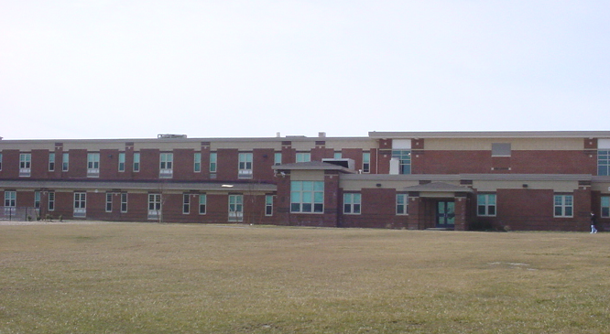

New Addition of Jacobs Elementary School

Picture 2

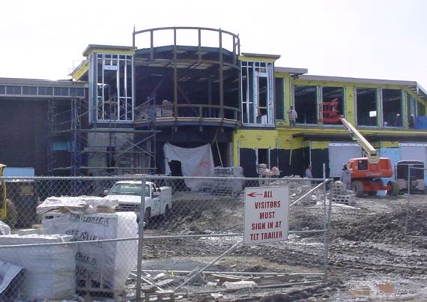

Renovation of Original JES Adjacent to New Addition
Picture 3

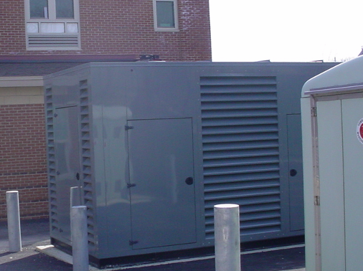

Emergency Generator at Rear of Building

Picture 4

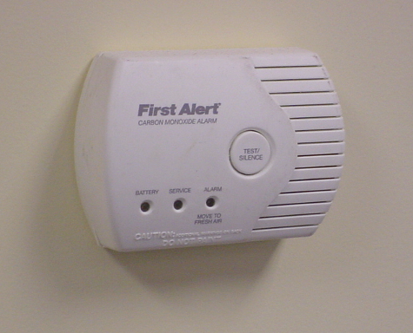

Wall-Mounted Carbon Monoxide Detector in Classroom
Picture 5

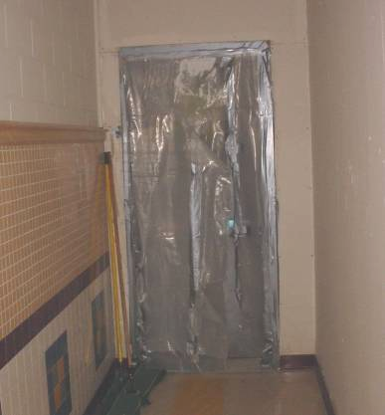

First Floor Construction Barrier

Picture 6

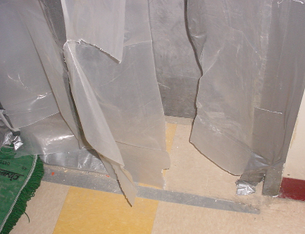

Close-Up of Bottom of First Floor Construction Barrier in Preceding Picture,
Note Torn Plastic and Duct Tape
Picture 7

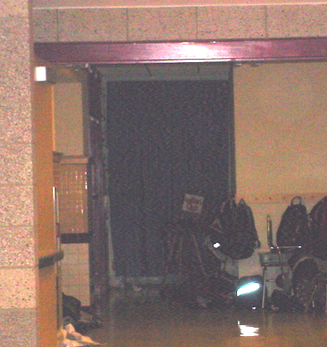

2nd Floor Door to Construction Zone Covered by Hanging Curtain

Picture 8

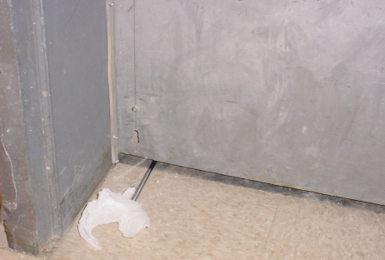

Close-Up of Bottom of 2nd Floor Door to Construction Zone in Preceding Picture, Note Probe Inserted beneath Door Indicating That No Construction Barriers were Present Allowing Free Airflow into Occupied Areas of the School
Picture 9

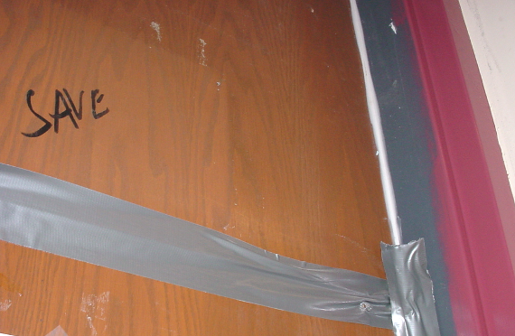

Close-Up of Door in Classroom 243, Note Door is Sealed Tightly with Duct Tape and Caulking

Picture 10

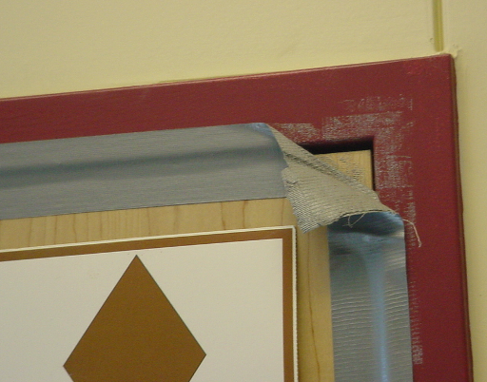

Classroom C-143 Door Sealed with Duct Tape, Note tape Failing along Top Corner
Picture 11

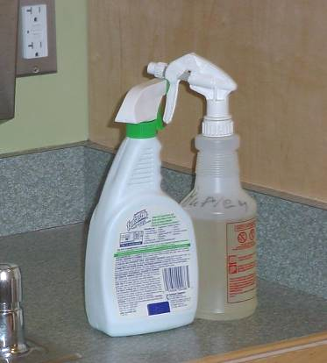

Spray Cleaning Bottles on Countertop in Classroom

Picture 12

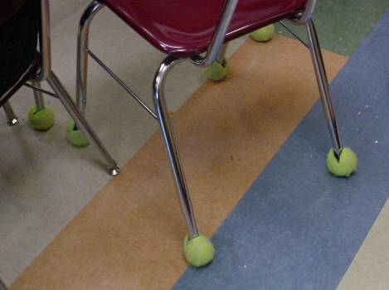

Tennis Balls on Chair Legs in Classroom
Picture 13

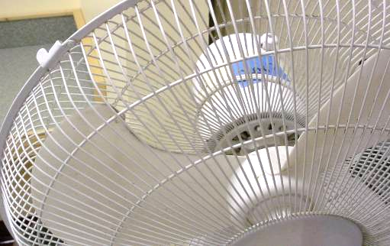

Accumulated Dust/Debris on Fan Blades/Cage
Location/ Room | Occupants  in Room | Temp  (°F) | Relative  Humidity  (%) | Carbon  Dioxide  (ppm) | Carbon Monoxide  (ppm) | TVOCs  (ppm) | PM2.5  (µg/m3) | Windows  Openable | Ventilation |  | Remarks
 |  |  |  |  |  |  |  |  | Supply | Exhaust | Remarks
background |  | 54 | 20 |  | ND | ND | 13 |  |  |  | cool, mostly sunny, wind
C 101 | 19 | 70 | 18 | 568 | ND |  | 6 | Y | Y | Y | DO
C 103 | 20 | 70 | 18 | 573 | ND |  | 7 | Y | Y | Y | DEM; CFs; PF
C 105 | 19 | 70 | 18 | 589 | ND |  | 5 | Y | Y | Y | 2 CT WD – plumb leak
C 107 | 19 | 70 | 18 | 629 | ND |  | 8 | Y | Y | Y | Univent blocked by furniture; Cleaners; DO
C 109 | 18 | 70 | 19 | 693 | ND |  | 8 | Y | Y | Y | DO
C 111 | 18 | 69 | 18 | 682 | ND |  | 7 | Y | Y | Y
C 113 | 5 | 69 | 18 | 655 | ND |  | 7 | Y | Y | Y | DO
C 117 | 17 | 69 | 19 | 723 | ND |  | 9 | N | Y | Y | DEM; Cleaners
C 123 | 22 | 68 | 19 | 618 | ND |  | 5 | Y | Y | Y | DO
C 141 | 5 | 69 | 17 | 610 | ND |  | 6 | Y | Y | Y | DO
C 142 | 0 | 71 | 17 | 491 | ND |  | 7 | Y | Y | Y | Univent blocked; AP; DEM; PS
C 143 | 0 | 69 | 18 | 534 | ND | ND | 7 | Y | Y | Y | Exhaust above door; Space under exterior door; Door to Construction breached barrier; DEM; DO; CFs; Cleaners
C 201 | 20 | 69 | 19 | 597 | ND |  | 8 | Y | Y | Y | Exhaust above door; DEM; CFs
C 202 | 0 | 74 | 17 | 781 | ND |  | 10 | Y | Y | Y | Occupants gone 5 mins; DEM; DO
C 203 | 19 | 69 | 20 | 847 | ND |  | 9 | Y | Y | Y | Exhaust above door; DEM; CFs
C 204 | 0 | 69 | 15 | 665 | ND |  | 8 | Y | Y | Y | Items on univent air diffuser; Occupants gone 5 mins; DEM; Spray deodorizer
C 205 | 18 | 68 | 19 | 727 | ND |  | 9 | Y | Y | Y | Exhaust above door; DEM; DO; CFs
C 206 | 0 | 69 | 17 | 693 | ND |  | 8 | Y | Y | Y | Univent blocked, items on air diffuser, table in front; Cleaners on counter; DO
C 207 | 12 | 68 | 19 | 703 | ND |  | 8 | Y | Y | Y | DEM; DO; CFs; Clutter
C 208/209 | 22 |  |  | 1070 | ND |  | 5 | N | Y | Y | HEPA AP; PF
C 224 | 2 | 71 | 20 | 767 | ND |  | 6 | N | Y | Y
C 226 Office | 0 | 71 | 20 | 797 | ND |  | 10 | Y | Y | Y | AC; DO
C 228 | 1 | 72 | 19 | 619 | ND |  | 7 | Y | Y | Y | AC; DEM
C 229 | 0 | 71 | 20 | 676 | ND |  | 7 | N | Y | Y | AC
C 241 | 24 | 69 | 17 | 777 | ND |  | 7 | Y | Y | Y | TB; DEM
C 242 | 21 | 72 | 20 | 798 | ND |  | 12 | Y | Y | Y | Univent blocked by stored materials; DEM; CFs; Clutter
C 243 | 26 | 70 | 19 | 748 | ND |  | 6 | Y | Y | Y | TB; DEM; Plant
C 243 | 25 | 68 | 17 | 650 | ND | ND | 7 | Y | Y | Y | Testing near construction barrier/classroom door, sealed with caulk and duct tape
Cafeteria  (in gym) | 50 | 70 | 18 | 677 | ND | ND | 9 | N | Y | Y
Construction Barrier 1st Floor Hallway |  | 69 | 19 | 580 | ND | ND | 7 |  |  |  | Plastic barrier torn, loose
Construction Barrier 2nd Floor Hallway |  | 69 | 19 | 753 | ND | ND | 9 |  |  |  | No sealant on door-space under door into construction zone
Gym | 50 | 70 | 18 | 532 | ND | ND | 7 | N | Y | Y
Library | 1 | 70 | 17 | 468 | ND |  | 6 | Y | Y | Y

