**INDOOR AIR QUALITY ASSESSMENT**

**Lincoln-Hancock Elementary School**

**300 Granite Street**

**Quincy, Massachusetts**

Lincoln-Hancock Elementary School, 300 Granite Street, Quincy, Massachusetts


Prepared by:

Massachusetts Department of Public Health

Bureau of Environmental Health

Indoor Air Quality Program

June 2017

# Background

|  |  |
| --- | --- |
| Building: | Lincoln-Hancock Elementary School |
| Address: | 300 Granite Street, Quincy, MA |
| Assessment Requested by: | Kevin Segalla, Coordinator of Custodial Services, Quincy Public Schools |
| Reason for Request: | General indoor air quality (IAQ) assessment, respiratory issues and mold concerns |
| Date of Assessment: | June 2, 2017 |
| Massachusetts Department of Public Health/Bureau of Environmental Health (MDPH/BEH) Staff Conducting Assessment: | Cory Holmes, Environmental Analyst/Inspector, IAQ Program |
| Building Description: | Three-story brick school building, finished in 1971. Assessment was limited to several basement areas where concerns were reported. |
| Windows: | Some of the areas examined had openable windows. |

# Methods

Please refer to the IAQ Manual and appendices for methods, sampling procedures, and interpretation of results (MDPH, 2015).

# Results and Discussion

The following is a summary of indoor air testing results (Table 1).

* ***Carbon dioxide*** measurements were below the MDPH recommended level of 800 parts per million (ppm) in areas surveyed.
* ***Temperature*** was within the MDPH recommended range of 70°F to 78°F at the time of assessment.
* ***Relative humidity*** was within the MDPH recommended range of 40 to 60% in all areas tested.
* ***Carbon monoxide*** levels were non-detectable in all areas tested.
* ***Particulate matter (PM2.5)*** concentrations measured were below the National Ambient Air Quality (NAAQS) level of 35 μg/m3 in all areas tested.

## Ventilation

A heating, ventilating and air-conditioning (HVAC) system has several functions. First it provides heating and, if equipped, cooling. Second, it is a source of fresh air. Finally, an HVAC system will dilute and remove normally occurring indoor environmental pollutants by not only introducing fresh air, but also filtering the airstream and ejecting stale air to the outdoors via exhaust ventilation.

Testing results suggest that sufficient fresh air was being introduced into the space at the time of assessment. Outside air is brought in via an air handling unit (AHU) and delivered to classrooms via ceiling-mounted supply diffusers (Picture 1). Air is exhausted from ceiling-mounted exhaust vents on the opposite side of the room (Picture 2). Exhaust vents are located near classroom doors. Note that when classroom doors are open, exhaust vents will tend to pull hallway air *into* the classroom instead of removing stale air/pollutants *from* the room and out the building.

Although temperature measurements were within/close to MDPH recommendations at the time of assessment, excessive temperature/comfort complaints were reported. It is also important to note that relative humidity levels in the building would be expected to be low during the winter months due to atmospheric conditions and heating. Low relative humidity can lead to common symptoms such as: dry skin, lips, and scalp; dry/scratchy throats and noses (nose bleeds); exacerbation of asthma, eczema, or allergies; dry/irritated eyes; and irritation of respiratory tract.

It is recommended that AHUs be outfitted with pleated filters of a Minimum Efficiency Reporting Value (MERV) of 8, which are adequate in filtering out pollen and mold spores (ASHRAE, 2012). In addition, filters should be changed 2-4 times a year or in accordance with the manufacture’s recommendations. Mr. Segalla reported that AHU filters are MERV 8 and are changed 3 times per year.

## Microbial/Moisture Concerns

In order for building materials to support mold growth, a source of water exposure is necessary. It was reported that the area (room 106) experiences periodic leaks from the exterior during heavy wind-driven rain, particularly behind a large bookcase in the left/front corner of the classroom. It was also reported that numerous attempts have been made to make repairs/water-proof the exterior in this area to prevent further leaking. At the time of assessment, the area was dry and no visible mold growth was observed on building materials. Small stains were observed on a ceiling tile (Picture 3) in the corner of the classroom, which is evidence of leakage and should be changed after a leak is identified/repaired. Adjacent rooms 104 and 109 also contained a few water-damaged ceiling tiles.

Visible water damage/mold growth was observed on a paper/cardboard item in classroom 106 (Picture 4). This item was removed and discarded. It was recommended that all other paper/porous classroom items stored in known areas of leaks be inspected by school staff and discarded if water-damaged/moldy.

Classroom 106 also contained a plant/terrarium. Plants and terrariums can be a source of pollen and mold, which can be respiratory irritants to some individuals. Plants should be properly maintained and equipped with drip pans to prevent water damage to porous materials. Plants should also be located away from air diffusers to prevent the aerosolization of dirt, pollen, and mold.

**Other IAQ Evaluations**

Exposure to low levels of total volatile organic compounds (TVOCs) may produce eye, nose, throat, and/or respiratory irritation in some sensitive individuals. To determine if VOCs were present, BEH/IAQ staff examined rooms for products containing VOCs. BEH/IAQ staff noted hand sanitizers, cleaners, and dry erase materials in use within the building. All of these products have the potential to be irritants to the eyes, nose, throat, and respiratory system of sensitive individuals.

In a number of areas, items were observed on the floor, windowsills, tabletops, counters, bookcases and desks. The large number of items stored provides a source for dusts to accumulate. These items (e.g., papers, folders, boxes) make it difficult for custodial staff to clean. Items should be relocated and/or be cleaned periodically to avoid excessive dust build up. In addition, dusty materials can accumulate on flat surfaces (e.g., desktops, windowsills and carpets) in occupied areas and subsequently be re-aerosolized causing further irritation. Accumulated dust/debris was noted on vents and surrounding ceiling tiles, which should be cleaned periodically (e.g., after regular filter changes).

Room 109 contained area rugs. Carpets should be cleaned annually (or semi-annually in soiled/high traffic areas) in accordance with Institute of Inspection, Cleaning and Restoration Certification (IICRC) recommendations, (IICRC, 2012).

Chalk/chalkboards are used in room 106. Chalk dust is a fine/respirable irritant; chalk treys should be regularly cleaned with a damp cloth to avoid accumulated chalk dust.

Note that the Environmental Protection Agency (EPA) conducted a National School Radon Survey in which it discovered nearly one in five schools had “…at least one frequently occupied ground contact room with short-term radon levels above 4 [picocuries per liter] pCi/L” (US EPA 1992). The BEH/IAQ Program therefore recommends that every school be tested for radon, and that this testing be conducted during the heating season while school is in session in a manner consistent with USEPA radon testing guidelines. Radon measurement specialists and other information can be found at [www.nrsb.org](http://www.nrsb.org/) and <http://aarst-nrpp.com/wp>, with additional information at: <http://www.mass.gov/eohhs/gov/departments/dph/programs/environmental-health/exposure-topics/iaq/radon>.

# Conclusions and Recommendations

In view of the findings at the time of the visit, the following recommendations are made:

1. Work with HVAC technician/school maintenance personnel and school staff to investigate/improve excessive heat conditions in room 106 (and other areas of complaints) to improve comfort.
2. Continue to work to identify/repair potential sources of leaks from the building envelope.
3. Relocate bookcase in classroom 106 away from area of reported leaks.
4. Remove/relocate all paper/porous items stored in known areas of leaks. If water-damaged/moldy, discard.
5. For more information about mold/remediation consult “Mold Remediation in Schools and Commercial Buildings” published by the US Environmental Protection Agency (US EPA, 2008).
6. Use openable windows in conjunction with mechanical ventilation to increase air exchange. Care should be taken to ensure windows are properly closed at night and weekends to avoid the freezing of pipes and potential flooding.
7. Close classroom doors to maximize air exchange/improve exhaust capabilities.
8. For buildings in New England, periods of low relative humidity during the winter are often unavoidable. Therefore, scrupulous cleaning practices should be adopted to minimize common indoor air contaminants whose irritant effects can be enhanced when the relative humidity is low. To control for dusts, a high efficiency particulate arrestance (HEPA) filter-equipped vacuum cleaner in conjunction with wet wiping of all surfaces is recommended. Avoid the use of feather dusters. Drinking water during the day can help ease some symptoms associated with a dry environment (throat and sinus irritation).
9. Keep plants/terrariums in good condition, avoid overwatering, and remove from the airstream of univents and other air sources.
10. Clean supply/exhaust/return vents and personal fans regularly to prevent aerosolization of debris.
11. Reduce clutter building-wide and increase dust control.
12. Continue to use pleated MERV 8 filters, which are adequate in filtering out pollen and mold spores (ASHRAE, 2012). Continue to change 2-4 times a year or in accordance with the manufacture’s recommendations.
13. Clean carpeting and area rugs regularly and discard those that are worn out or too soiled to be cleaned.
14. Reduce use of products and equipment that create VOCs.
15. Continue to adopt the US EPA (2000) document, “Tools for Schools”, as an instrument for maintaining a good IAQ environment in the building available at: <http://www.epa.gov/iaq/schools/index.html>.
16. The school should be tested for radon by a certified radon measurement specialist during the heating season when school is in session. Radon measurement specialists and other information can be found at: [www.nrsb.org](http://www.nrsb.org/), and <http://aarst-nrpp.com/wp/>.
17. Refer to resource manual and other related IAQ documents located on the MDPH’s website for further building-wide evaluations and advice on maintaining public buildings. These documents are available at <http://mass.gov/dph/iaq>

# REFERENCES

ASHRAE. 2012. American Society of Heating, Refrigeration and Air Conditioning Engineers (ASHRAE) Standard 52.2-2012 -- Method of Testing General Ventilation Air-Cleaning Devices for Removal Efficiency by Particle Size (ANSI Approved).

IICRC. 2012. Institute of Inspection, Cleaning and Restoration Certification. Carpet Cleaning: FAQ. Retrieved from <http://www.iicrc.org/consumers/care/carpet-cleaning>.

MDPH. 2015. Massachusetts Department of Public Health (MDPH). 2015. Indoor Air Quality Manual: Chapters I-III. Available at: <http://www.mass.gov/eohhs/gov/departments/dph/programs/environmental-health/exposure-topics/iaq/iaq-manual/>.

US EPA. 1992. Radon Measurement in Schools, Revised Edition. Office of Air and Radiation, Office of Radiation and Indoor Air, Indoor Environments Division (6609J). EPA 402-R-92-014. <https://www.epa.gov/sites/production/files/2014-08/documents/radon_measurement_in_schools.pdf>

US EPA. 2000. Tools for Schools. Office of Air and Radiation, Office of Radiation and Indoor Air, Indoor Environments Division (6609J). EPA 402-K-95-001, Second Edition. <http://www.epa.gov/iaq/schools/index.html>.

US EPA. 2008. “Mold Remediation in Schools and Commercial Buildings”. US EPA. Office of Air and Radiation, Indoor Environments Division, Washington, DC. EPA 402-K-01-001. Available at: <http://www.epa.gov/mold/mold-remediation-schools-and-commercial-buildings-guide>.

**Picture 1**

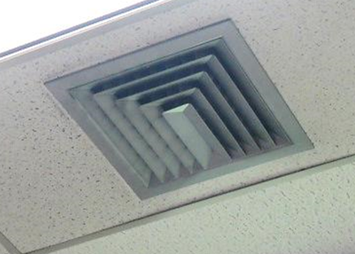

**Supply vent**

**Picture 2**

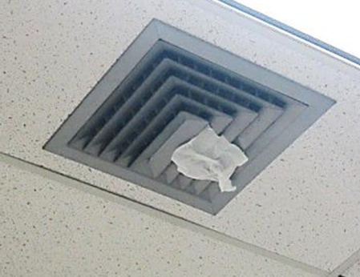

**Exhaust/return vent, tissue shows air draw into vent/out of classroom**

**Picture 3**

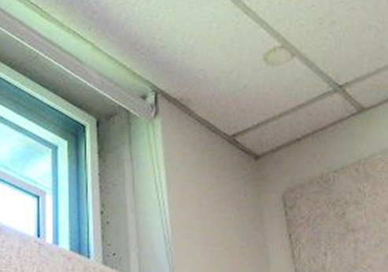

**Stained ceiling tile in room 106**

**Picture 4**

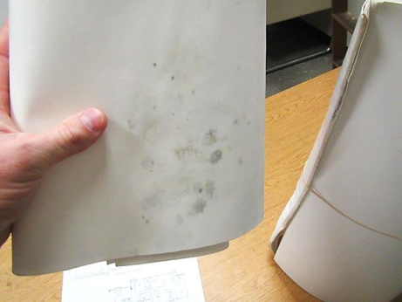

**Visible mold growth on water-damaged paper item in classroom 106**

| **Location** | **Carbon**  **Dioxide**  **(ppm)** | **Carbon Monoxide**  **(ppm)** | **Temp**  **(°F)** | **Relative**  **Humidity**  **(%)** | **PM2.5**  **(µg/m3)** | **Occupants**  **in Room** | **Windows**  **Openable** | **Ventilation** | | **Remarks** |
| --- | --- | --- | --- | --- | --- | --- | --- | --- | --- | --- |
| **Supply** | **Exhaust** |
| Background (outdoors) | 396 | ND | 64 | 43 | 7 |  |  |  |  | Clear skies, warm, light breeze |
| 104 | 509 | ND | 73 | 41 | 1 | 7 | N | Y | Y | Dust/debris vents, WD CT |
| 106 | 535 | ND | 70 | 46 | 1 | 4 | Y | Y | Y | DO, AI, DEM, chalkboard, hand sanitizer, terrarium/plant, WD CTs-corner, WD paper item/visible mold growth, heat complaints, reported leak in corner of room behind bookcase |
| 109 | 749 | ND | 72 | 45 | 2 | 21 | Y | Y | Y | 5 WD CTs, area rugs |