INDOOR AIR QUALITY ASSESSMENT

Department of Mental Health
Lindemann Building, Chelsea Conference Room Suite
25 Staniford Street
Boston, MA

Prepared by:
Massachusetts Department of Public Health
Bureau of Environmental Health
Indoor Air Quality Program
October 2016

Background
Building: | Department of Mental Health Lindemann Building, Chelsea Conference Room Suite (CCR)
Address: | 25 Staniford Street
Assessment Requested by: | Parrish Rossi, Facility Manager, Division of Capital Asset Management and Maintenance
Reason for Request: | Concerns about IAQ and health
Date of Assessment: | October 4, 2016
Massachusetts Department of Public Health/Bureau of Environmental Health (MDPH/BEH) Staff Conducting Assessment: | Ruth Alfasso, Environmental Engineer/Inspector, IAQ Program
Building Description: | This suite is a part of the Erich Lindemann Mental Health Center, a Brutalist concrete building constructed in the 1960s.
Building Population: | Approximately 3 employees
Windows: | Not openable

Methods
Please refer to the IAQ Manual for methods, sampling procedures, and interpretation of results (MDPH, 2015).

IAQ Testing Results
The following is a summary of indoor air testing results (Table 1).
- Carbon dioxide levels were below 800 parts per million (ppm) in all areas assessed, indicating adequate fresh air in the space.
- Temperature was within the recommended range of 70°F to 78°F in all areas assessed.
- Relative humidity was within the recommended range of 40% to 60% in all areas assessed.
- Carbon monoxide levels were non-detectable in all indoor areas assessed.
- Fine particulate matter (PM2.5) concentrations measured were below the National Ambient Air Quality Standard (NAAQS) level of 35 μg/m³ in all areas assessed.
- Total Volatile Organic Compounds (TVOC) were not detected in the area assessed.

Ventilation
A heating, ventilating, and air conditioning (HVAC) system has several functions. First, it provides heating and, if equipped, cooling. Second, it is a source of fresh air. Finally, an HVAC system will dilute and remove normally occurring indoor environmental pollutants by not only introducing fresh air, but also filtering the airstream and ejecting stale air to the outdoors via exhaust ventilation. Even if an HVAC system is operating as designed, point sources of respiratory irritation may exist and affect symptoms in sensitive individuals. The following analysis examines and identifies components of the HVAC system and likely sources of respiratory irritant/allergen exposure due to water damage, aerosolized dust, and/or chemicals found in the indoor environment.
Fresh air is provided by air handling units (AHUs). Air from the AHUs is filtered, heated/cooled, and delivered to rooms via ducted supply vents (Pictures 1 and 2). Air is returned/exhausted through vents in the ceiling (Picture 3). Additional heating is provided by radiators along outside edges of the building (Picture 4).
The assessment results indicate that the ventilation system is providing adequate fresh air for the occupancy in the suite. It is recommended that HVAC systems be re-balanced every five years to ensure adequate air systems function (SMACNA, 1994). It is unknown when the last time this system was balanced.

Microbial/Moisture Concerns
No water-damaged porous materials were observed in the office suite. A supply vent in the main office showed signs of rust (Picture 1) which indicates that water has condensed on the metal surface of the vent during humid conditions. If this is a frequent occurrence, the temperature of the supply air may need to be adjusted.
A few plants were observed in the office (Picture 5). Plants should be kept in good condition, not overwatered and not placed on porous materials or in the airstream of HVAC equipment.

Other IAQ Evaluations
Exposure to low levels of total volatile organic compounds (TVOCs) may produce eye, nose, throat, and/or respiratory irritation in some sensitive individuals. To determine if VOCs were present, BEH/IAQ staff measured levels of TVOCs in the suite, and all the levels were non detect. BEH/IAQ staff also examined rooms for products containing VOCs. BEH/IAQ staff noted cleaning/sanitizing products in use which have the potential to be irritants to the eyes, nose, throat, and respiratory system of sensitive individuals.
Sunlight leading to solar heating was observed through the window in the main office area (Picture 5). This is also near the thermostat for the office. Shades/blinds should be used to reduce the impact of solar gain on the office temperature, especially if solar heating of the thermostat leads to excess cooling in the office.
Some portions of the offices were carpeted. Carpets should be cleaned annually (or semi-annually in soiled/high traffic areas) in accordance with Institute of Inspection, Cleaning and Restoration Certification (IICRC) recommendations, (IICRC, 2012).
Items, including books and papers, were found on top of radiator vents (Picture 4). Radiator vents in the CCR were also dusty. When the vents are in operation, the heat creates a stack effect that distributes heated air to the rest of the room, and can thereby distribute dust and odors from materials on top of the vents. All vents should be kept free of items and cleaned periodically.
In some other areas, including the front hallway of the suite, stored materials and accumulated items make it more difficult for custodial staff to clean; items should be stored neatly and moved periodically for cleaning. Note that the suite contains oddly-shaped corners/spaces that can provide a challenge for cleaning and can provide harborage for pests if not kept free of items and debris.

Conclusions/Recommendations
Based on observations at the time of assessment, the following is recommended:
- Continue to operate supply and exhaust ventilation in all areas during occupied periods.
- Have the HVAC system balanced every 5 years in accordance with SMACNA recommendations (SMACNA, 1994).
- For buildings in New England, periods of low relative humidity during the winter are often unavoidable. Therefore, scrupulous cleaning practices should be adopted to minimize common indoor air contaminants whose irritant effects can be enhanced when the relative humidity is low. To control for dusts, a high efficiency particulate arrestance (HEPA) filter equipped vacuum cleaner in conjunction with wet wiping of all surfaces is recommended. Avoid the use of feather dusters. Drinking water during the day can help ease some symptoms associated with a dry environment (throat and sinus irritations).
- Change filters on AHUs on a regular schedule at least twice a year.
- Remove items from the top of radiators.
- Clean flat surfaces, vents and radiators periodically to remove dust that may become aerosolized.
- If condensation regularly occurs on supply vents during humid weather, contact the building maintenance department regarding the temperature of the supply air.
- Ensure plants are well maintained, not overwatered and not placed on porous surfaces.
- Reduce use of cleaning products, sanitizers and other products that contain VOCs.
- Use shades to reduce solar heating and the impact on the thermostat in the office.
- Clean carpeting in accordance with IICRC recommendations (IICRC, 2012).
- Reduce accumulated materials on flat surfaces and store in an organized manner to allow for thorough cleaning.
- Refer to resource manual and other related IAQ documents located on the MDPH’s website for further building-wide evaluations and advice on maintaining public buildings. These documents are available at: http://mass.gov/dph/iaq.

References
IICRC. 2012. Institute of Inspection, Cleaning and Restoration Certification. Carpet Cleaning: FAQ. Retrieved from http://www.iicrc.org/consumers/care/carpet-cleaning.
MDPH. 2015. Massachusetts Department of Public Health. Indoor Air Quality Manual: Chapters I-III. Available at: http://www.mass.gov/eohhs/gov/departments/dph/programs/environmental-health/exposure-topics/iaq/iaq-manual/.
SMACNA. 1994. HVAC Systems Commissioning Manual. 1st ed. Sheet Metal and Air Conditioning Contractors’ National Association, Inc., Chantilly, VA.
Picture 1
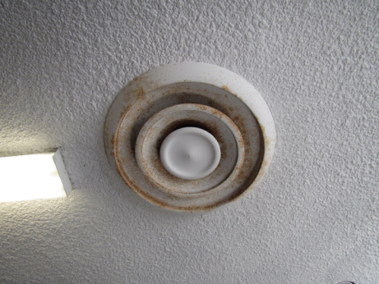
Supply vent, note rust
Picture 2
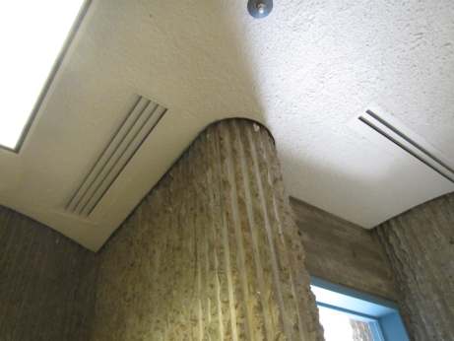
Supply vents
Picture 3
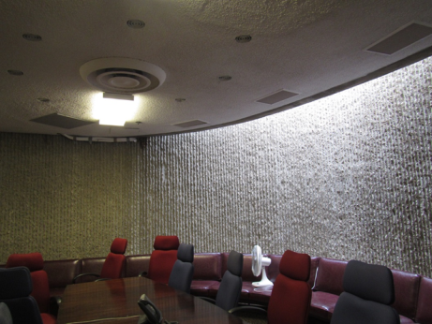
Exhaust vents (arrows)
Picture 4
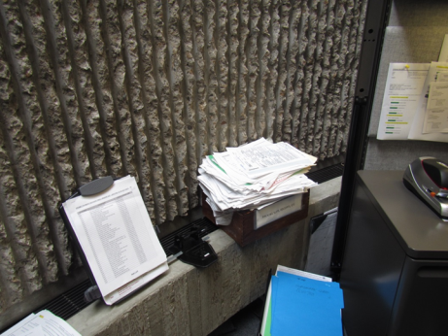
Items on radiator
Picture 5
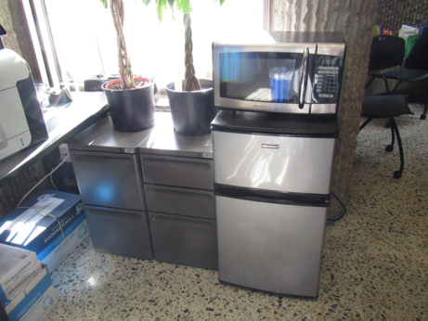
Plants in the office, note strong sunlight through window

Location | Carbon  Dioxide  (ppm) | Carbon Monoxide  (ppm) | Temp  (°F) | Relative  Humidity  (%) | PM2.5  (µg/m³) | Occupants  in Room | VOCs  (ppm) | Windows  Openable | Ventilation |  | Remarks
 |  |  |  |  |  |  |  |  | Supply | Exhaust
Background | 339 | 0.5 | 68 | 52 | 10 |  |  |  |  |  | Mowing nearby, sunny
Office area | 477 | ND | 73 | 59 | 4 | 3 | ND | N | Y | Y | Cleaning products, plants, solar gain, items on radiators refrigerator, shredder, tile floor with area rug
Chelsea Conference Room | 476 | ND | 74 | 56 | 4 | 0 | ND | N | Y | Y | Carpeted, dust on radiators, personal fan
Reception Desk | 470 | ND | 74 | 55 | 4 | 0 | ND | N | Y | Y | Cleaning products
Hallway | 465 | ND | 75 | 55 | 4 | 0 | ND | N | Y | N | Window to next floor down, not carpeted, accumulated items/storage

