**INDOOR AIR QUALITY ASSESSMENT**

**Linden S.T.E.A.M Academy**

**29 Wescott Street**

**Malden, MA**

Exterior view of the Malden Linden STEAM school

Prepared by:

Massachusetts Department of Public Health

Bureau of Environmental Health

Indoor Air Quality Program

June 2022

# BACKGROUND

|  |  |
| --- | --- |
| **Building:** | Linden S.T.E.A.M. Academy (Linden Steam) |
| **Address:** | 29 Wescott Street, Malden, MA |
| Assessment Requested by: | Chris Webb, Health Director, City of Malden |
| **Reason for Request:** | Concerns about odors and general indoor air quality (IAQ) issues |
| **Date of Assessment:** | April 7, 2022 |
| **Massachusetts Department of Public Health/Bureau of Environmental Health (MDPH/BEH) Staff Conducting Assessment:** | Michael Feeney Director, Ruth  Alfasso Environmental  Engineer/Inspector, and Jennifer  Lajoie, Environmental  Analyst/Inspector, IAQ Program |
| **Building Description:** | Linden Steam is a three-story brick school originally constructed in 2001. Approximately 700 students in grades K-6 attend the school. The school contains classrooms, offices, and accessory areas including a gymnasium, auditorium, and a cafeteria |
| **Windows:** | Windows in most areas are openable. |

# METHODS

Please refer to the IAQ Manual for methods, sampling procedures, and interpretation of results (MDPH, 2015).

# RESULTS AND DISCUSSION

The following is a summary of indoor air testing results (Table 1):

* ***Carbon Dioxide*** was above the MDPH recommended guideline of 800 parts per million (ppm) in about a quarter of the areas assessed. Note that many areas had low occupancy, Carbon dioxide levels may be higher with increased occupancy.
* ***Temperature*** was within or close to the lower end of the MDPH recommended range of 70°F to 78°F in all areas tested.
* ***Relative Humidity*** was within or close to the lower end of the MDPH recommended range of 40 to 60% in the areas tested.
* ***Carbon Monoxide*** was not detected (ND) in the areas assessed.
* ***Particulate matter (PM2.5)*** concentrations measured were below the National Ambient Air Quality (NAAQS) level of 35 μg/m3 in all areas tested.

## Ventilation

A heating, ventilating and air conditioning (HVAC) system has several functions. First it provides heating and, if equipped, cooling. Second, it is a source of fresh air. Finally, an HVAC system will dilute and remove normally occurring indoor environmental pollutants by not only introducing fresh air, but by filtering the airstream and ejecting stale air to the outdoors via exhaust ventilation. Even if an HVAC system is operating as designed, point sources of respiratory irritation may exist and cause symptoms in sensitive individuals.

Fresh air in the areas assessed is provided by air-handling units (AHUs) located on the roof. These areas were not accessible during the visit. Fresh air is drawn into the AHUs from outside, heated or cooled, and delivered to occupied space via supply diffusers (Picture 1). Exhaust vents remove stale air from classrooms (Picture 2).

Heating, cooling, filtration, and recirculation is provided by fan coil units (FCUs) that are located in most rooms in the exterior wall corners adjacent to the window (Picture 3). FCU are installed inside columns covered with gypsum wallboard (GW). FCUs do not provide fresh air.

Many of the FCU supply and return vents were blocked by items placed in front of them (Pictures 3 through 5). In addition, many of the units were found to be off during the assessment. In order to function effectively, the units need to be on when rooms are occupied, and the area around them needs to be kept clear to allow for air circulation.

Some classrooms also had attached restrooms with exhaust vents. To maximize air exchange, the IAQ program recommends that both supply and exhaust ventilation operate continuously during periods of occupancy.

To have proper ventilation with a mechanical ventilation system, the systems must be balanced after installation to provide an adequate amount of fresh air to the interior of a room while removing stale air from the room. It is recommended that HVAC systems be re-balanced every five years to ensure adequate air systems function (SMACNA, 1994). These systems were reportedly balanced recently.

Of note are some HVAC system configuration and installation issues. IAQ staff noted that most of the ceiling-mounted supply vents in classrooms had louvers designed to direct air towards the interior side of the classroom. This configuration may pose air circulation challenges and possible moisture exposure to materials that exist along walls between classrooms and hallways.

* As a ceiling-mounted vent system operates, air is directed toward the ceiling/wall junction and is then drawn towards an exhaust vent. Exhaust vents are in closets installed onto the hallway wall above a shelf over six feet above the ground. These shelves were often found to be dusty, and/or used for storage of materials made of cardboard and paper.
* As an HVAC system operates during hot, humid weather, outdoor air passes across coils chilled with coolant. This not only cools the air but removes water vapor in the form of condensation on the coils. Condensation forms water droplets, which then fall into a pan connected to a drain. In general. HVAC systems can reduce some, but not all humidity in air during normal operations in an occupied building.
* During extremely hot, humid weather, water vapor remaining in the supply air can moisten materials that are in the stream of air. This may include cardboard, paper, dust, and other debris on top of cabinets. If moistened materials are notdried within 24 hours, such materials may become media for growing mold.

One of the FCUs in a classroom was opened and examined. Filters were found to be a pleated type with a minimum efficiency reporting value (MERV) of at least 10. Facility staff report that filters are changed quarterly.

Of note was the configuration of the FCU coils, which were installed at an angle (Picture 6), with the filter installed on the underside of the coil. This configuration would pose no issue when FCUs are operating in heating mode. However, this configuration will pose moisture/mold problems when the FCU is providing chilled air as described under **Moisture/Microbial Issues** below.

## Moisture/Microbial Issues

As mentioned above, IAQ program staff identified potential issues due to the configuration of the filter bracket in relation to the coils inside an FCU. This is particularly important because during the process of air chilling, condensation is created that needs to be drained. If extended periods of continuous hot, humid weather occur (e.g., a heat wave), increased atmospheric water vapor can overwhelm the drainage capacity of various components of the HVAC system. This may result in wetting of building components.

It is important to note that Massachusetts experienced extended periods of relative humidity during the summer of 2021. July of 2021 was the wettest ever recorded in Massachusetts, and the three-month period from June through August, known as the meteorological summer, was the fourth wettest on record, according to the National Oceanic and Atmospheric Administration’s Centers for Environmental Information. The three-month period also was the third warmest ever in the state and was tied for the warmest on record across the United States. (HG, 2021, NOAA, 2021).

In most HVAC systems that provide air chilling observed by the IAQ Program, cooling coils are installed in a configuration that is parallel or perpendicular to a drip pan, to drain condensation (Figure 1). If installed in a slanted configuration, with the filter below, as seen in the Linden Steam, condensation would drip downward from the coils which would be wet the filter (Figure 2), as well as the floor and any dust and debris. Once moistened, filters, dust and debris may become colonized with mold, and the filters may start to degrade, both of which can produce odors which the FCU would distribute into the classroom.

The following conditions were noted that would result in condensation moistening building materials.

1. FCUs do not appear to have drip pans installed beneath the coils.
2. The floor of each FCU does not appear to have either drip pans or a means to drain accumulated condensation on the floor of the FCU column. This means evaporation of condensation would be the only means for water to exit the FCU columns. During humid weather, condensation accumulation would likely exceed evaporation, leading to accumulated water inside the FCU enclosure, moistening the floor, walls, and debris.
3. In the configuration seen, the filter media, frames and accumulated debris would be routinely moistened since filters are installed directly on the *underside* of the coils (Picture 6).

It is not known if all FCUs in the building are configured this way; facility staff was alerted to the issue and will examine units when the filters are next changed. If other FCUs are configured this way, there is no easy way to repair them. Increasing the set-point of the cooling system, or leaving off the air conditioning entirely, would help prevent mold growth and associated odors. In order to provide condensation drainage, extensive renovation to FCU system is likely.

One of the reasons for this visit was reports of odors in classrooms, particularly on the third floor of the building. While no odors were detected by IAQ staff during the visit, potential sources of odor were identified during the visit, including the FCU configuration issue described above. Odors reportedly were noted early in the day and later dissipated. This may occur because the ventilation system is turned off overnight, leading to a buildup of stale air.

Many ceiling tiles, particularly on the top floor, were found to be slightly sagging in the ceiling tile grid. Ceiling tiles that are bowed in this manner frequently indicate exposure to high humidity for an extended period of time, as may occur during a long period of hot, humid weather.

Water-damaged (stained) ceiling tiles were noted in some classrooms and other areas in the building (Table 1). Given the locations, many of these are likely caused by leaks or condensation from the HVAC system. Areas above water-damaged ceiling tiles should be examined for HVAC leaks, and for any HVAC piping that lacks appropriate insulation. Once these conditions are repaired, water-damaged ceiling tiles should be replaced. The numerous water-damaged ceiling tiles in the media center (Pictures 7 and 8) may result from roof leaks in this area. The Media Center is carpeted, and contains books and other porous items, so repair and prevention of water leaks in this area is necessary to prevent costly damage.

Plants were found in several classrooms and offices (Table 1; Pictures 3 and 9). Plants should be well maintained and not overwatered to prevent water damage and pests. This includes plants used for science experiments. Aquariums were noted in some classrooms, however all of them were empty and clean at the time of the visit. Aquariums, terrariums, and similar items should be kept clean to prevent odors and microbial growth.

Sinks were found in many classrooms and the attached restrooms, many of which were in poor repair, including dripping faucets, or covered in plastic (Picture 10) likely indicating they are out of order. Leaky plumbing can be a source of moisture to nearby materials. Many of the backsplashes behind sinks had a gap (Table 1) which can allow water in to moisten the underlying building material, or capture dust and debris which can grow mold when moistened. A few classroom sinks had a large amount of material such as paper and cardboard stored underneath. The area under a sink is a moist environment; items stored under the sink may become moistened and colonized with mold. In addition, a large amount of material under sinks may make plumbing leaks harder to detect.

The exterior of the building was examined for potential sources of water infiltration and other IAQ issues. Some doors to the exterior lacked weather-stripping, which can allow pests and unfiltered air into the building. The brick exterior is equipped with weep holes (Picture 11) which were in good condition. However, they appeared to lack screens, which may allow insects to enter into the space between the exterior and interior of the building.

The gaskets of the windows on the top floor were worn and broken in most rooms (Table 1). This reduces the ability of the windows to insulate the interior from high or low exterior temperatures. If window gaskets are significantly deteriorated, water leakage may occur during heavy rains.

Bushes were found planted close to the building along one side (Picture 12). Plants close to the building can hold water and prevent the exterior from drying. Roots can potentially damage brick and foundation materials. In addition, they can provide food and harborage for pests.

Water damage and deterioration was noted in a few areas of the building exterior, including:

* Efflorescence on brick in a few areas showing that water is draining out through the brick rather than the weepholes as designed,
* Damage to the flashing along the top edge of the building,
* Moss growth against the side of the building.

Over time, these issues can lead to water damage to the interior of the building. The building exterior has areas of different color brick. Where dissimilar materials meet on a building envelope, the building is more likely to leak.

## Other issues

Exposure to low levels of total volatile organic compounds (TVOCs) may produce eye, nose, throat, and/or respiratory irritation in some sensitive individuals. BEH/IAQ staff examined spaces for products containing VOCs. BEH/IAQ staff noted hand sanitizers, cleaning products, and plug-in air fresheners (Table 1; Picture 13). All of these products have the potential to be irritants to the eyes, nose, throat, and respiratory system of sensitive individuals. Scented products such as plug-in air fresheners should not be used in schools, as many people are sensitive to the chemical compounds used in them. Consult the document “[Clean Air Is Odor Free](https://www.mass.gov/doc/clean-air-is-odor-free-removing-fragrances-to-improve-indoor-air-quality-in-schools-and-0/download)” for more information on use of scented products. While hand sanitizers may be necessary, these should be used in areas with good ventilation, with the containers kept closed when not in use.

Photocopiers were noted in some office/staff areas. Photocopiers can be a source of odors, particulates, and VOCs, particularly if older or heavily used. Photocopiers should be placed in well-ventilated areas away from occupants and near an exhaust vent whenever possible. A laminator was found in a staff room. Laminators melt plastic and can create odors and waste heat. They should be used away from occupants to the extent possible and with good ventilation, preferably a direct exhaust vent.

3-D printers were found in several technology classrooms (Picture 14). These 3-D printers may produce a variety of emissions, depending on brand and use. These may include both VOCs, and fine and ultrafine particles with a variety of chemical compositions. Levels of pollutants produced may exceed health-based limits under some conditions (UL 2020). 3-D printers should be used away from occupants and preferably be equipped with a direct-vented exhaust. One of the technology classrooms also had a laser cutter, which was equipped with a direct-vented exhaust (Picture 15).

Air purifying units were noted in several offices and other areas (Table 1). Some of the units were of a type that operates by ionizing air (Picture 16). These can produce ozone. Ozone is a respiratory irritant that may also react with other chemical in the air to create other potentially harmful byproducts. Air purifiers that may produce ozone should not be used in occupied areas (USEPA 2003). Air purifiers using high-efficiency particulate arrestance (HEPA) filters are a good choice to remove suspended particles in the air. They should be used and maintained, including filter changes, in accordance with manufacturer's instructions.

Items were observed on flat surfaces in many rooms (Pictures 17 and 18). Items stored in classrooms, offices and storerooms provide a source for dusts to accumulate and make it difficult for custodial staff to clean. Items should be stored neatly and sorted frequently to remove items that are no longer needed.

Items were also found hanging from the ceiling, which can collect dust and are difficult to clean (Picture 19). Hanging items from the ceiling tile system can also allow dust and debris from the ceiling plenum into occupied areas.

As shown in Picture 18 and Table 1, many classrooms had area rugs. Carpets and area rugs should be vacuumed regularly with a HEPA-filter-equipped vacuum cleaner and cleaned annually (or semi-annually in soiled/high traffic areas) in accordance with Institute of Inspection, Cleaning and Restoration Certification (IICRC) recommendations (IICRC, 2012). Second-hand area rugs should not be used in classrooms, as they may bring allergens such as pest hair into the school. In addition, area rugs should be rolled and stored off the floor in a dry environment during summer break. Fabric covered furniture was also present in many common areas. Items such as chairs and couches need to be cleaned periodically to remove the build-up of dust, dirt, and debris.

Food and food preparation equipment such as microwaves and small refrigerators, were found in many classrooms and staff areas. Food can be attractive to pests. Debris inside food preparation equipment can give off smoke and odors when the equipment is used. Evidence of a spill was noted in the staff room refrigerator (Picture 20). Refrigerators should be kept clean to prevent odors and potential microbial growth.

The Environmental Protection Agency (EPA) conducted a National School Radon Survey in which it discovered nearly one in five schools had “…at least one frequently occupied ground contact room with short-term radon levels above 4 [picocuries per liter] pCi/L” (US EPA, 1993). The BEH/IAQ Program therefore recommends that every school be tested for radon, and that this testing be conducted during the heating season while school is in session in a manner consistent with USEPA radon testing guidelines. Radon measurement specialists and other information can be found at [www.nrsb.org](http://www.nrsb.org) and <http://aarst-nrpp.com/wp>, with additional information at: <http://www.mass.gov/eohhs/gov/departments/dph/programs/environmental-health/exposure-topics/iaq/radon>.

# CONCLUSIONS AND RECOMMENDATIONS

The HVAC system appears to lack sufficient capacity to drain condensation from classroom FCU when operating in chilling mode. An HVAC system should have drip pans and piping to drain condensation from each FCU. In its current configuration, the AHU filter catches condensation, which moistens the filter media and captured debris, like causing musty odors. IAQ staff did not examine all AHUs so did not determine if all are in the configuration described. IAQ staff recommends that facility staff examine each AHU during the next scheduled filter change to determine if this AHU configuration exists in other classrooms

In view of the findings at the time of the visit, the following recommendations are made these recommendations are separated into short-term recommendations, and long-term recommendations that may require planning and capital funds to achieve:

## Short-term recommendations

## Ventilation Recommendations

1. Operate supply and exhaust ventilation continuously when the building is occupied.
2. Remove blockages from the sides of the fan coil units in classrooms.
3. Continue with regular filter changes for AHUs using the best quality/highest Minimum Efficiency Reporting Value (MERV) rated filters that can be used with current equipment. During filter changes, vacuum debris out from AHU and FCU cabinets.
4. Check the functioning of exhaust vents and repair as needed.
5. Consider turning ventilation systems on prior to occupancy to allow any odors from startup to dissipate.
6. Use openable windows to supplement fresh air ventilation during periods of mild weather. Ensure all windows are closed tightly at the end of each day. Avoid opening windows when air conditioning is operating in the room.
7. Consider adopting a balancing schedule of every 5 years for all mechanical ventilation systems, as recommended by ventilation industrial standards (SMACNA, 1994).

## Water Damage Recommendations

1. Limit the amount of moisture introduced into the building by keeping windows closed during hot, humid weather when the HVAC system is in its chilling mode.
2. Change filters in AHUs after extended periods of hot, humid weather to minimize odors from wet filters.
3. Determine the source of water-damaged ceiling tiles in the Media Center (e.g. a roof leak), and repair. Until the repair is completed, remove porous items away from areas where leaking is likely to occur and use buckets or plastic to protect building materials and carpeting.
4. Replace water-damaged ceiling tiles. Inspect the area above the stained tiles for other signs of water damage and clean/repair as needed. Use methods from US EPA’s “Mold Remediation in Schools and Commercial Buildings” during any mold removal activities (US EPA, 2008).
5. Ensure plants are well-maintained and not overwatered.
6. Ensure any aquariums, terrariums and similar items are kept clean.
7. Repair plumbing in classrooms to prevent leaks. If plumbing fixtures are no longer needed, have them properly cut and capped.
8. Avoid storage of porous materials or large amounts of items under sinks.
9. Repair sink backsplashes with an appropriate caulking material or replace with a one-piece counter/backsplash unit.
10. Consider adding screening material to weep holes if insect infiltration is an issue.
11. Consider repair or replacement of windows in areas where gaskets have failed.
12. Trim plants and bushes away from the building a minimum of five feet.
13. Examine areas of exterior building deterioration such as efflorescence and corrosion of flashing and repair as needed.

## Other recommendations

1. Avoid bringing in cleaners, deodorizers, scented products, or candles into the building. Use only school-provided cleaning materials to avoid potential product interactions.
2. Consider moving heavily used photocopiers away from occupants and to areas with exhaust ventilation.
3. Use laminators away from occupants and in areas with exhaust ventilation
4. Consider equipping 3-D printers with exhaust ventilation. Avoid using them when the room is occupied. Clean the equipment and the area around it thoroughly to remove plastic residues.
5. Remove air purifiers that are likely to produce ozone, including those that say they use ionization for operation. Keep all air purifiers clean and maintained in accordance with manufacturer's instructions.
6. Store items neatly and off the floor to assist with cleaning.
7. Avoid hanging items from the ceiling.
8. Keep food stored in tightly closed pest-proof containers.
9. Keep food storage preparation equipment clean.
10. Clean area rugs and carpets in accordance with IIRC recommendations. Store area rugs rolled up and off the floor in a dry area during summer break.
11. Consider adopting the US EPA document, “Tools for Schools” as a method for maintaining a good indoor air quality environment. This document can be downloaded from the Internet at <http://www.epa.gov/iaq/schools/index.html>.
12. Consider adopting the US EPA document, “Tools for Schools” as a method for maintaining a good indoor air quality environment. This document can be downloaded from the Internet at http://www.epa.gov/iaq/schools/index.html.
13. Refer to the resource manual and other related indoor air quality documents located on the MDPH’s website for further building-wide evaluations and advice on maintaining public buildings. These documents are available at <http://mass.gov/dph/iaq>.
14. The school should be tested for radon by a certified radon measurement specialist during the heating season when school is in session. Radon measurement specialists and other information can be found at: [www.nrsb.org](http://www.nrsb.org), and <http://aarst-nrpp.com/wp>.
15. To learn more about radon, review the MDPH’s Radon in Schools and Child Care Programs factsheet, with additional information at: <http://www.mass.gov/eohhs/gov/departments/dph/programs/environmental-health/exposure-topics/iaq/radon>.

## Long-term recommendations

If the AHU drainage configuration is confirmed by school maintenance staff during filter changes, the following recommendations are made to address the odor issue:

1. Consult with a ventilation engineer on the most appropriate manner to limit condensation wetting of filters and improve condensation drainage. Such measures could include:
   1. Raising the set point temperature to reduce condensation.
   2. Maximize the removal of humidity by rooftop AHUs.
   3. Reconfigure AHUs by removing filters from the underside of coils and install filters on front of FCU return air vents.
   4. Retrofit a drip plan on the floor of each FCU to catch condensation, which would then evaporate. If installed, such evaporative drip pans should be inspected and cleaned after extended periods of (2 days or longer) of hot, humid weather.
   5. If a drip pan is installed, a means to remove condensation is recommended. Installation of a condensation pump for each AHU may be a possible option.
2. When HVAC system components reach the end of service life, consideration should be given to installation of a system of sufficient capacity to drain condensation from all HVAC equipment designed to chill air.

# REFERENCES

HG. 2021. Mold keeps South Hadley High School shuttered. Hampshire Gazette. <https://www.gazettenet.com/South-Hadley-High-School-still-closed-amid-mold-remediation-42413519>.

IICRC. 2012. Institute of Inspection, Cleaning and Restoration Certification. Carpet Cleaning: FAQ.

MDPH. 2015. Massachusetts Department of Public Health. Indoor Air Quality Manual: Chapters I-III. Available at: <https://www.mass.gov/lists/indoor-air-quality-manual-and-appendices#indoor-air-quality-manual->

NOAA. 2021. Summer 2021 neck and neck with Dust Bowl summer for hottest on record. National Oceanic and Atmospheric Administration, 1401 Constitution Avenue NW, Room 5128, Washington, DC 20230 <https://www.noaa.gov/news/summer-2021-neck-and-neck-with-dust-bowl-summer-for-hottest-on-record>

SMACNA. 1994. HVAC Systems Commissioning Manual. 1st ed. Sheet Metal and Air Conditioning Contractors’ National Association, Inc., Chantilly, VA.

UL. 2020. Phase 1 Research on Chemical and Particle Emissions from 3D Printing. Underwriter’s Limited Chemical Insights Program. Marietta, Georgia.

<https://chemicalinsights.org//wp-content/uploads/2019/09/3DPrinting_BasicFacts.pdf>

US EPA. 1993. Radon Measurement in Schools, Revised Edition. Office of Air and Radiation, Office of Radiation and Indoor Air, Indoor Environments Division (6609J). EPA 402-R-92-014

US EPA. 2003. “Ozone Generators that are Sold as Air Cleaners: An Assessment of Effectiveness and Health Consequences”. US Environmental Protection Agency, Office of Air and Radiation, Indoor Environments Division, Washington, D.C. <https://www.epa.gov/indoor-air-quality-iaq/ozone-generators-are-sold-air-cleaners> last updated on March 17, 2016

US EPA. 2008. “Mold Remediation in Schools and Commercial Buildings”. Office of Air and Radiation, Indoor Environments Division, Washington, DC. EPA 402-K-01-001. September 2008. Available at: <http://www.epa.gov/mold/mold-remediation-schools-and-commercial-buildings-guide>.

Figures 1 and 2 showing a diagram of coil and condensation drainage  in a vertical orientation (Figure 1) and in a slanted orientation (Figure 2)

**Picture 1**

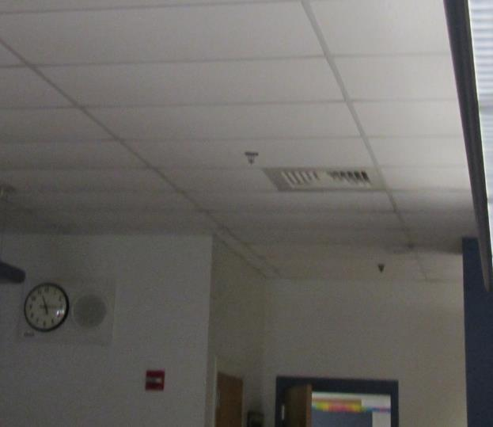

**Typical supply vent**

**Picture 2**

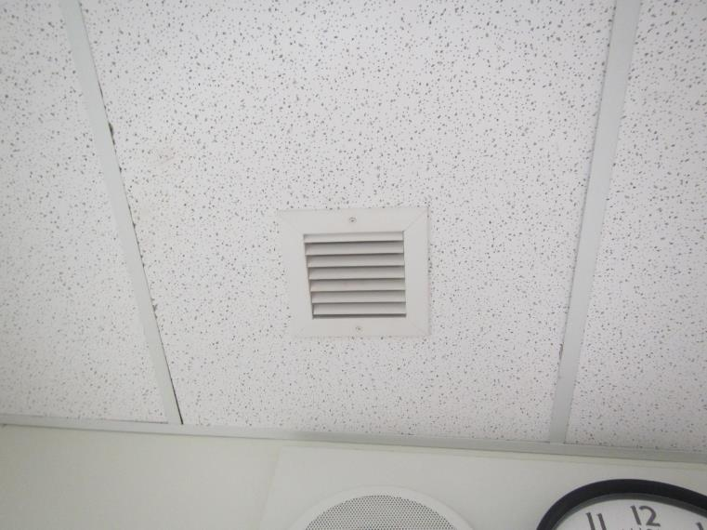

**Exhaust vent in classroom ceiling**

**Picture 3**

Fan coil unit in the corner of the room, the lower vent is a return, the upper is a supply
(note plants in front of unit)


**Fan coil unit in the corner of the room, the lower vent is a return, the upper is a supply**

**(note plants in front of unit)**

**Picture 4**

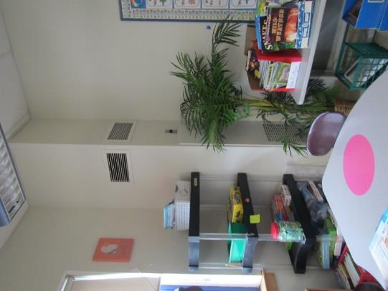

**Plants and furniture blocking FCU vents**

**Picture 5**

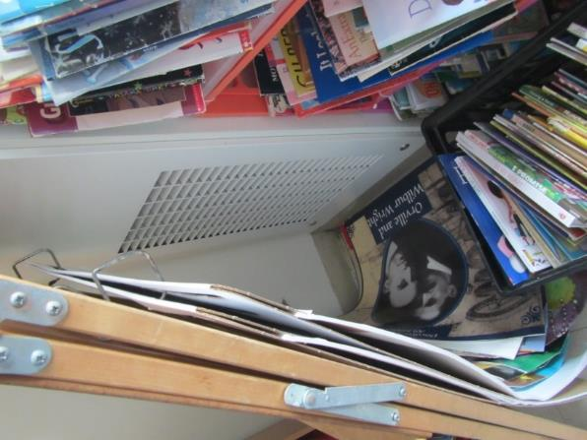

**Items blocking return part of the FCU**

**Picture 6**

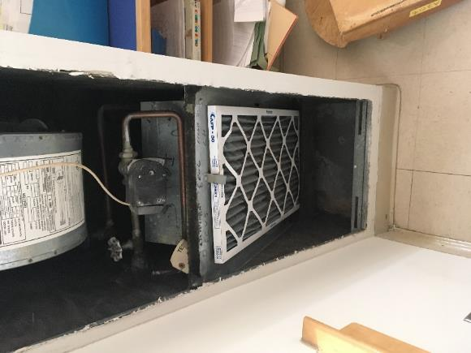

**Filter and bracket (arrow) below heating/cooling coils**

**Picture 7**

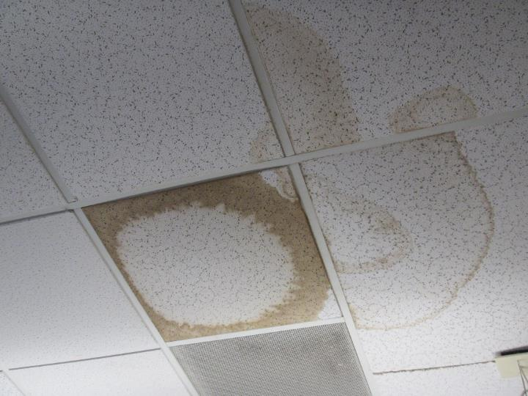

**Water-damaged ceiling tiles in the Media Center**

**Picture 8**

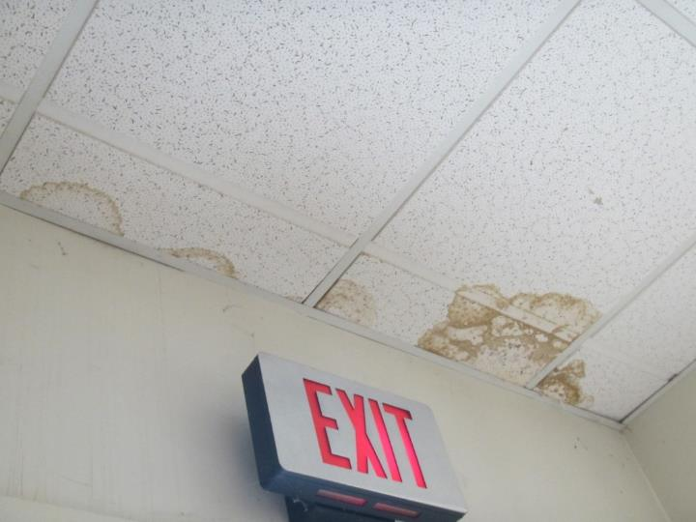

**Water-damaged ceiling tiles near the exterior door in the Media Center**

**Picture 9**

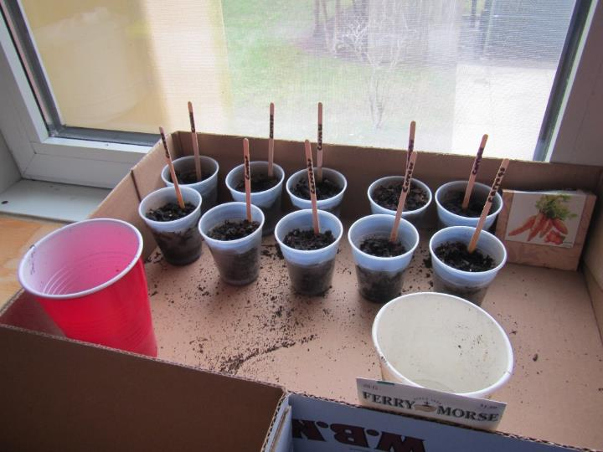

**Plants and soil in a classroom**

**Picture 10**

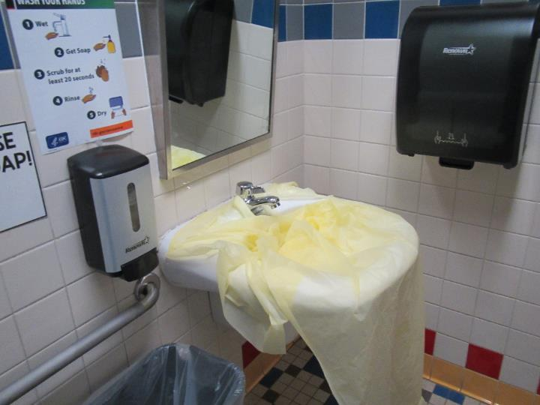

**Sink covered in plastic**

**Picture 11**

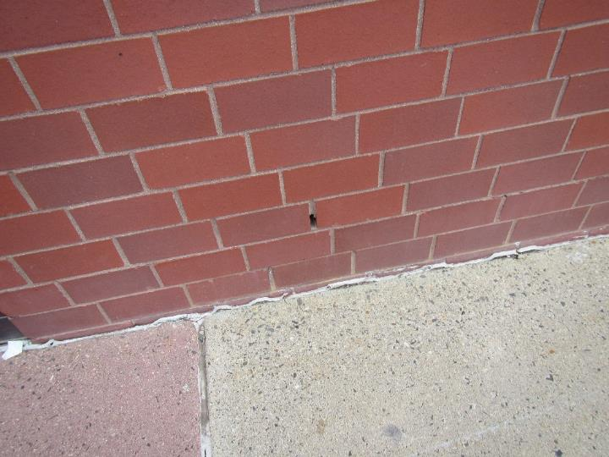

**Weep hole in the brick exterior wall**

**Picture 12**

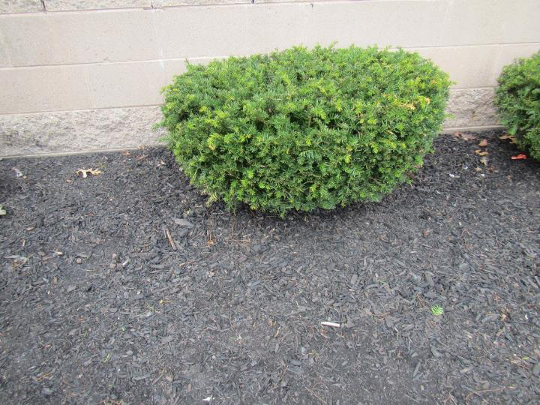

**Bushes and mulch next to the building**

**Picture 13**

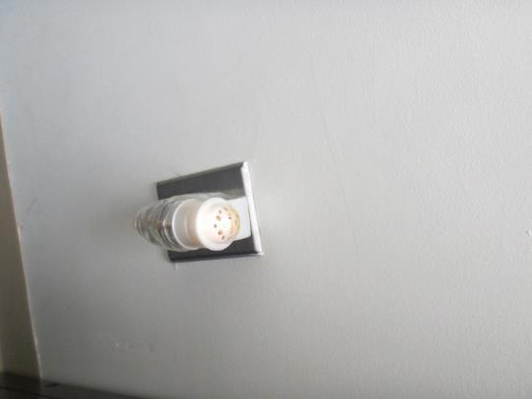

**Plug-in air freshener**

**Picture 14**

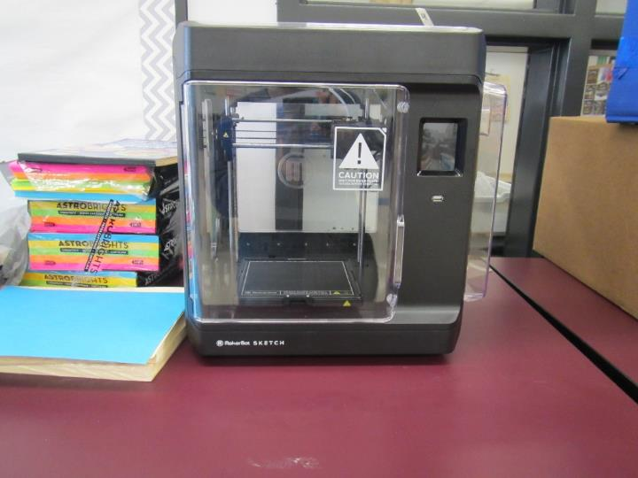

**3-D printer in a technology classroom**

**Picture 15**

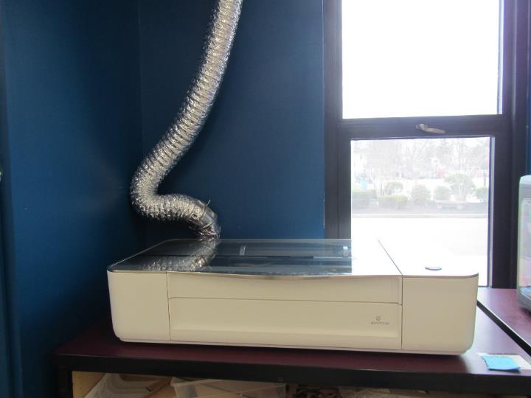

**Laser cutter with exhaust vent to the outside**

**Picture 16**

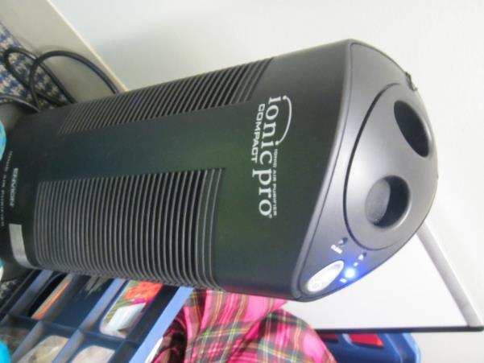

**Air purifier that may produce ozone**

**Picture 17**

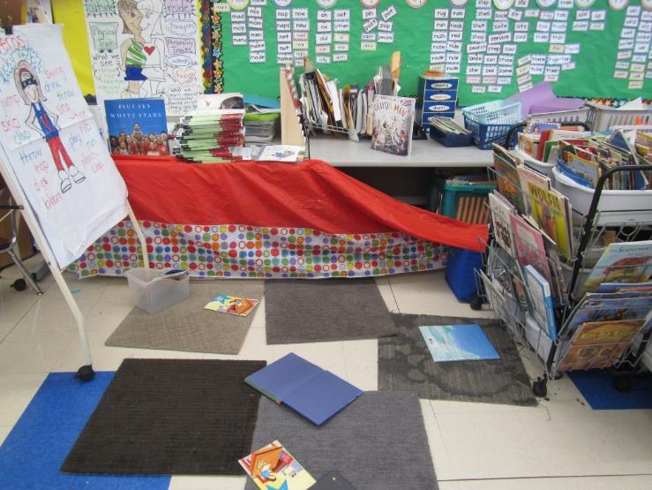

**Items in a classroom**

**Picture 18**

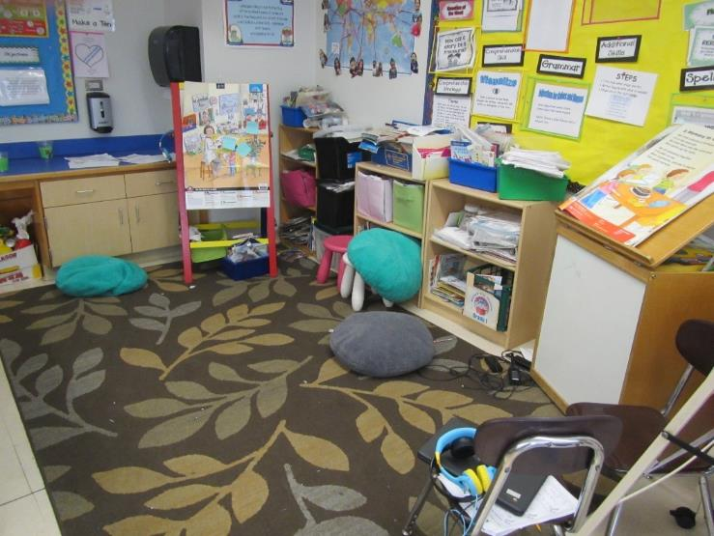

**Items, pillows and area rugs in a classroom**

**Picture 19**

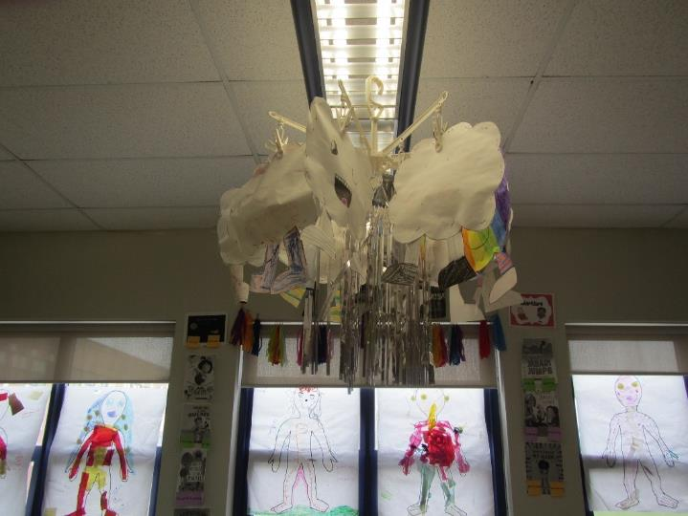

**Items hanging from the ceiling**

**Picture 20**

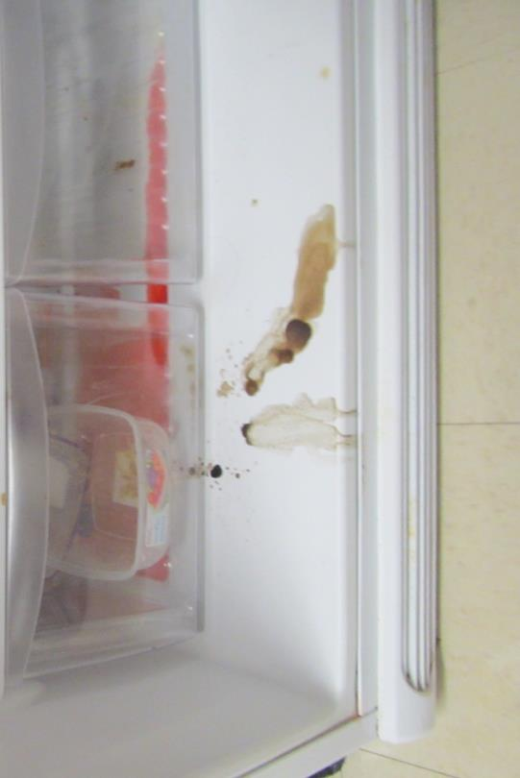

**Spill inside staffroom fridge**

| **Location/ Room** | **Carbon**  **Dioxide**  **(ppm)** | **Carbon Monoxide**  **(ppm)** | **Temp**  **(°F)** | **Relative**  **Humidity**  **(%)** | **PM2.5**  **(µg/m3)** | **Occupants**  **in Room** | **Windows**  **Openable** | **Ventilation** | | **Remarks** |
| --- | --- | --- | --- | --- | --- | --- | --- | --- | --- | --- |
| **Supply** | **Exhaust** |
| Background (outside) | 390 | ND | 51 | 56 | 1 |  |  |  |  | Windy |
| Third Floor | | | | | | | | | | |
| A316 | 829 | ND | 67 | 39 | ND | 1 | Y | Y | Y | Bowed CT, window gasket broken, DEM |
| A318 | 727 | ND | 66 | 40 | ND | 0 | Y | Y | Y | Bowed CT, window gasket broken, DEM |
| A317 | 793 | ND | 69 | 37 | ND | 22 | Y | Y | Y | Bowed CT, window gasket broken, DEM |
| A315 | 614 | ND | 68 | 37 | ND | 1 | Y | Y | Y | Bowed CT, window gasket broken, DEM |
| A314 | 726 | ND | 67 | 39 | ND | 18 | Y | Y | Y | Bowed CT, window gasket broken, DEM |
| A307 | 625 | ND | 67 | 37 | ND | 1 | Y | Y | Y | DEM |
| A313 | 552 | ND | 68 | 36 | ND | 1 | Y | Y | Y | Bowed CT, window gasket broken, DEM.WD-CT, plants |
| A312 | 533 | ND | 68 | 37 | ND | 1 | Y | Y | Y | Bowed CT, DEM |
| A300 | 467 | ND | 64 | 39 | ND | 0 | Y | Y | Y | Bowed CT, window gasket broken, DEM |
| A308 | 516 | ND | 62 | 40 | ND | 1 | Y | Y | Y | Bowed CT, window gasket broken, DEM |
| A313 | 560 | ND | 66 | 38 | ND | 1 | Y | Y | Y | Bowed CT, window gasket broken, DEM |
| A311 | 652 | ND | 67 | 38 | ND | 0 | Y | Y | Y | Bowed CT, window gasket broken, DEM |
| A303 | 525 | ND | 68 | 36 | ND | 9 | Y open | Y | Y | Bowed CT, DEM |
| 5-8 | 531 | ND | 66 | 35 | ND | 1 | N | Y | Y | Bowed CT, window gasket broken, DEM |
| C315 | 614 | ND | 71 | 35 | ND | 0 | Y | Y | Y | Bowed CT, window gasket broken, DEM. 2 missing CT |
| C316 | 1045 | ND | 71 | 40 | ND | 21 | Y | Y off | Y | Bowed CT, window gasket broken, DEM. |
| C313 | 766 | ND | 71 | 36 | ND | 26 | Y | Y | Y | Bowed CT, WD CT, window gasket broken, DEM |
| C312 | 750 | ND | 71 | 36 | ND | 12 | Y | Y | Y | Bowed CT, window gasket broken, DEM |
| C309 | 779 | ND | 71 | 37 | ND | 18 | Y | Y | Y | Bowed CT, window gasket broken, DEM |
| C311 | 921 | ND | 72 | 38 | ND | 26 | Y | Y | Y | Bowed CT, window gasket broken, DEM |
| C306 | 792 | ND | 71 | 37 | ND | 4 | N | Y | Y | Bowed CT, window gasket broken, DEM |
| C304 | 661 | ND | 71 | 36 | ND | 17 | Y | Y | Y | Bowed CT, window gasket broken, DEM |
| Second floor | | | | | | | | | | |
| C214 | 769 | ND | 70 | 35 | ND | 1 | Y | Y | Y on | DEM, CP, plant, fan |
| C215 | 990 | ND | 72 | 39 | ND | 19 | Y | Y | Y blocked | DEM |
| C212 | 839 | ND | 71 | 35 | ND | 0 | 3 open | Y | Y on |  |
| C209 | 767 | ND | 72 | 35 | ND | 0 | 1 open | Y | Y on | Plants |
| C205 | 761 | ND | 72 | 35 | ND | 0 | 4 open | Y | Y | DEM, items hanging from ceiling |
| C204 science | 640 | ND | 71 | 35 | ND | 0 | N | Y | Y off, blocked | Plants, emergency shower, sink, DEM |
| Gym | 501 | ND | 69 | 34 | ND | 0 | Y | Y | Y | A few gym mats |
| A203 | 516 | ND | 69 | 35 | ND | 0 | Y | Y | Y on, blocked | Area rug, microwave, refrigerator, perfume odor, DEM |
| A215 | 692 | ND | 69 | 35 | ND | 0 | Y | Y on | Y on | Area rug, plants, sink backsplash open |
| A217 | 1116 | ND | 69 | 41 | ND | 24 | Y | Y on | Y on | Plants, area rug |
| A216 | 964 | ND | 68 | 40 | ND | 25 | Y some blocked | Y on | Y on blocked | Area rug, sink backsplash open, DEM, DO |
| A218 | 1094 | ND | 68 | 39 | ND | 23 | Y | Y | Y | Area rug, pencil shavings |
| OT/PT | 445 | ND | 68 | 35 | ND | 0 | Y | Y | Y | Mats and other rubber items, plants |
| C216 | 1057 | ND | 71 | 42 | ND | 24 | Y | Y | Y | Hole in CT |
| C213 | 1106 | ND | 73 | 40 | ND | 24 | Y | Y | Y | Hole in CT |
| C211 | 902 | ND | 72 | 38 | ND | 15 | Y | Y | Y | Clutter by vent |
| B244- Breakroom | 570 | ND | 70 | 36 | ND | 0 | N/A | Y | Y | Backsplash open, multiple PCs and laminator, dust on vents |
| Auditorium | 658 | ND | 69 | 37 | ND | 0 | N/A | Y | Y | Carpet, upholstered chairs |
| A211 | 497 | ND | 68 | 37 | ND | 0 | Y | Y | Y | Backsplash open, clutter, throw rugs |
| A212 | 494 | ND | 67 | 37 | ND | 0 | Y | Y | Y | Soft chairs, blocked vent, clutter |
| A214 | 933 | ND | 68 | 41 | ND | 22 | Y | Y | Y | Backsplash open, vent blocked, throw rugs, snacks |
| A213 | 452 | ND | 67 | 37 | ND | 8 | Y | Y | Y | Cleaning supplies, backsplash open, blocked vent |
| A205 | 503 | ND | 69 | 36 | ND | 1 | Y | Y | Y | Vent blocked, mini fridge, microwave |
| First Floor | | | | | | | | | | |
| A138 Kinder | 963 | ND | 68 | 38 | ND | 15 | Y | Y | Y off | Clutter, area rugs, items under sink, sink backsplash open, food, has attached restroom with exhaust vent, sink leaks |
| A143 | 969 | ND | 67 | 38 | ND | 15 | Y | Y on | Y blocked | Area rugs, DEM, has attached restroom with exhaust vent, restroom sink covered in plastic (out of order?) |
| A136 | 893 | ND | 68 | 38 | ND | 20 | Y | Y off | Y off | Area rugs, CP in restroom, clutter, sink leaks and backsplash open |
| A144 | 707 | ND | 67 | 37 | ND | 4 | N | Y dusty, on | Y | Area rug, plants, DEM |
| A125 | 745 | ND | 67 | 39 | ND | 1 | N | Y | Y | DEM |
| A129 | 602 | ND | 67 | 37 | ND | 0 | Y | Y | Y | Sink backsplash open, DEM, PC, plant |
| A128 | 750 | ND | 69 | 37 | ND | 11 | Y | Y | Y on | CT bowed and dusty, sink backsplash open |
| A127 | 676 | ND | 69 | 36 | ND | 1 | N | Y | Y | Plug-in air freshener, carpet,  “ionic pro” air purifier |
| Nurse | 710 | ND | 68 | 37 | ND | 5 | N | Y | Y |  |
| Nurse interior office | 701 | ND | 69 | 37 | ND | 2 | Y | Y | Y | Air purifier |
| A111 | 716 | ND | 68 | 37 | ND | 0 | N | Y | Y | PC, DEM, basketballs |
| Media center main | 617 | ND | 68 | 35 | ND | 2 | N | Y | Y | 9 WD CT, carpet |
| Media Center stacks area | 517 | ND | 69 | 34 | ND | 3 | N | Y | Y | Door to outside, door is deteriorated |
| B105 kitchen | 662 | ND | 69 | 36 | ND | 1 | Y | Y | Y | 2 WD CT, spill in fridge, PC, sink backsplash open, other appliances present |
| C101 | 698 | ND | 69 | 36 | ND | 6 | Y | Y | Y, on blocked | Area rugs, sink backsplash open, salt amp, 2 WD CT |
| C106 tech | 794 | ND | 71 | 35 | ND | 0 | Y | Y | Y on | Area rug, DEM, 3-D printer, DO |
| C108 tech | 731 | ND | 70 | 34 | 1 | 1 | Y | Y | Y on blocked | 3 3-D printers, laser cutter (with exhaust), area rugs |
| C112 | 816 | ND | 70 | 35 | 1 | 3 | Y | Y | Y | DEM, “ionic pro” air purifier, area rug, clutter |
| C111 | 795 | ND | 71 | 36 | ND | 2 | Y | Y | Y | Area rug, DEM, sink backsplash open, 2 WD CT, debris on floor |
| C115 | 791 | ND | 70 | 35 | ND | 7 | Y | Y | Y off | Area rug, DEM |
| A123 Office | 639 | ND | 68 | 37 | ND | 0 | NA | Y | Y | Carpet, clutter on floor |
| A122 Office | 825 | ND | 67 | 40 | ND | 1 | NA | Y | Y | Carpet |
| Cafeteria | 715 | ND | 68 | 39 | ND | 60 | N | Y | Y |  |
| C103 | 816 | ND | 70 | 38 | ND | 9 | Y | Y | Y | WD CT |
| C105 | 632 | ND | 71 | 35 | ND | 0 | Y | Y | Y | WD CT |
| C107 | 710 | ND | 71 | 36 | ND | 1 | Y | Y | Y | Sink backsplash open, clutter, WD CTs |