 | Commonwealth of Massachusetts  City/Town of  Local Upgrade Approval  Form 9B
DEP has provided this form for use by local Boards of Health if they choose to do so.

The Local Upgrade Approval is to be completed by the local Board of Health and a signed copy provided to the system owner.
 | A. Facility Information
Important: When filling out forms on the computer, use only the tab key to move your cursor - do not use the return key.  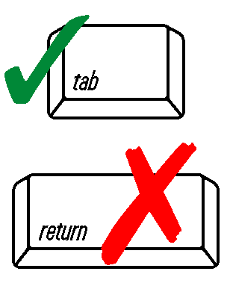 | 1. Facility Name and Address
 | Name
 | Street Address
 | City/Town |  |  | State |  |  |  | Zip Code
 | 2. Owner Name and Address (if different from above):
 | Name |  |  | Street Address
 | City/Town |  |  | State
 | Zip Code |  |  | Telephone Number
 | 3. Type of Facility (check all that apply):
 | Residential Institutional Commercial School
 | 4. Design flow per 310 CMR 15.203: |  | gpd
 | 5. System Designer: |  | Name |  |  | PE RS
 | Address | City/Town |  |  | State, ZIP
 | B. Approval
 | 1. Local Upgrade Approval is granted for:
 | Reduction in setback(s) – specify:
 | Reduction in SAS area of up to 25%: |  |  | SAS size, sq. ft. |  |  | % reduction
 | B. Approval (continued)
 | Reduction in separation between the SAS and high groundwater:
 | Separation reduction |  |  | ft.
 | Percolation rate |  |  | min./inch
 | Depth to groundwater |  |  | ft.
 | Relocation of water supply well (explain):
 | Reduction of 12-inch separation between inlet and outlet tees and high groundwater
 | Use of only one deep hole in proposed disposal area
 | Use of a sieve analysis as a substitute for a perc test
 | List local variances granted:
 | Approving Authority
 | Print or Type Name and Title | Signature |  |  | Date

