**Appendix A: Emissions and Dispersion Modeling**

# INTRODUCTION

## BACKGROUND ON AIR DISPERSION MODELING for Logan airport health study

### INTRODUCTION

The lack of environmental exposure data for Logan Airport Health Study (LAHS) required the use of surrogates for the initial exposure classification in the sampling design of the health survey. Air dispersion modeling was subsequently performed to quantify the ambient air pollution concentrations in the study area and improve the exposure classification for the health outcome data analysis. The purpose of the dispersion modeling analysis for the LAHS was to supplement the exposure assessments with estimations of the ambient air quality impacts associated with emissions from sources operating at Logan Airport in 2005. The ambient air pollution concentrations associated with operations at the airport obtained from the air dispersion modeling analysis was used to geographically stratify the study area into distinct exposure areas. This information was then used to evaluate the association between environmental exposures arising from airport operations and targeted health outcomes among the study population.

The air dispersion modeling analysis was based upon modeling the air emissions of all the important sources of pollutants at the Logan Airport. Using meteorological data that are representative of air flows in the study area as inputs to an appropriate dispersion model the analysis provides estimates of ambient air quality concentrations throughout the study area. A protocol for the modeling effort was prepared by Dr. Bruce Egan of Egan Environmental Inc. with the assistance of MDPH/BEH. The following people provided technical assistance on the modeling effort: Massport contractors: Mike Kenny of KB Environmental Science, and Robert Metzer of HMMH; Ralph Ionvinelli of the US FAA, and US FAA contractors at CSSI, Inc. including Clifford Hall, Philip Soucacos, Kojoe Yirenkyi, and Alex Nguyen.

This appendix describes background information on the dispersion model used in the analysis, input data to the model, and results of the dispersion modeling analysis. In addition, the results of different sensitivity model runs that reveal how the predicted concentrations depend upon different model inputs are also provided.

### US FAA’s Emissions and Dispersion Modeling System (EDMS)

Emissions from airport operations[1] are primarily from combustion of aviation fuel from aircraft and combustion of diesel fuel or gasoline from mobile source emissions (e.g., motor vehicle fleets, ground service equipment, and auxiliary power units, APUs). In addition, Logan Airport has its own oil-fired power plant. In all of these cases, exhaust from fossil-fuel combustion contains a complex mixture of oxides of nitrogen (NOx), sulfur dioxide (SO2), volatile organic compounds (VOCs), carbon monoxide (CO), carbon dioxide (CO2), and particulate matter (PM10, PM2.5, ultrafine particles – collectively referred to as PM) (U.S. EPA, 2007). Numerous speciated VOCs, including hazardous air pollutants, are emitted from these sources including acetylene, aldehydes (e.g., formaldehyde, acetaldehyde), butane, pentane, propane, toluene and benzene. Fuel vapors and aerosols are also emitted during aircraft refueling, mobile source refueling, and from fuel storage tanks located on the grounds of the airport (Zhou et al., 2009).

Mathematical simulations of atmospheric transport and dispersion phenomena provide a methodology to relate emissions and meteorological information to estimates of ambient air quality concentration impacts. Dispersion modeling is a mandatory component of the permitting process for new or modified sources required under the New Source Review regulations of the Clean Air Act. For this reason US EPA allocates considerable resources to advancing atmospheric dispersion models and in updating their Guideline on Air Quality Modeling.

The US Federal Aviation Administration (US FAA) developed and maintains the Emissions and Dispersion Modeling System (EDMS) for permitting and evaluation purposes of air pollutant emissions and atmospheric dispersion at airports. With an early focus on emissions modeling, the EDMS has unique and extensive capabilities of simulating emissions of aircraft engines for operating modes of takeoff, landings, taxiing, and emissions while at a terminal. From a modeling system standpoint it is appropriate to envision EDMS as having two key components -a standalone emissions model coupled to the US EPA approved atmospheric dispersion model, AERMOD. Massport uses the emission inventory module to quantify and report emissions from operations at Logan Airport. These are reported in Massport’s annual Environmental Data Report (EDR).

When the LAHS began, the choice of the most appropriate dispersion model was uncertain. US EPA was in a transition mode with respect to replacing the long standing guideline model, the Industrial Source Complex Model Version 3 (ISCST3) with a newly developed model, AERMOD, which showed considerable performance improvements in dispersion modeling capabilities. Massport had been using ISC in different studies at Logan Airport. However, the choice of dispersion models narrowed after the US EPA moved to replace the ISCST3 model with AERMOD model for regulatory applications. In 2006, the US EPA promulgated the AMS/EPA Regulatory Model Improvement Committee Model, “AERMOD” as the recommended atmospheric dispersion model for calculating air quality impacts within 50 km of sources. This model replaced a series of different models that were required for applications to sources in both simple and complex terrain settings.

AERMOD is an advanced Gaussian plume type model with improvements primarily in the parameterization of how winds speeds and turbulent mixing rates vary as a function of height above the ground surface. The US FAA simultaneously made several major upgrades to EDMS including changing the dispersion model to AERMOD in 2006.

EDMS has undergone five revisions since the LAHS began that have improved upon the aircraft fleet database and upon the emissions simulation algorithms. The most recent version (EDMS 5.1.3) also includes updated engine emission parameters for hundreds of different aircrafts and engine combinations, alternative ground support equipment types, and auxiliary power units and the most recent version of US EPA’s AERMOD. The details and documentation of the EDMS model are provided in US FAA documents: a User’s Manual and Appendices[2] (EDMS, 2010).

# INPUTS TO AERMOD

## AIRPORT LAYOUT

### AIRSIDE NETWORK LAYOUT

MAPPING OF AIRPORT

AERMOD requires the detailed locations of all runways, taxiways, and terminals so that the spatial allocation of all aircraft emissions can be included. EDMS provides detail maps (Airport View) of every airport in the US. The maps provide geographically accurate representations of building, runways, taxiways, stationary sources, and roadways. Labels associated with specific data that are entered into EDMS are displayed on the map.

GATE ASSIGNMENT

Gate assignments for terminals for 2005 were provided by Massport.

ROADWAYS

Roadway files were provided by Massport and their consultant, VHB, Inc. The files contain the roadway segments (links) in and around the airport, along with their traffic counts and emission factors. VHB Inc. provided MDPH/BEH with a map and assistance with the roadway configuration. Review of this information resulted in modification of the roadway configuration to coincide with conditions in 2005. Additional information is provided in Attachment 1.

TAXIPATHS

A total of 1108 taxipaths were developed to identify and model aircraft movement along taxiways that aircraft take from each terminal gate to each runway for takeoffs and from runway to terminal gate for landings. Although aircraft are not required to adhere to specific routes during taxiing, the taxipaths created were based on the most direct route aircraft can take to and from the terminal.

## MODELING DOMAIN AND TOPOGRAPHIC FEATURES

The LAHS study area was defined by the authorizing legislation as the area within 5 miles of Logan Airport. This was interpreted as the area extending 5 statute miles beyond the Airport perimeter. All communities that intersected the 5-mile radius were included in the modeling domain.

Logan Airport sits on land that was originally Governor’s Island and Bird Island Flats in Boston Harbor. It has an average height of about 20 feet above sea level. It is immediately surrounded on three sides by portions of Boston Harbor. Clockwise from the north to the southeast is a protected bay that extends from the shores of East Boston, Winthrop, and Deer Island. A part of the main shipping channel of Boston Harbor runs along the southern shore of the airport. To the southwest and west is Boston Inner Harbor. Further to the west is downtown Boston. To the northwest through the north is East Boston comprised of relatively low buildings and then Chelsea across portions of the Mystic River.

The topography of the LAHS area is relatively flat. A radial array (Figure A-1) was used for establishing the receptors for predicting emissions concentrations at 10 degree intervals. The array extends out to a radius of up to 12 miles from the airport center in order to include all communities involved in the LAHS health survey so that all communities that are intersect the 5-mile radius are included in the modeling domain. Note that the center of the coordinate system for the radial array of receptors was chosen to be the official aeronautical center of the airport with the aim of evaluating the impact of the airport out to a distance of five miles from the airport boundary.

This extension of the modeling domain allows graphical interpolation of model calculations at the 5 mile extent of the study area. The array of rings of receptor locations were located at radial distances of 1, 1.25, 1.5, 1.75, 2, 2.25, 2.5,2.75, 3, 3.25, 3.5, 3.75, 4, 5, 6, 8, 10, and 12 miles from the airport center. These receptors were assigned elevations of 1.8 meters above the ground surface and have base elevations set at 5.59 meters above sea level. An additional 27 receptors were placed at the aeronautical center point of Logan Airport, the Logan Statue and at other specific landmarks or easily identifiable locations in the LAHS area (see Table A-1).

## POLLUTANTS OF CONCERN

For the LAHS study, the MADPH is primarily concerned with emissions of Particulate Matter (PM2.5), Nitrogen dioxide (NO2), and Sulfur dioxide (SO2). The modeling effort also included carbon monoxide (CO) and volatile organic compounds (VOCs) emissions. To be consistent with Massport emission inventory methods, measurements of PM2.5 from aircraft engines indicated that most of the particles are less than 10 microns in diameter (PM10), it is assumed for this analysis that they are all classifiable as PM2.5. Similarly, for the purposes of this analysis, PM2.5 emissions from other non-aircraft sources are primarily combustion emissions and classified at PM2.5. Thus, in the absence of additional information, for modeling purposes, the emission rates for PM10 and PM2.5 are generally assumed to be same and are identified in this report as PM2.5.

Averaging times for the dispersion model simulations are associated with the National Ambient Air Quality Standards (NAAQS) with annual averages for SO2, NO2, and PM2.5; additional daily averages for SO2, PM2.5; and hourly averages for CO, SO2 and NO2. SO2 and NO2 have been modeled as SOx and NOx, respectively to be consistent with the emissions inventory data.

## EMISSION SOURCES

### MASSPORT EMISSIONS INVENTORY

The air pollutant sources considered in the LAHS are those associated with the routine operations at Logan Airport. These include all aircraft approaching and departing in the air, landings and takeoffs, aircraft movements on the runways ,taxiways , and areas near the terminals, aircraft ground support equipment (GSE) that is needed at the terminal to load or handle arriving or departing aircraft, and auxiliary power units (APUs ) at the terminals used to energize aircraft at the terminals. The emissions data also includes motor vehicle traffic on the Logan Airport property, emissions from vehicles in the parking garages and emissions from stationary sources including Massport‘s power boilers that provide power or steam to the airport. The Central Heating Plant with stacks 115 feet tall has the highest release points. All other sources have been assigned release heights appropriate for their activities. Massport provided their emissions inventory data for all the above activities for 2005.

Table A-2 summarizes the 2005 annual emissions by Massport source category. Aircraft emissions contribute by far the largest portion and account for about 71% of the NOx, 47% of the PM2.5, and 49% of the SOx. Ground support equipment is the next largest contributor to both NOx and PM2.5, and the third largest contributor to SOx. The stationary sources are the third largest source of PM2.5 at 17% and the second largest contributor to SOx. Each of the other categories contributes less than 15% of the totals.

The Massport emissions inventory data as calculated by EDMS includes emission rate input data for use with EDMS for aircraft on a-per unit of fuel burned basis for the following pollutants: SOx, NOx, CO, PM2.5, total Hydrocarbons, Non methane Hydrocarbons and Hydrocarbons. Therefore the inventory is keyed to aircraft types.

In order to perform the dispersion modeling, information on the timing and locations of emissions at Logan Airport is required. Massport provided their flight operations data base for that purpose. This data includes the exact time of every aircraft arrival and every departure by runway that were included in the Base year 2005 run (See description below for more details).

### AIRCRAFT ACTIVITY

AIRCRAFT OPERATIONS AND SCHEDULE

Aircraft operations account for the largest fraction of total emissions at Logan Airport. EDMS provides detailed emissions rate calculations for each source category but aircraft emissions and motions during approach and departure modes have been an area of advanced algorithm development by the US FAA. EDMS simulates the approach pathway of an airborne air craft as a series of elevated area sources of different elevations above the ground surface. Once the aircraft has touched down, the remaining travel along the runway and taxiways back to the terminal are modeled as ground surface area sources. Similarly, the emissions during departures are simulated as ground level releases from area sources representing the travel on taxiway routes from the terminal to the departure runway and then along the runway until the aircraft is airborne. Once airborne, EDMS estimates the emissions along the trajectory in the climb out stage in detail up to 3000 feet. These calculations for each of the travel modes include all the relevant information about the engine types, the number of engines, aircraft type, and emission factors for the specific engines by pollutant as well as emission rates during engine warm-up periods.

Figure A-2 shows an example of the flight log by time of day of the 357282 flights that were included in the raw database provided by Massport of individual aircraft operations for 2005 at Logan Airport. Analysis of the raw data provided operations data on the identification of the carrier and aircraft type, exact arrival and departure date and time, and runway used, for 356,566 flights at Logan Airport in 2005. The other aircraft operations were missing key data including unidentifiable ICAO aircraft codes which precluded use in the schedule. To maximize the number of aircraft operations for EDMS modeling of Base year 2005 for those aircraft operations that were not in the EDMS database, MDPH/BEH substituted other similar aircraft in aircraft database EDMS 5.1.3. This is primarily for GA aircraft that are typically grouped together in noise and air quality modeling analysis. Table A-3 lists the substitutions made for the Base year 2005.

The “schedule” file includes all of the flights that were modeled in the noise analysis. For the emissions inventory and noise modeling for Massport’s annual EDRs, each flight record has an operation count that has been scaled based on the counts by airline provided to us from the Massport Revenue office and when summed equals the reported operations at Logan Airport for that year. The noise and air quality operations reported in Massport’s EDR are based on the same scaled operations by airline that HMMH develops from the revenue data.

Air dispersion modeling requires the allocation of aircraft according to their spatial and operational patterns associated with takeoffs, taxiing and departures. Thus, information on the identification of the aircraft, operator, date/time of departure/landing, and runway is necessary. Of the total number of aircraft operations reported in the 2005 EDR of 409066 the air dispersion modeling analysis incorporated information for 356566 operations. Thus, a total of 356,566 flights were modeled for the Base year 2005. Differences in the emissions inventory from EDMS and reported by Massport may be due in part to the differences in aircraft operations used in the air dispersion modeling analysis for the Logan Airport Health Study. Figure A-3 shows the temporal flights distributed by quarter hour, hour, day of the week, and by month in 2005. The frequency of occurrence of flights provides the statistical data used to characterize emissions by each of these time or location events for all source categories in EDMS. In other words, the distributions used to parameterize emissions from the other sources (e.g., roadways and parking facilities) at Logan Airport were keyed to airport operations.

CONFIGURATIONS

Airports operate under different configurations or patterns of aircraft arrivals and departures on specific runways. These configurations change over the course of a year depending on the weather, capacity, and noise abatement plans although the primary determinant of which runway will be used by a departing or arriving aircraft is wind direction. Flavio Leo of Massport provided the most common configurations used at Logan Airport for input to EDMS. EDMS uses defined Configurations to dynamically assign aircraft to different runways at run-time based upon weather conditions, time of day, and aircraft weight category.

TAXI TIMES AND SEQUENCE MODELING

According the EDMS User’s Guide, EDMS contains a Sequencing Model to perform simulations to dynamically determine spatial taxing information. The Sequencing model simulated the movement of aircraft along the taxiways (as prescribed by the taxipaths described above) between the runways and gates for both arriving and departing aircraft. Modeling of taxi queuing is provided for departing flights but not arriving aircraft, which are assumed to have unimpeded taxiing to their gate. The departure aircraft are sequenced in the proper order to provide the duration that each aircraft spends on each taxiway segment. EDMS predicts delays are by determining airport capacity based on the runway configuration (see Configuration in Attachment 1) that is combined with the hourly meteorological information to determine the associated airport capacity at each hour of the year. The airport capacity information and the information from the schedule are then processed by a delay model to determine the airport throughput of aircraft. EDMS then adjusts that estimated gate push-back time (for departures) and estimated touchdown time (for arrivals) into actual times that are possibly delayed. Based on this information, the departure aircraft form queues along the taxiways that feed into the corresponding runways.

GROUND SERVICE EQUIPMENT (GSE) AND AUXILIARY POWER UNITS (API)

GSE assignments were provided by the EDMS model. Gate assignments for each airline that would include the GSE assignments were provided by Massport for 2005.

AUXILIARY POWER UNITS

Auxiliary Power Units (APUs) are on-board generators that provide electric power to the aircraft while its engines are shut down. EDMS adapted US EPA’s emissions inventory methods to calculate the emissions generated from APUs per Landing-Take-Off (LTO) cycle and are reported together with aircraft emissions.

### MOTOR VEHICLE EMISSIONS

Motor vehicle emissions were provided by Massport as part of the emissions inventory. See Attachment 1 for more details. Roadway files were provided by Massport and their consultant, VSB, Inc. The files contained the roadway segments (links) in and around the airport, their traffic counts and emission factors. A map was provided by VHB Inc., showing the roadway configuration. VHB Inc. provided MDPH/BEH with a map and assistance with the roadway configuration. Review of this information resulted in modification of the roadway configuration to coincide with conditions in 2005.

### STATIONARY SOURCES

As discussed above, in addition to aircraft, GSE, and APU emissions incorporated in the dispersion modeling analysis are emissions for a wide range of additional related source categories. These include spray paint booth, runway deicing operations, cooling tower emissions, fuel tank emissions, combustion equipment emissions (boilers, generators, burners), refueling emissions (jet fuel, diesel, aviation gasoline, distillate fuel #2 and #6, automobile gasoline, natural gas), and tank emissions. Additional information is provided in Attachment 1.

### TRAINING FIRES

Emissions data associated with training fires were provided by Massport. Two training fires were modeled for 2005: one that burned 8105 gallons of TekFlame and the other that burned 550 gallons of JP-8. It is assumed that the fire training occurred at the Fire Training Facility. See Attachment 1 for more details.

## METEOROLOGICAL INPUT DATA

US EPA applications using AERMOD often rely upon the use of meteorological data from a nearby representative airport. The ideal meteorological data for an air quality study involving Logan Airport are the measurements from the National Weather Service (NWS) Automated Surface Observation Station (ASOS) at Logan Airport. AERMOD requires both surface and upper air meteorological data inputs. The NWS ASOS at Logan Airport is located south of taxiway C and east of Runway 4-22 and about 2000 feet east of the structures of terminals B and C and more than half mile from any of the airport coastal boundaries. This is a fortuitous location for the surface data needed for the LAHS modeling effort as it represents the locations of the most important category of emissions required for the study. The ASOS anemometer height is 26 feet above the ground surface. The surface data includes wind speed and direction, temperature, dew point and cloud cover.[3]

The upper air observations are from the NWS station in Chatham, MA. Upper air soundings are taken two times per day and are required for the estimation of mixing depths. Historic meteorological data was obtained from the National Weather Service (NWS) for the years 2003-2007. Annual wind roses for all these years are shown in Figure A-4 to Figure A-8. The wind roses provide a comparison of the frequencies of wind directions and speeds with those of the 2005 study year. Although there is significant year to year variability, the wind roses show similar patterns of the frequent occurrences of winds from the west through the northwest and a second high frequency of winds from the southwest and south southwest. Winds from the south southeast are consistently the least frequent. Overall the winds in all years are more likely to have a component from the west than a component from the east. The percentage of calm winds is also consistently low (3.1% for 2005 and in the range of 2.8% to 4.1% for the other years).

Meteorological input data for AERMOD is provided by a pre-processor program, AERMET, which transforms the raw NWS meteorological data into the needed formats to run AERMOD. As described below, AERMET utilizes land use data from the preprocessor program AERSURFACE to develop the wind and temperature profiles needed for AERMOD.

### SURFACE CHARACTERISTICS

AERMOD calculates the diffusion rates and wind speed profiles using algorithms based upon an advanced understanding of air flow in the surface boundary layer and upon how the flow and the turbulent diffusion rates are dependent upon three specific parameters that characterize the ground or water surface. These parameters are the surface roughness (roughness length), the surface reflectivity of incoming solar radiation (albedo) and a measure of the importance of surface moisture in the transfer of heat to the air above the surface (Bowen ratio). The values of these parameters are obtained from land use data using a program, AERSURFACE. US EPA ‘s AERSURFACE program uses USGS land use data through an interactive program to calculate average values of these three surface characteristic parameters based on latitude and longitude and estimates about seasonal vegetation and snow cover. The surface characteristics values are input into the AERMET meteorological preprocessor to determine the dispersion rates in the atmospheric boundary layer. The estimation of each of the surface characteristic inputs is described in detail in the AERMET User’s Guide (AERMET 2004) and briefly discussed further below.

### SURFACE ROUGHNESS LENGTH

The roughness length relates to the size of obstacles on the earth’s surface that slow the air flow very near to the surface and that affect the variation of wind speed with height above the ground surface. The increase of wind speed with height in the surface layer is generally depicted as logarithmic. Assuming a logarithmic profile, the roughness length zo, is mathematically defined as the height above the surface where the horizontal wind speed is calculated to be zero.

For example, for neutral atmospheric conditions, the wind speed at any height, z, is calculated using the ASOS measured wind speed, Uref, and the formula U(z) =Uref * Ln (z/zo) /Ln (zref/zo), where zref is the anemometer height.

The AERMET User’s Guide (AERMET, 2004) provides a range of values for different terrain descriptions. The primary role of the roughness length in AERMOD is used to extrapolate the wind speeds measured at the anemometer height at the Logan Airport ASOS to winds at higher and lower elevations above the ground. Emissions from airborne aircraft approaching or departing Logan Airport, and the emission from the power plant are at release heights above the ASOS anemometer height. Most of the other emissions associated with the airport’s operations, occur from near ground level. The wind speeds that are used in the modeling act to initially dilute these emissions are the speeds measured at the anemometer and interpolated from the anemometer height to estimate the value at the height of release. Because the release height of the lower level emissions are near or below the anemometer height, the above equation indicates that for these emissions, the extrapolation of the anemometer wind speeds to the release heights is not especially important to the calculation of the initial dilution effect on downwind concentrations. For elevated releases, however, there is a greater dependence on the wind speeds calculated at the release height and therefore on the roughness length values.

Current US EPA guidance is to estimate and utilize the surface roughness for the area within a 1 kilometer (km) radius of the meteorological tower. This radius is thought to be sufficient to establish a quasi-steady state of turbulence levels at an anemometer height of 10 meters or less for even the most stable boundary layers. If a steady state is assumed then the turbulence intensity can be determined simply from the measured value of the wind speed at the anemometer height and the assumed value of the surface roughness. The user has an option of calculating z0 for up to 12 different 30 degree upwind sectors or for a single, all-encompassing 360 degree sector.

### ALBEDO

The albedo is defined as the ratio of the amount of the incoming solar radiation that is reflected by the surface back to outer space. Albedo enters into the calculation of net heat flux from the surface. Surfaces with a low albedo absorb more solar energy. The AERMET User’s Guide provides US EPA’s estimated values of the noontime albedo for different surfaces. The values range from 0.1 for thick, deciduous forests to 0.9 for fresh snow cover. In AERMOD, the values are modified to consider sun angle as a function of time of day and season.

### BOWEN RATIO

The Bowen ratio is a measure of the relative importance of the sensible heat flux from the surface compared to the latent heat of evaporation from the surface. It is higher for surfaces with lower moisture contents. The values range from 0.1 over water bodies to about 10 over desert surfaces. The AERMET User’s Guide displays US EPA’s recommended midday values. The values of Bowen ratio and reflectivity have a seasonal dependence on ground cover (e.g. snow, vegetation).

Sensitivity studies performed by the US EPA show that the predicted concentrations are most sensitive to the values of the roughness length and less sensitive to the values of albedo and the Bowen ratio input to AERMOD. US EPA developed a preprocessing program, AERSURFACE, (US EPA, January 2008) that generates the above parameters from land use data directly. US EPA also recommends preferred weighting schemes to use with land use data for the specification of the three surface parameters. US EPA recommends that a 1 to 5 km radius be used for the determination of the roughness length, with a recommended default value of 1.0 kilometer. They specify that no more than 12 wind direction sectors be used - each having a width no smaller than 30 degrees for these determinations and that an inverse-distance weighted geometric mean be used.

For the reflectivity and the Bowen ratio, US EPA recommends that a default domain of 10 km by 10 km be used and that simple unweighted average values be calculated. We note that in terms of surface parameters, the interactive EDMS model as supplied by the FAA has an important limitation with respect to the use of surface data. It allows only as single value of the surface roughness length to be input for the entire study area. This limitation affects the concentrations predicted for different wind directions if the surface roughness varies for different upwind fetch wind directions. The interactive nature of the program version also does not require information on the local Bowen ratio or the albedo, as single default values are built into the code. To input values for the surface roughness as a function of wind direction fetch, and to use local data on albedo or Bowen ratio , we needed to generate separate input files with AERMET to be imported into EDMS for use with AERMOD.

### SUMMARY OF INPUT TO AERMOD

AERMOD was run with wind direction dependent values of the roughness length for each 30 degree sector within a 1 km radius of the ASOS tower. In accordance with US EPA guidance a single value of the Bowen ratio and the Albedo was calculated with AERSURFACE for a 10 km square centered on the airport. These values of the surface parameters were applied to the entire modeling domain and provided in Table A-4. The effect of buildings as obstructions to the flow and in enhancing the roughness length can be seen for the upwind directions to the west and northwest of the airport. The smallest roughness lengths are associated with over- the- water fetches from the east northeast and from the southeast.

# MODELING RUNS

A total of 8 modeling runs were conducted for the LAHS:

* 2005 emissions inventory with 2005 meteorological data as the Base year 2005 for refining exposure areas in the data analysis of health survey data
* 2005 emissions inventory with 2003, 2004, 2006, and 2007 meteorological data for sensitivity analysis
* 2005 emissions inventory with three alternative values for surface roughness

# QUALITY ASSURANCE OF AIR DISPERSION MODELING RESULTS

Quality assurance of input and output data associated with the air dispersion modeling conducted for LAHS was conducted throughout the analysis as follows:

INPUT DATA FROM MASSPORT

All input data from Massport was verified by comparing EDMS program files to spreadsheets provided by Massport (see Attachment 1 for more details on data from Massport).

OUTPUT DATA FROM AERMOD

Two quality assurance steps were performed.

1. The AERMET processing program generates AERMOD-ready meteorological data files that can be used in modeling analyses. The AERMET program performs quality-assurance (QA) checks on the raw, observational data and error messages are generated in a specific output file. These data are then combined with user-defined values for the albedo, Bowen ratio and surface roughness values. The error messages were reviewed after each run to ensure that the model runs were complete.
2. Final review and analysis of the EDMS output was conducted by Dr. Bruce Egan of Egan Environmental Inc.

# RESULTS

## SUMMARY OF AIR DISPERSION MODELING RESULTS

EDMS was run separately for each of the pollutants in the study. A summary of the distribution of annual average concentrations (µg/m3) for NOx, PM2.5[4], SO2, CO and VOCs in the modeling domain is presented in Table A-5. Air pollutant concentrations fall off rapidly to values less than 1% with increased radial distances beyond the airport perimeter.

## RELATIVE IMPACTS OF EMISSIONS BY SOURCE CATEGORIES

The relative contribution of air pollutant concentrations across the modeling domain for different source groups for two of the major pollutants modeled for this study (NOx and PM2.5) area is presented in Table A-6. For example, the power plant is a unique source in that it is the most significant source of SO2 and the maximum impacts of the power plant are further out because the emissions are from a higher elevation compared to other sources.

## RELATIVE IMPACT OF POLLUTANTS BY SOURCE LOCATIONS

Although the emissions of NOx and PM2.5 at Logan Airport come from sources at different locations and sources that differ significantly in strength, the EDMS modeling results show that the concentrations are not only strongly correlated with time, but also with respect to geographic location of ambient air concentrations.

Analysis of the maximum normalized values that are calculated by dividing all predicted concentrations by the highest predicted concentration show similar normalized concentrations for both pollutants across the modeling domain. This is illustrated in Figure A-9 for normalized concentration values for NOx and PM2.5. To quantify the degree that the spatial patterns are similar, Figure A-10 plots the differences between the NOx and PM2.5 normalized concentrations over the study area. The blue receptors are where EDMS is predicting PM2.5 concentrations to be relatively larger. The maximum difference is 13% on the second ring of receptor and to the northwest of the airport center. The red receptors show the locations where the NOx normalized concentrations are greater than the PM2.5 values. The maximum difference shown is 14% to the north northeast of the airport center at the end of the runway 04-22. This figure also illustrates that operations near the terminals contribute in a major way to the air pollution concentrations in East Boston. In contrast, the aircraft takeoffs and landings are the largest contributor to concentrations on the innermost receptor ring to the north and east near Winthrop, and near the ends of other major runways. As discussed above, the power plant is a unique source in that it is the most significant source of SO2. In addition, the maximum impacts of the power plant are further out because the emissions are from a higher elevation compared to other sources.

## DEPENDENCE OF MAXIMUM VALUES ON AVERAGING TIME

Table A-7 compares the maximum calculated concentrations for the different averaging times for PM2.5, NOx, and SO2. Overall, as expected, the shorter the averaging time, the larger are the maximum concentrations. Because of the different source origins of the three pollutants, the ratios do vary somewhat by pollutant. The ratios show the greatest range of values for PM2.5. The wind directions associated with the maximum concentrations are the same for PM2.5 and NOx but differ for SO2.

## MULTICOLLINEARITY OF AIR DISPERSION MODELING RESULTS

Multicollinearity occurs when input variables are highly correlated with each other. For example, if PM2.5 predicted concentrations may be highly correlated with NO2 predicted concentrations. When this occurs the regression analyses may produce coefficients A, B, and C that are seemingly erratic and counterintuitive: changing from A being dominant and B being of low value to the opposite with only relatively small changes in the values of the input variables x and z.

For Logan Airport, this may occur as a consequence of the fact that modeled emissions are highly correlated in time in the modeling. To see how the effect of multicollinearity may affect the determination of the coefficients A, B, and C, a spreadsheet was created to calculate these coefficients and other statistics with manufactured data sets wherein one could quantify the dependence with a combination of hypothesized variables and a controllable component of randomized variability.

The hypothetical model was as follows: **Ya=0.5xi + 0.5zi** where Ya is the actual observed values of Y in the dataset and where xi and zi increased monotonically from 50 to 150 creating perfectly correlated uniform distributions with mean values of 100. The expected mean values of the sum of xi and zi were 100 and the expected value of Ya was therefore also 100.

The “x” values for predictive purposes were then calculated as: **x=xi+J*random(i)** and **z=zi+K*random(i)** where J and K are controllable scaling factors and random(i) is a random number ranging from -0.5 to +0.5. When J or K equal 100, a standard deviation is produced equal to that of the uniform distribution. As set up, perfect correlation would yield values of A and B equal to 1.0, C equal to 0.0, and a correlation coefficient for the predicted Yp to the observed values Ya to be 1.0.

Table A-8 shows the values of the least squares fit regression coefficients A, B, and C; the correlation coefficient (R) for the variables x and z; and additional statistics associated with changes in the strength of the random component multipliers J and K. When the random components of x and z are equally small (e.g. J and K < 100), the coefficients A and B are about equal and the constant C is small. Note that the correlation between x and z is very strong and the correlation between Yp and Ya is very strong.

When the random components of x and z are larger and equal (e.g. J and k=300 OR 1000), A and B are smaller and the constant C becomes a more significant term. When the strengths of the random components for x and z differ, the regression coefficients A and B show wide variability. For example, when J is 30 and K is 100, the slope A becomes dominant with a value of 1.77, while B drops to 0.21. With J=100 and K=30 the trend reverses and B becomes dominant with a value of 1.85 and A becomes 0.12.[5] This is counterintuitive for the manufactured example because the postulated model had equal weight of x and z. The values of A and B are, therefore, expected to be about the same.

A recommended method to avoid the counterintuitive values of A, B, and C if multicollinearity is anticipated is to create a new single variable from the two initial variables. To demonstrate the changes, a new variable, v, was set to equal the sum of x and z. Simple linear regression was then run, solving for the slope and constant Yp versus v.

The results are shown in the far right columns of Table A-8 for the slope Av, the constant Cv, the correlation coefficient (R) for v versus Ya and the associated standard errors. Comparing these results with the coefficients derived from the multiple regressions for each of the tests, the following differences are observed:

1. With multiple regression, the values of the computed least square regression coefficients are sensitive to the amount of uncertainty associated with each of the predictive variables and differences in the relative uncertainty can cause one regression slope to be much larger than the other.
2. Replacing the two variables with a single composite variable results in consistently near unity slopes and nearly equal or only slightly degraded correlation coefficients and standard errors. The results are more intuitive.

An examination of the terms in the regression equation reveals that a decrease of uncertainty in one variable will increase the strength of the regression coefficient for that variable but also decrease the strength of the second variable thus amplifying the differences. When a combined variable is used, a decrease of uncertainty in the combined variable will strengthen the coefficient for the combined variable and increase the correlation of predicted with observed.

## SENSITIVITY ANALYSES

A series of EDMS model runs were made to quantify the sensitivity of the model results to changes in input parameters and to illustrate how the predicted ambient air concentrations across pollutants and averaging times depend upon the relative locations of emissions sources.

The sensitivity analyses which have been performed using the EDMS model fall into two categories:

1. Testing some of the sensitivity of the output findings to assumptions about specific input parameters and;
2. Revealing how the modeling results depend upon specific source groups and locations of populated areas relative to airport operations.

An analysis of the sensitivity of the modeled air quality impacts is performed by identifying key assumptions made in the model input data and in the model parameterization that, if incorrect, could significantly change the dispersion modeling results. Generally, sensitivity analyses look at the results of using reasonably agreed upon alternative data input sets. There is little uncertainty that we are aware of with the operations data supplied by Massport. Similarly, the meteorological data collected by the ASOS station at Logan Airport and at the upper air station at Chatham should be quite reliable and there are no alternative data sources that would be reasonable to test. Therefore, the sensitivity analysis regarding model input parameters was narrowed to values of the surface roughness length. As discussed earlier, the values used are dependent upon recommendations made in US EPA guidance with respect to the local upwind land use and on how the values would be different for different upwind fetch directions. US EPA has provided specific default recommendations on how these parameters should be estimated for regulatory applications but the model allows different alternative parameterizations.

### DEPENDENCE ON THE SURFACE ROUGHNESS LENGTH

The roughness length is the surface characteristic that will have the largest influence on modeling predictions within the study domain. When using AERSURFACE, one has options of having the roughness vary by upwind wind direction for up to twelve 30 degree sectors or choosing a single 360 degree sector to obtain a single value. We chose to utilize the wind direction dependent values for z0 in the Base Case. We used US EPA’s default radial distance for an ASOS station of 1 km for z0 and values of Reflectivity and Bowen ratio for the default 10 km square area centered on the anemometer. To explore the sensitivity of predicted air quality concentrations to the z0 values we ran EDMS for 3 other sets of reasonable values. The same values of Bowen ratio and for surface albedo were used for these tests.

The alternative values of zo were as follows:

1. z0= 0.04 m, which was the roughness length obtained using AERSURFACE for a single 360 degree sector;
2. z0 = 0.059 m which was the average of the 12 wind direction specific values weighted by frequency of occurrence; and
3. z0=0.1 m (a default value referenced in US EPA guidance for airports).

Table A-9 shows the results that we obtained with the Base case, using the wind direction dependent values of the roughness, and the three alternative constant values of roughness. For both PM2.5 and NOx, the highest maximum values are for the case where z0 =0.04 m, the lowest of the constant values. This suggests that the sources that contribute the most to the maximum values are at elevations below the anemometer height because the higher value of z0 would result in lower wind speed and, therefore, less initial dilution of these sources. Conversely, the lowest of the maximum values is for the z0=0.1 m, the highest of the constant values tested. The highest maximum value is about 20% greater than the lowest maximum value.

Note that in this and subsequent tables, the locations of the maximum values relative to the airport center are provided as if they were wind directions from the airport center. That is, 90 degrees denotes an east wind –flowing from the east toward the west and that the location of the maximum concentration is to the west of the airport center.

### DEPENDENCE ON THE YEAR OF METEOROLOGICAL DATA

The Base case for modeling Logan Airport for the LAHS is based on 2005 operations when the health survey was administered. To understand how much year to year difference in meteorological records would affect the air modeling predictions, other years of data were also modeled. Table A-10 summarizes the results for the maximum PM2.5 and NOx concentrations for years 2003 through 2007. The differences are within 10% of the values for the Base year. The average of all years is within 5% of the Base year values. It should be noted that 2005 aircraft activity was assumed in the modeling of these additional years so the differences in the results only can be attributed to differences in meteorological conditions for these years.

### Correlation among pollutants

Correlation analyses of air pollutant concentrations assigned to each household revealed that the annual averages of all five modeled air pollutants (CO, NOx, PM2.5, SO2, and VOCs) were highly correlated with one another with Pearson correlation coefficients greater than 0.945 for all associations (Table A-11). Therefore, a combined exposure variable was developed to categorize study participants based on their exposure to all five targeted compounds (see report for details).

REFERENCES

AERMET, 2004: AERMET User’s Guide. (<http://www.epa.gov/scram001/metobsdata_procaccprogs.htm#aermet>)

US EPA, 2005: US Environmental Protection Agency (2005) *Appendix W to Part 51 – Guideline on Air Quality Models*, 40 CFR Ch. I (11-9-05 Edition).

US EPA, 2008: AERSURFACE User’s Guide. EPA-454/B-08-001. January 2008.

EDMS, 2010: Emissions and Dispersion Modeling System (EDMS) User’s Guide. Document FAA-AEE-07-01, Federal Aviation Administration. Washington, DC.

**Table A-1: Special Receptors for Logan Airport Air Dispersion Modeling Analysis**

|  |  |  |  |  |
| --- | --- | --- | --- | --- |
| **Name** | **X(M)** | **Y(M)** | **Height** | **Elevation** |
| **ANNAVOY_ST** | 1438.35 | 2591.41 | 1.8 | 5.79 |
| **APC** | 543.15 | 165.51 | 1.8 | 5.79 |
| **APC2** | 543.15 | 604.11 | 1.8 | 5.79 |
| **BROPHY_PARK** | -2083.61 | 997.61 | 1.8 | 5.79 |
| **COTTAGE_PK_YACHT CLUB** | 963.17 | 1116.18 | 1.8 | 5.79 |
| **COURT_RD** | 1312.16 | 1601.72 | 1.8 | 5.79 |
| **EMISSION_CENTER_PT** | 0 | 0 | 1.8 | 5.79 |
| **GREEN_ISLAND** | 9816.08 | -625.75 | 1.8 | 5.79 |
| **HARRISON_AVE** | -6994.25 | -3068.42 | 1.8 | 5.79 |
| **HULL_WINDMILL** | 7420.97 | -6155.74 | 1.8 | 5.79 |
| **JEFFRIES_POINT** | -1444.45 | 701.04 | 1.8 | 5.79 |
| **KENMORE_SQUARE** | -5634.53 | -1135.38 | 1.8 | 5.79 |
| **LOGAN_ATHLETIC_FIELD** | -1440.18 | 1390.5 | 1.8 | 5.79 |
| **LOGAN_STATUE** | -944.58 | 993.95 | 1.8 | 5.79 |
| **LONG_ISLAND_RD** | 3902.96 | -4017.26 | 1.8 | 5.79 |
| **LOVELL_ISLAND** | 6806.18 | -3223.87 | 1.8 | 5.79 |
| **LYNNE-GEN_E_BR** | 3818.23 | 9624.06 | 4.57 | 5.79 |
| **MAVERICK_SQUARE** | -2209.8 | 1666.65 | 1.8 | 5.79 |
| **NAHANT_CEMETARY** | 7041.49 | 7561.48 | 1.8 | 5.79 |
| **ORIENT_HEIGHTS_ YACHT CLUB** | 820.52 | 2930.35 | 1.8 | 5.79 |
| **PLEASANT_ST_WIN** | 1662.68 | 2569.16 | 1.8 | 5.79 |
| **POINT_SHIRLEY** | 3132.12 | 484.33 | 1.8 | 5.79 |
| **REVERE_PINES_R** | 2395.42 | 8210.09 | 1.8 | 5.79 |
| **RUNWAY_22L** | 963.17 | 1787.04 | 1.8 | 5.79 |
| **SBOS_TELEGRAPH_HILL** | -2794.41 | -2905.35 | 1.8 | 5.79 |
| **THOMPSON_ISLAND** | 442.57 | -4460.14 | 1.8 | 5.79 |
| **WINTHROP_HEIGHTS** | 2992.53 | 3243.68 | 1.8 | 5.79 |

**Table A-2: Emission Inventory for Logan Airport 2005 (kg/year)**

|  |  |  |  |  |  |  |  |  |  |  |
| --- | --- | --- | --- | --- | --- | --- | --- | --- | --- | --- |
| **Source Category** | **CO** | **Percent** | **VOC** | **Percent** | **NOx** | **Percent** | **SO2** | **Percent** | **PM2.5** | **Percent** |
| **Aircraft** | 1149808 | 26.14% | 434959 | 65.17% | 1193034 | 70.00% | 111641 | 44.44% | 21368 | 43.63% |
| **GSE** | 2262228 | 51.43% | 79166 | 11.86% | 254757 | 14.95% | 20161 | 8.02% | 7425 | 15.16% |
| **APUs** | 48849 | 1.11% | 3267 | 0.49% | 22971 | 1.35% | 3933 | 1.57% | 4443 | 9.07% |
| **Parking Facilities** | 545896 | 12.41% | 111635 | 16.73% | 74347 | 4.36% | 0 | 0.00% | 1137 | 2.32% |
| **Roadways** | 378889 | 8.61% | 37526 | 5.62% | 85137 | 5.00% | 0 | 0.00% | 2596 | 5.30% |
| **Stationary Sources** | 11382 | 0.26% | 663 | 0.10% | 74169 | 4.35% | 115507 | 45.97% | 11626 | 23.74% |
| **Training Fires** | 1371 | 0.03% | 216 | 0.03% | 22 | 0.00% | 2 | 0.00% | 375 | 0.77% |
| **Grand Total** | 4398423 |  | 667432 |  | 1704437 |  | 251244 |  | 48970 |  |
| **2005 MA Inventory** | 1,305,950,505 |  | 233,421,694 |  | 218,522,179 |  | 114,766,614 |  | 83,752,862 |  |

**Table A-3: Replacements for Schedule for Base Year 2005 Modeling Runs**

|  |  |  |  |  |  |  |
| --- | --- | --- | --- | --- | --- | --- |
| **TYPE** | **OPER** | **Replacements** |  | **TYPE** | **OPER** | **Replacements** |
| **AA5A** | GA | PA28 |  | C210 | GA | C172 |
| **AC11** | GA | PA28 |  | C25/ | GA | C500 |
| **AC68** | GA | PA28 |  | C25A | GA | C500 |
| **AC69** | GA | PA28 |  | C25B | GA | C500 |
| **AC90** | GA | PA28 |  | C310 | GA | C172 |
| **AC95** | GA | PA28 |  | C337 | GA | C172 |
| **AEST** | GA | PA31 |  | C337 | KAP | C172 |
| **ASTR** | EJM | GLF2 |  | C337 | NGF | C172 |
| **ASTR** | GA | GLF2 |  | C340 | GA | C172 |
| **B717** | MEP | B712 |  | C402 | GA | C172 |
| **B73Q** | GA | B733 |  | C404 | GA | C172 |
| **BE19** | UCA | BE02 |  | C414 | GA | C172 |
| **BE30** | GA | BE20 |  | C421 | GA | C172 |
| **BE33** | GA | BE20 |  | C425 | GA | C208 |
| **BE35** | GA | BE20 |  | C501 | GA | C500 |
| **BE36** | GA | BE20 |  | C526 | GA | C500 |
| **BE55** | GA | BE40 |  | C56X | GA | C560 |
| **BE58** | GA | BE40 |  | C680 | GA | C650 |
| **BE60** | GA | BE40 |  | C72R | GA | C750 |
| **BE76** | GA | BE40 |  | C77R | GA | C750 |
| **BE90** | GA | BE99 |  | C82/ | GA | C750 |
| **BE90** | UCA | BE99 |  | C82R | GA | C172 |
| **BE9T** | GA | BE9L |  | CL30 | GA | CL60 |
| **C10T** | GA | C208 |  | COL3 | GA | C172 |
| **C177** | GA | C172 |  | CRJT | FLG | CRJ1 |
| **C182** | GA | C172 |  | DA10 | GA | FA10 |
| **C206** | GA | C172 |  | DA40 | GA | FA20 |
| **C207** | GA | C172 |  | DA50 | GA | FA20 |
| **G550** | GA | GLF5 |  | LR35 | OAE | LJ35 |
| **GLEX** | GA | CL60 |  | LR35 | USC | LJ35 |
| **LJ29** | GA | LJ24 |  | LR45 | GA | LJ35 |
| **LJ40** | GA | LJ25 |  | LR45 | LXJ | LJ35 |
| **LR25** | GA | LJ25 |  | M020 | GA | C441 |
| **LR31** | GA | LJ31 |  | M20/ | GA | C441 |
| **LR35** | GA | LJ35 |  |  |  |  |

|  |  |  |  |  |  |  |
| --- | --- | --- | --- | --- | --- | --- |
| **TYPE** | **OPER** | **Replacements** |  | **TYPE** | **OPER** | **Replacements** |
| **PA23** | GA | PA24 |  | DA90 | GA | FA20 |
| **PARO** | GA | PA32 |  | F2TH | EJA | FA20 |
| **PASE** | GA | PA32 |  | F2TH | GA | FA20 |
| **PAY1** | GA | PAY2 |  | F406 | GA | C208 |
| **PAY3** | GA | PAY2 |  | F900 | GA | FA50 |
| **PC12** | GA | PAY4 |  | FA90 | GA | Fa50 |
| **R721** | GA | B721 |  | G200 | GA | GLF2 |
| **R722** | GA | B722 |  | G3/Q | GA | GLF3 |
| **TB20** | GA | TOBA |  | G3GQ | GA | GLF3 |
| **TBM7** | GA | TOBA |  | G4/Q | GA | GLF4 |
| **M20P** | GA | C441 |  | G450 | GA | GLF4 |
| **M20T** | GA | C441 |  | G4GQ | GA | GLF4 |
| **MO20** | GA | C441 |  | G5/Q | GA | GLF5 |

**Table A-3: continued**

**Table A-4: Surface Parameters Applied To the Entire Modeling Domain**

|  |  |  |  |  |
| --- | --- | --- | --- | --- |
| **Direction Range** |  | **Roughness Length** | **Reflectivity** | **Bowen ratio** |
| **Degrees** |  | m | n.d | n.d. |
| **0-30** |  | 0.042 | 0.16 | 0.3 |
| **30-60** |  | 0.057 | 0.16 | 0.3 |
| **60-90** |  | 0.032 | 0.16 | 0.3 |
| **90-120** |  | 0.064 | 0.16 | 0.3 |
| **120-150** |  | 0.028 | 0.16 | 0.3 |
| **150-180** |  | 0.039 | 0.16 | 0.3 |
| **180-210** |  | 0.049 | 0.16 | 0.3 |
| **210-240** |  | 0.044 | 0.16 | 0.3 |
| **240-270** |  | 0.079 | 0.16 | 0.3 |
| **270-300** |  | 0.075 | 0.16 | 0.3 |
| **300-330** |  | 0.081 | 0.16 | 0.3 |
| **330-360** |  | 0.072 | 0.16 | 0.3 |

**Table A-5: Summary of Annual Air Pollutant Concentrations (µg/m3) from LAHS Air Dispersion Modeling of 2005 Airport Operations (all receptors)**

|  |  |  |  |  |  |
| --- | --- | --- | --- | --- | --- |
|  | **CO** | **VOC** | **NOx** | **SO2** | **PM2.5** |
| **Minimum** | 0.307 | 0.041 | 0.093 | 0.015 | 0.003 |
| **Maximum** | 440.549 | 41.204 | 71.315 | 4.860 | 2.278 |
| **Average** | 15.450 | 1.841 | 3.556 | 0.337 | 0.108 |
| **95th percentile** | 57.672 | 6.482 | 14.632 | 1.282 | 0.383 |

|  |  |  |  |  |  |  |
| --- | --- | --- | --- | --- | --- | --- |
|  | | | | | | |
| **NOx Annual Average Concentrations in Modeling Domain (µg/m3)** | | | | | | |
|  | **Aircraft** | **Gates** | **Parking** | **Roadways** | **Stationary** | **Total** |
| **Minimum** | 0.06 | 0.02 | 0.00 | 0.00 | 0.00 | 0.09 |
| **Maximum** | 22.34 | 49.35 | 7.37 | 44.69 | 0.35 | 71.32 |
| **Annual Average** | 1.65 | 1.08 | 0.25 | 0.54 | 0.05 | 3.56 |
| **PM2.5 Annual Average Concentrations in Modeling Domain (µg/m3)** | | | | | | |
|  | **Aircraft** | **Gates** | **Parking** | **Roadways** | **Stationary** | **Total** |
| **Minimum** | 0.00 | 0.00 | 0.00 | 0.00 | 0.00 | 0.00 |
| **Maximum** | 0.42 | 1.91 | 0.11 | 1.37 | 0.06 | 2.28 |
| **Annual Average** | 0.03 | 0.05 | 0.00 | 0.02 | 0.01 | 0.11 |

**Table A-6: NOx and PM2.5 Annual Average Concentrations in Modeling Domain for Different Source Groups**

**Table A-7: Base Case Maximum Predicted Concentrations for PM2.5, NOx, and SO2 by Averaging Times and Wind Direction from Airport Center**

|  |  |  |  |  |  |  |
| --- | --- | --- | --- | --- | --- | --- |
|  | **Maximum Predicted PM2.5 Concentration (µg/m3)** | **Wind Direction from Airport Center (degrees)** | **Maximum Predicted NOx Concentration (µg/m3)** | **Wind Direction from Airport Center (degrees)** | **Maximum Predicted SO2 Concentration (µg/m3)`** | **Wind Direction from Airport Center (degrees)** |
| **2005 Base Case Annual Averages** | 2.28 | 90 | 71.3 | 90 | 2.75 | 60 |
|  |  |  |  |  |  |  |
| **Daily Average Maximum** | 89.9 | 70 | 486 | 70 | 41.56 | 70 |
|  |  |  |  |  |  |  |
| **One hour Maximum** | 431 | 130 | 9056 | 130 | 370.1 | 60 |

**Table A-8: Comparison of Multiple Regression Statistics for Hypothetical Cases**

|  |  |  |  |  |  |  |  |  |  |  |  |
| --- | --- | --- | --- | --- | --- | --- | --- | --- | --- | --- | --- |
| **Hypothetical Cases** | |  |  |  |  |  |  |  |  |  |  |
| **x random component strength, J** | **z random component strength, K** | **R(x, z)** | **A** | **B** | **C** | **R(Yp, Ya)** | **Standard Error**  **(Yp, Ya)** | **R(v, Ya)** | **Av** | **Cv** | **Standard Error**  **(v, Ya)** |
|  |  |  |  |  |  |  |  |  |  |  |  |
|  |  |  |  |  |  |  |  |  |  |  |  |
| **1** | 1 | 1 | 0.996 | 1.004 | 0.055 | 0.998 | 0.2 | 0.998 | 1.001 | -0.02 | 0.2 |
| **10** | 10 | 0.989 | 1.06 | 0.94 | 0.055 | 0.998 | 2.05 | 0.998 | 0.997 | 0.24 | 2.05 |
| **30** | 30 | 0.921 | 0.986 | 1.01 | 0.147 | 0.9633 | 6.13 | 0.978 | 0.961 | 3.6 | 6.64 |
| **100** | 100 | 0.54 | 1.02 | 0.85 | 3.3 | 0.807 | 19.7 | 0.8105 | 0.668 | 32.5 | 20.6 |
| **300** | 300 | 0.05 | 0.683 | 0.724 | 24.4 | 0.402 | 45.9 | 0.403 | 0.173 | 81.8 | 61.7 |
| **1000** | 1000 | 0.057 | 0.17 | 0.23 | 78.3 | 0.078 | 78.9 | 0.11 | 0.016 | 97.8 | 205.7 |
| **10** | 100 | 0.677 | 1.972 | 0.033 | 0.165 | 0.995 | 2.8 | 0.11 | 0.804 | 18.9 | 14.68 |
| **100** | 10 | 0.706 | 0.034 | 1.95 | 0.027 | 0.995 | 2.85 | 0.884 | 0.804 | 20.06 | 14.71 |
| **30** | 100 | 0.645 | 1.77 | 0.205 | 0.88 | 0.96 | 8 | 0.884 | 0.786 | 20.6 | 15.8 |

**Table A-9: Maximum Predicted Concentrations for PM2.5 and NOx for Alternative Surface Roughness Parameter Choices**

|  |  |  |  |  |  |  |  |  |
| --- | --- | --- | --- | --- | --- | --- | --- | --- |
|  |  | **Surface parameter** | | | **Maximum Predicted**  **PM2.5 Conc (µg/m3)** | **Wind Direction from Airport Center (degrees)** | **Maximum Predicted NOx Conc (µg/m3)** | **Wind Direction from Airport Center (degrees)** |
|  |  | Min | Max | Avg |  |  |  |  |
| **Base Case 2005** |  |  |  |  | 2.28 | 90 | 71.3 | 90 |
| **Values primarily vary as a function of wind direction, small dependence on season** | Zo | 0.022 | 0.085 | 0.059 |  |  |  |  |
| **Values as a function of season** | Bo | 0.22 | 0.034 | 0.031 |  |  |  |  |
| **Values vary by time of day, season, and ground cover** | r | 0.14 | 1 | 0.63 |  |  |  |  |
| **CASE 1** |  |  |  |  | 2.35 | 90 | 73.5 | 90 |
| **Zo: 360 degree sector value** | Zo | 0.04 | 0.04 | 0.04 |  |  |  |  |
| **Values as a function of Season** | Bo | 0.22 | 0.034 | 0.031 |  |  |  |  |
| **Values vary by time of day, season, and ground cover** | r | 0.14 | 1 | 0.63 |  |  |  |  |
| **CASE 2** |  |  |  |  | 2.19 | 110 | 69 | 90 |
| **Zo is annual average value all hours** | Zo | 0.059 | 0.059 | 0.059 |  |  |  |  |
| **Values a function of Season** | Bo | 0.22 | 0.034 | 0.031 |  |  |  |  |
| **Values vary by time of day, season, and ground cover** | r | 0.14 | 1 | 0.63 |  |  |  |  |

Table A-10: Results of Sensitivity Runs Using Other Years of Meteorological Data

|  |  |  |  |  |
| --- | --- | --- | --- | --- |
|  | **Maximum Predicted PM2.5 Concentration (µg/m3)** | **Wind Direction from Airport Center (degrees)** | **Maximum Predicted NOx Concentration (µg/m3)** | **Wind Direction from Airport Center (degrees)** |
|  |  |  |  |  |
|  |  |  |  |  |
| **Year 2003** | 2.34 | 90 | 74.7 | 90 |
|  |  |  |  |  |
| **Year 2004** | 2.48 | 90 | 78.6 | 90 |
|  |  |  |  |  |
| **Base Case 2005 Annual Average** | 2.28 | 90 | 71.3 | 90 |
|  |  |  |  |  |
| **Year 2006** | 2.47 | 90 | 78.5 | 90 |
|  |  |  |  |  |
| **Year 2007** | 2.39 | 90 | 74.4 | 90 |
|  |  |  |  |  |
| **Five Year Mean Maximum** | 2.392 |  | 75.5 |  |
| **Year 2005/Mean of all years** | 0.95 |  | 0.94 |  |

**Table A-11: Pearson Correlations of LAHS Annual Average Pollutant Concentrations from Air Dispersion Modelinga**

|  |  |  |  |  |  |
| --- | --- | --- | --- | --- | --- |
|  | **PM2.5** | **NOx** | **SOx** | **CO** | **VOC** |
| **PM2.5** | 1.000 | 0.991 | 0.973 | 0.994 | 0.999 |
| **NOx** | 0.991 | 1.000 | 0.990 | 0.974 | 0.989 |
| **SOx** | 0.973 | 0.990 | 1.000 | 0.945 | 0.973 |
| **CO** | 0.994 | 0.974 | 0.945 | 1.000 | 0.993 |
| **VOC** | 0.999 | 0.989 | 0.973 | 0.993 | 1.000 |

aP-values for all correlations are <0.0001.

**Figure A-1: Radial display of receptors for air dispersion modeling of Logan Airport Health Study**

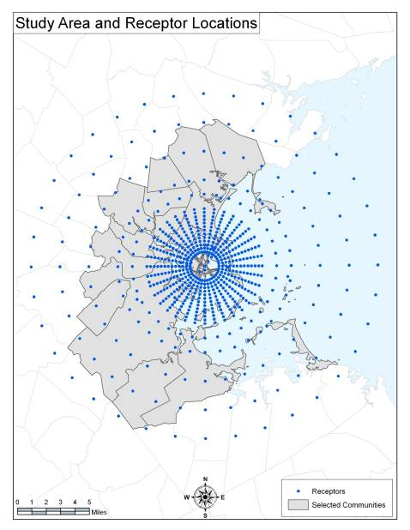

**Figure A-2: Example of operations log for Logan Airport in 2005**

|  |  |  |  |  |
| --- | --- | --- | --- | --- |
| **Time** | **Count** |  | **Time** | **Count** |
| **12:00 AM** | 1759 |  | 12:00 PM | 5303 |
| **12:15 AM** | 1088 |  | 12:15 PM | 4614 |
| **12:30 AM** | 579 |  | 12:30 PM | 5220 |
| **12:45 AM** | 338 |  | 12:45 PM | 4897 |
| **1:00 AM** | 273 |  | 1:00 PM | 4902 |
| **1:15 AM** | 207 |  | 1:15 PM | 4444 |
| **1:30 AM** | 246 |  | 1:30 PM | 4656 |
| **1:45 AM** | 211 |  | 1:45 PM | 4739 |
| **2:00 AM** | 163 |  | 2:00 PM | 5630 |
| **2:15 AM** | 237 |  | 2:15 PM | 5341 |
| **2:30 AM** | 270 |  | 2:30 PM | 5236 |
| **2:45 AM** | 230 |  | 2:45 PM | 5111 |
| **3:00 AM** | 201 |  | 3:00 PM | 5608 |
| **3:15 AM** | 248 |  | 3:15 PM | 5157 |
| **3:30 AM** | 145 |  | 3:30 PM | 5642 |
| **3:45 AM** | 179 |  | 3:45 PM | 5684 |
| **4:00 AM** | 277 |  | 4:00 PM | 5809 |
| **4:15 AM** | 308 |  | 4:15 PM | 6024 |
| **4:30 AM** | 290 |  | 4:30 PM | 6091 |
| **4:45 AM** | 337 |  | 4:45 PM | 5578 |
| **5:00 AM** | 611 |  | 5:00 PM | 5754 |

**Figure A-3: Temporal distribution of flight operations at Logan Airport in 2005**

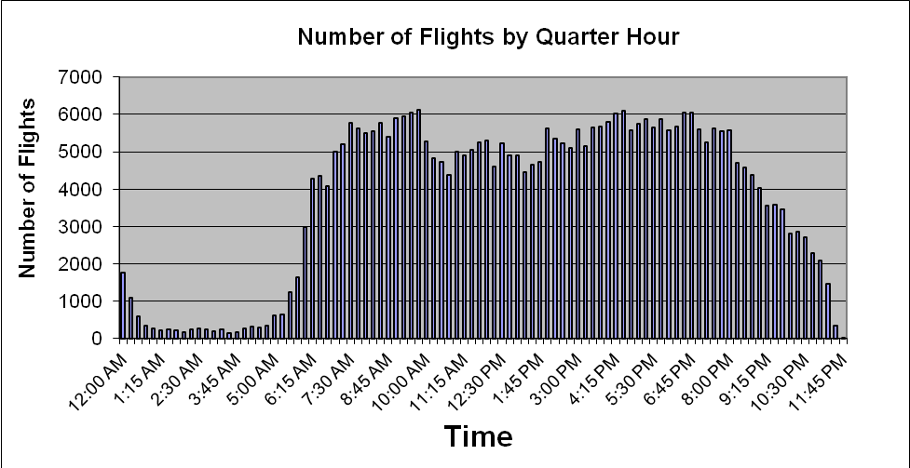

**Figure A-3: Temporal distribution of flight operations at Logan Airport in 2005 (continued)**



**Figure A-3: Temporal distribution of flight operations at Logan Airport in 2005 (continued)**

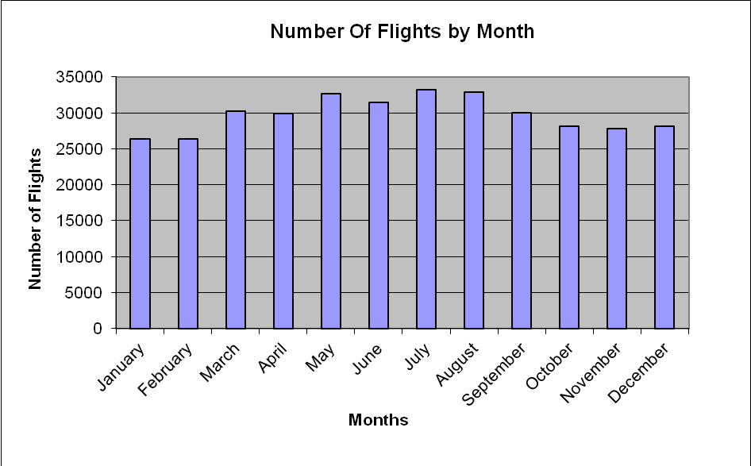

**Figure A-4: Wind rose from weather station at Logan Airport – 2003**

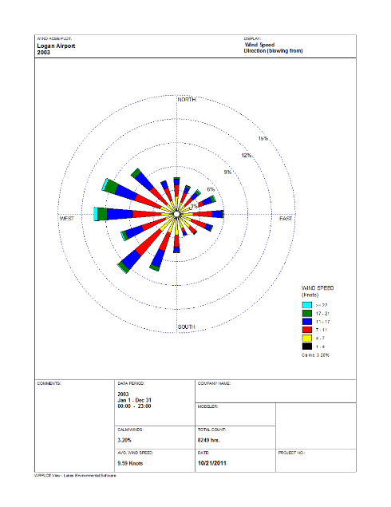

**Figure A-5: Wind rose from weather station at Logan Airport – 2004**

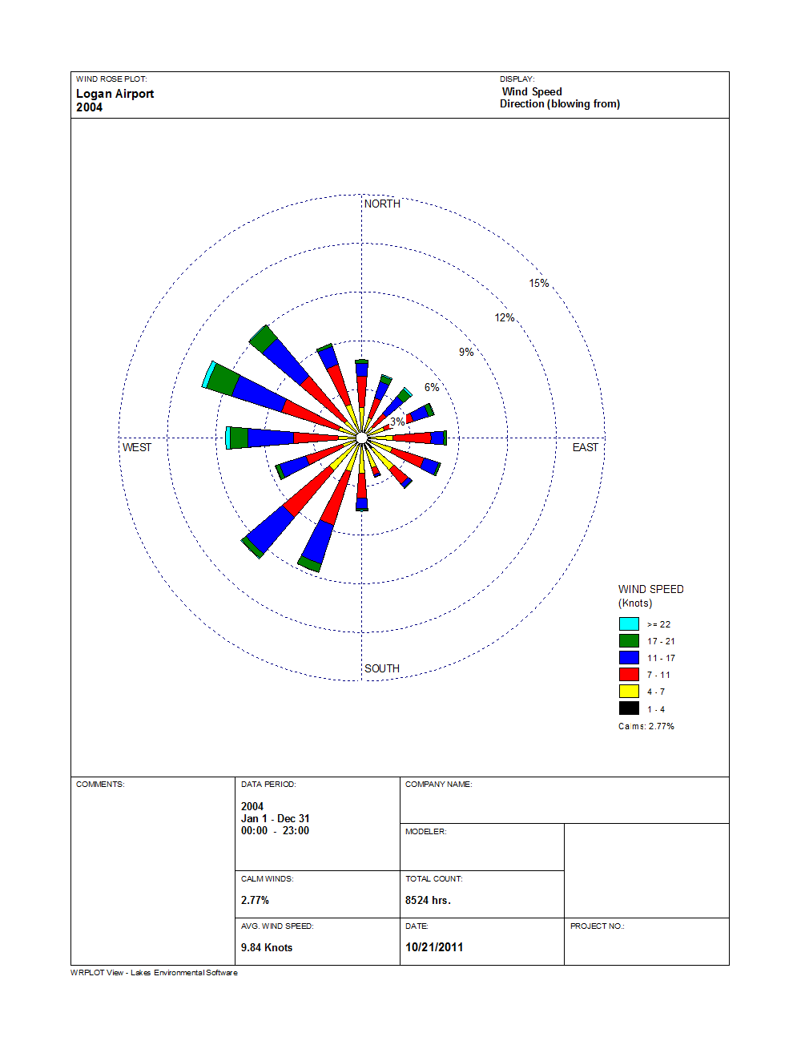

**Figure A-6: Wind rose from weather station at Logan Airport – 2005**

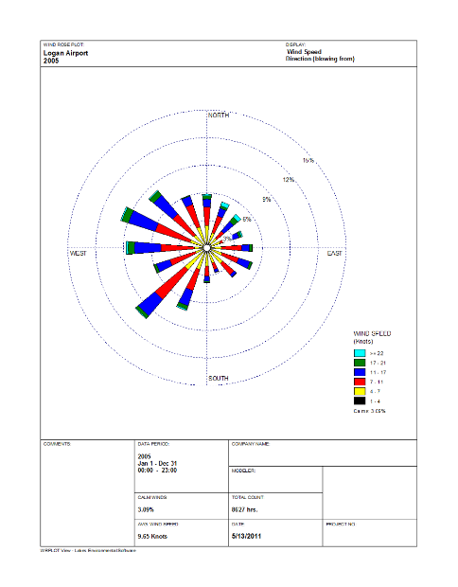

**Figure A-7: Wind rose from weather station at Logan Airport – 2006**

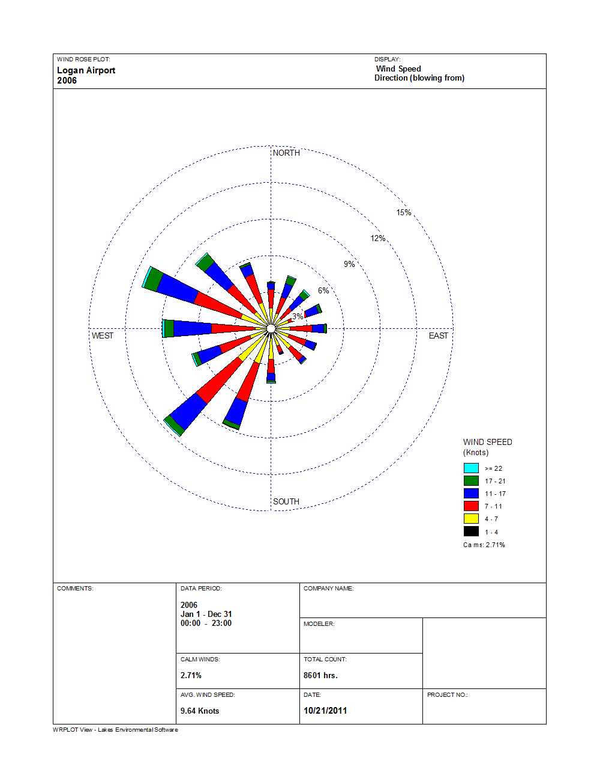

**Figure A-8: Wind rose from weather station at Logan Airport – 2007**

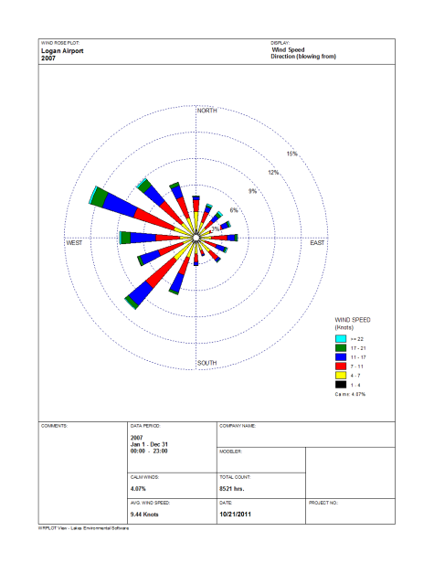

**Figure A-9: Normalized annual average concentrations for NOx and PM2.5**

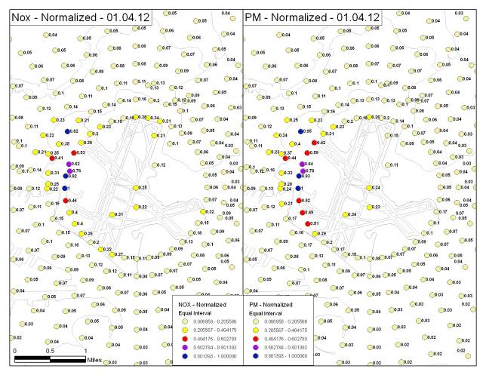

**Figure A-10: Relative contribution of NOx and PM2.5 air pollutant concentrations at Logan Airport**

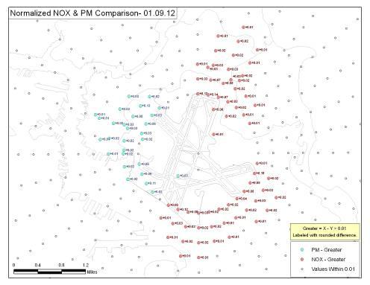

**Attachment 1: Modeling Inputs to EDMS**

**OPERATIONAL PROFILES FOR AIRCRAFT**

The operational profiles obtained from Massport (BOS_2005.DBF) contained 357,282 records of flight information including: TYPE (type of aircraft), IDENT (airline identifier), OPER (airline operator in ICAO), DATE (the date of the flight), START (start time of flight), END (end time of flight), ARR (arrival), DEP (departure), RWY (runway), NOPSDAY, NOPSEVENIN, NOPSNIGHT (these three are the adjusted flight values).

Analysis of the raw data from Massport provided operations data on the identification of the carrier and aircraft type, exact arrival and departure date and time, runway used, for 356,566 flights at Logan Airport in 2005 from Massport.

A Microsoft Access database was reconfigured according to the format specified by EDMS for importing into the model according to the date of the flight, start time, the day of the month, week, hour, and minute. The data were also categorized according to the flights by quarter hour. The data were then normalized for import into EDMS.

**PARKING**

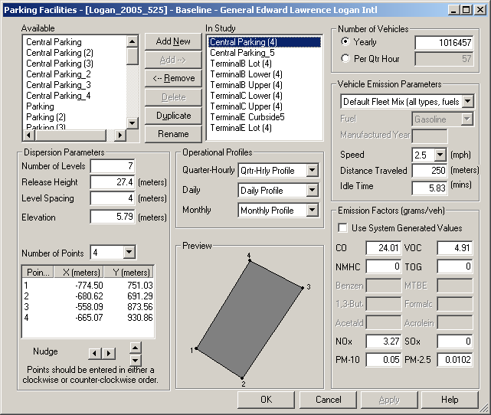

**Number of Vehicles**

The number of vehicles for each of the parking facilities in the study came from calculations based on the parking and curbside table from the 2005 emissions inventory files from Massport (the 2005_vmt_results file). A Microsoft Excel worksheet was created from this file with the addition of three columns for Lot Totals, Lower Totals, and Upper Totals. The three new columns correspond to daily total number of cars in the parking facility, and number of cars in the lower, and upper decks multiplied by 365 days per year for annual totals as required by EDMS.

**Vehicle Parameters**

The inputs for the vehicle parameter inputs were direct figures from the Parking Emissions 2005 tab of the 2005_vmt_results file.

**Emission Factors**

The emission factors for each of the parking facilities in the study came from calculations based on the parking and curbside table from the 2005_vmt_results file. These were manually entered into EDMS

**Operational Profiles**

These were selected from the drop down menu to match aircraft operational profiles that had been previously uploaded into EDMS.

**Parking Garage**

Massport provided information on the number of levels, and the heights (ft) of the central parking garage, and Terminal B. The heights had to be converted into meters for input into EDMS.

**STATIONARY SOURCES**

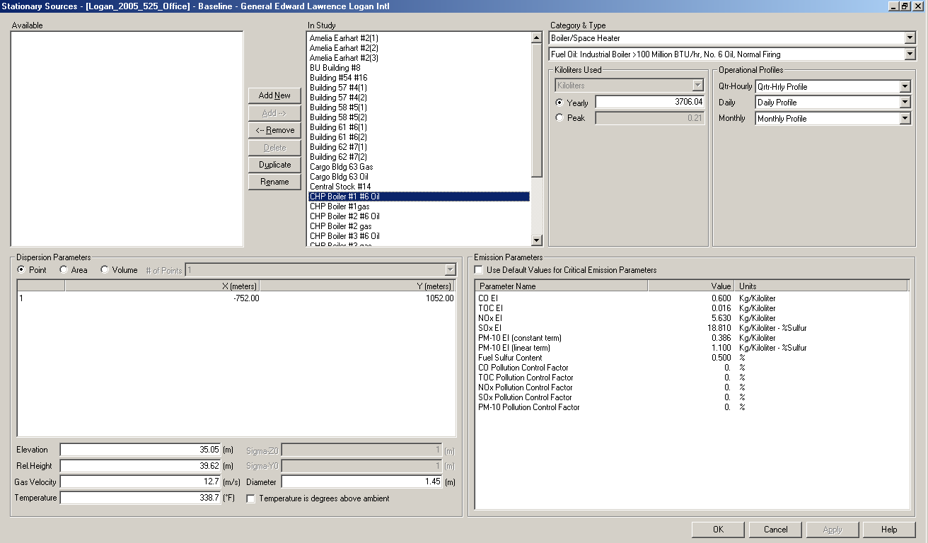

**Category and type**

The category and type of stationary sources were chosen based on the SCC ID from AP05; the SCC ID was placed into <http://cfpub.epa.gov/webfire/> search engine to determine the type.

**Kiloliters Used**

In order to determine the annual total use of fuel for each of the stationary sources, the original data contained in AP05 provided by Massport had to be converted from kGal (1000 gallons) into kiloliters for boilers using oil and from Mft3 to km3 for boilers using gas. The first step was converting kGal into gallons, and then converting gallons into kiloliters. For the stationary sources that used natural gas there was also a two-step process. The calculation first involved converting Mft3 into ft3, and then it was converting ft3 into m3.

Oil Conversion Steps

kGal x 1000 = gallons (Gal)

Gal *0.00378541178 = Kiloliters

Gas Conversion Steps

Mft3*1000000 = ft3

Ft3 *0.0283168466 = m3

**Locations**

The locations for the stationary sources were determined by applying coordinates determined by Google maps into a custom formula created by our contractor. This converted the degrees of latitude and longitude into (x, y) coordinates for EDMS.

Files Used:

**EMISSION PARAMETERS**

The emission parameters were determined from data received by Massport.

|  |  |  |  |  |  |
| --- | --- | --- | --- | --- | --- |
|  | **CO** | **VOC** | **NOX** | **SOX** | **PM2.5** |
| **Amelia Erhart** | | | | | |
| **LB/kGal** | 5 | 0.2 | 24 | 157(S) | 2 |
| **Kg/Kl** | 0.6 | 0.0122 | 2.87 | 18.81 | 0.239 |
| **#2 Oil** | | | | | |
| **LB/kGal** | 5 | 0.34 | 24 | 157(S) | 2 |
| **Kg/Kl** | 0.6 | 0.0208 | 2.87 | 18.81 | 0.239 |
| **Natural Gas** | | | | | |
| **1 mft3** | 84 | 5.5 | 100 | 0.6 | 7.6 |
| **1 cm3** | 1.344 | 0.088 | 1.6 | 0.01 | 0.122 |
| **CHP** | | | | | |
| **LB/kGal** | 5 | 0.28 | 47 | 157(S) | 9.19(S)+3.22 |

1 pounds / (1000 US gallons) = 0.119826427 kilogram / kiloliter

1 pounds / (1000 Cubic Feet) = 0.0160184634 kilogram / 1000 Cubic Meters

**RECEPTOR LOCATIONS**

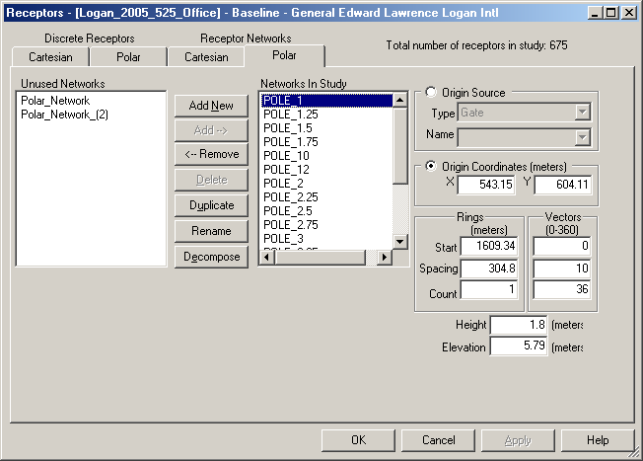

**Origin Coordinates**

The origin coordinates were set that the center of the airport.

**Receptors**

Each network (ring) in the study consists of 36 receptors spaced 10 degrees apart. There are 13 rings between 1 mile and 4 miles, spaced evenly ¼ mile apart. After 4 miles there were additional rings placed at mile 5, 6, 8, 10, 12. There were also special Cartesian receptors strategically placed throughout the study. There were 675 receptors in total within the study.

**RECEPTORS**

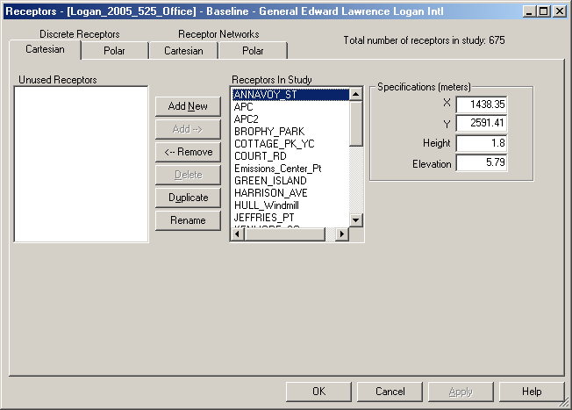

**RUNWAYS**

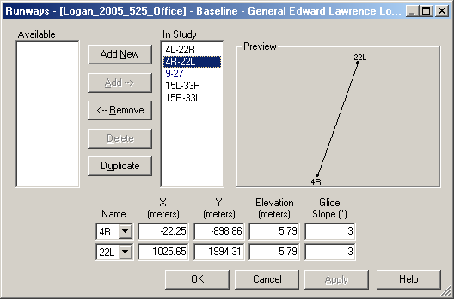

The location of the runways for the airport was input manually based on data provided by Massport. This sheet lists the name of the runway, x,y (feet), x,y(meters), elevation, and glide slope.

**ROADWAYS**

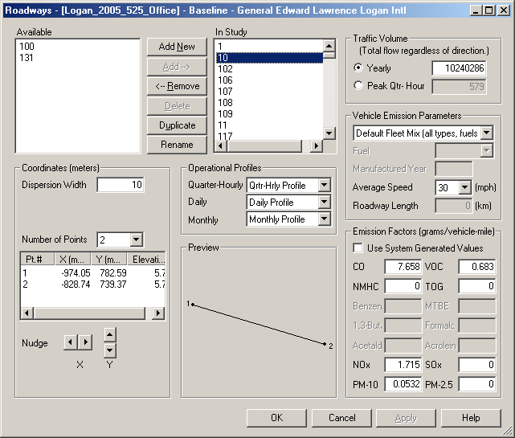

Roadway files were provided by Massport and their consultant, VHB, Inc. (Link Attributes for VHB 051611). The files contained the roadway segments (links) in and around the airport, their traffic counts and emission factors. A map was provided by VHB Inc., showing the roadway configuration (see Review map provided by VHB 05-20-2011). VHB Inc. provided MDPH/BEH with a map and assistance with the roadway configuration. Review of this information resulted in modification of the roadway configuration to coincide with conditions in 2005.

The specific links that were removed are highlighted in yellow and orange in this file (Link Attributes for VHB 051611). An excel spreadsheet (Roadways_2005_Final) was created to capture all data necessary for input into EDMS, including x and y for each link, traffic volumes, speed, emission factors, etc. The data were saved as a text file that would be suitable for import into EDMS.

**CONFIGURATIONS**

Airports operate under different configurations or patterns of aircraft arrivals and departures on specific runways. These configurations change over the course of a year depending on the weather, capacity, and noise abatement plans although the primary determinant of which runway will be used by a departing or arriving aircraft is wind direction.

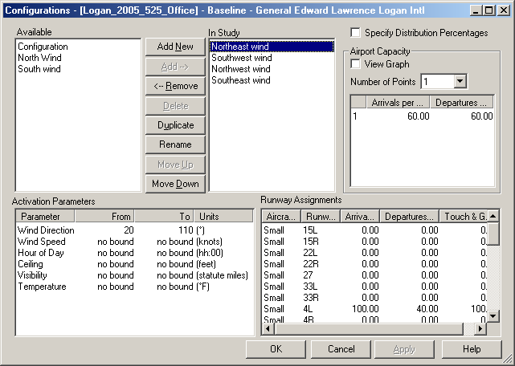

|  |  |  |  |  |  |
| --- | --- | --- | --- | --- | --- |
| BOS Runway Stats Provided by Massport- Data is Approximate Note- 2005 No R 14/32 | | | | | |
| Flows | **Arrival Rwys** | **Depart Rwys** | **% Usage** | **Arr/hr** | **Dep/Hr** |
| **Northeast** | 4R, 4L | 4R, 4L, 9 | 40% | 60 | 60 |
| **Southwest** | 22L,27 | 22R,22L | 40% | 60 | 60 |
| **Northwest** | 33L, 27 | 33L, 27 | 15% | 45 | 45 |
| **Southeast** | 15R | 15R, 9 | 5% | 30 | 30 |
| Flow/A-C Types | **Arrivals** | | **Departures** | | |
| **Northeast** | 4R | 4L | 4R | 4L | 9 |
| **H** | 90% | 10% | 10% | 0% | 90% |
| **L** | 70 | 30 | 10 | 0 | 90 |
| **S** | 0 | 100 | 0 | 40 | 60 |
|  |  |  |  |  |  |
| **Southwest** | 22L | 27 | 22R | 22L | N/A |
| **H** | 10 | 90 | 80 | 20 | N/A |
| **L** | 30 | 70 | 90 | 10 | N/A |
| **S** | 100 | 0 | 100 | 0 | N/A |
|  |  |  |  |  |  |
| **Northwest** | 33L | 33R | 33L | 27 | N/A |
| **H** | 100 | 0 | 30 | 70 | N/A |
| **L** | 100 | 0 | 20 | 80 | N/A |
| **S** | 50 | 50 | 0 | 100 | N/A |
|  |  |  |  |  |  |
| **Southeast** | 15R |  | 15R | 9 | N/A |
| **H** | 100 |  | 10 | 90 | N/A |
| **L** | 100 |  | 10 | 90 | N/A |
| **S** | 100 |  |  | 100 | N/A |

**SENSITIVITY RUNS**

The sensitivity analysis consisted of running the model with meteorological data other than the Base year 2005 (i.e., 2003, 2004, 2006, 2007) and with varying the roughness length, Zo (360 degrees sector value, annual average value for all hours, and constant airport default value for all hours). In order to complete the sensitivity runs 3 changes to the Base year 2005 inputs had to be made. First the meteorological data for the specific year had to be changed, as well as the designated study year in order to correspond to the meteorological file. In order for the rest of the study to run correctly the roadway and schedule needed to be modified to the corresponding year of meteorological data.

**Appendix B: Background Pollutant Concentrations**

1. Identifying monitoring sites and locations in study area: Using the 2005 Massachusetts Department of Environmental Protection (MassDEP) Annual Air Monitoring Report[6], monitoring sites for each pollutant were identified in the LAHS modeling domain. The location for each of the monitoring sites by latitude and longitude were identified using the following EPA site: <http://www.epa.gov/air/data/reports.html>. The five monitoring sites identified are listed below.

|  |  |  |  |  |
| --- | --- | --- | --- | --- |
| **County** | **Airs Code** | **Pollutant** | **Location** | **Concentration (µg/m3)** |
| Essex | 2006 | PM2.5 | 390 Parkland | 9.4 |
| Suffolk | 0002 | PM2.5 | Kenmore Sq | 12.9 |
| Suffolk | 0027 | PM2.5 | One City Sq | 13.6 |
| Suffolk | 0042 | PM2.5 | Harrison Av | 11.3 |
| Suffolk | 0043 | PM2.5 | 174 North St | 13.6 |

1. Using SAS, annual average concentrations were calculated for each of the identified monitoring sites. In the event that there were two monitors for the same pollutant located at a monitoring site, a weighted average was calculated[7].
2. Annual average concentrations were converted from PPM to µg/m3 (except for PM2.5 which was already in µg/m3).
3. The monitoring sites were then plotted in ArcMap:
   1. A separate point file was created for each pollutant (using the definition query function in ArcMap.) – this resulted in 4 files (PM2.5, CO, NO2, and SO2)
   2. ArcMAP Spatial Analyst IDW tools were used to create surfaces for each pollutant
   3. A predicted annual average air pollutant concentration from 2005 airport operations was assigned to each monitoring site via the Extract Values to Points tool in ArcMap, utilizing the interpolation option
   4. Lastly, the households were spatially joined to each of the four pollutant datasets (4b) based on proximity to each of the monitoring sites.
4. Each household was assigned a background value for the four pollutants

**Analysis of Background air quality concentrations**

The total concentrations that people are exposed to are the sum of the contributions from the operations being modeled at Logan Airport and all the other sources in the surrounding area. This latter contribution is called ‘background’ for this study. The estimation of background concentrations is often addressed by identifying ambient air quality measurement data that would represent upwind concentrations for selected time periods. For example, for an issue of compliance with a short term ambient standard for an isolated source, US EPA recommends identifying specific hours when background concentrations plus a source’s impact would threaten a standard and modeling selected sources for the hours where that is most likely to occur. That approach is not feasible or appropriate for the LAHS. However, to gain some sense of the importance of background concentrations on an annual basis, we can compare the annual average impacts of the sources in the LAHS inventory with the annual average measurements at ambient air monitoring stations in the Metropolitan Boston area (Table 1).

The locations of each household in the study area were compared to the locations of each monitoring station, and each household was assigned the concentration value of the closest monitor as a first estimate of the background value. To recognize that the measurement data theoretically include contributions from Logan Airport operations, and to avoid double counting, the predicted annual average concentrations from Logan Airport were then subtracted from the first estimate of the background values at each receptor to obtain a better estimate of background. These values may be seen in the summary tables of computations.

Table 1 provides a summary of the average PM2.5 predicted Logan Airport and background contributions at each household and the ratio of the two. The ratio of average Logan Airport contributions to average background values of PM2.5 for each household location is about 0.006. Since this ratio includes a large number of predictions at large distances from the airport, we have also included in Table 1 the ratios that occur for those households with the highest predicted Logan Airport concentrations. These include ratios of Logan Airport to background for the 3% of households with predicted Logan Airport PM2.5 concentrations that exceed 50% of the maximum value and the 0.6% of households with predicted Logan Airport PM2.5 concentrations that exceed 75% of the maximum value. It may be seen that for those exceeding 50% and 75% of the maximum predicted Logan Airport PM2.5 value, the ratio of the Logan Airport contributions to the background estimates are 0.033 and 0.043, respectively.

**Table B-1: Logan Airport PM2.5 Concentration Predictions and Background Concentrations**

|  |  |  |  |
| --- | --- | --- | --- |
|  | **Average Logan Contribution, µg/m3** | **Average Background Contribution,**  **µg/m3** | **Ratio of Averages: Logan Airport to Background** |
| **All Respondent Locations** | 0.07 | 12.21 | 0.0057 |
| **Logan Airport predicted values > 50% of maximum** | s0.43 | 13.06 | 0.0329 |
| **Logan Airport predicted values > 75% of maximum** | 0.55 | 12.94 | 0.0425 |

**Appendix C-1: Health-Related Behaviors, Occupational Exposures, And Household Characteristics Of Adult Residents Of The Logan Airport Health Study (LAHS) Area By Airport-Related Air Or Noise Exposure Area**

|  |  |  |  |  |  |
| --- | --- | --- | --- | --- | --- |
|  |  | **Prevalencea, %** | | | |
|  | Sample Size | Total Study Area | Exposure Areab | | |
| **Covariate** | Lower | Medium | Higher |
| **Smoking status** | 5972 |  |  |  |  |
| **Current smoker** |  | 18.7 | 17.4 | 21.3 | 20.9 |
| **Former smoker** |  | 25.8 | 25.9 | 24.6 | 29.7 |
| **Never smoked** |  | 55.6 | 56.7 | 54.1 | 49.4 |
| **Alcohol consumption, drinks/week** | 6020 |  |  |  |  |
| **None** |  | 35.9 | 34.9 | 36.8 | 44.2 |
| **<1** |  | 18.6 | 19.1 | 17.3 | 17.6 |
| **1-6** |  | 29.7 | 30.3 | 29.4 | 25.0 |
| **7-13** |  | 9.9 | 10.0 | 10.1 | 7.6 |
| **14+** |  | 5.8 | 5.7 | 6.4 | 5.6 |
| **Binge drinking episodes per week** | 6014 |  |  |  |  |
| **None** |  | 81.1 | 82.6 | 78.1 | 78.7 |
| **≤1** |  | 14.1 | 13.0 | 16.5 | 15.2 |
| **>1** |  | 4.8 | 4.4 | 5.4 | 6.1 |
| **Occupational exposure to dust, gas, or chemical fumes** | 6072 |  |  |  |  |
| **No** |  | 71.2 | 69.9 | 73.8 | 74.5 |
| **Yes** |  | 26.2 | 27.3 | 23.9 | 23.9 |
| **Missing** |  | 2.6 | 2.8 | 2.3 | 1.6 |
| **Occupational exposure to loud noise for 3 month duration** | 6072 |  |  |  |  |
| **No** |  | 78.4 | 78.7 | 69.4 | 70.6 |
| **Yes (wore protective equipment)** |  | 7.2 | 7.2 | 7.3 | 13.3 |
| **Yes (no protective equipment)** |  | 14.0 | 13.7 | 22.9 | 16.2 |
| **Missing** |  | 0.4 | 0.4 | 0.4 | 0.0 |
| **Potential exposure to smoking in household** | 6064 |  |  |  |  |
| **No** |  | 84.4 | 85.0 | 82.8 | 84.7 |
| **Yes** |  | 15.6 | 15.0 | 17.2 | 15.3 |
| **aSurvey data weighted to population demographics to produce prevalence estimates representative of the study area.** | | | | | |
| **bPrevalence estimates for all covariates are presented by airport-related air pollution exposure areas except for Massport soundproofing and occupational noise exposure, which are presented by noise exposure areas.** | | | | | |

|  |  |  |  |  |  |
| --- | --- | --- | --- | --- | --- |
|  |  | **Prevalencea, %** | | | |
|  | Sample Size | Total Study Area | Exposure Areab | | |
| **Covariate** | Lower | Medium | Higher |
| **Potential exposure to NO2 in household** | 6054 |  |  |  |  |
| **No** |  | 29.5 | 27.8 | 34.0 | 29.4 |
| **Yes** |  | 70.5 | 72.2 | 66.0 | 70.6 |
| **Potential exposure to mold in household** | 5994 |  |  |  |  |
| **No** |  | 74.3 | 72.4 | 78.1 | 78.1 |
| **Yes** |  | 25.7 | 27.6 | 21.9 | 21.9 |
| **Potential exposure to allergens in household** | 6042 |  |  |  |  |
| **No** |  | 59.9 | 58.9 | 63.0 | 57.6 |
| **Yes** |  | 40.1 | 41.1 | 37.0 | 42.4 |
| **Potential exposure to chemicals in household** | 5949 |  |  |  |  |
| **No** |  | 61.5 | 60.5 | 64.3 | 59.5 |
| **Yes** |  | 38.5 | 39.5 | 35.7 | 40.5 |
| **Massport soundproofing** | 6072 |  |  |  |  |
| **No** |  | 85.5 | 86.4 | 67.4 | 48.8 |
| **Yes** |  | 4.0 | 3.2 | 23.6 | 43.9 |
| **Unsure** |  | 10.4 | 10.5 | 9.0 | 7.3 |
| **Years of residence in current exposure area** | 5967 |  |  |  |  |
| **<1** |  | 5.3 | 3.3 | 10.5 | 4.5 |
| **1 to 2** |  | 19.0 | 17.0 | 24.5 | 18.4 |
| **3 to 5** |  | 19.8 | 19.8 | 19.6 | 20.3 |
| **6 to 10** |  | 18.0 | 18.5 | 17.0 | 16.9 |
| **11 to 21** |  | 19.2 | 21.0 | 14.4 | 19.3 |
| **21+** |  | 18.8 | 20.5 | 14.0 | 20.6 |
| **Distance from major roadway** | 6072 |  |  |  |  |
| **> 200 m** |  | 84.3 | 87.5 | 78.1 | 76.0 |
| **≤ 200 m** |  | 15.7 | 12.5 | 21.9 | 24.0 |
| **PM2.5 background pollution, µg/m3** | 6072 |  |  |  |  |
| **≤11.35** |  | 10.7 | 13.4 | 6.2 | 0.0 |
| **11.36-12.83** |  | 51.5 | 51.3 | 60.7 | 14.9 |
| **12.84-13.47** |  | 25.6 | 34.6 | 8.4 | 0.0 |
| **13.48** |  | 12.2 | 0.7 | 24.6 | 85.1 |
| **aSurvey data weighted to population demographics to produce prevalence estimates representative of the study area.** | | | | | |
| **bPrevalence estimates for all covariates are presented by airport-related air pollution exposure areas except for Massport soundproofing and occupational noise exposure, which are presented by noise exposure areas** | | | | | |

**Table C-1 (continued):**

**Table C-2. Household Exposure Characteristics Of Children Residing In The Logan Airport Health Study (LAHS) Area By Airport-Related Air Or Noise Exposure Area**

|  |  |  |  |  |  |
| --- | --- | --- | --- | --- | --- |
|  |  | **Prevalencea, %** | | | |
|  | Sample Size | Total Study Area | Exposure Areab | | |
| **Covariate** | Lower | Medium | Higher |
| **Potential exposure to smoking in household** | 2213 |  |  |  |  |
| **No** |  | 85.2 | 87.6 | 76.9 | 85.7 |
| **Yes** |  | 14.8 | 12.4 | 23.1 | 14.3 |
| **Potential exposure to NO2 in household** | 2208 |  |  |  |  |
| **No** |  | 21.9 | 19.2 | 30.9 | 22.3 |
| **Yes** |  | 78.1 | 80.8 | 69.1 | 77.7 |
| **Potential exposure to mold in household** | 2180 |  |  |  |  |
| **No** |  | 68.2 | 65.1 | 74.2 | 84.0 |
| **Yes** |  | 31.8 | 34.9 | 25.8 | 16.0 |
| **Potential exposure to allergens in household** | 2200 |  |  |  |  |
| **No** |  | 48.9 | 49.9 | 48.4 | 38.1 |
| **Yes** |  | 51.1 | 50.1 | 51.6 | 61.9 |
| **Potential exposure to chemicals in household** | 2169 |  |  |  |  |
| **No** |  | 49.5 | 47.8 | 56.9 | 44.9 |
| **Yes** |  | 50.5 | 52.2 | 43.1 | 55.1 |
| **Massport soundproofing** | 2215 |  |  |  |  |
| **No** |  | 86.6 | 87.4 | 67.1 | 40.5 |
| **Yes** |  | 4.8 | 3.9 | 28.8 | 49.3 |
| **Unsure** |  | 8.6 | 8.7 | 4.1 | 10.2 |
| **Years of residence in current exposure area** | 2203 |  |  |  |  |
| **<1** |  | 4.0 | 1.4 | 12.2 | 5.7 |
| **1 to 2** |  | 13.6 | 10.0 | 25.7 | 13.6 |
| **3 to 5** |  | 27.2 | 28.1 | 23.7 | 29.1 |
| **6 to 10** |  | 34.8 | 38.2 | 24.3 | 31.9 |
| **11 to 17** |  | 20.5 | 22.4 | 14.2 | 19.6 |
| **Distance from major roadway** | 2215 |  |  |  |  |
| **>200 m** |  | 88.3 | 91.7 | 80.0 | 77.0 |
| **≤ 200 m** |  | 11.7 | 8.3 | 20.0 | 23.0 |
| **PM2.5 background pollution, µg/m3** | 2215 |  |  |  |  |
| **≤11.35** |  | 14.9 | 16.5 | 13.6 | 0.0 |
| **11.36-12.83** |  | 58.4 | 61.1 | 62.7 | 12.6 |
| **12.84-13.47** |  | 16.0 | 21.5 | 2.2 | 0.0 |
| **13.48** |  | 10.7 | 0.9 | 21.5 | 87.4 |
| **aSurvey data weighted to population demographics to produce prevalence estimates representative of the study area.** | | | | | |
| **bPrevalence estimates for all covariates are presented by airport-related air pollution exposure areas except for Massport soundproofing, which is presented by noise exposure areas.** | | | | | |

**Appendix D: Continuous Exposure Analyses**

**Table D-1. Estimated Exposure to Airport-related PM2.5 a and Adjusted Odds of Respiratory and Cardiovascular Disease among Adults Living in the Logan Airport Health Study Area (2005)**

|  |  |  |  |  |  |
| --- | --- | --- | --- | --- | --- |
| **Health Outcome** | **Sample Size** | **Odds Ratiob** | **Lower 95% CI** | **Upper 95% CI** | **p-value** |
| **Lifetime Asthma** | 5829 | 0.99 | 0.98 | 1.01 | *0.24* |
| **Current Asthma** | 5806 | 1.00 | 0.98 | 1.01 | *0.74* |
| **Current Asthma with Medication Usec** | 5805 | 1.00 | 0.98 | 1.02 | *0.84* |
| **Probable Asthma** | 4934 | 1.01 | 0.99 | 1.03 | *0.45* |
| **Asthma Hospitalizationd** | 638 | 1.06 | 1.01 | 1.10 | *0.01* |
| **COPDe** | 5689 | 1.01 | 0.99 | 1.03 | *0.22* |
| **Coronary Heart Disease** | 5603 | 1.04 | 0.98 | 1.11 | *0.22* |
| **Myocardial Infarction** | 5608 | 1.01 | 0.98 | 1.04 | *0.74* |
| aPM2.5 was modeled in increments of 0.01 µg/m3; odds ratios can, therefore, be interpreted as the change in odds of disease per 0.01 µg/m3 increase in PM2.5 concentration.  bAll models were adjusted for age, sex, race, ethnicity, household income (PIR), education, smoking status, and background air pollution exposure. Cardiovascular outcomes (MI and CHD) were also adjusted for binge drinking, diabetes, hypertension, high cholesterol, and family history of heart disease. Exposure to background air pollution was adjusted using estimated residential background PM2.5 concentrations and an indicator variable for whether the residence lies within 200 meters of a major road.  cAlso adjusted for household indoor smoking.  dAnalysis conducted among those with current asthma. Also adjusted for household indoor smoking, BMI, alcohol intake, GERD, and use of chemicals in the home.  eAlso adjusted for household indoor smoking and use of chemicals such as pesticides in the home. | | | | | |

**Table D- 2. Estimated Exposure to Airport-related PM2.5a and Adjusted Odds of Respiratory Disease among Children Living in the Logan Airport Health Study Area (2005)**

|  |  |  |  |  |  |
| --- | --- | --- | --- | --- | --- |
| **Health Outcome** | **Sample Size** | **Odds Ratiob** | **Lower 95% CI** | **Upper 95% CI** | **p-value** |
| **Lifetime Asthma** | 2081 | 1.00 | 0.98 | 1.02 | *0.72* |
| **Current Asthma** | 2072 | 1.01 | 0.99 | 1.04 | *0.27* |
| **Current Asthma with Medication Use** | 2071 | 1.01 | 0.98 | 1.03 | *0.51* |
| **Probable Asthma** | 1644 | 1.03 | 1.00 | 1.06 | *0.04* |
| **Asthma Hospitalization** | 319 | 0.98 | 0.93 | 1.04 | *0.55* |
| **Chronic Bronchitis / Chest Infections** | 2082 | 1.02 | 0.99 | 1.05 | *0.17* |
| aPM2.5 was modeled in increments of 0.01 µg/m3; odds ratios can, therefore, be interpreted as the change in odds of disease per 0.01 µg/m3 increase in PM2.5 concentration.  bAll models were adjusted for age, sex, household income (PIR), maternal education, household indoor smoking, household NO2 sources, household allergens, household mold, and background air pollution exposure. Exposure to background air pollution was adjusted using estimated residential background PM2.5 concentrations and an indicator variable for whether the residence lies within 200 meters of a major road**.** | | | | | |

1. Estimated by Massport to total approximately 4400 tons per year for NOx, CO, and PM (EDR, 2006). This estimate does not include ultrafine particles, which are characterized by particle number and size distribution.
2. <http://www.faa.gov/about/office_org/headquarters_offices/apl/research/models/edms_model/>
3. (See: <http://www.webmet.com/State_pages/SURFACE/14739_sur.htm> and [*http://www4.ncdc.noaa.gov/cgi-win/wwcgi.dll?wwDI~StnPhoto~20009288~a~000*](http://www4.ncdc.noaa.gov/cgi-win/wwcgi.dll?wwDI~StnPhoto~20009288~a~000))
4. To be consistent with Massport emission inventory methods, measurements of PM2.5 from aircraft engines indicated that most of the particles are less than 10 microns in diameter, it is assumed for this analysis that they are all classifiable as PM2.5. Similarly, for the purposes of this analysis, PM2.5 emissions from other non-aircraft sources are primarily combustion emissions and classified at PM2.5. Thus, in the absence of additional information, for modeling purposes, the emission rates for PM10 and PM2.5 are generally assumed to be same and are identified in this report as PM2.5.
5. The values are not exactly symmetric with x and z because of the use of a random number generator and having only 100 values in each data set.
6. <http://www.mass.gov/dep/air/aq/aq_repts.htm>
7. Weighted average considers the number of monitoring days for each monitor