First Time Logging Into HR/CMS v9
(Pilot Employees/Approvers/Payroll & Timekeepers)

1. When you open the link to HRCMS 9.0, in the blank “User ID” field.
2. Enter your Employee ID (including leading zero’s if applicable)
3. Enter the password provided to you
4. Click on the “Sign In” button.

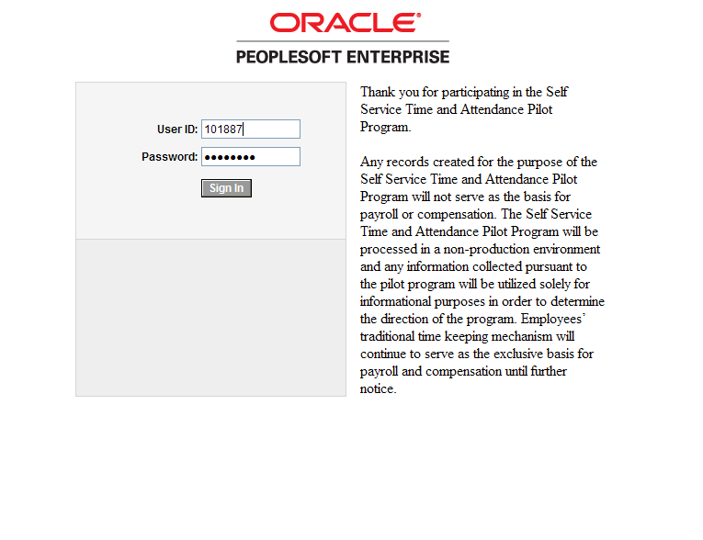

5. You will see the message “Your password has expired”.
6. Click on the blue underlined link: “Click here to change your password”

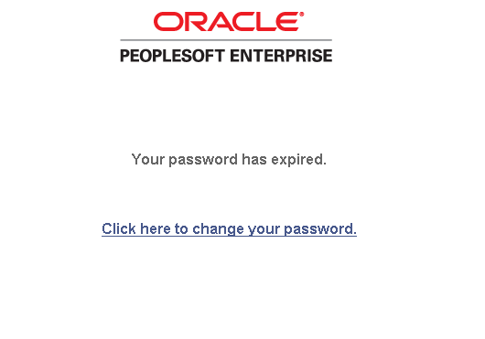
11. Enter your current password into the “Current Password” field
12. Enter your new password into the field called “New Password”.
The new password must be at least 8 characters long, and include at least one number.
13. Enter your new password again into the next field called “Confirm Password”.
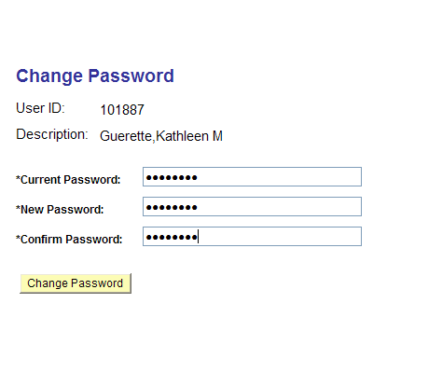
14. Click on the “Change Password” button.

15. You will see the Password Saved page. Click on the OK button.
