Commonwealth of Massachusetts
Executive Office of Health and Human Services

Office of Medicaid
www.mass.gov/masshealth

MassHealth
Long-Term-Care Facility Bulletin 108
April 2014

TO: Nursing Facilities and Chronic Disease and Rehabilitation Inpatient Hospitals Participating in MassHealth

FROM: Kristin L. Thorn, Medicaid Director 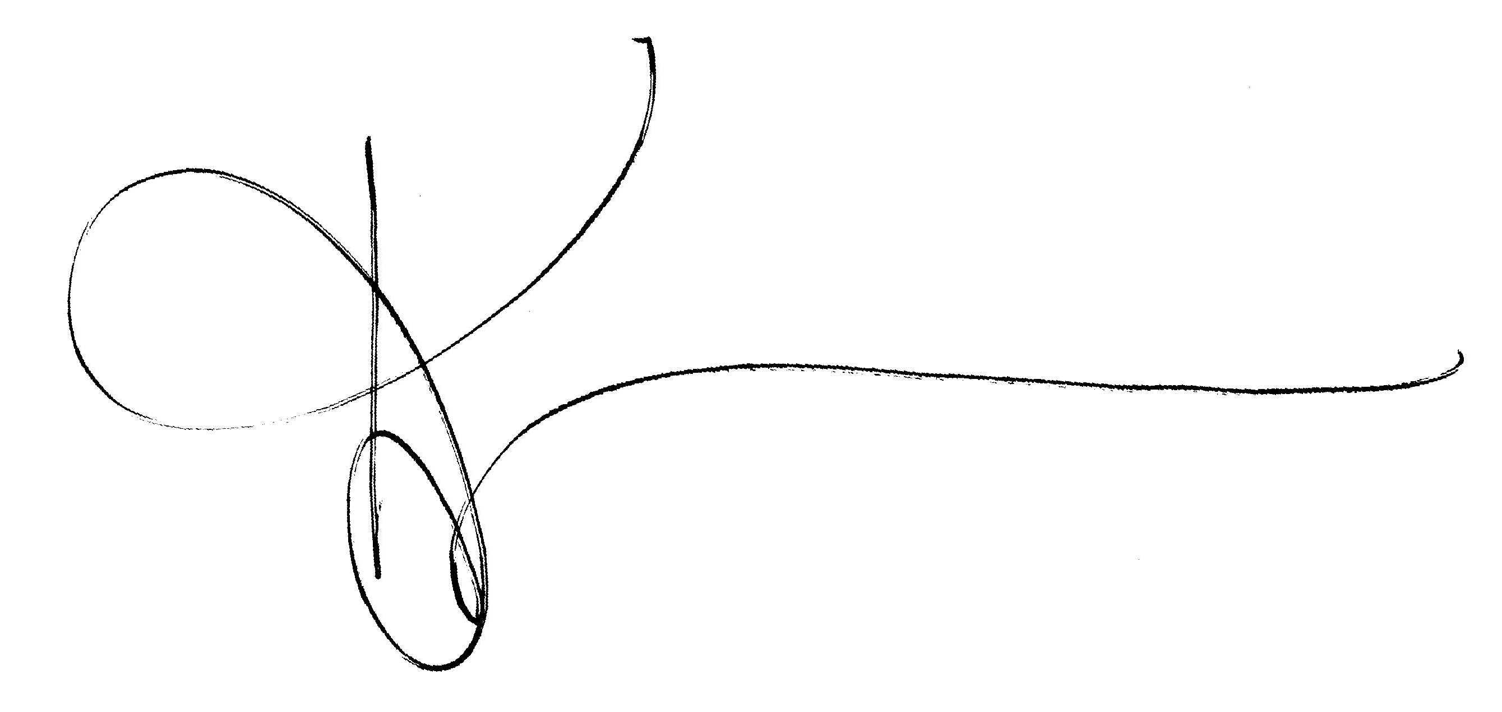

RE: Annual Accounting for Personal Needs Account

Background

MassHealth requires that nursing facilities and chronic disease and rehabilitation inpatient hospitals account for the balances of personal needs account (PNA) funds (see 130 CMR 456.615).

Providers submit PNA forms to indicate that they maintain or do not maintain MassHealth members’ PNA funds.

PNA submissions

PNA forms are available online. To access the forms and instructions needed to fulfill the annual filing requirement, go to https://secure.chcf-umms.org and do the following.

      - Enter your MassHealth provider number and location code as the Login ID.

      - Enter the default password “1Welcome.”

      - Click the Login button. You will be prompted to change your password at the first login. Your new password must contain at least eight characters, which must include at least one alphabetical character, one capital letter, and one number. The initial screen will display an instruction file containing details for filing. Please refer to these instructions when filing your PNA accounting.

Deadline for PNA submissions

The PNA form seeks information about PNA funds managed by the provider, including members’ names and MassHealth ID numbers, amount of petty cash held in the facility for the members, amount held in individual bank accounts for the members, balance held in the trustee account for the members, and information about any other money being held for the members by the facility as of February 28, 2014. These forms must be submitted by Friday, May 30, 2014.

(continued on next page)

MassHealth

Long-Term-Care Facility Bulletin 108

April 2014

Page 3

Deadline for PNA submissions (cont.)

Providers must also provide copies of bank statements and a reconciliation of the trustee account (if one is used) electronically. If electronic submission is not possible, faxed or mailed copies will be accepted.

The reconciled bank balance must agree with the total PNA balance on the PNA form. If providers do not handle PNA funds for any members, they must state this on the PNA form.

All PNA filings must be dated and signed electronically by the administrator, under the pains and penalties of perjury, and submitted via the secure website.

Penalties

If a provider does not submit the PNA form by May 30, 2014, or if the filing is incomplete and not reconciled to the bank statement, the provider may be subject to administrative sanction.

Questions

If you have any questions about the information in this bulletin or have difficulty accessing the website, please contact the MassHealth Financial Compliance Unit at PNAReview@umassmed.edu.

