The Commonwealth of Massachusetts
Executive Office of Health and Human Services
Department of Public Health
Bureau of Health Care Safety and Quality
67 Forest Street, Marlborough, MA 01752
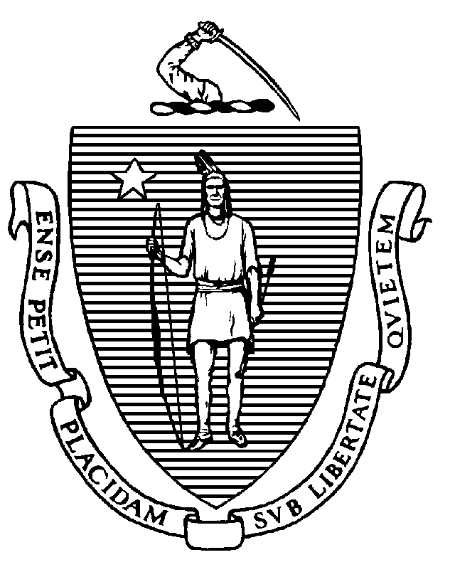

KATHLEEN E. WALSH
Secretary
ROBERT GOLDSTEIN, MD, PhD Commissioner

Tel: 617-624-6000
www.mass.gov/dph

MAURA T. HEALEY
Governor
KIMBERLEY DRISCOLL
Lieutenant Governor

Memorandum

TO: Long-Term Care Facility Administrators and Directors of Nursing
FROM: Elizabeth Daake Kelley, MPH, MBA, Director
Bureau of Health Care Safety and Quality
SUBJECT: Long-Term Care Facility Health Care Personnel Vaccination for COVID-19 and Influenza
DATE: November 6, 2023

The purpose of this memorandum is to inform Massachusetts nursing homes and rest homes of the steps needed to fulfill the Massachusetts Department of Public Health (DPH) requirement to vaccinate healthcare personnel (HCP) for influenza and COVID-19 and to submit these data in accordance with DPH guidelines outlined in this memorandum.
COVID-19 and Influenza Vaccination Requirement:
As a condition of licensure, under 105 CMR 150.002(D)(8) and (11), DPH long-term care facility regulations require licensed long-term care facilities to ensure all HCP are vaccinated annually with seasonal influenza vaccine and are up to date with vaccine doses for COVID-19 as recommended by the Centers for Disease Control and Prevention (CDC), unless an individual is exempt from vaccination. For the purposes of this memo, being up to date with vaccine doses for COVID-19 means that HCP must receive one updated COVID-19 vaccine, at least two months after getting the last dose of any COVID-19 vaccine. An individual who has not previously received any doses of COVID-19 vaccine but who receives one dose of the updated COVID-19 vaccine is also up-to-date.
HCP means an individual or individuals who either work at or come to the licensed facility site and who are employed by or affiliated with the facility, whether directly, by contract with another entity, or as an independent contractor, paid or unpaid including, but not limited to, employees, members of the medical staff, contract employees or staff, students, and volunteers, whether or not such individual(s) provide direct care.
All HCP, who are not subject to an exemption, must be up-to-date with COVID-19 vaccine no later than December 31, 2023. In alignment with the CDC and the Centers for Medicare and Medicare Care Services (CMS), all HCP, who are not subject to an exemption, must have received the 2023-2024 seasonal influenza vaccine no later than March 31, 2024.
For any individual that is subject to the vaccine exemption, the long-term care facility must require such individual to take mitigation measures in addition to continuing to self-assess for any signs or symptoms of illness. Mitigation measures that the long-term care facility can require an individual to take if they are exempt from vaccination include, but are not limited to:
- wearing a facemask during all resident care encounters for the duration of the respiratory illness season; and
- avoiding direct resident care.
DPH continues to recommend staff using personal protective equipment consistent with the Department’s Comprehensive PPE Guidance.
Facility Documentation:
The regulation requires nursing homes and rest homes maintain for each individual proof of seasonal influenza vaccination and being up-to-date with COVID-19 vaccination or the individual’s declination statement should the HCP decline vaccination. This must be maintained via a central system to track the vaccination status of all personnel and be available to DPH upon request. Examples of individual proof of current vaccination include but are not limited to:
- Copy of CDC Vaccination Card
- Copy of MA Immunization Information System (MIIS) Vaccination Record
- Copy of vaccination from an electronic health record
- COVID-19 SmartHealthcard from the Commonwealth’s MyVaxRecords public portal
Declination statements from personnel must include a signed statement certifying they received information about the risks and benefits of COVID-19 and/or influenza vaccine.
Nursing Home Reporting
COVID-19 Vaccination:
To comply with the regulation, all Massachusetts nursing homes must use the CDC’s National Healthcare Safety Network (NHSN) to report cumulative weekly COVID-19 vaccination for residents and personnel through the Long-Term Care Facility Component. DPH will use data submitted through the weekly COVID-19 vaccination modules to provide consistent reporting and comparable data across facilities. NHSN data can be used to monitor COVID-19 vaccination trends over time, identify facilities with lower resident and/or personnel vaccination rates, and inform planning and implementation decisions regarding vaccine supply and distribution. The Department will use the data submitted for the week ending December 31, 2023 to determine a nursing home’s compliance with the required regulation.
Training, data collection forms, and instructions can be found on the following NHSN website under ‘HCP & Resident COVID-19 Vaccination’: https://www.cdc.gov/nhsn/ltc/weekly-covid-vac/index.html
Facilities can access the COVID-19 vaccination modules by logging into NHSN (via Secure Access Management Service) as they would for any of the other NHSN reporting (cdc.gov). On the NHSN Home page, select the ‘COVID-19’option on the left-hand navigation bar. Personnel and resident data should be entered by selecting ‘COVID-19 Vaccination-HCW’ and ‘COVID-19 Vaccination-Residents’ respectively. This reporting is separate from the ‘Daily Entry’ where facilities enter weekly case counts and supply data.
Influenza Vaccination:

Consistent with the Centers for Medicare & Medicaid Services (CMS) July 31, 2023 final rule, beginning with the 2023-2024 influenza season, DPH requires Nursing Homes to report HCP influenza vaccination summary data via CDC’s NHSN and make the data available to DPH in NHSN. Nursing homes have the requirement to submit healthcare personnel (HCP) influenza data to the CDC’s NHSN by May 15, 2023. NHSN training materials are located at: http://www.cdc.gov/nhsn/training/index.html

Rest Home Reporting
To comply with the regulation, all Massachusetts rest homes must annually report its aggregate HCP COVID-19 and influenza data through Virtual Gateway’s Health Care Facility Reporting System (HCFRS). For reporting users should create a new case and use the incident type “HCP COVID and influenza reporting.”

- Only reports submitted through HCFRS will be accepted. HCFRS can be accessed at: https://sso.hhs.state.ma.us/vgportal/login.
- Each licensed Rest Home is required to report the following:

No later than May 15, 2024:
  - Number of HCP who worked in the healthcare facility for at least 1 day between October 1, 2023 and March 31, 2024
  - Number of HCP who received an influenza vaccine as of March 31, 2024 since the influenza vaccine became available this season
  - Number of HCP who are exempt from the influenza vaccine (unvaccinated at time of reporting).
No later than February 15, 2024:
  - Number of HCP who worked in the healthcare facility for at least 1 day between October 1, 2023 and December 31, 2023
  - Number of HCP who are up-to-date with COVID-19 vaccine as of December 31, 2023
  - Number of HCP who are exempt from being up-to-date with COVID-19 vaccine (unvaccinated at time of reporting).

To assist facilities in documenting, monitoring and tracking HCP COVID-19 & influenza vaccination data throughout the respiratory season, DPH has developed a Facility COVID-19 & Flu Tracking Tool, available at the following link: Health Care Personnel Influenza Vaccination References and Resources | Mass.gov

Updated COVID-19 vaccine means one dose of the updated Pfizer-BioNTech, Moderna or Novavax COVID-19 vaccine. https://www.cdc.gov/coronavirus/2019-ncov/vaccines/stay-up-to-date.html

