
Commonwealth of Massachusetts
Long-Term Fiscal Policy Framework

Executive Office for Administration & Finance
January 2014

Introduction
The Patrick Administration is the first in the Commonwealth’s history to develop a formal policy framework that sets out goals for long-term sustainability informed by independent revenue and economic forecasts. The purpose of the Long-Term Fiscal Policy Framework is to inform and guide annual budgetary decisions in order to ensure that the level of vital government services and investments is sustainable over time based on existing resources.
The framework continues the Patrick Administration’s focus on fiscal discipline. During the past seven years, the Patrick Administration has ensured balanced budgets during the worst economic downturn in a generation, introduced the state’s first ever debt affordability analysis, passed landmark pension reform and health care cost containment legislation, and implemented a number of long-term fiscal policy measures to eliminate the state’s structural deficit. The Administration’s fiscal discipline has been validated by the national credit rating agencies, which have awarded the state its highest ever bond ratings.
The Administration’s Long-Term Fiscal Policy Framework includes three goals: (1) structural balance; (2) sustainable spending growth; and (3) disciplined management of long-term liabilities.
- Structural balance is achieved when budgetary spending is based on sustainable levels of revenue, excluding fluctuations that can occur as a result of the economic cycle.

- Sustainable spending growth is targeted to maintain structural balance throughout a five-year rolling forecast period and evaluated by comparing annual spending growth to projected long-term rates of revenue growth.

- Disciplined management of long-term liabilities is necessary to protect intergenerational equity by preventing the costs associated with debt and unfunded retirement benefit obligations from crowding out other government services and investments in the future.
The Administration’s Long-Term Fiscal Policy Framework includes specific benchmarks and objectives to measure performance against the three policy goals noted above. The inputs used to develop these benchmarks include best practices for long-term planning recommended by the Government Finance Officers Association (GFOA), proposed standards for measuring fiscal sustainability prescribed by the Government Accounting Standards Board (GASB) and an analytic framework developed by the Executive Office for Administration and Finance (A & F). These inputs are referenced throughout this document and summarized in Table 1 and Figure 1.
Table 1
Successful Long-Term Financial Planning Components
GFOA Best Practices¹ | GASB Fiscal Sustainability Information Components²
- Technically sound process - including revenue and expenditure forecasts, for sound decision making  - A collaborative and participative approach to planning - involving many different types of stakeholders  - Policy driven process – driven by both financial policies and government priorities  - Connection to budget process – to allow for implementation of financial strategies  - Flexible approach and processes planning that conforms to government needs in a timely manner | - Projections of total cash inflows and major individual cash inflows  - Projections of total cash outflows and major individual cash outflows  - Projections of financial obligations and major individual financial obligations (includes bonds, pensions, OPEB and other long-term contracts)  - Projections of annual debt service payments (principal and interest)  - Narrative discussion of major intergovernmental service interdependencies
1. Kavanagh, Shayne C. "Financing the Future: Long-Term Financial Planning for Local Government." Government Finance Officers Association. 2007.
2. Governmental Accounting Standards Board of the Financial Accounting Foundation. "Preliminary Views of the Governmental Accounting Standards Board on major issues related to Economic Condition Reporting: Financial Projections." November 29, 2011 No. 13-2.
Figure 1
Analytic Framework
Long-Term Tax Revenue
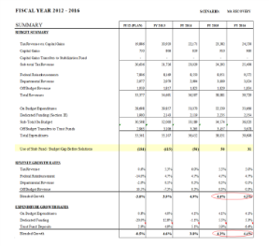
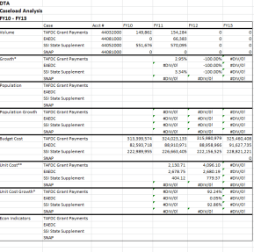
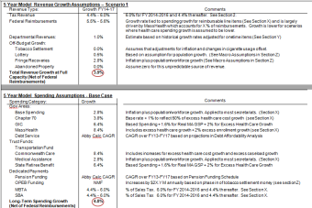
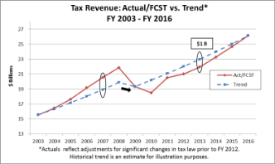
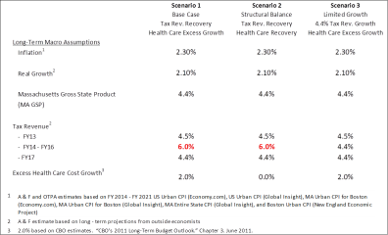

Macro Assumptions
Five Year Model
Revenue / Spending Growth

Caseload Forecasting
Using these policy benchmarks, the FY 2014 budget supports the achievement of our long-term fiscal goals as follows:
- Structural Balance: The budget is in structural balance based on the projected use of $686 M in one-time solutions (or $567 M net of $119 M in projected Stabilization Fund deposits) compared to an estimated $1 B cyclical deficit in tax revenue that is the result of the economy operating below its sustainable capacity. See Section 1D for details.

- Sustainable Spending Growth: Projected spending growth of 4.5% for FY 2014, net of federal reimbursements, exceeds the sustainable spending growth benchmark of 3.6%, which is based on estimated long-term rates of total revenue growth excluding federal reimbursements. However, projected spending growth is lower than projected revenue growth of 4.7%, excluding federal reimbursements. Five-year projections indicate that annual spending growth excluding federal reimbursements will decrease through FY 2016 but then grow to 4.3% by FY 2018. These projections assume that recent health care cost containment legislation, Chapter 224 of the Acts of 2012, will be successful in eliminating excess growth in health care costs. If instead health care costs continue to grow at a level that is consistent with both historic trends and projected rates of growth estimated by the Congressional Budget Office (CBO), annual spending growth is projected to increase to 4.9% by FY 2018.

Revenue and spending growth rates for this sustainable spending growth benchmark are calculated net of federal reimbursements because these inflows (e.g. Medicaid reimbursements) typically represent a fixed percentage of program cost. As a result, excluding reimbursements provides a more useful comparison of “net” spending relative to the Commonwealth’s other sources of revenue. In particular, the current framework has been updated to account for expected increases in health care spending and federal reimbursements as a result of the Affordable Care Act (ACA).

- Long-Term Liability Management: The policy objective for long-term liabilities is to implement a comprehensive plan to manage debt and reduce unfunded retirement liabilities over time. The disciplined management of long-term liabilities is necessary to ensure that the decisions made to balance the budget today do not result in shifting fiscal burdens to future generations. The analysis in Section 3 identifies the Commonwealth’s Debt Affordability Analysis and policies currently in place to address unfunded pension liabilities. In February 2013, Governor Patrick filed legislation which included measures to address unfunded liabilities for retiree health care. These liabilities, which are also referred to as Other Post Employment Benefit or “OPEB” obligations, total over $16 B for employees and retirees of the state and are estimated to be $25 B or more for cities and towns in the Commonwealth. The potential savings from this proposed reform is between $15 B and $20 B for the state and local systems over the next 30 years.

Document Road-Map
Section 1 describes the concept of structural balance and the long-term tax revenue forecast for the Commonwealth, as well as policy benchmarks for the allowable use of one-time resources, Stabilization Fund deposits, and the allowable use of excess tax revenue in the state budget. Section 2 includes an analysis of sustainable spending growth under different scenarios using the five-year model. Section 3 outlines existing policies to manage long-term liabilities and the need to further address unfunded liabilities associated with OPEB. Section 4 identifies areas for further study to enhance the Long-Term Fiscal Policy Framework. The appendices include a glossary of the technical terms used throughout the document (Appendix A) and the detailed output from the five-year model (Appendix B).
The long-term tax revenue forecast, five-year model, and analyses of long-term liabilities were developed using models and assumptions that are updated periodically as additional information becomes available. The Long-Term Fiscal Policy Framework for FY 2014 includes updates to reflect new trends in revenue growth, spending, and other factors.

Section 1 – Structural Balance and Long-Term Tax Revenue Forecasting
1A. Overview
Structural balance is achieved when budgetary spending is based on sustainable levels of revenue and does not include excess spending that would result in a structural deficit. When the economy is operating below its sustainable capacity (or below “full employment”), the policy benchmark to evaluate structural balance compares the cyclical deficit in tax revenue to the amount of one-time solutions included in the budget to offset this deficit. When the economy is operating above its sustainable capacity (or above full employment), the policy benchmark to evaluate structural balance compares the cyclical surplus in tax revenue to the amounts deposited into the Stabilization Fund. These policy benchmarks are based on a framework for long-term tax revenue forecasting developed by the Executive Office of Administration and Finance (A & F) in collaboration with the Commonwealth’s Office of Tax Policy Analysis (OTPA), using revenue projections provided by outside economists. The FY 2014 budget proposal is in structural balance based on these benchmarks because the proposed use of $686 M in one-time resources, or $567 M net of Stabilization Fund deposits, is significantly less than an estimated $1 B cyclical deficit. The goal to maintain structural balance is further supported by policies that account for actual-to-budgeted variances in tax revenue and place limits on the use of non-recurring sources of tax revenue in the budget.

1B. Structural Balance Policy Framework

Government budget gaps are comprised of two sources of fiscal imbalance: cyclical and structural. Cyclical imbalance occurs when an economy is operating at a level that is over or under its sustainable capacity. Cyclical imbalance is reflected in fluctuations in tax revenue as well as enrollment in welfare safety net programs. The FY 2014 Consensus Tax Revenue estimate reflects a cyclical deficit, as the economy is still recovering from the recession and operating below its sustainable capacity. This stands in contrast to the cyclical surpluses and excess tax revenue that existed before the recession, most notably during FY 2006-FY 2008, when the economy was operating above a sustainable level. Structural imbalance refers to any difference between recurring spending and recurring revenue across the economic cycle. Structural imbalance, therefore, is the amount of any budget gap excluding cyclical imbalance. See Appendix A for a glossary of terms.

The formula Total Budget Gap = Structural Imbalance + Cyclical Imbalance provides a framework to evaluate structural balance throughout the economic cycle. During periods of cyclical deficit, structural balance is achieved so long as the use of one-time solutions to close any budget gap does not exceed the level of cyclical deficit. This deficit, as discussed above, includes the shortfall in tax revenue compared to the level that would be expected if the economy were operating at full employment. The use of one-time resources during a period of cyclical deficit, however, can only be rationalized if policies are also in place to prevent over-spending during periods of cyclical surplus. To maintain structural balance during a period of cyclical surplus, there should be limitations on the use of one-time resources and requirements to deposit excess tax revenue into the Stabilization Fund.

Based on this framework for maintaining structural balance, the Administration has adopted the following policies: (1) in a state of cyclical deficit, the allowable use of one-time budget solutions should be limited to not more than the level of cyclical deficit and (2) in a state of cyclical surplus, the budget should not rely on any one-time resources and all of the excess tax revenue that is associated with the economy operating above its sustainable capacity should be deposited into the Stabilization Fund. The Long-Term Fiscal Policy Framework defines structural balance as the absence of a structural deficit (rather than quantifying any estimate of structural surplus). Note also that the Long-Term Fiscal Policy Framework currently takes a conservative posture by not including estimates for sources of cyclical deficit other than tax revenue (e.g. higher spending for welfare safety net programs). See Appendix D for a more formal treatment of the development of these policy benchmarks.
1C. Long-Term Tax Revenue Forecast
The foundation for the long-term tax revenue forecast is 10-year tax revenue projections developed by outside economists for the FY 2013 - FY 2022 time period. These forecasts also include an estimate of the long-run “steady state” tax revenue growth rate, which reflects the level of annual tax revenue growth that may be expected over the next 10 to 20 years when the economy is operating at full employment. This steady state growth is used to develop the long-term trend line for tax revenue that is included in Figure 2 and referenced in Table 3.
Preliminary forecasts for FY 2013 – FY 2022 were developed in December 2012, in parallel with the annual consensus revenue process, and used to inform the development of the Governor’s FY 2014 budget proposal. These forecasts showed strong revenue growth of 6.0% annually during a projected economic recovery between FY 2014 and FY 2017 and a steady state of 4.0% applied to the period between FY 2018 and FY 2022. At that time, A & F estimated a cyclical shortfall of $1.313 B, which represents the difference between the FY 2014 consensus tax revenue estimate of $22.334 B and the estimated $23.647 B in tax revenue that the Commonwealth would generate if the economy were operating at full capacity.
These tax forecasts were updated in July 2013. Based on these forecasts, A & F estimates less robust revenue growth of 5.5% annually during the projected economic recovery between FY 2014 and FY 2017, before reaching the steady state of 4.0% applied to the period between FY 2018 and FY 2022. Additionally, the FY 2014 revenue estimate has been increased to $22.797 B to reflect changes in tax law effective in FY 2014, including the elimination of the utilities corporation designation, the implementation of sales factor sourcing for services, increases to the tobacco excise, and increases to the gas and special fuels taxes.
A summary of the external forecasts, the Administration’s estimates for long-term tax revenue growth, key assumptions and calculations are reflected in Table 2.
Table 2
Long-Term Tax Revenue Forecast Summary
The estimated FY 2014 cyclical deficit of $1.001B reflects the difference between the $22.797 M budgetary tax revenue estimate adjusted for changes in tax law and the FY 2014 estimate of $23.798 B associated with the tax revenue trend-line calculated using the formula described in above and noted in Table 2.
1D. Measuring Structural Balance

The Governor’s FY 2014 budget proposal achieves structural balance based on an estimated $1B cyclical deficit and the use of $567 M in one-time resources, net of Stabilization Fund deposits (see Table 3). The cyclical deficit reflects the difference between the FY 2014 consensus tax revenue forecast and the estimated amount of tax revenue that the Commonwealth would generate if the economy were at its sustainable capacity, represented by the revenue trend line in Figure 2.
Figure 2
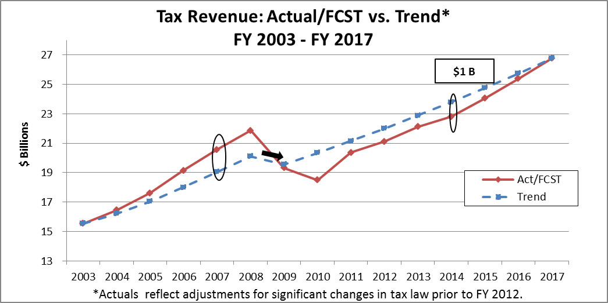

The $567M limitation on the use of one-time resources provides a significant margin of safety in comparison to the cyclical deficit and the $231 M limitation on the net use of Stabilization Funds will maintain an estimated $1.3 B in Stabilization Fund balances at the end of FY 2014. The Commonwealth’s estimated Stabilization Fund balance at the end of FY 2013 was the fourth highest in the country, and the projected Stabilization Fund for year-end FY 2014 will provide sufficient resources to support the balance of the economic recovery and protection in the event of another economic slowdown.

Table 3
FY 2014 One-Time Resources
 | $Ms
Budgetary Resources:
Stabilization Resources | $350
Stabilization Fund Interest | $11
Delay FAS 109 Deduction | $46
Adjust DSTI Hospital Payments Fund | $41
One-Time Gaming Funds Supporting Ongoing Costs | $32
Sale of Assets | $42
Procurement Savings | $30
OPEB funded through Debt Service Reversions | $51
Non-Budgetary Resources:
Trust Sweeps or Cost Shifts | $40
Group Insurance Trust Funds | $21
One-Time Shift of Health Care Costs to Gaming Funds | $16
Quasi-Public Contributions | $7
Total One-Time Resources: | $686
Less: Stabilization Fund Deposits | -$119
Total One-Time Resources Net of Deposits: | $567

1F. Related Policy Benchmarks

Limitation on Use of Capital Gains Tax Revenue

Legislation filed by Governor Patrick to limit the use of tax revenue from capital gains to $1 B for budgetary purposes was enacted with the FY 2011 budget. This policy was designed to protect against over-spending during periods when the economy is operating above a sustainable level. Tax revenue from capital gains represents approximately 5% of tax revenue on average but can account for as much as 50% of the cyclical volatility to trend in tax revenue (See Figure 3). The difference between the $2.1 B of tax revenue from capital gains received in FY 2008 compared to a $1.0 B threshold, for example, would explain the majority of the estimated excess revenue shown in Figure 2.
Under state finance law, tax revenues collected from capital gains income during a fiscal year that exceed a specified threshold are required to be transferred to the Commonwealth’s Stabilization Fund, with 5% of the amount so deposited then transferred to the State Retiree Benefits Trust Fund and an additional 5% transferred to the Commonwealth’s Pension Liability Fund. A threshold of $1 B was in effect for FY 2011, 2012 and 2013. For fiscal years after FY 2013, the threshold is subject to annual adjustment to reflect the average annual rate of growth in U.S. gross domestic product over the preceding five years. The adjusted threshold is certified annually by the Department of Revenue each December for the ensuing fiscal year. On December 28, 2012, the Department of Revenue determined the FY 2014 capital gains collections threshold to be $1.023 B. The Department of Revenue is also required, after each quarter, to certify the amount of tax revenues estimated to have been collected during the preceding quarter from capital gains income, and, once the threshold has been exceeded, the Comptroller is required to transfer the excess to the Commonwealth Stabilization Fund.
For FY 2013, the preliminarily certified amount of tax revenues collected from capital gains income as of July 18, 2014 was $1.467 B, or $467 M above the statutory threshold. Based on this and previous certifications, the Comptroller transferred $467 M to the Commonwealth Stabilization Fund and then made transfers from the Stabilization Fund to the Commonwealth’s Pension Liability Fund and the State Retiree Benefit Trust Fund of approximately $23.4 M each.

Figure 3
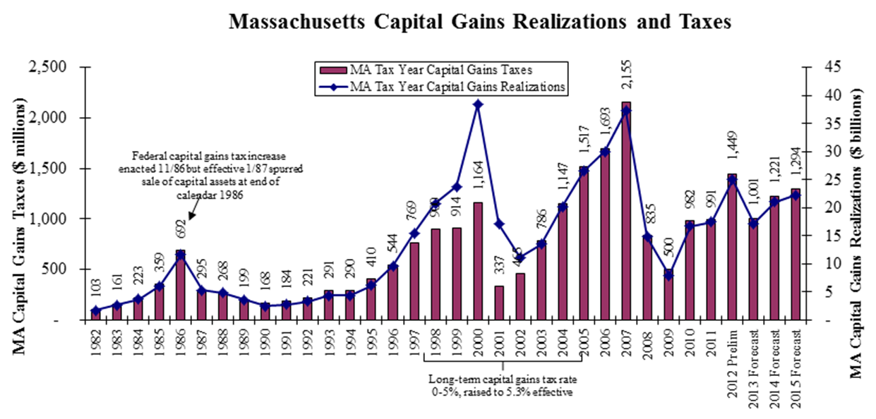
Source: Department of Revenue – Calendar Year Basis.

Settlements and Judgments
Legislation filed by Governor Patrick to deposit any settlements and judgments in excess of $10 M into the Stabilization Fund was enacted with the FY 2011 budget. Approximately $375 M and $33 M of such settlements and judgments were deposited into the fund in FY 2012 and 2013, respectively. The FY 2014 budget assumes $66 M of such settlements and judgments into the fund. This policy further reflects the discipline that has allowed the Commonwealth to accumulate one of the highest Stabilization Fund balances in the country since the end of the recession.
1G. Assumptions for Changes in Tax Law
The long-term tax revenue projections assume the impact of all changes in tax law that were enacted as of October 1, 2014 but do not assume any future changes. Notably, the long-term tax revenue projections do not include the impact of the possible reductions in the personal income tax rate from 5.25%. Chapter 62 of the Massachusetts General Laws was modified in 2002 to provide for a series of annual tax cuts over a ten-year period, provided that annual tax revenue growth is at least 2.5% after adjusting for inflation. The first four tax cuts were implemented in FY 2005 through FY 2008 as increases to the personal exemption and now have the effect of reducing annual tax revenue by approximately $600 M a year. In FY 2012, the fifth tax cut reduced the personal income tax rate from 5.30% to 5.25%. The remaining tax cuts, if implemented, would reduce the personal income tax rate to 5.00%. A & F estimates that the annual impact could reach $1 B by FY 2019.
1H. Development of Macroeconomic Assumptions for the Five-Year Model
The long-term tax revenue forecasts performed by outside economists provides certain macroeconomic indicators that have been applied by A & F to develop “Base Case” economic assumptions for the five-year model. These assumptions are summarized in Table 4 and referenced in the discussions of revenue and spending assumptions in Sections 2B and 2C. Note that these assumptions are updated periodically to reflect changes in economic conditions (e.g. more recent estimates indicate lower rates of inflation in the near-term).
Table 4
Long-Term Macroeconomic Assumptions: Base Case Scenario
 | Inflation¹ |  | 2.0%
 | Real Growth Per Capita ² |  | 1.6%
 | Population Growth |  | 0.5%
 | Excess Health Care Cost Growth |  | 0.0%
 | Excess Health Care Caseload Growth |  | 2.0%
 | Excess Ch. 70 Growth |  | 1.0%
1 | U.S. Urban CPI for FY 2014 - FY 2018 per Economy.com and Global Insight
2 | A&F estimate based on long-term projections from outside economists
Section 2 – Sustainable Spending Growth and Five-Year Model Results
2A. Summary of Results
The policy benchmark for sustainable spending growth is informed by the long-term tax revenue forecast described in Section 1E and evaluated using a five-year model informed by GFOA recommendations. The 3.6% benchmark for sustainable spending growth is based on the long-term weighted average of projected growth across all revenue sources, net of federal reimbursements (Table 5). This benchmark is largely driven by the long-term tax revenue growth rate of 4.0% discussed in Section 1E and is reduced by lower rates of growth for Departmental Revenue and Transfers From Off Budget Trust Funds (see Section 2B below). Note that the long-term policy benchmark for spending growth may change with updates to underlying assumptions and that spending may exceed the benchmark in certain years - particularly during periods of economic recovery - provided that structural balance is maintained over the five-year forecast period.
Table 5
Composition and Growth of Net Revenue
 |  | Net of Federal Reimbursements
 | Revenue/ Other Cash Inflows ($Ms) | Revenue/ Other Cash Inflows ($Ms) | % of Total | LT Growth Rate
Tax Revenue | $22,856 | $22,856 | 80.3% | 4.0%
Federal Reimbursements | $8,555 | n/a | n/a | n/a
Departmental Revenue | $3,673 | $3,673 | 12.9% | 2.0%
Transfers from Off Budget Trusts | $1,940 | $1,940 | 6.8% | 1.8%
Total | $37,025 | $28,469 | 100.0% | 3.6%

The FY 2014 budget projects spending growth of 4.5%, based on projected spending net of federal reimbursements of $27,459 M in FY 2013 and $28,691 in FY 2014 (Table 6). Although projected spending growth exceeds the long-term policy benchmark, projected spending growth is below projected revenue growth of 4.7%, after adjusting the FY 2014 consensus revenue estimate for recently enacted tax law changes. Structural balance is maintained for the five-year model results for FY 2015 – FY 2017, because spending growth of 3.7%, 3.6%, and 4.0%, respectively, is offset by strong tax revenue growth of 5.5% annually during an expected economic recovery.
In FY 2018, projected spending growth of 4.3% exceeds projected revenue growth of 3.6%. However, the FY 2018 budget is projected to be in balance without the need for spending cuts or other solutions, with total revenues exceeding spending by an estimated $388 M.

Table 6
FY 2013 and FY 2014 Spending and Recent/Projected Spending Growth
 | Total ($Ms) | Total ($Ms) | Growth
 | FY 2013 | FY 2014 | FY 13 - 14
Budgetary
MassHealth | $10,801 | $12,105 | 12.1%
Group Insurance Commission | $1,278 | $1,350 | 5.6%
Health and Human Services | $4,811 | $5,094 | 5.9%
Chapter 70 | $4,174 | $4,301 | 3.1%
Education | $2,033 | $2,173 | 6.8%
Debt Service | $2,340 | $2,431 | 3.9%
Public Safety | $958 | $996 | 4.0%
Local Aid | $926 | $949 | 2.4%
Remaining Budgetary Spending | $2,879 | $2,824 | -1.9%
Sub-Total | $30,201 | $32,222 | 6.7%
Dedicated Revenue | $1,532 | $1,553 | 1.4%
Sub-Total on Budget | $31,733 | $33,775 | 6.4%
Transfers to Off Budget Trust Funds
Pension | $1,552 | $1,630 | 5.0%
Transportation | $349 | $590 | 69.2%
Health Care Related¹ | $1,827 | $1,248 | -31.7%
All Other | $7 | $3 | -59.6%
Sub-Total | $3,735 | $3,471 | -7.1%
Total Spending | $35,468 | $37,246 | 5.0%
Less: Federal Reimbursements | -$8,008 | -$8,555 | 6.8%
Total Net of Federal Reimbursements | $27,459 | $28,691 | 4.5%
1. Includes the Commonwealth Care Trust Fund, State Retirees Benefit Trust Fund, Medical Assistance Trust Fund, and Delivery System Transformation Initiatives Trust Fund.

These projections assume that health care cost containment legislation will be successful in eliminating excess health care cost growth but that health care spending will continue to outpace revenue growth as a result of increases in health care related caseloads. See the discussion of health care cost growth in Section 2C. An additional driver of spending growth during the five-year forecast period is growth in the Commonwealth’s long-term liabilities. Based on the current pension funding schedule, transfers to the state pension fund are expected to increase 6.0% annually for FY 2015-FY 2017 and 8.4% for FY 2016-FY 2017. Transfers to the State Retiree Benefit Trust Fund to pay for retiree health benefits are expected to increase 5.5% annually, higher than historical rates and based on actuarial projections, as a result of both health care cost growth and demographic shifts.
2B. Five-Year Model
The components of the five-year model include: (1) Macroeconomic Assumptions; (2) projections for Revenue and Other Cash Inflows; (3) Projections for Spending and Other Cash Outflows; and (4) Scenario Analysis. The structure of the model follows GASB’s preliminary view on financial projections with respect to forecasting inflows, outflows, and debt service. The ability to perform scenario analysis supports a policy driven process, as prescribed by the GFOA.
Macroeconomic Assumptions
The five-year model applies consistent assumptions from Table 4 as building blocks for revenue and spending projections. The framework uses an inflation estimate of 2.0%, based on inflation forecasts provided by outside vendors. This inflation assumption plus the estimate of 1.6% real growth per capita were used in the development of a long-term estimate of 3.6% annual growth in Massachusetts Potential Gross State Product (PGSP), defined as the long-run average growth rate in the Commonwealth’s economy, excluding fluctuations due to the business cycle. As provided in Chapter 224, PGSP is also used as the foundation for projected rates of health care cost growth, as discussed in Section 2C. The 3.6% PGSP estimate, plus an estimated 0.5% population growth, closely aligns with the model’s 4.0% long-run tax revenue growth assumption.
Revenue and other Cash Inflows
Revenue and other cash inflows include tax revenue, federal reimbursements, departmental revenue, and transfers from off budget trust funds. Tax revenue of $22.856 B, including $59 M in budgeted use of one-time tax and other settlements, accounts for 61% of all inflows (Figure 4) in the FY 2014 Budget and is projected to grow by 4.0%-5.5% annually between FY 2014 and FY 2018, as discussed in Section 1D.
Figure 4
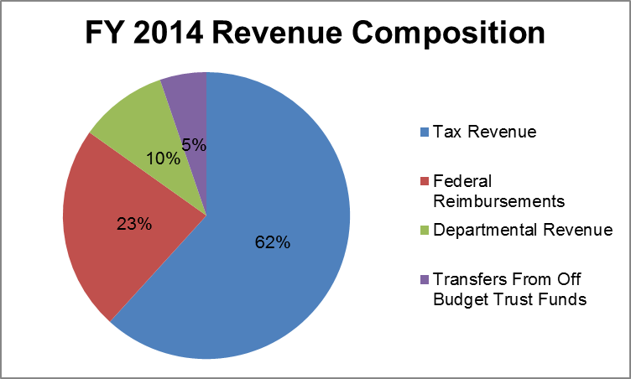
Federal reimbursements of $8.555 B make up 23% of projected FY 2014 revenue. Over 70% of these inflows are associated with Medicaid reimbursements to MassHealth. The long-term model’s projections take into account increased federal reimbursements as a result of the ACA, which will take effect on January 1, 2014. Under the ACA, the Commonwealth will see increased federal reimbursements as a result of the expansion of Medicaid coverage to low-income adults and the availability of enhanced Federal Medical Assistance Percentages (FMAPs) for the newly covered population. Additionally, the ACA will increase the already enhanced FMAP for the Children’s Health Insurance Program (CHIP) beginning October 1, 2015. As a result of these changes, federal Medicaid reimbursements are projected to grow by 18% from FY 2014 to FY 2015, the first full year of implementation (See Table 7). Note that the MassHealth federal reimbursements associated with the ACA Medicaid Expansion Population in Table 7 include reimbursements for both newly eligible populations and populations previously covered by MassHealth.
Table 7
MassHealth Federal Reimbursements
 | Federal Reimbursements ($Ms)
 | FY 2014 | FY 2015 | FY 2016 | FY 2017 | FY 2018
ACA Medicaid Expansion Population | $652 | $1,458 | $1,672 | $1,869 | $2,072
ACA CHIP FMAP Increase | $0 | $0 | $76 | $102 | $102
ACA Subtotal | $652 | $1,458 | $1,748 | $1,971 | $2,174
All Other | $5,440 | $5,706 | $6,200 | $6,736 | $7,319
Total | $6,093 | $7,165 | $7,948 | $8,707 | $9,493
Growth Rate |  | 18% | 11% | 10% | 9%

Federal reimbursements attributed to the Commonwealth Care Trust Fund are expected to decrease over the forecast period, as certain groups become newly eligible for Medicaid or begin receiving federal premium tax credits to help pay for qualified health plans purchased through the Health Connector. The new ConnectorCare plans, which provide subsidized insurance for income-eligible individuals, will receive at least a 50% reimbursement on premiums from the federal government. Other federal reimbursements are projected to grow with associated spending, with the exception of education grants, which are assumed to be flat.
Departmental revenues comprise 10% of estimated FY 2014 revenue and are generated across multiple agencies in state government (See Figure 5). The significant majority of departmental revenues are associated with three agencies: A & F (26%), including chargebacks from non-state entities for use of the Group Insurance Commission (GIC), Health & Human Services (23%), and Transportation (16%), including registration and vehicle title fees generated by the Registry of Motor Vehicles.
Figure 5
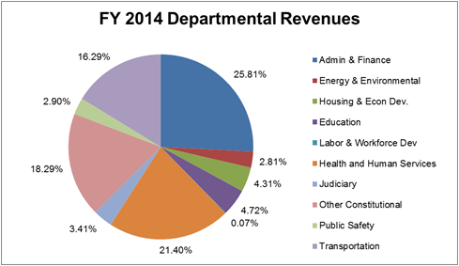
The projected growth rate for departmental revenues of 2.0% for FY 2014-FY 2018, as shown in Figure 6, is conservative relative to three- and five-year compound annual growth rates of 3.7% and 5.1%, respectively. These growth rate calculations exclude reimbursements from non-state entities participating in the GIC and health care drug rebates from the federal government (See Figure 6). The impact of growth in GIC reimbursements, which are expected to increase over time as a result of Chapter 69 of the Acts of 2011, the municipal health care reform law, was excluded from the historical growth rate calculation given that these revenues will be directly offset by budgetary spending and the uncertainty of projecting the rate at which municipalities will adopt the GIC. The impact of growth in health care drug rebates was excluded given that significant growth over recent years reflects, in part, changes in federal payments under the Affordable Care Act. Revenues from these sources are included in the FY 2014 budget estimate and, for purposes of the five-year model, are assumed to grow at the rate applied to all departmental revenues for FY 2015-FY 2018.

Figure 6
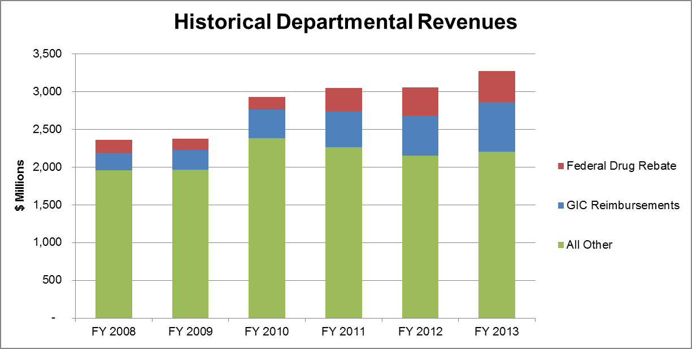

Transfers from off budget trust funds of $1.940 B in the FY 2014 budget include revenues from the lottery ($1.037 B), the Master Settlement Agreement or “tobacco proceeds” ($254 M), fringe recoveries to the general fund ($292 M), and unclaimed property recoveries ($82 M). Lottery revenues are projected to grow at 2.0% annually based on a long-term historical trend analysis provided by the Office of the State Comptroller. Master Settlement Agreement proceeds refer to the annual payments made by participating tobacco manufacturers, stemming from a settlement agreement between the tobacco companies, the Massachusetts Attorney General, and 45 other states. Tobacco proceeds are assumed to be flat based on the expectation that adjustments for inflation and other variables that would otherwise increase the amounts paid to the states will be offset by reduced cigarette usage and other factors that may lower future payments, based on the formula included in the settlement agreement.

Fringe recoveries represent the state’s share of fringe benefit costs – health insurance, pensions and terminal leave salaries – on all Federal grant and other non-budgetary accounts. The assessment of fringe benefits on Federal funds is mandated by section 6B of Chapter 29 of the Massachusetts General Laws. Section 5D of the same law extends that assessment to all other funds of the Commonwealth except the General Fund. The fringe rate is determined on a two-year lagged basis, with adjustments for over and under-recoveries. In FY 2011 and FY 2012, the Commonwealth over-recovered fringe and payroll taxes, primarily due to lower than projected GIC costs and some Medicare tax adjustments. The FY 2013 and FY 2014 fringe rates were reduced to offset the over-recoveries in those years. The FY 2015 rate will not be reduced due to over-recoveries and will return to the “true” annual cost of fringe benefits. As a result, fringe recoveries are projected to grow by approximately 20% from FY 2014-FY 2015 and by approximately 10% from FY 2015-FY 2016. For FY 2016-FY 2017 and FY 2017-2018, fringe recoveries are projected to grow by 4.7% and 5.4%, respectively, based on a methodology provided by the Office of the State Comptroller using spending growth rates for the Group Insurance Commission and pensions. Total growth for off budget trust funds is projected at 1.4%-2.3% annually during FY 2015-FY 2018, based on these assumptions.

Spending/Cash Outflows
Spending and other cash outflows are comprised of budgetary spending (86.5%), dedicated revenue (4.2%), and transfers to off budget trust funds (9.3%). FY 2014 spending includes budgetary spending of $32.222 B, which is projected to grow by between 4.5% and 5.9% annually, driven primarily by maintenance spending of 2.7% for most programs and a blended average of 6.9% for health care related spending as discussed in Section 2C. The detailed spending growth assumptions are included in Table 9.
Dedicated revenues account for $1.553 B in spending in FY 2014 and include mandated allocations to the Massachusetts Bay Transit Authority (MBTA) and the School Building Authority (SBA), both of which are tied to the sales tax. Transfers to off budget trust funds account for $3.471 B in spending and include deposits into the Commonwealth’s Pension Liability Fund, State Retiree Benefits Trust Fund, Commonwealth Care Trust Fund, Medical Assistance Trust Fund and Commonwealth Transportation Fund.
Projected growth in transfers to the Commonwealth Care Trust Fund is based on internal analysis of spending and revenue offsets, accounting for recent policy changes. The ACA will reduce Commonwealth Care spending beginning in the second half of FY 2014, as some groups move from state-funded programs to receiving federal premium tax credits to help purchase insurance. Additionally, new employer responsibility payments and the recently enacted increase in the tobacco tax will offset spending in FY 2014 and future years. As a result, transfers to the CCTF are expected to decrease from $340 M in FY 2014 to $19 M in FY 2015. However, the model indicates that transfers will increase in future years, reaching $80 M in FY 2018, because growth in spending is projected to exceed growth in offsets.
Transfers to the Commonwealth Transportation Fund are expected to increase by $241 M, to $590M, in FY 2014 and to reach $804 M FY 2018. This increase in the transferred amount would eliminate the need to use bonds to pay for MassDOT’s daily operations and payroll; eliminate the Massachusetts Bay Transportation Authority (MBTA)’s operating deficit; and end the practice of funding in arrears the operating budgets of the regional transit authorities (RTAs), thereby eliminating the need for the RTAs to take on short-term debt in order to fund annual operating costs.

2C. Health Care Spending Growth
Health care spending growth is a focal point of the five-year model given that health care’s share of on-budget spending, before federal reimbursements, has increased from 23% to 43% between FY 2000 and FY 2014.

Figure 7
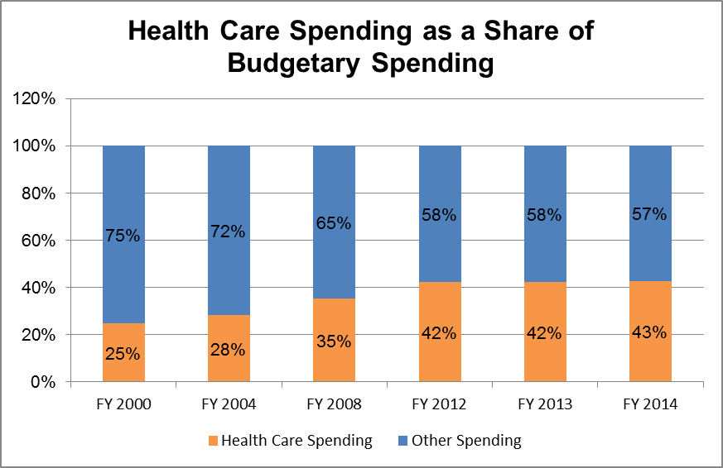

This increase in health care spending as a share of budgetary spending is the result of high enrollment growth in the federally subsidized Medicaid programs, as well as excess health care cost growth. Enrollment growth in MassHealth has been especially rapid as a result of the increased demand for safety net programs since the onset of the recession. Between FY 2007 and FY 2013, MassHealth enrollment increased at a compound annual growth rate of 4.7%. Enrollment growth is expected to slow somewhat as the economy recovers, reflected in projected enrollment growth of 3.25% annually.

Excess cost growth is defined as the extent to which health care spending per capita is growing faster than the overall economy. In the United States, excess growth for all health care expenditures has ranged from 1.2% to 1.9% annually over the past 20 to 35 years.

Table 8
* Based on Governor’s FY 2013 Budget proposal
Excess Cost Growth in U.S. Spending for Health Care
 | Medicare | Medicaid | Other | Overall
1975 to 2011 | 2.0% | 1.6% | 1.9% | 1.9%
1980 to 2011 | 1.7% | 1.2% | 1.8% | 1.7%
1985 to 2011 | 1.5% | 0.8% | 1.6% | 1.5%
1990 to 2011 | 1.3% | 0.2% | 1.3% | 1.2%
Source: Congressional Budget Office

In August 2012, Governor Patrick signed into law Chapter 224 of the Acts of 2012, the next phase of Massachusetts health care reform, which aims to limit health care cost growth to the growth in the overall state economy and ensure that health care costs do not squeeze out spending for other priorities. The legislation establishes a statewide health care cost growth goal linked to growth in the state’s overall economy, defined as the growth rate of potential gross state product (PGSP), and introduces a number of payment and other reforms in order to bring down costs. The law is projected to result in savings of nearly $200 B over 15 years for families, businesses, and government.

Five-Year Model Assumptions

Health care related spending includes benefits for state employees and retirees administered by the Group insurance Commission (GIC) as well as federally subsidized programs overseen by MassHealth and the Health Connector. In the FY 2014 budget, health care accounts for approximately 43% of on-budget spending and 29% of spending net of federal reimbursements. Note that this figure also GIC spending as a result of the municipal health care reform law, even though this spending is directly offset by revenues.

The framework’s base case assumes that recent health care cost containment legislation is successful in limiting health care cost growth to growth in potential gross state product (PGSP). Section 30(b) of Chapter 224 requires the Secretary of A & F and the House and Senate Committees on Ways & Means to set a benchmark for the estimated growth rate of potential gross state product (PGSP), which is then used by the health policy commission to establish the Commonwealth’s health care cost growth benchmark. On January 15, 2013, the PGSP estimate for calendar year 2014 was set at 3.6% as part of the state’s existing consensus tax revenue forecast process, with input from outside economists and in consultation with Administration & Finance, the House and Senate Committees on Ways & Means, the Department of Revenue’s Office of Tax Policy Analysis, and members of the Health Policy Commission. The model assumes a 3.6% PGSP growth rate over the five-year forecast period.

For scenarios in which health care costs growth occurs, excess cost grow is assumed to be 1.8% annually, informed by estimates that total health expenditures per capita in Massachusetts grew at an annualized rate of 5.9% from 1991 to 2009 (see Figure 9). This implies 1.8% excess cost growth based on an estimated per capita economic growth of 4.1% during this time period.
Table 10
Annual Rate of Increase of Per Capita Health Expenditures by Service in Massachusetts
 | 1991-2000 | 2000-2009 | 1991-2009
Hospital Care | 3.3% | 7.3% | 5.3%
Physician & Other Professional | 5.4% | 6.9% | 6.2%
Other Personal Health Care | 7.0% | 6.7% | 6.8%
Prescription Drugs | 9.4% | 6.5% | 7.9%
Nursing Home Care | 3.5% | 4.7% | 4.1%
Total | 5.0% | 6.8% | 5.9%
Source: Centers for Medicare and Medicaid Services

Enrollment growth is estimated to be 0.5% for the Group Insurance Commission, based on annualized growth over the past three years, and 3.25% for MassHealth, based on historical trends and internal projections.

2D. Results and Scenario Analysis
Scenario 1: Economic Recovery & No Excess Health Care Cost Growth
The results of the revenue and spending assumptions described in Sections 1E, 2B, 2C and Table 9 are summarized in Figure 10 and provided in more detail in Appendix B as “Scenario 1 – Base Case.” These projections show declining cyclical deficits between FY 2014 and FY 2016 as the economy recovers from the recession. Structural balance is maintained over the five-year forecast period; however, the projections show spending growth outpacing revenue growth beginning in FY 2018.
Budget gaps are projected to persist through FY 2015, despite forecasts of high revenue growth during the first three years of the forecast period, because the rate of revenue growth is not sufficient to offset the fact that in FY 2014 current revenue is $567 M less than current spending. Note that these projections assume only maintenance-level spending for most existing government programs. They do not include significant new investments or the restoration of past budget cuts and may require policy changes to match revenue and spending growth in the long-term.
Figure 8
Scenario 1: Base Case - Economic Recovery & No Excess Health Care Cost Growth
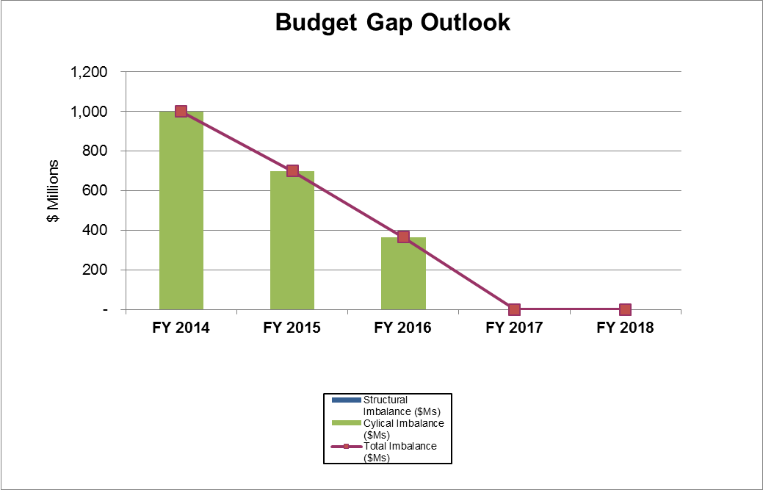

 | FY 2014 | FY 2015 | FY 2016 | FY 2017 | FY 2018
Cyclical Imbalance ($Ms) | $1,001 | $699 | $366 | - | -
Structural Imbalance ($Ms) | - | - | - | - | -
Total Imbalance ($Ms) | $1,001 | $699 | $366 | - | -
Revenue Growth | 4.7% | 4.3% | 4.9% | 4.8% | 3.6%
Spending Growth | 4.5% | 3.8% | 3.6% | 4.0% | 4.3%

The remaining scenarios show the risks associated with excess health care cost growth and/or lower than expected tax revenue growth. See Appendix B for details.
Scenario 2: Slow Recovery & No Excess Health Care Cost Growth
Scenario 2 assumes annual growth in tax revenue that is equal to the long-term estimate of 4.0% (3.6% net of federal reimbursements) but does not assume the higher levels of growth that would be consistent with a strong economic. Health care cost growth assumptions are consistent with Scenario 1. Scenario 2 indicates that if the economy does not recover as expected, cumulative budget gaps of more than $2 B over FY 2015- FY 2018 would result in structural deficits throughout the five-year forecast period and would result in a $780 M deficit in the Stabilization Fund balance by FY 2018. The depletion of the Stabilization Fund is based on the simplifying assumption, for purposes of this analysis, that these funds are required to offset any budget gap.
Figure 9
Scenario 2: Slow Recovery & No Excess Cost Growth
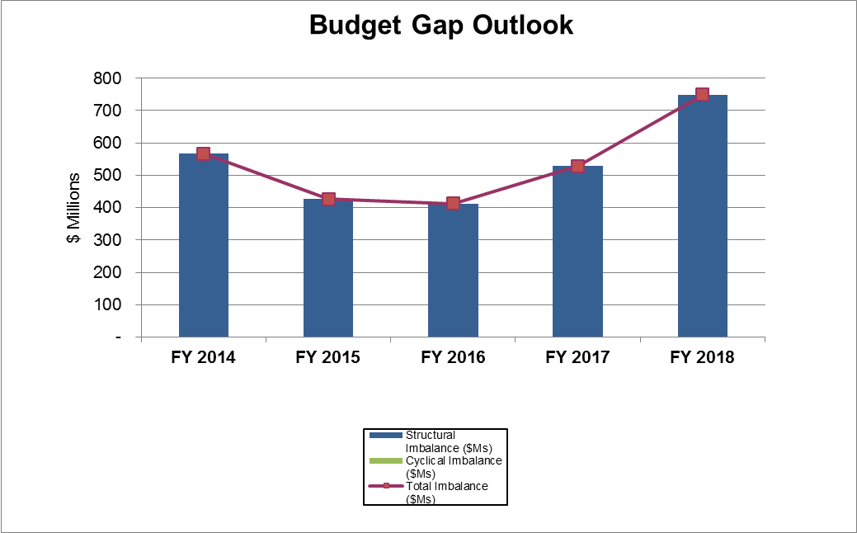

 | FY 2014 | FY 2015 | FY 2016 | FY 2017 | FY 2018
Cyclical Imbalance ($Ms) | - | - | - | - | -
Structural Imbalance ($Ms) | $567 | $426 | $412 | $528 | $749
Total Imbalance ($Ms) | $567 | $426 | $412 | $528 | $749
Revenue Growth | 4.7% | 3.1% | 3.6% | 3.6% | 3.6%
Spending Growth | 4.5% | 3.8% | 3.5% | 3.9% | 4.2%

Scenario 3: Economic Recovery & Excess Health Care Cost Growth
Scenario 3 assumes growth in tax revenue consistent with the long-term tax revenue forecast and assumes 1.8% excess growth in health care costs, which increases growth in health care spending. Scenario 3 demonstrates that even with a projected tax revenue recovery, excess health care cost growth would need to be eliminated in order to maintain structural balance over time. If excess health care cost growth persists, structural deficits would emerge beginning in FY 2018. The analysis projects budget gaps in FY 2015 and FY 2018, with modest surpluses in the intervening years. Cumulative budget gaps of $490 M over FY 2015- FY 2018 would reduce the stabilization fund balance by approximately one-third.
Figure 10
Scenario 3: Economic Recovery & Excess Cost Growth
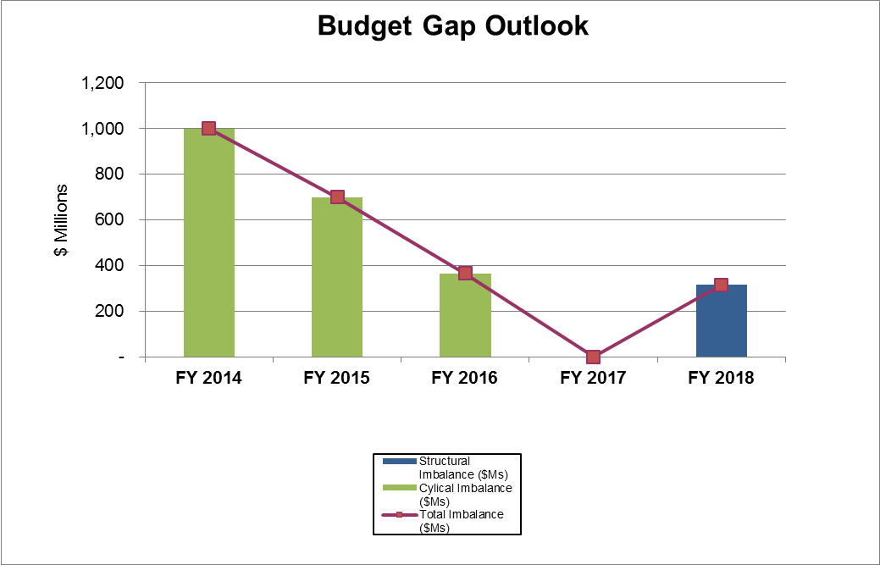
 | FY 2014 | FY 2015 | FY 2016 | FY 2017 | FY 2018
Cyclical Imbalance ($Ms) | $1,001 | $699 | $366 | - | -
Structural Imbalance ($Ms) | - | - | - | - | $317
Total Imbalance ($Ms) | $1,001 | $699 | $366 | - | $317
Revenue Growth | 4.7% | 4.3% | 4.9% | 4.8% | 3.6%
Spending Growth | 4.5% | 4.3% | 4.1% | 4.5% | 4.9%

Scenario 4: Slow Recovery & Excess Health Care Cost Growth
Scenario 4 assumes both a slow economic recovery, with annual growth in tax revenue equal to the long-term estimate of 4.0% (3.6% net of federal reimbursements), and 1.8% excess growth in health care costs. This scenario forecasts growing structural deficits over the five-year forecast and cumulative budget gaps of $3.7 B over FY 2015- FY 2018, resulting in a deficit in the Stabilization Fund of over $2 B by FY 2018.
Figure 11
Scenario 4: Slow Recovery & Excess Cost Growth

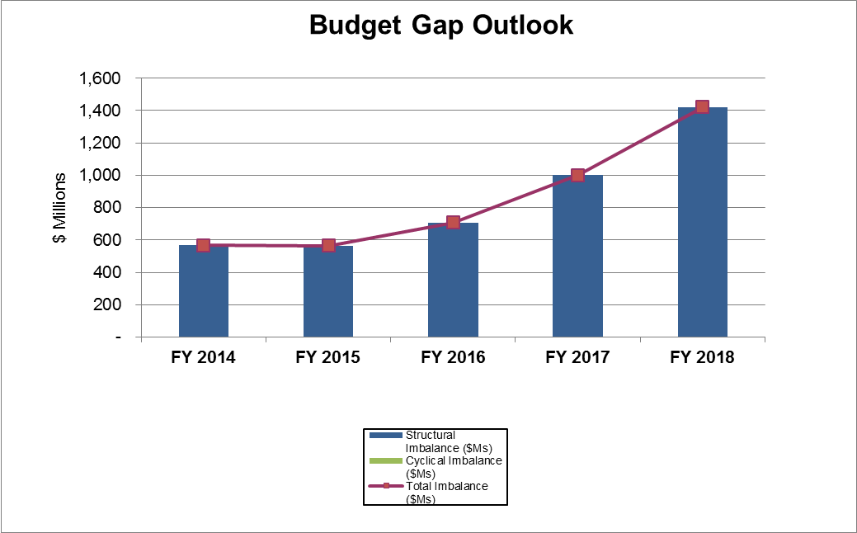

 | FY 2014 | FY 2015 | FY 2016 | FY 2017 | FY 2018
Cyclical Imbalance ($Ms) | - | - | - | - | -
Structural Imbalance ($Ms) | $567 | $566 | $707 | $1,000 | $1,421
Total Imbalance ($Ms) | $567 | $566 | $707 | $1,000 | $1,421
Revenue Growth | 4.7% | 3.1% | 3.7% | 3.6% | 3.6%
Spending Growth | 4.5% | 4.3% | 4.1% | 4.5% | 4.8%

Section 3 – Disciplined Management of Long-Term Liabilities
Overview
The Administration’s policy goal for long-term liabilities is to implement a comprehensive plan to manage long-term debt and address unfunded retirement liabilities. The management of Commonwealth debt is governed by the state’s Debt Affordability Analysis, which can be found here: http://www.mass.gov/bb/cap/fy2013/exec/hdebtaffordability.htm. Unfunded pension liabilities are addressed through adherence to a mandated funding schedule, best practices in benefit design, and a demonstrated commitment to pension reform to ensure system sustainability. The Commonwealth has also taken measures to address the unfunded liabilities associated with OPEB, which are estimated to be over $16 B for the state and over $25 B for municipalities. Additional policy measures to address OPEB liabilities, however, will be required to achieve the Long Term Fiscal Policy Framework goal to establish a comprehensive plan to manage long-term liabilities.
Pension Liabilities
The Commonwealth’s pension funding schedule is based on a statute that requires full funding by FY 2040 and triennial updates to the funding schedule. The current schedule was enacted as part of the FY 2012 Budget. The enabling legislation also included a provision that requires minimum contribution amounts through FY 2017, in order to prevent the use of asset gains to lower future appropriations. For a more detailed review of funding practices, see the PERAC 1/1/12 Actuarial Valuation (http://www.mass.gov/perac/pubdir/commvalreport.htm).
The Commonwealth has demonstrated a commitment to pension funding best practices while protecting benefits and improving the system through pension reform legislation. Most public employees in Massachusetts contribute 10% - 11% of their salary for future pension benefits, one of the highest contribution rates in the nation. The state, moreover, has made steady contributions (See Table 10) to the system at increasing levels in 17 of the last 20 years. Best practices followed by the Commonwealth include excluding overtime from pension calculations, limitations on cost of living adjustments, and a cap on benefits equal to 80% of compensation. The Administration has also been persistent in its pension reform efforts including the most recent legislation that is summarized in Table 11. The impact of this legislation is estimated to save state and local retirement systems in the Commonwealth more than $5 B over 30 years.
These measures will help to ensure that the Commonwealth can maintain a pension system that is fair and sustainable.
Table 10
Historical Pension Funding Amounts
Table 11
2011 Pension Reform
- Raises target retirement ages by two years, from 65 to 67 for most employees
- Aligns with social security
- Raises minimum retirement age to 60 for most employees
- Aligns with range of benefits available to taxpayers for 401(k) at 59 ½ and social security at 62
- Eliminates subsidies for early retirement
- Aligns with social security
- Savings of $5 B+ over 30 years for state and local systems
- Reforms measures to promote fairness and further address abuse:
- Eliminates Double Dipping – eliminates the right to receive a pension while receiving compensation or service as an elected official in the same position unless one year has passed from the end of the previous elected term.
- Introduces anti-spiking rule – limits the annual increase in pensionable earnings to no more than 10 percent of the average pensionable earnings over the last two years.
- Pro-Rates Benefits – retirement allowance for new employees who serve in more than one group will be pro-rated, taking into account the number of years of service in each group.
- Implements good governance initiatives to reform the operation of retirement boards by requiring training, filing of statements of financial interests and better regulation of procurements, stipends, and other management provisions.
- Improves equity within the system - benefit changes have the smallest impact on career employees with 30+ years of service, as these employees currently pay for the highest share of their pension benefit.

OPEB and Unfunded Liabilities for Retiree Health Care Benefits
The Commonwealth pays 80% of health insurance premium costs for new retirees with 10 or more years of public service. Local governments pay a varying share of retiree health insurance premium costs, but on average pay an estimated 75% of cost. The average cost of retiree health benefits for public employees in Massachusetts is among the highest of the 50 states and more generous than the benefit available to 80-90% of private sector employees in the Commonwealth. The present value of the unfunded OPEB liability for state and local public employees in Massachusetts is estimated to be over $40 B, which represents approximately $100 B in future payments.
The Patrick Administration has taken a number of steps to address this challenge including: increasing the share of health insurance costs paid by employees and retirees; establishing an investment trust for the purpose of funding future retiree health care liabilities; the commitment to phase-in proceeds from tobacco settlements to provide resources for the trust; allocating 5% of capital gains tax revenue over $1 B to the trust; and the recent pension reform legislation which raises retirement ages and as a result, is projected to lower retiree health care costs years by an estimated $2 B for the state and municipalities in the Commonwealth over the next 30 years.
These efforts, however, will only address a small part of the challenge. In February 2012, Governor Patrick introduced legislation that would take more significant steps towards lowering state and municipal OPEB obligations. This legislation was modeled after the recommendations of an OPEB Commission that was mandated as part of the pension reform legislation signed into law by Governor Patrick in November 2011. If enacted, this legislation would result in savings of $15 to $20 B for the Commonwealth and municipalities over the next 30 years. Reforms proposed in the bill include:
- Increasing the minimum years of service requirement from 10 to 20 years;
- Increasing the minimum age for eligibility by five years;
- Prorating benefits on a scale from a 50% premium contribution at 20 years to the maximum available benefit (currently, an 80% premium contribution for state retirees) at 30 years.
The proposed legislation would exempt all current retirees and certain employees who are very close to retirement age from the reforms. Certain other employees would be partially exempt from their reforms, based on their age and their years of service.
Section 4 –Areas for Further Study
In preparing future updates to this document, the Administration will reassess the adequacy of the Long Term Fiscal Policy Framework as a whole and identify additional measures and analyses to better support long-term fiscal planning. Areas for Further Study may include:
Expanded Use of Long-Term Economic Projections:
The long-term tax revenue forecasts provided by outside economists utilize certain assumptions with regard to workforce growth, productivity, population growth, and demographics in Massachusetts. Additional analyses of these projections could be used to improve the five-year model and to inform policy decisions across state government.

Improved Caseload Forecasting:
A & F’s Caseload Forecasting Office works with agencies, members of the legislature and outside experts to improve transparency and accuracy of caseload projections. These efforts will improve the five-year model projections by providing more accurate assumptions for long-term caseload growth for certain programs.

Comprehensive Evaluation of Long-Term Liabilities:
A & F has begun to monitor long-term liabilities as a percentage of state GSP including the liability categories – debt, pension, and OPEB – that were identified for initial evaluation by GASB. The Administration may consider policy benchmarks using this ratio and/or inclusion of additional liabilities in the calculations, such as deferred maintenance.

Analysis of Federal Government Dependencies:
The Commonwealth continues to monitor the potential impact on the state budget of policies to reduce the federal deficit. It is reasonable to assume that the state’s budget will be impacted directly through reduced federal reimbursements and the potential loss of jobs in defense and other key industries. The state may also be impacted indirectly in the event that federal budget cuts increase the level of services that states governments are required to provide. These impacts will continue be monitored going forward, consistent with the GASB proposed standard for a narrative related to interdependencies on other government entities.

Appendix A - GLOSSARY
Caseload Forecasting Office: Function within the Commonwealth Performance, Accountability and Transparency (CPAT) office charged with forecasting caseloads for “state-subsidized childcare, MassHealth, emergency assistance and housing programs, the group insurance commission, direct benefits provided by the department of transitional assistance” promoting “accuracy and transparency in all caseload forecasts” and performing “other related economic forecasts.” For more detail see G.L. Chapter 7 Section 4R.
Commonwealth’s Debt Affordability Analysis: The Patrick-Murray Administration’s formal analysis to ensure a transparent, rational policy for determining the annual bond cap. See http://www.mass.gov/bb/cap/fy2009/dnld/fy12capplan_a.pdf
Commonwealth’s Office of Tax Policy Analysis (OTPA): The Office of Tax Policy Analysis provides tax revenue forecasts, statistics on the Massachusetts tax system and estimates the fiscal impact of tax law changes. The OTPA is part of the Department of Revenue.
Congressional Budget Office (CBO): Since its founding in 1974, the Congressional Budget Office has produced independent, nonpartisan analysis of economic and budgetary issues to support the Congressional budget process.
Cyclical Deficit: Budget imbalance when the economy is operating below its sustainable capacity (i.e. below full employment), reflected in a shortfall in tax revenue and higher welfare spending compared to the level that would be expected if the economy were operating at its sustainable capacity (i.e. at full employment).
Cyclical Surplus: Budget imbalance when the economy is operating above its sustainable capacity (i.e. above full employment), reflected in excess tax revenue and lower welfare spending compared to the level that would be expected if the economy were operating at its sustainable capacity (i.e. at full employment).
Cyclical Imbalance: The presence of any cyclical deficit or surplus.
Debt Service: Annual payment of principal and interest on Commonwealth bonds. The Commonwealth borrows funds through the issuance of bonds to fund the majority of its capital investments. The issuance of bonds generates financial resources to fund capital programs, and also obligates future annual operating revenue for repayment of the bonds.
Dedicated revenues: Mandated expenditures for the Massachusetts Bay Transit Authority (MBTA) and the School Building Authority (SBA), both of which are tied to the sales tax.
Fringe recoveries: Fringe recoveries represent the state’s share of fringe benefit costs – health insurance, pensions and terminal leave salaries – on all Federal grant and other non-budgetary accounts. The assessment of fringe benefits on Federal funds is mandated by section 6B of Chapter 29 of the Massachusetts General Laws. Section 5D of the same law extends that assessment to all other funds of the Commonwealth except the General Fund.
GASB: The Government Accounting Standards Board is an independent body that sets accounting policies for government entities.
GFOA: The Government Finance Officers Association’s mission is to enhance and promote the professional management of governments for the public benefit by identifying and developing financial policies and best practices and promoting their use through education, training, facilitation of member networking, and leadership.
Gross Domestic Product (GDP): The market value (not quantity) of all final goods and services produced within the borders of a country within a specific time period, usually a calendar quarter or a year.
Gross State Product (GSP): The market value of all final goods and services produced within the borders of a state during within a specific time period, usually a calendar quarter or a year.
Inflation Rate: The percentage change in various prices indices, such as the consumer price index, from one period to the next.
Long-Term Liabilities: obligations which are not going to be paid for at least one year. These include future pension benefits, retiree health care benefits, and debt service payments.
Off Budget Trust Funds: Deposits and expenditures associated with the Pension Fund, State Retiree Benefit Trust Fund, Commonwealth Care Trust Fund, and Medical Assistance Trust Fund.
Other Post-Employment Benefits (OPEB): OPEB includes Post-Employment healthcare benefits as well as other retirement benefits provided separately from a pension plan, excluding benefits that are associated with termination.
Stabilization Fund: The Stabilization Fund accounts for amounts calculated in accordance with State Finance Law (Chapter 29, Section 5c of the General Laws) and maintains a reserve to enhance the Commonwealth's fiscal stability; It is a reserve of surplus revenues to be used for the purposes of: (1) covering revenue shortfalls, (2) covering state or local losses of federal funds, or (3) for any event which threatens the health, safety or welfare of the people or the fiscal stability of the Commonwealth or any of its political subdivisions. The fund is sometimes referred to as the state's "rainy day fund," serving as a source of financial support for the state budget in times of slow or declining revenue growth and as the primary source of protection against having to make drastic cuts in state services in periods of economic downturns.
State Retiree Benefit Trust Fund: Fund that invests assets allocated by the state to fund health care benefits of retired government employees.
Steady-State: A stable economy at full employment that is growing at a steady rate.
Structural Balance: Achieved when budgetary spending is based on sustainable levels of revenues, excluding fluctuations that can occur as a result of economic cycles; absence of a structural deficit
Structural Deficit: When recurring government spending exceeds the recurring revenue that is associated with the economy operating at a sustainable level of capacity (or full employment)
Sustainable Capacity: When the economy is operating at full employment
Total Budget Gap: The difference between total revenues and total government spending; comprised of both cyclical and structural components.
Trend-Line: Based on an estimate of what tax revenue would be in each year if the economy were at full employment.

Appendix B: Scenario Analysis
Key Assumptions

Base Case Revenue and Spending Growth Assumptions
Revenue Category | Growth | Comments
Tax Revenue | 4.0%-5.5% | 5.5% for FY 2014-2016 and 4.0% thereafter (See Section 1D).
Federal Reimbursements | 7.5%-11.6% | Growth is largely driven by MassHealth which accounts for 71% of reimbursements, with increases beginning FY14 as a result of the Affordable Care Act. Growth is lower for scenarios where health care spending growth is assumed to be lower.
Departmental Revenues | 2.0% | Estimate based on historical growth rates (See Section 2B).
Transfers From Off Budget Trust Funds
Lottery | 1.0% | Modest growth assumption. Historical growth has been relatively flat.
Tobacco Settlement | 0.0% | Assumes that adjustments for inflation and changes in cigarette usage offset.
Fringe Recoveries | See Section 2B | Function of growth in GIC and pensions
Abandoned Property | 0.0% | Assume zero growth for this unpredictable source of revenue.
Long-Term Blended Growth –  Net of Federal Reimbursements | 3.6% | Based on long-term growth rate of 4.0% for Tax Revenue

Spending Category | Growth | Comments
Budgetary Spending
MassHealth | 8.7% | Includes health care cost growth of 3.6% based on cost containment target plus 3.25% enrollment growth (See Section 2C).
GIC | 5.9% | Includes health care cost growth of 3.6% based on cost containment target plus 0.5% enrollment growth (See Section 2C).
Health and Human Services | 2.7% | Base growth rate. Informed by inflation plus population/workforce growth.
Chapter 70 | 3.7% | Base rate + 1% to reflect higher growth since 2008 (See Section 2B).
Debt Service | 3.0% | CAGR over FY14-FY18 based on projections in Debt Affordability Analysis.
Remaining Budgetary Spending | 2.7% | Base growth rate. Informed by inflation plus population/workforce growth.
Transfers to Off Budget Trust Funds
Pension Funding | 6.6% | CAGR over FY14-FY18 based on Pension Funding Schedule
Commonwealth Care | See Section 2B | Based on analysis of spending and revenue offsets, accounting for recent policy changes including the Affordable Care Act.
Medical Assistance | 0.0% | Assume zero growth.
State Retiree Benefit | 5.5% | Includes health care cost growth of 3.6% based on cost containment target plus 1.9% enrollment growth (See Section 2C).
Transportation Fund | See Section 2B | Based on analysis of transportation finance legislation.
Dedicated Revenue
OPEB Funding | $27M annually | Increases by $27M annually based on phase-in of tobacco settlement money
MBTA | 4.0%-5.5% | % of Sales Tax. 5.5% for FY 2014-2016 and 4.0% thereafter (See Section 1D).
SBA | 4.0%-5.5% | % of Sales Tax. 5.5% for FY 2014-2016 and 4.0% thereafter (See Section 1D).
Long-Term Blended Growth –  Net of Federal Reimbursements | 4.4% | CAGR over FY14-FY18.

Scenario 1: Base Case – Economic Recovery & Excess Health Care Cost Growth

 |  | FY 2014 | FY 2015 | FY 2016 | FY 2017 | FY 2018
REVENUE / OTHER CASH INFLOWS
 | Tax Revenue | $22,856 | $24,090 | $25,415 | $26,813 | $27,886
 | Federal Reimbursements | $8,555 | $9,436 | $10,131 | $10,781 | $11,434
 | Departmental Revenue | $3,673 | $3,630 | $3,702 | $3,776 | $3,852
 | Transfers From Off Budget Trust Funds | $1,940 | $1,969 | $2,014 | $2,043 | $2,076
 | Total Revenue / Cash Inflow | $37,025 | $39,124 | $41,263 | $43,413 | $45,247
SPENDING / OTHER CASH OUTFLOWS
 | Budgetary Spending | $32,222 | $34,144 | $35,694 | $37,327 | $39,048
 | Dedicated Revenue | $1,553 | $1,696 | $1,784 | $1,883 | $1,954
 | Sub-Total On Budget | $33,775 | $35,840 | $37,478 | $39,210 | $41,002
 | Transfers to Off Budget Trust Funds | $3,471 | $3,381 | $3,505 | $3,653 | $3,890
 | Total Spending / Cash Outflow | $37,246 | $39,221 | $40,984 | $42,863 | $44,892
 | Budget Gap Before Solutions | -$221 | -$96 | $279 | $550 | $355
REVENUE GROWTH RATES
 | Tax Revenue | 3.3% | 5.4% | 5.5% | 5.5% | 4.0%
 | Federal Reimbursements | 6.8% | 10.3% | 7.4% | 6.4% | 6.1%
 | Departmental Revenue | 12.3% | -1.2% | 2.0% | 2.0% | 2.0%
 | Transfers From Off Budget Trust Funds | 7.3% | 1.5% | 2.3% | 1.4% | 1.6%
 | Total Growth | 5.2% | 5.7% | 5.5% | 5.2% | 4.2%
 | Total Growth ex. Federal Reimbursements | 4.7% | 4.3% | 4.9% | 4.8% | 3.6%
EXPENDITURE GROWTH RATES
 | Budgetary Spending | 6.7% | 6.0% | 4.5% | 4.6% | 4.6%
 | Dedicated Revenue | 1.4% | 9.2% | 5.2% | 5.5% | 3.8%
 | Transfers to Off Budget Trust Funds | -7.1% | -2.6% | 3.7% | 4.2% | 6.5%
 | Total Growth | 5.0% | 5.3% | 4.5% | 4.6% | 4.7%
 | Total Growth ex. Federal Reimbursements | 4.5% | 3.8% | 3.6% | 4.0% | 4.3%
STABILIZATION FUND BALANCE
 | Beginning Balance | $1,557 | $1,336 | $1,240 | $1,519 | $2,069
 | Budget Gap Before Solutions | -$221 | -$96 | $279 | $550 | $355
 | Ending Balance / (Deficit) Before Solutions | $1,336 | $1,240 | $1,519 | $2,069 | $2,424

Scenario 2: Slow Recovery & No Excess Health Care Cost Growth

 |  | FY 2014 | FY 2015 | FY 2016 | FY 2017 | FY 2018
REVENUE / OTHER CASH INFLOWS
 | Tax Revenue | $22,856 | $23,748 | $24,698 | $25,686 | $26,713
 | Federal Reimbursements | $8,555 | $9,436 | $10,131 | $10,781 | $11,434
 | Departmental Revenue | $3,673 | $3,630 | $3,702 | $3,776 | $3,852
 | Transfers From Off Budget Trust Funds | $1,940 | $1,969 | $2,014 | $2,043 | $2,076
 | Total Revenue / Cash Inflow | $37,025 | $38,782 | $40,545 | $42,286 | $44,075
SPENDING / OTHER CASH OUTFLOWS
 | Budgetary Spending | $32,222 | $34,144 | $35,694 | $37,327 | $39,048
 | Dedicated Revenue | $1,553 | $1,683 | $1,758 | $1,834 | $1,886
 | Sub-Total On Budget | $33,775 | $35,827 | $37,452 | $39,161 | $40,934
 | Transfers to Off Budget Trust Funds | $3,471 | $3,381 | $3,505 | $3,653 | $3,890
 | Total Spending / Cash Outflow | $37,246 | $39,208 | $40,957 | $42,814 | $44,824
 | Budget Gap Before Solutions | -$221 | -$426 | -$412 | -$528 | -$749
REVENUE GROWTH RATES
 | Tax Revenue | 3.3% | 3.9% | 4.0% | 4.0% | 4.0%
 | Federal Reimbursements | 6.8% | 10.3% | 7.4% | 6.4% | 6.1%
 | Departmental Revenue | 12.3% | -1.2% | 2.0% | 2.0% | 2.0%
 | Transfers From Off Budget Trust Funds | 7.3% | 1.5% | 2.3% | 1.4% | 1.6%
 | Total Growth | 5.2% | 4.7% | 4.5% | 4.3% | 4.2%
 | Total Growth ex. Federal Reimbursements | 4.7% | 3.1% | 3.6% | 3.6% | 3.6%
EXPENDITURE GROWTH RATES
 | Budgetary Spending | 6.7% | 6.0% | 4.5% | 4.6% | 4.6%
 | Dedicated Revenue | 1.4% | 8.4% | 4.4% | 4.3% | 2.8%
 | Transfers to Off Budget Trust Funds | -7.1% | -2.6% | 3.7% | 4.2% | 6.5%
 | Total Growth | 5.0% | 5.3% | 4.5% | 4.5% | 4.7%
 | Total Growth ex. Federal Reimbursements | 4.5% | 3.8% | 3.5% | 3.9% | 4.2%
STABILIZATION FUND BALANCE
 | Beginning Balance | $1,557 | $1,336 | $910 | $498 | -$30
 | Budget Gap Before Solutions | -$221 | -$426 | -$412 | -$528 | -$749
 | Ending Balance / (Deficit) Before Solutions | $1,336 | $910 | $498 | -$30 | -$779

Scenario 3: Economic Recovery & Excess Health Care Cost Growth

 |  | FY 2014 | FY 2015 | FY 2016 | FY 2017 | FY 2018
REVENUE / OTHER CASH INFLOWS
 | Tax Revenue | $22,856 | $24,090 | $25,415 | $26,813 | $27,886
 | Federal Reimbursements | $8,555 | $9,554 | $10,391 | $11,205 | $12,047
 | Departmental Revenue | $3,673 | $3,630 | $3,702 | $3,776 | $3,852
 | Transfers From Off Budget Trust Funds | $1,940 | $1,969 | $2,019 | $2,052 | $2,090
 | Total Revenue / Cash Inflow | $37,025 | $39,243 | $41,527 | $43,847 | $45,875
SPENDING / OTHER CASH OUTFLOWS
 | Budgetary Spending | $32,222 | $34,395 | $36,233 | $38,197 | $40,294
 | Dedicated Revenue | $1,553 | $1,696 | $1,784 | $1,883 | $1,954
 | Sub-Total On Budget | $33,775 | $36,091 | $38,017 | $40,080 | $42,248
 | Transfers to Off Budget Trust Funds | $3,471 | $3,388 | $3,526 | $3,689 | $3,943
 | Total Spending / Cash Outflow | $37,246 | $39,479 | $41,544 | $43,768 | $46,191
 | Budget Gap Before Solutions | -$221 | -$236 | -$16 | $78 | -$317
REVENUE GROWTH RATES
 | Tax Revenue | 3.3% | 5.4% | 5.5% | 5.5% | 4.0%
 | Federal Reimbursements | 6.8% | 11.7% | 8.8% | 7.8% | 7.5%
 | Departmental Revenue | 12.3% | -1.2% | 2.0% | 2.0% | 2.0%
 | Transfers From Off Budget Trust Funds | 7.3% | 1.5% | 2.5% | 1.7% | 1.8%
 | Total Growth | 5.2% | 6.0% | 5.8% | 5.6% | 4.6%
 | Total Growth ex. Federal Reimbursements | 4.7% | 4.3% | 4.9% | 4.8% | 3.6%
EXPENDITURE GROWTH RATES
 | Budgetary Spending | 6.7% | 6.7% | 5.3% | 5.4% | 5.5%
 | Dedicated Revenue | 1.4% | 9.2% | 5.2% | 5.5% | 3.8%
 | Transfers to Off Budget Trust Funds | -7.1% | -2.4% | 4.1% | 4.6% | 6.9%
 | Total Growth | 5.0% | 6.0% | 5.2% | 5.4% | 5.5%
 | Total Growth ex. Federal Reimbursements | 4.5% | 4.3% | 4.1% | 4.5% | 4.9%
STABILIZATION FUND BALANCE
 | Beginning Balance | $1,557 | $1,336 | $1,100 | $1,084 | $1,162
 | Budget Gap Before Solutions | -$221 | -$236 | -$16 | $78 | -$317
 | Ending Balance / (Deficit) Before Solutions | $1,336 | $1,100 | $1,084 | $1,162 | $846
Scenario 4: Slow Recovery and Excess Health Care Cost Growth

 |  | FY 2014 | FY 2015 | FY 2016 | FY 2017 | FY 2018
REVENUE / OTHER CASH INFLOWS
 | Tax Revenue | $22,856 | $23,748 | $24,698 | $25,686 | $26,713
 | Federal Reimbursements | $8,555 | $9,554 | $10,391 | $11,205 | $12,047
 | Departmental Revenue | $3,673 | $3,630 | $3,702 | $3,776 | $3,852
 | Transfers From Off Budget Trust Funds | $1,940 | $1,969 | $2,019 | $2,052 | $2,090
 | Total Revenue / Cash Inflow | $37,025 | $38,901 | $40,810 | $42,719 | $44,702
SPENDING / OTHER CASH OUTFLOWS
 | Budgetary Spending | $32,222 | $34,395 | $36,233 | $38,197 | $40,294
 | Dedicated Revenue | $1,553 | $1,683 | $1,758 | $1,834 | $1,886
 | Sub-Total On Budget | $33,775 | $36,078 | $37,991 | $40,030 | $42,180
 | Transfers to Off Budget Trust Funds | $3,471 | $3,388 | $3,526 | $3,689 | $3,943
 | Total Spending / Cash Outflow | $37,246 | $39,467 | $41,517 | $43,719 | $46,123
 | Budget Gap Before Solutions | -$221 | -$566 | -$707 | -$1,000 | -$1,421
REVENUE GROWTH RATES
 | Tax Revenue | 3.3% | 3.9% | 4.0% | 4.0% | 4.0%
 | Federal Reimbursements | 6.8% | 11.7% | 8.8% | 7.8% | 7.5%
 | Departmental Revenue | 12.3% | -1.2% | 2.0% | 2.0% | 2.0%
 | Transfers From Off Budget Trust Funds | 7.3% | 1.5% | 2.5% | 1.7% | 1.8%
 | Total Growth | 5.2% | 5.1% | 4.9% | 4.7% | 4.6%
 | Total Growth ex. Federal Reimbursements | 4.7% | 3.1% | 3.7% | 3.6% | 3.6%
EXPENDITURE GROWTH RATES
 | Budgetary Spending | 6.7% | 6.7% | 5.3% | 5.4% | 5.5%
 | Dedicated Revenue | 1.4% | 8.4% | 4.4% | 4.3% | 2.8%
 | Transfers to Off Budget Trust Funds | -7.1% | -2.4% | 4.1% | 4.6% | 6.9%
 | Total Growth | 5.0% | 6.0% | 5.2% | 5.3% | 5.5%
 | Total Growth ex. Federal Reimbursements | 4.5% | 4.3% | 4.1% | 4.5% | 4.8%
STABILIZATION FUND BALANCE
 | Beginning Balance | $1,557 | $1,336 | $770 | $63 | -$937
 | Budget Gap Before Solutions | -$221 | -$566 | -$707 | -$1,000 | -$1,421
 | Ending Balance / (Deficit) Before Solutions | $1,336 | $770 | $63 | -$937 | -$2,358

Appendix C

The development of policy rules using the Total Budget Gap formula is provided below:

- Total Budget Gap = Structural Imbalance + Cyclical Imbalance

Re-arranging terms:

- Structural Imbalance = Total Budget Gap – Cyclical Imbalance

Replacing Total Budget Gap with the negative value of One-Time Solutions OR Stabilization Fund deposits:

- a) During Cyclical Deficit: Structural Imbalance = Cyclical Deficit – One-Time Solutions
Therefore, IF One-Time Solutions ≤ Cyclical Deficit, THEN Structural Surplus/Balance

b) During Cyclical Surplus: Structural Imbalance = Stab Fund Deposits – Cyclical Surplus
Therefore, IF Stab Fund Deposits ≥ Cyclical Surplus, THEN Structural Surplus/Balance

See http://www.mass.gov/treasury/debt-management/key-resources/rating-report-history-chart.html
The purpose of this document is not to assess whether the level of services and investments that can sustainably be provided is adequate or excessive. The appropriate role of government and whether government should be doing more or less is a policy question that this analysis does not attempt to address. Rather, this Long-Term Policy Framework is intended to help ensure that the level of government services and investments currently provided is sustainable over time based on existing resources.
Excess growth refers to “the extent to which the annual growth rate of health spending per beneficiary – adjusted for demographic characteristics of the relevant populations – is assumed to exceed the annual growth rate of nominal gross domestic product per capita.” Congressional Budget Office. “CBO’s 2011 Long-Term Budget Outlook.” Chapter 3. June 2011.
The “net of federal reimbursements” growth rates are calculated by reducing total revenue and total spending by the amount of federal reimbursements projected in each fiscal year.
The State’s liability is based on the 1/1/2012 actuarial valuation. Massachusetts Taxpayers Foundation estimates that state and municipal OPEB liabilities total between $40 B and $45 B. See Massachusetts Taxpayers Foundation. “The Crushing Burden of Municipal Retiree Health Care Liabilities.” January 2012.
The terms “sustainable capacity” and “full employment” both refer to an economy that is producing the maximum level of output that will not result in excess rates of inflation. These terms are used interchangeably in this document.
The $686 M in one-time resources (See Table 2) includes $350 M in Stabilization Fund resources. The “net” use of Stabilization Fund and total one-time resources is $231 M and $567 M, respectively, after taking account for the projected deposit of $119 M into the Stabilization Fund from tax revenue from capital gains receipts, one-time tax and other settlements above $10 M, and the repayment of gaming licensing revenues associated with the 2011 Expanded Gaming Act provision that used $20 M of Stabilization Fund proceeds to fund the start-up costs for gaming oversight activities.
Organisation for Economic Co-Operation and Development. Government at a Glance 2011. July 2011.
Ibid.
The imputed revenue-trend line is developed using the FY 2022 tax revenue estimate for each forecast, discounted for the steady-state rate of revenue growth and calculating trend revenue for each year “t” between the current year and year “s,” the final year forecasted, where “g” is the long-run steady state growth rate. For year t<s: Tax Revenue_{t} = (Tax Revenues)/(1+g)^{(s-t)} For year t>s: Tax Revenue_{t} = (Tax Revenues)*(1+g)^{(t-s)}
The Center for Budget and Policy Priorities recently completed a projection of what aggregate state government tax revenues would be had the pre-recession trend continued. See “States Continue to Feel Recession’s Impact.” http://www.cbpp.org/cms/index.cfm?fa=view&id=711
See footnote 9
The National Governors Association and the National Association of State Budget Officers. “The Fiscal Survey of States: Spring 2013.”
G.L. c. 29, sec. 5G, inserted by Section 19 of Chapter 131 of the Acts of 2010
Represents fiscal year receipts. Figure 3 is on a calendar year basis.
G.L. c. 29, sec. 2H, as amended by Section 37 of Chapter 68 of the Acts of 2011
See page 4 for a detailed explanation of the rationale for evaluating revenue and spending net of federal reimbursements.
The next triennial funding schedule is due to be filed by the Secretary of Administration and Finance on January 15, 2014 and will be informed by the January 1, 2013 valuation. The Commonwealth’s pension contribution, based on that updated schedule, is expected to increase as a result of an increase in the Commonwealth’s unfunded actuarial liability, due to the final recognition of investment losses in 2008 and revised actuarial assumptions.
Note that the spending growth projections for GIC implicitly assume a 0.5% rate of enrollment growth, which is not intended to account for significant increases resulting from municipal health care reform.
Drug rebates are determined by a federal formula. Recent growth has been impacted by increased spending in pharmacy related healthcare. The ACA also allowed states to claim rebates under managed care capitation payments which has also contributed to a significant growth in recent years.
Congressional Budget Office. “The 2013 Long-Term Budget Outlook.” Chapter 2. September 2013.
Includes payments made for state retirees through the State Retiree Benefits Trust Fund
G.L. c. 32, sec. 22C
Acts of 2011, c. 68 sec. 46. Letter filed with the Triennial Funding Schedule by Jay Gonzalez. Executive Office of Administration & Finance. January 18, 2011.
“The Revenue Demands of Public Employee Pension Promises”, Robert Novy-Marx and Joshua D. Rauh, June 2011; The PEW Center on the States. “The Widening Gap: The Great Recession’s Impact on State Pension and Retiree Health Care Costs.” April 2011
Chapter 176 of the Acts of 2011.
The Massachusetts Taxpayer Foundation. “The Crushing Burden of Municipal Retiree Health Care Liabilities.” January 13 2012.
Munnell, Alicia H., Jean-Pierre Aubry, Josh Hurwitz, and Laura Quinby. “Comparing Compensation: State-Local Versus Private Sector Workers.” Center for Retirement Research at Boston College. Number 20, September 2011.
2009 Division of Health Care Finance and Policy Annual Survey
Various technical definitions are from Hubbard, R. Glenn, and Anthony Patrick O’Brien. Economics. 3rd Edition. December 2009.
Congressional Budget Office. Overview. http://www.cbo.gov/about/overview
GFOA. About Us. Mission Statement. http://www.gfoa.org/index.php?option=com_content&task=view&id=76&Itemid=96

