INDOOR AIR QUALITY ASSESSMENT

Lottery Building
160 Winthrop Avenue
Lawrence, MA

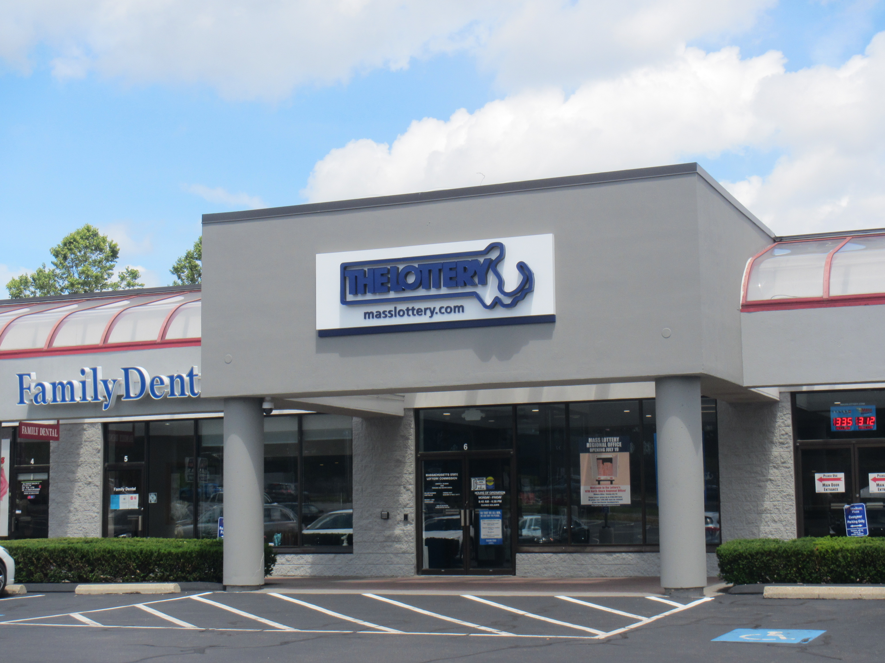

Prepared by:
Massachusetts Department of Public Health
Bureau of Environmental Health
Indoor Air Quality Program
July 2022

BACKGROUND
Building: | Lottery Building, Sales Operations section
Address: | 160 Winthrop Avenue, Lawrence
Assessment Requested by: | Deborah Russell, Project Manager,  Division of Capital Asset Management  and Maintenance (DCAMM)
Reason for Request: | Odor, Mold, and Indoor Air Quality (IAQ) concerns
Dates of Assessment: | June 24, 2022
Massachusetts Department of Public Health/Bureau of Environmental Health (MDPH/BEH) Staff Conducting Assessment: | Ruth Alfasso, Environmental  Engineer/Inspector, Indoor Air Quality  (IAQ) Program
Building Description: | The Lottery is in a single-story flat-  roofed building located in a shopping  plaza, adjacent to other businesses  including retail sales, a nail salon, and  a pizza restaurant. The area assessed  contains offices, cubicles, a kitchen  area, and accessory areas.
Windows: | Windows in this building do not open.

METHODS
Please refer to the IAQ Manual for methods, sampling procedures, and interpretation of results (MDPH, 2015).

IAQ TESTING RESULTS
The Lottery Sales Operations Area was assessed during this visit. A full post-occupancy visit to this site was conducted in August of 2021. The report from that visit is available at the web address https://www.mass.gov/doc/lawrence-lottery-building-august-2021/download . The following is a summary of indoor air testing results taken on June 24, 2022 (Table 1):
- Carbon dioxide levels were below MDPH guideline of 800 parts per million (ppm) in all areas surveyed, indicating adequate air exchange. Note that the overall occupancy of this area was low.
- Temperature was within the recommended range of 70°F to 78°F in all areas tested.
- Relative humidity was within recommended range of 40 to 60% in the areas tested.
- Carbon monoxide levels were non-detectable (ND) in all indoor areas tested.
- Fine particulate matter (PM2.5) concentrations measured were below the National Ambient Air Quality (NAAQS) limit of 35 μg/m³ in all areas tested.

Ventilation
A heating, ventilating and air conditioning (HVAC) system has several functions. First it provides heating and, if equipped, cooling. Second, it is a source of fresh air. Finally, an HVAC system will dilute and remove normally occurring indoor environmental pollutants by not only introducing fresh air, but by filtering the airstream and ejecting stale air to the outdoors via exhaust ventilation. Even if an HVAC system is operating as designed, point sources of respiratory irritation may exist and cause symptoms in sensitive individuals.
Fresh air is provided by air handling units (AHUs) located on the roof. These could not be examined at the time of the visit. Air from the AHUs is filtered, heated/cooled, and delivered to rooms via ducted supply vents (Picture 1). Air is returned/exhausted through return vents also in the ceiling.
The area examined was outfitted with numerous thermostats (Picture 2). During the visit an attempt was made by building occupants to engage the ventilation system using various thermostats. Only some of the supply vents could be determined to be working. The function of the return vents could not be assessed. In addition, while the thermostats could be set to different temperatures, there was no indication whether the system could be set for continuous ventilation rather than only in response to a call for cooling (or heat in the heating season). The MDPH IAQ program recommends that ventilation systems be on and supplying fresh air during all occupied periods regardless of a need for temperature control. Note also that the thermostats examined were showing the wrong time, possibly indicating the system time had not been changed during the switch to daylight savings time. System parameters should be checked periodically so that setback times correspond to hours of occupancy.
The assessment results indicate that the ventilation system is providing adequate fresh air for the current occupancy. It is recommended that HVAC systems be re-balanced every five years to ensure adequate air systems function (SMACNA, 1994). This system was likely balanced before the building was originally occupied by the Lottery in August of 2021.

Microbial/Moisture Concerns
This assessment was prompted by concerns of excess humidity, water damage and odors specifically in the Sales Operations area of the building. A musty odor was noticeable in the main open area, and in several of the offices examined. A source for this odor was not identified during the visit. Several potential sources were examined:
- Water leaks have been reported on the rear of the building including under the door into this section of the office (Pictures 3 and 4). These leaks have reportedly moistened carpeting and other materials in the offices along that location. Because there had been little rain in the weeks prior to the assessment, water intrusion had not occurred recently and no obvious signs of water damage to carpeting or wallboard were noted during the visit. Using a moisture meter, carpeting was found to be dry, and a close examination of carpeting did not show any odors from the carpet itself.
- Coving along the edge of the wall was firmly adhered. Chronic or recurrent water damage frequently loosens the glue holding this material to the wall allowing it to be readily pulled away from the wall.
- Wallboard along the exterior wall was also found to be dry at the time of the visit and did not appear to be a source of odor. However, this does not rule out hidden damage that may have led to mold growth underneath coving or on the reverse side of the wallboard.
- Windows along the exterior wall have reportedly leaked in the past, however no signs of water damage (e.g., stains, peeling paint) were noted at the time of the visit.
- Temperatures of the floor were measured using a laser thermometer to determine the potential for condensation on the floor in contact with the slab. Floor temperatures were very similar to air temperatures in all areas measured, suggesting that the slab has sufficient insulation. Where slabs are installed without appropriate insulation, floor temperatures may be significantly lower than the indoor air temperature, which can lead to condensation on the floor during humid weather.
Humidity control is reported to be an issue in this area of the building. At the time of the assessment, humidity was within the MDPH/IAQ guidelines of 40%-60% relative humidity, which was similar to outside. However, the use of air conditioning generally results in a reduction of relative humidity. In addition, this section of the office had several humidity-reduction efforts in place. Several dehumidifiers were present in this section of the building (Pictures 5 and 6). Staff in the office reported that when in use, these need to be emptied daily. Several hanging containers of “DampRid” were also present (Picture 7). However, this material appears to be spent (the crystals have all dissolved in water) and should be discarded. Occupants reported that humidity issues, including the need for dehumidifiers to be emptied frequently, exists even during the heating season, when typically, relative humidity drops due to dry outside air and the impact of heating.
Since no obvious source of the odors was found in the space at the time of the assessment, nor a source of excess water vapor that would increase humidity, it is possible that the odor and humidity issues are due to an issue with HVAC equipment which includes the rooftop AHU serving this part of the office, or other HVAC equipment located in the ceiling plenum. If condensation drains or drip pans do not drain properly, stagnant water can lead to odors being drawn into units and distributed via supply vents. Corrosion or microbial growth on cooling coils may lead to odors. Filters can also become moistened and lead to odors. These conditions can be identified through inspection of the rooftop units and any equipment in the ceiling plenum.
Other potential issues were identified related to water damage. Items were found stored on floors and on windowsills in areas that had been reportedly subject to leaks in the past (Picture 8). Porous items such as boxes, books and papers can become water-damaged and mold-colonized if stored in damp areas. In addition, stored items can make leaks and other issues harder to identify and can make it harder for custodial staff to clean.
The US Environmental Protection Agency (US EPA) and the American Conference of Governmental Industrial Hygienists (ACGIH) recommends that porous materials (e.g., wallboard, carpeting) be dried with fans and heating within 24 to 48 hours of becoming wet (US EPA, 2008; ACGIH, 1989). If porous materials are not dried within this time frame, mold growth may occur.

Other IAQ Evaluations
Other issues were noted in the space which may impact indoor air quality. As noted, there were boxes of stored material in the space, including brochures and promotional items. Printed materials can release odors and volatile organic compounds (VOCs) which can be irritating to the respiratory tract of sensitive people. A photocopier is also located in the space. Photocopiers, particularly those that are older or heavily used, can release particulate matter, VOCs, and odors during operation.

CONCLUSIONS AND RECOMMENDATIONS
The Lawrence Lottery Building has a water vapor source that could not be readily identified. The IAQ Program would recommend revisiting this building during fall and/winter months when outdoor weather is less humid. IAQ staff could not assess the rooftop AHUs. If such revisit is scheduled, it is recommended that a means for IAQ staff to access the rooftop AHU be provided on the date of the revisit.
Based on observations at the time of assessment, the following is recommended:

Ventilation Recommendations:
- Operate supply and exhaust ventilation continuously in all areas during occupied periods.
- Ensure thermostats are set to the correct time, and that they are set for proper operation of the system including setbacks for unoccupied periods.
- Determine which AHU on the roof corresponds to the Sales Operation section and identify any HVAC equipment in the ceiling plenum serving the section, and examine the units, including:
  - Examine the condensation drainage of each unit serving this area for stagnant water and poor drainage and repair as needed,
  - Examine all filters for water damage and change as needed,
  - Examine cooling coils and other internal parts for corrosion, scale or other damage and clean/replace as needed,
  - Ensure dampers for fresh air/return circulation are functional and allow for some proportion of fresh air into the system during operation,
  - Ensure that there are no other sources of moisture and odor adjacent to fresh air intakes, including exhaust vent stacks, puddles, plant growth or debris such as bird waste.
- Ensure filters on all HVAC equipment are changed periodically, and that good quality filters with a Minimum Efficiency Rating Value (MERV) of 8 or better are used.

Water Damage Recommendations
- If examination and repair of the HVAC system does not alleviate the odor, consider an examination of the interior of the wall cavity in the offices along the exterior wall. Small holes can be cut to check the condition of the other side of the wallboard. If water-damaged/mold-colonized materials are found, replace the affected wallboard, including a margin of undamaged material, and clean the wall cavity. If no water damage is found, test holes can be capped with blank wall plates.
- If odors remain, consider having the storm drainage system (under the downspouts shown in Picture 4) examined by a licensed plumber for clogs and leaks, including smoke testing or camera tracing to find connections with the interior of the building.
- Consider measures to correct drainage that directs water from the paved area to the side of the building, including installing drains to divert water directly into the storm system.
- Avoid storing porous items on floors and windowsills to prevent items becoming water-damaged.
- If flooding reoccurs, follow the guidelines in the EPA document “Mold Remediation in School and Commercial Buildings” (EPA, 2008) including proper disposal of water-damaged and mold-contaminated material.
- Discard spent bags of DampRid.
- Ensure dehumidifiers are emptied regularly and cleaned in accordance with manufacturer’s instructions to prevent a buildup of odorous material.

Other Recommendations
- Store printed materials in closed boxes and away from occupants to reduce exposure to VOCs
- Refer to resource manual and other related IAQ documents located on the MDPH’s website for further building-wide evaluations and advice on maintaining public buildings. These documents are available at: mass.gov/dph/iaq

REFERENCES
ACGIH. 1989. Guidelines for the Assessment of Bioaerosols in the Indoor Environment. American Conference of Governmental Industrial Hygienists, Cincinnati, OH.
MDPH. 2015. Massachusetts Department of Public Health. Indoor Air Quality Manual: Chapters I-III. Available at: https://www.mass.gov/lists/indoor-air-quality-manual-and-appendices.
SMACNA. 1994. HVAC Systems Commissioning Manual. 1st ed. Sheet Metal and Air Conditioning Contractors’ National Association, Inc., Chantilly, VA.
US EPA. 2008. “Mold Remediation in Schools and Commercial Buildings”. Office of Air and Radiation, Indoor Environments Division, Washington, DC. EPA 402-K-01-001. September 2008. Available at: http://www.epa.gov/mold/mold-remediation-schools-and-commercial-buildings-guide.

Picture 1

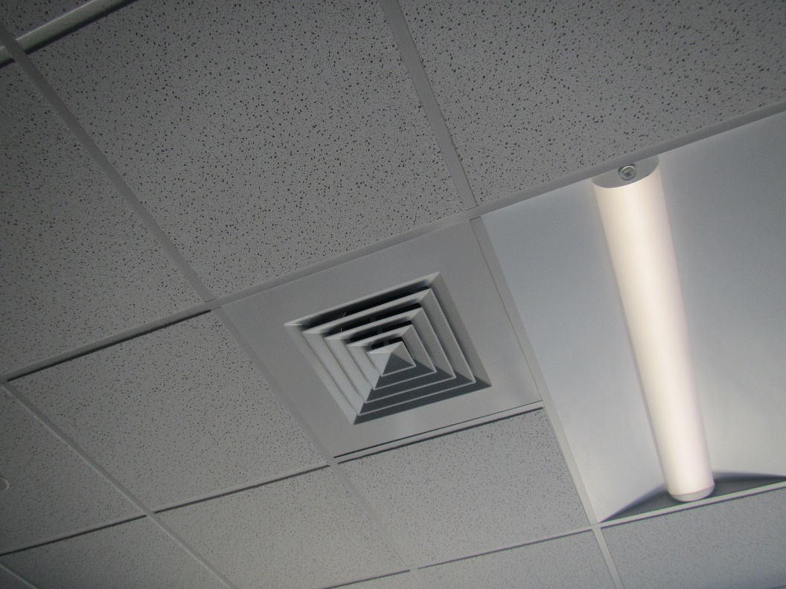
Ceiling-mounted supply vent
Picture 2
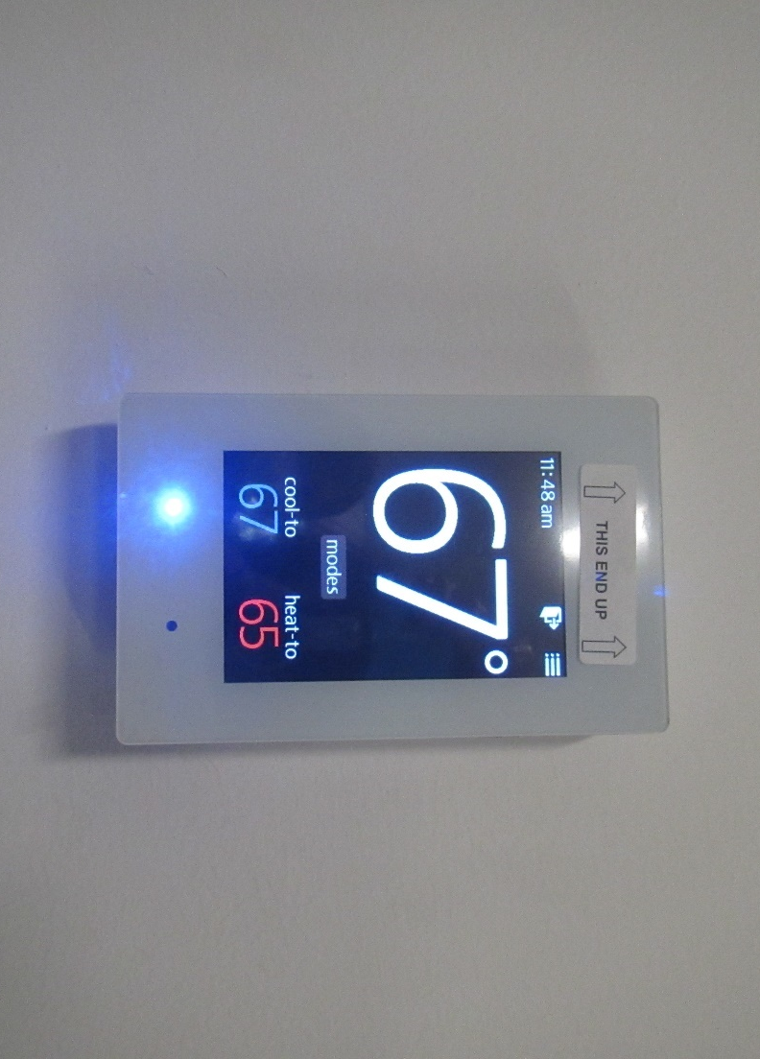
Typical thermostat, time was one hour off
Picture 3
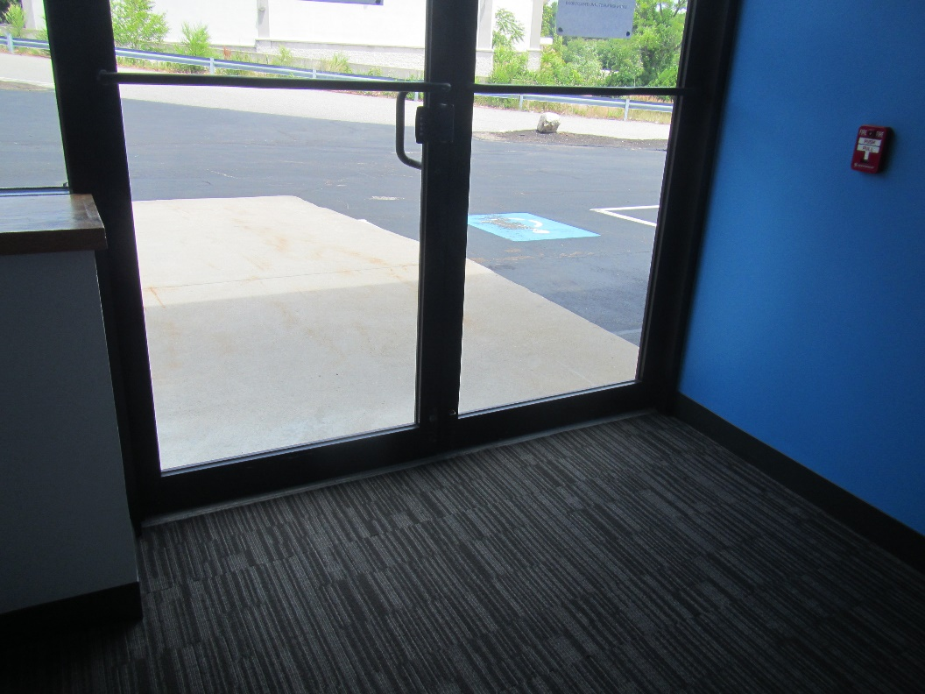
Door to outside located in the assessed space
Picture 4
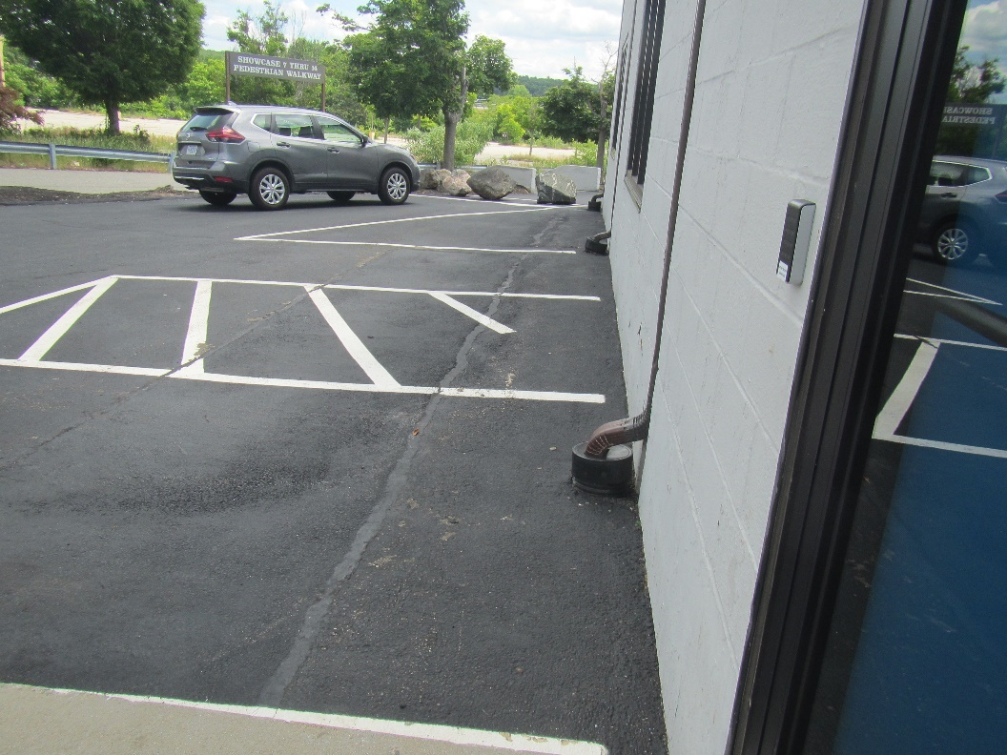
Paved area outside rear door shown in previous picture, note downspouts into drainage system
Picture 5
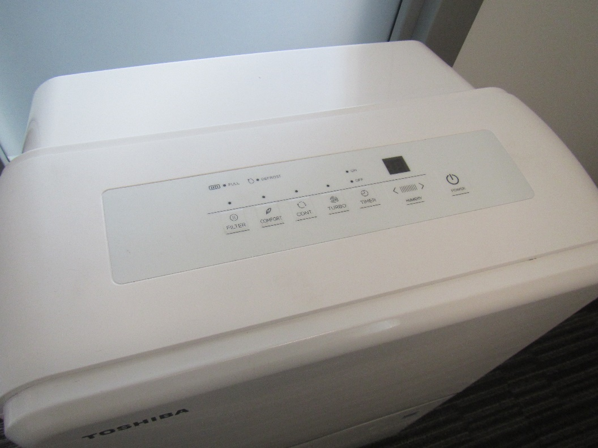
Top view of dehumidifier in an office
Picture 6
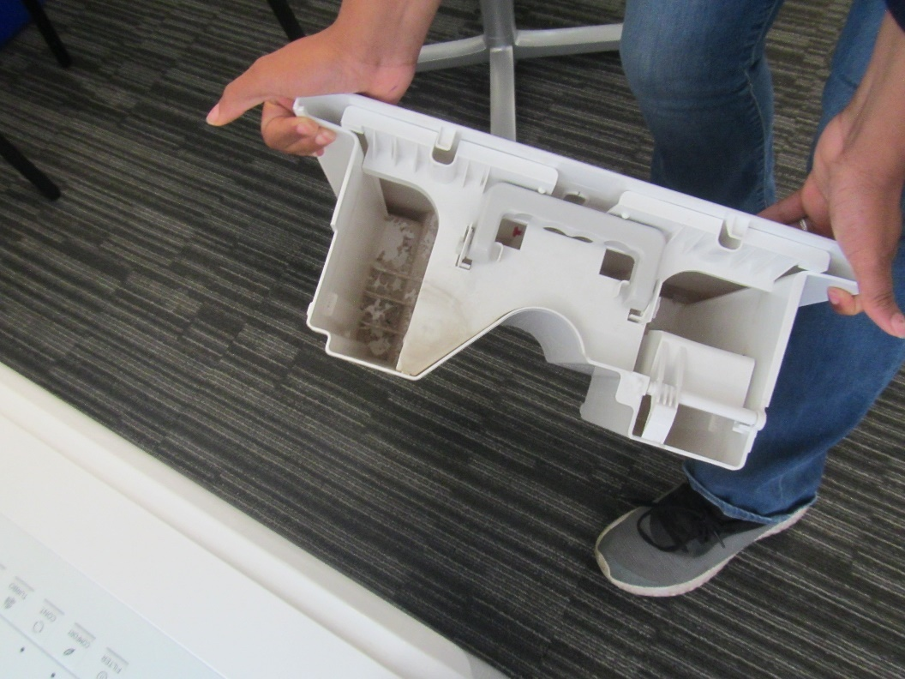
Interior water collection chamber from a dehumidifier, note debris at the bottom
Picture 7
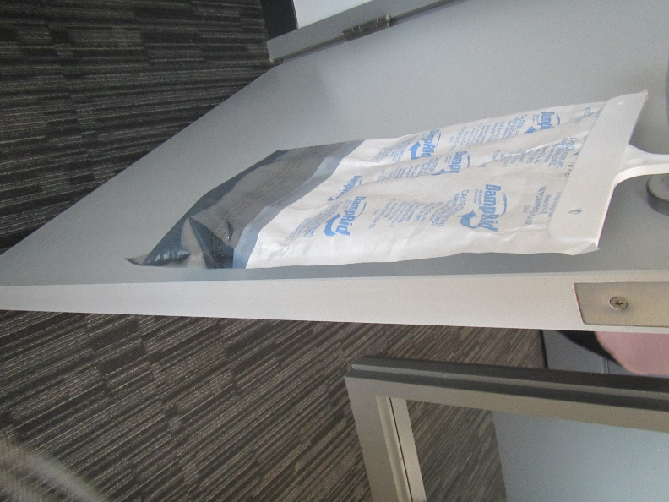
“DampRid” bag in an office, appears to be completely spent
Picture 8
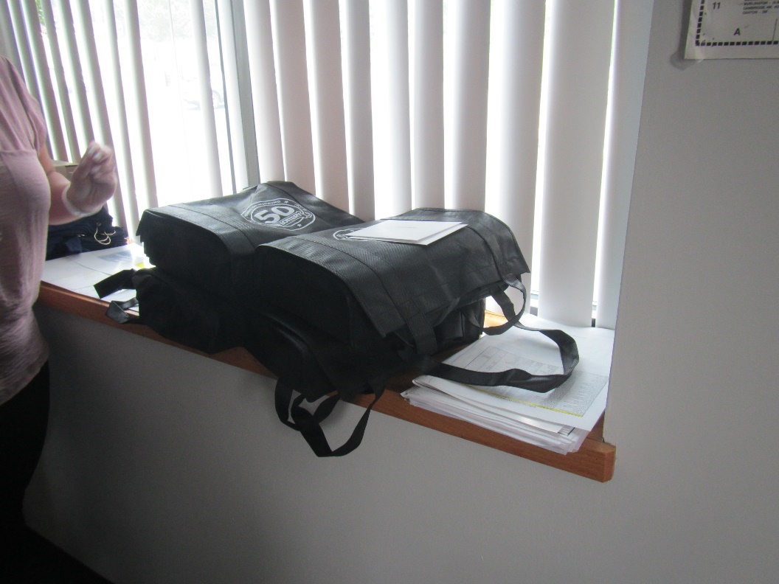
Items on a windowsill where water reportedly leaks in
Picture 9
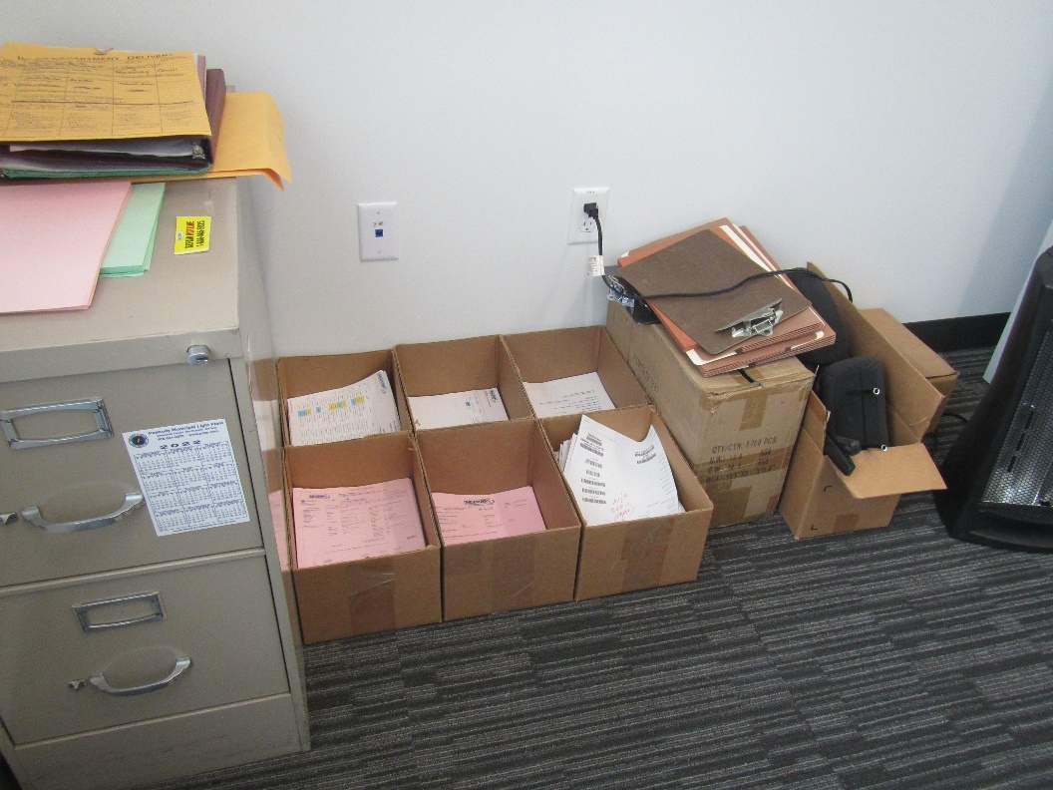
Boxes on the floor

Location | Carbon  Dioxide  (ppm) | Carbon Monoxide  (ppm) | Temp  (°F) | Relative  Humidity  (%) | PM2.5  (µg/m³) | Occupants  in Room | Windows  Openable | Ventilation |  | Remarks
 |  |  |  |  |  |  |  | Supply | Exhaust
Background | 432 | 0.5 | 81 | 49 | 7
Sales operations main area | 502 | ND | 73 | 53 | ND | 0 | N | Y | Y | Slight musty odor
OC 109 | 510 | ND | 73 | 53 | 3 | 1 | N | Y | Y | Slight musty odor, dehumidifier
Office | 464 | ND | 71 | 54 | 3 | 0 | N | Y | Y | Slight musty odor, “DampRid” bag

