**ODOR ASSESSMENT**

**Braintree Lottery Building**

**1515 Washington Street**

**Braintree, MA**

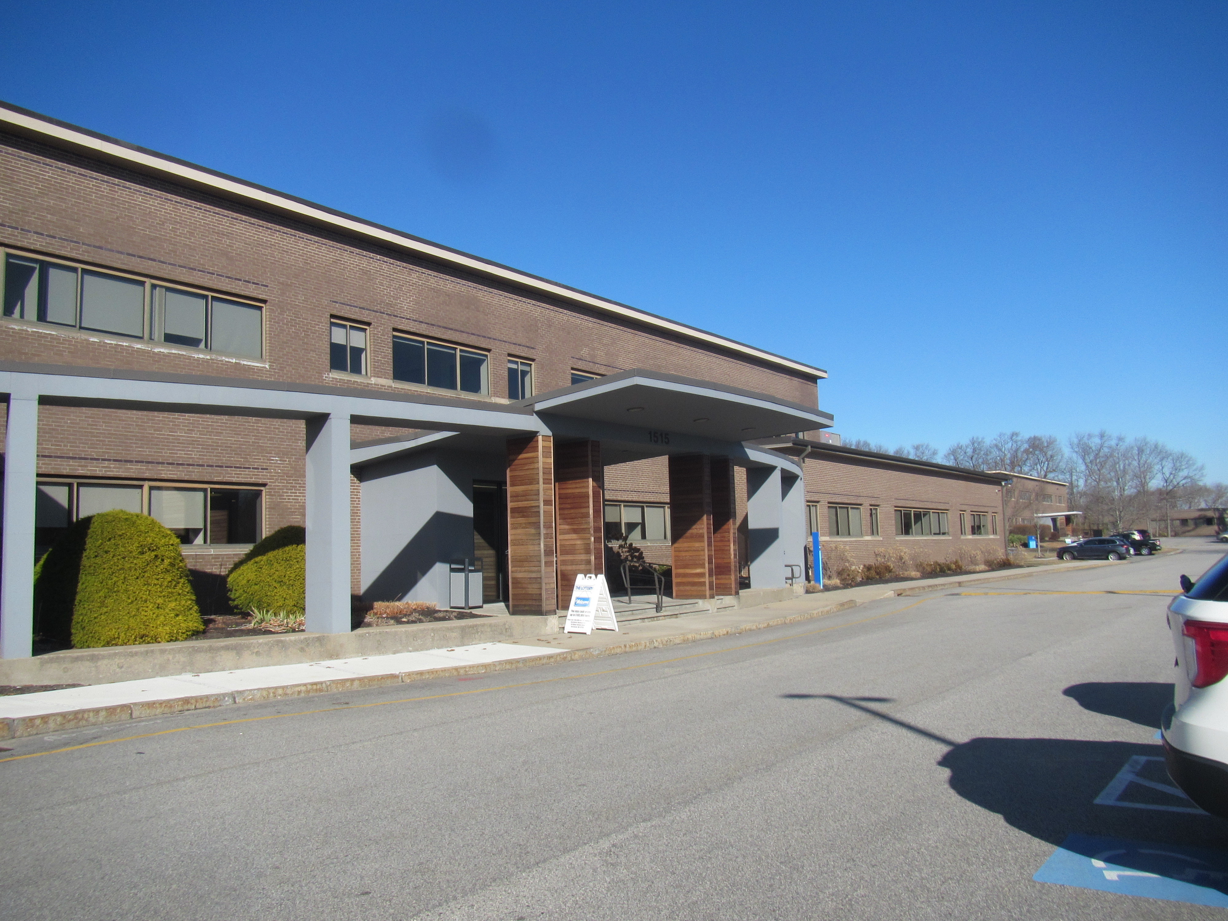

Prepared by:

Massachusetts Department of Public Health

Bureau of Climate and Environmental Health

Division of Health Regulations and Standards

March 2025

# BACKGROUND

|  |  |
| --- | --- |
| Building: | Braintree Lottery Building |
| Address: | 1515 Washington Street  Braintree, MA |
| Assessment Requested by: | Jennifer Hart, Regional Planner, Project Manager, Division of Capital Asset Management & Maintenance (DCAMM) Office of Leasing and State Office Planning |
| Reason for Request: | Concerns about water damage and odors in several interior offices following a plumbing leak |
| Date of Assessment: | March 11, 2025 |
| Massachusetts Department of Public Health, Bureau of Climate and Environmental Health, **Division of Environmental Health Regulations and Standards (MDPH/BCEH/EHRS)** Staff Conducting Assessment: | Ruth Alfasso, Environmental  Engineer, EHRS |
| Building Description: | The Braintree Lottery offices are on the first floor of a brick and metal-sided building in a light industrial office park. This building was originally constructed for manufacturing in the 1950s. The Lottery has occupied this building for approximately 5 years. The building has a flat roof and a slab foundation. Several interior rooms were examined during this visit. |
| Windows: | No windows were present in the areas examined. |

# METHODS

Please refer to the indoor air quality (IAQ) Manual for methods, sampling procedures, and interpretation of results (MDPH, 2015).

# RESULTS AND DISCUSSION

Measurements for IAQ parameters are shown in Table 1 and summarized below:

* ***Carbon dioxide*** measurements were below the MDPH guideline of 800 parts per million (ppm) in all the areas sampled.
* ***Temperature*** was within the recommended range of 70°F to 78°F in the areas tested.
* ***Relative humidity*** was below the recommended range of 40% to 60% in all areas tested, which is common during the heating season.
* ***Carbon monoxide*** levels were non-detectable (ND) in all areas tested.
* ***Fine particulate matter (PM2.5)*** concentrations were below the National Ambient Air Quality Standard (NAAQS) level of 35 μg/m3 in all areas tested.
* ***Total volatile organic compounds (TVOC)*** ranged from ND to 3 ppm in the areas assessed.

## Ventilation

A heating, ventilating, and air conditioning (HVAC) system has several functions. First, it provides heating and, if equipped, cooling. Second, it is a source of fresh air. Finally, an HVAC system will dilute and remove normally-occurring indoor environmental pollutants by not only introducing fresh air but also filtering the airstream and ejecting stale air outdoors via exhaust ventilation. Even if an HVAC system is operating as designed, point sources of respiratory irritation may exist and affect symptoms in sensitive individuals.

Fresh air for the offices tested is provided by air-handling units that are most likely located on the roof. They were not examined during this visit. Most of the offices examined had a supply vent but no exhaust or return vent (Table 1). This configuration is designed to draw stale air out of offices under the door to an exhaust vent in a central area. However, the main area to which these offices are attached appears to have only one exhaust vent located at quite a distance from the offices (Picture 1). A lack of air exchange in these offices, and the lack of a window or exterior wall for flushing air through the room is likely exacerbating any issues with odors and water damage in these areas.

Note that while levels of carbon dioxide in these offices were below the MDPH comfort level of 800 ppm, they ranged from 749 to 790 ppm, which is closer to the MDPH level than would typically be expected given that the offices, Wellness room, and janitor’s closet were unoccupied, and the main room (140) was a large open space with only a few occupants.

A room outside this area, labeled Conference Room in Table 1, is located in a different section of the building had a carbon dioxide level of 577. If this room is served by a different HVAC unit than the one serving room 140, this may indicate an issue with that unit. Without sufficient fresh supply air and removal of stale air, odors and other constituents can build up and lead to complaints.

The ventilation system should be on and operating to supply fresh air continuously during occupied periods. Thermostats and control systems should be checked to ensure that the setting for occupied periods is to have the fan *on* rather than operating on an *automati*c setting during occupied hours. This will supply fresh air continuously rather than only when temperatures need to be adjusted. It is recommended that HVAC systems be re-balanced every five years to ensure adequate air systems function (SMACNA, 1994). It is likely that the last time these systems were balanced was when the Lottery occupied this building approximately five years ago, so rebalancing may be warranted.

## Water Damage and Odor Concerns in and near Room 140

Water damage and odor concerns in the inner offices of room 140 (142 and 143) prompted this assessment. Water damage is reported to have occurred due to an overflow of the sink in the Wellness room (Picture 2) several months ago. Increasing odors were reported in the time since. The Wellness room floor is not carpeted. Coving along the base of the gypsum wallboard was well adhered to the walls and could not be pulled away. This suggests that the area was not inundated with water for a long period of time, as moisture exposure readily leads to failure of the glue on the back of coving, allowing it to be pulled away easily.

No odors were noted from the sink area, the floor, or the appliances in this room. The sink is in a laminate countertop that is attached to the walls at the corner. The backsplash along the side wall had come away from the wall (Picture 3), and it looks as if it had previously been attached. Whether this detachment was caused by water exposure from the overflow, or whether it happened because the sink cabinet settled or moved, the wallboard next to the sink hidden by the sink cabinet, should be examined for water damage. Once an examination is complete and any damage found is repaired, this backsplash should be rendered watertight against the wall using a slightly flexible, water-resistant material.

Room 143 is on the other side of the wall from the Wellness room and is where the odor is strongest both at the time of the visit, and as reported by occupants. The room next door, 142, has the staff break room on the other side of the wall. The odor in both rooms was musty, but it was not specifically a mold smell. The rooms had previously been carpeted, but at the time of the visit, the flooring in both these rooms had been removed. In room 143, the floor was still covered with remains of carpet glue/mastic and the rear wallboard had been cut about two feet up from the floor (Picture 4). It was not known if the removed wallboard had been measured or otherwise determined to be wet or mold-colonized prior to removal. Examination of the visible wall cavity did not show any evidence of water exposure to wallboard or insulation and the odor did not seem to be emanating from there. Carpet glue may have an odor, but it is typically more prominent when the carpeting is new. However, moisture exposure may increase the odor from carpet glues.

Room 142 had cardboard placed on the floor over where the carpeting had been removed (Picture 5) and the odor was not as strong in this room but still noticeable. Mastic was reportedly present under the cardboard. No wallboard had been removed in this room.

Odors can linger in locations without any ventilation. The configuration described in the ventilation section above makes effective flushing of air through the affected offices very difficult. Using the existing exhaust vent not only does not provide the flow of air needed, but it will also draw the odors through the occupied areas in room 140.

### Volatile organic compounds in rooms 140, 142, and 143

Note that low levels of total volatile organic compounds (TVOCs) were detected both inside offices 142 and 143, and in the open space of room 140. Activities in room 140 involve repairing and adjusting lottery equipment that can not be managed at regional service centers. Various cleaning, degreasing, and other products were in use (Pictures 6 and 7). Many of these products can release TVOCs which may linger in the air. In areas where odors, particulates or VOCs may be produced, it is recommended to have exhaust ventilation that vents the air directly out of the building. For frequent or intense work of this type, task-based local exhaust may be useful to remove fumes before they enter the general room air. The use of air purifiers with high efficiency particulate arrestance (HEPA) and carbon filters may be used to supplement ventilation and remove VOCs and associated odors.

## Other Concerns

Other issues were discussed during this site visit. The janitorial closet on the other side of the staff break room has both a mop sink and a floor drain. If this drain is not often used, the trap may dry out and allow sewer gases into the room. All drains should be wetted periodically to ensure the trap seal stays intact.

Staff expressed concerns regarding tile flooring and carpeting in other areas of the building that lifted (Picture 8), popped off, or became stained much earlier than would be expected given this office has only been occupied for five years. There are several potential reasons for this, none of which could be confirmed at the time of the visit:

* The use of the wrong products or wrong installation techniques;
* Moisture emanating from the concrete floor beneath the carpet or tiles. Concrete can hold water and if it wasn’t completely dry when flooring was installed this could compromise the glues/mastics. If the floor is in contact with soil underneath with no vapor barriers or insulation, it could continue to draw water long after the flooring is installed; and/or
* Condensation on floors due to the temperature differential between an uninsulated slab in contact with soil, and hot, humid air during the summer. To determine if this is an issue, dew point temperatures inside during a hot, humid day should be compared to the temperature of the floor.

Given that issues reportedly occur with flooring only in the area of the building that had originally been the manufacturing side, and the 1959 construction date of the building, it is highly likely that the slab has neither insulation nor a vapor barrier making the above issues more likely.

Note that other sources of odors and TVOCs in past visits to Lottery offices include printed and promotional materials (brochures, plastic toys, etc.). When these materials are stored in occupied areas, the boxes should be kept closed as much as possible to contain the odors. Large quantities of such materials should be kept in storage areas away from occupants.

# CONCLUSIONS/RECOMMENDATIONS

No obvious and specific source of the odors in rooms 142 and 143 were found during this visit. Several suggestions are made that may alleviate the odor and otherwise improve IAQ:

## Ventilation Recommendations

1. Operate supply and exhaust ventilation in all areas during occupied periods. Ensure that all control systems allow for the fan to be on when the office is occupied.
2. Have the HVAC system balanced every 5 years in accordance with SMACNA recommendations (SMACNA, 1994).
3. Ensure filters are replaced in HVAC units at least twice a year, or per the manufacturers’ instructions.
4. Vacuum out the interiors of air handling unit (AHU) cabinets during regular filter changes.
5. Consider opening the dampers on the HVAC unit serving room 140 and adjacent areas to allow more fresh air, up to 100%, during temperate weather conditions.
6. Consider methods to improve exhaust ventilation in rooms 142 and 143 either temporarily or permanently.
   1. Temporary measures to flush out the air in this room could include the use of a blower attached to a length of hose directed out of the building either through the ceiling plenum or through open doors.
   2. The availability of make-up air should be considered during flushing.
7. Consider methods to improve exhaust ventilation permanently in room 140 to remove odors and VOCs from the products in use there. If possible, this room or the individual task areas should be directly vented outside rather than recirculating through the general ventilation system.

## Water Damage and Odor Recommendations

1. Continue with plans to remove mastic/glue from the floor of room 143. Take care to contain any debris and odors and conduct the most disruptive work when the building, or at least room 140, is unoccupied.
2. If mastic removal and flushing resolve the odor, repair room 142 in the same manner.
3. Check the wall in the Wellness room to the left side of the sink cabinet for water damage. Once done, reattach the backsplash for the Wellness room sink to the wall using a water-resistant and flexible sealant to protect the wall going forward.
4. Ensure that all products used by the technicians in room 140 are kept in tightly closed containers when not in use to reduce exposure to VOCs.
5. Use of air purifiers equipped with both a HEPA filter and a carbon filter can remove particles and odors. Units that may produce ozone or other byproducts should be avoided. Units should be placed so that the filtered air is in the breathing zone of occupants. Clean, maintain, and change filters on these units in accordance with manufacturer’s instructions.
6. Ensure any drains (e.g. floor drains) that are not used often are kept wetted by having water poured down them regularly, every week or two.
7. Store all printed/promotional materials that are in occupied areas in closed containers.

## Other Recommendations

1. Monitor dew point and floor temperatures during the first period of hot, humid summer weather. If the dew point is similar to the floor temperature, use the air chilling system and/or stand-alone dehumidification to reduce the dew point until weather is cooler and drier.
2. Consider consulting with a flooring expert as to the best materials and methods to use when putting flooring on uninsulated concrete.
3. Continue with noting and replacing or taping tiles and carpeting to reduce tripping hazards.
4. Refer to resource manual and other related IAQ documents located on the MDPH’s website for further building-wide evaluations and advice on maintaining public buildings. These documents are available at: <http://mass.gov/dph/iaq>.

# REFERENCES

MDPH. 2015. Massachusetts Department of Public Health. Indoor Air Quality Manual: Chapters I-III. Available at: <https://www.mass.gov/lists/indoor-air-quality-manual-and-appendices>.

SMACNA. 1994. HVAC Systems Commissioning Manual. 1st ed. Sheet Metal and Air Conditioning Contractors’ National Association, Inc., Chantilly, VA.

**Picture 1**

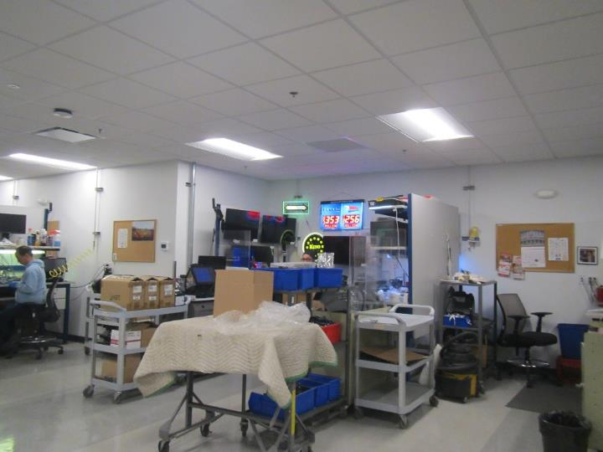

**Single exhaust vent in Room 140, located a distance from the doors to rooms 142 and 143**

**Picture 2**

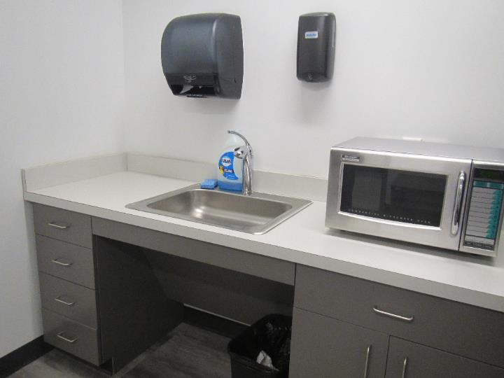

**Wellness room sink**

**Picture 3**

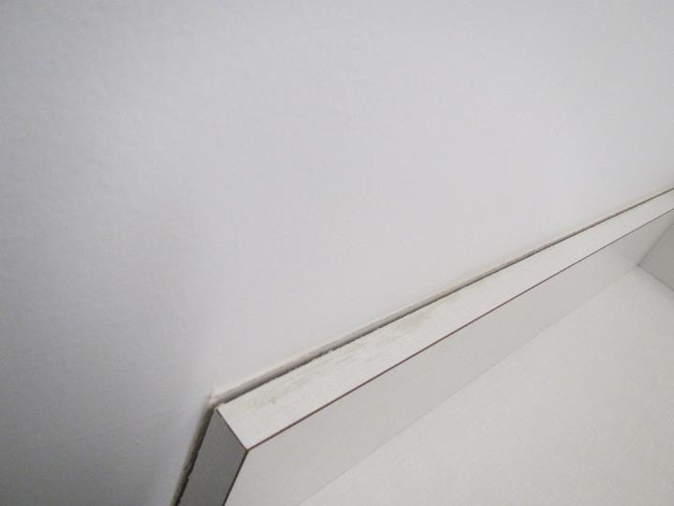

**Gap between countertop and wall in Wellness room that looks as if it used to be sealed**

**Picture 4**

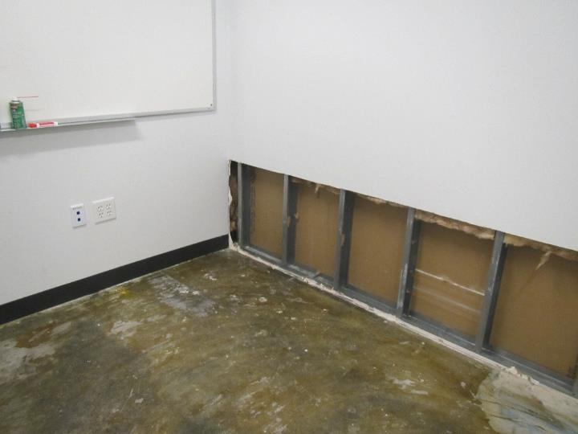

**Inside office 143 with the carpeting removed, and wallboard cut along the rear wall**

**Picture 5**

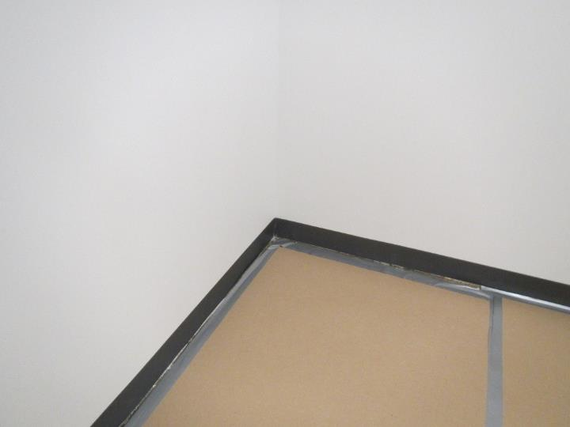

**Cardboard covering the floor in room 142**

**Picture 6**

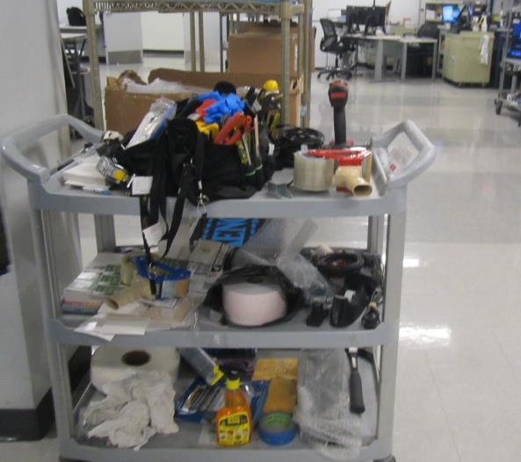

**Cleaning products and tools in use in room 140**

**Picture 7**

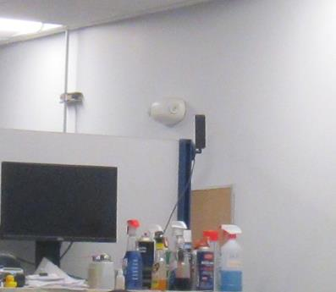

**Shelf of cleaning products and oils above a workstation in room 140**

| **Location** | **Carbon**  **Dioxide**  **(ppm)** | **Carbon Monoxide**  **(ppm)** | **Temp**  **(°F)** | **Relative**  **Humidity**  **(%)** | **PM2.5**  **(µg/m3)** | **TVOC (ppm)** | **Occupants**  **in Room** | **Windows**  **Openable** | **Ventilation** | | **Remarks** |
| --- | --- | --- | --- | --- | --- | --- | --- | --- | --- | --- | --- |
| **Supply** | **Exhaust** |
| Background | 455 | ND | 52 | 44 |  |  |  |  |  |  | Sunny, springlike |
| 142 | 780 | ND | 70 | 23 | ND | 3 | 0 | No | Y | N | Floor pulled up and covered in cardboard, some odor, coving tightly adhered, no moisture in walls |
| 143 | 750 | ND | 70 | 22 | 1 | 2 | 0 | No | Y | N | Floor pulled up with mastic visible and odor – musty or glue-like, walls cut about 2’ from floor, dry inside, coving on remaining walls tightly adhered |
| 140 main area | 790 | ND | 71 | 22 | 1 | 3 | 3 | No | Y | Y | Multiple stations for cleaning/repairing equipment in a large open room, cleaning and degreasing products |
| Janitor’s closet | 749 | ND | 70 | 23 | 1 | 1 | 0 | No | N | Y | Cleaning products, mop bucket and mop sink |
| Wellness room | 756 | ND | 70 | 23 | ND | ND | 0 | No | Y | Y | This sink source of water (overflow), floor is not carpeted and did not appear damp, fridge is clean, coving tightly adhered, sink backsplash against side wall has a gap |
| Conference room | 577 | ND | 71 | 19 | 1 | ND | 0 | No | Y | N | Carpeting here and in other nearby rooms does not stay adhered to floor, faint odor (unidentifiable and no obvious source) |