LOW-LEVEL RADIOACTIVE WASTE TREND REPORT

2009-2013



MASSACHUSETTS DEPARTMENT OF PUBLIC HEALTH
BUREAU OF ENVIRONMENTAL HEALTH
RADIATION CONTROL PROGRAM
SCHRAFFT BUILDING, SUITE 1M2A
529 MAIN STREET
BOSTON, MA 02129
(617) 242-3035

LOW-LEVEL RADIOACTIVE WASTE TREND REPORT

2009-2013
THE COMMONWEALTH OF MASSACHUSETTS
CHARLES D. BAKER, GOVERNOR

EXECUTIVE OFFICE OF HEALTH AND HUMAN SERVICES
MARYLOU SUDDERS, SECRETARY

MASSACHUSETTS DEPARTMENT OF PUBLIC HEALTH
Monica Bharel, COMMISSIONER

BUREAU OF ENVIRONMENTAL HEALTH
SUZANNE K. CONDON, ASSOCIATE COMMISSIONER/DIRECTOR

RADIATION CONTROL PROGRAM
JOHN M. PRIEST, JR., DIRECTOR

TABLE OF CONTENTS

ABSTRACT v
EXECUTIVE SUMMARY vi
1. INTRODUCTION vii
1.1 Overview and Objectives viii
1.2 LLRW Data viii
2. ANALYSIS of LLRW SURVEY DATA 9
2.1.1. All LLRW by Radioactivity 9
2.1.2. LLRW Radioactivity by Waste Generator Category 11
2.1.3. LLRW Radioactivity by Waste Class 11
2.1.4. Top Radioactivity Generators in CY 2009-2013 12
2.2. LLRW by Volume 13
2.2.1. All LLRW by Volume 13
2.2.2. LLRW Volume by Waste Generator Category 15
2.2.3. LLRW Volume by Facility Type 15
2.2.4. LLRW Volume by Waste Class 16
2.2.5. Top Generators by Volume in CY 2009-2013 17
2.3. Class A LLRW by Radioactivity 18
2.3.1. All Class A Radioactivity 18
2.3.2. Class A Radioactivity by Waste Generator Category 19
2.3.3. Class A Radioactivity by Facility Type 19
2.3.4. Top Class A Radioactivity Generators in CY 2009-2013 20
2.4. Class A LLRW by Volume 21
2.4.1. All Class A Volume 21
2.4.2. Class A Volume by Waste Generator Category 22
2.4.3. Class A Volume by Facility Type 22
2.4.4. Top Class A Volume Generators in CY 2009-2013 23
2.5. Class B LLRW by Radioactivity 24
2.5.1. All Class B by Radioactivity 24
2.5.2. Class B Radioactivity by Waste Generator Category 25
2.5.3. Class B Radioactivity by Facility Type 25
2.5.4. Top Class B Radioactivity Generators in CY 2009-2013 26
2.6. Class B LLRW by Volume 27
2.6.1. All Class B by Volume 27
2.6.2. Class B Volume by Waste Generator Category 28
2.6.3. Class B Volume by Facility Type 28
2.6.4. Top Class B Volume Generators in CY 2009-2013 29
2.7. Class C LLRW by Radioactivity 30
2.7.1. All Class C Radioactivity 30
2.7.2. Class C Radioactivity by Waste Generator Category 31
2.7.3. Class C Radioactivity by Facility Type 31
2.7.4. Top Class C Radioactivity Generators in CY 2009-2013 32
2.8. Class C LLRW by Volume 33
2.8.1. All Class C by Volume 33
2.8.2. Class C Volume by Waste Generator Category 34
2.8.3. Class C Volume by Facility Type 34
2.8.4. Top Class C Volume Generators from CY 2009-2013 35
2.9. HVLA LLRW by Radioactivity 36
2.9.1. All HVLA by Radioactivity 36
2.9.2. HVLA Radioactivity by Waste Generator Category 37
2.9.3. HVLA Radioactivity by Facility Type 37
2.9.4. Top HVLA Radioactivity Generators in CY 2009-2013 38
2.10. HVLA LLRW by Volume 39
2.10.1 All HVLA by Volume 39
2.10.2. HVLA Volume by Waste Generator Category 40
2.10.3. HVLA Volume by Facility Type 40
2.10.4. Top HVLA Volume Generators in CY 2009-2013 41
3. NATIONAL DATA 42
4. FINANCIAL DATA 43
Appendix A - Glossary of Terms 45
Appendix B - Commercial Low Level Radioactive Waste - Recent History 46
Appendix C - Massachusetts LLRW Classes 48
Appendix D - Waste Generator Category Descriptions 49
Appendix E - Facility Type Descriptions 50
Appendix F - Acronyms 51

ABSTRACT

This report presents information on trending and analysis of the volume and radioactivity of the low level radioactive waste (LLRW) reported to the Massachusetts Department of Public Health, Bureau of Environmental Health, Radiation Control Program (RCP) in the annual survey as generated in calendar years 2009-2013. The LLRW surveys are administered to RCP and Nuclear Regulatory Commission (NRC) licensees located in Massachusetts. The survey also provides information on the potential impact to licensees should access to out-of state LLRW disposal facilities be denied.

The four LLRW classes in this report are: A, B, and C as described in 105 CMR 120.299, and High Volume, Low Activity (HVLA) waste as described in 345 CMR 1.13. As appropriate, the LLRW is further classified into five waste generator categories: (1) Academic, (2) Commercial, (3) Government, (4) Health, and (5) Utility; and six Facility Types: (1) Federal Agency, (2) State Agency, (3) State Education, (4) Municipality, (5) Private, Profit, and (6) Private, Non-Profit.

EXECUTIVE SUMMARY

This report summarizes the data on low-level radioactive waste (LLRW) generated in the state of Massachusetts for calendar years 2009-2013. This report is compiled from the annual low-level waste survey from radioactive material licensees.

The total volume of LLRW generated in Massachusetts from 2009-2013 was 1,220,316 cubic feet (ft3), and the total LLRW activity was approximately 62,144 curies (Ci).

LLRW Volume Generated from 2009-2013 (ft3)
Class | 2009 | 2010 | 2011 | 2012 | 2013
A | 46,978 | 27,326 | 47,396 | 31,039 | 51,717
B | 720 | 386 | 418 | 586 | 249
C | 35 | 30 | 52 | 37 | 97
HVLA | 329,984 | 412,623 | 265,074 | 5,521 | 48
TOTAL | 377,717 | 440,365 | 312,940 | 37,183 | 52,111

LLRW Activity Generated from 2009-2013 (Ci)
Class | 2009 | 2010 | 2011 | 2012 | 2013
A | 527 | 784 | 1,105 | 860 | 718
B | 9,959 | 11,484 | 9,368 | 10,551 | 16,425
C | 61 | 55 | 57 | 48 | 71
HVLA | 20 | 39 | 9.87 | 1.11 | 1.10
TOTAL | 10,567 | 12,362 | 10,539.87 | 11,460.11 | 17,215.10

The volume and radioactivity generated from 2009-2013 varied due to one-time-only events such as decommissioning projects, source manufacturing projects or nuclear power plant outages. For example, 2009 and 2010 saw a large increase of LLRW from the Shpack landfill, a National Priority List Superfund site cleanup headed by the U.S. Army Corps of Engineers.

Additionally, scheduled plant outages at the Entergy Pilgrim Nuclear Power Plant (PNPS) contributed a larger amount of waste to the total LLRW figures in 2009, 2011, and 2013. These scheduled refueling outages occur every 24 months with some resulting in higher generation volumes. In addition, unplanned shut-down outages, such as those that occurred in 2013, further contribute to the generation increases.

On July 1, 2008, the LLRW facility in Barnwell, SC – the last in the United States that accepted out-of-compact Class B and C waste – closed. Massachusetts is not in a multistate compact. After mid-2008, the generation of Class B and C waste declined. Notably, Class C activity generation declined by more than 100 fold, and volumes by ten-fold. This decrease was likely due to the utilities and commercial facilities altering work and waste processing practices to avoid generation of Class B & C wastes and to avoid storing Class C wastes on site.

Class A radioactivity generation (Ci) from utilities and commercial facilities has tripled due to the increased scope of maintenance and repair activities. Class A volumes (ft3) have remained stable, except from academic facilities, which are generating lower volumes due to their decreasing use of radioactive material in research and development.
Low Level Radioactive Waste
Trend Report: Calendar Years 2009-2013

1. INTRODUCTION

Low-level radioactive waste (LLRW) is radioactive material that (1) is neither high-level radioactive waste, nor spent fuel, nor uranium mill tailings; and, (2) is classified by the U.S. Nuclear Regulatory Commission (NRC) as LLRW. This does not include waste owned or generated by the U.S. Department of Energy, the U.S. Navy (e.g., decommissioning Navy vessels), or by the federal government as a result of any research, development, testing, or production of any atomic weapon, all of which remain a federal responsibility.

LLRW typically consists of radioactively contaminated trash such as paper, rags, plastic, glassware, syringes, protective clothing (e.g. gloves, coveralls), cardboard, packaging material, organic material, spent pharmaceuticals, used (e.g. decayed) sealed radioactive sources, and water-treatment residues. The radioactivity of LLRW can range from just above background levels found in nature to highly radioactive in certain cases. The maximum concentration for each class of LLRW can be found in 105 CMR 120.299 for Class A, B, and C wastes, and 345 CMR 1.13(B) for high volume low activity (HVLA) waste.

Typical applications of LLRW include:

- The production of contaminated ion-exchange resins and filters, tools, clothing, and irradiated metals and other hardware by a nuclear power plant;
- The production and end-use of radiopharmaceuticals for medical procedures such as cancer and thyroid dysfunction diagnosis and treatment, radioimmunoassay and diagnostic imaging examinations;
- Research and development in the life science and biotechnology industry for the treatment and prevention of various diseases and medical conditions, and in the environmental field to study the effects of chemicals on plant and aquatic life, and for ocean studies;
- Commercial uses such as within instruments that measure level, thickness, and density or that are used in moisture analysis and quality control; sealed sources that are used for industrial radiography of pressure vessels and other structural welds; smoke detectors and exit signs in buildings and commercial aircraft; and,
- University education and research in medicine, material science and biotechnology.

1.1 Overview and Objectives
Annually each specific licensee that produces LLRW is surveyed to summarize the amount (e.g. volume and activity) of LLRW generated (e.g. transferred and in-storage) by waste classification, and the radioisotopes generated in each waste class. The LLRW data are evaluated by RCP to identify trends; significant generation and generators; and determine storage, treatment, and disposal solutions. This information supports the formulation of LLRW policy in the Commonwealth.

A database for tracking LLRW was developed by the Massachusetts Department of Public Health, Bureau of Environmental Health, Radiation Control Program (RCP) in 2002. This database contains records of LLRW reported to the RCP by their licensees, as well as from Nuclear Regulatory Commission (NRC) licensees located in Massachusetts. The database is maintained by the RCP and contains almost 6,000 surveys submitted from approximately 2000 to the present.

In Massachusetts, there are four waste classifications from which the Licensees report: Class A, Class B, Class C, and High Volume Low Activity (HVLA) (see Appendix C for further discussion of these waste classes). To better analyze the data in terms of usage and generation trends, each Specific Licensee is further classified into five waste generator categories and six facility types:

Waste Generator Categories
Academic
Commercial
Government
Health
Utility

Facility Types
Federal Agency
State Agency
State Education
Municipality
Private, Profit
Private, Non-Profit

1.2 LLRW Data

The data presented in this report summarizes LLRW generated in the calendar years 2009-2013. There was no attempt to remove LLRW waste data that was either not required to be reported or was mixed with waste that was required to be reported. This report provides a review of the annual trend data for each waste classification, waste generator category, and facility type.

Trends in this report consider only volumes, activities, and waste class reported; the report does not directly account for external issues such as changes to regulatory requirements or changes in the number of licensees.
2. ANALYSIS of LLRW SURVEY DATA

2.1 LLRW by Radioactivity (Ci)

2.1.1 All LLRW by Radioactivity

Figure 1 – LLRW by Radioactivity from 2009-2013
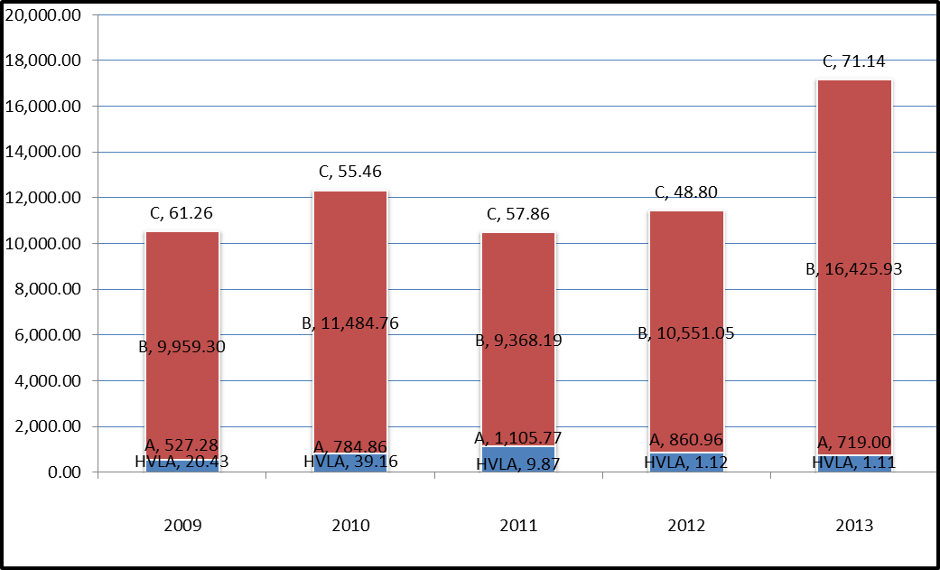

The following observations are made regarding the data in Figure 1.

- Entergy (resins), PerkinElmer (radiopharmaceutical manufacturer), and QSA Global (industrial radioactive source manufacturer) generated large quantities of Class B radioactivity from 2009-2013.

- Entergy (resin and irradiated metals) and PerkinElmer generated the most Class C radioactivity from 2009-2013.

- PerkinElmer and U.S. Army Corps of Engineers (Shpack landfill cleanup) generated the most Class HVLA radioactivity from 2009-2013.

Figure 2 - Annual Radioactivity of LLRW Generated Excluding Entergy, QSA Global, and PerkinElmer radioactivity waste totals
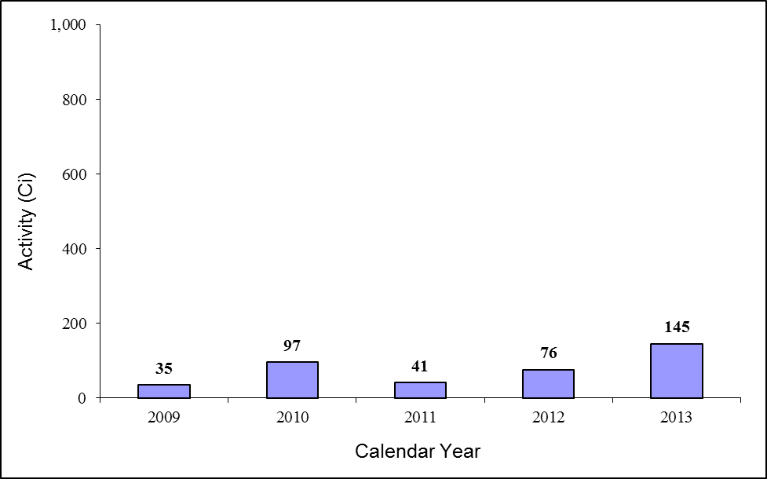

- Comparing Figure 1 to Figure 2 shows that Entergy, PerkinElmer, & QSA Global account for at least 98% of the LLRW generated every year.

- Beverly Microwave Division, Herley New England, Industrial Nuclear Co., Petnet Solutions, and Thermo Scientific generated the most Class A radioactivity from 2009-2013.

- Top Class B radioactivity generators for years 2009, 2010, 2012, and 2013:
Mevion Medical Systems;
Morpho Detection;
Tufts University; and,
UMass Lowell

- Top Class HVLA radioactivity generators for years 2009, 2010, and 2012:
Areva, NP, Inc.;
Mass. General Hospital;
Pfizer; and,
Philotechnics, Ltd.

2.1.2. LLRW Radioactivity by Waste Generator Category

Table 1. Calendar Year by Radioactivity (Ci)
 | 2009 | 2010 | 2011 | 2012 | 2013
Academic | 0.77 | 0.73 | 0.45 | 14.86 | 0.63
Commercial | 10,260.67 | 11,030.24 | 10,185.76 | 10,617.06 | 17,082.94
Government | 12.64 | 34.62 | 9.84 |  | 0.00
Health | 1.68 | 0.94 | 1.64 | 0.30 | 3.01
Utility | 292.50 | 1,297.70 | 344.00 | 829.70 | 130.60

- Due to their manufacturing and nuclear power production activities, commercial and to a lesser extent utility facilities dominate the amount of radioactivity generated in any given year in the A Waste Generator category.

- Fluctuations in radioactivity generated are much greater from commercial & utility entities due to outages and planned and unplanned decommissioning projects. In 2010 Entergy PNPS generated a larger than anticipated volume of Class C wastes due to maintenance activities in the refuel and spent fuel pool.

- The apparent increasing trend of Government radioactivity is due to the Shpack landfill clean up by the U.S. Army Corps of Engineers which was essentially finished in 2010.

2.1.3. LLRW Radioactivity by Waste Class

Table 2. Radioactivity by LLRW Waste Class (Ci)
 | 2009 | 2010 | 2011 | 2012 | 2013
A | 527 | 784.85 | 1,105 | 860.95 | 718
B | 9,959 | 11,484 | 9,368 | 10,551 | 16,425
C | 61.26 | 55.46 | 57.86 | 48.80 | 71.14
HVLA | 20.42 | 39.15 | 9.87 | 1.11 | 1.10

- PerkinElmer, Inc. generated the most Class A radioactivity from 2009-2013.

- PerkinElmer, Inc. and QSA Global reported a combined total of 54,771 Ci of Class B waste from 2009-2013.

- Entergy PNPS generated the largest share of Class C waste – 47.7 Ci for years 2009-2013.

- From 2011-2013, HVLA radioactivity decreased due to the conclusion of the Shpack landfill clean up by the U.S. Army Corps of Engineers.

2.1.4. Top Radioactivity Generators in CY 2009-2013

Table 3. Top Activity Generators in 2009
Facility Name | Total Activity (Ci)
PERKINELMER, INC. | 6,981
QSA GLOBAL, INC. | 3,259
ENTERGY NUCLEAR GENERATION COMPANY | 292

Table 4. Top Activity Generators in 2010
Facility Name | Total Activity (Ci)
QSA GLOBAL, INC. | 9,983
ENTERGY NUCLEAR GENERATION COMPANY | 1,297
PERKINELMER, INC. | 986

Table 5. Top Activity Generators in 2011
Facility Name | Total Activity (Ci)
PERKINELMER, INC. | 9,830
ENTERGY NUCLEAR GENERATION COMPANY | 344
QSA GLOBAL, INC. | 326

Table 6. Top Activity Generators in 2012
Facility Name | Total Activity (Ci)
QSA GLOBAL, INC. | 9,552
PERKINELMER, INC. | 1,003
ENTERGY NUCLEAR GENERATION COMPANY | 829

Table 7. Top Activity Generators in 2013
Facility Name | Total Activity (Ci)
QSA GLOBAL, INC. | 10,622
PERKINELMER, INC. | 6,318
ENTERGY NUCLEAR GENERATION COMPANY | 130

2.2. LLRW by Volume

2.2.1. All LLRW by Volume (ft3)

Figure 3 – LLRW by Volume from 2009-2013

- Waste volumes are largely influenced by one-time-only decommissioning projects. The Shpack landfill National Priority List Superfund site cleanup headed by the U.S. Army Corps of Engineers accounted for 87% & 94% in 2009 and 2010, respectively.
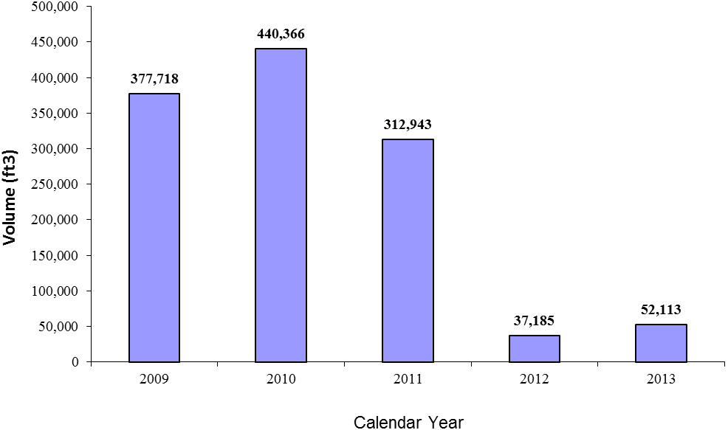

- Consistent large volume generators include Entergy, PerkinElmer, Inc., and Unitech Services Group.

- Entergy generated 53% of the total volume in 2012 due to site maintenance activities.

- In 2013, Entergy generated 79% of the total volume due to scheduled refueling outage.

Figure 4 - Annual Volume of LLRW Generated from 2009-2013, Excluding Shpack Landfill Cleanup.

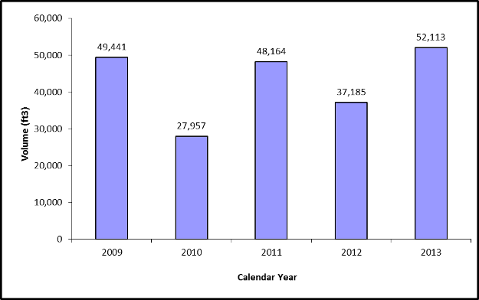

- Facilities that generated the most volume from 2009-2013:

  - Entergy Nuclear
  - PerkinElmer;
  - Unitech Services Group, Inc.
  - Dana-Farber Cancer Institute;
  - Lantheus Medical Imaging; Philotechnics, Ltd; and,

2.2.2. LLRW Volume by Waste Generator Category

Table 8. Volume (ft³) by Waste Generator Category
 | 2009 | 2010 | 2011 | 2012 | 2013
Academic | 436 | 545 | 468 | 830 | 1,055
Commercial | 12,515 | 11,749 | 14,121 | 14,573 | 9,459
Government | 328,281 | 412,409 | 264,783 |  | 4
Health | 2,941 | 964 | 671 | 2,187 | 562
Utility | 33,545 | 14,699 | 32,899 | 19,595 | 41,030

- Waste volumes are largely influenced by one-time-only decommissioning projects.

- In 2009 & 2010, the Government increase is largely due to the Shpack landfill clean-up by the U.S. Army Corps. of Engineers.

- Entergy (Utility) generated the most volume from 2009-2013.

2.2.3. LLRW Volume by Facility Type

Table 9. Volume (ft³) by Facility Type
 | 2009 | 2010 | 2011 | 2012 | 2013
Federal Agency | 328,369 | 412,432 | 264,848 | 51 | 9.06
Private, Non-Profit | 3,194 | 1,292 | 965 | 2,815 | 1,338
Private, Profit | 46,060 | 26,448 | 47,020 | 34,159 | 50,489
State Education Facility | 95 | 194 | 110 | 160 | 274

- Waste volumes are largely influenced by one-time-only decommissioning projects.

- In 2009 & 2010, the Federal Agency category increase is largely due to the Shpack landfill clean-up by the U.S. Army Corps. of Engineers.

- Private, profit volume generation among the top facilities:
  - Dana-Farber Cancer Institute;
  - Lantheus Medical Imaging, Inc.;
  - PerkinElmer, Inc.; and,
  - Unitech Services Group, Inc.

2.2.4. LLRW Volume by Waste Class

Table 10. Volume (ft³) by Waste Class
Class | 2009 | 2010 | 2011 | 2012 | 2013
A | 46,978 | 27,326 | 47,397 | 31,040 | 51,717
B | 720 | 387 | 419 | 586 | 250
C | 35 | 30 | 53 | 37 | 98
HVLA | 329,984 | 412,623 | 265,074 | 5,522 | 48

- HVLA waste volumes are largely influenced by one-time-only decommissioning projects.

- Shpack landfill cleanup (in 2009 & 2010) is responsible for most of the HVLA waste generated.

- Entergy Nuclear, Unitech Services Group, and PerkinElmer were the largest generators of Class A volume from 2009-2013.

2.2.5. Top Generators by Volume from CY 2009-2013

Table 11 Top Generators by Volume (ft³) in Calendar Year 2009
Facility Name | Waste Volume (ft³)
US ARMY CORPS OF ENGINEERS, SHPACK SUPERFUND/FUSRAP SITE | 328,277
ENTERGY NUCLEAR GENERATION COMPANY | 33,545
UNITECH SERVICES GROUP, INC. | 4,200

Table 12. Top Generators by Volume (ft³) in Calendar Year 2010
Facility Name | Waste Volume (ft³)
US ARMY CORPS OF ENGINEERS, SHPACK SUPERFUND/FUSRAP SITE | 412,409
ENTERGY NUCLEAR GENERATION COMPANY | 14,699
UNITECH SERVICES GROUP, INC. | 2,600

Table 13. Top Generators by Volume (ft³) in Calendar Year 2011
Facility Name | Waste Volume (ft³)
US ARMY CORPS OF ENGINEERS, SHPACK SUPERFUND/FUSRAP SITE | 264,779
ENTERGY NUCLEAR GENERATION COMPANY | 32,899
UNITECH SERVICES GROUP, INC. | 4,600

Table 14. Top Generators by Volume (ft³) in Calendar Year 2012
Facility Name | Waste Volume (ft³)
ENTERGY NUCLEAR GENERATION COMPANY | 19,595
PHILOTECHNICS, LTD | 4,085
UNITECH SERVICES GROUP, INC. | 2,370

Table 15. Top Generators by Volume (ft³) in Calendar Year 2013
Facility Name | Waste Volume (ft3)
ENTERGY NUCLEAR GENERATION COMPANY | 41,030
UNITECH SERVICES GROUP, INC. | 2,550
PERKINELMER, INC. | 1,803

2.3. Class A LLRW by Radioactivity

2.3.1. All Class A Radioactivity (Ci)

Figure 5 - Class A Radioactivity

- Class A radioactivity generation has trended upwards until 2011. Upward trend likely due to generators altering use handling processes to make less Class B & C radioactivity, resulting in more generation of Class A radioactivity.
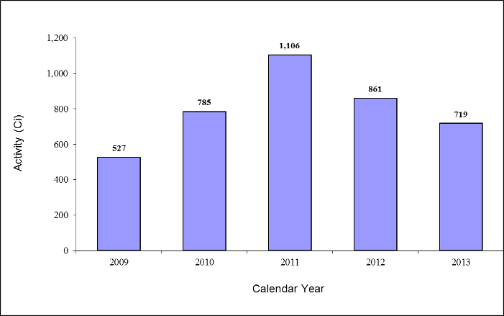

- In 2008, the last LLRW disposal facility in the U.S. still accepting out-of-compact Class B and C wastes closed. Since then, generation of Class B and C waste has declined, likely due to the utilities and commercial facilities storing on site or altering work and waste processing practices to avoid generation of Class B & C wastes.

- PerkinElmer reported a combined total of 1,127 Ci of Class A in 2012 and 2013, respectively.
Entergy Nuclear generated a combined total of 240 Ci of Class A in 2012 and 2013, respectively.
2.3.2. Class A Radioactivity by Waste Generator Category

Table 16. Class A Radioactivity (Ci) by Waste Generator Category
 | 2009 | 2010 | 2011 | 2012 | 2013
Academic | 0.77 | 0.73 | 0.44 | 0.86 | 0.62
Commercial | 399.64 | 603 | 860 | 702 | 632.46
Health | 1.67 | 0.94 | 1.63 | 0.29 | 3
Utility | 125 | 180 | 243 | 157 | 82.90

The following observations are made regarding the data in Table 17.

- Commercial facilities generated the most Class A radioactivity from 2009-2013. For example, PerkinElmer was the top generator of Class A radioactivity for five consecutive years.

- Entergy Nuclear (Utility) generated the most Class A radioactivity for each year.

2.3.3. Class A Radioactivity by Facility Type

Table 17. Class A Radioactivity (Ci) by Facility Type
 | 2009 | 2010 | 2011 | 2012 | 2013
Federal Agency | 0.28 | 0.55 | 1.30 | 0.00 | 0.00
Private, Non-Profit | 2.11 | 1.07 | 0.72 | 1.13 | 3.51
Private, Profit | 524 | 783 | 1,103 | 859 | 715
State Education Facility | 0.03 | 0.05 | 0.05 | 0.01 | 0.112

The following observations are made regarding the data in Table 18.

- Private, for-profit facilities dominate Class A radioactivity generation.

2.3.4. Top Class A Radioactivity Generators from CY 2009-2013

Table 18. Top Class A Radioactivity (Ci) in Calendar Year 2009
Facility Name | Class A  (Ci)
PERKINELMER, INC. | 358
ENTERGY NUCLEAR GENERATION COMPANY | 125
QSA GLOBAL, INC. | 20

Table 19. Top Class A Radioactivity (Ci) in Calendar Year 2010
Facility Name | Class A  (Ci)
PERKINELMER, INC. | 534
ENTERGY NUCLEAR GENERATION COMPANY | 180
PETNET SOLUTIONS, INC. | 19

Table 20. Top Class A Radioactivity (Ci) in Calendar Year 2011
Facility Name | Class A  (Ci)
PERKINELMER, INC. | 829
ENTERGY NUCLEAR GENERATION COMPANY | 243
BEVERLY MICROWAVE DIVISION OF COMMUNICATIONS AND POWER | 10

Table 21. Top Class A Radioactivity (Ci) in Calendar Year 2012
Facility Name | Class A  (Ci)
PERKINELMER, INC. | 635
ENTERGY NUCLEAR GENERATION COMPANY | 157
PETNET SOLUTIONS, INC. | 20

Table 22. Top Class A Radioactivity (Ci) in Calendar Year 2013
Facility Name | Class A  (Ci)
PERKINELMER, INC. | 490
ENTERGY NUCLEAR GENERATION COMPANY | 82
INDUSTRIAL NUCLEAR COMPANY, INC. | 80

2.4. Class A LLRW by Volume

2.4.1. All Class A Volume

Figure 6 - Class A Volume

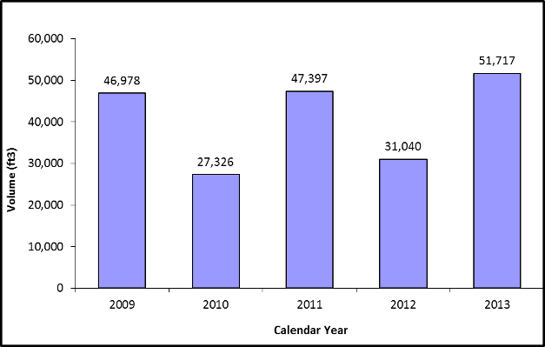

- Class A volume variability is largely due to planned and unplanned utility outages and other decommissioning projects.

- Entergy Nuclear generated 69% of total Class A volume from 2009-2013.

2.4.2. Class A Volume by Waste Generator Category

Table 23. Class A Volume (ft³) by Waste Generator Category
 | 2009 | 2010 | 2011 | 2012 | 2013
Academic | 413 | 544 | 467 | 815 | 1,055
Commercial | 12,211 | 11,417 | 13,554 | 9,897 | 9,083
Government | 4 |  | 4 |  | 4
Health | 1,369 | 964 | 670 | 826 | 556
Utility | 32,980 | 14,400 | 32,700 | 19,500 | 41,015

- The annual variability in Class A volume from Utility=s is due to outages.

- Commercial facilities generated a significant amount of Class A waste from 2009-2013:

Lantheus Medical Imaging, Inc.;
PerkinElmer, Inc.; and,
Unitech Services Group, Inc.

2.4.3. Class A Volume by Facility Type

Table 24. Class A Volume (ft³) by Facility Type
 | 2009 | 2010 | 2011 | 2012 | 2013
Federal Agency | 91 | 23.60 | 69 | 51 | 4
Private, Non-Profit | 1,622 | 1,291 | 964 | 1,455 | 1,337
Private, Profit | 45,191 | 25,817 | 46,253 | 29,388 | 50,098
State Education Facility | 72 | 193 | 109 | 145 | 274

- Private, Profit facilities dominated the generation of Class A volumes.

- Private, Profit varies from year to year due to Utility outages and planned and unplanned decommissioning work.

2.4.4. Top Class A Volume Generators from CY 2009-2013

Table 25. Top Class A Volume Generators in Calendar Year 2009
Facility Name | Class A (ft³)
ENTERGY NUCLEAR GENERATION COMPANY | 32,980
UNITECH SERVICES GROUP, INC. | 4,200
PERKINELMER, INC. | 1,455

Table 26. Top Class A Volume Generators in Calendar Year 2010
Facility Name | Class A (ft³)
ENTERGY NUCLEAR GENERATION COMPANY | 14,400
UNITECH SERVICES GROUP, INC. | 2,600
PERKINELMER, INC. | 2,467

Table 27. Top Class A Volume Generators in Calendar Year 2011
Facility Name | Class A (ft³)
ENTERGY NUCLEAR GENERATION COMPANY | 32,700
UNITECH SERVICES GROUP, INC. | 4,600
PERKINELMER, INC. | 2,329

Table 28. Top Class A Volume Generators in Calendar Year 2012
Facility Name | Class A (ft³)
ENTERGY NUCLEAR GENERATION COMPANY | 19,500
UNITECH SERVICES GROUP, INC. | 2,370
PERKINELMER, INC. | 1,780

Table 29. Top Class A Volume Generators in Calendar Year 2013
Facility Name | Class A (ft³)
ENTERGY NUCLEAR GENERATION COMPANY | 41,015
UNITECH SERVICES GROUP, INC. | 2,550
PERKINELMER, INC. | 1,465

2.5. Class B LLRW by Radioactivity

2.5.1. All Class B by Radioactivity

Figure 7 - All Class B by Radioactivity

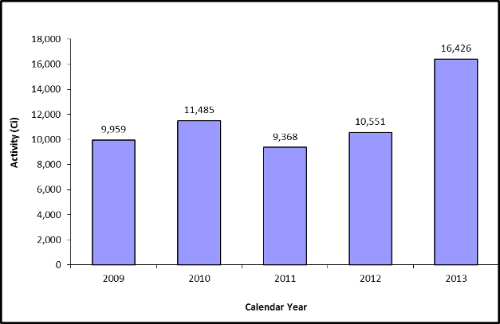

- Class B radioactivity generation appears to have an upward trend (years 2011-2013) likely due to:

- Commercial facilities ramping up source production
- Radioactive waste system resins capturing more activity during refueling and spent fuel pool maintenance activities.

- QSA Global, PerkinElmer, and Entergy reported the most Class B radioactivity from 2009-2013.

2.5.2. Class B Radioactivity by Waste Generator Category

Table 30. Class B Radioactivity (Ci) by Waste Generator Category
 | 2009 | 2010 | 2011 | 2012 | 2013
Academic | 2.00e-05 | 2.00e-05 |  | 14
Commercial | 9,839 | 10,414 | 9,314 | 9,912 | 16,425
Utility | 119 | 1,070 | 53.2 | 625

- Commercial facilities dominate the generation of Class B radioactivity.

2.5.3. Class B Radioactivity by Facility Type

Table 31. Class B Radioactivity (Ci) by Facility Type
 | 2009 | 2010 | 2011 | 2012 | 2013
Federal Agency | 12.92 | 35.17 | 11.14 | 0.00 | 0.00
Private, Non-Profit | 2.14 | 1.07 | 0.73 | 1.14 | 3.52
Private, Profit | 10,553.17 | 12,327.94 | 10,529.76 | 11,446.76 | 17,213.54
State Education Facility | 0.04 | 0.05 | 0.06 | 14.02 | 0.11

- Private, For Profit facilities dominate the generation of Class B radioactivity.

2.5.4. Top Class B Radioactivity Generators from CY 2009-2013

Table 32. Top Class B Radioactivity Generators in Calendar Year 2009
Facility Name | Class B  (Ci)
PERKINELMER, INC. | 6,600
QSA GLOBAL, INC. | 3,238
ENTERGY NUCLEAR GENERATION COMPANY | 119

Table 33. Top Class B Radioactivity Generators in Calendar Year 2010
Facility Name | Class B  (Ci)
QSA GLOBAL, INC. | 9,974
ENTERGY NUCLEAR GENERATION COMPANY | 1,070
PERKINELMER, INC. | 440

Table 34. Top Class B Radioactivity Generators in Calendar Year 2011
Facility Name | Class B  (Ci)
PERKINELMER, INC. | 8,991
QSA GLOBAL, INC. | 323
ENTERGY NUCLEAR GENERATION COMPANY | 53

Table 35. Top Class B Radioactivity Generators in Calendar Year 2012
Facility Name | Class B  (Ci)
QSA GLOBAL, INC. | 9,546
ENTERGY NUCLEAR GENERATION COMPANY | 625
PERKINELMER, INC. | 365

Table 36. Top Class B Radioactivity Generators in Calendar Year 2013
Facility Name | Class B  (Ci)
QSA GLOBAL, INC. | 10,619
PERKINELMER, INC. | 5,803
MORPHO DETECTION, INC. | 2.23

2.6. Class B LLRW by Volume

2.6.1. All Class B by Volume

Figure 8 - All Class B by Volume
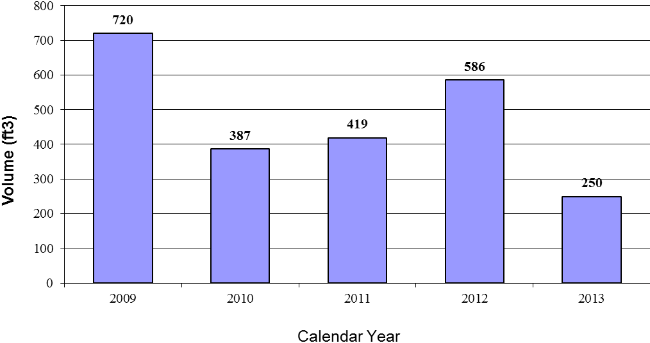
- Entergy, PerkinElmer, and Unitech Services Group generated the most Class B volume from 2009-2013.

2.6.2. Class B Volume by Waste Generator Category

Table 37. Class B Volume (ft³) by Waste Generator Category
 | 2009 | 2010 | 2011 | 2012 | 2013
Academic | 1.40e-04 | 1.40e-04 |  | 7.30
Commercial | 170 | 102 | 234 | 499 | 249.75
Utility | 550 | 284 | 184 | 80

- Utility facility’s Class B volume varies due to outages at Entergy PNPS.

- Commercial facilities that generated the most Class B volume from 2009-2013: Entergy, PerkinElmer, Morpho Detection, and QSA Global.

2.6.3. Class B Volume by Facility Type

Table 38. Class B Volume (ft³) by Facility Type
 | 2009 | 2010 | 2011 | 2012 | 2013
Private, Non-Profit | 1.40e-04 | 1.40e-04
Private, Profit | 720 | 386 | 418 | 579 | 249.75
State Education Facility |  | 0 |  | 7.30

- Private, Profit facilities (i.e., PerkinElmer & Entergy) dominate the volume of Class B generated every year.

2.6.4. Top Class B Volume Generators in CY 2009-2013

Table 39. Top Class B Volume Generators in Calendar Year 2009
Facility Name | Class B  (ft³)
ENTERGY NUCLEAR GENERATION COMPANY | 550
PERKINELMER, INC. | 169
QSA GLOBAL, INC. | 0.89

Table 40. Top Class B Volume Generators in Calendar Year 2010
Facility Name | Class B  (ft³)
ENTERGY NUCLEAR GENERATION COMPANY | 284
PERKINELMER, INC. | 51.79
MEVION MEDICAL SYSTEMS, INC. | 50

Table 41. Top Class B Volume Generators in Calendar Year 2011
Facility Name | Class B  (ft³)
PERKINELMER, INC. | 184
ENTERGY NUCLEAR GENERATION COMPANY | 184
MEVION MEDICAL SYSTEMS, INC. | 50

Table 42. Top Class B Volume Generators in Calendar Year 2012
Facility Name | Class B  (ft³)
PERKINELMER, INC. | 498
ENTERGY NUCLEAR GENERATION COMPANY | 80
MASS. -LOWELL, UNIVERSITY OF | 7.30

Table 43. Top Class B Volume Generators in Calendar Year 2013
Facility Name | Class B  (ft³)
PERKINELMER, INC. | 247.5
MORPHO DETECTION, INC. | 1.36
QSA GLOBAL, INC. | 0.88

2.7. Class C LLRW by Radioactivity

2.7.1. All Class C Radioactivity

Figure 9 - All Class C Radioactivity

- Utility and commercial entities generated the majority of Class C radioactivity.
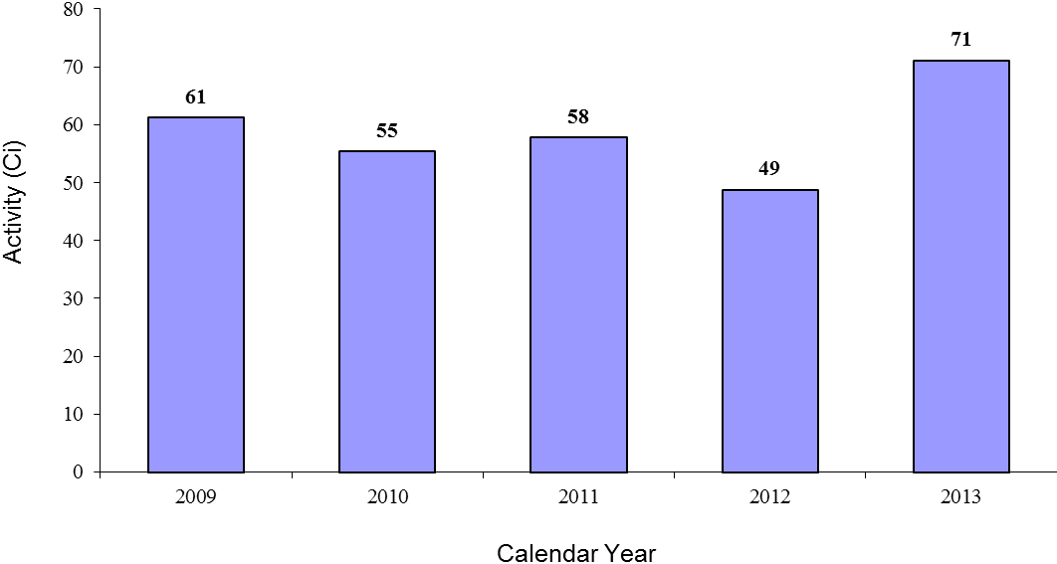

2.7.2. Class C Radioactivity by Waste Generator Category

Table 44. Class C Radioactivity (Ci) by Waste Generator Category
 | 2009 | 2010 | 2011 | 2012 | 2013
Academic |  | 0 |  | 3.00e-03
Commercial | 13.56 | 7.76 | 10.15 | 1.10 | 23.4
Utility | 47.7 | 47.7 | 47.7 | 47.7 | 47.7

- Utility and commercial facilities (i.e., PerkinElmer & Entergy) dominate the radioactivity generation of Class C every year.

2.7.3. Class C Radioactivity by Facility Type

Table 45. Class C Radioactivity (Ci) by Facility Type
 | 2009 | 2010 | 2011 | 2012 | 2013
Private, Profit | 61.26 | 55.46 | 57.86 | 48.8 | 71.14
State Education Facility |  | 0 |  | 3.00e-03

- Private, Profit facilities (i.e., PerkinElmer & Entergy) dominate the radioactivity generation of Class C every year.

2.7.4. Top Class C Radioactivity Generators from CY 2009-2013

Table 46. Top Class C Radioactivity Generators in 2009
Facility Name | Class C  (Ci)
ENTERGY NUCLEAR GENERATION COMPANY | 47.70
PERKINELMER, INC. | 13.56

Table 47. Top Class C Radioactivity Generators in 2010
Facility Name | Class C  (Ci)
ENTERGY NUCLEAR GENERATION COMPANY | 47.70
PERKINELMER, INC. | 7.76

Table 48. Top Class C Radioactivity Generators in 2011
Facility Name | Class C  (Ci)
ENTERGY NUCLEAR GENERATION COMPANY | 47.70
PERKINELMER, INC. | 10.15

Table 49. Top Class C Radioactivity Generators in 2012
Facility Name | Class C  (Ci)
ENTERGY NUCLEAR GENERATION COMPANY | 47.70
PERKINELMER, INC. | 1.10

Table 50. Top Class C Radioactivity Generators in 2013
Facility Name | Class C  (Ci)
ENTERGY NUCLEAR GENERATION COMPANY | 47.70
PERKINELMER, INC. | 23.44

2.8. Class C LLRW by Volume

2.8.1. All Class C by Volume

Figure 10 - All Class C by Volume

The following observations are made regarding the data in Figure 10.
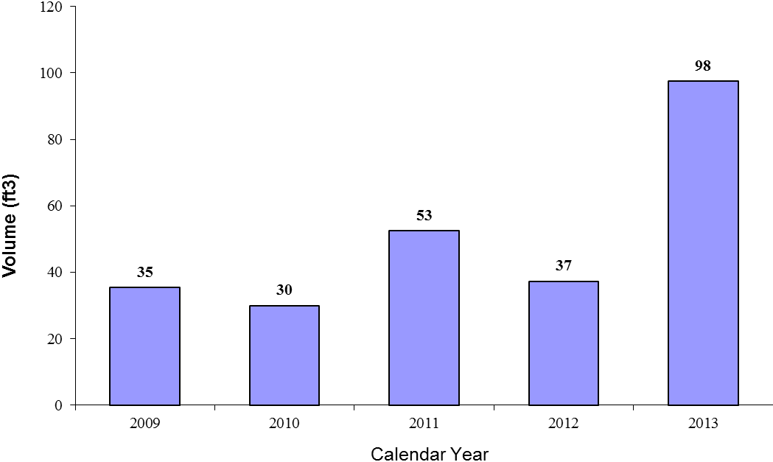

- The large variability in Class C volumes is due to utility outages, which results in more radionuclide production. Scheduled outages at Entergy PNPS can contribute significantly to total LLRW figures; outages occur approximately every 24 months and some are much more comprehensive than others (e.g. produce more waste).
2.8.2. Class C Volume by Waste Generator Category

Table 51. Class C Volume (ft³) by Waste Generator Category
 | 2009 | 2010 | 2011 | 2012 | 2013
Academic |  | 0 |  | 7.30
Commercial | 20.3 | 15 | 37.5 | 15 | 82.5
Utility | 15 | 15 | 15 | 15 | 15

- Utility and commercial facilities (i.e., PerkinElmer & Entergy) dominate the volume generation of Class C every year.

- University of Massachusetts Lowell generated 7.30 ft3 of Class C in 2012 due to reactor cleanout activities.

2.8.3. Class C Volume by Facility Type

Table 52. Class C Volume (ft³) by Facility Type
 | 2009 | 2010 | 2011 | 2012 | 2013
Private, Profit | 35.39 | 30 | 52.5 | 30 | 97.5
State Education Facility |  | 0 |  | 7.30

- Private, Profit facilities (i.e., PerkinElmer & Entergy) dominate the volume generation of Class C every year.

- University of Massachusetts Lowell generated 7.30 ft3 of Class C in 2012.

2.8.4. Top Class C Volume Generators from CY 2009-2013

Table 53. Top Class C Volume Generators in Calendar Year 2009
Facility Name | Class C  (ft³)
PERKINELMER, INC. | 20.39
ENTERGY NUCLEAR GENERATION COMPANY | 15

Table 54. Top Class C Volume Generators in Calendar Year 2010
Facility Name | Class C  (ft³)
ENTERGY NUCLEAR GENERATION COMPANY | 15
PERKINELMER, INC. | 15

Table 55. Top Class C Volume Generators in Calendar Year 2011
Facility Name | Class C  (ft³)
PERKINELMER, INC. | 37.5
ENTERGY NUCLEAR GENERATION COMPANY | 15

Table 56. Top Class C Volume Generators in Calendar Year 2012
Facility Name | Class C  (ft³)
PERKINELMER, INC. | 15
ENTERGY NUCLEAR GENERATION COMPANY | 15

Table 57. Top Class C Volume Generators in Calendar Year 2013
Facility Name | Class C  (ft³)
PERKINELMER, INC. | 82.5
ENTERGY NUCLEAR GENERATION COMPANY | 15

2.9. HVLA LLRW by Radioactivity

2.9.1. All HVLA by Radioactivity

Figure 11 - All HVLA by Radioactivity
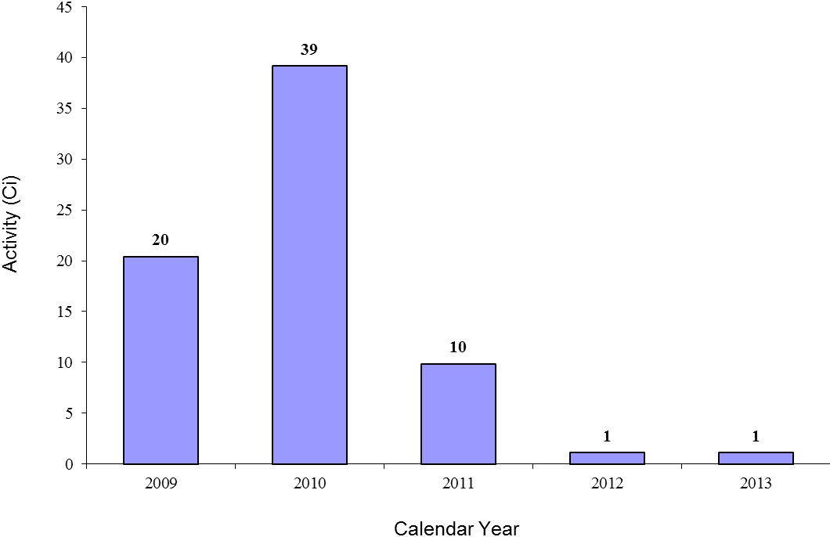
- HVLA radioactivity levels are highly reliant upon decommissioning projects, which are unpredictable (e.g., U.S. Army Corps of Engineers).

- U.S. Army Corps of Engineers and PerkinElmer generated the most HVLA from 2009-2011.

2.9.2. HVLA Radioactivity by Waste Generator Category

Table 58. HVLA Radioactivity (Ci) by Waste Generator Category
 | 2009 | 2010 | 2011 | 2012 | 2013
Academic | 4.69e-04 | 0
Commercial | 7.76 | 4.53 | 3.24e-02 | 1.11 | 1.10
Government | 12.64 | 34.61 | 9.84
Health | 1.57e-02 | 0 | 6.99e-04 | 3.87e-03 | 1.00e-07

- The Government category dominates HVLA radioactivity generation (e.g., U.S. Army Corps of Engineers involvement in the Shpack landfill cleanup).

2.9.3. HVLA Radioactivity by Facility Type

Table 59. HVLA Radioactivity (Ci) by Facility Type
 | 2009 | 2010 | 2011 | 2012 | 2013
Federal Agency | 12.64 | 34.61 | 9.84 |  | 1.00e-07
Private, Non-Profit | 1.57e-02 | 0 | 6.99e-04 | 3.87e-03
Private, Profit | 7.76 | 4.53 | 3.24e-02 | 1.11 | 1.10
State Education Facility | 4.69e-04 | 0

- The Federal Agency category dominates HVLA radioactivity generation (e.g., U.S. Army Corps of Engineers involvement in the Shpack landfill cleanup).

- The 2010 Private, Profit HVLA radioactivity generation was largely due to PerkinElmer, who appeared to be using this decommissioning created class of waste for some of their routine disposals.
2.9.4. Top HVLA Radioactivity Generators from CY 2009-2013

Table 60. Top HVLA Radioactivity Generators in Calendar Year 2009
Facility Name | HVLA  (Ci)
US ARMY CORPS OF ENGINEERS, SHPACK SUPERFUND/FUSRAP SITE | 12.64
PERKINELMER, INC. | 7.73
PFIZER, INC. | 0.03

Table 61. Top HVLA Radioactivity Generators in Calendar Year 2010
Facility Name | HVLA  (Ci)
US ARMY CORPS OF ENGINEERS, SHPACK SUPERFUND/FUSRAP SITE | 34.61
PERKINELMER, INC. | 4.50
AREVA NP, INC. | 0.03

Table 62. Top HVLA Radioactivity Generators in Calendar Year 2011
Facility Name | HVLA  (Ci)
US ARMY CORPS OF ENGINEERS, SHPACK SUPERFUND/FUSRAP SITE | 9.84
CHARM SCIENCES INC. | 0.01
LONZA BIOLOGICS, INC. | 0.006

Table 63. Top HVLA Radioactivity Generators in Calendar Year 2012
Facility Name | HVLA  (Ci)
PERKINELMER, INC. | 1.10
PHILOTECHNICS, LTD | 0.006
DANA-FARBER CANCER INSTITUTE | 0.003

Table 64. Top HVLA Radioactivity Generators in Calendar Year 2013
Facility Name | HVLA  (Ci)
PERKINELMER, INC. | 1.10
MICROTEST LABORATORIES, INC. | 0.003
CHARM SCIENCES INC. | 0.001

2.10. HVLA LLRW by Volume

2.10.1. All HVLA by Volume

Figure 12 - All HVLA by Volume

- HVLA volumes are highly reliant upon decommissioning projects, hence trending is difficult (e.g., U.S. Army Corps of Engineers).
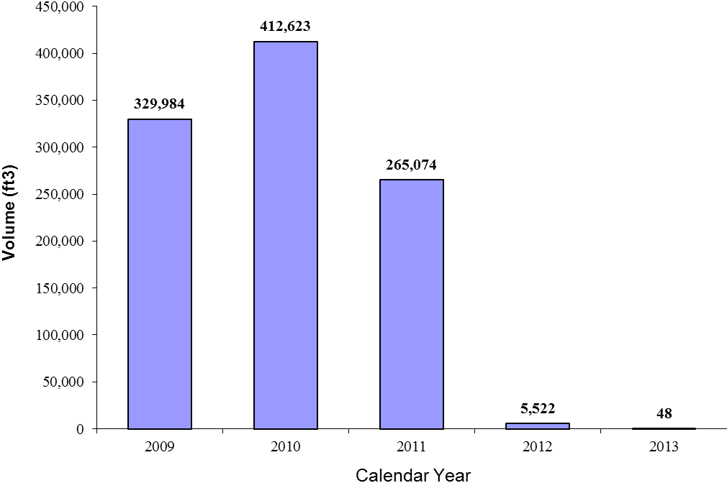

2.10.2. HVLA Volume by Waste Generator Category

Table 65. HVLA Volume (ft³) by Waste Generator Category
 | 2009 | 2010 | 2011 | 2012 | 2013
Academic | 23 | 0
Commercial | 112 | 214 | 294.86 | 4,161 | 43.34
Government | 328,277 | 412,409 | 264,779
Health | 1,571 | 0 | 0.51 | 1,360 | 5.06

- All the Government HVLA volume generation is attributed to the Shpack landfill decommissioning project, which was led by the U.S. Army Corps of Engineers.

- In 2009, Massachusetts General Hospital generated 1,571 ft3 of HVLA.

- In 2012, Philotechnics, Ltd. generated 4,085 ft3 out of 4,161ft3 of HVLA; Dana-Farber Cancer Institute produced 1,360 ft3 of HVLA.

2.10.3. HVLA Volume by Facility Type

Table 66. HVLA Volume (ft³) by Facility Type
 | 2009 | 2010 | 2011 | 2012 | 2013
Federal Agency | 328,277 | 412,409 | 264,779 |  | 5.06
Private, Non-Profit | 1,571 |  | 0.51 | 1,360
Private, Profit | 112 | 214 | 294.86 | 4,161 | 43.34
State Education Facility | 23 | 0

- All the Federal Agency HVLA volume generation is due to the Shpack landfill decommissioning project, which ended in 2010.

- Private, Non-Profit and Private, Profit generated the most HVLA volume in 2009 and 2012, respectively.

2.10.4. Top HVLA Volume Generators from CY 2009-2013

Table 67. Top HVLA Volume Generators in Calendar Year 2009
Facility Name | HVLA  (ft ³ )
US ARMY CORPS OF ENGINEERS, SHPACK SUPERFUND/FUSRAP SITE | 328,277
MASS. GENERAL HOSPITAL | 1,571
PFIZER, INC. | 46

Table 68. Top HVLA Volume Generators in Calendar Year 2010
Facility Name | HVLA  (ft ³ )
US ARMY CORPS OF ENGINEERS, SHPACK SUPERFUND/FUSRAP SITE | 412,409
AREVA NP, INC. | 190
CHARM SCIENCES INC. | 15

Table 69. Top HVLA Volume Generators in Calendar Year 2011
Facility Name | HVLA  (ft ³ )
US ARMY CORPS OF ENGINEERS, SHPACK SUPERFUND/FUSRAP SITE | 264,779
PLANSEE USA, LLC | 143
LONZA BIOLOGICS, INC. | 45

Table 70. Top HVLA Volume Generators in Calendar Year 2012
Facility Name | HVLA  (ft ³ )
PHILOTECHNICS, LTD | 4,085
DANA-FARBER CANCER INSTITUTE | 1,360
LONZA BIOLOGICS, INC. | 35.8

Table 71. Top HVLA Volume Generators in Calendar Year 2013
Facility Name | HVLA  (ft³)
MICROTEST LABORATORIES, INC. | 34.77
PERKINELMER, INC. | 7.50
HEALTH & HUMAN SERVICES, DEPT. OF | 5.06

3. NATIONAL DATA

Commercial disposal of LLRW in the U.S. has been nationally tabulated in the Manifest Information Management System (MIMS) since 1998; the database was developed for and is maintained by the U.S. Department of Energy (DOE) in response to provisions in 42 U.S.C. 2021g(a). The data in MIMS comes from waste manifests shipments to one closed LLRW disposal facility (i.e. Beatty, Nevada) and three operating commercial LLRW disposal facilities (U.S. Ecology [Richland, Washington], Duratek / Chem Nuclear [Barnwell, South Carolina], and Energy Solutions, formerly Envirocare of Utah [Clive, Utah]).

Reports in MIMS contain information on LLRW volume, radioactivity, and number of shipments to each facility. Waste generators are not specifically identified in MIMS but instead are given a unique code indicating the state of origin. Some shipments include waste from multiple states and or waste generators which are delivered via brokers or waste processors.

The scope of the data in MIMS is limited to LLRW from utilities, industries including waste brokers/processors, academic/research institutions, medical facilities, and government (state and Federal agencies outside DOE). MIMS data can be found at http://mims.apps.em.doe.gov/.

According to MIMS data, all LLRW generated in Massachusetts from 2009-2013 was received at Envirocare in Clive, Utah due to the closure of Barnwell, SC (2008) and Hanford, WA (1992) sites to non-compact members. However, the MIMS data does not show is where Massachusetts’ Class B & C waste is received, since Envirocare only accepts Class A waste. It is possible that Massachusetts’ Class B & C waste is being treated then disposed as Class A or temporarily stored on site or at a waste broker’s facility.

4. FINANCIAL DATA

Funds to manage the requirements of M.G.L. Chapter 111H (Massachusetts Low-Level Radioactive Waste Management Act), as amended, require the assessment of an annual fee on licensees and registrants. Pursuant to M.G.L. Chapter 111H, section 4A, the Low-Level Radioactive Waste Management Board shall annually assess each person licensed or registered to receive, possess, use, transfer or acquire radioactive materials in the Commonwealth, amounts sufficient to defray the costs annually incurred by the board for such purposes.

Any unpaid assessments are charged interest at 12% per annum on and after the due date, which is 90 days from the invoice date. After 180 days any outstanding fee users are issued a collection letter and subject to intercept of any state payments or tax refunds.

Cities and towns are exempt from the annual LLRW fees per M.G.L. Chapter 29, section 27C, however municipalities must still submit the annual LLRW survey when requested.

Pursuant to 345 CMR 4.03(2), the annual LLRW fee is a function of volume, class, and activity of waste generated per year, as shown in the equation below:

Annual Fee = FF + {[(CRF)*(CA + 3CB +5CC)]*(PF)} + [(HVLA*(PF_{HVLA})]

Where:
FF - Flat Fee. Currently $100 for XRF only licenses; $150 for all other licenses.

CRF - Classification of Radioactivity Factor. Varies from 1.0 to 1.3 depending on the gross activity generated (excluding HVLA waste) - See Table 75 below.

CA - Class A LLRW volume in ft³.

CB - Class B LLRW volume in ft³.

CC - Class C LLRW volume in ft³.

PF - Proportional Fee for Class A, B, and C Wastes - Currently set at $5.10/ ft³.

PF_{HVLA} - Proportional Fee for HVLA Waste - Currently set at $1.275/ft³.

HVLA- Volume of HVLA waste in ft³.

Table 72. Classification of Radioactivity Factor (CRF) per 345 CMR 4.03B table
Radioactivity of Waste Shipped for Disposal Off Site, or Stored for Later Disposal | Classification of Radioactivity Factor (CRF)

Less than 1.0 Ci/year | 1.0
1.0 curie/year or more but less than 10.0 Ci/year | 1.1
10.0 Ci/year or more but less than 100.0 Ci/year | 1.2
100.0 Ci/year or more | 1.3

U.S. DOE FUNDING

The Massachusetts Department of Public Health, Radiation Control Program, received no federal funding from 2009 to 2013, pursuant to the federal Low-Level Radioactive Waste Policy Act, as amended (P.L. 99-240). The funds were collected by certain LLRW disposal sites as a surcharge to use these disposal sites. The funds are held by DOE, and rebated to various states based upon their success in meeting milestones outlined in federal law. Since Massachusetts ceased its disposal siting activities in 1996 and remains an unaffiliated disposal state, no funds were received during the time frame of this report.

Appendix A - Glossary of Terms

Broker A person engaged in the business of arranging for the collection, transportation, treatment, storage or disposal of low-level radioactive waste.

High Volume, Low Activity (HVLA)
Soils or demolition rubble waste that have average concentrations of radioactive material less than or equal to the concentrations set forth in 345 CMR 1.13, Table 1.13B and that have been accepted for disposal at a licensed LLRW disposal facility.

Licensee A person holding a license issued pursuant to Part C of 105 CMR 120.000 by DPH or a license issued by the U.S. Nuclear Regulatory Commission to transfer, acquire, own, possess or use quantities of, or devices or equipment utilizing, radioactive material.

Low-Level Radioactive Waste (LLRW)
Radioactive material that (1) is neither high level waste, nor spent nuclear fuel, nor byproduct material as defined in ' 11(e)(2) of the Atomic Energy Act of 1954, as amended, 42 U.S.C. ' 2014(e); and (2) is classified by the Federal Government as low-level radioactive waste, but not including waste which remains a Federal responsibility, as designated in ' 3(b) of the Low-Level Radioactive Waste Policy Act, as amended, 42 U.S.C. ' 2021c(b), as in effect as of December 8, 1987.

RCRA Corrective Action (RCRA) sites
Facilities that treat, store, and/or dispose of hazardous wastes. These facility owners are required to clean up environmental contaminants released into soil, ground water, surface water, and air at their sites under the Resource Conservation and Recovery Act (RCRA).

Shallow Depth Disposal
A land disposal method that relies on the sites’ natural characteristics as the primary barrier for isolation of the waste.

Appendix B - Commercial Low Level Radioactive Waste - Recent History

Low Level Radioactive Waste Policy Act (LLRWPA)

By the late 1970s, only three disposal facilities accepted commercially produced LLRW in the United States; these facilities were located in South Carolina, Nevada, and Washington state. These states urged Congress to pass the Low Level Radioactive Waste Policy Act (LLRWPA) in 1980 (P.L. 96-573). The act established that:

1. Each state is responsible for the LLRW generated within its boundaries;

2. States were encouraged to form multi-state compacts to facilitate managing LLRW generated within the boundaries of the compact states; and,

3. The right of regional compacts to prohibit disposal at their regional facilities of LLRW generated in non-compact states after January 1, 1986.

Low-Level Radioactive Policy Amendments Act (LLRWPAA)

It was soon recognized that further adjustments to the LLRWPA were needed. The law’s siting processes were lengthy and there were established penalties if Congressional deadlines for developing new disposal facilities were not met. Thus, the Low-Level Radioactive Policy Amendments Act (LLRWPAA) was passed in 1986 (Public Law 99-240). In short, the LLWPAA:

1. Extended the original January 1, 1986 deadline to develop new disposal facilities by seven years to January 1, 1993. At which time the existing facilities could decline commercial LLRW from non-compact states;

2. Established new milestones and deadlines. Failure to reach a deadline allowed the states operating disposal facilities (still SC, NV, and WA) authorization to deny disposal access to those states in violation of the milestones;

3. Established financial penalties on waste disposed of at existing disposal facilities if certain milestones were not met;

4. The Department of Energy (DOE) was assigned the task of:
A. Collection of and disbursal of LLWRAA-levied surcharges;
B. Assigned responsibility for disposing GTCC waste;
C. Provide financial and technical assistance to the states and compacts;
D. Prepare certain status reports on the management of national LLRW inventories (e.g., Manifest Information Management System (MIMS)); and,

5. The Nuclear Regulatory Commission (NRC) was required to do the following:
A. Review all LLRW disposal facility license applications;
B. Develop standards and procedures for exempting certain LLRW from disposal in licensed facilities;
C. Provide regulatory and technical assistance to Agreement States; and,
D. Determine procedures for granting emergency access to LLRW facilities for wastes generated in other regions.

Failure of Massachusetts to enter a Compact required it to develop regulatory framework compatible with the requirements of 10 CFR Part 61 and other NRC guidance. Hence, in 1987, Massachusetts enacted M.G.L. Chapter 111H. One of the requirements was for the establishment of a LLRW Board to oversee the siting of a LLRW facility in Massachusetts. In 2002, M.G.L. Chapter 111H was amended to abolish the LLRW Board and authorize the Department of Public Health, Bureau of Environmental Health, Radiation Control Program to regulate the management of low-level radioactive waste. Complete copies of the general law are available at http://www.mass.gov/legis/laws/mgl/gl-111h-toc.htm.

Federal Government

From 1979 to 2000, the Department of Energy (DOE) sponsored publication of an annual state-by-state assessment report that provided information on the types and quantities of commercial LLRW being generated. Additionally, in 1986, DOE developed the Manifest Information Management System (MIMS) to monitor the management of commercial LLRW. The database essentially replaced the annual state-by-state assessment report series. In 2000, Congress stopped appropriating money for DOE’s national LLRW program with the exception of the funds necessary to maintain MIMS.

As part of its regulatory oversight function, the NRC attends regular meetings of the Low-Level Radioactive Waste Forum, monitors Agreement States progress implementing LLRWPAA milestones, and has made its decision making more transparent.

Since 2001, a site near Grand View, ID (operated by U.S. Ecology) accepts commercial NARM, NORM, certain NRC-exempt items and devices, radiological-contaminated waste from NRC or NRC Agreement State licensees to be disposed of if the material has been specifically exempted from regulation according to a clearly described set of waste acceptance criteria established by U.S. Ecology and approved by the state.

From 2009-2013, there were four LLRW disposal sites in the United States: Hanford, WA, Barnwell, SC, Clive, UT, and Andrews, TX. Clive, UT (operated by Energy Solutions) was accepting any out-of-state LLRW Class A waste only. Massachusetts LLRW has not been accepted at Hanford, WA since 1992, and Barnwell, SC since July 1, 2008.

Commonwealth of Massachusetts

In 2004, the Government Accountability Office (GAO) determined shortcomings in the quality of the MIMS data and recommended that the NRC take responsibility for generating the required reports. Furthermore, LLRW sent to the new Andrews, TX (operated by Waste Control Specialists) site is not maintained in MIMS. Since the reliability of the MIMS data is in question, Massachusetts continues to survey its LLRW generators and maintain a separate database, to assist in forecasting future disposal needs.

Appendix C - Massachusetts LLRW Classes

The NRC has defined four classes of LLRW (e.g. Class A, B, C, and Greater Than Class C (GTCC)) each with specified disposal and waste requirements based on its potential hazard. These classes have progressively higher levels of concentrations of radioactive material, with A having the lowest and C having the highest level. Class A waste accounts for more than 95% of the total volume of LLRW in the United States.

The fourth class of LLRW, GTCC, is not generally acceptable for near-surface, shallow-depth disposal, hence, the LLRW Policy Act of 1985 assigned the Federal Government (i.e. DOE) responsibility for the disposal of GTCC LLRW that results from NRC and Agreement State licensed activities. Thus, the volume and activity of GTCC generated in Massachusetts is not surveyed or tracked.

Massachusetts uses an additional class of LLRW called High Volume, Low Activity (HVLA) waste. It is anticipated that much of this waste will be produced by decommissioning nuclear licensed sites and will typically include soils & rubble with low concentrations (e.g. 100 pCi/g) of total activity that have the potential to be disposed in non-LLRW landfill sites, such as a Resource Conservation and Recovery Act (RCRA) Subtitle C or D site; else, this waste would be classified as Class A.

Thus, Massachusetts annual LLRW survey has four classes: HVLA, Class A, Class B, and Class C. The determination of the classification of waste is a complex process and has been codified in 345 CMR 1.12 (i.e., 105 CMR 120.299) for Class A, B, and C, and HVLA waste as described in 345 CMR 1.13.

Appendix D - Waste Generator Category Descriptions

Massachusetts uses essentially the same five waste generator categories as the DOE’s MIMS database system: Academic, Commercial, Government, Health, and Utility (MIMS calls these categories: Academic, Industry, Government, Medical, and Utility, respectively). All entities that submit a LLRW survey is assigned just one waste generator category, as described below:

Academic all institutions of learning (i.e., colleges, universities, etc.) are assigned this category, regardless if the entity is commercial or not.

Commercial all for-profit entities not designated as a Health, Utility, or Academic generator category.

Government all entities which are closely affiliated, generally by government ownership or control, with Federal, State and local governments.

Health all entities supplying medical patient services regardless if it is for-profit or not. Generally this category will include all hospitals, medical clinics, etc.

Utility all entities which supply electrical power regardless if it is for-profit or not. This includes any private, public, or government-owned nuclear power plant.

Appendix E - Facility Type Descriptions

To further analyze the submitted LLRW data, Massachusetts further classifies each entity with a facility type designation, as follows:

Federal Agency - all entities which are closely affiliated, generally by government ownership or control, with the Federal government.

State Agency - all entities which are closely affiliated, generally by government ownership or control, with the State government, excluding State Education facilities.

State Education - all education (i.e., colleges, universities, etc.) entities which are closely affiliated, generally by government ownership or control, with the State government.

Municipality - all entities which are closely affiliated, generally by government ownership or control, with local government (i.e., city, town, board of health, etc.).

Private, Profit - any for-profit entity.

Private, Non-Profit - any non-profit entity that is not government affiliated.

Appendix F - Acronyms

CFR Code of Federal Regulations

CMR Code of Massachusetts Regulations

DOE U.S. Department of Energy

EPA U.S. Environmental Protection Agency

GTCC Greater than Class C

HVLA High Volume, Low Activity (radioactive waste)

LLRW Low Level Radioactive Waste

MDPH Massachusetts Department of Public Health

MIMS Manifest Information Management System

RCP Massachusetts Radiation Control Program

NPP Nuclear Power Plant

NRC Nuclear Regulatory Commission

RCRA Resource Conservation and Recovery Act

XRF X-ray Fluorescence

