Background/Introduction

INDOOR AIR QUALITY ASSESSMENT

Commonwealth of Massachusetts
Department of Children and Families
33 East Merrimack Street
Lowell, MA

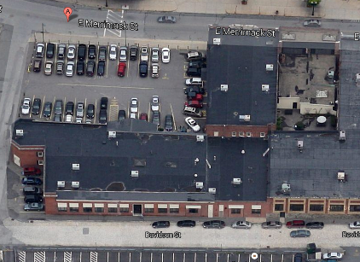

Prepared by:
Massachusetts Department of Public Health
Bureau of Environmental Health
Indoor Air Quality Program
April 2015

At the request of Ms. Deborah Coleman, Facilities Director, Executive Office of Health and Human Services (EOHHS), an indoor environmental investigation was conducted at the Massachusetts Department of Children and Families (DCF), Lowell Regional Office, 33 East Merrimack Street, Lowell, Massachusetts. The Massachusetts Department of Public Health (MDPH), Bureau of Environmental Health (BEH) conducted the assessment in response to concerns related to water damage that occurred during recent snowstorms as well as general indoor air quality (IAQ) concerns. On February 20, 2015, a site visit was made by Cory Holmes, Environmental Analyst/Regional Inspector in BEH’s IAQ Program. This report focuses on general IAQ conditions in the building at the time of the assessment. A separate report regarding water damage conditions with advice on remediation was previously issued (MDPH, 2015).
The DCF has occupied space in the building for over 20 years. The building is a single-story, flat-roofed structure that was built in the early 1890s. It was reported that the space had previously been used as a car dealership and has been renovated a number of times over the years to accommodate office space. The DCF has recently expanded to occupy office space in an adjacent building called the “annex”. Windows are openable along the perimeter of the building.

Methods
Air tests for carbon dioxide, carbon monoxide, temperature and relative humidity were taken with the TSI, Q-Trak, IAQ Monitor 7565. Air tests for airborne particle matter with a diameter less than 2.5 micrometers were taken with the TSI, DUSTTRAK™ Aerosol Monitor Model 8520. BEH/IAQ staff also performed a visual inspection of building materials for water damage and/or microbial growth.

Results
The DCF has an employee population of approximately 130 with up to 15 members of the public conducting business at the office daily. Test results appear in Table 1.

Discussion

Ventilation
It can be seen from Table 1 that carbon dioxide levels were above 800 parts per million (ppm) in fourteen of forty-seven areas tested, indicating a lack of air exchange in some areas at the time of the assessment. It is important to note that the site visit occurred after several days of sub-freezing weather. During extreme cold conditions, the openings of fresh air intake louvers for the heating, ventilating and air-conditioning (HVAC) systems are often limited to reduce the amount of cold air supplied to the HVAC. Limiting cold air increases thermal comfort of occupants and prevents freezing of pipes and/or damage to HVAC equipment.
Fresh air is provided by rooftop air-handling units (AHUs; Picture 1). Fresh air is drawn into the AHUs, heated or cooled and delivered to occupied areas via ducted air diffusers (Picture 2). Return air is drawn into ceiling or wall-mounted vents and ducted back to rooftop AHUs (Pictures 3 and 4).
The HVAC system is controlled by digital thermostats (Pictures 5 through 7). Thermostats examined had a fan switch with two settings, on and auto. When the fan is set to on, the system provides a continuous source of air circulation and filtration. The automatic setting on the thermostat activates the HVAC system at a pre-set temperature. Once the pre-set temperature is reached, the HVAC system is deactivated. Therefore, no mechanical ventilation is provided until the thermostat re-activates the system. At the time of the assessment, the thermostat fan settings were in the “auto” position (Pictures 5 though 7). As mentioned, this thermostat setting can limit airflow. The MDPH typically recommends that thermostats be set to the fan on setting during occupied hours to provide continuous air circulation.
In order to have proper ventilation with a mechanical supply and exhaust system, the systems must be balanced to provide an adequate amount of fresh air to the interior of a room while removing stale air from the room. It is recommended that HVAC systems be re-balanced every five years to ensure adequate air systems function (SMACNA, 1994). At the time of the assessment, the last date of balancing was not known.
Minimum design ventilation rates are mandated by the Massachusetts State Building Code (MSBC). Until 2011, the minimum ventilation rate in Massachusetts was higher for both occupied office spaces and general classrooms, with similar requirements for other occupied spaces (BOCA, 1993). The current version of the MSBC, promulgated in 2011 by the State Board of Building Regulations and Standards (SBBRS), adopted the 2009 International Mechanical Code (IMC) to set minimum ventilation rates. Please note that the MSBC is a minimum standard that is not health-based. At lower rates of cubic feet per minute (cfm) per occupant of fresh air, carbon dioxide levels would be expected to rise significantly. A ventilation rate of 20 cfm per occupant of fresh air provides optimal air exchange resulting in carbon dioxide levels at or below 800 ppm in the indoor environment in each area measured. MDPH recommends that carbon dioxide levels be maintained at 800 ppm or below. This is because most environmental and occupational health scientists involved with research on IAQ and health effects have documented significant increases in indoor air quality complaints and/or health effects when carbon dioxide levels rise above the MDPH guidelines of 800 ppm for schools, office buildings and other occupied spaces (Sundell et. al., 2011). The ventilation must be on at all times that the room is occupied. Providing adequate fresh air ventilation with open windows and maintaining the temperature in the comfort range during the cold weather season is impractical. Mechanical ventilation is usually required to provide adequate fresh air ventilation.
Carbon dioxide is not a problem in and of itself. It is used as an indicator of the adequacy of the fresh air ventilation. As carbon dioxide levels rise, it indicates that the ventilating system is malfunctioning or the design occupancy of the room is being exceeded. When this happens, a buildup of common indoor air pollutants can occur, leading to discomfort or health complaints. The Occupational Safety and Health Administration (OSHA) standard for carbon dioxide is 5,000 parts per million parts of air (ppm). Workers may be exposed to this level for 40 hours/week, based on a time-weighted average (OSHA, 1997).
The MDPH uses a guideline of 800 ppm for publicly occupied buildings. A guideline of 600 ppm or less is preferred in schools due to the fact that the majority of occupants are young and considered to be a more sensitive population in the evaluation of environmental health status. Inadequate ventilation and/or elevated temperatures are major causes of complaints such as respiratory, eye, nose and throat irritation, lethargy and headaches. For more information concerning carbon dioxide, please see Appendix A.
Indoor temperatures at the time of the assessment ranged from 69°F to 78°F (Table 1), which were within or very close to the MDPH recommended comfort range. The MDPH recommends that indoor air temperatures be maintained in a range of 70°F to 78°F in order to provide for the comfort of building occupants. In many cases concerning indoor air quality, fluctuations of temperature in occupied spaces are typically experienced, even in a building with an adequate fresh air supply.
Relative humidity measurements at the time of the assessment ranged from 7 to 25 percent (Table 1), which were below the MDPH recommended comfort range in all areas surveyed. The MDPH recommends a comfort range of 40 to 60 percent for indoor air relative humidity. Relative humidity levels in the building would be expected to drop during the winter months due to heating. The sensation of dryness and irritation is common in a low relative humidity environment. Low relative humidity is a very common problem during the heating season in the northeast part of the United States.

Microbial/Moisture Concerns
In order for building materials to support mold growth, a source of water exposure is necessary. As mentioned previously, water infiltration issues related to recent winter snowstorms were addressed in a separate report (MDPH, 2015). However, other chronic water infiltration issues were also observed/reported by occupants.
Water-damaged ceiling tiles were observed in a number of areas throughout the space, which can indicate current or historic roof leaks, plumbing leaks and/or condensation from HVAC components (Table 1). If repeatedly moistened, water-damaged ceiling tiles can provide a source of mold. These tiles should be replaced after a water leak is discovered and repaired. It was reported by building maintenance personnel that a new roof was being planned for the spring of 2015.
Gaps between the sink countertop and backsplash were noted in the kitchen/break area (Picture 8). Improper drainage or sink overflow can lead to water penetration of countertop wood, the cabinet interior and areas behind cabinets. Like other porous materials, if these materials become wet repeatedly they can provide a medium for mold growth.
The US EPA and the American Conference of Governmental Industrial Hygienists (ACGIH) recommend that porous materials be dried with fans and heating within 24 to 48 hours of becoming wet (US EPA, 2001; ACGIH, 1989). If porous materials are not dried within this time frame, mold growth may occur. Once mold has colonized porous materials, they are difficult to clean and should be removed and discarded.

Other IAQ Evaluations
Indoor air quality can be negatively influenced by the presence of respiratory irritants, such as products of combustion. The process of combustion produces a number of pollutants. Common combustion emissions include carbon monoxide, carbon dioxide, water vapor, and smoke (fine airborne particle material). Of these materials, exposure to carbon monoxide and particulate matter with a diameter of 2.5 micrometers (μm) or less (PM2.5) can produce immediate, acute health effects upon exposure. To determine whether combustion products were present in the indoor environment, BEH/IAQ staff obtained measurements for carbon monoxide and PM2.5.

Carbon Monoxide
Carbon monoxide is a by-product of incomplete combustion of organic matter (e.g., gasoline, wood, and tobacco). Exposure to carbon monoxide can produce immediate and acute health effects. Several air quality standards have been established to address carbon monoxide and prevent symptoms from exposure to these substances. The MDPH established a corrective action level concerning carbon monoxide in ice skating rinks that use fossil-fueled ice resurfacing equipment. If an operator of an indoor ice rink measures a carbon monoxide level over 30 ppm, taken 20 minutes after resurfacing within a rink, that operator must take actions to reduce carbon monoxide levels (MDPH, 1997).
The American Society of Heating Refrigeration and Air-Conditioning Engineers (ASHRAE) has adopted the National Ambient Air Quality Standards (NAAQS) as one set of criteria for assessing indoor air quality and monitoring of fresh air introduced by HVAC systems (ASHRAE, 1989). The NAAQS are standards established by the US EPA to protect the public health from six criteria pollutants, including carbon monoxide and particulate matter (US EPA, 2006). As recommended by ASHRAE, pollutant levels of fresh air introduced to a building should not exceed the NAAQS levels (ASHRAE, 1989). The NAAQS were adopted by reference in the Building Officials & Code Administrators (BOCA) National Mechanical Code of 1993 (BOCA, 1993), which is now an HVAC standard included in the Massachusetts State Building Code (SBBRS, 2011). According to the NAAQS, carbon monoxide levels in outdoor air should not exceed 9 ppm in an eight-hour average (US EPA, 2006).
Carbon monoxide should not be present in a typical, indoor environment. If it is present, indoor carbon monoxide levels should be less than or equal to outdoor levels. Outdoor carbon monoxide concentrations were non-detect (ND) at the time of the assessment (Table 1). No measurable levels of carbon monoxide were detected inside the building during the assessment (Table 1).

Particulate Matter
The US EPA has established NAAQS limits for exposure to particulate matter. Particulate matter includes airborne solids that can be irritating to the eyes, nose, and throat. The NAAQS originally established exposure limits to PM with a diameter of 10 μm or less (PM10). In 1997, US EPA established a more protective standard for fine airborne particulate matter with a diameter of 2.5 μm or less (PM2.5). The NAAQS has subsequently been revised, and PM2.5 levels were reduced. This more stringent PM2.5 standard requires outdoor air particle levels be maintained below 35 μg/m³ over a 24-hour average (US EPA, 2006). Although both the ASHRAE standard and BOCA Code adopted the PM10 standard for evaluating air quality, MDPH uses the more protective PM2.5 standard for evaluating airborne PM concentrations in the indoor environment.
Outdoor PM2.5 concentrations the day of the assessment were measured at 12 μg/m³. PM2.5 levels measured inside the building ranged from 5 to 11 μg/m³ (Table 1). Both indoor and outdoor PM2.5 levels were below the NAAQS PM2.5 level of 35 μg/m³. Frequently, indoor air levels of particulate matter (including PM2.5) can be at higher levels than those measured outdoors. A number of mechanical devices and/or activities that occur indoors can generate particulate matter during normal operations. Sources of indoor airborne particulate matter may include but are not limited to particles generated during the operation of fan belts in the HVAC system, use of stoves and/or microwave ovens in kitchen areas; use of photocopiers, fax machines and computer printing devices; operation of an ordinary vacuum cleaner and heavy foot traffic indoors.

Other Conditions
Other conditions that can affect indoor air quality were observed during the assessment. Fiberglass insulation was inserted into the supply vents of Ms. Miller’s office (Picture 9), reportedly in an effort to to reduce drafts. Fiberglass insulation can be a source of skin, eye and respiratory irritation if damaged or disturbed. Use of this material to block fresh air grates is not recommended.
A number of supply diffusers, return grates and exhaust vents were observed to have accumulated dust/debris. If exhaust vents are not functioning, backdrafting can occur, which can re-aerosolize accumulated dust particles. Re-activated supply vents can also aerosolize dust accumulated on vents.
In several areas, items were observed on the floor, windowsills, tabletops, counters, bookcases and desks. The large number of items on flat surfaces provides a source for dusts to accumulate and makes it difficult for custodial staff to clean. Items should be relocated and/or be cleaned periodically to avoid excessive dust build up.
Carpeting in the main DCF office space consists mainly of carpet squares, which appeared in relatively good shape. Carpeting in the annex area was wall-to-wall and its age was unknown. The average lifespan of carpeting is approximately eleven years (Bishop, 2002). The Institute of Inspection, Cleaning and Restoration Certification (IICRC), recommends that carpeting be cleaned annually (or semi-annually in soiled high traffic areas) (IICRC, 2012).

Conclusions/Recommendations
In view of the findings at the time of the visit, the following recommendations are made:
- Consider setting thermostats to the fan “on” position to provide continuous air circulation/filtration during business hours.
- Consider adopting a balancing schedule of every 5 years for all mechanical ventilation systems, as recommended by ventilation industrial standards (SMACNA, 1994).
- For buildings in New England, periods of low relative humidity during the winter are often unavoidable. Therefore, scrupulous cleaning practices should be adopted to minimize common indoor air contaminants whose irritant effects can be enhanced when the relative humidity is low. To control for dusts, a high efficiency particulate arrestance (HEPA) filter equipped vacuum cleaner in conjunction with wet wiping of all surfaces is recommended. Avoid the use of feather dusters. Drinking water during the day can help ease some symptoms associated with a dry environment (throat and sinus irritations).
- Continue with plans for roof replacement. In the interim, continue to investigate roof/plumbing/HVAC leaks and make repairs as needed.
- Remove/replace water-damaged ceiling tiles. Examine the areas above and around for mold growth. Disinfect areas of water leaks with an appropriate antimicrobial.
- Seal areas around sinks (e.g., kitchen/breakroom) to prevent water damage to the interior of cabinets and adjacent wallboard.
- Remove fiberglass insulation from supply vents in Ms. Miller’s office. Consider installing a supply vent with adjustable louvers to control airflow in this area.
- Clean air diffusers, exhaust and return vents periodically of accumulated dust/debris.
- Relocate or consider reducing the amount of materials stored on flat surfaces to allow for more thorough cleaning. Clean items regularly with a wet cloth or sponge to prevent excessive dust build-up.
- Clean area carpets annually or semi-annually in soiled high traffic areas as per the recommendations of the Institute of Inspection, Cleaning and Restoration Certification (IICRC, 2012). Consider a schedule for replacing any worn carpeting that is beyond its service life.
- Refer to resource manual and other related indoor air quality documents located on the MDPH’s website for further building-wide evaluations and advice on maintaining public buildings. These documents are available at http://mass.gov/dph/iaq.

References
ACGIH. 1989. Guidelines for the Assessment of Bioaerosols in the Indoor Environment. American Conference of Governmental Industrial Hygienists, Cincinnati, OH.
ASHRAE. 1989. Ventilation for Acceptable Indoor Air Quality. American Society of Heating, Refrigeration, and Air Conditioning Engineers. ANSI/ASHRAE 62-1989.
Bishop. 2002. Bishop, J. & Institute of Inspection, Cleaning and Restoration Certification. A Life Cycle Cost Analysis for Floor Coverings in School Facilities.
BOCA. 1993. The BOCA National Mechanical Code/1993. 8th ed. Building Officials and Code Administrators International, Inc., Country Club Hill, IL.
IICRC. 2012. Carpet Cleaning FAQ 4 Institute of Inspection, Cleaning and Restoration Certification. Institute of Inspection Cleaning and Restoration, Vancouver, WA.
MDPH. 1997. Requirements to Maintain Air Quality in Indoor Skating Rinks (State Sanitary Code, Chapter XI). 105 CMR 675.000. Massachusetts Department of Public Health, Boston, MA.
MDPH. 2015. Water Damage Investigation, Lowell DCF. Massachusetts Department of Public Health, Bureau of Environmental Health, Boston, MA. March 2015.
OSHA. 1997. Limits for Air Contaminants. Occupational Safety and Health Administration. Code of Federal Regulations. 29 C.F.R 1910.1000 Table Z-1-A
SBBRS. 2011. Mechanical Ventilation. State Board of Building Regulations and Standards. Code of Massachusetts Regulations, 8th edition. 780 CMR 1209.0
SMACNA. 1994. HVAC Systems Commissioning Manual. 1st ed. Sheet Metal and Air Conditioning Contractors’ National Association, Inc., Chantilly, VA.
Sundell. 2011. Sundell, J., H. Levin, W. W. Nazaroff, W. S. Cain, W. J. Fisk, D. T. Grimsrud, F. Gyntelberg, Y. Li, A. K. Persily, A. C. Pickering, J. M. Samet, J. D. Spengler, S. T. Taylor, and C. J. Weschler. 2011. Ventilation rates and health: multidisciplinary review of the scientific literature. Indoor Air, Volume 21: pp 191–204.
US EPA. 2001. “Mold Remediation in Schools and Commercial Buildings”. Office of Air and Radiation, Indoor Environments Division, Washington, DC. EPA 402-K-01-001. March 2001. Available at: http://www.epa.gov/mold/mold_remediation.html.
US EPA. 2006. National Ambient Air Quality Standards (NAAQS). US Environmental Protection Agency, Office of Air Quality Planning and Standards, Washington, DC. http://www.epa.gov/air/criteria.html
Picture 1
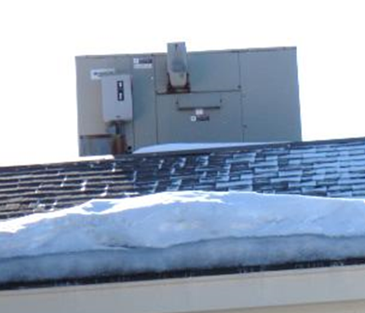
Rooftop air handling unit

Picture 2
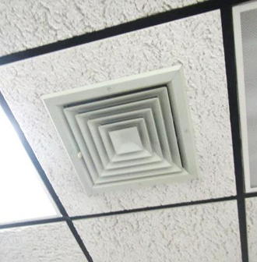
Ceiling-mounted supply diffuser
Picture 3
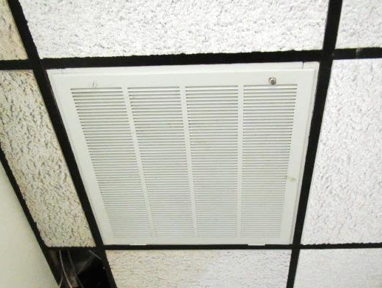
Ceiling-mounted return vent in annex

Picture 4
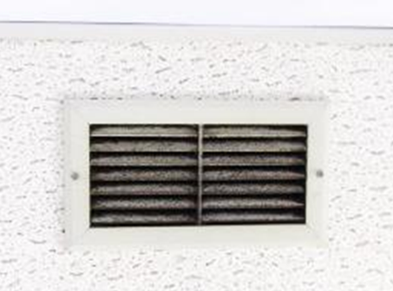
Ceiling-mounted exhaust/return vent in breakroom, note dust/debris accumulation
Picture 5
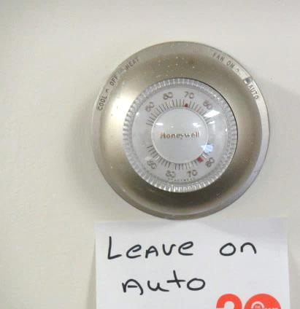
HVAC thermostat in annex

Picture 6
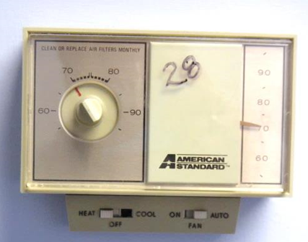
HVAC thermostat in main DCF area
Picture 7
Digital HVAC thermostat in main DCF area

Picture 8
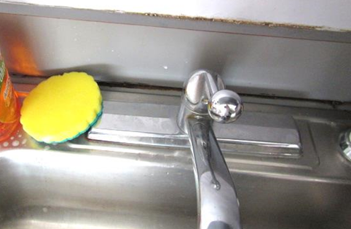
Space between sink countertop and backsplash, dark staining/debris may indicate mold growth
Picture 9
Fiberglass insulation inserted into supply diffusers in Ms. Miller’s office
(note hole in diffuser which suggests this vent should have had adjustable louvers installed inside)

Location | Carbon  Dioxide  (ppm) | Carbon Monoxide  (ppm) | Temp  (°F) | Relative  Humidity  (%) | PM2.5  (µg/m³) | Occupants  in Room | Windows  Openable | Ventilation |  | Remarks
 |  |  |  |  |  |  |  | Supply | Exhaust
Background | 363 | ND | <32 | 31 | 12 |  |  |  |  | Cold, west winds 14-18 mph, gusts up to 28 mph
Annex
Jen’s Office | 780 | ND | 74 | 24 | 6 | 1 | Y | Y | Y | WD/missing CTs, wall to wall carpet, active leaks (snow/ice melt)
Main Area | 777 | ND | 74 | 25 | 5 | 2 | N | Y | Y
Back Area | 773 | ND | 75 | 24 | 6 | 1 | N | Y | Y
Main Building
Pekarski Office | 807 | ND | 77 | 12 | 7 | 0 | Y | Y | N
Rainone Office | 848 | ND | 77 | 13 | 6 | 0 | Y | Y | N | DO
Rosario Office | 798 | ND | 77 | 12 | 5 | 1 | Y | Y | N | DO
Contarino Office | 795 | ND | 76 | 13 | 6 | 0 | Y | Y | N | DO, 2 WD CT
Ortiz Office | 625 | ND | 78 | 15 | 6 | 0 | Y | Y | N | DO, WD GW around window frames, WD CT
Biggs Office | 744 | ND | 77 | 11 | 6 | 0 | Y | Y | N | DO
Martel Office | 747 | ND | 76 | 11 | 6 | 1 | Y | Y | N | DO
McNulty Office | 785 | ND | 75 | 12 | 6 | 0 | Y | Y | N
Ortega-Rodriguez Office | 790 | ND | 75 | 12 | 7 | 0 | Y | Y | N | DO
Kinship B | 863 | ND | 76 | 13 | 7 | 3 | Y | Y | N
Marquis Office | 858 | ND | 76 | 12 | 6 | 5 | Y | Y | N | DO
Reception | 794 | ND | 76 | 12 | 7 | 2 | N | Y | N | DO
Kotsakis Office | 903 | ND | 74 | 19 | 11 | 1 | N | Y | N | DO
Unit E | 775 | ND | 74 | 16 | 9 | 1 | N | Y | N
STS | 852 | ND | 74 | 17 | 8 | 1 | N | Y | Y
Unit F | 926 | ND | 74 | 17 | 7 | 4 | Y | Y | N | WD CT
Bastien Office | 886 | ND | 72 | 15 | 7 | 1 | Y | Y | N | DO
Sesito Office | 824 | ND | 73 | 17 | 7 | 1 | Y | Y | N | WD CT, DO
Case Record Room A | 739 | ND | 74 | 14 | 6 | 0 | N | Y | N | DO
Meeting Room | 798 | ND | 74 | 15 | 6 | 0 | N | Y | Y | DO
Kitchen | 940 | ND | 75 | 18 | 7 | 0 | Y | Y | Y | Space between sink countertop and backsplash-mold growth, 3 WD CT, dusty exhaust vent
Clapp Office | 875 | ND | 76 | 16 | 7 | 1 | Y | Y | N | DO
Adoption Unit | 792 | ND | 78 | 13 | 9 | 1 | Y | Y | N | WD GW around window
Family Return | 829 | ND | 75 | 12 | 6 | 3 | Y | Y | N
Kelly-Stebbins Office | 730 | ND | 75 | 10 | 7 | 1 | Y | Y | N | DO
Wai Lam Office | 670 | ND | 75 | 9 | 6 | 0 | N | Y | N | DO
Kinship Unit A | 612 | ND | 74 | 7 | 6 | 2 | Y | Y | N | WD CT
Family Resources | 643 | ND | 73 | 9 | 6 | 2 | Y | Y | N | 2 WD CT
Ongoing C | 708 | ND | 73 | 12 | 9 | 2 | Y | Y | N
Investigation Unit A | 667 | ND | 73 | 11 | 9 | 1 | Y | Y | N
Intake and Investigation Unit B | 674 | ND | 73 | 11 | 7 | 2 | Y | Y | N | WD CTs, active leak reported
Miller Office | 634 | ND | 71 | 11 | 8 | 1 | Y | Y | N | Supply vents stuffed with fiberglass insulation
Medina Office | 787 | ND | 69 | 24 | 9 | 0 | Y | Y | Y | DO
Labo Office | 656 | ND | 70 | 22 | 9 | 0 | N | Y | N
Field Office | 718 | ND | 71 | 22 | 7 | 1 | N | Y | N | DO
File Room | 674 | ND | 71 | 21 | 8 | 0 | N | Y | N | DO
Steph Office | 774 | ND | 72 | 15 | 6 | 0 | Y | Y | N | DO
Break Room | 827 | ND | 72 | 14 | 8 | 6 | Y | Y | N | WD CT
Ongoing Unit A | 715 | ND | 73 | 15 | 6 | 3 | N | Y | N
Intake and Investigation Unit | 780 | ND | 73 | 17 | 7 | 1 | Y | Y | N
Krugh Office | 700 | ND | 72 | 19 | 11 | 0 | Y | Y | N
Lois Unit | 805 | ND | 73 | 21 | 11 | 0 | N | Y | N | 2 WD CT
Ongoing Unit B | 796 | ND | 73 | 19 | 7 | 4 | N | Y | N
STS B | 776 | MD | 73 | 17 | 7 | 1 | N | Y | N | 3 WD CT

