WATER DAMAGE FOLLOW-UP
Massachusetts Department of Children and Families
33 East Merrimack Street
Lowell, Massachusetts
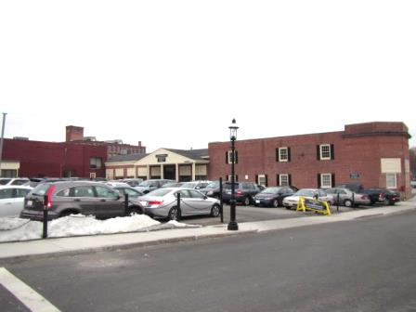
Prepared by:
Massachusetts Department of Public Health
Bureau of Environmental Health
Indoor Air Quality Program
August 2015

Background/Introduction
Building: Massachusetts Department of Children and Families (DCF), Lowell Regional Office

Address: 33 East Merrimack Street, Lowell, Massachusetts
Assessment Requested by: Ms. Deborah Coleman, Facilities Director, Executive Office of
Health and Human Services (EOHHS)

David Devine, Project Manager, Office of Leasing and State Office Planning (OLSOP), Division of Capital Asset Management and Maintenance (DCAMM)

Date of Assessment: June 5, 2015
BEH/IAQ Staff
Conducting Assessment: Ruth Alfasso, Environmental Engineer/Inspector

Date of Building
Construction: 1970s

Reason for Request: The assessment in order to evaluate the efficacy of continued
remediation efforts of water-damaged materials that occurred over
the winter of 2015 and ongoing leaks that occurred due to damaged roofing.

Previous IAQ Assessments

Several other reports on this building have been issued, including a report dated March 2, 2015, based on an initial assessment of the water damage, a report released on April 23, 2015 for general IAQ in the building and a report based on a follow-up assessment which was released on May 28, 2015.

Methods
BEH/IAQ staff performed a visual inspection of remediation efforts of water-damaged building materials and examined the space for the presence of other environmental concerns.

Results and Discussion

Water Damage/Moisture/Microbial Issues
At the time of this follow-up assessment, all water-damaged ceiling tiles, gypsum wallboard (GW), carpeting and other interior building materials from the water damage that had occurred over the winter had been removed by a professional flooding restoration firm, including items that were still outstanding at the time of the March 30, 2015 visit, including:
- Repair of water-damaged windowsills and window areas in Ms. Ortiz office.
- Replacement of water-damaged ceiling tiles in the Adoption Unit and Investigative Unit B.
- Replacement of the downspout around which the original ice dams had formed (Picture 1). Note that the end of this downspout is very close to the building, which may allow water to pool at the base of the foundation. If possible, the downspout should be extended to direct rainwater away from the foundation. Damage to mortar and brick remains where ice formations had previously been noted (Pictures 1 and 2). Over time, these breaches in the building envelope can provide a source of water penetration into the building.
Additional water-damaged ceiling tiles and other signs of water intrusion were observed due to the current roof leaks (Pictures 3 and 4). It was reported by building maintenance staff and occupants that ceiling tiles had been changed recently but that more recent leaks have occurred leading to additional stained tiles. At the time of the visit, the building owner’s representative reported that the roof was scheduled for additional repairs the weekend of June 6, 2015. Once repair of the roof has been completed, water damage to ceiling tiles and other building materials should cease. Note that the area above the ceiling tile system was examined; this area is open and does not contain additional porous materials that may become water-damaged or a source of microbial growth.
The US Environmental Protection Agency (US EPA) and the American Conference of Governmental Industrial Hygienists (ACGIH) recommends that porous materials (e.g., wallboard, carpeting) be dried with fans and heating within 24 to 48 hours of becoming wet (US EPA, 2001; ACGIH, 1989). If porous materials are not dried within this time frame, mold growth may occur.
Other moisture/microbial issues were observed inside the space, including:
- Poorly maintained plants (Picture 5), including some without drip pans. Plants can be a source of pollen, mold and odors, particularly if they are not well maintained or chronically overwatered. Spills from plants can damage surfaces if they are not protected with drip pans.
- Water coolers and refrigerators in carpeted areas (Pictures 6 and 7). Spills or leaks from these appliances can moisten carpeting. When possible, they should be placed in non-carpeted areas or on waterproof mats.
- Stains/spills inside refrigerators/freezers (Pictures 8 and 9). Refrigerators should be cleaned regularly, including removal of spoiled food and cleaning of surfaces with an antimicrobial solution to prevent odors and microbial growth.
In addition, conditions of the building’s exterior were noted that may result in further water infiltration and other problems. A downspout off the peaked roof at the front of the building was broken/disconnected (Picture 10), which should be repaired to direct water away from the building. Plants were also observed to be in close proximity to the building foundation (Picture 10). Plants can hold moisture against the building and plant roots can eventually weaken building materials. These conditions can undermine the integrity of the building envelope and provide a means of water entry by capillary action into the building through exterior walls, foundation concrete and masonry (Lstiburek & Brennan, 2001). In addition, these breaches can provide a means of drafts and pest entry into the building.

Other Issues
Other issues were observed that may contribute to IAQ concerns in the space. Use of fragranced products including plug-in air fresheners and diffuser reeds were observed in a few locations. These products contain volatile organic compounds (VOCs) that can be irritating to the respiratory tract.
Concerns were expressed by occupants regarding pests, including rodents and ants. No signs of rodent or insect activity were observed at the time of the visit. However conditions that may be attractive to pests, including food, food debris, and accumulations of items including paper and fabrics were found in some areas. Removal of sources of food, water and harborage as well as ensuring the integrity of the building envelope, are key to reducing or eliminating pest problems such as rodents or ants.

Conclusions/Recommendations
At the time of the follow-up assessment, all of the water-damaged materials from the winter-weather-related water damage had been removed and remediated. In view of the findings at the time of the visit, the following recommendations are made:
- Conduct roof repair work as indicated.
- Once roof damage has been fixed, replace any remaining water-damaged ceiling tiles and carpet squares.
- Water-damaged building materials should be removed in a manner consistent with recommendations found in “Mold Remediation in Schools and Commercial Buildings” published by the US Environmental Protection Agency (US EPA, 2001).
- Contact a masonry firm to make repairs to exterior brickwork to prevent water infiltration and damage to building materials.
- Consider extending the downspout shown in Picture 1, away from the building.
- Repair the downspout shown in Picture 10.
- Trim plants away from the side of the building.
- Properly maintain indoor plants.
- Consider placing water dispensers and refrigerators in non-carpeted areas or on waterproof mats.
- Ensure that refrigerators are cleaned regularly.
- Avoid the use of air freshener/scented products.
- Use the principles of Integrated Pest Management (IPM), including removal of food, food debris and harborage for pests inside the building. Additional information on IPM can be found at the following Internet address: http://www.mass.gov/eea/docs/agr/pesticides/publications/ipm-kit-for-bldg-mgrs.pdf.

References
ACGIH. 1989. Guidelines for the Assessment of Bioaerosols in the Indoor Environment. American Conference of Governmental Industrial Hygienists, Cincinnati, OH.
Lstiburek, J. & Brennan, T. 2001. Read This Before You Design, Build or Renovate. Building Science Corporation, Westford, MA. U.S. Department of Housing and Urban Development, Region I, Boston, MA.
US EPA. 2001. Mold Remediation in Schools and Commercial Buildings. US Environmental Protection Agency, Office of Air and Radiation, Indoor Environments Division, Washington, D.C. EPA 402-K-01-001. http://www.epa.gov/mold/mold_remediation.html
Picture

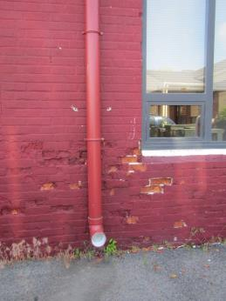

New downspout with damaged bricks, note spout does not extend from the foundation

Picture 2

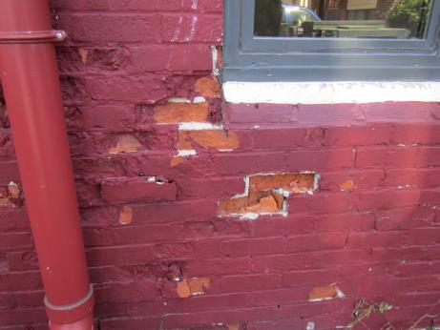

Closer view of damaged brickwork
Picture 3

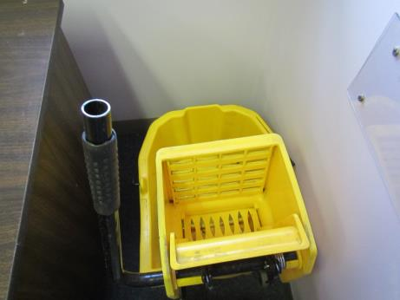

Water collection bucket

Picture 4

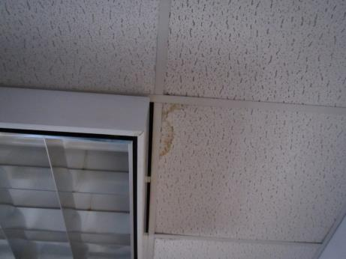

Water-damaged ceiling tile
Picture 5

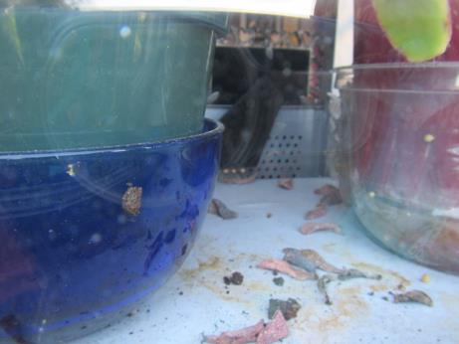

Plant debris and water-stained surface

Picture 6

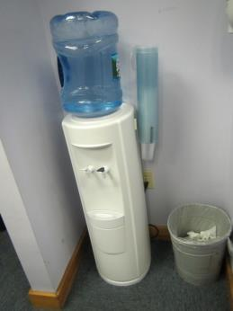

Water cooler on carpet
Picture 7

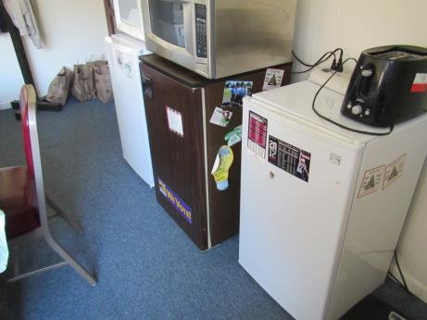

Refrigerators on carpet

Picture 8

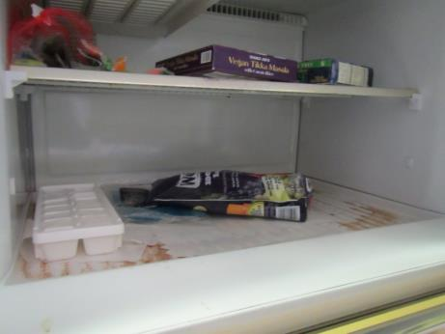

Stains/spills inside freezer compartment
Picture 9

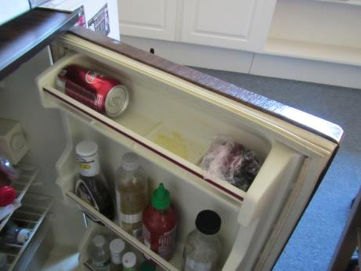

Stains/spills inside refrigerator

Picture 10

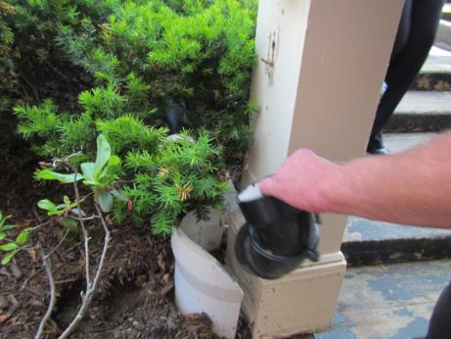

Broken downspout, also note plants in close proximity to building materials

