WATER DAMAGE INVESTIGATION

Massachusetts Department of Children and Families
33 East Merrimack Street
Lowell, Massachusetts

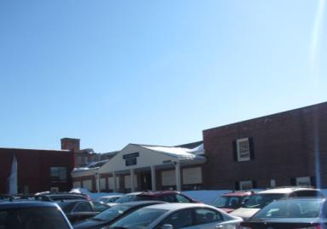

Prepared by:
Massachusetts Department of Public Health
Bureau of Environmental Health
Indoor Air Quality Program
March 2015

Background/Introduction
At the request of Ms. Deborah Coleman, Facilities Director, Executive Office of Health and Human Services (EOHHS), an indoor environmental investigation was conducted at the Massachusetts Department of Children and Families (DCF), Lowell Regional Office, 33 East Merrimack Street, Lowell, Massachusetts. The Massachusetts Department of Public Health (MDPH), Bureau of Environmental Health (BEH) conducted the assessment in response to concerns related to water damage and potential mold growth as a result of water infiltration issues that occurred during the recent snowstorms. On February 20, 2015, a site visit was made by Cory Holmes, Environmental Analyst/Regional Inspector in BEH’s Indoor Air Quality (IAQ) Program. At the time of the assessment, BEH/IAQ staff also performed general IAQ testing. Results of the general IAQ assessment will be the subject of a separate report.

Methods
BEH/IAQ staff performed a visual inspection of building materials for water damage and/or microbial growth. Moisture content of porous building materials (i.e., gypsum wallboard, wood and carpeting) was measured using a Delmhorst, BD-2000 Model Moisture Detector. Moisture testing results are included as Table 1.

Results and Discussion
Water infiltration was occurring in three main areas (Lavoie office, Barghi office and DCF space in a separate building called the annex) on February 20, 2015, due to severe snow pack and ice formations along the exterior wall (Pictures 1 and 2). Several buckets/containers were being used to capture ceiling leaks. Ceiling tiles and carpeting in several areas were observed to be saturated with moisture (Pictures 3 through 11; Table 1). Carpeting in the main building consists of carpet squares whereas the annex has commercial grade wall-to-wall carpeting. Due to on-going moisture conditions, DPH recommended that all wet/water-damaged carpeting be removed as much as possible. In addition, water-damaged fiberglass insulation around ductwork and gypsum wallboard (GW) above the ceiling should also be removed to prevent these materials from becoming media for mold growth (Pictures 12 through 14).
Two other areas (Adoption Unit and Ortiz office) were also found to have moistened GW around window frames. A bucket was positioned on the windowsill of the Adoption Unit; and visible signs of water infiltration in the form of peeling paint and damaged GW were observed in both areas (Pictures 15 through 17). Active leaks were reported in the Intake and Investigation Unit B, where water-damaged ceiling tiles were noted. In this area, a hole was made in a ceiling tile to drain the leaking water (Picture 18).
The US Environmental Protection Agency (US EPA) and the American Conference of Governmental Industrial Hygienists (ACGIH) recommends that porous materials (e.g., wallboard, carpeting) be dried with fans and heating within 24 to 48 hours of becoming wet (US EPA, 2001; ACGIH, 1989). If porous materials are not dried within this time frame, mold growth may occur.

Conclusions/Recommendations
In view of the findings at the time of the visit, the following recommendations are made:
- Due to the scope of water infiltration/water-damaged materials, a flooding restoration/remediation specialist should be consulted to coordinate remediation activities.
- Measures to remove snow pack and ice formations along the roof and exterior of the building should be taken.
- Water-damaged carpeting, ceiling tiles, GW and insulation should be removed in a manner consistent with recommendations found in “Mold Remediation in Schools and Commercial Buildings” published by the US Environmental Protection Agency (US EPA, 2001).
- During remediation the following steps should be taken to reduce exposure to remediation debris, odors and/or airborne particulate matter:
- Remediation work should be done during unoccupied periods;
- Remove furniture and personal items or cover employee workstations in areas of remediation to protect items and facilitate cleanup;
- Place water-damaged/mold-colonized materials in plastic bags for transport;
- Ensure air handling units are deactivated and/or seal vents temporarily in remediation areas during removal/remediation;
- Once removal/remediation is complete, clean areas/surfaces in remediation area with a high efficiency particulate arrestance (HEPA) filter equipped vacuum cleaner in conjunction with wet wiping of all non-porous surfaces.
- Once leaks are repaired/snow and ice removed and remediation is complete, replace water-damaged building materials. Consider replacing wall-to-wall carpet in annex with carpet squares.

References
ACGIH. 1989. Guidelines for the Assessment of Bioaerosols in the Indoor Environment. American Conference of Governmental Industrial Hygienists, Cincinnati, OH.
US EPA. 2001. Mold Remediation in Schools and Commercial Buildings. US Environmental Protection Agency, Office of Air and Radiation, Indoor Environments Division, Washington, D.C. EPA 402-K-01-001. http://www.epa.gov/iaq/molds/mold_remediation.html
Picture 1
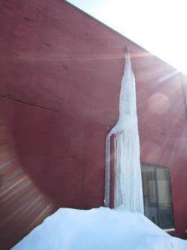
Ice and snow accumulation on/around building’s exterior

Picture 2
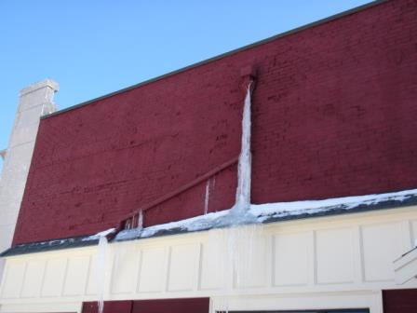
Ice and snow accumulation on/around building’s exterior
Picture 3
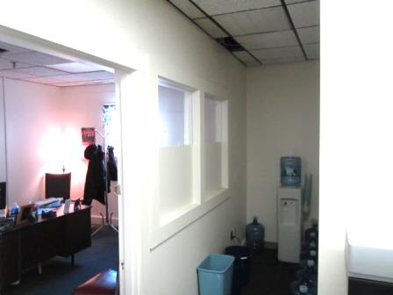
Water-damaged areas/wet carpeting in annex (Jen’s office and water cooler area)

Picture 4
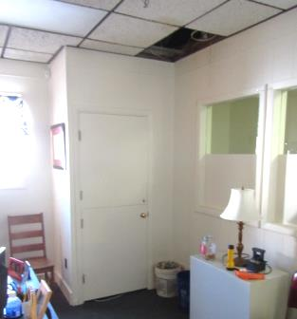
Water-damaged areas/wet carpeting and buckets in annex (Jen’s office)
Picture 5
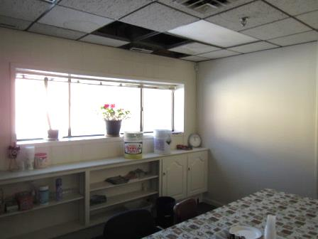
Buckets and water infiltration in annex breakroom

Picture 6
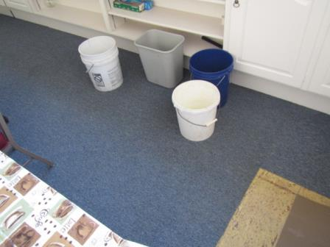
Buckets in annex breakroom
Picture 7
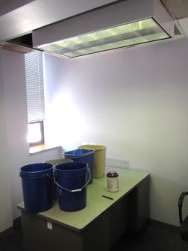
Severe water infiltration in Lavoie office

Picture 8
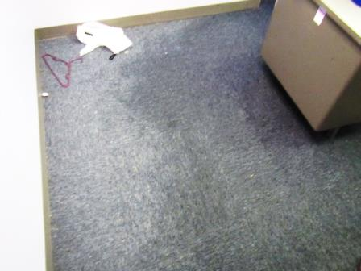
Saturated carpet in Lavoie office
Picture 9
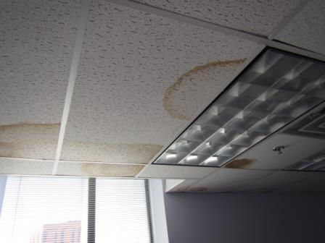
Water-damaged ceiling tiles in Barghi office

Picture 10
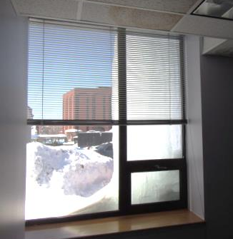
Interior view of ice formation from Barghi office, note ice covers entire right side window
Picture 11
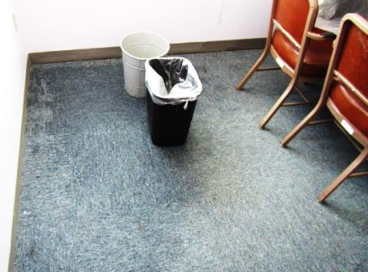
Wet carpeting and buckets in Barghi office

Picture 12
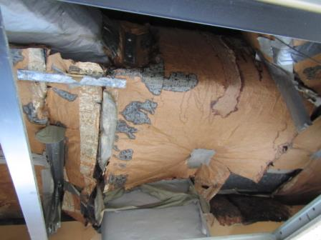
Water-damaged insulation above ceiling in annex breakroom
Picture 13
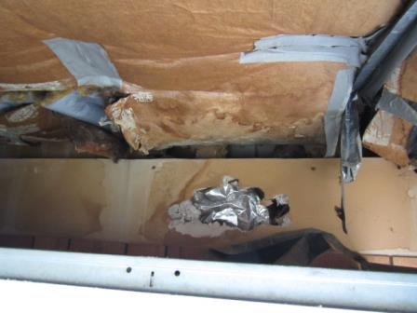
Water-damaged insulation and gypsum wallboard above ceiling in annex breakroom

Picture 14
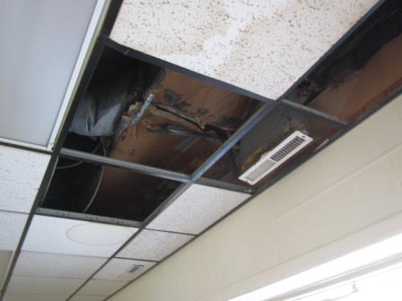
Water-damaged insulation and ceiling tiles in annex breakroom
Picture 15
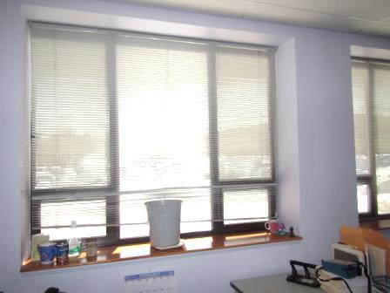
Moistened GW around window in Adoption Unit, note bucket to catch leaks

Picture 16
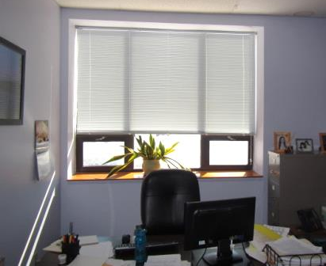
Moistened/damaged GW around window in Ortiz office
Picture 17
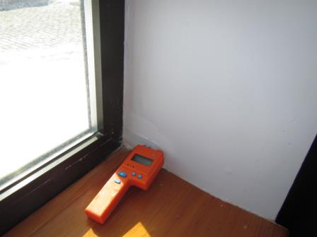
Moistened/damaged GW around window in Ortiz office

Picture 18
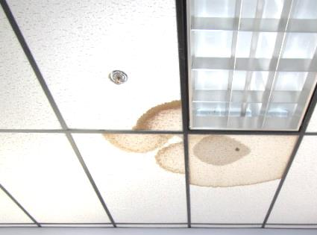
Water-damaged ceiling tiles in Intake and Investigation Unit B, Note hole in tile (arrow) to allow for drainage
Location | Moisture testing |  | Remarks
Annex: Jen’s Office |  | Carpet-wet  Ceiling tiles-wet |  | Active leaks-buckets, water-damaged/missing ceiling tiles and wet/damaged insulation
Annex: Water Cooler Area |  | Carpet-wet |  | Active leaks-buckets, water-damaged/missing ceiling tiles and wet/damaged insulation
Annex: Breakroom |  | Insulation-wet  Gypsum wallboard (above ceiling)-wet  Carpet-dry  Wood/walls-dry |  | Active leaks-buckets, water-damaged/missing ceiling tiles and wet/damaged insulation
Lavoie Office |  | Carpet-wet  Ceiling tiles-wet  Gypsum wallboard (along floor)-wet |  | Active leaks-buckets, water-damaged/missing ceiling tiles
Barghi Office |  | Carpet-wet  Ceiling tiles-wet  Gypsum wallboard (along floor)-dry |  | Active leaks-buckets, water-damaged/missing ceiling tiles
Adoption Unit |  | Gypsum wallboard (around window frame)-moist  Carpet-dry |  | Leaks from ceiling/top of window reported, bucket, signs of water damage (peeling paint)
Ortiz Office |  | Gypsum wallboard (around window frame)-wet  Carpet-dry |  | Signs of water damage (peeling paint and damage to gypsum wallboard around window frames
Intake Investigation B |  | Carpet-dry |  | Active leak reported, water-damaged ceiling tiles (hole for drainage)

