WATER DAMAGE FOLLOW-UP
INVESTIGATION

Massachusetts Department of Children and Families
33 East Merrimack Street
Lowell, Massachusetts

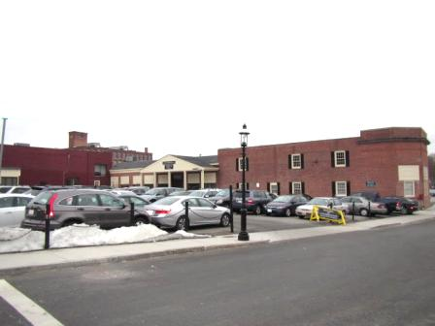

Prepared by:
Massachusetts Department of Public Health
Bureau of Environmental Health
Indoor Air Quality Program
May 2015

Background/Introduction
At the request of Ms. Deborah Coleman, Facilities Director, Executive Office of Health and Human Services (EOHHS), a follow-up investigation was conducted at the Massachusetts Department of Children and Families (DCF), Lowell Regional Office, 33 East Merrimack Street, Lowell, Massachusetts. The Massachusetts Department of Public Health (MDPH), Bureau of Environmental Health (BEH) conducted the investigation in order to evaluate the efficacy of remediation efforts of water-damaged materials that occurred over the winter of 2015. A previous report detailing building conditions at the time of the initial assessment and recommendations for remediation was issued on March 2, 2015 (MDPH, 2015). On March 30, 2015, a follow-up site visit was made by Cory Holmes, Environmental Analyst/Regional Inspector in BEH’s Indoor Air Quality (IAQ) Program.

Methods
BEH/IAQ staff performed a visual inspection of remediation efforts of water-damaged building materials.

Results and Discussion
At the time of the follow-up assessment, all water-damaged ceiling tiles, gypsum wallboard (GW) and carpeting had been removed by a professional flooding restoration firm, with the exception of the Adoption Unit and a few ceiling tiles in Investigative Unit B. According to the scope of work provided by the remediation firm; once water-damaged materials were removed, the areas were cleaned with an antimicrobial agent, dried and sealed with plastic polyethylene sheeting (Pictures 1 through 8). In Ms. Ortiz’s office, dark staining was observed on a piece of wood installed over the window (Picture 9), which may be surface mold. BEH/IAQ staff recommended that the surface of the wood be cleaned/sanded and/or the wood be replaced.
The US Environmental Protection Agency (US EPA) and the American Conference of Governmental Industrial Hygienists (ACGIH) recommends that porous materials (e.g., wallboard, carpeting) be dried with fans and heating within 24 to 48 hours of becoming wet (US EPA, 2001; ACGIH, 1989). If porous materials are not dried within this time frame, mold growth may occur.
Extensive damage to mortar and brick was observed where ice formations had previously been noted (Pictures 10 through 13). Over time, these breaches in the building envelope can provide a source of water penetration into the building.

Conclusions/Recommendations
At the time of the follow-up indoor environmental assessment, all of the water-damaged materials had been removed, with the exception of the Adoption Unit and a few ceiling tiles in Investigative Unit B. During the visit, building management reported that they would contact their flooding restoration firm to complete activities as instructed by MDPH in the Adoption Unit. Building management should coordinate with EOHHS/DCF officials to schedule installation of new GW, ceiling tiles and carpeting, preferable during unoccupied periods and/or under isolation/depressurization conditions. In view of the findings at the time of the visit, the following recommendations are made:
- Continue with plans to work with flooding restoration firm to complete remediation of water-damaged GW around window in the Adoption Unit.
- Water-damaged building materials should be removed in a manner consistent with recommendations found in “Mold Remediation in Schools and Commercial Buildings” published by the US Environmental Protection Agency (US EPA, 2001).
- During remediation/reconstruction the following steps should be taken to prevent exposure to remediation debris, odors and/or airborne particulate matter:
- Remediation work should be done during unoccupied periods;
- Remove furniture and personal items or cover employee workstations in areas of remediation to protect items and facilitate cleanup;
- Place water-damaged/mold-colonized materials in plastic bags for transport;
- Ensure air handling units are deactivated and/or seal vents temporarily in remediation areas during removal/remediation;
- Once removal/remediation is complete, clean areas/surfaces in remediation area with a high efficiency particulate arrestance (HEPA) filter equipped vacuum cleaner in conjunction with wet wiping of all non-porous surfaces.
- Ensure leaks are repaired and change ceiling tiles in Investigative Unit B.
- Clean/sand surface of the wood above Ms. Ortiz office window. If it cannot be adequately cleaned, replace it.
- Contact a masonry firm to make repairs to exterior brickwork to prevent water infiltration and damage to building materials.

References
ACGIH. 1989. Guidelines for the Assessment of Bioaerosols in the Indoor Environment. American Conference of Governmental Industrial Hygienists, Cincinnati, OH.
MDPH. 2015. Water Damage Investigation, Department of Children and Families, 33 East Merrimack Street, Lowell, MA. Massachusetts Department of Public Health, Bureau of Environmental Health Assessment, Boston, MA. March 2, 2015.
US EPA. 2001. Mold Remediation in Schools and Commercial Buildings. US Environmental Protection Agency, Office of Air and Radiation, Indoor Environments Division, Washington, D.C. EPA 402-K-01-001. http://www.epa.gov/mold/mold_remediation.html
Picture 1
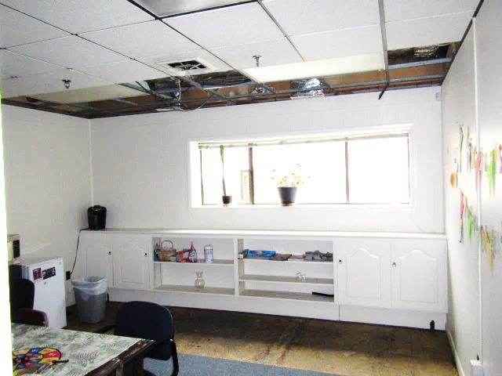
Water-damaged ceiling tiles, insulation and carpeting removed in annex breakroom
Picture 2
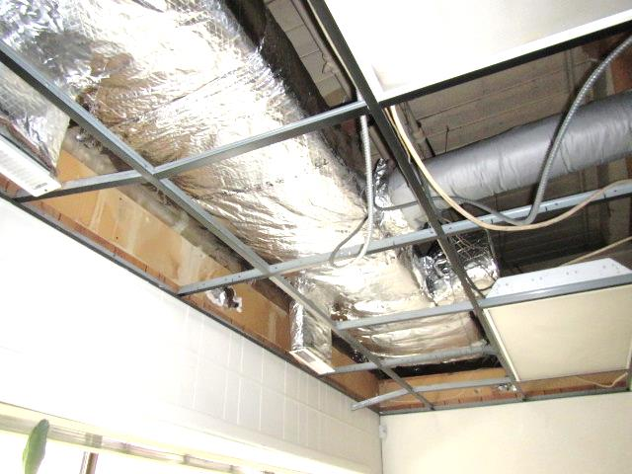
New insulation installed on ductwork in breakroom annex
Picture 3
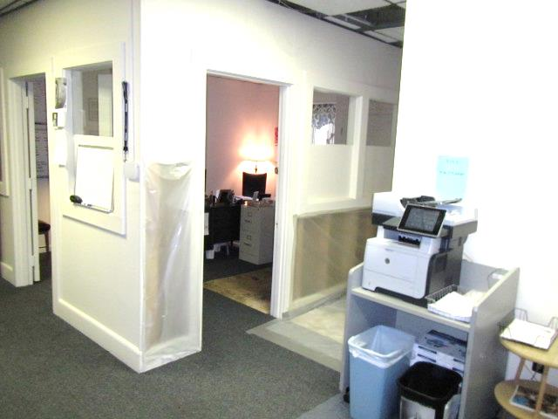
Water-damaged gypsum wallboard and carpeting removed in annex
Picture 4
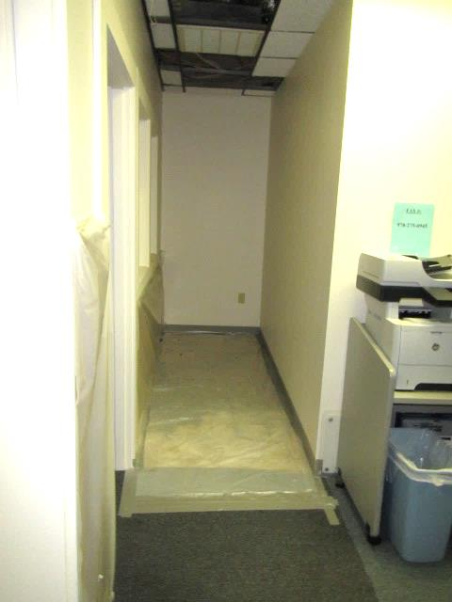
Water-damaged gypsum wallboard, ceiling tiles and carpeting removed in annex
Picture 5
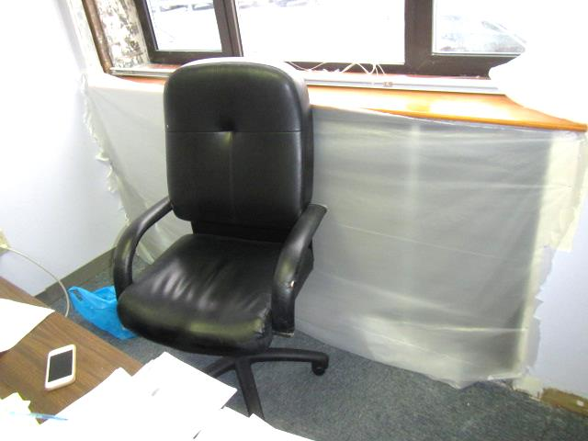
Water-damaged gypsum wallboard removed in Ortiz Office
Picture 6
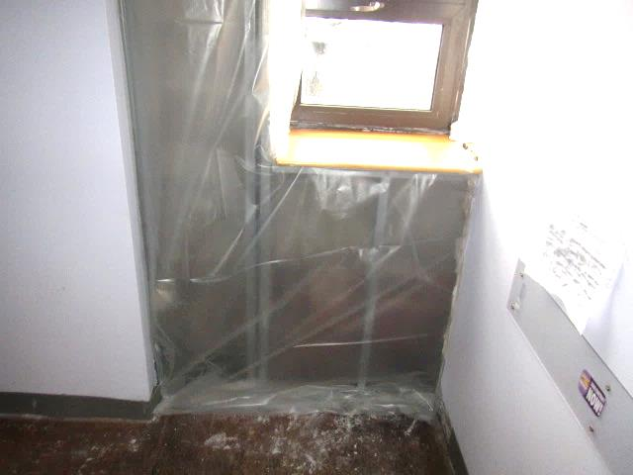
Water-damaged gypsum wallboard and carpeting removed in Lavoie office
Picture 7
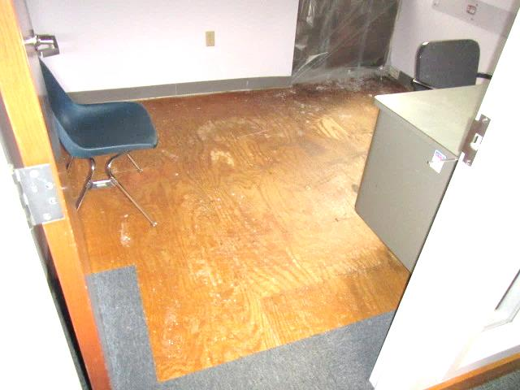
Water-damaged gypsum wallboard and carpeting removed in Lavoie office
Picture 8
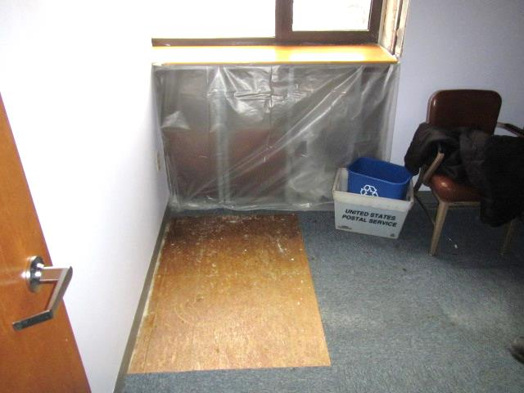
Water-damaged gypsum wallboard and carpeting removed from Barghi office
Picture 9
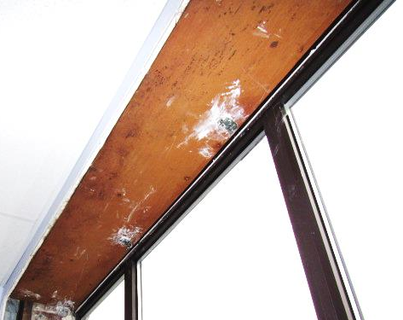
Stained/discolored wood over window in Ortiz office
Picture 10
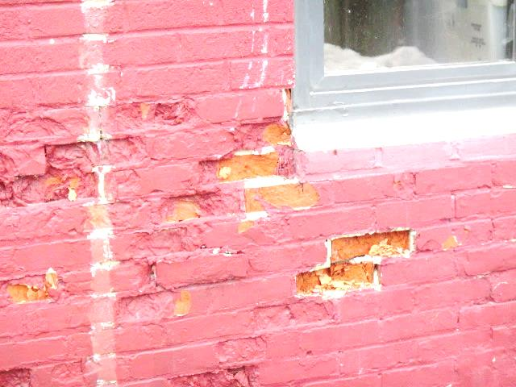
Damaged exterior brickwork
Picture 11
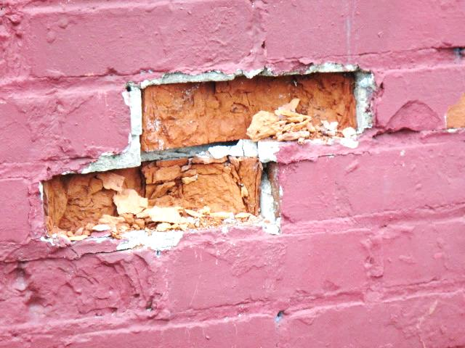
Damaged exterior brickwork
Picture 12
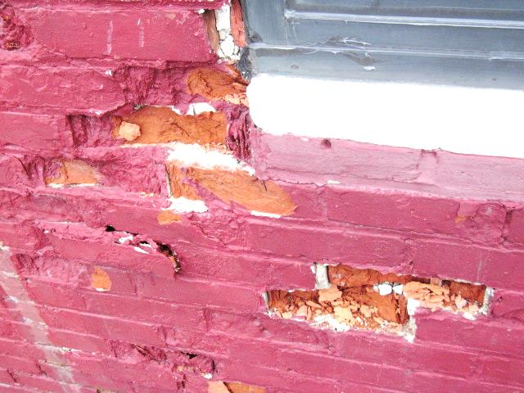
Damaged exterior brickwork
Picture 13
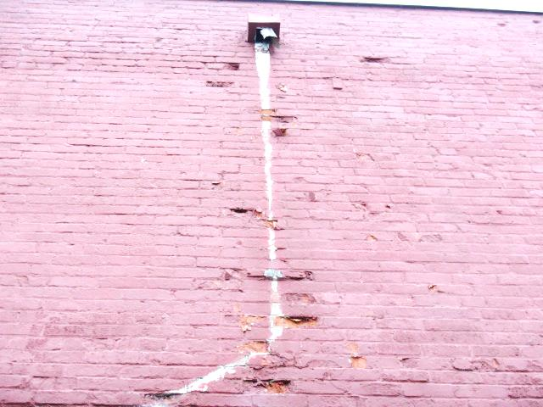
Damaged exterior brickwork

