INDOOR AIR QUALITY ASSESSMENT

Lowell District Court
41 Hurd Street
Lowell, Massachusetts



Prepared by:
Massachusetts Department of Public Health
Bureau of Environmental Health
Indoor Air Quality Program
August 2012

Background/Introduction
At the request of Mike Lane, Administrative Officer at the Massachusetts Office of the Trial Court (OTC), the Massachusetts Department of Public Health (MDPH), Bureau of Environmental Health (BEH) conducted an indoor air quality assessment at Lowell District Court (LDC), 41 Hurd Street, Lowell, Massachusetts. Concerns about flooding in a crawlspace beneath restrooms in the clerk’s office prompted this assessment. On March 14, 2012 Michael Feeney, Director of the BEH’s Indoor Air Quality (IAQ) Program and Sharon Lee, an Environmental Analyst with the IAQ Program, visited this building.
The LDC consists of two separate buildings that are joined by a hallway and elevator shaft. The original Lowell District Courthouse was constructed in 1925. Adjacent to the original courthouse is a building constructed circa 1950 reportedly for the American Telephone and Telegraph Company (AT&T). The former AT&T building was acquired by the OTC, who converted it into courtrooms and office space. Each building operates on separate heating, ventilation and air conditioning (HVAC) systems located in the basements. Conditions noted in this report will be denoted as the original Lowell District Courthouse (old building) and AT&T building (new building).
The old building contains session courtrooms (except 4th session), adult probation, juvenile probation, a large two-story lobby, cashier’s office and second floor hallway. The new building contains the 4th session courtroom, two jury rooms, and purchasing and clerk’s office. The buildings share a cooling tower, which provides chilled water to fan coil units (FCUs) throughout the LDC.

Methods
Air tests for carbon monoxide, carbon dioxide, temperature and relative humidity were conducted with the TSI, Q-Trak, IAQ Monitor, Model 7565. Air tests for airborne particle matter with a diameter less than 2.5 micrometers were taken with the TSI, DUSTTRAK™ Aerosol Monitor Model 8520. BEH staff also performed visual inspection of building materials for water damage and/or microbial growth. Moisture content of porous building materials in the break room was measured with a Tramex Encounter Plus, Non-Destructive Moisture Meter.

Results
The LDC contains approximately 280 employees and can be visited by several hundred people a day. Tests were taken during normal operations and are provided in Table 1.

Discussion

Ventilation
It can be seen from the tables that carbon dioxide levels were above 800 parts per million (ppm) in 16 out of 56 areas sampled throughout the LDC. These carbon dioxide levels are indicative of an inadequate fresh air supply in several areas within the LDC. In a number of areas, the HVAC system was deactivated. This problem is acute in the cell block control room and cells, where significant odors were noticeable.
Fresh air is supplied to the old building by a fan located in the boiler room. While carbon dioxide levels in the old building were below 800 ppm, a number of areas were unoccupied or had windows open both of which would be expected to result in lower carbon dioxide levels. Fresh air is drawn through a vent the size of a windowpane in a window frame located at ground level next to the front steps of the old building. Fresh air supply vents could not be identified in several rooms (Table 1). Exhaust ventilation is provided by a gravity system, which terminates on the roof of the old building in four sheltered airshafts.
Fresh air in the new building is provided by an air handling unit (AHU) located in the basement. The fresh air intake for this AHU is located in a sheltered area created by the joining of the old and new buildings by the main entrance and elevator. Fresh air is drawn from the roof to the AHU by a three-story-high duct. Fresh air intakes are located near AHU intake fans to maximize airflow. Air conditioning is provided by FCUs throughout the building complex. The elevator and lobby structure that connects the old to the new building creates a sheltered roof cul-de-sac. The water-chilling unit for the FCUs is located in this area. Heating and cooling is supplemented using FCUs along exterior walls. In many areas, the FCUs were found deactivated. With FCUs either inoperable or unused, staff in these areas do not have air conditioning during summer months, and windows are opened to provide temperature control and a source of fresh air.
To maximize air exchange, the MDPH recommends that both supply and exhaust ventilation operate continuously during periods of occupancy. In order to have proper ventilation with a mechanical supply and exhaust system, the systems must be balanced to provide an adequate amount of fresh air to the interior of a room while removing stale air from the room. It is recommended that HVAC systems be re-balanced every five years to ensure adequate air systems function (SMACNA, 1994).
The Massachusetts Building Code requires that each room have a minimum ventilation rate of 20 cubic feet per minute (cfm) per occupant of fresh outside air or openable windows (SBBRS, 1997; BOCA, 1993). The ventilation must be on at all times that the room is occupied. Providing adequate fresh air ventilation with open windows and maintaining the temperature in the comfort range during the cold weather season is impractical. Mechanical ventilation is usually required to provide adequate fresh air ventilation.
Carbon dioxide is not a problem in and of itself. It is used as an indicator of the adequacy of the fresh air ventilation. As carbon dioxide levels rise, it indicates that the ventilating system is malfunctioning or the design occupancy of the room is being exceeded. When this happens, a buildup of common indoor air pollutants can occur, leading to discomfort or health complaints. The Occupational Safety and Health Administration (OSHA) standard for carbon dioxide is 5,000 parts per million parts of air (ppm). Workers may be exposed to this level for 40 hours/week, based on a time-weighted average (OSHA, 1997).
The MDPH uses a guideline of 800 ppm for publicly occupied buildings. A guideline of 600 ppm or less is preferred in schools due to the fact that the majority of occupants are young and considered to be a more sensitive population in the evaluation of environmental health status. Inadequate ventilation and/or elevated temperatures are major causes of complaints such as respiratory, eye, nose and throat irritation, lethargy and headaches. For more information concerning carbon dioxide, please see Appendix A.
Temperature readings ranged from 69°F to 75°F, which were within or close to the MDPH recommended comfort guidelines at the time of assessment. The MDPH recommends that indoor air temperatures be maintained in a range of 70°F to 78°F in order to provide for the comfort of building occupants. In many cases concerning indoor air quality, fluctuations of temperature in occupied spaces are typically experienced, even in a building with an adequate fresh air supply.
The relative humidity measured in the LDC ranged from 33 to 44 percent, which was within or slightly below the MDPH recommended comfort range in some areas surveyed. The MDPH recommends a comfort range of 40 to 60 percent for indoor air relative humidity. Relative humidity levels in the building would be expected to drop during the winter months due to heating. The sensation of dryness and irritation is common in a low relative humidity environment. Low relative humidity is a very common problem during the heating season in the northeast part of the United States.

Microbial/Moisture Concerns
The primary purpose of this assessment was for BEH staff to examine water damage in a crawlspace adjacent to the clerk’s kitchen (Picture 1). This crawlspace is accessible via an opening in a wall in the room. As mentioned, a bathroom leak resulted in water entering the crawlspace. At the time of the inspection, BEH staff found the crawlspace to be clean and free of odors and observed no mold growth. Moisture testing of the walls surrounding the crawl space indicated that moisture levels were normal (i.e., dry). It is important to note that moisture content of materials measured represents a real-time measurement of the conditions in the building at the time of the assessment.
As mentioned, FCUs are designed to provide air-conditioning during the summer months. BEH staff observed the condition of a typical FCU and noted a layer of accumulated materials in a drip pan (Picture 2). The debris observed indicates that water may periodically stagnate in the pan, allowing materials to settle and proliferate in the water. Measures should be taken to ensure drip pans drain properly and debris is cleared from the pan to prevent odors and mold growth.
Water-damaged wall plaster, peeling paint and efflorescence were observed in a number of areas (Picture 3). Water damage is most likely the result of historic water penetration through the building envelope. Efflorescence is a characteristic sign of water damage to brick and mortar, but it is not mold growth. As moisture penetrates and works its way through mortar, brick or plaster, water-soluble compounds dissolve, creating a solution. As the solution moves to the surface of the material, the water evaporates, leaving behind white, powdery mineral deposits.
Water-damaged ceiling tiles were observed throughout the building, which can indicate a roof or exterior wall leak or plumbing problem. Missing and water-damaged ceiling tiles in the Clerk’s Office were attributed to leaking valves in the heating system. In another area, a waste basket was observed in an area where a ceiling tile was missing, suggesting that the receptacle was being used to catch water leaks (Picture 3). In some areas, repeated exposure to moisture has resulted in mold growth on ceiling tiles (Picture 4). Water-damaged ceiling tiles should be replaced after a water leak is discovered and repaired.
The US Environmental Protection Agency (US EPA) and the American Conference of Governmental Industrial Hygienists (ACGIH) recommends that porous materials be dried with fans and heating within 24 to 48 hours of becoming wet (US EPA, 2001; ACGIH, 1989). If porous materials are not dried within this time frame, mold growth may occur. Water-damaged porous materials cannot be adequately cleaned to remove mold growth. The application of a mildewcide to moldy porous materials is not recommended.
Plants were noted in several areas (Picture 5). Plants should be properly maintained and equipped with drip pans made of a non-porous material. Drip pans should be cleaned and inspected periodically to prevent mold growth. Plants should be located away from ventilation sources to prevent aerosolization of dirt, pollen or mold.

Other IAQ Evaluations
Indoor air quality can be negatively influenced by the presence of respiratory irritants, such as products of combustion. The process of combustion produces a number of pollutants. Common combustion emissions include carbon monoxide, carbon dioxide, water vapor and smoke (fine airborne particle material). Of these materials, exposure to carbon monoxide and particulate matter with a diameter of 2.5 micrometers (μm) or less (PM2.5) can produce immediate, acute health effects upon exposure. To determine whether combustion products were present indoor, BEH staff obtained measurements for carbon monoxide and PM2.5.

Carbon Monoxide
Carbon monoxide is a by-product of incomplete combustion of organic matter (e.g., gasoline, wood and tobacco). Exposure to carbon monoxide can produce immediate and acute health affects. Several air quality standards have been established to address carbon monoxide and prevent symptoms from exposure to these substances. The MDPH established a corrective action level concerning carbon monoxide in ice skating rinks that use fossil-fueled ice resurfacing equipment. If an operator of an indoor ice rink measures a carbon monoxide level over 30 ppm, taken 20 minutes after resurfacing within a rink, that operator must take actions to reduce carbon monoxide levels (MDPH, 1997).
The American Society of Heating Refrigeration and Air-Conditioning Engineers (ASHRAE) has adopted the National Ambient Air Quality Standards (NAAQS) as one set of criteria for assessing indoor air quality and monitoring of fresh air introduced by HVAC systems (ASHRAE, 1989). The NAAQS are standards established by the US EPA to protect the public health from six criteria pollutants, including carbon monoxide and particulate matter (US EPA, 2006). As recommended by ASHRAE, pollutant levels of fresh air introduced to a building should not exceed the NAAQS levels (ASHRAE, 1989). The NAAQS were adopted by reference in the Building Officials & Code Administrators (BOCA) National Mechanical Code of 1993 (BOCA, 1993), which is now an HVAC standard included in the Massachusetts State Building Code (SBBRS, 1997). According to the NAAQS, carbon monoxide levels in outdoor air should not exceed 9 ppm in an eight-hour average (US EPA, 2006).
Carbon monoxide should not be present in a typical, indoor environment. If it is present, indoor carbon monoxide levels should be less than or equal to outdoor levels. On the day of the assessment, outdoor carbon monoxide concentrations were non-detect (ND). No carbon monoxide was detected inside the building during the assessment (Table 1).

Particulate Matter (PM2.5)
The US EPA has established NAAQS limits for exposure to particulate matter. Particulate matter is airborne solids that can be irritating to the eyes, nose and throat. The NAAQS originally established exposure limits to particulate matter with a diameter of 10 μm or less (PM10). According to the NAAQS, PM10 levels should not exceed 150 micrograms per cubic meter (μg/m³) in a 24-hour average (US EPA, 2006). These standards were adopted by both ASHRAE and BOCA. Since the issuance of the ASHRAE standard and BOCA Code, US EPA established a more protective standard for fine airborne particles. This more stringent PM2.5 standard requires outdoor air particle levels be maintained below 35 μg/m³ over a 24-hour average (US EPA, 2006). Although both the ASHRAE standard and BOCA Code adopted the PM10 standard for evaluating air quality, MDPH uses the more protective PM2.5 standard for evaluating airborne particulate matter concentrations in the indoor environment.
Outdoor PM2.5 concentrations were measured at 14 μg/m³ (Table 1). Indoor PM2.5 levels ranged from 3 to 39 μg/m³ (Table 1), which were below the NAAQS PM2.5 level of 35 μg/m³ in all but one location Frequently, indoor air levels of particulates (including PM2.5) can be at higher levels than those measured outdoors. A number of mechanical devices and/or activities that occur indoors can generate particulate during normal operations. Sources of indoor airborne particulates may include but are not limited to: fan belts in the HVAC system; cooking and the use of microwave ovens; use of photocopiers, fax machines and computer printing devices; operation of an ordinary vacuum cleaner; and heavy foot traffic.

Other Concerns
Of note were numerous holes in floors around retrofitted FCUs in the old building (Pictures 6 and 7). Such breaches can allow for odors and particles to migrate between floors and also serve as a means for pests to migrate.
A container of permethrin/pyrethrin-based pesticide was observed in the staff kitchen (Picture 8). Pyrethrins have been associated with cross sensitivity with individuals who have ragweed allergy (US EPA, 1989). Applicators of this product should be in full compliance with federal and state rules and regulations that govern pesticide use including posting and notification requirements (333 CMR 13.10). Under no circumstances should untrained personnel apply this material. This product should not be applied prior to or during normal work hours. Under current Massachusetts law (effective November 1, 2001), the principles of integrated pest management (IPM) must be used to remove pests in state buildings (Mass Act, 2000). Pesticide use indoors can introduce chemicals into the indoor environment that can be sources of eye, nose and throat irritation.
Excessive dust was observed in the file storage room (Picture 9). Dust was observed on the blades of personal fans (Picture 10). Dust was also observed on ceiling tiles around fresh air diffusers, which results when dust particles in a room can becoming positively charged. Over time, the charged particles are deposited on the ceiling tiles due to attraction to the negatively charged ceiling tile. A greater charge, hence greater deposition, occurs when the humidity is lower during the heating season. Dust can be an irritant to the eyes and respiratory system. Measures should be taken to increase cleaning and reduce the accumulation of dust in the building. Fans should be cleaned periodically in order to prevent them from serving as a source of aerosolized particulates.

Conclusions/Recommendations
It appears that the water leaks in the crawlspace have been adequately cleaned and repaired; however, other conditions were noted within the LDC. In view of the findings at the time of the assessment, the following recommendations are made.
- Consider installing an access door in the kitchen wall to allow periodic inspections of the crawlspace. Ensure this access door is air tight to prevent crawlspace odors/materials and pests from migrating into occupant space.
- Seal breaches around FCU pipes to prevent movement of odors, materials and pests into occupied areas.
- Operate the HVAC system when the building is occupied. Repair as needed. Use openable windows to supplement fresh air in areas where the air-conditioning is not operational.
- Contact an HVAC engineering firm for an assessment of ventilation systems building-wide (e.g., controls, air intake louvers, thermostats and ductwork/insulation).
- Consider balancing the mechanical ventilation systems every 5 years, as recommended by ventilation industrial standards (SMACNA, 1994).
- For buildings in New England, periods of low relative humidity during the winter are often unavoidable. Therefore, scrupulous cleaning practices should be adopted to minimize common indoor air contaminants whose irritant effects can be enhanced when the relative humidity is low. To control for dusts, a high efficiency particulate arrestance (HEPA) filter equipped vacuum cleaner in conjunction with wet wiping of all surfaces is recommended. Avoid the use of feather dusters. Drinking water during the day can help ease some symptoms associated with a dry environment (throat and sinus irritations).
- Repair water-damaged wall plaster.
- Replace water-damaged ceiling tiles.
- Ensure all plants are equipped with drip pans that are made of a non-porous material. Examine drip pans for mold growth and disinfect areas of water leaks with an appropriate antimicrobial where necessary. Move plants away from ventilation sources.
- Remove all pesticide products from the building. Implement the principles of integrated pest management (IPM) to rid this building of pest. A copy of the Massachusetts IPM plan is available from the Massachusetts Department of Agricultural Resources: http://www.mass.gov/agr/pesticides/publications/docs/IPM_kit_for_bldg_mgrs.pdf. Activities that can be used to eliminate pest infestation may include the following activities:
  - Rinse out recycled food containers. Seal recycled containers in bins with tight-fitting lids to prevent pest access.
  - Store foods in pest-proof containers.
  - Avoid eating at work stations. In areas were food is consumed, periodic vacuuming to remove crumbs is recommended.
  - Regularly clean crumbs and other food residues from toasters, toaster ovens, microwave ovens, coffee pots and other food preparation equipment.
  - Holes as small as ¼” provide enough space for rodents to enter. Examine each room and the exterior walls of the building for means of pest egress and seal any breaches found. If doors do not seal at the bottom, install a weather strip as a barrier to pestss.
  - Reduce harborages (cardboard boxes) where pests may reside (MDFA, 1996).
- Routinely clean accumulated dust and debris periodically from the surface of supply/exhaust vents and blades of personal fans.
- Refer to resource manual and other related indoor air quality documents for further building-wide evaluations and advice on maintaining public buildings; these materials are located on the MDPH’s website: http://mass.gov/dph/iaq.
References
ACGIH. 1989. Guidelines for the Assessment of Bioaerosols in the Indoor Environment. American Conference of Governmental Industrial Hygienists, Cincinnati, OH.
ASHRAE. 1989. Ventilation for Acceptable Indoor Air Quality. American Society of Heating, Refrigeration and Air Conditioning Engineers. ANSI/ASHRAE 62-1989.
BOCA. 1993. The BOCA National Mechanical Code/1993. 8th ed. Building Officials and Code Administrators International, Inc., Country Club Hill, IL. Section M-308.1.1.
Mass. Act. 2000. An Act Protecting Children and families from Harmful Pesticides. 2000 Mass Acts c. 85 sec. 6E.
MDFA. 1996. Integrated Pest Management Kit For Building Managers. Massachusetts Department of Food and Agriculture, Pesticide Bureau, Boston, MA.
MDPH. 1997. Requirements to Maintain Air Quality in Indoor Skating Rinks (State Sanitary Code, Chapter XI). 105 CMR 675.000. Massachusetts Department of Public Health, Boston, MA.
OSHA. 1997. Limits for Air Contaminants. Occupational Safety and Health Administration. Code of Federal Regulations. 29 C.F.R 1910.1000 Table Z-1-A.
SBBRS. 1997. Mechanical Ventilation. State Board of Building Regulations and Standards. Code of Massachusetts Regulations. 780 CMR 1209.0
SMACNA. 1994. HVAC Systems Commissioning Manual. 1st ed. Sheet Metal and Air Conditioning Contractors’ National Association, Inc., Chantilly, VA.
US EPA. 1989. Recognition and Management of Pesticide Poisonings, 4th Edition. US Environmental Protection Agency, Office of Air and Radiation, Indoor Environments Division, Washington. pps. 25-27.
US EPA. 2001. Mold Remediation in Schools and Commercial Buildings. US Environmental Protection Agency, Office of Air and Radiation, Indoor Environments Division, Washington, DC. EPA 402-K-01-001. March 2001.
US EPA. 2006. National Ambient Air Quality Standards (NAAQS). US Environmental Protection Agency, Office of Air Quality Planning and Standards, Washington, DC. http://www.epa.gov/air/criteria.html
Picture 1

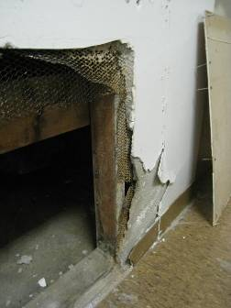

Crawlspace access in the break room (note plaster and wire lathe)

Picture 2

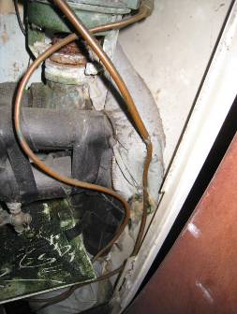
Drip pan

Growth in drip pan

Picture 3

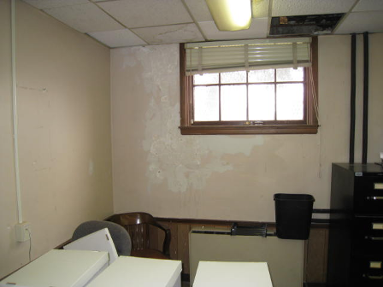

Water-damaged wall plaster and ceiling tile (note missing tile and basket for catching water)

Picture 4

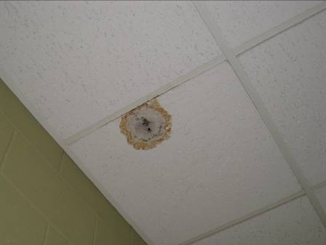

Darkening of a water-damaged ceiling tile suggesting mold growth

Picture 5

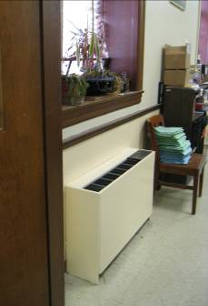

Plants on windowsill near a FCU

Picture 6

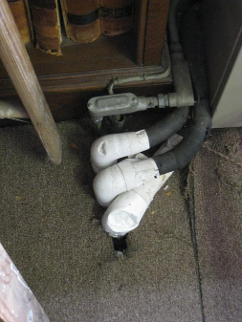

Breaches around pipes
Picture 7

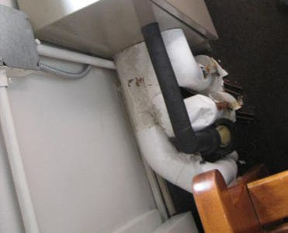

Breaches around pipes

Picture 8

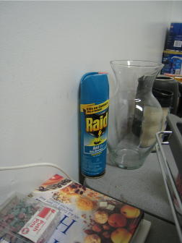

Pesticide in kitchen

Picture 9

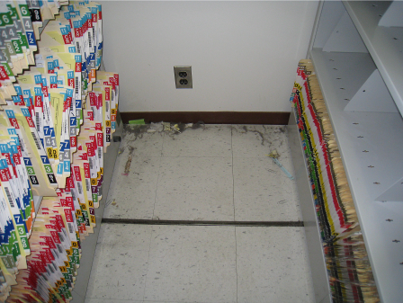

Dust accumulation in file storage room

Picture 10

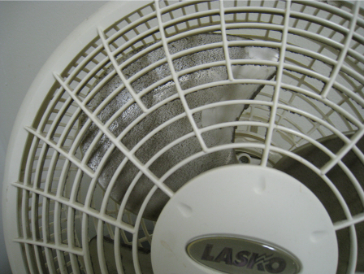

Dust on fan blade
Location | Carbon  Dioxide  (ppm) | Carbon Monoxide  (ppm) | Temp  (°F) | Relative  Humidity  (%) | PM2.5  (µg/m3) | Occupants  in Room | Windows  Openable | Ventilation |  | Remarks
 |  |  |  |  |  |  |  | Supply | Exhaust | Remarks
Background | 223 | ND | 60 | 35 | 14
A | 666 | ND | 73 | 36 | 11 | 4 | Y | Y | N | FCU off
ASAP office | 737 | ND | 75 | 38 | 15 | 2 | Y | Y | N
B | 522 | ND | 71 | 35 | 14 | 0 | N | Y | N | DO
Break room | 1052 | ND | 70 | 40 | 30 | 0 | N | Y | Y
C | 511 | ND | 72 | 35 | 13 | 0 | N | Y | N | DO
Cash office | 1581 | ND | 71 | 41 | 23 | 3 | Y | Y | Y | Plants, 3 WD-CTs, Items
Clerk by coat rack | 1026 | ND | 70 | 38 | 28 | 10 | Y | Y | Y | Paper shredder
Clerk juror exit | 1109 | ND | 69 | 40 | 27 | 10 | Y | Y | Y | Photocopier, 3 WD-CTs, DO, AD
Clerk near windows | 1089 | ND | 71 | 37 | 21 | 4 | Y | Y | Y | Photocopier, PF, Items, Plants
Clerk of courts office | 1043 | ND | 71 | 36 | 21 | 0 | Y | Y | Y | Refrigerator on carpet, DO, Items on radiator
D | 599 | ND | 71 | 37 | 20 | 0 | Y | Y | N | Supply off, FCU off, DO
File room P | 1054 | ND | 71 | 34 | 26 | 0 | Y | Y | Y | DO
Ground floor probation | 340 | ND | 71 | 37 | 18 | 0 | Y | Y | N | DO, Photocopier
Judge’s Lobby | 722 | ND | 72 | 36 | 14 | 0 | N | Y | N | Water cooler on carpet, CPs
Juror’s hallway | 841 | ND | 73 | 38 | 22 | 0 | Y | N | N | Door open
Jurors AA | 755 | ND | 74 | 36 | 23 | 0 | N | Y | Y | DO, Refrigerator, Toaster, Microwave oven
Jury Pool | 780 | ND | 73 | 38 | 25 | 0 | Y | Y | Y | 6 WD-CTs, DO
Jury pool BB | 687 | ND | 73 | 36 | 24 | 0 | Y | Y | N | DO, WD wall
Kitchen clerk’s | 1218 | ND | 70 | 40 | 27 | 3 | N | N | N | Microwave oven, Toaster oven, Food storage, Pesticide, 2 WD-CTs, AD, DO, Dusty PF
L | 470 | ND | 71 | 38 | 17 | 0 | Y | Y | Y | WD- wall paneling
Lock up control | 860 | ND | 70 | 44 | 16 | 6 | N | Y | Y | Supply off, Exhaust off, Odor
M | 1044 | ND | 71 | 36 | 21 | 0 | Y | Y | Y | DO
M clerks office | 1125 | ND | 71 | 38 | 23 | 16 | Y | Y | Y | Items, AD
N | 1056 | ND | 70 | 38 | 23 | 0 | Y | Y | Y | WD light lens, DO, Refrigerator
N clerks office | 1282 | ND | 71 | 38 | 23 | 16 | N | Y | Y
O | 341 | ND | 72 | 35 | 16 | 0 | N | Y | N
Probation A | 647 | ND | 73 | 36 | 10 | 1 | Y | Y | N | FCU-off, Missing CTs
Probation B | 566 | ND | 73 | 37 | 12 | 0 | Y | Y | N | FCU-off, DO
Probation C | 564 | ND | 72 | 37 | 11 | 0 | Y | Y | N
Probation copy room/office | 585 | ND | 73 | 37 | 16 | 1 | Y | N | N | Water cooler
Probation F | 578 | ND | 73 | 38 | 39 | 1 | N | Y | N
Probation files area | 552 | ND | 73 | 33 | 15 | 2 | Y | N | N | DO, Photocopier, Fax machine
Probation front desk | 658 | ND | 72 | 39 | 17 | 8 | Y | N | N | WD-ceiling plaster, DO, PF
Probation office left | 763 | ND | 73 | 36 | 15 | 0 | Y | N | N | DO
Probation waiting | 540 | ND | 70 | 39 | 27 | 2 | N | N | N | DO
Public defenders | 628 | ND | 71 | 36 | 18 | 0 | Y | N | N
Q | 325 | ND | 71 | 36 | 13 | 0 | Y | Y | N | PF, Refrigerator
R | 370 | ND | 71 | 37 | 16 | 0 | Y | Y | N | Plants, Items on FCU
S | 323 | ND | 71 | 36 | 17 | 0 | Y | Y | N | PF, WD-plaster, Missing CT, Valve leak
T | 877 | ND | 71 | 41 | 3 | 1 | Y | Y | Y | Supply off, FCU off, WD-plaster
Vaulted file room | 1075 | ND | 71 | 33 | 21 | 0 | N | N | N | 1 moldy CT, DO, 3 WD-CTs, Efflorescence
1st session | 627 | ND | 74 | 37 | 15 | 0 | Y | Y | Y | PF, Industrial size floor fan, 3 WD-CTs
2nd session | 631 | ND | 71 | 37 | 13 | 0 | Y | Y | Y | Window open, Supply off, Exhaust off
2M | 435 | ND | 70 | 38 | 15 | 0 | Y | Y | Y | 2 WD-CT
3rd session waiting area by window | 512 | ND | 74 | 35 | 23 | 0 | Y | N | N
3rd session | 593 | ND | 74 | 35 | 16 | 0 | Y | Y | N | New windows
3N | 407 | ND | 70 | 38 | 15 | 0 | Y | Y | Y | Supply off
4th session | 1161 | ND | 73 | 39 | 20 | 1 | Y | Y | Y
5th session | 666 | ND | 74 | 34 | 18 | 0 | Y | Y | Y | WD-ceiling plaster
6th Session | 668 | ND | 73 | 36 | 25 | 0 | Y | Y | Y | WD-plaster
3rd floor waiting area 3rd session | 537 | ND | 74 | 35 | 21 | 4 | Y | N | N
7th session | 463 | ND | 74 | 34 | 19 | 0 | Y | Y | N | Window AC, Photocopier
3rd floor waiting area outside 6th session | 654 | ND | 73 | 36 | 21 | 4 | Y | N | N
3rd session waiting by 7th session door | 498 | ND | 74 | 35 | 21 | 0 | Y | N | N
27G | 655 | ND | 73 | 40 | 26 | 0 | Y | Y | N | FCU-off, DO
28H | 691 | ND | 73 | 39 | 14 | 1 | Y | Y | N | FCU-off

