Field House
1920’s Building
1980’s Building
INDOOR AIR QUALITY ASSESSMENT
Lowell High School
1922 Building
14 French Street
Lowell, MA
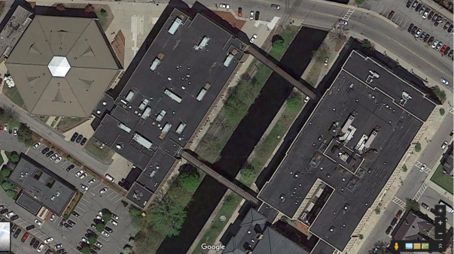
Prepared by:
Massachusetts Department of Public Health
Bureau of Environmental Health
Indoor Air Quality Program
August 2017

Background

Building: | Lowell High School
Address: | 14 French Street, Lowell, MA
Assessment Coordinated Through: | Lowell Public Schools
Reason for Request: | General Indoor Air Quality (IAQ) concerns. Note that this represents a preliminary walkthrough of the building. Additional visits, including air testing, will be conducted during the school year when the buildings are occupied.
Date of Assessment: | July 26, 2017
Massachusetts Department of Public Health/Bureau of Environmental Health (MDPH/BEH) Staff Conducting Assessment: | Mike Feeney Director, IAQ Program;  Cory Holmes, Environmental Analyst;  Jason Dustin, Environmental Analyst, and  Ruth Alfasso, Environmental Engineer
Building Description: | Brick and concrete construction with complex shape. The Building at 14 French Street was built in 1922. The building contains classrooms and offices. This building is connected to the building at 50 Father Morissette Blvd by several enclosed walkways.
Windows: | Openable

Ventilation
A heating, ventilating, and air conditioning (HVAC) system has several functions. First it provides heating and, if equipped, cooling. Second, it is a source of fresh air. Finally, an HVAC system will dilute and remove normally occurring indoor environmental pollutants by not only introducing fresh air, but by filtering the airstream and ejecting stale air to the outdoors via exhaust ventilation. Even if an HVAC system is operating as designed, point sources of respiratory irritation may exist and cause symptoms in sensitive individuals.
Note that during this preliminary site assessment no indoor air testing was performed and the buildings were mostly unoccupied. However, components of the HVAC were examined and are described here.
Fresh air is provided by multiple air-handling units (AHUs) located on the roof (Pictures 1 to 3). These units vary in size, age, and condition. In general, AHUs draw fresh air through an intake vent, where the air is filtered, then heated or cooled (i.e., conditioned). The conditioned fresh air is mixed with some air returned from rooms, then supplied to rooms through supply diffusers/grates throughout the building (Pictures 4 and 5). Return vents in rooms (Picture 6) bring stale air back to the AHU where a portion of this air is exhausted through louvres in the AHU. Some of the AHUs appeared to require maintenance and filter changes.
In the basement area, some classrooms were equipped with separate AHUs/fan coil units mounted in the ceiling. Some of these units were in disrepair (Picture 7).
In order to have proper ventilation with a mechanical supply and exhaust system, these systems must be balanced to provide an adequate amount of fresh air while removing stale air from a room. It is recommended that existing ventilation systems be re-balanced every five years to ensure adequate air systems function (SMACNA, 1994). It is unknown the last time these systems were balanced.

Microbial/Moisture Concerns
The 1800’s and 1920’s building sections were constructed with materials that, for the most part, are not susceptible to mold growth. The majority of these building sections consist of brick, concrete, tile, plaster, and glass; none of which contain carbon and are resistant to mold growth even with chronic moistening. Hardwood is also highly resistant to microbial growth. Hardwood was observed throughout these sections in flooring, support beams, and trim.
The 1980’s section and other renovations that occurred later added “porous” building materials such as carpeting, ceiling tiles, and gypsum wallboard. All of these materials contain carbon, which can support mold/microbial growth.
Musty/stale odors were noted in a number of classrooms with wall-to-wall carpeting. Classrooms with either wood or tiled floors did not have the stale, musty odor. Wall-to-wall carpeting was also noted in offices as well as below grade spaces. Wall-to-wall carpeting is not recommended in school classrooms in general, due to the difficulty in maintaining in good condition, including wear, dirt and spills. Carpeting is also not recommended in below-grade areas due to the likelihood of moisture exposure from condensation forming on floors in contact with the ground during humid weather and/or ground or storm water infiltration. Roof leaks leading to stained ceiling tiles and water-damaged plaster can also be a source of water to moisten carpeting. Carpeting moistened periodically will be subject to microbial growth. The odors detected in these carpeted areas are likely from water damage that subsequently led to microbial colonization of carpeting, as well as a buildup of dirt and debris in older carpeting that could no longer be adequately cleaned. Some carpeting was visibly stained, wrinkled, or threadbare (Pictures 8 and 9), indicating it was past its service life. The service life of carpeting in schools is approximately 10-11 years (IICRC, 2002). Aging carpet can produce fibers that can be irritating to the respiratory system. In addition, tears or lifting carpet can create tripping hazards. Carpeting should be cleaned annually or semi-annually in soiled high traffic areas as per the recommendations of the Institute of Inspection, Cleaning, and Restoration Certification (IICRC, 2012).
Water-damaged ceiling tiles and gypsum wallboard were observed in classrooms, offices, and hallways (Pictures 10 to 12; Table 1). Damage to these materials indicates leaks from the building envelope or plumbing system. In a few locations (e.g., basement room 24), the ceiling tiles and/or gypsum wallboard were found to be colonized with mold (Pictures 13 and 14, Table 1). Ceiling tiles and gypsum wallboard should be replaced after the leak is found and repaired. In general, ceiling tiles have an open space above them (the ceiling plenum) and tend to dry out quickly, reducing the chance that they will be colonized with mold.
Measures should be taken to ensure water-damaged materials are cleaned, replaced, and/or repaired in a manner consistent with the U.S. Environmental Protection Agency’s guidelines (US EPA, 2008). The US EPA and the American Conference of Governmental Industrial Hygienists (ACGIH) recommend that porous materials (e.g., ceiling tiles, gypsum wallboard) be dried with fans and heating within 24 to 48 hours of becoming wet (US EPA, 2008; ACGIH, 1989). If not dried within this time frame they should be removed/discarded.
Of note are the AHUs located above the 1980’s section of the building. Both AHUs lack bird screens over the fresh air intakes (Picture 15). Screens are necessary to prevent birds and other animals from nesting inside the HVAC equipment. No signs of bird roosting were noted inside the fresh air intakes at the time of this assessment. In addition, fans exist in ductwork connected to each AHU in this section. Each fan has a louver system that faces upwards (Picture 16), which would allow rainwater to readily enter the fan housing and connected ductwork. Usually a candy cane-shaped duct cap is installed over a louver system to prevent water accumulation.
BEH/IAQ staff noted the ductwork insulation of an AHU to be badly deteriorated (Picture 17). This condition may allow water or condensation to enter the ductwork. Deteriorating insulation reduce the capacity of the material to insulate.
To prevent water damage, sources of water infiltration need to be minimized. The exterior walls of the 1980’s building section exhibited a significant coating of white material along the edge of the roof (Picture 18). This material is efflorescence. Please note, efflorescence is not mold; it is a sign of water exposure in brick and mortar. As moisture penetrates and works its way through mortar, brick, or plaster, water-soluble compounds dissolve, creating a solution. As the solution moves to the surface of the material, the water evaporates, leaving behind white, powdery mineral deposits.
The roof in this area is flat with a raised parapet. The parapet itself was cracked and spalling with efflorescence above the roof membrane (Picture 19). Signs of chronic moisture issues (staining) were also visible along the front of the building below the parapet on the brick. These stains indicate damage is occurring to the parapet, roof, and façade of the building in this section.
Note that the building has a complex shape with several levels of roof; roof seams were observed where exterior wall sections meet. Water from recent rains was observed pooling on some of the roof segments (Picture 20). This can lead to leakage inside the building once the roof membrane becomes damaged. Roof drains, roofing materials and flashing/connections between roof segments and walls should be examined regularly for pooling water and other indications of deterioration with repairs made as needed. Roof drains were clogged with debris in some areas (Picture 21). This condition will also increase the chance for pooling/leaks to occur. These drains should be cleaned regularly to allow for proper function.
Many areas of the roof appeared to have deteriorated roof decking/underlayment. This was apparent during the walk through as many of these areas were spongy and depressed. The decking/underlayment help to support the membrane as well as provide proper grading to aid in directing storm water from the roof toward drains.
BEH/IAQ staff noted many areas with missing/ajar ceiling tiles (Picture 22). These ceiling tiles should be replaced to avoid serving as pathways to unconditioned areas.
In some areas, including the interior courtyard, vegetation was observed close to/against the building exterior (Picture 23). This can allow moisture to build up in building materials leading to damage and moisture infiltration. Root growth can damage the foundation. Vegetation can also be a source of allergens such as pollen and mold, which can enter the building through open windows.
Windows open in most exterior classrooms. . Open windows can be an additional source of fresh air. However, windows need to be tightly closed at the end of each day to prevent water infiltration and pest intrusion. Note that a few windows were found to be misaligned so that they would be difficult to close completely (Table 1); these should be repaired/replaced.
Some areas in the buildings are equipped with air conditioning from the AHUs. Doors between these areas and non-air-conditioned areas should be kept closed to prevent condensation of humid air on chilled surfaces. A few other areas were equipped with portable or window air conditioners. It is important that these units have the ability to properly drain any condensation they generate so that it does not leak and moisten building materials.
Sinks were observed in a number of classrooms. In a few areas, the backsplashes were unsealed (Picture 24). Some bathroom sinks were dripping and could not be shut off. Leaking plumbing can be a source of moisture to classroom materials and the indoor environment, particularly when outdoor humidity is high. Some sinks examined also had porous items (books, paper) stored inside the sink cabinet, which is a moist environment.
Porous items (e.g., boxes, books, paper, clothing) stored directly on flooring in some areas. This condition may lead to microbial growth, especially in below grade spaces.

Other Conditions
Filters for the AHUs should be changed in accordance with manufacturer’s instructions (e.g., two to four times a year). The MDPH recommends pleated filters with a Minimum Efficiency Reporting Value (MERV) of 8, which are adequate in filtering out pollen and mold spores (ASHRAE, 2012).
Equipment such as window/portable air conditioners and personal air filters are also equipped with filters that need to be cleaned or changed in accordance with manufacturer’s instructions.
Many classrooms had personal fans. Some of these had dusty blades/housing (Table 1). Many supply and exhaust vents were also observed to have accumulated dust/debris (Table 1). Dust on ventilation and fan equipment can be aerosolized when the units are activated.
Some toilets, urinals, and water fountains were found labeled out of order or covered with trash bags. Until repairs can be made, it is important to add water regularly to these drains to avoid dry drain traps which may result in sewer gases entering the building. If these fixtures are no longer needed then they should be properly abandoned and capped.
Missing/ajar light covers were seen in a few areas (Picture 25; Table 1). Fixtures should be equipped with access covers installed with bulbs fully secured in their sockets. Breakage of glass can cause injuries and may release mercury and/or other hazardous compounds. Other fluorescent lights had dust and debris inside them which should be cleaned.

Conclusions/Recommendations
The following recommendations are made to assist in improving IAQ:
- Remove any water-damaged, musty, or worn carpeting. Alternative floor coverings should be explored for below grade areas as carpeting is not recommended.
- Replace any water-damaged/mold-colonized porous building materials (e.g., ceiling tiles, gypsum wallboard) in classrooms, hallways and stairwell areas. Ensure water-damaged materials are cleaned, replaced, and/or repaired in a manner consistent with the U.S. Environmental Protection Agency’s guidelines (US EPA, 2008).
- Consult with an HVAC contractor to thoroughly examine all HVAC system components to ensure proper function. Make any necessary repairs to ensure the system is working as designed.
- Ensure that a system of regular “Operations and Maintenance” remains in place to keep HVAC systems in proper working order.
- Operate all supply and exhaust ventilation equipment continuously during occupied periods. Do not block supply or exhaust vents with furniture or items.
- Consult with a roofing contractor to assess the roof membrane and underlayment/decking system. Repairs should be made to stop leaks and chronic water damage to building materials. The roofing system should then be monitored regularly for water pooling, leaks, and other deteriorating conditions.
- Roof drains should be inspected regularly to remove any debris to avoid clogging/pooling.
- Exterior HVAC ductwork should be inspected to find any missing or damaged insulation or unintended gaps which may allow moisture or pests to be introduced into the ductwork. Perform any necessary repairs. This would also include adding the “candy cane” vent covers to the exhaust louvres open to the elements.
- Inspect and repair/replace any fresh air intakes that have missing or damaged bird screens or pre-filters.
- Consult with a building engineer to inspect the building envelope to address any areas of water intrusion (e.g., windows, brickwork/mortar, flashing). This would include the brickwork noted with efflorescence and the spalling parapet.
- Use openable windows to supplement fresh air during temperate weather. Ensure all windows are tightly closed at the end of the day. Inform occupants that windows should not be opened while the HVAC system is in cooling mode to avoid condensation.
- Replace any missing or ajar ceiling tiles to avoid pathways to unconditioned areas.
- Consider adopting a balancing schedule of every 5 years for all mechanical ventilation systems, as recommended by ventilation industrial standards (SMACNA, 1994).
- Ensure any plumbing leaks are repaired to avoid chronic water damage in the building.
- Repair sinks and sink backsplashes in classrooms.
- Regularly add water to any fixtures/drains that are out of order or are rarely used to avoid dry drain traps. Make necessary repairs or if fixtures are deemed unnecessary they should be properly abandoned and capped.
- Ensure that condensation from AHU equipment is draining properly. Check collector pans, piping and any associated pumps for clogs and leaks and clean periodically to prevent stagnant water build-up and remove debris that may provide a medium for microbial growth.
- Regularly inspect window and portable air conditioning units to ensure proper drainage of condensate and regular cleaning of filters.
- Ensure that doors are closed between areas with air conditioning and areas without air conditioning, to avoid condensation of humid air on chilled surfaces.
- Refrain from storing porous items (e.g., boxes, books, paper, clothing) directly on flooring, in below grade spaces, or under sink cabinets to avoid microbial colonization.
- Trim back trees/vegetation within 5′ of the building. Remove any vegetation (e.g., ivy) that is growing on the building to avoid damage to exterior from associated moisture.
- Consider utilizing MERV 8 filters in AHUs. Check with manufacturer’s recommendations before changing filter efficiency. Continue to change filters 2-4 times a year.
- Regularly clean supply/return vents and fans to avoid aerosolizing accumulated particulate matter.
- Clean any remaining carpeting and area rugs annually or more often in high-traffic locations in accordance with IICRC recommendations (IICRC, 2012) and discard those that are worn out or too soiled to be cleaned.
- Replace/repair fluorescent light covers; ensure fluorescent lights are fully secured to prevent breakage and clean debris out of covers.
- Encourage faculty to report classroom/building related issues via a tracking program.
- Continue to adopt the US EPA (2000) document, “Tools for Schools”, as an instrument for maintaining a good IAQ environment in the building available at: http://www.epa.gov/iaq/schools/index.html.
- Refer to resource manual and other related IAQ documents located on the MDPH’s website for further building-wide evaluations and advice on maintaining public buildings. These documents are available at: http://mass.gov/dph/iaq.

References
ACGIH. 1989. Guidelines for the Assessment of Bioaerosols in the Indoor Environment. American Conference of Governmental Industrial Hygienists, Cincinnati, OH.
ASHRAE. 2012. American Society of Heating, Refrigeration and Air Conditioning Engineers (ASHRAE) Standard 52.2-2012 -- Method of Testing General Ventilation Air-Cleaning Devices for Removal Efficiency by Particle Size (ANSI Approved). 2012.
IICRC. 2002. Institute of Inspection, Cleaning and Restoration Certification. A Life-Cycle Cost Analysis for Floor Coverings in School Facilities.
IICRC. 2012. Institute of Inspection, Cleaning and Restoration Certification. Carpet Cleaning: FAQ. Retrieved from http://www.iicrc.org/consumers/care/carpet-cleaning.
SMACNA. 1994. HVAC Systems Commissioning Manual. 1st ed. Sheet Metal and Air Conditioning Contractors’ National Association, Inc., Chantilly, VA.
US EPA. 2000. Tools for Schools. Office of Air and Radiation, Office of Radiation and Indoor Air, Indoor Environments Division (6609J). EPA 402-K-95-001, Second Edition. http://www.epa.gov/iaq/schools/index.html.
US EPA. 2008. “Mold Remediation in Schools and Commercial Buildings”. Office of Air and Radiation, Indoor Environments Division, Washington, DC. EPA 402-K-01-001. September 2008. Available at: http://www.epa.gov/mold/mold-remediation-schools-and-commercial-buildings-guide.
Picture 1
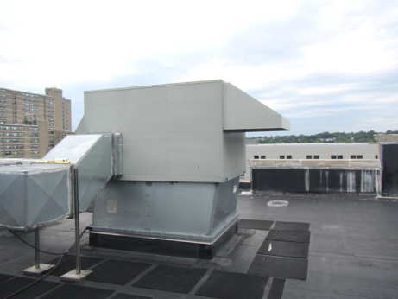
Air handling unit (AHU) on the roof
Picture 2
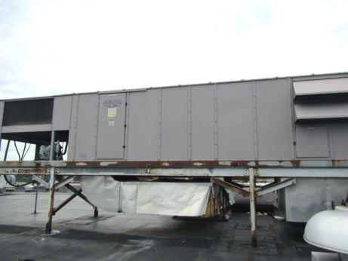
“Packaged” AHU on roof
Picture 3
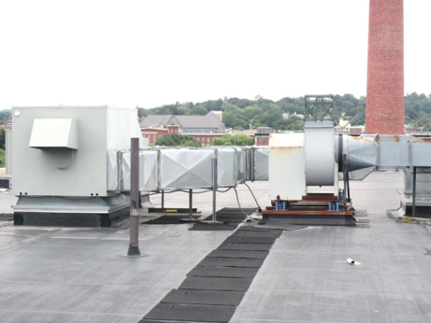
AHU on roof
Picture 4
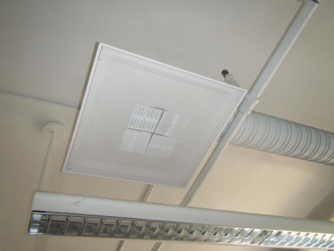
Classroom supply air vent
Picture 5
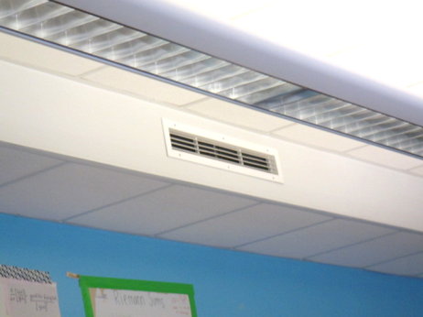
Classroom supply vent
Picture 6
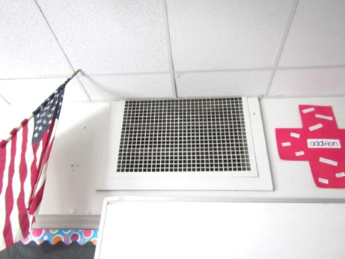
Exhaust/return vent in classroom
Picture 7
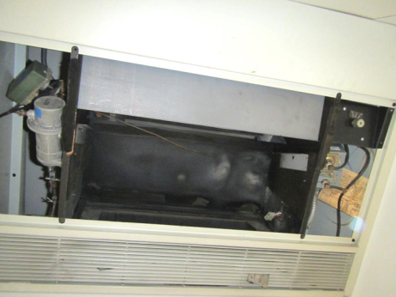
Ceiling-mounted fan coil unit in disrepair
Picture 8
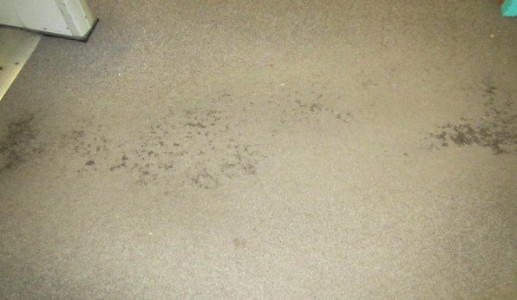
Stained, worn carpeting
Picture 9
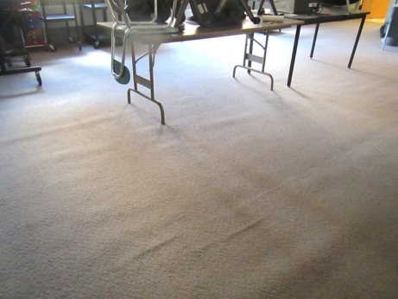
Worn, wrinkled carpeting
Picture 10
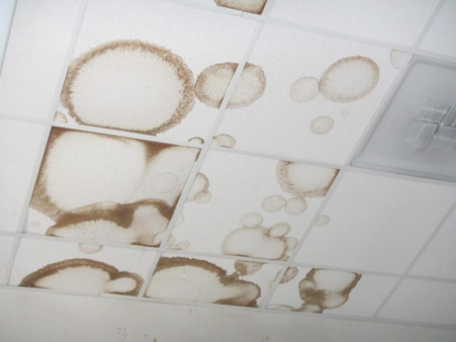
Water-damaged ceiling tiles
Picture 11
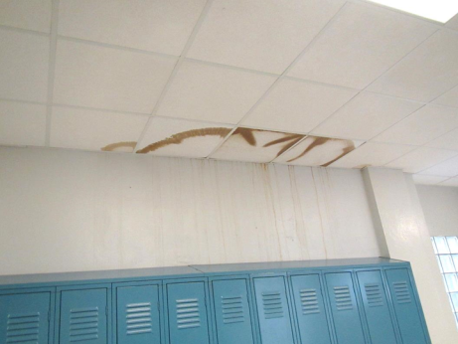
Water-damaged ceiling tiles
Picture 12
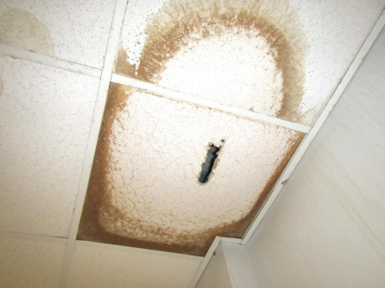
Water-damaged ceiling tiles
Picture 13
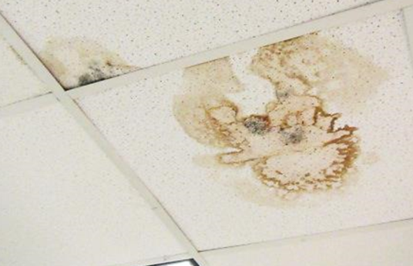
Water-damaged/mold-colonized ceiling tiles
Picture 14
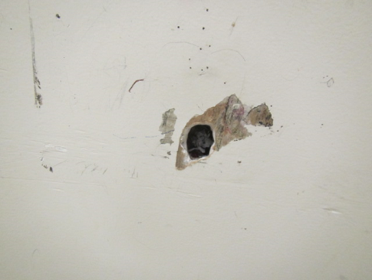
Water-damaged/mold-colonized gypsum wallboard
Picture 15
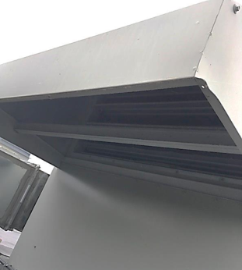
Rooftop fresh air intake lacking bird screen/pre-filter
Picture 16
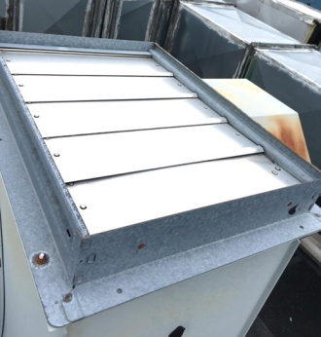
Exhaust duct louvers lacking “candy cane” vent cap
Picture 17
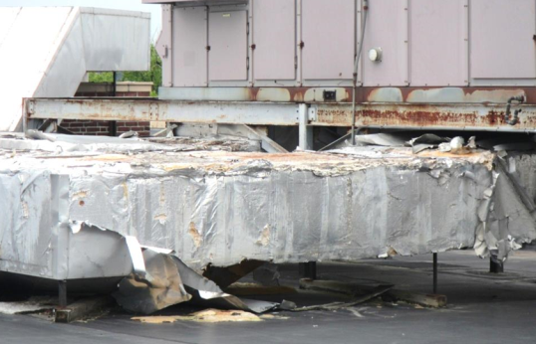
Deteriorated exterior duct insulation
Picture 18
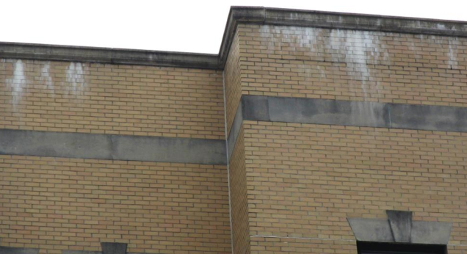
Efflorescence in brickwork near roof edge
Picture 19
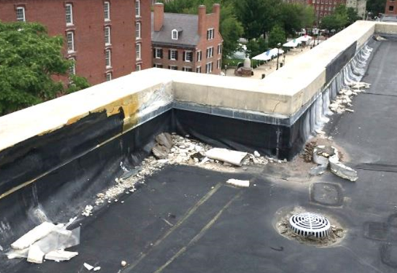
Evidence of spalling parapet and efflorescence
Picture 20
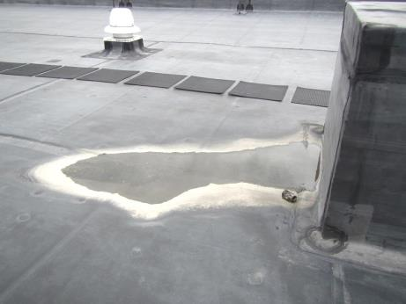
Water pooling on roof
Picture 21
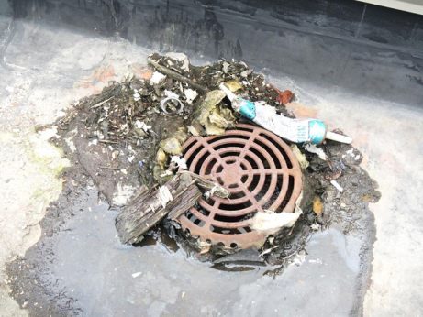
Debris around roof drain
Picture 22
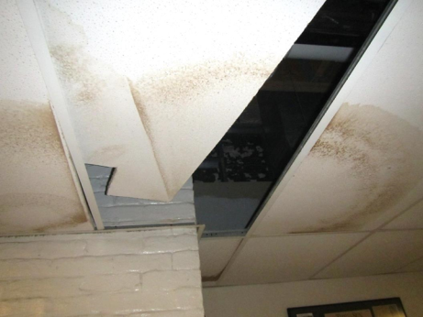
Missing ceiling tiles
Picture 23
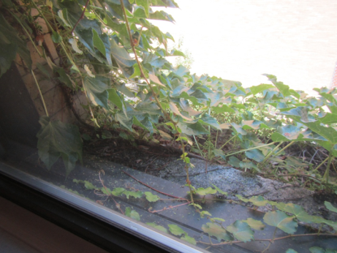
Vegetation against exterior of building
Picture 24
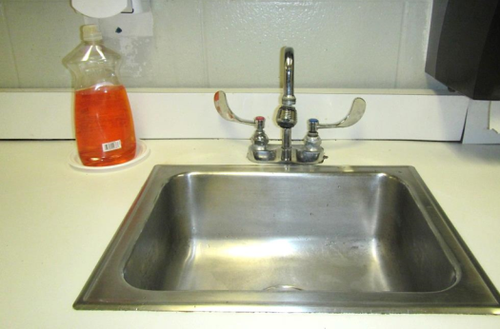
Backsplash behind sink lacking caulking
Picture 25
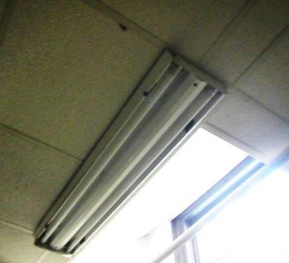
Missing light cover

Location | Windows  Openable | Ventilation |  | Remarks
 |  | Intake | Exhaust
301 A (Main Area) |  |  |  | 6 WD CT
301 A (Slattery Office) |  |  |  | Hole in wall-exposed fiberglass insulation
304 |  | Y | Y | 12+ WD CT, tile floor, dry drain, PC
305 A |  | Y | Y | Carpeted, dust/debris on vents, WD CP along windows/corner
305 B |  | Y | Y | Carpeted, dust/debris on vents
306 | Y | Y | Y | Musty carpet odor
308 |  | Y | Y | 5 WD CT, carpeted, WD plaster
310 | Y | Y | Y
311 |  |  |  | WD CP, peeling paint, open pipe ceiling
312 | Y | Y | Y | Storage/desk, 1 WD CT, carpeted, WD plaster
313 | Y | Y | Y | Wood floor, dirty lights
314 Chemistry | Y | Y | Y | Stored chemicals, chemical odors, HS, sinks, floor tiles damaged, WD ceiling
314 Storage |  | N | N | 9 WD CT, tile floor
315 |  |  |  | WD CP, peeling paint, PF
318 |  | Y | Y | 2 WD CT and plaster, carpeted
319 |  |  |  | PF
320 |  | Y | N | Carpeted
321 | Y | Y | Y | Tile floor, damaged, PF, DEM, science sinks and eyewash
323 R |  |  |  | Carpeted, WAC
324 Physics | Y | Y | Y | Carpeted, DEM
325 |  | Y | Y | Exhaust vent obstructed w/file cabinet, WD CP and peeling paint
326 |  | Y | Y | WD plaster, carpeted
329 |  |  |  | WD CP and peeling paint, PF, ajar CT-wiring
330 |  | Y | Y | 10+ WD CT, carpeted
331 |  |  |  | WD CP and peeling paint, WD CT
332 |  | Y | Y | 4 WD CT, carpeted
333 | Y | Y | Y | Wood floor, PF
334 |  | Y | Y | 4 WD CT, carpeted
338 |  | Y | Y | wood floor
346 | Y open | Y | Y | Carpet
349 Computer Lab | Y open | Y | Y | Worn carpeting, numerous computers
351 |  |  |  | Carpeted, WD CP and peeling paint, stained CP, 3 WD CTs
389 | Y | Y | Y | WD CT, PC, worn carpeting
Boys Restroom | N | N | Y | WD plaster, broken urinal
Crowell Office |  |  |  | 3 WD CTs, WD CP along windows
Custodial Closet | N | N | Y | Slop sink, WD CP, open pipe, odors
Faculty Men’s Restroom | N | N | Y | WD ceiling plaster
Girls Restroom | N | N | Y | WD CP
Hallway (323) |  |  |  | Abandoned water fountain-covered w/trash bag
Stairwell B | N | N | N | WD CT, MT, dirty lights,
Teacher’s Center  -Upstairs | N | Y | Y | Carpet, PC, plants, AI, DEM, mechanical room access
Teacher’s Center  -Tile Side | N | Y | Y | NC, PF, CPs, WD CTs x 10, dusty vents, boxes stored on floor
Teachers Center Conference Area | Y | Y | Y | PC, carpeted
Teachers Center Food Area | Y | Y | Y | NC, 2 fridges, microwave
201 B |  |  |  | Carpeted
203 |  |  |  | Carpeted
206 B | Y | Y | Y | Carpet, PF
206 D |  | Y | Y | Carpet, PF, HS, AF
207 A |  | Y | Y | Dust/debris on vents, portable AC unit
207 B |  | Y | Y | Carpeted, window in disrepair-sign “do not touch window”, dust/debris on vents
208 B | N | Y | Y | Carpet
209 R | N | Y | Y | WD and MT, carpeted, DEM
209 A | N | Y | Y | Carpet in waiting room area
209 B | Y open | Y | Y | Hallways in this area are new Pergo flooring, this office is carpeted (new), window poorly sealed/off track
209 E | N | Y | Y | New carpet
210 | Y open | Y | Y | Carpet, DEM
212 A |  | Y | Y | Carpeted
213 |  |  |  | Carpeted, PF, WD CP and peeling paint/corner
214 A | Y | Y | Y | Wood floor, WD CT
214 B | Y open | Y | Y | Asphalt odor detected (roof below?), WD plaster ceiling
215 | Y open | Y | Y | Wood floor
216 |  | Y | Y | Wood floor
217 |  |  |  | Carpeted, PF
218 |  | Y | Y | Wood floor
219 | Y open | Y | Y | WD CT, wood floor, PF
220 |  | Y | Y | Carpeted
223 | Y open | Y | Y | Wood floor
226 |  | Y | Y | Wood floor
227 |  |  |  | PF
229 |  | Y | Y | Carpeted, PF, ajar CT, dust/debris on vents, WD CP and peeling paint
230 |  | Y | Y | Wood floor
231
232 |  | Y | Y | Carpeted
235 |  |  |  | PFs
236 |  |  |  | Custodial closet, odor of cleaners/mop
237 Computer Lab |  | Y | Y | Dust/debris on vents
239 |  |  |  | Peeling paint
240 |  | y | y | carpeted no odor, 1 WD CT
249 | Y open | Y | Y | 1 WD CT, carpet
254 |  | Y | Y | 1 WD CT, carpeted floor
255 |  | Y | Y | 1 WD CT, carpeted
259 Hall |  | Y | Y | WD CT
Auditorium Upper Level | N | Y | Y | AC, carpet, upholstered chairs
Boys Restroom | N | N | Y | Many WD CT, CP, wall tiles
Español | Y open | Y | Y | Carpeted, DEM, cleaning products
Girls Restroom | N | N | Y | A few WD CT, CP
Girls Restroom |  | Y | Y | 5 WD CT, carpeted floor, WD GW ceiling
Men’s Faculty Restroom | N | N | Y | WD plaster
Mural room | N | N | N | Missing light cover
Second Floor Stairwell B | Y open | N | N
Womens restroom | Y open | Y | Y | Dusty vents
101 |  | Y | Y | Carpeted
101 Storage |  | Y | Y | 2 WD CT, WD GW, mold
102 | Y | Y | Y | DEM, carpet
105 |  |  |  | Carpeted, PF, severely damaged wall and ceiling plaster/corner
106 | Y | Y | Y | DEM, newer carpet, , WAC, microwave/fridge, PC, reports of previous flood from 3rd floor, slight foul odor
106 A | N | Y | Y | Carpet
107 | Y open | Y | Y | Carpet, PFs, WD GW ceiling, carpeted
109 | Y open | Y | Y | DEM, carpet w/stains
110 |  | Y | Y | Wood floor
112 | Y | Y | Y | Carpet, mini fridge, computer lab
114 |  | Y | Y | Wood floor
115 |  | Y | Y | 1 WD CT, wood floor
116 | Y | Y | Y | AI, carpet
117 | Y | Y | Y | Portable AC - on, new carpet, fridge and microwave
118 |  | Y | Y | Tile floor, WD plaster and peeling paint
119 |  | Y | Y | Wood floor
120 B | Y | Y | N | CPs, carpet, UF
120 E | N | Y | N | MT, DEM
122 | Y | Y | Y | Carpet (musty odor), DEM, debris on carpet
123 |  | Y | Y | Wood floor
126 A | Y | Y | Y | Storage, old carpet, ajar CT, wood floor
126 B | Y | Y | Y | SPED sensory room, upholstery and cloth items, tile floor
128 |  |  |  | Cobwebs near windowsill
131 |  |  |  | Carpeted, PF
132
133 |  |  |  | Carpeted, PF
134 |  | Y | Y | Carpeted, PF, dust/debris on vents
137 |  |  |  | Utility hole in wall
139 |  |  |  | Carpeted, ajar CT
144 |  | Y | Y | Carpeted, 4 WD CTs, dust/debris on vents, filter in ceiling vent, PC
145 Computer Lab |  | Y | Y | Carpeted, dust/debris on vents, 3 WD CTs, filter in ceiling vent
147 |  | Y | Y | Carpeted, dust/debris on vents, WD CT
199 | Y open | Y | Y | Carpet
Auditorium Lower Level | N | Y | Y
B House | Y | Y | N | PC, Carpet, gap around utilities in CT
Boys Restroom |  |  | Y | Dust/debris on vents, WD CP and peeling paint
Girls Restroom | N | Y | Y
Staff/SPED Restroom |  |  | Y | Air filter, WD ceiling, toileting materials
Stage |  |  |  | Wood floor
Womens Restroom | N | N | Y | WD plaster, cleaning products
004 |  | Y | Y | 1 WD CT, carpeted, WD plaster
009 Courtyard Restaurant |  | Y | Y | Dust/debris on vents
010 |  | Y | Y | 3 WD CT, carpeted
012 | Y | Y | Y | Musty odor, tile floor, WD CTs x 4, PF, CPs, sinks
012 |  | Y | Y | 1 WD CT, tile floor
012 Kitchen Area | Y | Y | Y | Dirty supply vents/ghosting, DEM
013 |  |  |  | WD CTs, missing light cover
016 |  | Y | Y | Tile floor
017 | Y | Y | Y | NC, sinks, fridge, stoves
019 | Y | Y | Y | NC, FCU in ceiling, sinks
020 | N | Y | Y | Tile floor, DEM
021 | Y | Y | Y | WD CT, stained carpeting
021 Laundry | N | Y | Y | MT, WD ceiling, ceiling-mounted AC/FCUs
024 |  | Y | Y | Carpeted, WD/moldy CTs
025 |  | Y | Y | Carpeted, dust/debris on vents
026 Music |  | Y | Y | Stained CT and dust
028 | N | Y | Y | Carpet, cleaner odors, WD CT, microwave
028 Waiting Room | N | Y | Y | NC
038 |  | Y | Y
039 |  | Y | Y | Carpeted, dust/debris on vents, PF
Band Storage Room
Basement Girls Restroom | N | Y | Y | Sink, WD ceiling plaster, broken toilet
Boys Restroom |  |  | Y | WD ceiling
Mailroom |  | Y | Y | Tile floor
Music | N | Y | Y | Carpet, musty odor, MTs x 5, WD plaster ceiling above
Music-Office | N | Y | Y | WD CT, costumes, musty odor

