INDOOR AIR QUALITY REASSESSMENT

Lowell High School
1922 Building
14 French Street
Lowell, MA

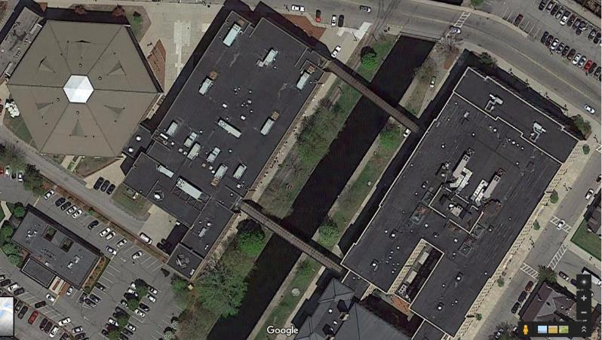

Prepared by:
Massachusetts Department of Public Health
Bureau of Environmental Health
Indoor Air Quality Program
December 2019

Background

Building: | Lowell High School (LHS)
Address: | 14 French Street, Lowell, MA
Assessment Coordinated Through: | Lowell Public Schools
Reason for Request: | Reassessment based on actions taken since the previous visit in 2017.
Date of Assessment: | October 25, 2019
Massachusetts Department of Public Health/Bureau of Environmental Health (MDPH/BEH) Staff Conducting Assessment: | Jason Dustin, Environmental Analyst’  Cory Holmes, Environmental Analyst,  Ruth Alfasso, Environmental Engineer, and Mike Feeney Director, Indoor Air Quality Program (IAQ)
Building Description: | The Building at 14 French Street was built in 1922 and has brick and concrete construction in a complex shape. This building is connected to the building at 50 Father Morissette Boulevard by several enclosed walkways.
Windows: | Openable

This school was visited previously in 2017. Two visits were made: one during the summer when the school was unoccupied and again in the fall during normal occupancy. Recommendations were made in a report following each visit. The MDPH/IAQ Program returned to the school this year for a follow-up visit, in part to assess the response to recommendations made in our previous report as well as to provide further recommendations to improve IAQ. Appendix A shows recommendations from the 2017 reports. In addition, the LHS complex will be undergoing significant renovations over the next several years. Recommendations included in this report will also address planning for renovation-related issues.

Methods
Please refer to the IAQ Manual for methods, sampling procedures, and interpretation of results (MDPH, 2015).

IAQ Testing Results
Table 1 includes indoor air testing results, which are summarized below.
- Carbon dioxide levels were above the MDPH guideline of 800 parts per million (ppm) in more than a third of all areas assessed including all occupied classrooms, indicating a lack of air exchange in those areas of the building. Appendix B is an additional resource about carbon dioxide.
- Temperature was within or close to the recommended range of 70°F to 78°F in areas tested the day of assessment.
- Relative humidity was within or close to the lower end of the recommended range of 40 to 60% in the areas tested.
- Carbon monoxide levels were non-detectable in the areas tested.
- Fine particulate matter (PM2.5) concentrations measured were below the National Ambient Air Quality (NAAQS) limit of 35 μg/m³ in all but four areas tested. This is discussed further in the “Other Conditions” section of the report.

Ventilation
A heating, ventilating, and air conditioning (HVAC) system has several functions. First it provides heating and, if equipped, cooling. Second, it is a source of fresh air. Finally, an HVAC system will dilute and remove normally occurring indoor environmental pollutants by not only introducing fresh air, but by filtering the airstream and ejecting stale air to the outdoors via exhaust ventilation. Even if an HVAC system is operating as designed, point sources of respiratory irritation may exist and cause symptoms in sensitive individuals.
Fresh air is provided by multiple air-handling units (AHUs) located on the roof. These units vary in size, age, and condition. According to building facility staff, several of the units have been replaced since the 2017 visits. In general, AHUs draw fresh air through an intake vent, where the air is filtered, then heated or cooled (i.e., conditioned). The conditioned fresh air is mixed with some air returned from rooms, then supplied to rooms through supply diffusers/grates throughout the building (Pictures 1 and 2). Return vents in rooms (Picture 3) bring stale air back to the AHU where a portion of this air is exhausted through louvers in the AHU. In the basement area, some classrooms were equipped with separate AHUs/fan coil units mounted in the ceiling.
In the oldest parts of the school, remnants of the original ventilation system still exist, including the gravity exhaust vents at the base of classroom walls (Picture 4). It was not known if these vents were still connected to ductwork or to any vents on the roof. If they do not function, they should be sealed up in an airtight manner, as they could provide pathways for dust, odors and pests to travel in the building.
Based on air sampling, many classrooms with normal occupancy appeared to have a lack of air exchange provided by the HVAC system in its current operating mode. Given the age and operation of the existing HVAC system, it may be necessary to open windows during temperate weather to supplement fresh air supply for classrooms.
The HVAC systems should be regularly maintained and operate continuously during occupied hours. It may be possible to adjust AHUs to allow more fresh air into the system, e.g. by opening supply louvers or adjusting the proportion of air exhausted rather than recirculated. Exhaust ventilation should also be checked periodically to ensure a draw of air from classrooms.
It was noted that the cooking area in the basement (Room 17) lacked exhaust ventilation, which is particularly important in areas where pollutants would be generated. Levels of particulate matter were elevated in this area (Table 1) and there was an odor of cooking. In addition, at least one of the stoves uses natural gas, which can create nitrous oxides and other products of combustion.
In order to have proper ventilation with a mechanical supply and exhaust system, these systems must be balanced to provide an adequate amount of fresh air while removing stale air from a room. It is recommended that existing ventilation systems be re-balanced every five years to ensure adequate air systems function (SMACNA, 1994). It is unknown the last time these systems were balanced.

Microbial/Moisture Concerns
As noted in previous reports, the building was constructed with materials that, for the most part, are not susceptible to mold growth. The majority of these building sections consist of brick, concrete, tile, plaster, and glass; none of which contain carbon and are resistant to mold growth, even with chronic moistening. Hardwood is also highly resistant to microbial growth. Hardwood was observed throughout these sections in flooring, support beams, and trim.
Building renovations that occurred in later years added porous building materials such as carpeting, ceiling tiles, and gypsum wallboard. These materials contain carbon, which can support mold/microbial growth.
Carpeting is a material that can become water-damaged and colonized with mold. The MDPH/IAQ program does not recommend the use of carpeting in schools, particularly in lower levels, due to the likelihood of it becoming moistened due to spills, tracked in moisture and condensation. During the previous visits to LHS, musty odors were noted in many classrooms with carpeting found in poor condition/beyond its service life. Much of the older carpeting has been removed from the building since the 2017 visit (Table 1). Due to the construction of the flooring in this part of the school complex, which is plywood, new carpet tiles were installed rather than non-porous flooring.
Some old carpeting remains in the building, including some that is visibly stained, wrinkled, or threadbare (Picture 5; Table 1), indicating it is past its service life. The service life of carpeting in schools is approximately 10-11 years (IICRC, 2002). Aging carpet can produce fibers that can be irritating to the respiratory system. In addition, tears or lifting carpet can create tripping hazards. Carpeting should be cleaned annually or semi-annually in soiled high traffic areas as per the recommendations of the Institute of Inspection, Cleaning, and Restoration Certification (IICRC, 2012).
Water-damaged ceiling tiles, plaster, gypsum wallboard and flooring were observed in classrooms, offices, hallways and closets (Pictures 6 through 10; Table 1). Damage to these materials indicates leaks from the building envelope or HVAC/plumbing system. Ceiling tiles and gypsum wallboard should be replaced after a leak is found and repaired. In general, ceiling tiles have an open space above them (the ceiling plenum) and tend to dry out quickly, reducing the chance that they will be colonized with mold. Building facility staff reported that the 1920s building roof has been replaced since the last visit, so most of the observed water-damaged ceiling tiles are from historic leaks. However, a recent leak was reported in room 351. Replacement of all water-damaged ceiling tiles is planned as funds for new materials becomes available.
Measures should be taken to ensure water-damaged materials are cleaned, replaced, and/or repaired in a manner consistent with the U.S. Environmental Protection Agency’s guidelines (US EPA, 2008). The US EPA and the American Conference of Governmental Industrial Hygienists (ACGIH) recommend that porous materials (e.g., ceiling tiles, gypsum wallboard) be dried with fans and heating within 24 to 48 hours of becoming wet (US EPA, 2008; ACGIH, 1989). If not dried within this time frame they should be removed/discarded.
In many areas, some ceiling tiles were also missing (Picture 7; Table 1). These need to be replaced to maintain a continuous ceiling plenum and prevent dust and debris from above the ceiling tiles entering occupied areas.
Water-damaged plaster, efflorescence and peeling paint was observed in a number of areas (Pictures 8 and 9; Table 1). Efflorescence is a characteristic sign of water damage to building materials such as brick, mortar, or plaster, but it is not mold growth. As moisture penetrates and works its way through mortar around brick, water-soluble compounds dissolve, creating a solution. As the solution moves to the surface of the brick or mortar, water evaporates, leaving behind white, powdery mineral deposits. This condition indicates that water from the exterior has penetrated into the building. When present, efflorescence can be readily cleaned.
A severely water-damaged floor was observed in the closet of room 105A (Picture 10). The wooden floor was springy/spongy underfoot and could serve as a safety hazard. This area should be locked/off limits until repairs can be made.
Some areas in the building are equipped with air conditioning from the AHUs. Doors between these areas and non-air-conditioned areas should be kept closed to prevent condensation of humid air on chilled surfaces. A few other areas were equipped with portable or window air conditioners (Picture 11). It is important that these units have the ability to properly drain any condensation they generate so that it does not leak and moisten building materials.
Windows are openable in most exterior classrooms. Open windows can be an additional source of fresh air. However, windows need to be tightly closed at the end of each day to prevent water infiltration and pest intrusion. Windows should not be opened in a room where air conditioning is operating.
Refrigerators were found in some classrooms and offices (Picture 12; Table 1). Refrigerators should be kept clean and free of spills and spoiled food. Refrigerators and water dispensers should not be placed in carpeted areas where spills or leaks could moisten carpeting (e.g., Picture 5).
There are sinks in some classrooms, some of which appear not to be used. There may also be unused floor drains. The trap seals in unused drains can dry out and allow sewer gas and odors into occupied areas. Seldom used drains should be wetted periodically to maintain the trap seal. Some science rooms had safety showers, which should be monitored and maintained to prevent leaks. No porous materials should be stored under or near the safety showers.
Plants were noted in a few areas, including some in carpeted areas and in poor condition (Picture 13). Plants should be well maintained, placed on non-porous drip pans, and kept away from the airstream of ventilation equipment.
Ivy was observed growing on the exterior of the building (Picture 14). Ivy can damage masonry and also holds moisture against the building, preventing it from drying and increasing the potential for water damage.

Other Conditions
Exposure to low levels of volatile organic compounds (VOCs) may produce eye, nose, throat, and/or respiratory irritation in some sensitive individuals. BEH/IAQ staff examined spaces for products containing VOCs, noting cleaning products, air fresheners, hand sanitizers and dry erase materials in a number of areas throughout the space (Picture 15; Table 1). All of these products have the potential to be irritants to the eyes, nose, throat, and respiratory system of sensitive individuals. Other sources of total volatile organic compounds (TVOCs) include copy machines and laminators. Excess heat, odors, VOCs and ozone can be produced by photocopiers, particularly if the equipment is older and in frequent use. Ozone is a respiratory irritant (Schmidt Etkin, 1992). Laminators produce TVOCs and plastic odors. This equipment should be used in well-ventilated areas away from occupants.
As mentioned previously, Room 17 had an unvented stove which was observed to produce elevated particulate matter with a diameter of 2.5 micrometers (μm) or less (PM2.5). In addition, the hallway outside of the network hub room on the second floor had elevated PM2.5 levels. No source of combustion could be located in this area, however MDPH/IAQ staff did note that this hallway had old, worn carpeting. It is possible that the carpeting could produce fine particulates with high foot traffic, especially if it is not regularly vacuumed. Fragrance diffusers, humidifiers, and candles can also produce elevated PM2.5 and should be eliminated from the building. Elevated PM2.5 levels can produce immediate, irritant effects upon exposure.
In many areas, items, including books, papers, and decorative items were observed on floors, windowsills, tabletops, counters, bookcases, and desks, which can make it more difficult for custodial staff to clean (Table 1). Many classrooms had personal fans and some of these had dusty blades. Many supply and exhaust vents were also observed to be dusty (Picture 3; Table 1). Dust on ventilation and fan equipment can be aerosolized when the units are activated.

Conclusions/Recommendations
The following recommendations are made to assist in improving IAQ:
- Consult Appendix A for previous recommendations that need additional work.
- Limit access to storage closet in room 105A, until floor repairs are made.
- Operate supply and exhaust ventilation continuously during occupied hours. Adjust ventilation equipment (e.g. louvers, flow rates) where possible to increase fresh air, particularly to frequently used classrooms.
- Do not block supply or exhaust vents with furniture or items. Check exhaust/return vents periodically for proper function. Where exhaust vents are switch-operated, ensure they are turned on when the room is occupied.
- Use openable windows to supplement fresh air during temperate weather. Ensure all windows are tightly closed at the end of the day. Inform occupants that windows should not be opened while the HVAC system is in cooling mode to avoid condensation.
- Ensure areas which generate pollutants, such as cooking areas, have operable exhaust functioning.
- Assess the status of existing old gravity exhaust vents and seal as needed.
- Ensure that a system of regular “Operations and Maintenance” remains in place to keep HVAC systems in proper working order.
- Consider adopting a balancing schedule of every 5 years for all mechanical ventilation systems, as recommended by ventilation industrial standards (SMACNA, 1994).
- Replace remaining water-damaged ceiling tiles and monitor for new leaks (e.g., room 351). Prioritize replacement of ceiling tiles with potential mold staining and in frequently-occupied areas.
- Remove remaining water-damaged, musty, or worn carpeting. Replace with non-porous materials if possible.
- Repair water-damaged plaster; scrape off/vacuum peeling paint and efflorescence (e.g., Pictures 8 and 9).
- Repair/replace any other water-damaged/mold-colonized porous building materials (e.g., gypsum wallboard) in classrooms, hallways and stairwell areas.
- Ensure water-damaged materials are cleaned, replaced, and/or repaired in a manner consistent with the U.S. Environmental Protection Agency’s guidelines (US EPA, 2008).
- Replace any missing or ajar ceiling tiles to avoid pathways to unconditioned areas.
- Regularly inspect window and portable air conditioning units to ensure proper drainage of condensate and regular cleaning of filters.
- Ensure that doors are closed between areas with air conditioning and areas without air conditioning, to avoid condensation of humid air on chilled surfaces.
- Refrain from storing porous items (e.g., boxes, books, paper, clothing) directly on flooring, in below grade spaces, under sink cabinets and near safety showers to avoid microbial colonization.
- Avoid placing refrigerators and water dispensers on carpet.
- Clean refrigerators frequently to prevent spills and odors.
- Trim back trees/vegetation within 5′ of the building. Remove vegetation (e.g., ivy) that is growing on the building to avoid damage to exterior from associated moisture.
- Reduce the use of products containing fragrances and VOCs.
- Locate photocopiers and laminators in well ventilated areas away from occupants.
- Ensure Material Safety Sheets are available for all laboratory, maintenance and janitorial chemicals used in the building.
- Regularly clean supply/return vents and fans to avoid aerosolizing accumulated particulate matter.
- Consider reducing the amount of items stored in classrooms to make cleaning easier. Periodically move items to clean flat surfaces.
- Clean any remaining carpeting and area rugs annually or more often in high-traffic locations in accordance with IICRC recommendations (IICRC, 2012) and discard those that are worn out or too soiled to be cleaned.
- For buildings in New England, periods of low relative humidity during the winter are often unavoidable. Therefore, scrupulous cleaning practices should be adopted to minimize common indoor air contaminants whose irritant effects can be enhanced when the relative humidity is low. To control for dusts, a high efficiency particulate arrestance (HEPA) filter equipped vacuum cleaner in conjunction with wet wiping of all surfaces is recommended. Avoid the use of feather dusters. Drinking water during the day can help ease some symptoms associated with a dry environment (throat and sinus irritations).
- Encourage faculty to report classroom/building related issues via a tracking program.
- As construction on this building is planned and commences, use the guidance “Methods Used to Reduce/Prevent Exposure to Construction/Renovation Generated Pollutants in Occupied Buildings” which is included as Appendix C.
- Continue to adopt the US EPA (2000) document, “Tools for Schools”, as an instrument for maintaining a good IAQ environment in the building available at: http://www.epa.gov/iaq/schools/index.html.
- Refer to resource manual and other related IAQ documents located on the MDPH’s website for further building-wide evaluations and advice on maintaining public buildings. These documents are available at: http://mass.gov/dph/iaq.

References
ACGIH. 1989. Guidelines for the Assessment of Bioaerosols in the Indoor Environment. American Conference of Governmental Industrial Hygienists, Cincinnati, OH.
IICRC. 2002. Institute of Inspection, Cleaning and Restoration Certification. A Life-Cycle Cost Analysis for Floor Coverings in School Facilities.
IICRC. 2012. Institute of Inspection, Cleaning and Restoration Certification. Carpet Cleaning: FAQ.
MDPH. 2015. Massachusetts Department of Public Health. “Indoor Air Quality Manual: Chapters I-III”. Available at: http://www.mass.gov/eohhs/gov/departments/dph/programs/environmental-health/exposure-topics/iaq/iaq-manual/.
Schmidt Etkin, D. 1992. Office Furnishings/Equipment & IAQ Health Impacts, Prevention & Mitigation. Cutter Information Corporation, Indoor Air Quality Update, Arlington, MA.
SMACNA. 1994. HVAC Systems Commissioning Manual. 1st ed. Sheet Metal and Air Conditioning Contractors’ National Association, Inc., Chantilly, VA.
US EPA. 2000. Tools for Schools. Office of Air and Radiation, Office of Radiation and Indoor Air, Indoor Environments Division (6609J). EPA 402-K-95-001, Second Edition. http://www.epa.gov/iaq/schools/index.html.
US EPA. 2008. “Mold Remediation in Schools and Commercial Buildings”. Office of Air and Radiation, Indoor Environments Division, Washington, DC. EPA 402-K-01-001. September 2008. Available at: http://www.epa.gov/mold/mold-remediation-schools-and-commercial-buildings-guide.
Picture 1
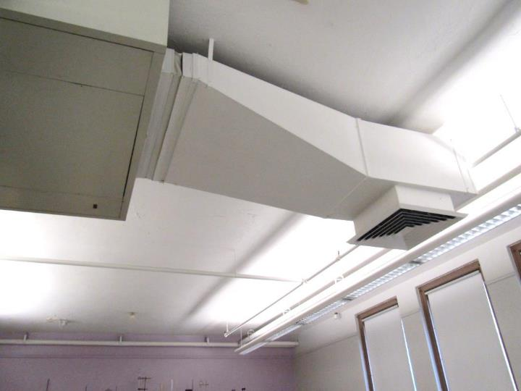
Supply duct and vent in a classroom without suspended ceiling tile system
Picture 2
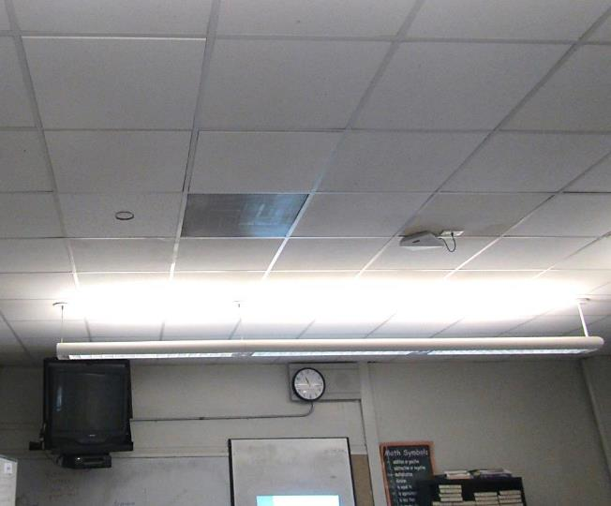
Supply vent in suspended ceiling tile system
Picture 3
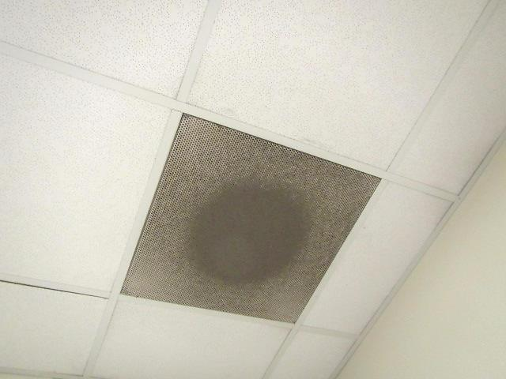
Return vent, note dust and debris on grill
Picture 4
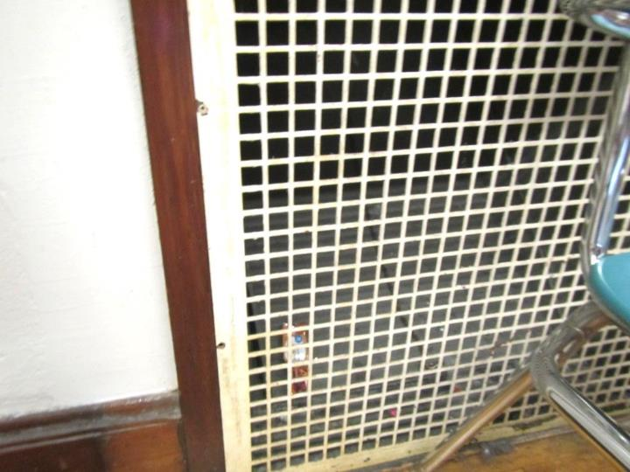
Old gravity exhaust vent
Picture 5
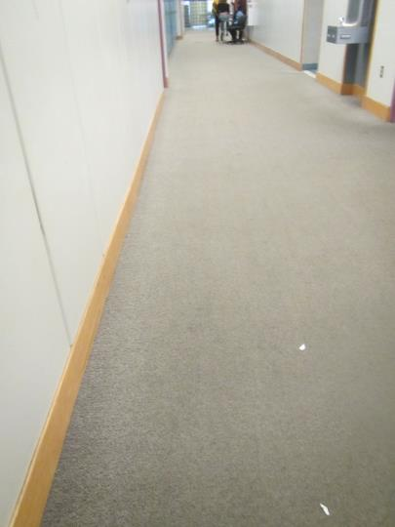
Worn, stained carpeting in a hallway, note water fountain over carpet
Picture 6
\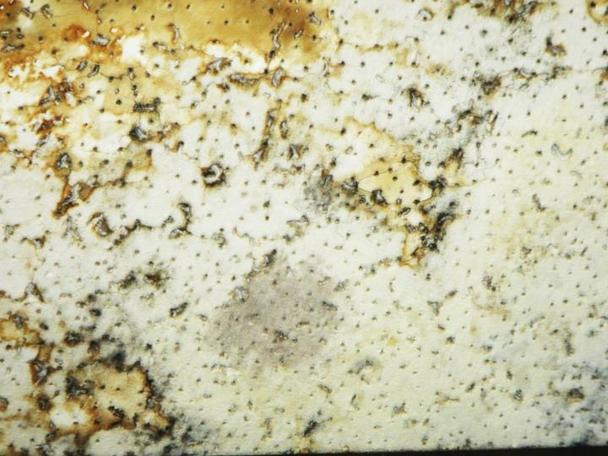
Water-damaged ceiling tile with dark staining that may indicate mold
Picture 7
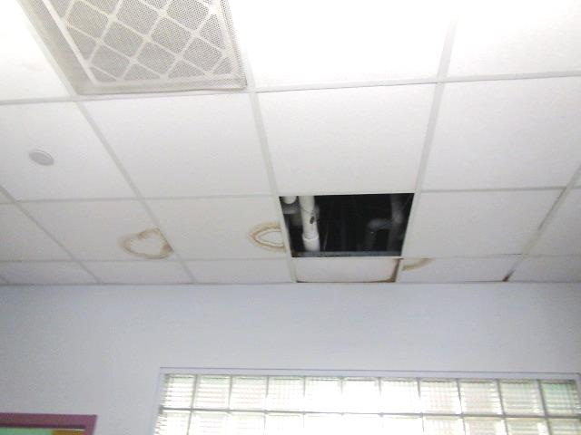
Water-damaged ceiling tiles and missing tile
Picture 8
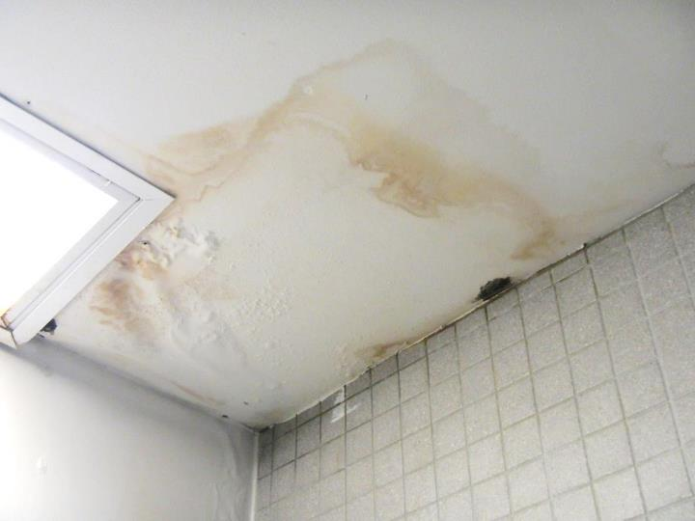
Water-damaged ceiling plaster
Picture 9
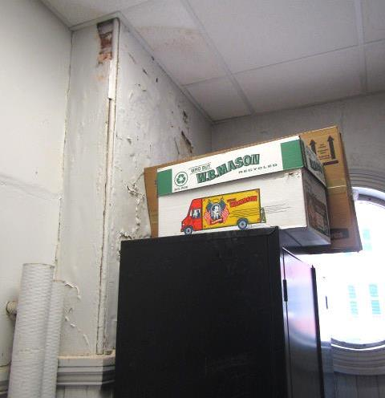
Water-damaged plaster, peeling paint and efflorescence in closet of room 101
Picture 10
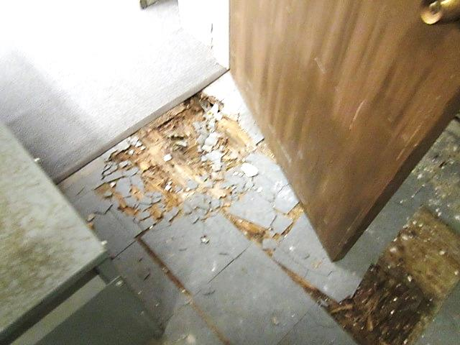
Severely damaged floor due to water leak in closet of room 105A
Picture 11
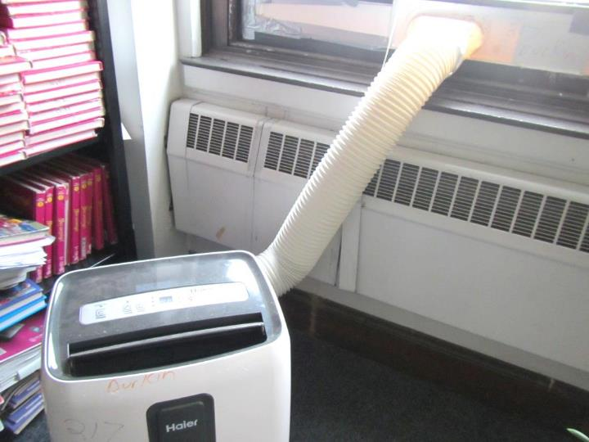
Portable air conditioner
Picture 12
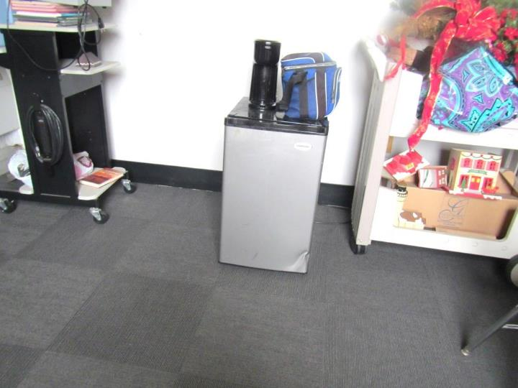
Small refrigerator on carpet
Picture 13
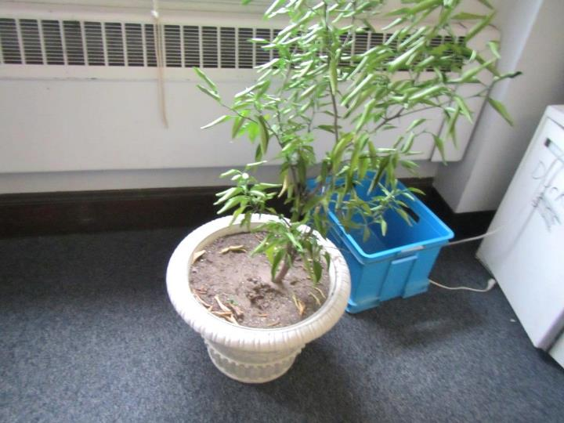
Plant in a carpeted area, plant was in poor condition
Picture 14
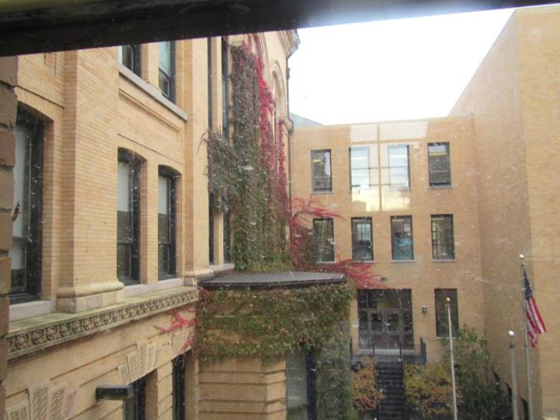
Ivy growing on the side of the building
Picture 15
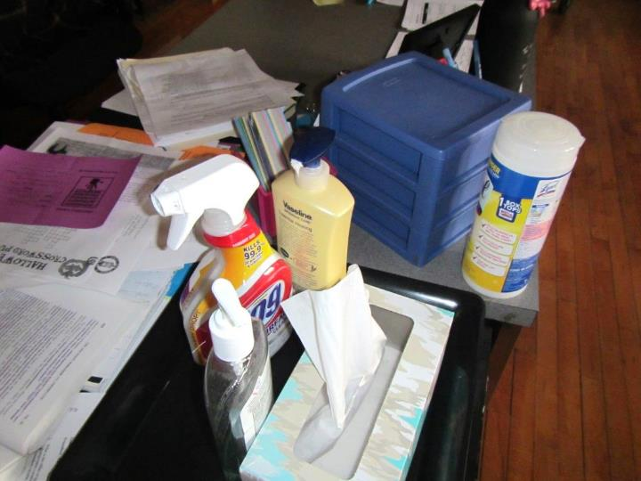
Cleaning products and hand sanitizer

Location | Carbon  Dioxide  (ppm) | Carbon Monoxide  (ppm) | Temp  (°F) | Relative  Humidity  (%) | PM2.5  (µg/m³) | Occupants  in Room | Windows  Openable | Ventilation |  | Remarks
 |  |  |  |  |  |  |  | Supply | Exhaust
Background (outside) | 422 | ND | 59 | 52 | 12 | - | - | - | -
Third Floor
Book room | 750 | ND | 70 | 41 | 8 | 0 | N | Y | Y | MT, books, some on floor
Food prep area | 628 | ND | 71 | 40 | 7 | 0 | Y | Y | Y | Fridges and microwave, fridge has spill
Guidance A-L | 758 | ND | 73 |  | 9 | 1 | Y | Y | Y | DEM, WD CT and cracked plaster
House Dean | 766 | ND | 73 | 39 | 8 | 2 | Y | Y | Y | WAC, carpet
Office | 660 | ND | 71 | 38 | 8 | 0 | N | Y | Y | Old carpet, food, PF
Open area | 682 | ND | 71 | 40 | 7 | 1 | Y | Y | Y | Old carpet
Open area with round tables | 591 | ND | 71 | 39 | 7 | 0 | Y 1 open | Y | N | Old carpet – worn, vending machines
Teachers’ center |  |  |  |  |  |  |  |  |  | Old carpet
Upper section office | 577 | ND | 72 | 37 | 5 | 0 | N | Y | Y | NC, AI
Upper section, Department Head office | 635 | ND | 71 | 44 | 5 | 1 | N | Y | Y | Fridge on carpet, old carpet
Upper section, office with round windows | 597 | ND | 71 | 38 | 5 | 0 | N | Y | Y | Dusty vents, CP, missing floor tiles
Workroom | 624 | ND | 70 | 38 | 5 | 0 | Y | Y | Y | New carpet, DEM
301 area office | 766 | ND | 73 | 38 | 9 | 1 | Y | Y | Y | WD CT (small), water cooler on carpet
301 E | 776 | ND | 72 | 39 | 9 | 1 | Y | Y | Y | PF, new carpet ( 2 years)
304A | 757 | ND | 72 | 41 | 7 | 0 | Y | Y | Y | NC, chalk, plants, soil, sinks
304A Closet |  |  |  |  |  |  |  |  |  | WD CT and MT, peeling paint
305A | 749 | ND | 72 | 38 | 10 | 1 class just left | Y 1 open | Y | Y | New carpet, DEM
305C | 642 | ND | 70 | 38 | 8 | 0 | Y | Y | Y | New carpet, PF, food, CP, fridge
306 conference | 651 | ND | 71 | 39 | 8 | 0 | Y | Y | Y | New carpet
308 | 946 | ND | 70 | 47 | 10 | 3 | Y | Y | Y | New carpet, WD CT, HS, PF
308 inner room | 895 | ND | 70 | 44 | 12 | 0 | Y | Y | Y | Dusty exhaust vents, carpet, fridge on carpet, microwave
309 | 782 | ND | 70 | 41 | 12 | 6 | Y | Y | Y | Copy machine, new carpet, DEM
309 inner | 655 | ND | 70 | 39 | 8 | 0 | N | Y | Y | WD CT, boxes on floor
310 | 1020 | ND | 72 | 42 | 10 | 25 | Y | Y | Y | Tile floor, open doors, DEM, chalk, HS
311 | 1130 | ND | 72 | 44 | 10 | 30 left recently | Y | Y | Y | Wood floor, DEM, old unit
312 | 807 | ND | 71 | 39 | 9 | 17 | Y 1 open | Y | Y | Computer, old carpet, DEM
313 | 1159 | ND | 73 | 43 | 11 | 20 | Y | Y | Y | Wood floor, DEM, sink (may be unused)
314 | 662 | ND | 73 | 37 | 8 | 1 | Y  (maybe) | Y | Y | Science room, gas spigots, NC, PS, safety shower
315 | 1234 | ND | 73 | 43 | 11 | 2 plus class left | Y | Y | Y | Wood floor, DEM, PF
316 | 1046 | ND | 73 | 41 | 12 | 12 | Y 1 open | Y | Y | Old carpet, DEM, chalk, WD CT
317 |  |  |  |  |  |  |  |  |  | Closet
318 | 1073 | ND | 72 | 41 | 13 | 0 | Y | Y | Y | Wood floor, WD CT, chalk, DEM
319 | 820 | ND | 74 | 39 | 10 | 0 | Y | Y | Y | DEM, wood floor
320 | 938 | ND | 73 | 41 | 11 | 0 class left earlier | Y | Y | Y | New carpet, DEM
321 | 1119 | ND | 74 | 45 | 12 | 4 | Y | Y | Y | Tile and wood flooring, dusty vent, DEM
323 | 798 | ND | 74 | 38 | 10 | 0 | Y | Y | Y | New carpet, UF, PF
323 inner | 719 | ND | 74 | 37 | 27 | 0 | Y | Y | Y | WAC, fridge
324 | 727 | ND | 72 | 38 | 9 | 15 just left | Y | Y | Y | Older carpet – good condition, DEM, PF, AI, studio arts room
325 | 1031 | ND | 74 | 40 | 9 | 16 | Y | Y | Y | Wood floor, DEM
326 | 863 | ND | 72 | 39 | 11 | 1 | Y | Y | Y | HS, new carpet
330 | 1208 | ND | 72 | 43 | 18 | 15 | Y | Y | Y | New carpet, DEM, chalk
331 | 798 | ND | 73 | 38 | 9 | 17 | Y | Y | Y | DEM
333 | 920 | ND | 74 | 40 | 10 | 17 | Y | Y | Y | Wood floor, PF, DEM
334 | 850 | ND | 71 | 40 | 10 | 15 | Y | Y | Y | New carpet, DEM
338 | 738 | ND | 72 | 38 | 15 | 14 | Y | Y | Y | Wood floor, DEM, 2 WD CT
346 | 691 | ND | 73 | 38 | 10 | 1 | Y 1 open | Y | Y | Older carpet – stains, DEM, PF
348 | 824 | ND | 73 | 38 | 28 | 17 | Y 1 open | Y | Y | New carpet, DEM, 2 WD CT
349 | 629 | ND | 75 | 37 | 8 | 4 | Y | Y | Y | Old carpet
351 | 686 | ND | 74 | 36 | 10 | 13 | Y 1 open | Y | Y | New carpet, WD CT (reportedly new leak), DEM
352 | 891 | ND | 73 | 42 | 36 | 15 | Y 1 open | Y | Y | New carpet, DEM
392 | 1095 | ND | 74 | 40 | 9 | 15 | Y | Y | Y | Wood floor, DEM, PF
Second Floor
Mrs. Tortie | 690 | ND | 72 | 45 | 7 | 0 | N | Y | Y | Plants, area rug and carpet
Faculty men’s room | - | - | - | - | - | - | - | - | Y  off | WD ceiling
Hallway near network hub | - | - | - | - | 77-111 | - | - | - | - | Old carpet, high particulates
202 | 984 | ND | 71 | 43 | 10 | 22 | Y | Y | Y | Old carpet, DEM, dusty exhaust vent
203 | 867 | ND | 72 | 42 | 13 | 22 | Y | Y | Y | DEM, old carpet
204 A | 542 | ND | 71 | 38 | 8 | 0 | Y a few open | Y | Y | DEM, plant, area rug, carpet
206 A | 880 | ND | 72 | 41 | 9 | 1 | N | Y | Y | Carpet
206 A | 712 | ND | 72 | 39 | 8 | 0 | N | Y | Y | PF, carpet
206 Computer | 711 | ND | 72 | 39 | 9 | 0 | Y | Y | Y | Ivy outside window, carpet
207A | 738 | ND | 71 | 40 | 9 | 5 | Y | Y | Y | Carpet
207B | 806 | ND | 71 | 41 | 9 | 0 | Y | Y | Y | Carpet, several years old, DEM, dusty vents
208 A | 813 | ND | 71 | 41 | 7 | 4 | Y | Y | Y | Clothes
209A | 987 | ND | 72 | 40 | 9 | 0 | N | Y | Y | 5 year old carpet, microwave
209C | 744 | ND | 71 | 40 | 10 | 0 | N | Y | Y | DEM
209 | 653 | ND | 70 | 39 | 9 | 1 | Y 1 open | Y | Y | 5 year old carpet, HS, DEM
210 | 1080 | ND | 70 | 51 | 18 | 26 | Y | N | N | Old carpet, plants, radiators
212A | 630 | ND | 68 | 44 | 18 | 26 | Y open | N | N | Carpet
213 | 982 | ND | 72 | 44 | 13 | 19 | Y open | N | N | Newer carpet, DEM, HS, plants
214A | 778 | ND | 72 | 42 | 16 | 0 | Y | N | N | Wood floor, PF, DEM, HS
214 | - | - | - | - | - | - | - | - | - | Locked/unoccupied, old carpet
215 | - | - | - | - | - | - | - | - | - | Locked/unoccupied, wood floor
216 | 987 | ND | 68 | 49 | 16 | 22 | Y open | N | N | DEM, wood floor
217 | 787 | ND | 73 | 41 | 14 | 0 | Y open | N | N | Newer carpet (reported: no hardwood under), Portable AC, DEM, plants, PF, HS
218 | 1142 | ND | 71 | 49 | 14 | 0 | Y | Y  off | N | Wood floor, DEM
219 | 1228 | ND | 74 | 44 | 15 | 20 | Y | N | N | CPs, wood floor
220C | 749 | ND | 70 | 44 | 15 | 5 | Y | N | N | Carpet
223 | 1107 | ND | 73 | 43 | 16 | 20 | Y | Y off | N | DEM, wood floor, HS
224 | 898 | ND | 72 | 43 | 16 | 15 | Y open | N | N | Old carpet, DEM, allergy complaints
227 | 1321 | ND | 74 | 46 | 16 | 24 | Y | N | N | DEM, wood floor
229 | 963 | ND | 73 | 43 | 17 | 9 | Y | N | N | Carpet, DEM
231 | 979 | ND | 73 | 42 | 14 | 15 leaving | Y | N | N | DEM, hardwood floor, PF
235 | 773 | ND | 73 | 40 | 13 | 10 | Y open | N | N | HS, wood floor, DEM, plants
237 | - | - | - | - | - | - | - | - | - | Locked/unoccupied, hardwood, computer lab
239 | 566 | ND | 72 | 40 | 14 | 1 | Y | Y off | Y off | HS
249 | 1183 | ND | 74 | 45 | 17 | 50 | Y | Y off | N | Hosting large presentation, reports of mice, AHU inactive due to leaks/loud noise, carpet
251 | 994 | ND | 74 | 42 | 39 | 0 | Y | Y off | Y off | Old carpet, HS, mini fridge, DEM
254 | 689 | ND | 71 | 43 | 14 | 0 | Y | Y | Y | Old carpet, DEM
First Floor
Auditorium | 680 | ND | 73 | 38 | 7 | ~50 | N | Y | Y | Some carpet
101 | 782 | ND | 71 | 42 | 8 | 21 | Y | Y | Y | 3 WD CT, WD plaster in closet, DO
102 | 852 | ND | 73 | 40 | 5 | 20 | Y | Y | Y | Carpet, DO
104 | 890 | ND | 73 | 41 | 6 | 25 | Y | Y | Y | Carpet, DO
105A | 751 | ND | 71 | 43 | 8 | 20 | Y | Y | Y | WD wall plaster (former leak), WD wooden floor in closet (potential tripping/safety hazard)
106A | 551 | ND | 74 | 38 | 4 | 0 | Y | Y | Y | Carpet, AC, WD windowsill
107 | 555 | ND | 70 | 39 | 7 | 24 | Y | Y | Y | Carpet
109 | 947 | ND | 72 | 43 | 8 | 24 | Y | Y | Y | Carpet
110 | 778 | ND | 71 | 42 | 7 | 16 | Y | Y | Y
112 | 515 | ND | 71 | 39 | 5 | 0 | Y | Y | Y | Carpet
113 | 584 | ND | 70 | 41 | 6 | 7 | Y Open | Y | Y | Carpet
114 | 926 | ND | 72 | 43 | 8 | 6 | Y | Y | Y
115 | 1159 | ND | 72 | 45 | 8 | 17 | Y  Open | Y | Y | DO
116 | 702 | ND | 71 | 41 | 9 | 2 | Y | Y | Y | Carpet, DO
117 | 613 | ND | 70 | 40 | 9 | 12 | Y  Open | Y | Y | Carpet
118 | 812 | ND | 72 | 43 | 8 | 6 | Y | Y | Y | DO
119 | 1048 | ND | 70 | 40 | 8 | 18 | Y  Open | Y | Y
120 | 658 | ND | 72 | 40 | 7 | 6 | Y | Y | Y | Carpet, DO
120C | 545 | ND | 71 | 39 | 7 | 0 | Y | Y | Y | Carpet
120F | 573 | ND | 70 | 41 | 8 | 1 | N | Y  Door | Y | Exhaust not drawing, PF, DO
120G | 634 | ND | 70 | 41 | 8 | 0 | N | Y  Door | N
121 | 635 | ND | 70 | 41 | 7 | 0 | Y | Y | Y | Old/soiled carpet, small fridge, toaster, microwave
122 | 959 | ND | 72 | 43 | 8 | 5 | Y | Y | Y | Carpet
123 | 874 | ND | 70 | 39 | 8 | 19 | Y | Y | Y | PF
125 | 1065 | ND | 71 | 46 | 8 | 6 | Y | Y | Y
126B | 773 | ND | 73 | 40 | 7 | 1 | Y | Y | Y
128 | 875 | ND | 72 | 41 | 8 | 13 | Y | Y | Y | DO
131 | 541 | ND | 71 | 39 | 7 | 0 | Y  Open | Y | Y | Old/worn carpet, PF, HS, AF
132 | 909 | ND | 73 | 42 | 8 | 22 | Y | Y | Y | DO
133 | 663 | ND | 70 | 41 | 9 | 23 | Y  Open | Y | Y | Carpet, DO
134 | 564 | ND | 72 | 45 | 8 | 3 | Y | Y | Y
135 Stage | 768 | ND | 73 | 40 | 8 | 10 | N | Y | Y
136 | 858 | ND | 74 | 42 | 7 | 21 | Y | Y | Y
137 | 768 | ND | 71 | 41 | 7 | 7 | Y | Y | Y | DO
139 | 755 | ND | 73 | 41 | 9 | 17 | Y  Open | Y | Y | Carpet, DO
142 | 679 | ND | 70 | 39 | 9 | 22 | Y | Y | Y | Carpet stain, 3 WD CTs
144 | 515 | ND | 73 | 37 | 9 | 4 | Y | Y | Y | MT, WD CT, DO
145 | 620 | ND | 73 | 38 | 7 | 14 | Y | Y | Y | Cracked window, carpet, MT, 4 WD CT
147 | 905 | ND | 73 | 43 | 8 | 23 | Y | Y | Y | 2 windows inoperable, DO, carpet, plants, PF-dusty, WD CT
Basement
001 | 966 | ND | 71 | 46 | 6 | 28 | Y | Y | Y | 1 MT, 1 WD CT
002 | 916 | ND | 71 | 46 | 8 | 0 | Y | Y | Y
003 | 567 | ND | 70 | 40 | 4 | 4 | Y | Y | Y | 3 MT, 1 WD CT
005 | 659 | ND | 70 | 44 | 8 | 6 | N | Y | Y
007 | 672 | ND | 72 | 41 | 9 | 1 | N | Y | Y | Carpet
008 | 693 | ND | 71 | 44 | 8 | 0 | Y | Y | Y
009 | 635 | ND | 71 | 43 | 17 | 5 | N | Y | Y | Restaurant
009 kitchen | 651 | ND | 72 | 49 | 25 | 30+ | N | Y | Y
012 | 765 | ND | 70 | 47 | 8 | 8 | Y | Y | Y | 8 WD CT
013 | 683 | ND | 71 | 41 | 5 | 0 | Y | Y | Y | 1 WD CT
014 | 597 | ND | 69 | 45 | 5 | 2 | Y | Y | Y | Carpet
015 | 613 | ND | 71 | 41 | 3 | 0 | N | Y | Y
016 | 713 | ND | 70 | 46 | 7 | 11 | N | Y | Y
017 | 1148 | ND | 73 | 53 | 175 | 13 | Y | Y | Y | Cooking, stoves, no exhaust, 1 stove gas-fired
018 | 723 | ND | 72 | 48 | 2 | 1 | N | Y | Y
019 | 910 | ND | 72 | 49 | 16 | 0 | Y | Y | Y | Cooking odors
020 | 766 | ND | 72 | 45 | 5 | 5 | Y | Y | Y | Tennis balls as glides
021 | 1020 | ND | 71 | 48 | 5 | 4 | Y | Y | Y | Carpet
022 | 782 | ND | 72 | 43 | 6 | 2 | Y | Y | Y
024 | 657 | ND | 73 | 42 | 13 | 0 | Y | Y | Y | Ajar CT, carpet
028 | 536 | ND | 72 | 41 | 4 | 0 | Y | Y | Y | Carpet, 3 WD CT
029 | 900 | ND | 73 | 44 | 12 | 50+ | Y | Y | Y | Carpet
030 | 596 | ND | 72 | 42 | 7 | 0 | Y | Y | Y | Carpet
037 | 513 | ND | 70 | 44 | 6 | 0 | Y | Y | Y | Carpet
039 | 838 | ND | 72 | 46 | 15 | 22 | Y | Y | Y | Carpet
Band meeting room | 531 | ND | 73 | 39 | 6 | 3 | Y | Y | Y
ROTC | 693 | ND | 71 | 44 | 9 | 2 | Y | Y | Y | 7 WD CT
Storage | 682 | ND | 72 | 44 | 22 | 0 | N | Y | Y | 5 ajar CT

APPENDIX A
Previous Recommendations

Conclusions/Recommendations from the visit made in July of 2017
The following recommendations are made to assist in improving IAQ:
- Remove any water-damaged, musty, or worn carpeting. Alternative floor coverings should be explored for below grade areas as carpeting is not recommended.
- Replace any water-damaged/mold-colonized porous building materials (e.g., ceiling tiles, gypsum wallboard) in classrooms, hallways and stairwell areas. Ensure water-damaged materials are cleaned, replaced, and/or repaired in a manner consistent with the U.S. Environmental Protection Agency’s guidelines (US EPA, 2008).
- Consult with an HVAC contractor to thoroughly examine all HVAC system components to ensure proper function. Make any necessary repairs to ensure the system is working as designed.
- Ensure that a system of regular “Operations and Maintenance” remains in place to keep HVAC systems in proper working order.
- Operate all supply and exhaust ventilation equipment continuously during occupied periods. Do not block supply or exhaust vents with furniture or items.
- Consult with a roofing contractor to assess the roof membrane and underlayment/decking system. Repairs should be made to stop leaks and chronic water damage to building materials. The roofing system should then be monitored regularly for water pooling, leaks, and other deteriorating conditions.
- Roof drains should be inspected regularly to remove any debris to avoid clogging/pooling.
- Exterior HVAC ductwork should be inspected to find any missing or damaged insulation or unintended gaps which may allow moisture or pests to be introduced into the ductwork. Perform any necessary repairs. This would also include adding the “candy cane” vent covers to the exhaust louvres open to the elements.
- Inspect and repair/replace any fresh air intakes that have missing or damaged bird screens or pre-filters.
- Consult with a building engineer to inspect the building envelope to address any areas of water intrusion (e.g., windows, brickwork/mortar, flashing). This would include the brickwork noted with efflorescence and the spalling parapet.
- Use openable windows to supplement fresh air during temperate weather. Ensure all windows are tightly closed at the end of the day. Inform occupants that windows should not be opened while the HVAC system is in cooling mode to avoid condensation.
- Replace any missing or ajar ceiling tiles to avoid pathways to unconditioned areas.
- Consider adopting a balancing schedule of every 5 years for all mechanical ventilation systems, as recommended by ventilation industrial standards (SMACNA, 1994).
- Ensure any plumbing leaks are repaired to avoid chronic water damage in the building.
- Repair sinks and sink backsplashes in classrooms.
- Regularly add water to any fixtures/drains that are out of order or are rarely used to avoid dry drain traps. Make necessary repairs or if fixtures are deemed unnecessary they should be properly abandoned and capped.
- Ensure that condensation from AHU equipment is draining properly. Check collector pans, piping and any associated pumps for clogs and leaks and clean periodically to prevent stagnant water build-up and remove debris that may provide a medium for microbial growth.
- Regularly inspect window and portable air conditioning units to ensure proper drainage of condensate and regular cleaning of filters.
- Ensure that doors are closed between areas with air conditioning and areas without air conditioning, to avoid condensation of humid air on chilled surfaces.
- Refrain from storing porous items (e.g., boxes, books, paper, clothing) directly on flooring, in below grade spaces, or under sink cabinets to avoid microbial colonization.
- Trim back trees/vegetation within 5′ of the building. Remove any vegetation (e.g., ivy) that is growing on the building to avoid damage to exterior from associated moisture.
- Consider utilizing MERV 8 filters in AHUs. Check with manufacturer’s recommendations before changing filter efficiency. Continue to change filters 2-4 times a year.
- Regularly clean supply/return vents and fans to avoid aerosolizing accumulated particulate matter.
- Clean any remaining carpeting and area rugs annually or more often in high-traffic locations in accordance with IICRC recommendations (IICRC, 2012) and discard those that are worn out or too soiled to be cleaned.
- Replace/repair fluorescent light covers; ensure fluorescent lights are fully secured to prevent breakage and clean debris out of covers.
- Encourage faculty to report classroom/building related issues via a tracking program.
- Continue to adopt the US EPA (2000) document, “Tools for Schools”, as an instrument for maintaining a good IAQ environment in the building available at: http://www.epa.gov/iaq/schools/index.html.
- Refer to resource manual and other related IAQ documents located on the MDPH’s website for further building-wide evaluations and advice on maintaining public buildings. These documents are available at: http://mass.gov/dph/iaq.

Conclusions/Recommendations from the visit made in December of 2017

- For information regarding the roof and recommendations, please refer to the August 2017 IAQ assessment.
- Remove any water-damaged, musty, or worn carpeting and replace with non-porous flooring in classrooms and below-grade areas.
- Use openable windows to supplement fresh air during temperate weather. Ensure all windows are tightly closed at the end of the day. Inform occupants that windows should not be opened while the HVAC system is in cooling mode to avoid condensation.
- Consult with an HVAC contractor to thoroughly examine all HVAC system components to ensure proper function. Make any necessary repairs to ensure the system is working as designed. Assess whether adjustments can be made to allow more fresh air into the system.
- Operate all supply and exhaust ventilation equipment continuously during occupied periods. Do not block supply or exhaust vents with furniture or items. Check exhaust/return vents periodically for proper function. Where exhaust vents are switch-operated, ensure they are turned on when the room is occupied.
- Ensure areas which generate pollutants, such as cooking class areas, have operable exhaust functioning.
- Ensure that a system of regular “Operations and Maintenance” remains in place to keep HVAC systems in proper working order.
- Consider adopting a balancing schedule of every 5 years for all mechanical ventilation systems, as recommended by ventilation industrial standards (SMACNA, 1994).
- Repair water leaks in Room 105A. Repair plaster once water leak once repaired.
- Replace any water-damaged/mold-colonized porous building materials (e.g., ceiling tiles, gypsum wallboard) in classrooms, hallways and stairwell areas. Ensure water-damaged materials are cleaned, replaced, and/or repaired in a manner consistent with the U.S. Environmental Protection Agency’s guidelines (US EPA, 2008).
- Replace any missing or ajar ceiling tiles to avoid pathways to unconditioned areas.
- Ensure that a system of regular “Operations and Maintenance” remains in place to keep HVAC systems in proper working order.
- Ensure pipe leak in room 113 is repaired.
- Regularly inspect window and portable air conditioning units to ensure proper drainage of condensate and regular cleaning of filters.
- Ensure that doors are closed between areas with air conditioning and areas without air conditioning, to avoid condensation of humid air on chilled surfaces.
- Refrain from storing porous items (e.g., boxes, books, paper, clothing) directly on flooring, in below grade spaces, or under sink cabinets to avoid microbial colonization.
- Trim back trees/vegetation within 5′ of the building. Remove any vegetation (e.g., ivy) that is growing on the building to avoid damage to exterior from associated moisture.
- Reduce the use of products containing VOCs.
- Locate photocopiers and laminators in well ventilated areas away from occupants.
- Ensure Material Safety Sheets are available for all laboratory, maintenance and janitorial chemicals used in the building.
- Regularly clean supply/return vents and fans to avoid aerosolizing accumulated particulate matter.
- Consider reducing the amount of items stored in classrooms to make cleaning easier. Periodically move items to clean flat surfaces.
- Clean any remaining carpeting and area rugs annually or more often in high-traffic locations in accordance with IICRC recommendations (IICRC, 2012) and discard those that are worn out or too soiled to be cleaned.
- Encourage faculty to report classroom/building related issues via a tracking program.
- Continue to adopt the US EPA (2000) document, “Tools for Schools”, as an instrument for maintaining a good IAQ environment in the building available at: http://www.epa.gov/iaq/schools/index.html.
- Refer to resource manual and other related IAQ documents located on the MDPH’s website for further building-wide evaluations and advice on maintaining public buildings. These documents are available at: http://mass.gov/dph/iaq.

