Field House
1920’s Building
1980’s Building

INDOOR AIR QUALITY ASSESSMENT

Lowell High School
“1980 Building”
50 Father Morissette Boulevard
Lowell, MA

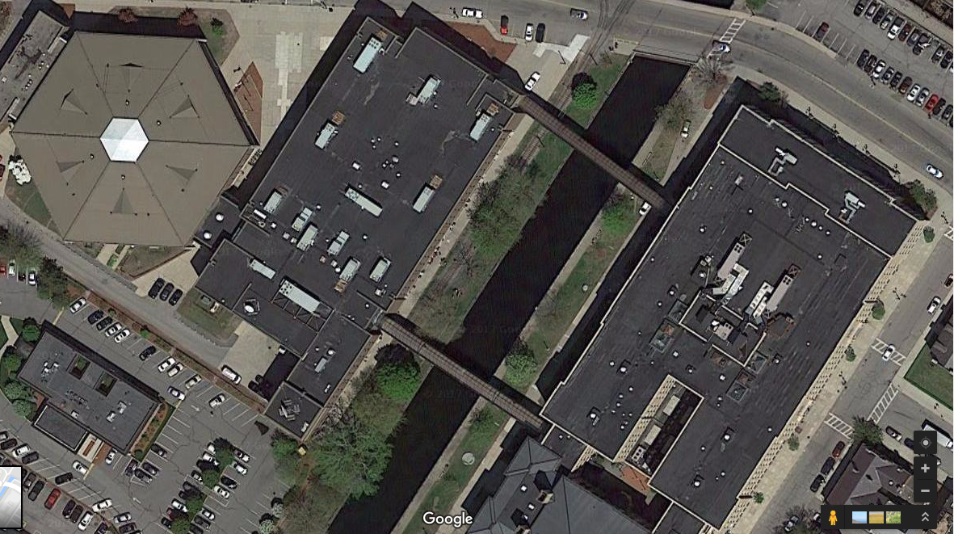

Prepared by:
Massachusetts Department of Public Health
Bureau of Environmental Health
Indoor Air Quality Program
December 2017

Background

Building: | Lowell High School
Address: | 50 Father Morissette Blvd., Lowell, MA
Assessment Coordinated Through: | Lowell Public School Department
Reason for Request: | General Indoor Air Quality (IAQ) concerns. Note that a preliminary walkthrough of the building was conducted over the summer while this visit was conducted during the school year while the building was under normal operation/occupancy.
Date of Assessment: | December 12, 2017
Massachusetts Department of Public Health/Bureau of Environmental Health (MDPH/BEH) Staff Conducting Assessment: | Cory Holmes, Environmental Analyst,  Jason Dustin, Environmental Analyst,  Sharon Lee, Environmental Analyst  Ruth Alfasso, Environmental Engineer, and Mike Feeney Director, IAQ Program
Building Description: | The building at 50 Father Morissette Blvd is a brick and concrete complex was constructed in 1980. It has an attached Fieldhouse containing gymnasiums, locker rooms, and a pool.
Windows: | Openable

Methods
Please refer to the IAQ Manual for methods, sampling procedures, and interpretation of results (MDPH, 2015).

IAQ Testing Results
Table 1 shows the information collected during the preliminary walkthrough in July of 2017. Table 2 includes indoor air testing results collected during this visit, which are summarized below.
- Carbon dioxide levels were above 800 parts per million (ppm) in about half of all areas surveyed indicating that many areas, particularly occupied classrooms, need additional fresh air supply.
- Temperature was within the recommended range of 70°F to 78°F in most areas tested with cooler temperatures found in some areas.
- Relative humidity was below the recommended range of 40 to 60% in all areas tested apart from the pool; this is typical during the heating season.
- Carbon monoxide levels were non-detectable (ND) in all areas tested except for the nurses’ office on the first floor, where it was measured at 2.7 ppm.
- Fine particulate matter (PM2.5) concentrations measured were below the National Ambient Air Quality (NAAQS) limit of 35 μg/m³ in all areas tested.

Ventilation
A heating, ventilating, and air conditioning (HVAC) system has several functions. First it provides heating and, if equipped, cooling. Second, it is a source of fresh air. Finally, an HVAC system will dilute and remove normally occurring indoor environmental pollutants by not only introducing fresh air, but by filtering the airstream and ejecting stale air to the outdoors via exhaust ventilation. Even if an HVAC system is operating as designed, point sources of respiratory irritation may exist and cause symptoms in sensitive individuals. (For a description of the HVAC system, please refer to the August 2017 IAQ assessment).
Based on air sampling, it appears that most classrooms with normal occupancy appeared to have inadequate air exchange provided by the HVAC system in its current operating mode as demonstrated by carbon dioxide levels above 800 ppm. Given the age and operation of the existing HVAC system, it may be necessary to use opening windows to supplement fresh air supply for classrooms. Windows open in most exterior classrooms, which can be a useful supply of fresh air. However windows need to be tightly closed at the end of each day to prevent water and pest intrusion. Windows should also remain closed while the HVAC system is in cooling mode to prevent condensation.
The HVAC systems should be regularly maintained and operate continuously during occupied hours. It may be possible to adjust AHUs to allow more fresh air into the system, e.g. by opening supply louvers or adjusting the proportion of air exhausted rather than recirculated.
Temperature control concerns were expressed in some areas and some supply vents were deliberately blocked (Table 2) presumably to reduce drafts. It may be possible to change the type of diffusers or the locations of them to allow for fresh air distribution without unwanted drafts. Exhaust/return vents should also be checked for proper function, as removal of stale air and associated particulates, moisture, odors and other pollutants will reduce indoor air related complaints.
In order to have proper ventilation with a mechanical supply and exhaust system, these systems must be balanced to provide an adequate amount of fresh air while removing stale air from a room. It is recommended that existing ventilation systems be re-balanced every five years to ensure adequate air systems function (SMACNA, 1994). It is unknown the last time these systems were balanced.

Microbial/Moisture Concerns
Water-damaged ceiling tiles and plaster walls were observed in many classrooms, offices, and hallways (Table 2), indicating leaks from the building envelope or plumbing system. Ceiling tiles should be replaced after the leak is found and repaired. In general, ceiling tiles have an open space above them (the ceiling plenum) and tend to dry out quickly, reducing the chance for mold colonization. A ceiling tile with dark stains was observed in the Student Support Services office, which may be mold growth. Plaster ceilings and walls do not contain organic material; therefore, will not support microbial growth even when frequently moistened. However, dust or paint on the surface of plaster can become mold colonized. If this occurs, plaster can often be cleaned to remove the mold. Following the report issued over the summer, some work on replacing water-damaged and missing ceiling tiles had been conducted.
Considering the amount of water damage to ceiling tiles and plaster, the roofing system should be assessed to find and repair these leaks. Roof drains, roofing materials, and flashing/connections between roof segments and walls should be examined regularly for pooling water and other indications of deterioration with repairs made as needed.
Water damage and subsequent mold growth can be a source of allergies and irritation. Measures should be taken to ensure water-damaged materials are cleaned, replaced, and/or repaired in a manner consistent with the U.S. Environmental Protection Agency’s guidelines (US EPA, 2008). The US EPA and the American Conference of Governmental Industrial Hygienists (ACGIH) recommend that porous materials (e.g., ceiling tiles, gypsum wallboard) be dried with fans and heating within 24 to 48 hours of becoming wet (US EPA, 2008; ACGIH, 1989). If not dried within this time frame, these materials should be removed/discarded.
Wall-to-wall carpeting was observed in some classrooms and offices (Tables 1 and 2). Wall-to-wall carpeting is not recommended in school classrooms in general, due to the difficulty in maintaining it in good condition, including wear, dirt, and spills. Roof leaks leading to stained ceiling tiles can also be a source of water to moisten carpeting. Carpeting moistened for more than a short period of time will be subject to microbial growth. Some carpeting was visibly stained. Carpeting in the Little Theater had a musty smell suggesting it has been subject to chronic moistening and microbial growth (Table 2). Water dispensers and refrigerators were observed in carpeted areas (Picture 1; Table 2) which can be an additional source of leaks and spills to moisten carpeting. Carpeting should be cleaned annually or semi-annually in soiled high traffic areas as per the recommendations of the Institute of Inspection, Cleaning, and Restoration Certification (IICRC, 2012). Note that the service life of carpeting in schools is approximately 10-11 years (IICRC, 2002). Aging carpet can produce fibers that can be irritating to the respiratory system. In addition, tears or lifting carpet can create tripping hazards.
Some sinks observed had gaps in the backsplash (Picture 2; Table 2) which can lead to water damage and microbial growth in the underlying material. Some of the lab areas had science sinks and eyewash/safety shower stations which should be maintained in good repair and monitored periodically for leaks. Porous items should not be stored underneath or adjacent to sinks or near safety showers.
Doors between air-conditioned and non-air-conditioned areas should be kept closed to prevent condensation from forming when chilled air mixes with humid air. Note that the field house contains a swimming pool and the humidity in that area was 55%, which is significantly higher than elsewhere in the building. Pools can be a significant source of moisture to the indoor environment, as well as odors and contamination from pool treatment chemicals. IAQ staff detected pool odors in the field house gym area. The pool’s chemical balance should be regularly monitored to ensure that levels of off-gassing chemicals and odors are minimized. Exhaust systems in pool rooms should be adjusted to effectively remove odors and moisture and remain on at all times. In addition, doors between the pool and other indoor areas should be weather tight to prevent the migration of water vapor and odors to other occupied areas.

Other Conditions
Exposure to low levels of volatile organic compounds (VOCs) may produce eye, nose, throat, and/or respiratory irritation in some sensitive individuals. BEH/IAQ staff examined spaces for products containing VOCs, noting cleaning products, air fresheners, hand sanitizers and dry erase materials in a number of areas throughout the office space (Table 2). All of these products have the potential to be irritants to the eyes, nose, throat, and respiratory system of sensitive individuals. Other sources of total volatile organic compounds (TVOCs) include copy machines and laminators (Table 2). Excess heat, odors, VOCs and ozone can be produced by photocopiers, particularly if the equipment is older and in frequent use. Ozone is a respiratory irritant (Schmidt Etkin, 1992). Laminators produce TVOCs and plastic odors. This equipment should be used in well-ventilated areas away from occupants.
There were several laboratory storage areas examined. Chemicals were found on shelves in a somewhat disorganized manner along with other items (Picture 3). Laboratory chemicals should be stored neatly with only compatible products together and all containers well labeled. Materials Safety Sheets (MSS) should be available for all chemicals on site both in science labs and janitorial/maintenance areas. In addition, laboratory chemicals should be reviewed and sorted regularly to remove outdated and unneeded chemicals. Appendix A contains additional information regarding school chemical laboratory safety (“Guidance Concerning Proper Use and Storage of Chemicals in Schools to Protect Public Health”).
Filters for the AHUs should be changed in accordance with manufacturer’s instructions (e.g., two to four times a year). The MDPH recommends pleated filters with a Minimum Efficiency Reporting Value (MERV) of 8, which are adequate in filtering out pollen and mold spores (ASHRAE, 2012).
In many areas, items, including books, papers, and decorative items were observed on floors, windowsills, tabletops, counters, bookcases, and desks, which can make it more difficult for custodial staff to clean (Table 2). Many classrooms had personal fans. Some of these had dusty blades. Many supply and exhaust vents were also observed to be dusty (Table 2). Dust on ventilation and fan equipment can be aerosolized when the units are activated.
Lastly, an electrical outlet in detached from its wall in the medical office (Picture 4) as well as unidentifiable wires hanging from walls (Picture 5).

Conclusions/Recommendations
The following recommendations are for improving indoor air and environmental quality:
- Consult with an HVAC contractor to thoroughly examine all HVAC system components to ensure proper function. Make any necessary repairs to ensure the system is working as designed. Assess whether adjustments can be made to allow more fresh air into the system.
- Operate all supply and exhaust ventilation equipment continuously during occupied periods. Do not block supply or exhaust vents with furniture or items. Check exhaust/return vents periodically for proper function.
- Consider changing the style of fresh air vents or relocating them to prevent drafts (e.g., Hosmer office; Table 2).
- Ensure that a system of regular “Operations and Maintenance” remains in place to keep HVAC systems in proper working order.
- Consider adopting a balancing schedule of every 5 years for all mechanical ventilation systems, as recommended by ventilation industrial standards (SMACNA, 1994).
- Use openable windows to supplement fresh air during temperate weather. Ensure all windows are tightly closed at the end of the day. Inform occupants that windows should not be opened while the HVAC system is in cooling mode to avoid condensation.
- Replace any water-damaged or mold-colonized porous building materials (e.g., ceiling tiles, gypsum wallboard, carpeting) in the library, classrooms, hallways, and stairwell areas. Ensure water-damaged materials are cleaned, replaced, and/or repaired in a manner consistent with the U.S. Environmental Protection Agency’s guidelines (US EPA, 2008).
- Consult with a roofing contractor to assess the roofing system. Repairs should be made to stop leaks and chronic water damage to building materials. The roofing system should then be monitored regularly for water pooling, leaks, and other deteriorating conditions.
- Consider removal of wall-to-wall carpeting in classrooms and other areas where spills, leaks or wear are a concern. Replace with non-porous flooring.
- Avoid locating refrigerators and water dispensers in carpeted areas. Place on non-porous flooring or use a waterproof mat to protect the carpet.
- Seal gaps in sink backsplashes with an appropriate waterproof sealant. Do not store porous items underneath or adjacent to sinks and safety showers/eyewashes.
- Ensure doors seal tightly between air conditioned and non-air-conditioned areas and that these doors are closed when air conditioning is in use.
- Ensure chemical treatment of the pool is controlled to minimize pool odors. Ensure the exhaust system in the pool area is operating at all times and properly adjusted to effectively remove odors and moisture. In addition, ensure that doors between the pool and other occupied areas are weather-tight to prevent migration of odors and moisture.
- Ensure any plumbing leaks are repaired to avoid chronic water damage in the building.
- Ensure that condensation from AHU equipment is draining properly. Check collector pans, piping and any associated pumps for clogs and leaks and clean periodically to prevent stagnant water build-up and remove debris that may provide a medium for microbial growth.
- Replace water-damaged and mold-colonized ceiling tiles after leaks have been addressed. Clean/remediate any moldy wall materials consistent with the U.S. Environmental Protection Agency’s guidelines (US EPA, 2008).
- Replace any missing or ajar ceiling tiles to avoid pathways to unconditioned areas.
- Reduce the use of products containing VOCs.
- Locate photocopiers and laminators in well ventilated areas away from occupants.
- Store laboratory chemicals in an organized manner consistent with the guidance in Appendix A (“Guidance Concerning Proper Use and Storage of Chemicals in Schools to Protect Public Health”).
- Ensure Material Safety Sheets are available for all laboratory, maintenance and janitorial chemicals used in the building.
- Consider utilizing MERV 8 filters in AHUs. Check with manufacturer’s recommendations before changing filter efficiency. Continue to change filters 2-4 times a year.
- Regularly clean supply/return vents and fans to avoid aerosolizing accumulated particulate matter. If soiled ceiling tiles around vents cannot be cleaned, replace.
- Consider reducing the amount of items stored in classrooms to make cleaning easier. Periodically move items to clean flat surfaces.
- Clean carpeting and area rugs annually or more often in high-traffic locations in accordance with IICRC recommendations (IICRC, 2012) and discard those that are worn out or too soiled to be cleaned.
- Affix the electrical outlet in medical office to wall. Identify the purpose of the wires in the medical office and cap/remove as needed.
- Encourage faculty to report classroom/building related issues via a tracking program.
- The school should be tested for radon by a certified radon measurement specialist during the heating season when school is in session. Radon measurement specialists and other information can be found at: www.nrsb.org, and http://aarst-nrpp.com/wp.
- Continue to adopt the US EPA (2000) document, “Tools for Schools”, as an instrument for maintaining a good IAQ environment in the building available at: http://www.epa.gov/iaq/schools/index.html.
- Refer to resource manual and other related IAQ documents located on the MDPH’s website for further building-wide evaluations and advice on maintaining public buildings. These documents are available at: http://mass.gov/dph/iaq.

References
ACGIH. 1989. Guidelines for the Assessment of Bioaerosols in the Indoor Environment. American Conference of Governmental Industrial Hygienists, Cincinnati, OH.
ASHRAE. 2012. American Society of Heating, Refrigeration and Air Conditioning Engineers (ASHRAE) Standard 52.2-2012 -- Method of Testing General Ventilation Air-Cleaning Devices for Removal Efficiency by Particle Size (ANSI Approved). 2012.
IICRC. 2002. Institute of Inspection, Cleaning and Restoration Certification. A Life-Cycle Cost Analysis for Floor Coverings in School Facilities.
IICRC. 2012. Institute of Inspection, Cleaning and Restoration Certification. Carpet Cleaning: FAQ. Retrieved from http://www.iicrc.org/consumers/care/carpet-cleaning.
MDPH. 2015. Massachusetts Department of Public Health. “Indoor Air Quality Manual: Chapters I-III”. Available at: http://www.mass.gov/eohhs/gov/departments/dph/programs/environmental-health/exposure-topics/iaq/iaq-manual/.
Schmidt Etkin, D. 1992. Office Furnishings/Equipment & IAQ Health Impacts, Prevention & Mitigation. Cutter Information Corporation, Indoor Air Quality Update, Arlington, MA.
SMACNA. 1994. HVAC Systems Commissioning Manual. 1st ed. Sheet Metal and Air Conditioning Contractors’ National Association, Inc., Chantilly, VA.
US EPA. 1993. Radon Measurement in Schools, Revised Edition. Office of Air and Radiation, Office of Radiation and Indoor Air, Indoor Environments Division (6609J). EPA 402-R-92-014. https://www.epa.gov/sites/production/files/2014-08/documents/radon_measurement_in_schools.pdf.
US EPA. 2000. Tools for Schools. Office of Air and Radiation, Office of Radiation and Indoor Air, Indoor Environments Division (6609J). EPA 402-K-95-001, Second Edition. http://www.epa.gov/iaq/schools/index.html.
US EPA. 2008. “Mold Remediation in Schools and Commercial Buildings”. Office of Air and Radiation, Indoor Environments Division, Washington, DC. EPA 402-K-01-001. September 2008. Available at: http://www.epa.gov/mold/mold-remediation-schools-and-commercial-buildings-guide.
Picture 1
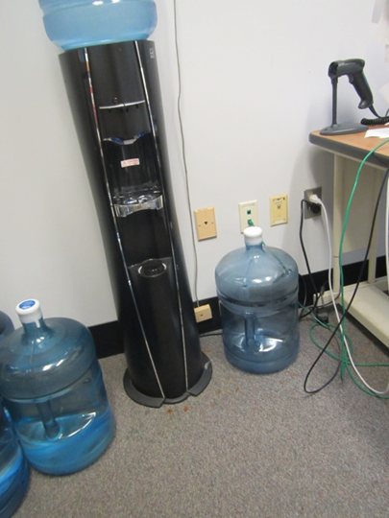
Water dispenser on carpet
Picture 2
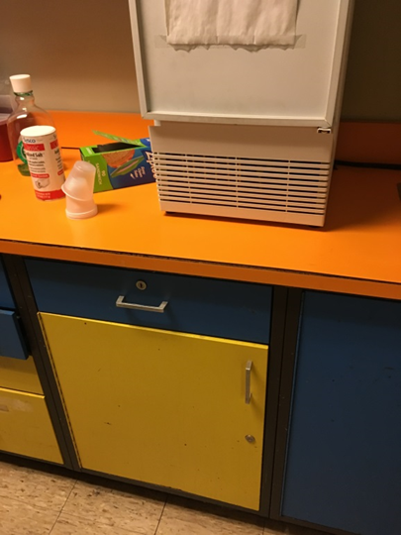
Loose countertop facing in medical office
Picture 3
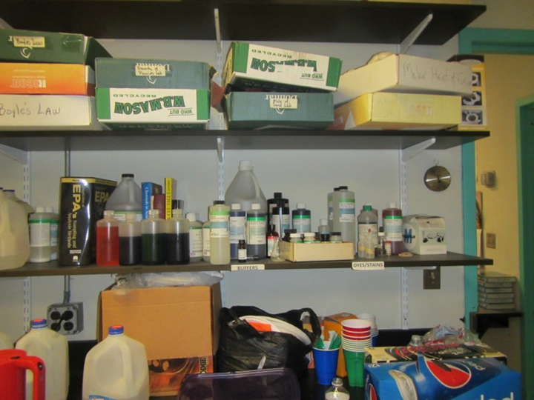
Lab chemical storage
Picture 4
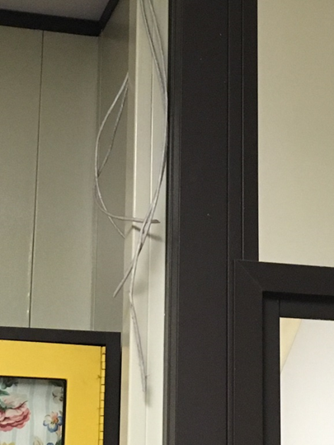
Loose electrical outlet
Picture 5
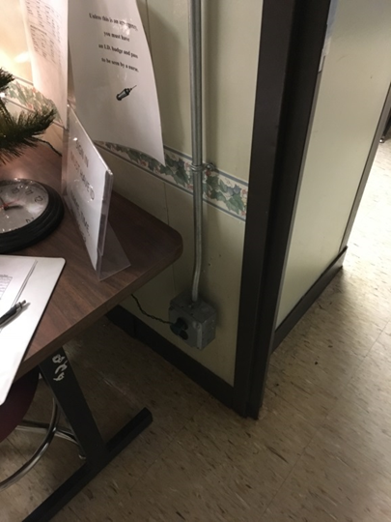
Unidentifiable wires hanging loose in medical office
Location | Windows  Openable | Ventilation |  | Remarks
Location | Windows  Openable | Intake | Exhaust
3rd floor Men’s restroom | N | N | Y | 1 MT, 1 WD CT
610 copy | Y | Y | Y | carpeted, PC, MT, DEM, window does not close tightly
610B | N | Y | Y | Carpeted
611 | Y | Y | Y | NC, fake plant, DEM
612 | Y | Y | Y | PF, DEM, cleaning products, fridge
613 | Y | Y | Y | DEM
614 | Y | Y | Y | DEM, dusty vents, mini refrigerator
615 | Y | Y | Y | DEM, CPs
616 | Y | Y | Y | Dusty return vent
617 | Y | Y | Y | Chalk board, DEM, dusty return vent
618 | Y | Y | Y | DEM, cleaning products
620 | N | Y | Y | WD CT
622c | N | Y | Y
623 | N | Y | Y
624 | N | Y | Y
625 | N | Y | Y
626 | N | Y | Y | 2 WD CT
628 | N | Y | Y | WD
629 | N | Y | Y
630 |  |  |  | Dust, debris on vents, hole in wall
640 |  |  |  | Dust, debris on vents, PF
642 |  |  |  | WD CTs and light cover, hole in wall
643 |  |  |  | Dust, debris on vents & CTs
644 |  |  |  | Dust, debris on vents & CTs
645 |  |  |  | Dust, debris on vents & CTs
646-A |  |  |  | Dust, debris on vents
648 | N | Y | Y | MT, DEM, dusty vents
649 | N | Y | Y
652 | N | Y | Y | Sink, NC
653 | Y | Y | Y | Missing light covers, chalk, NC
654 | Y | Y | Y | Missing light covers, NC
655 | Y | Y | Y | DEM
656 | Y | Y | Y | NC
657 | Y | Y | Y | NC
658 | Y | Y | Y
658 hallway |  | N
Cafeteria | N | Y | Y | 4 MT, 12 WD CT
Cafeteria NW side | N | Y | N | 2 WD CT
Digital media | Y | Y | Y | NC
Hallway (outside 640) |  |  |  | Missing/damaged CTs
Hallway next to plant room | N | Y | Y | Several WD CT
Head of school conference room | N | Y | Y
Plant room | N | Y | Y | WD CT
Teacher’s dining | N | Y | Y
Teachers restroom | N | N | Y
TV studio | Y | Y | Y | Carpeted
512 | - | - | - | Locked
513 | - | - | - | Locked
514 | Y | Y | Y | Ajar CT, dirty return vent
515 | Y | Y | Y | WD CT x 2, ajar CT
516 | Y | Y | Y | WD CT, DEM, fridge
517 | Y | Y | Y | DEM, chalk board
518 | Y | Y | Y | DEM, WD CTs x 3, MTs x 2
522 | N | Y | Y | 4 WD CT with mold, 28 computers,
525 | N | Y | Y | WD CTs
526 | N | Y | Y
527 | N | Y | Y
529 | N | Y | Y
542 | N | Y | Y | Computers, WD CT, odors, NC, DEM
543 | N | Y | Y | WD CT in this room and hallways adjacent, NC, DEM
545 | N | Y | Y | NC
546 | N | Y | Y | WD and MT, NC
547 | N | Y | Y | NC, WD CT in hallway
552 |  |  |  | Dust, debris on vents & CTs, WD CT
553 |  |  |  | Dust, debris on vents
554 |  |  |  | Dust, debris on vents, CD
555 |  |  |  | Dust, debris on vents, ajar CT
556 |  |  |  | Dust, debris on vents, ajar CT
557 |  |  |  | Dust, debris on vents, damaged wall/hole, ajar CT
558 |  |  |  | Dust, debris on vents
Library | Y | Y | Y | Carpeting, stained and worn, computers, WD CT, soiled chairs with ripped upholstery, WD ceiling/walls
Staff lunch in library | Y | Y | Y | Fridge and microwave, carpeted, sink
Trios/training | N | Y | Y | Ceiling fans, on, stained carpet
Women’s restroom | N | N | Y | WD plaster
432A guidance suite | N | Y | Y | Area rug, PC
Conference room | N | Y | Y | Carpeted, DEM, fake plant
Nurses’ office | N | Y | Y | NC, PF
Guidance area lunchroom | N | Y | Y | Sink backsplash open
432A guidance suite | N | Y | Y | Area rug, PC
Conference room | N | Y | Y | Carpeted, DEM, fake plant
Nurses office | N | Y | Y | NC, PF
Guidance area lunchroom | N | Y | Y | Sink backsplash open
452 |  |  |  | Dust, debris on vents, PC-no exhaust vent, water cooler on carpet
Murphy Café |  |  |  | Dust, debris on vents, MTs
Gym | N | Y | Y | Large ceiling-mounted AHUs, some dark dust/debris on walls, odors detected from pool
Reception (main) | N | Y | Y | Carpet, plant, water cooler on carpet
-conference | N | Y | Y | DEM, carpet, dusty vent
-kitchen | N | Y | N | PC, gaps in sink/counter, water damage below sink, CPs, HS
Solarium bridges |  |  |  | Odors detected during strong sunlight, vinyl flooring

Location | Carbon  Dioxide  (ppm) | Carbon Monoxide  (ppm) | Temp  (°F) | Relative  Humidity  (%) | PM2.5  (µg/m³) | Occupants  in Room | Windows  Openable | Ventilation |  | Remarks
 |  |  |  |  |  |  |  | Supply | Exhaust | Remarks
Background | 331 | ND | 51 | 67 | 23 |  |  |  |  | Rain, sleet, wind
Third Floor
642 | 1046 | ND | 68 | 39 | 6 | 11 | N | Y | Y | 2 WD CT, DEM
643 | 1086 | ND | 71 | 36 | 5 | 14 | N | Y | Y | NC
Lab A | 1028 | ND | 71 | 33 | 5 | 0 | N | Y | Y | Dusty vents, NC, lab sinks, a few lab chemicals, DEM
644 | 1052 | ND | 73 | 31 | 5 | 0 | N | Y | Y | 2 WD CT, DEM, NC
Lab B | 1047 | ND | 73 | 30 | 5 | 0 | N | Y | Y | NC, fridge, microwave, coffee machine, lab sinks, HS, DEM
645 | 1091 | ND | 75 | 32 | 4 | 28 | N | Y | Y | NC, DEM
Lab C | 1022 | ND | 74 | 28 | 4 | 0 | N | Y | Y | DEM, lab sinks, eyewash and safety shower
646A | 1240 | ND | 74 | 31 | 6 | 27 | N | Y | Y | DEM, chalk, perfume odor, NC
648 | 836 | ND | 72 | 27 | 5 | 20 | N | Y | Y | DEM, chalk, computers, NC
640 Suite | 1103 | ND | 68 | 34 | 3 | 2 | N | Y | Y | PF, tile
-Office 1 | 927 | ND | 69 | 31 | 3 | 2 | N | Y | Y | PF
-Office 2 | 856 | ND | 69 | 31 | 4 | 0 | N | Y | Y
-Hosmer | 1002 | ND | 72 | 31 | 5 | 1 | N | Y | Y | Tile, supply vent blocked due to comfort complaints (Rec:change diffuser style)
612 | 1145 | ND | 71 | 31 | 5 | 22 | N | Y | Y | Tile, HS, plant
613 | 1011 | ND | 73 | 30 | 6 | 25 | N | Y | Y | HS, CP, tile
624 | 979 | ND | 73 | 30 | 3 | 3 | N | Y | Y | DEM
614 | 953 | ND | 73 | 30 | 6 | 18 | N | Y | Y | DEM, tile
615 | 1147 | ND | 73 | 30 | 6 | 19 | N | Y | Y | DEM, tile, HS
616 | 1246 | ND | 73 | 29 | 5 | 13 | Y | Y | Y | Tile, DEM
649 | 870 |  | 71 | 25 | 6 | 1 | N | Y | Y | NC, DEM, computers
618 | 1054 | ND | 71 | 31 | 7 | 21 | Y | Y | Y | NC, DEM, WD CT in hallway outside
617 | 963 | ND | 71 | 31 | 5 | 1 | Y | Y | Y | NC, DEM
630 | 1464 | ND | 70 | 38 | 11 | 23 | N | Y | N | DO
610A | 736 | ND | 71 | 30 | 8 | 13 | Y | Y  Dusty CTs | Y | DEM
610B | 1033 | ND | 72 | 32 | 11 | 15 | Y | Y | Y | DO, DEM
622C | 792 | ND | 74 | 31 | 10 | 1 | Y | Y  Dusty CTs | Y | DO, PF
623 | 1268 | ND | 74 | 34 | 10 | 22 | N | Y  Dusty | Y | DO, DEM
620 | 710 | ND | 70 | 27 | 11 | 0 | N | Y | Y | PF
625 | 872 | ND | 72 | 31 | 9 | 0 | N | Y | Y | DEM, DO, CPs
Media/TV area
Editing room | 594 | ND | 67 | 31 | 3 |  | N | Y | N
LHB editing | 588 | ND | 66 | 30 | 3 |  | N | Y | N | 1 WD CT, carpet
SC edit | 612 | ND | 66 | 30 | 3 |  | N | Y | N | Carpet
All edit | 635 | ND | 67 | 31 | 3 | 0 | N | Y | N | Carpet
OQ edit | 617 | ND | 66 | 30 | 3 | 0 | N | Y | Y | Carpet
Conference | 586 | ND | 66 | 29 | 2 | 0 | N | Y | Y | Carpet
SA edit | 582 | ND | 66 | 30 | 3 | 0 | N | Y | Y | Carpet
Engineering | 586 | ND | 65 | 30 | 3 | 0 | N | Y | Y | Carpet
PFSC edit | 566 | ND | 66 | 29 | 3 | 0 | N | Y | Y | Carpet
Mainframe | 591 | ND | 64 | 30 | 3 | 0 | N | Y | Y | Carpet
TV studio | 560 | ND | 66 | 30 | 3 | 0 | N | Y | Y | Carpet
TV control | 569 | ND | 66 | 31 | 3 | 0 | N | Y | Y | Carpet, 2 WD CT
651G | 581 | ND | 67 | 31 | 3 | 0 | N | Y | Y | Carpet
Office | 592 | ND | 61 | 30 | 2 | 0 | N | Y | Y | Carpet
Office | 590 | ND | 67 | 30 | 2 | 0 | N | Y | Y | Carpet
Second Floor
Little theater | 728 | ND | 70 | 23 | 4 | 0 | N | Y | Y | Carpet in some places worn, musty odor
LT control room | 639 | ND | 69 | 22 | 4 | 0 | N | N | Y | NC, 2 AT
558 | 1182 | ND | 71 | 33 | 8 | 22 | N | Y | Y | Missing vent cover, DEM, NC
556 | 1948 | ND | 74 | 35 | 4 | 24 | Y | Y | Y | Chalk, NC
555 | 1248 | ND | 75 | 30 | 9 | 25 | Y | Y | Y | NC, DEM
554 | 1203 | ND | 74 | 29 | 6 | 25 | Y  1 open | Y | Y | Chalk, DEM, NC
553 | 1229 | ND | 75 | 32 | 6 | 23 | Y | Y | Y | DEM, NC
552 | 1098 | ND | 74 | 28 | 7 | 20 | Y  1 slightly open | Y | Y | DEM, NC, 2 WD CT, microwave
Women’s restroom |  |  |  |  |  |  |  |  |  | WD CP, odors
537 | 1454 | ND | 73 | 35 | 4 | 16 | N | Y | Y | DO, 2 WD CTs, MT, dust/debris on vents
547 | 1377 | ND | 73 | 34 | 4 | 9 | N | Y | Y | WD CT, PF, dust/debris on vents
546 | 1141 | ND | 76 | 31 | 5 | 0 | N | Y | Y | MTs, 5 WD CTs, dust/debris on vents
545 | 1290 | ND | 76 | 32 | 5 | 20 | N | Y | Y | DO, WD CT
543 | 1422 | ND | 75 | 32 | 4 | 17 | N | Y | Y | 4 WD CT, dust/debris on vents
542 | 1346 | ND | 75 | 32 | 4 | 26 | N | Y | Y | AT, 15 WD CT, MT, dust/debris on vents
518 | 1239 | ND | 72 | 31 | 6 | 24 | Y | Y | Y | CPs, DEM
517 | 1380 | ND | 72 | 31 | 7 | 19 | Y | Y | Y | HS, tile, DEM
516 | 1175 | ND | 74 | 29 | 6 | 7 | Y | Y | Y | DEM, tile
515 | 1178 | ND | 73 | 29 | 5 | 26 | Y | Y | Y | DEM, tile
514 | 1211 | ND | 73 | 29 | 7 | 21 | Y | Y | Y | Tile, DEM
512 Suite | 942 | ND | 73 | 28 | 6 | 7 | N | Y | Y | HS, tile
512 Devost | 919 | ND | 73 | 26 | 5 | 0 | Y | Y | Y | HS, carpet, cleaning products
512 C House | 934 | ND | 73 | 26 | 5 | 2 | Y | Y | Y | Plants, AI
527 | 1442 | ND | 73 | 36 | 7 | 7 | N | Y | Y | DEM, DO
526 | 1402 | ND | 73 | 34 | 6 | 9 | N | Y | Y
525 | 1314 | ND | 74 | 35 | 12 | 27 | N | Y | Y | DO, CD
523 | 1163 | ND | 73 | 34 | 10 | 29 | N | Y | Y | DO, DEM
522 | 1257 | ND | 73 | 33 | 8 | 14 | N | Y | Y | DO, DEM, 28 computers
533 | 1226 | ND | 73 | 32 | 7 | 1 | 0 | Y  Dusty | Y | CD, 7WD-CT, AT
535 | 1274 | ND | 74 | 32 | 7 | 0 | 0 | Y | Y | PF, 7 WD-CT, DEM, cleaning products
Library | 623 | ND | 73 | 26 | 8 | 20 | N | Y | Y | WD-CTs, WD ceiling
Library conference room 6 | 631 | ND | 72 | 25 | 6 | 0 | N | Y | Y | DO
Library conference room 2 | 654 | ND | 73 | 25 | 5 | 0 | Y | Y | Y | DO
Library conference room 3 | 789 | ND | 74 | 26 | 7 | 1 | Y | Y | Y
Library multimedia room | 770 | ND | 74 | 26 | 6 | 0 | N | Y | Y | DO
Library lunch room | 675 | ND | 72 | 25 | 7 | 1 | Y | Y | Y | Sink breach, fridge on carpet
Library Downey office | 593 | ND | 72 | 26 | 6 | 0 | Y | Y | Y | Cooler on carpet, DO, cleaning products
First Floor
412 Main office | 711 | ND | 71 | 27 | 4 | 4 | N | Y | Y | Carpet, plants
Main office conference | 752 | ND | 72 | 27 | 5 | 0 | N | Y | Y | Hanging heater/fan, carpet, plants
Head of school office | 692 | ND | 72 | 26 | 4 | 0 | N | Y | Y | DEM, plants, fridge, hanging heater/fan, carpet
Attached toilet room |  |  |  |  |  |  |  |  |  | Hole in ceiling, no obvious exhaust vent
Main office break room | 700 | ND | 74 | 25 | 5 | 0 | N | N | N | NC, photocopier, fridge, food, microwave
432 | 718 | ND | 74 | 25 | 4 | 0 | N | Y | Y | Carpet
452A | 749 | ND | 72 | 26 | 5 | 1 | N | Y | Y | PC, carpet, plant, water cooler on carpet
452C | 778 | ND | 71 | 25 | 5 | 1 | N | Y | Y | Fridge on carpet, microwave
452B | 767 | ND | 71 | 25 | 5 | 0 | N | Y | Y | Wall is damaged but not from water, carpet
Security | 794 | ND | 72 | 26 | 4 | 3 | N | Y | Y | DEM, NC, fridge, DO
433 | 863 | ND | 73 | 29 | 5 | 4 | N | Y | Y | Nurses lobby/waiting
Head of school conference room | 651 | ND | 71 | 23 | 6 | 0 | N | Y | Y | Recently painted (paint odor), PF, carpet, upholstered chairs, DEM, sink, fridge
Nurses office | 926 | 2.7 | 75 | 30 | 4 |  |  |  |  | WD counters
Student Support Services (SSS) | 750 | ND | 72 | 29 | 5 | 1 | N | Y | Y | 4 WD CT, dust/debris on vents
SSS Kitchen | 730 | ND | 73 | 27 | 6 | 0 | N | Y | N | Spaces between sink countertop and backsplash, dust/debris on vents
SSS 432 C | 715 | ND | 73 | 27 | 4 | 0 | N | Y | Y | Carpet, WD CT, dust/debris on vents
SSS 432 E | 723 | ND | 73 | 26 | 4 | 0 | N | Y | Y | Carpet, dust/debris on vents
SSS 432 F | 766 | ND | 73 | 26 | 5 | 0 | N | Y | Y | Carpet, dust/debris on vents
SSS 432 H | 872 | ND | 74 | 25 | 5 | 0 | N | Y | Y | Peeling wallpaper, dust/debris on vents
SSS 432 I | 786 | ND | 74 | 25 | 5 | 0 | N | Y | Y | Carpet
SSS Conference room | 752 | ND | 74 | 26 | 5 | 0 | N | Y | Y | Carpet, dust/debris on vents
SSS Howe office | 727 | ND | 73 | 26 | 5 | 0 | N | Y | Y | Carpet, dust/debris on vents
Gym | 863 | ND | 68 | 31 | 4 | 40 | N | Y | Y
Cafeteria- front | 703 | ND | 71 | 29 | 8 | 70 | N | Y | Y
Cafeteria – rear | 683 | ND | 71 | 26 | 8 | 100 | N | Y | Y | 5 WD CTs
Student Activities | 618 | ND | 72 | 26 | 6 | 0 | N | Y | N | Carpet, AI, MT
Credit Union | 657 | ND | 72 | 26 | 7 | 3 | N | Y | N | Ductless AC, carpet, food odor
Pool | 579 | ND | 75 | 55 | 4 | 2 | N | Y | Y | Dust/debris on areas of ceiling
Athletic office | 702 | ND | 73 | 28 | 9 | 2 | N | Y | Y | DO
1826 school store | 702 | ND | 73 | 28 | 9 | 2 | N | Y | Y
Teachers’ lounge | 558 | ND | 74 | 26 | 10 | 2 | Y | Y | Y | Broken window
Student activities office | 703 | ND | 72 | 25 | 10 | 0 | N | Y | Y  Dusty

