INDOOR AIR QUALITY REASSESSMENT

Lowell High School
“1980 Building”
50 Father Morissette Boulevard
Lowell, MA

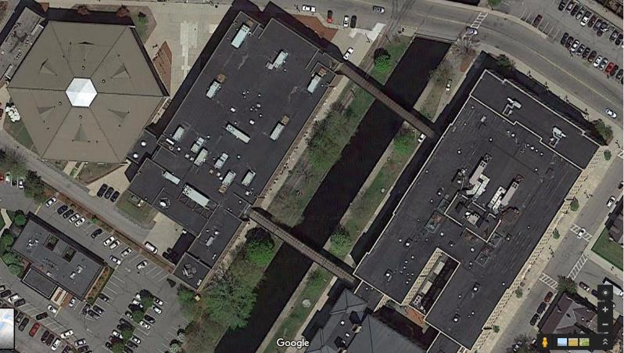

Prepared by:
Massachusetts Department of Public Health
Bureau of Environmental Health
Indoor Air Quality Program
December 2019

Background

Building: | Lowell High School (LHS) “1980s” building
Address: | 50 Father Morissette Boulevard, Lowell, MA
Assessment Coordinated Through: | Lowell Public Schools
Reason for Request: | Reassessment based on actions taken since the previous visit in 2017.
Date of Assessment: | October 25, 2019
Massachusetts Department of Public Health/Bureau of Environmental Health (MDPH/BEH) Staff Conducting Assessment: | Jason Dustin, Environmental Analyst’  Cory Holmes, Environmental Analyst,  Ruth Alfasso, Environmental Engineer, and Mike Feeney Director, Indoor Air Quality Program (IAQ)
Building Description: | The building at 50 Father Morissette Boulevard is a brick and concrete complex constructed in 1980. It has an attached fieldhouse containing gymnasiums, locker rooms, and a pool, which is now closed. This building is connected to the building at 14 French Street by several enclosed walkways.
Windows: | Openable

This school was visited previously in 2017. Two visits were made: one during the summer when the school was unoccupied and again in the fall during normal occupancy. Recommendations were made in a report following each visit. The MDPH/IAQ Program returned to the school this year for a follow-up visit, in part to assess the response to recommendations made in our previous report as well as to provide further recommendations to improve IAQ. Appendix A shows recommendations from both 2017 reports. In addition, the LHS complex will be undergoing significant renovations over the next several years. Recommendations included in this report will also address planning for renovation-related issues.

Methods
Please refer to the IAQ Manual for methods, sampling procedures, and interpretation of results (MDPH, 2015).

IAQ Testing Results
Table 1 includes indoor air testing results, which are summarized below.
- Carbon dioxide levels were above the MDPH guideline of 800 parts per million (ppm) in about half of all areas assessed, indicating a lack of air exchange in those areas of the building. Appendix B is an additional resource about carbon dioxide.
- Temperature was within the recommended range of 70°F to 78°F in all areas the day of assessment.
- Relative humidity was within or close to the lower end of the recommended range of 40 to 60% in the areas tested.
- Carbon monoxide levels were non-detectable (ND) in the areas tested.
- Fine particulate matter (PM2.5) concentrations measured were below the National Ambient Air Quality (NAAQS) limit of 35 μg/m³ in all areas tested.

Ventilation
A heating, ventilating, and air conditioning (HVAC) system has several functions. First it provides heating and, if equipped, cooling. Second, it is a source of fresh air. Finally, an HVAC system will dilute and remove normally occurring indoor environmental pollutants by not only introducing fresh air, but by filtering the airstream and ejecting stale air to the outdoors via exhaust ventilation. Even if an HVAC system is operating as designed, point sources of respiratory irritation may exist and cause symptoms in sensitive individuals.
Fresh air is provided by multiple air-handling units (AHUs) located on the roof. The AHUs are mostly “packaged” units that provide both heat and air conditioning (AC). Fresh air intakes draw in fresh air through an intake vent where it is filtered, then heated or cooled. The conditioned fresh air is mixed with some air returned from classrooms, then supplied to rooms through supply diffusers/grates throughout the building (Picture 1). Return vents (Picture 2) bring stale air back to the AHUs where a portion of this air is exhausted through louvers. The HVAC systems should be regularly maintained and operate continuously during occupied hours.
Based on air sampling, many classrooms with normal occupancy appeared to have a lack of air exchange provided by the HVAC system in its current operating mode. Given the age and operation of the existing HVAC system, it may be necessary to use openable windows to supplement fresh air supply for classrooms. It may be possible to adjust AHUs to allow more fresh air into the system, e.g. by opening supply louvers or adjusting the proportion of air exhausted rather than recirculated. Exhaust ventilation should also be checked periodically to ensure a draw of air from classrooms. In addition, no air circulation was detected in the Nurse’s suite from either the supply or return/exhaust vents. This area is entirely dependent on mechanical ventilation for it has no windows.
In order to have proper ventilation with a mechanical supply and exhaust system, these systems must be balanced to provide an adequate amount of fresh air while removing stale air from a room. It is recommended that existing ventilation systems be re-balanced every five years to ensure adequate air systems function (SMACNA, 1994). It is unknown the last time these systems were balanced.

Microbial/Moisture Concerns
Water-damaged ceiling tiles and plaster walls were observed in many classrooms, offices, and hallways (Picture 1, 3 and 4; Table 1), indicating leaks from the building envelope or plumbing system. The roof of the 1980s building has not undergone any significant repair/replacement since the previous IAQ visit in 2017, so roof leaks account for the majority of stained ceiling tiles. In addition, occupants report active leaks in some areas.
Ceiling tiles should be replaced after the leak is found and repaired. In general, ceiling tiles have an open space above them (the ceiling plenum) and tend to dry out quickly, reducing the chance for mold colonization. Ceiling plaster does not contain organic material; therefore, it will not support microbial growth even when frequently moistened. In some cases, dust or paint on the surface of plaster can become mold colonized. If this occurs, plaster can often be cleaned to remove the mold.
In many areas, ceiling tiles were also missing (Picture 5; Table 1). These need to be replaced to maintain a continuous ceiling plenum and prevent dust and debris from above the ceiling tiles entering occupied areas.
Carpeting is a material that can become water-damaged and colonized with mold. The BEH/IAQ Program does not recommend the use of carpeting in schools, particularly in ground floor or basement levels, due to the likelihood of it becoming moistened due to spills, tracked in moisture, and condensation. During the previous visits to LHS, musty odors were noted in many classrooms with carpeting, and carpeting in the building was mostly found to be beyond its service life and in poor condition. Much of the older carpeting has been removed from the building since the 2017 visit (Table 1).
Some old carpeting remains in the building including some that is visibly stained, wrinkled, or threadbare (Table 1), indicating it was past its service life. The service life of carpeting in schools is approximately 10-11 years (IICRC, 2002). Aging carpet can produce fibers that can be irritating to the respiratory system. In addition, tears or lifting carpet can create tripping hazards. Carpeting should be cleaned annually or semi-annually in soiled high traffic areas as per the recommendations of the Institute of Inspection, Cleaning, and Restoration Certification (IICRC, 2012).
Measures should be taken to ensure water-damaged materials are cleaned, replaced, and/or repaired in a manner consistent with the U.S. Environmental Protection Agency’s guidelines (US EPA, 2008). The US EPA and the American Conference of Governmental Industrial Hygienists (ACGIH) recommend that porous materials (e.g., ceiling tiles, gypsum wallboard) be dried with fans and heating within 24 to 48 hours of becoming wet (US EPA, 2008; ACGIH, 1989). If not dried within this time frame they should be removed/discarded.
Some areas in the buildings are equipped with AC from the AHUs. Doors between these areas and non-air-conditioned areas should be kept closed to prevent condensation of humid air on chilled surfaces. Windows should also not be opened in a room while AC is operating. This can lead to condensation on surfaces chilled by air conditioning which can moisten building materials.
Windows are openable in most exterior classrooms. Open windows can be an additional source of fresh air. However, windows need to be tightly closed at the end of each day to prevent water infiltration and pest intrusion. A window was found closed around ivy, which prevents a tight seal (Picture 6). In addition, ivy and other plants should be removed from in and adjacent to the exterior of the building as plants can hold water against the exterior and lead to building envelope deterioration. They can also be a source of pollen and odors through open windows.
Refrigerators and microwaves were found in some classrooms and offices (Table 1), which should be kept clean and free of spills and spoiled food (Picture 7). Refrigerators and water dispensers should not be placed in carpeted areas where spills or leaks could moisten carpeting.
There are sinks in some classrooms (and other areas; Table 1), some of which appear not to be used. There may also be unused floor drains. The trap seals in unused drains can dry out and allow sewer gas and odors into occupied areas. Seldom used drains should be wetted periodically to maintain the trap seal. Some science rooms had safety showers, which should be monitored and maintained to prevent leaks. No porous materials should be stored under or near the safety showers.

Other Conditions
Exposure to low levels of volatile organic compounds (VOCs) may produce eye, nose, throat, and/or respiratory irritation in some sensitive individuals. BEH/IAQ staff examined spaces for products containing VOCs, noting cleaning products, air fresheners, hand sanitizers and dry erase materials in a number of areas throughout the space (Table 1). All of these products have the potential to be irritants to the eyes, nose, throat, and respiratory system of sensitive individuals. Other sources of total volatile organic compounds (TVOCs) include copy machines and laminators. Excess heat, odors, VOCs and ozone can be produced by photocopiers, particularly if the equipment is older and in frequent use. Ozone is a respiratory irritant (Schmidt Etkin, 1992). Laminators produce TVOCs and plastic odors. This equipment should be used in well-ventilated areas away from occupants.
Some occupants reported problems with mice in occupied areas. Mouse urine is a known sensitizer/allergen having irritant effects upon some occupants.
In many areas, items, including books, papers, and decorative items were observed on floors, windowsills, tabletops, counters, bookcases, and desks, which can make it more difficult for custodial staff to clean (Table 1). Many classrooms had personal fans and some of these had dusty blades. Many supply and exhaust vents were also observed to be dusty (Picture 2; Table 1). Dust on ventilation and fan equipment can be aerosolized when the units are activated.

Conclusions/Recommendations
The following recommendations are made to assist in improving IAQ:
- Consult A for previous recommendations that need additional work.
- Operate supply and exhaust ventilation continuously during occupied hours. Adjust ventilation equipment (e.g. louvers, flow rates) where possible to increase fresh air, particularly to frequently used classrooms.
- Do not block supply or exhaust vents with furniture or items. Check exhaust/return vents periodically for proper function. Where exhaust vents are switch-operated, ensure they are turned on when the room is occupied.
- Ensure mechanical ventilation to the Nurse’s suite is functional/operating; make repairs as needed.
- Use openable windows to supplement fresh air during temperate weather. Ensure all windows are tightly closed at the end of the day. Inform occupants that windows should not be opened while the HVAC system is in cooling mode to avoid condensation.
- Ensure areas which generate pollutants, such as cooking class areas, have operable exhaust functioning.
- Ensure that a system of regular “Operations and Maintenance” remains in place to keep HVAC systems in proper working order.
- Consider adopting a balancing schedule of every 5 years for all mechanical ventilation systems, as recommended by ventilation industrial standards (SMACNA, 1994).
- Replace remaining water-damaged ceiling tiles and monitor for new leaks (e.g., room 617). Prioritize replacement of ceiling tiles with potential mold staining and in frequently-occupied areas.
- Remove remaining water-damaged, musty, or worn carpeting. Replace with non-porous materials if possible.
- Repair water-damaged plaster.
- Repair/replace any other water-damaged/mold-colonized porous building materials (e.g., gypsum wallboard) in classrooms, hallways and stairwell areas.
- Ensure water-damaged materials are cleaned, replaced, and/or repaired in a manner consistent with the U.S. Environmental Protection Agency’s guidelines (US EPA, 2008).
- Replace any missing or ajar ceiling tiles to avoid pathways to unconditioned areas.
- Regularly inspect window and portable air conditioning units to ensure proper drainage of condensate and regular cleaning of filters.
- Ensure that doors are closed between areas with air conditioning and areas without air conditioning, to avoid condensation of humid air on chilled surfaces.
- Refrain from storing porous items (e.g., boxes, books, paper, clothing) directly on flooring, in below grade spaces, under sink cabinets and near safety showers to avoid microbial colonization.
- Ensure unused or seldom used drains are wetted periodically to maintain the trap seal.
- Avoid placing refrigerators and water dispensers on carpet.
- Clean refrigerators frequently to prevent spills and odors.
- Trim back trees/vegetation within 5′ of the building. Remove vegetation (e.g., ivy) that is growing on the building to avoid damage to exterior from associated moisture.
- Reduce the use of products containing fragrances and VOCs.
- Locate photocopiers and laminators in well ventilated areas away from occupants.
- Ensure Material Safety Sheets are available for all laboratory, maintenance and janitorial chemicals used in the building.
- Contract with a pest control company to regularly inspect and control mice in occupied areas. Keep food in secure containers and seal any pathways that may allow rodent entry to the building. Thoroughly clean areas where mice have been observed to remove mouse dander and urine which are common allergens.
- Regularly clean supply/return vents and fans to avoid aerosolizing accumulated particulate matter.
- Consider reducing the amount of items stored in classrooms to make cleaning easier. Periodically move items to clean flat surfaces.
- Clean any remaining carpeting and area rugs annually or more often in high-traffic locations in accordance with IICRC recommendations (IICRC, 2012) and discard those that are worn out or too soiled to be cleaned.
- Encourage faculty to report classroom/building related issues via a tracking program.
- For buildings in New England, periods of low relative humidity during the winter are often unavoidable. Therefore, scrupulous cleaning practices should be adopted to minimize common indoor air contaminants whose irritant effects can be enhanced when the relative humidity is low. To control for dusts, a high efficiency particulate arrestance (HEPA) filter equipped vacuum cleaner in conjunction with wet wiping of all surfaces is recommended. Avoid the use of feather dusters. Drinking water during the day can help ease some symptoms associated with a dry environment (throat and sinus irritations).
- As construction on this building is planned and commences, use the guidance “Methods Used to Reduce/Prevent Exposure to Construction/Renovation Generated Pollutants in Occupied Buildings” which is included as Appendix C.
- Continue to adopt the US EPA (2000) document, “Tools for Schools”, as an instrument for maintaining a good IAQ environment in the building available at: http://www.epa.gov/iaq/schools/index.html.
- Refer to resource manual and other related IAQ documents located on the MDPH’s website for further building-wide evaluations and advice on maintaining public buildings. These documents are available at: http://mass.gov/dph/iaq.

References
ACGIH. 1989. Guidelines for the Assessment of Bioaerosols in the Indoor Environment. American Conference of Governmental Industrial Hygienists, Cincinnati, OH.
IICRC. 2002. Institute of Inspection, Cleaning and Restoration Certification. A Life-Cycle Cost Analysis for Floor Coverings in School Facilities.
IICRC. 2012. Institute of Inspection, Cleaning and Restoration Certification. Carpet Cleaning: FAQ.
MDPH. 2015. Massachusetts Department of Public Health. “Indoor Air Quality Manual: Chapters I-III”. Available at: http://www.mass.gov/eohhs/gov/departments/dph/programs/environmental-health/exposure-topics/iaq/iaq-manual/.
Schmidt Etkin, D. 1992. Office Furnishings/Equipment & IAQ Health Impacts, Prevention & Mitigation. Cutter Information Corporation, Indoor Air Quality Update, Arlington, MA.
SMACNA. 1994. HVAC Systems Commissioning Manual. 1st ed. Sheet Metal and Air Conditioning Contractors’ National Association, Inc., Chantilly, VA.
US EPA. 2000. Tools for Schools. Office of Air and Radiation, Office of Radiation and Indoor Air, Indoor Environments Division (6609J). EPA 402-K-95-001, Second Edition. http://www.epa.gov/iaq/schools/index.html.
US EPA. 2008. “Mold Remediation in Schools and Commercial Buildings”. Office of Air and Radiation, Indoor Environments Division, Washington, DC. EPA 402-K-01-001. September 2008. Available at: http://www.epa.gov/mold/mold-remediation-schools-and-commercial-buildings-guide.
Picture 1
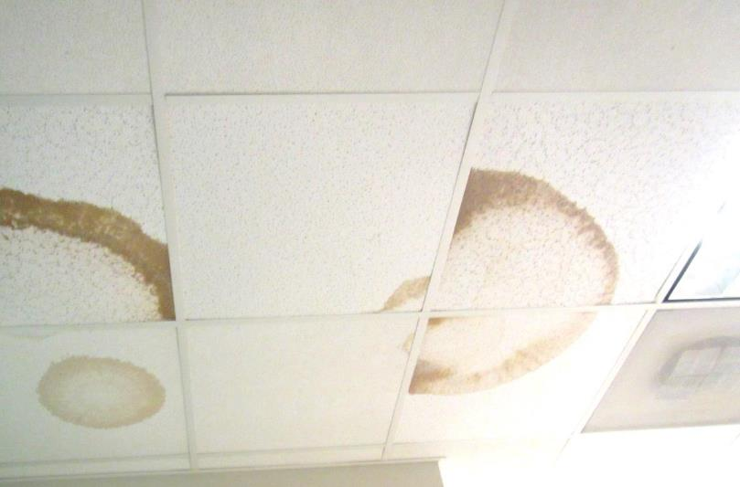
Supply vent (arrow) and water-damaged ceiling tiles
Picture 2
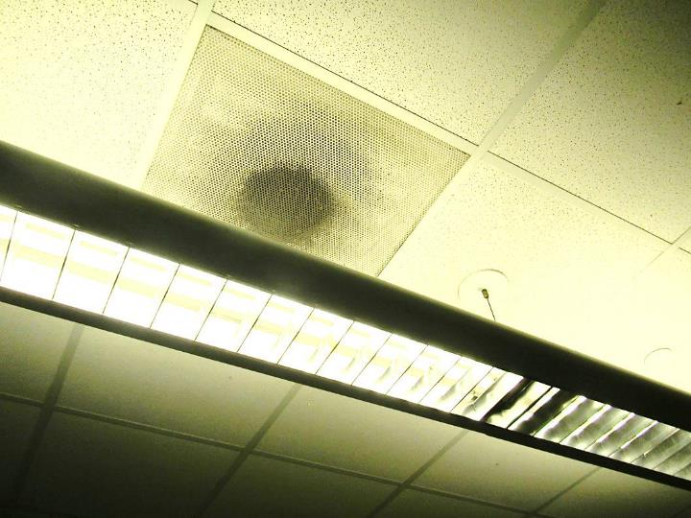
Return/exhaust vent, note dust on vent
Picture 3
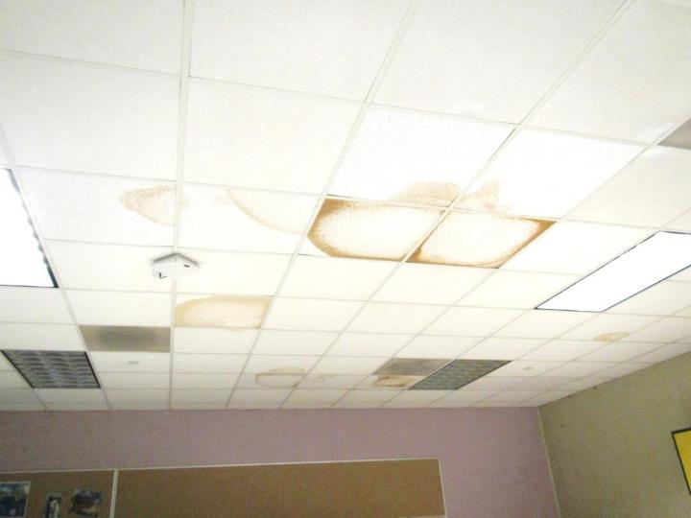
Water-damaged ceiling tiles
Picture 4
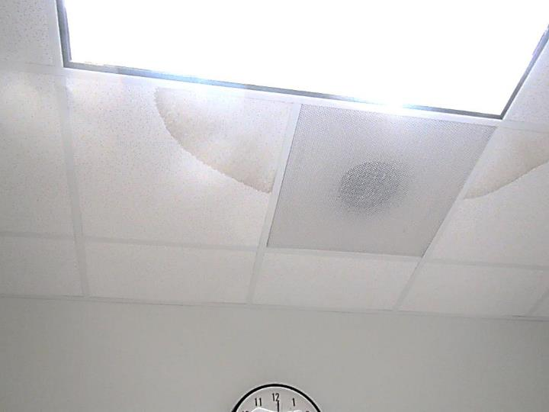
Water-damaged ceiling tiles
Picture 5
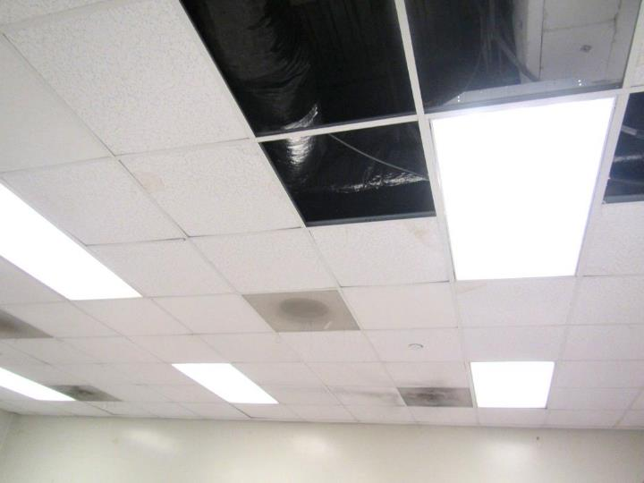
Missing ceiling tiles
Picture 6
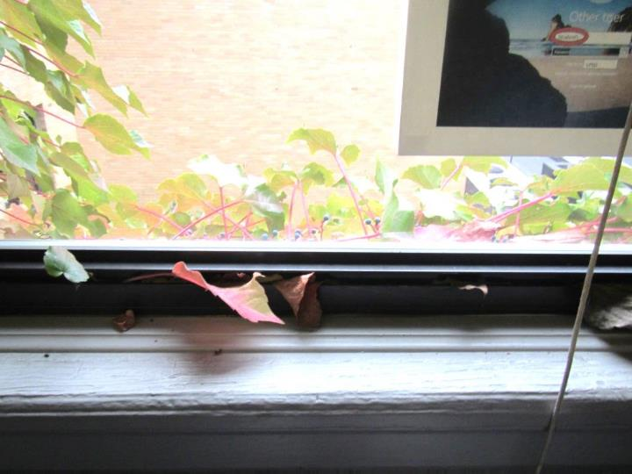
Ivy coming in window
Picture 7
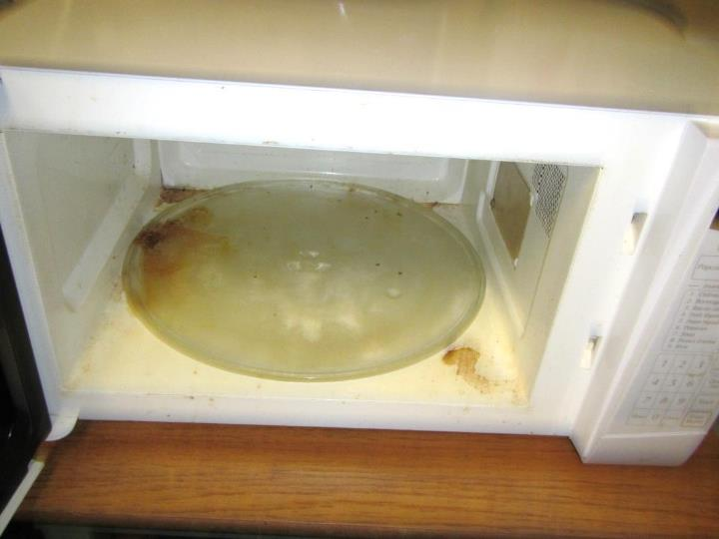
Microwave with food spill

Location | Carbon  Dioxide  (ppm) | Carbon Monoxide  (ppm) | Temp  (°F) | Relative  Humidity  (%) | PM2.5  (µg/m³) | Occupants  in Room | Windows  Openable | Ventilation |  | Remarks
 |  |  |  |  |  |  |  | Supply | Exhaust
Background (outside) | 422 | ND | 59 | 52 | 12 | - | - | - | -
Third Floor
Mr. O’Keefe | 1000 | ND | 74 | 44 | 14 | 1 | N | Y | Y | DEM, NC
Hosmer office | 906 | ND | 76 | 41 | 11 | 1 | N | Y | Y | NC
Quinton office | 943 | ND | 74 | 41 | 11 | 1 | N | Y | Y | NC, fridge
Consultant’s office | 852 | ND | 74 | 40 | 12 | 0 | N | Y | Y | NC
Plant room | 760 | ND | 76 | 38 | 12 | 1 | N | N | Y | PC, WD CT, floor drain, sink (currently used as an office)
Hallway next to plant room | - | - | - | - | - | - | - | - | - | WD CTs, MTs
610A | 957 | ND | 74 | 39 | 12 | 1 | N | Y | Y | HS, WD, DEM, computers
610B | 746 | ND | 73 | 39 | 11 | 1 | N | Y | Y | Carpet, DEM
612 | 1810 | ND | 74 | 48 | 14 | 25 | N | Y | Y | HS, WD
613 | 1328 | ND | 74 | 44 | 14 | 30 gone 20 minute | N | Y | Y | Active WD CTs
614 | 1107 | ND | 73 | 44 | 12 | 26 | N | Y | Y | DEM, HS
615 | 1027 | ND | 73 | 44 | 12 | 1 | N | Y | Y | WD CTs, DEM
616 | 941 | ND | 72 | 42 | 12 | 25 | N | Y | Y | MT, WD CT
617 | 1126 | ND | 73 | 43 | 7 | 15 | Y | Y | Y | NC, WD CT and MT, reports of leaks “raining inside”, DEM
619 | 1227 | ND | 73 | 47 | 10 | 26 | N | Y | Y
620 | 1232 | ND | 75 | 42 | 10 | 0 | N | Y | Y | NC, DEM, PF
622C | 770 | ND | 75 | 39 | 9 | 11 | N | Y | Y | 4 MT, WD CT, dusty vents and adjacent CT, DEM, NC
623 | 1223 | ND | 75 | 41 | 9 | 30 | N | Y | Y | NC, DEM, 4 WD CT
624 | 1028 | ND | 75 | 39 | 8 | 0 | N | Y | Y | DEM, loud vent, dusty vents and dusty CT
624 science lab | 1088 | ND | 75 | 40 | 8 | 0 | N | Y | Y | Science sinks, one drips, AI, fridge and microwave
625 | 978 | ND | 74 | 39 | 8 | 1 | N | Y | Y | DEM, CP
625 science lab | 1008 | ND | 75 | 39 | 9 | 16 | N | Y | Y | Science class in progress, DEM, dusty vents, auxiliary exhaust in lab – on
625 Science prep room |  |  |  |  |  |  |  |  | Y | Chemical storage in cabinets and shelves
626 | 849 | ND | 74 | 38 | 8 | 25 | N | Y | Y | 4 WD CT
626 lab | 808 | ND | 74 | 37 | 7 | 3 | N | Y | Y | Sink, dusty vents, CP, WD CT
628 computers | 899 | ND | 73 | 37 | 7 | 0 | N | Y | Y | Many WD CT, NC, computers
629 computers | 772 | ND | 73 | 37 | 7 | 30 | N | Y | Y | NC, DEM, computers
630 | 714 | ND | 75 | 37 | 9 | 0 | N | Y | Y | NC, DEM, PF – dusty
640 | 967 | ND | 73 | 42 | 11 | 1 | N | Y | Y | PF on
642 | 853 | ND | 74 | 40 | 10 | 0 | N | Y | Y | AF odor (plug-in), NC, DEM
643 | 1015 | ND | 74 | 43 | 9 | 25 | N | Y | Y | NC, DEM, dusty vents
644 | 907 | ND | 73 | 40 | 8 | 1 | N | Y | Y | NC, DEM, HS
645 | 1187 | ND | 74 | 46 | 8 | 25 | N | Y | Y | NC, dusty vents, DEM
646 A | 832 | ND | 73 | 40 | 7 | 11 | N | Y | Y | NC, WD CT, dusty vents
652 | 607 | ND | 71 | 40 | 8 | 1 | Y 1 open | Y | Y | NC, DEM, dusty vents, WD CT
653 | 838 | ND | 71 | 42 | 6 | 16 | Y | Y | Y | DEM, NC
654 | 754 | ND | 71 | 43 | 10 | 2 | N | Y | Y | DEM, HS
655 | 868 | ND | 72 | 42 | 7 | 25 | Y | Y | Y | DEM, chalk, NC
656 | 947 | ND | 72 | 44 | 11 | 28 | N | Y | Y | DEM
657 | 790 | ND | 72 | 41 | 8 | 18 | Y 3 open | Y | Y | NC, DEM, chalk
658 | 830 | ND | 72 | 43 | 9 | 1 | N | Y | Y | DEM, WD CT
Second Floor
Little Theater | 499 | ND | 72 | 37 | 7 | 0 | N | Y | Y | Carpet
Library | 553 | ND | 71 | 41 | 11 | 4 | N | Y | Y | Old carpet, WD CTs and ceiling, reported allergy triggers
512 | 775 | ND | 72 | 44 | 8 | 7 | N | Y | Y | HS, WD CT, WD GW
514 | 884 | ND | 73 | 43 | 8 | 11 | N | Y | Y
515 | - | - | - | - | - | - | - | - | - | Locked
516 | 788 | ND | 72 | 42 | 10 | 9 | N | Y | Y
517 | 724 | ND | 72 | 42 | 9 | 1 | Y | Y | Y | HS
518 | 693 | ND | 72 | 42 | 8 | 0 | Y | Y | Y | MTs, HS, WD CT
522 | 653 | ND | 73 | 39 | 7 | 14 | N | Y | Y | Computers, NC, DEM
523 | 764 | ND | 73 | 40 | 7 | 16 | N | Y | Y | NC, DEM, dusty vents
526 | 814 | ND | 72 | 41 | 8 | 23 | N | Y | Y | DEM, NC
527 | 1021 | ND | 74 | 42 | 9 | 12 | N | Y | Y | NC, DEM
533 | 626 | ND | 73 | 38 | 9 | 0 | N | Y | Y | DEM, 1 WD CT
535 | 727 | ND | 74 | 40 | 8 | 30 | N | Y | Y | PF – on, NC, 5 WD CT, food odors
537 | 790 | ND | 72 | 40 | 10 | 4 | N | Y | Y | NC, 1 WD CT
542 | 688 | ND | 74 | 36 | 8 | 18 | N | Y | Y | NC, DEM, computers
543 | 828 | ND | 74 | 37 | 13 | 30 | N | Y | Y | DEM, NC
545 | 1075 | ND | 74 | 41 | 8 | 25 | N | Y | Y | NC
546 | 842 | ND | 74 | 40 | 8 | 1 | N | Y | Y | DEM, WD CT and MT (3)
547 | 1022 | ND | 73 | 43 | 9 | 14 | N | Y | Y | NC, chalk, DEM
552 | 505 | ND | 72 | 39 | 12 | 7 | Y | Y | Y | WD CTs
553 | 607 | ND | 74 | 38 | 12 | 1 | Y | Y | Y | DEM
554 | 735 | ND | 73 | 42 | 10 | 16 | Y | Y | Y | DEM
555 | 661 | ND | 73 | 40 | 11 | 1 | Y | Y | Y | DEM
556 | 958 | ND | 73 | 44 | 13 | 21 | Y | Y | Y | MT
557 | 757 | ND | 73 | 41 | 12 | 0 | Y | Y | Y | DEM
558 | 867 | ND | 73 | 44 | 11 | 27 | Y | Y | Y | HS
First Floor
Small Cafeteria | 569 | ND | 72 | 41 | 8 | ~40 | N | Y | Y
Cafeteria | 644 | ND | 72 | 40 | 7 | ~200 | Y | Y | Y | Dust/debris on vents/CTs
Athletic Director Office | 810 | ND | 73 | 43 | 8 | 1 | N | Y | N | PC
Nurse’s Suite | 589 | ND | 74 | 46 | 9 | 3 | Y | Y | Y | No airflow detected from vents
Wrestling Room | 794 | ND | 72 | 43 | 6 | 28 | N | Y | Y | MTs
Weight Room | 733 | ND | 72 | 42 | 8 | 30 | N | Y | Y | Dust/debris on vents, MTs
Girls Locker Room | 545 | ND | 72 | 40 | 7 | 0 | N | Y | Y | Dust/debris on vents, MTs, broken floor tiles
Girls Varsity Locker Room | 528 | ND | 71 | 40 | 7 | 0 | N | Y | Y | Dust/debris on vents, WD CTs
Cardio Room | 589 | ND | 70 | 42 | 7 | ~25 | N | Y | Y | MTs
Boys Locker Room | 525 | ND | 72 | 42 | 9 | 0 | N | Y | Y | Dust/debris on vents
Boys Varsity Locker Room | 527 | ND | 71 | 40 | 6 | 4 | N | Y | Y | Dust/debris on vents, MTs
412 | 612 | ND | 73 | 38 | 7 | 3 | Y | Y | Y | Carpet
437 | 667 | ND | 74 | 38 | 5 | 0 | N | Y | Y | Carpet
452C | 796 | ND | 73 | 40 | 7 | 2 | N | N | Y | Dust/debris on vents, door open
Field House
Gym | 672 | ND | 71 | 43 | 5 | 200+ | N | Y | Y | Rubberized flooring

APPENDIX A

Previous Recommendations

Conclusions/Recommendations from the visit made in July of 2017
The following recommendations are made to assist in improving IAQ:
- Replace any water-damaged or mold-colonized porous building materials (e.g., ceiling tiles, gypsum wallboard, carpeting) in classrooms, hallways, and stairwell areas. Ensure water-damaged materials are cleaned, replaced, and/or repaired in a manner consistent with the U.S. Environmental Protection Agency’s guidelines (US EPA, 2008).
- Consult with a roofing contractor to assess the roofing system. Repairs should be made to stop leaks and chronic water damage to building materials. The roofing system should then be monitored regularly for water pooling, leaks, and other deteriorating conditions.
- Consult with an HVAC contractor to thoroughly examine all HVAC system components to ensure proper function. Make any necessary repairs to ensure the system is working as designed.
- Ensure that a system of regular “Operations and Maintenance” remains in place to keep HVAC systems in proper working order.
- Consider adopting a balancing schedule of every 5 years for all mechanical ventilation systems, as recommended by ventilation industrial standards (SMACNA, 1994).
- Operate all supply and exhaust ventilation equipment continuously during occupied periods. Do not block supply or exhaust vents with furniture or items.
- Use openable windows to supplement fresh air during temperate weather. Ensure all windows are tightly closed at the end of the day. Inform occupants that windows should not be opened while the HVAC system is in cooling mode to avoid condensation.
- Ensure chemical treatment of the pool is controlled to minimize pool odors. Ensure the exhaust system in the pool area is operating at all times and properly adjusted to effectively remove odors and moisture. In addition, ensure that doors between the pool and other occupied areas are weather-tight to prevent migration of odors and moisture.
- Ensure any plumbing leaks are repaired to avoid chronic water damage in the building.
- Ensure that condensation from AHU equipment is draining properly. Check collector pans, piping and any associated pumps for clogs and leaks and clean periodically to prevent stagnant water build-up and remove debris that may provide a medium for microbial growth.
- Ensure that doors are closed between areas with air conditioning and areas without air conditioning to avoid condensation of humid air on chilled surfaces.
- Replace water-damaged and mold-colonized ceiling tiles after leaks have been addressed. Clean/remediate any moldy wall material consistent with the U.S. Environmental Protection Agency’s guidelines (US EPA, 2008).
- Replace any missing or ajar ceiling tiles to avoid pathways to unconditioned areas.
- Consider utilizing MERV 8 filters in AHUs. Check with manufacturer’s recommendations before changing filter efficiency. Continue to change filters 2-4 times a year.
- Regularly clean supply/return vents and fans to avoid aerosolizing accumulated particulate matter.
- Clean carpeting and area rugs annually or more often in high-traffic locations in accordance with IICRC recommendations (IICRC, 2012) and discard those that are worn out or too soiled to be cleaned.
- Replace/repair fluorescent light covers; ensure fluorescent lights are fully secured to prevent breakage and clean debris out of covers.
- Encourage faculty to report classroom/building related issues via a tracking program.
- Continue to adopt the US EPA (2000) document, “Tools for Schools”, as an instrument for maintaining a good IAQ environment in the building available at: http://www.epa.gov/iaq/schools/index.html.
- Refer to resource manual and other related IAQ documents located on the MDPH’s website for further building-wide evaluations and advice on maintaining public buildings. These documents are available at: http://mass.gov/dph/iaq.

Conclusions/Recommendations from the visit made in December of 2017
The following recommendations are for improving indoor air and environmental quality:
- Consult with an HVAC contractor to thoroughly examine all HVAC system components to ensure proper function. Make any necessary repairs to ensure the system is working as designed. Assess whether adjustments can be made to allow more fresh air into the system.
- Operate all supply and exhaust ventilation equipment continuously during occupied periods. Do not block supply or exhaust vents with furniture or items. Check exhaust/return vents periodically for proper function.
- Consider changing the style of fresh air vents or relocating them to prevent drafts (e.g., Hosmer office; Table 2).
- Ensure that a system of regular “Operations and Maintenance” remains in place to keep HVAC systems in proper working order.
- Consider adopting a balancing schedule of every 5 years for all mechanical ventilation systems, as recommended by ventilation industrial standards (SMACNA, 1994).
- Use openable windows to supplement fresh air during temperate weather. Ensure all windows are tightly closed at the end of the day. Inform occupants that windows should not be opened while the HVAC system is in cooling mode to avoid condensation.
- Replace any water-damaged or mold-colonized porous building materials (e.g., ceiling tiles, gypsum wallboard, carpeting) in the library, classrooms, hallways, and stairwell areas. Ensure water-damaged materials are cleaned, replaced, and/or repaired in a manner consistent with the U.S. Environmental Protection Agency’s guidelines (US EPA, 2008).
- Consult with a roofing contractor to assess the roofing system. Repairs should be made to stop leaks and chronic water damage to building materials. The roofing system should then be monitored regularly for water pooling, leaks, and other deteriorating conditions.
- Consider removal of wall-to-wall carpeting in classrooms and other areas where spills, leaks or wear are a concern. Replace with non-porous flooring.
- Avoid locating refrigerators and water dispensers in carpeted areas. Place on non-porous flooring or use a waterproof mat to protect the carpet.
- Seal gaps in sink backsplashes with an appropriate waterproof sealant. Do not store porous items underneath or adjacent to sinks and safety showers/eyewashes.
- Ensure doors seal tightly between air conditioned and non-air-conditioned areas and that these doors are closed when air conditioning is in use.
- Ensure chemical treatment of the pool is controlled to minimize pool odors. Ensure the exhaust system in the pool area is operating at all times and properly adjusted to effectively remove odors and moisture. In addition, ensure that doors between the pool and other occupied areas are weather-tight to prevent migration of odors and moisture.
- Ensure any plumbing leaks are repaired to avoid chronic water damage in the building.
- Ensure that condensation from AHU equipment is draining properly. Check collector pans, piping and any associated pumps for clogs and leaks and clean periodically to prevent stagnant water build-up and remove debris that may provide a medium for microbial growth.
- Replace water-damaged and mold-colonized ceiling tiles after leaks have been addressed. Clean/remediate any moldy wall materials consistent with the U.S. Environmental Protection Agency’s guidelines (US EPA, 2008).
- Replace any missing or ajar ceiling tiles to avoid pathways to unconditioned areas.
- Reduce the use of products containing VOCs.
- Locate photocopiers and laminators in well ventilated areas away from occupants.
- Store laboratory chemicals in an organized manner consistent with the guidance in Appendix A (“Guidance Concerning Proper Use and Storage of Chemicals in Schools to Protect Public Health”).
- Ensure Material Safety Sheets are available for all laboratory, maintenance and janitorial chemicals used in the building.
- Consider utilizing MERV 8 filters in AHUs. Check with manufacturer’s recommendations before changing filter efficiency. Continue to change filters 2-4 times a year.
- Regularly clean supply/return vents and fans to avoid aerosolizing accumulated particulate matter. If soiled ceiling tiles around vents cannot be cleaned, replace.
- Consider reducing the amount of items stored in classrooms to make cleaning easier. Periodically move items to clean flat surfaces.
- Clean carpeting and area rugs annually or more often in high-traffic locations in accordance with IICRC recommendations (IICRC, 2012) and discard those that are worn out or too soiled to be cleaned.
- Affix the electrical outlet in medical office to wall. Identify the purpose of the wires in the medical office and cap/remove as needed.
- Encourage faculty to report classroom/building related issues via a tracking program.
- The school should be tested for radon by a certified radon measurement specialist during the heating season when school is in session. Radon measurement specialists and other information can be found at: www.nrsb.org, and http://aarst-nrpp.com/wp.
- Continue to adopt the US EPA (2000) document, “Tools for Schools”, as an instrument for maintaining a good IAQ environment in the building available at: http://www.epa.gov/iaq/schools/index.html.
- Refer to resource manual and other related IAQ documents located on the MDPH’s website for further building-wide evaluations and advice on maintaining public buildings. These documents are available at: http://mass.gov/dph/iaq.

