Field House
1920’s Building
1980’s Building
INDOOR AIR QUALITY ASSESSMENT
Lowell High School
“1980 Building”
50 Father Morissette Blvd
Lowell, MA
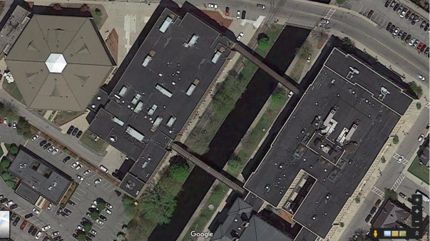
Prepared by:
Massachusetts Department of Public Health
Bureau of Environmental Health
Indoor Air Quality Program
August 2017

Background

Building: | Lowell High School
Address: | 50 Father Morissette Blvd, Lowell, MA
Assessment Coordinated Through: | Lowell Public School Department
Reason for Request: | General Indoor Air Quality (IAQ) concerns. Note that this represents a preliminary walkthrough of the building. Additional visits, including air testing, will be conducted during the school year when the buildings are occupied.
Date of Assessment: | July 26, 2017
Massachusetts Department of Public Health/Bureau of Environmental Health (MDPH/BEH) Staff Conducting Assessment: | Cory Holmes, Environmental Analyst,  Jason Dustin, Environmental Analyst,  Ruth Alfasso, Environmental Engineer, and Mike Feeney Director, IAQ Program
Building Description: | The building at 50 Father Morissette Blvd is a brick and concrete complex was constructed in 1980. It has an attached Fieldhouse containing gymnasiums, locker rooms, and a pool.
Windows: | Openable

Ventilation
A heating, ventilating, and air conditioning (HVAC) system has several functions. First it provides heating and, if equipped, cooling. Second, it is a source of fresh air. Finally, an HVAC system will dilute and remove normally occurring indoor environmental pollutants by not only introducing fresh air, but by filtering the airstream and ejecting stale air to the outdoors via exhaust ventilation. Even if an HVAC system is operating as designed, point sources of respiratory irritation may exist and cause symptoms in sensitive individuals.
Note that during this preliminary site assessment no indoor air testing was performed and the buildings were mostly unoccupied. However, components of the HVAC were examined and are described here.
Fresh air is provided by multiple air-handling units (AHUs) located on the roof. The AHUs are mostly “packaged” units that provide both heat and air conditioning (AC) (Pictures 1 and 2). Fresh air intakes draw in fresh air through an intake vent where it is filtered, then heated or cooled (Picture 3). The conditioned fresh air is mixed with some air returned from classrooms, then supplied to rooms through supply diffusers/grates throughout the building (Picture 4). Return vents (Picture 5) bring stale air back to the AHU where a portion of this air is exhausted through louvres in the AHU. The HVAC systems should be regularly maintained and operate continuously during occupied hours.
In order to have proper ventilation with a mechanical supply and exhaust system, these systems must be balanced to provide an adequate amount of fresh air while removing stale air from a room. It is recommended that existing ventilation systems be re-balanced every five years to ensure adequate air systems function (SMACNA, 1994). It is unknown the last time these systems were balanced.

Microbial/Moisture Concerns
Water-damaged ceiling tiles and plaster walls were observed in many classrooms, offices, and hallways (Pictures 6 through 8; Table 1), indicating leaks from the building envelope or plumbing system. Ceiling tiles should be replaced after the leak is found and repaired. In general, ceiling tiles have an open space above them (the ceiling plenum) and tend to dry out quickly, reducing the chance for mold colonization. Ceiling plaster does not contain organic material; therefore, it will not support microbial growth even when frequently moistened. In some cases, dust or paint on the surface of plaster can become mold colonized. If this occurs, plaster can often be cleaned to remove the mold.
Considering the number of water-damaged ceiling tiles observed, the roofing system should be assessed to find and repair these leaks. Roof drains, roofing materials, and flashing/connections between roof segments and walls should be examined regularly for pooling water and other indications of deterioration with repairs made as needed.
In a few locations, gypsum wallboard was found to be colonized with mold (Picture 9; Table 1). Mold growth can be a source of allergies and irritation. Measures should be taken to ensure water-damaged materials are cleaned, replaced, and/or repaired in a manner consistent with the U.S. Environmental Protection Agency’s guidelines (US EPA, 2008). The US EPA and the American Conference of Governmental Industrial Hygienists (ACGIH) recommend that porous materials (e.g., ceiling tiles, gypsum wallboard) be dried with fans and heating within 24 to 48 hours of becoming wet (US EPA, 2008; ACGIH, 1989). If not dried within this time frame, these materials should be removed/discarded.
Wall-to-wall carpeting was observed in some classrooms and offices. Wall-to-wall carpeting is not recommended in school classrooms in general, due to the difficulty in maintaining it in good condition, including wear, dirt, and spills. Roof leaks leading to stained ceiling tiles can also be a source of water to moisten carpeting. Carpeting moistened for more than a short period of time will be subject to microbial growth. Some carpeting was visibly stained (Picture 10). The service life of carpeting in schools is approximately 10-11 years (IICRC, 2002). Aging carpet can produce fibers that can be irritating to the respiratory system. In addition, tears or lifting carpet can create tripping hazards. Carpeting should be cleaned annually or semi-annually in soiled high traffic areas as per the recommendations of the Institute of Inspection, Cleaning, and Restoration Certification (IICRC, 2012).
Windows open in most exterior classrooms, which can be a useful supply of fresh air, however windows need to be tightly closed at the end of each day to prevent water and pest intrusion. Windows should remain closed while the HVAC system is in cooling mode to prevent condensation.
Doors between air-conditioned and non-air-conditioned areas should be kept closed to prevent condensation from forming when chilled air mixes with humid air. Note that the field house contains a swimming pool. Pools can be a significant source of moisture to the indoor environment, as well as odors and contamination from pool treatment chemicals. IAQ staff detected pool odors in the field house gym area. The pool’s chemical balance should be regularly monitored to ensure that levels of off-gassing chemicals and odors are minimized. Exhaust systems in pool rooms should be adjusted to effectively remove odors and moisture and remain on at all times. In addition, doors between the pool and other indoor areas should be weather tight to prevent the migration of water vapor and odors to other occupied areas.

Other Conditions
Filters for the AHUs should be changed in accordance with manufacturer’s instructions (e.g., two to four times a year). The MDPH recommends pleated filters with a Minimum Efficiency Reporting Value (MERV) of 8, which are adequate in filtering out pollen and mold spores (ASHRAE, 2012).
Many classrooms had personal fans. Some of these had dusty blades. Many supply and exhaust vents were also observed to be dusty (Pictures 11 and 12; Table 1). Dust on ventilation and fan equipment can be aerosolized when the units are activated.
Missing/ajar light covers were seen in a few areas (Picture 13; Table 1). Fixtures should be equipped with access covers installed with bulbs fully secured in their sockets. Breakage of glass can cause injuries and may release mercury and/or other hazardous compounds.
This building has two enclosed walkways that connect to the “1920’s” building from the second floor (Picture 14). A plastic-like odor was detected by IAQ staff when entering a walkway. It is likely that exposure of the soft vinyl flooring/adhesive to direct sunlight is causing the flooring to release these odors. When entering the walkway later in the day during overcast skies, there was no odor detected. It is the experience of the IAQ staff that odors are typically detected long before reaching established guidelines for volatile organic compounds (VOCs). However, VOC testing will be conducted to confirm this during the next scheduled visit to the school.

Conclusions/Recommendations
The following recommendations are for improving indoor air and environmental quality:
- Replace any water-damaged or mold-colonized porous building materials (e.g., ceiling tiles, gypsum wallboard, carpeting) in classrooms, hallways, and stairwell areas. Ensure water-damaged materials are cleaned, replaced, and/or repaired in a manner consistent with the U.S. Environmental Protection Agency’s guidelines (US EPA, 2008).
- Consult with a roofing contractor to assess the roofing system. Repairs should be made to stop leaks and chronic water damage to building materials. The roofing system should then be monitored regularly for water pooling, leaks, and other deteriorating conditions.
- Consult with an HVAC contractor to thoroughly examine all HVAC system components to ensure proper function. Make any necessary repairs to ensure the system is working as designed.
- Ensure that a system of regular “Operations and Maintenance” remains in place to keep HVAC systems in proper working order.
- Consider adopting a balancing schedule of every 5 years for all mechanical ventilation systems, as recommended by ventilation industrial standards (SMACNA, 1994).
- Operate all supply and exhaust ventilation equipment continuously during occupied periods. Do not block supply or exhaust vents with furniture or items.
- Use openable windows to supplement fresh air during temperate weather. Ensure all windows are tightly closed at the end of the day. Inform occupants that windows should not be opened while the HVAC system is in cooling mode to avoid condensation.
- Ensure chemical treatment of the pool is controlled to minimize pool odors. Ensure the exhaust system in the pool area is operating at all times and properly adjusted to effectively remove odors and moisture. In addition, ensure that doors between the pool and other occupied areas are weather-tight to prevent migration of odors and moisture.
- Ensure any plumbing leaks are repaired to avoid chronic water damage in the building.
- Ensure that condensation from AHU equipment is draining properly. Check collector pans, piping and any associated pumps for clogs and leaks and clean periodically to prevent stagnant water build-up and remove debris that may provide a medium for microbial growth.
- Ensure that doors are closed between areas with air conditioning and areas without air conditioning to avoid condensation of humid air on chilled surfaces.
- Replace water-damaged and mold-colonized ceiling tiles after leaks have been addressed. Clean/remediate any moldy wall material consistent with the U.S. Environmental Protection Agency’s guidelines (US EPA, 2008).
- Replace any missing or ajar ceiling tiles to avoid pathways to unconditioned areas.
- Consider utilizing MERV 8 filters in AHUs. Check with manufacturer’s recommendations before changing filter efficiency. Continue to change filters 2-4 times a year.
- Regularly clean supply/return vents and fans to avoid aerosolizing accumulated particulate matter.
- Clean carpeting and area rugs annually or more often in high-traffic locations in accordance with IICRC recommendations (IICRC, 2012) and discard those that are worn out or too soiled to be cleaned.
- Replace/repair fluorescent light covers; ensure fluorescent lights are fully secured to prevent breakage and clean debris out of covers.
- Encourage faculty to report classroom/building related issues via a tracking program.
- Continue to adopt the US EPA (2000) document, “Tools for Schools”, as an instrument for maintaining a good IAQ environment in the building available at: http://www.epa.gov/iaq/schools/index.html.
- Refer to resource manual and other related IAQ documents located on the MDPH’s website for further building-wide evaluations and advice on maintaining public buildings. These documents are available at: http://mass.gov/dph/iaq.

References
ACGIH. 1989. Guidelines for the Assessment of Bioaerosols in the Indoor Environment. American Conference of Governmental Industrial Hygienists, Cincinnati, OH.
ASHRAE. 2012. American Society of Heating, Refrigeration and Air Conditioning Engineers (ASHRAE) Standard 52.2-2012 -- Method of Testing General Ventilation Air-Cleaning Devices for Removal Efficiency by Particle Size (ANSI Approved). 2012.
IICRC. 2002. Institute of Inspection, Cleaning and Restoration Certification. A Life-Cycle Cost Analysis for Floor Coverings in School Facilities.
IICRC. 2012. Institute of Inspection, Cleaning and Restoration Certification. Carpet Cleaning: FAQ. Retrieved from http://www.iicrc.org/consumers/care/carpet-cleaning.
MDPH. 2015. Massachusetts Department of Public Health. “Indoor Air Quality Manual: Chapters I-III”. Available at: http://www.mass.gov/eohhs/gov/departments/dph/programs/environmental-health/exposure-topics/iaq/iaq-manual/.
SMACNA. 1994. HVAC Systems Commissioning Manual. 1st ed. Sheet Metal and Air Conditioning Contractors’ National Association, Inc., Chantilly, VA.
US EPA. 2000. Tools for Schools. Office of Air and Radiation, Office of Radiation and Indoor Air, Indoor Environments Division (6609J). EPA 402-K-95-001, Second Edition. http://www.epa.gov/iaq/schools/index.html.
US EPA. 2008. “Mold Remediation in Schools and Commercial Buildings”. Office of Air and Radiation, Indoor Environments Division, Washington, DC. EPA 402-K-01-001. September 2008. Available at: http://www.epa.gov/mold/mold-remediation-schools-and-commercial-buildings-guide.

Picture 1
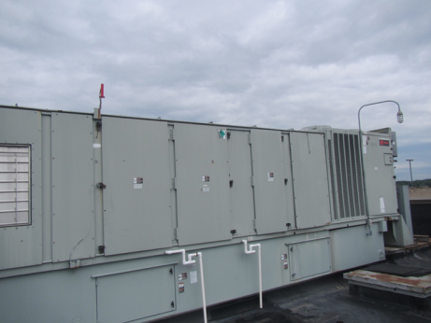
Large “packaged” AHU on the roof
Picture 2
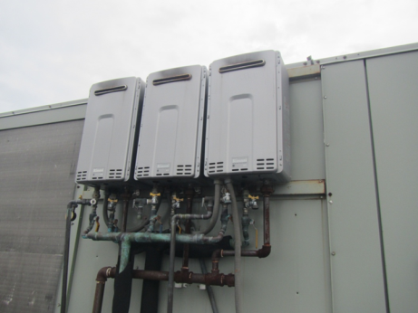
Direct gas-fired heating units on roof top AHU
Picture 3
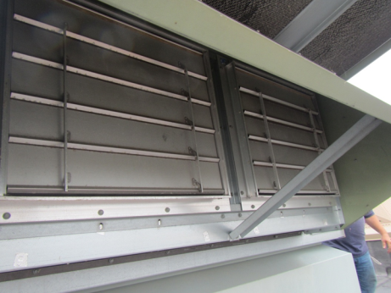
Fresh air intake vent (arrows) and closed exhaust louvres (below)
Picture 4
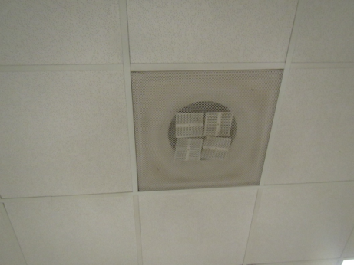
Ceiling-mounted supply vent
Picture 5
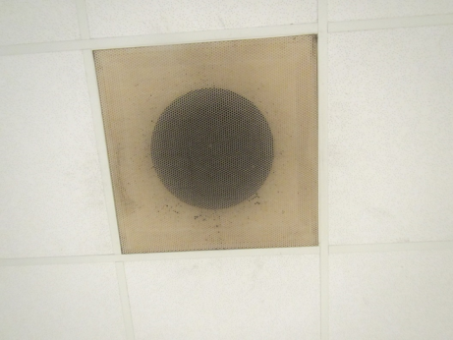
Ceiling-mounted exhaust vent
Picture 6
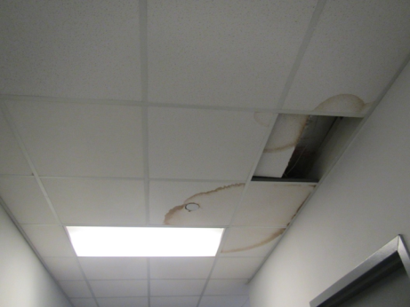
Water-damaged and missing ceiling tiles
Picture 7
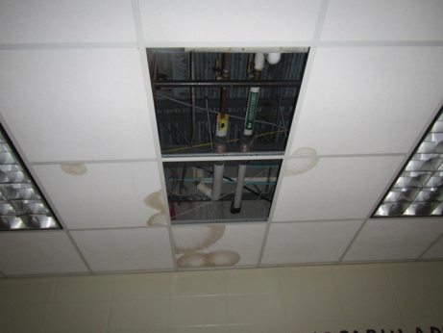
Water-damaged and missing ceiling tiles
Picture 8
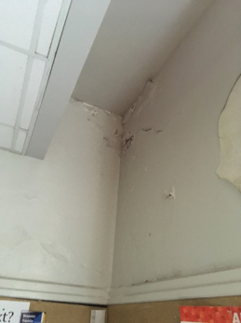
Water-damaged ceiling plaster
Picture 9
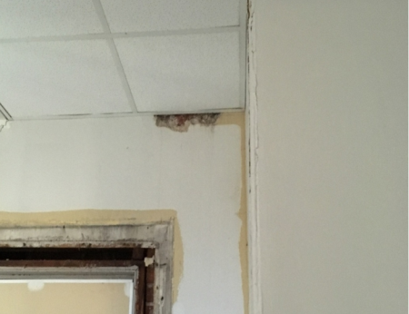
Mold staining on wall
Picture 10
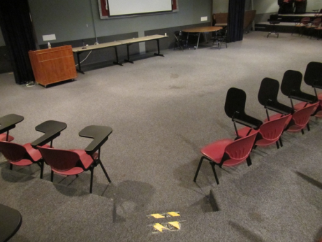
Stained carpeting
Picture 11
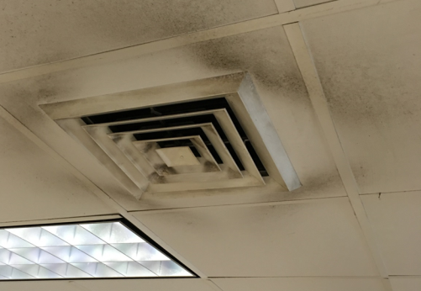
Dusty supply vent
Picture 12
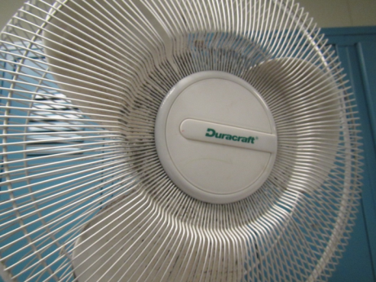
Dusty personal fan
Picture 13
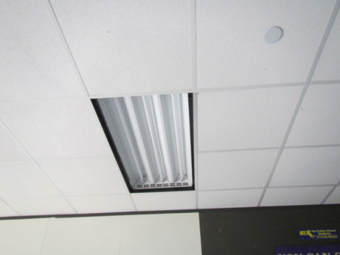
Missing fluorescent light cover
Picture 14
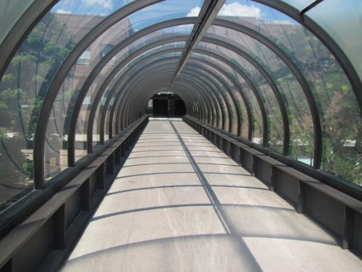
Enclosed walkway connecting 1980 building to 1920’s building
Location | Windows  Openable | Ventilation |  | Remarks
 |  | Intake | Exhaust
3rd floor Men’s restroom | N | N | Y | 1 MT, 1 WD CT
610 copy | Y | Y | Y | carpeted, PC, MT, DEM, window does not close tightly
610B | N | Y | Y | Carpeted
611 | Y | Y | Y | NC, fake plant, DEM
612 | Y | Y | Y | PF, DEM, cleaning products, fridge
613 | Y | Y | Y | DEM
614 | Y | Y | Y | DEM, dusty vents, mini refrigerator
615 | Y | Y | Y | DEM, CPs
616 | Y | Y | Y | Dusty return vent
617 | Y | Y | Y | Chalk board, DEM, dusty return vent
618 | Y | Y | Y | DEM, cleaning products
620 | N | Y | Y | WD CT
622c | N | Y | Y
623 | N | Y | Y
624 | N | Y | Y
625 | N | Y | Y
626 | N | Y | Y | 2 WD CT
628 | N | Y | Y | WD
629 | N | Y | Y
630 |  |  |  | Dust, debris on vents, hole in wall
640 |  |  |  | Dust, debris on vents, PF
642 |  |  |  | WD CTs and light cover, hole in wall
643 |  |  |  | Dust, debris on vents & CTs
644 |  |  |  | Dust, debris on vents & CTs
645 |  |  |  | Dust, debris on vents & CTs
646-A |  |  |  | Dust, debris on vents
648 | N | Y | Y | MT, DEM, dusty vents
649 | N | Y | Y
652 | N | Y | Y | Sink, NC
653 | Y | Y | Y | Missing light covers, chalk, NC
654 | Y | Y | Y | Missing light covers, NC
655 | Y | Y | Y | DEM
656 | Y | Y | Y | NC
657 | Y | Y | Y | NC
658 | Y | Y | Y
658 hallway |  | N
Cafeteria | N | Y | Y | 4 MT, 12 WD CT
Cafeteria NW side | N | Y | N | 2 WD CT
Digital media | Y | Y | Y | NC
Hallway (outside 640) |  |  |  | Missing/damaged CTs
Hallway next to plant room | N | Y | Y | Several WD CT
Head of school conference room | N | Y | Y
Plant room | N | Y | Y | WD CT
Teacher’s dining | N | Y | Y
Teachers restroom | N | N | Y
TV studio | Y | Y | Y | Carpeted
512 | - | - | - | Locked
513 | - | - | - | Locked
514 | Y | Y | Y | Ajar CT, dirty return vent
515 | Y | Y | Y | WD CT x 2, ajar CT
516 | Y | Y | Y | WD CT, DEM, fridge
517 | Y | Y | Y | DEM, chalk board
518 | Y | Y | Y | DEM, WD CTs x 3, MTs x 2
522 | N | Y | Y | 4 WD CT with mold, 28 computers,
525 | N | Y | Y | WD CTs
526 | N | Y | Y
527 | N | Y | Y
529 | N | Y | Y
542 | N | Y | Y | Computers, WD CT, odors, NC, DEM
543 | N | Y | Y | WD CT in this room and hallways adjacent, NC, DEM
545 | N | Y | Y | NC
546 | N | Y | Y | WD and MT, NC
547 | N | Y | Y | NC, WD CT in hallway
552 |  |  |  | Dust, debris on vents & CTs, WD CT
553 |  |  |  | Dust, debris on vents
554 |  |  |  | Dust, debris on vents, CD
555 |  |  |  | Dust, debris on vents, ajar CT
556 |  |  |  | Dust, debris on vents, ajar CT
557 |  |  |  | Dust, debris on vents, damaged wall/hole, ajar CT
558 |  |  |  | Dust, debris on vents
Library | Y | Y | Y | Carpeting, stained and worn, computers, WD CT, soiled chairs with ripped upholstery, WD ceiling/walls
Staff lunch in library | Y | Y | Y | Fridge and microwave, carpeted, sink
Trios/training | N | Y | Y | Ceiling fans, on, stained carpet
Women’s restroom | N | N | Y | WD plaster
432A guidance suite | N | Y | Y | Area rug, PC
Conference room | N | Y | Y | Carpeted, DEM, fake plant
Nurses’ office | N | Y | Y | NC, PF
Guidance area lunchroom | N | Y | Y | Sink backsplash open
432A guidance suite | N | Y | Y | Area rug, PC
Conference room | N | Y | Y | Carpeted, DEM, fake plant
Nurses office | N | Y | Y | NC, PF
Guidance area lunchroom | N | Y | Y | Sink backsplash open
452 |  |  |  | Dust, debris on vents, PC-no exhaust vent, water cooler on carpet
Murphy Café |  |  |  | Dust, debris on vents, MTs
Gym | N | Y | Y | Large ceiling-mounted AHUs, some dark dust/debris on walls, odors detected from pool
Reception (main) | N | Y | Y | Carpet, plant, water cooler on carpet
-conference | N | Y | Y | DEM, carpet, dusty vent
-kitchen | N | Y | N | PC, gaps in sink/counter, water damage below sink, CPs, HS
Solarium bridges |  |  |  | Odors detected during strong sunlight, vinyl flooring

