INDOOR AIR QUALITY ASSESSMENT

Lowell High School
Freshman Academy
40 Paige Street
Lowell, MA

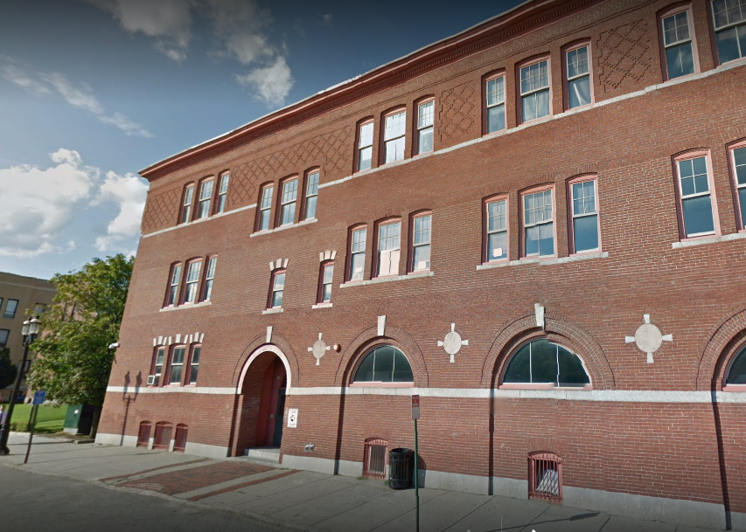

Prepared by:
Massachusetts Department of Public Health
Bureau of Environmental Health
Indoor Air Quality Program
December 2017

Background

Building: | Lowell High School, Freshman Academy
Address: | 40 Paige Street, Lowell, MA
Assessment Coordinated Through: | Lowell Public School Department
Reason for Request: | General Indoor Air Quality (IAQ) concerns. Note that this visit includes air testing during normal occupancy. The August 2017 report should be reviewed in conjunction with this air testing to assess overall building conditions.
Date of Assessment: | December 20, 2017
Massachusetts Department of Public Health/Bureau of Environmental Health (MDPH/BEH) Staff Conducting Assessment: | Jason Dustin, Environmental Analyst
Building Description: | The Freshman Academy building at 40 Paige Street was originally built in the 1800’s and renovated in the 1930’s and 1980’s. The three-story brick building contains classrooms, offices, laboratory spaces, an auditorium, and other spaces.
Windows: | Openable

Methods
Please refer to the IAQ Manual for methods, sampling procedures, and interpretation of results (MDPH, 2015).

IAQ Testing Results
Table 1 shows the information collected during the preliminary walkthrough included in the August 2017 report. Table 2 includes indoor air testing results, which are summarized below.
- Carbon dioxide levels were above 800 parts per million (ppm) in approximately two-thirds of all areas assessed including all occupied classrooms, indicating a lack of adequate air exchange in those areas of the building.
- Temperature was within the recommended range of 70°F to 78°F in all areas on the day of assessment.
- Relative humidity was below the recommended range of 40 to 60% in the areas tested which is typical during the heating season.
- Carbon monoxide levels were non-detectable in most areas tested.
- Fine particulate matter (PM2.5) concentrations measured were below the National Ambient Air Quality (NAAQS) limit of 35 μg/m³ in the majority of areas tested.

Ventilation
A heating, ventilating, and air conditioning (HVAC) system has several functions. First it provides heating and, if equipped, cooling. Second, it is a source of fresh air. Finally, an HVAC system will dilute and remove normally occurring indoor environmental pollutants by not only introducing fresh air, but by filtering the airstream and ejecting stale air to the outdoors via exhaust ventilation. Even if an HVAC system is operating as designed, point sources of respiratory irritation may exist and cause symptoms in sensitive individuals.
Based on air sampling, it appears that most classrooms with normal occupancy appeared to have a lack of air exchange provided by the HVAC system in its current operating mode as demonstrated by carbon dioxide levels above 800 ppm. Given the age and operation of the existing HVAC system, it may be necessary to use opening windows to supplement fresh air supply for classrooms. Although these slightly elevated levels of carbon dioxide are not hazardous, it indicates that normally occurring indoor air pollutants (e.g., odors, water vapor, and VOCs) may accumulate in these rooms. Some areas were noted to be vacant or sparsely occupied which may result in reduced carbon dioxide levels. It was also reported by Facilities staff that some exhaust motors were not functioning at the time of this assessment.
The HVAC systems should be regularly maintained and operate continuously during occupied hours. It may be possible to adjust the HVAC system to allow more fresh air into the system, e.g. by opening supply louvers or adjusting the proportion of air exhausted rather than recirculated. Exhaust ventilation should also be checked periodically to ensure a draw of air from classrooms.
In order to have proper ventilation with a mechanical supply and exhaust system, these systems must be balanced to provide an adequate amount of fresh air while removing stale air from a room. It is recommended that existing ventilation systems be re-balanced every five years to ensure adequate air systems function (SMACNA, 1994). It is unknown the last time these systems were balanced.

Microbial/Moisture Concerns
As mentioned in the preliminary report, water-damaged ceiling tiles and ceiling plaster were observed in some classrooms, offices, and hallways (Picture 1). Water-damaged ceiling tiles should be replaced after the leak is found and repaired.
Indoor plants were observed in some areas (Picture 2). Plants can be a source of pollen and mold, which can be respiratory irritants to some individuals. Plants should be properly maintained and equipped with drip pans and should be located away from air diffusers to prevent the aerosolization of dirt, pollen and mold.
Windows open in most exterior classrooms. Open windows can be an additional source of fresh air. However, windows need to be tightly closed at the end of each day to prevent water infiltration and pest intrusion.

Other Observations
In addition to the conditions noted in the preliminary report, IAQ staff noted many areas with air fresheners/candles, scented cleaning products, and hand sanitizers (Pictures 2 and 3). These products contain volatile organic compounds (VOCs) and other fragrances which may cause irritation of the eyes, nose, and respiratory system.
Some occupants expressed comfort complaints in rooms regarding temperature control. Temperature may influence perception of indoor air quality concerns.

Conclusions/Recommendations
The following recommendations are made to assist in improving IAQ:
- Operate all supply and exhaust ventilation equipment continuously during occupied periods.
- Increase fresh air supply to HVAC units serving areas with elevated carbon dioxide (Table 2).
- Use openable windows to supplement fresh air during temperate weather. Ensure all windows are tightly closed at the end of the day.
- Check exhaust vents for air draw periodically and repair as needed. Do not block exhaust vents with furniture or items.
- Consider adopting a balancing schedule of every 5 years for all mechanical ventilation systems, as recommended by ventilation industrial standards (SMACNA, 1994).
- Ensure roof and plumbing leaks are repaired and replace water-damaged ceiling tiles.
- Repair other water-damaged building materials (e.g., wall/ceiling plaster).
- Reduce or eliminate the use of products containing VOCs (e.g., air fresheners, scented cleaning products, and hand sanitizer).
- Properly maintain plants, including drip pans, to prevent water damage to porous materials. Plants should also be located away from air diffusers to prevent the aerosolization of dirt, pollen, and mold.
- Investigate rooms with temperature complaints to provide for adequate comfort of occupants and prevent negative perception of building IAQ.
- Continue to implement the remaining recommendations from the preliminary walkthrough report (MDPH, 2017).
- Encourage faculty to report classroom/building related issues via a tracking program.
- Continue to adopt the US EPA (2000) document, “Tools for Schools”, as an instrument for maintaining a good IAQ environment in the building available at: http://www.epa.gov/iaq/schools/index.html.
- Refer to resource manual and other related IAQ documents located on the MDPH’s website for further building-wide evaluations and advice on maintaining public buildings. These documents are available at: http://mass.gov/dph/iaq.

References
MDPH. 2015. Massachusetts Department of Public Health. “Indoor Air Quality Manual: Chapters I-III”. Available at: http://www.mass.gov/eohhs/gov/departments/dph/programs/environmental-health/exposure-topics/iaq/iaq-manual/.
MDPH. 2017. Indoor Air Quality Preliminary Walkthrough. Lowell High School; Freshman Academy. August 2017. http://www.mass.gov/eohhs/gov/departments/dph/programs/environmental-health/exposure-topics/iaq/pollution/lowell-high-school.html
SMACNA. 1994. HVAC Systems Commissioning Manual. 1st ed. Sheet Metal and Air Conditioning Contractors’ National Association, Inc., Chantilly, VA.
US EPA. 2000. Tools for Schools. Office of Air and Radiation, Office of Radiation and Indoor Air, Indoor Environments Division (6609J). EPA 402-K-95-001, Second Edition. http://www.epa.gov/iaq/schools/index.html.
Picture 1
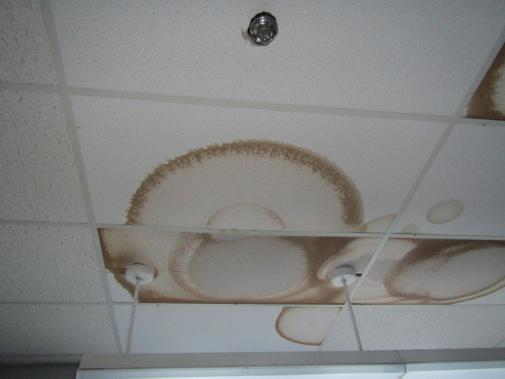
Water-damaged ceiling tiles in classroom
Picture 2
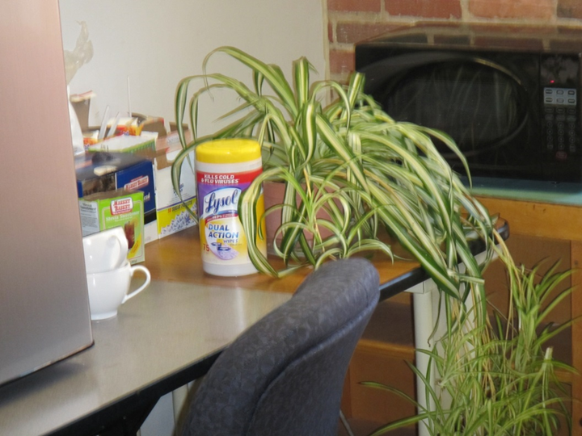
Plant and scented cleaning product in the Freshman Academy
Picture 3
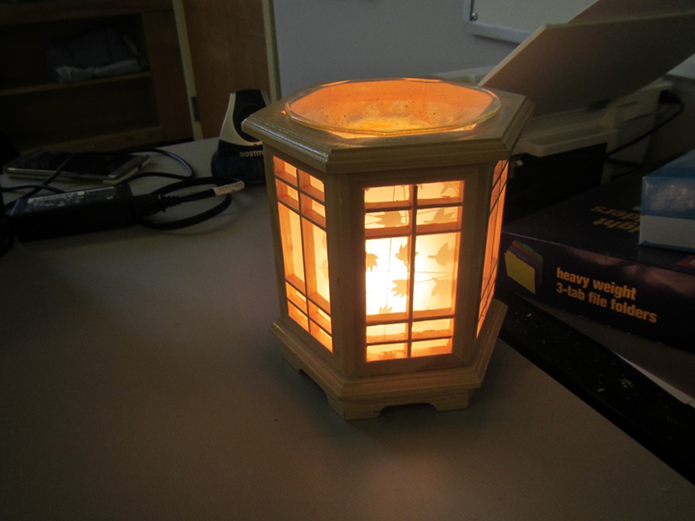
Scented candle in office area
Location | Windows  Openable | Ventilation |  | Remarks
Location | Windows  Openable | Intake | Exhaust
701 | N | Y | N | Supply blocked dryer sheets, tile floor
702 | N | Y | Y | Tile floor
703 | N | Y | N | Tile floor, DEM
703 Hallway |  |  |  | MT’s > 10
704 | N | Y | Y | Tile floor
711 | Y | Y | Y | WD CT
714 |  |  |  | Ajar CTs, dust/debris on vents
715 | Y | Y | Y | Odor
716 Guidance Suite |  |  |  | Dust/debris on vents, 3 WD CTs
720
723 | Y | Y | Y | Sink
724 | Y | Y | Y | WD and missing tiles, sink
Auditorium | N | Y | Y | No odor detected
Cafeteria | Y some | Y | Y | NC, large steel girders, overhead ductwork and exposed brick
Sick Bay |  |  |  | 1 WD CT
810
811 |  |  |  | WD CT
812 |  |  |  | Missing floor tiles, WD CT around vent
813 | Y open | Y | Y
816 |  |  |  | Missing floor tiles
817 | Y open | Y | Y | WAC not in window, sink, missing floor tiles
818
819 | Y open | Y | Y | Sink
820 |  |  |  | Missing floor tiles
821 | Y open | Y | Y | NC
851
852 |  |  |  | Missing/damaged floor tiles, dust/debris on vents
853 | Y open | Y | Y | Acoustical wall panels, classroom tiered, books, NC
854
855 | Y open | Y | Y | Books stored under sink, NC
856 |  |  |  | PF
857 | Y open | Y | Y | Paper stored under sink, WAC with dirty filter
858
859 | Y open | Y | Y | NC, roof puddles visible through window
860
861 Hallway |  |  |  | WD CP/CT
Boys Restroom | N | N | Y | Dusty vent
Girls Restroom | N | N | Y | Small water stain on ceiling
Women’s Restroom |  |  | Y | WD CT around vent
901 |  |  |  | 4 WD CT, dust/debris on vents, PF
903 Computer Lab
904 | Y | Y | Y
906 | Y | Y | Y | NC, WD CT,
907 |  |  |  | Dust/debris on vents, cobwebs corner
908 | Y | Y | Y | Missing floor tiles
909 |  |  |  | Numerous WD CTs
910 | Y | Y | Y | WD CT (3), sink
911 | Y open | Y | Y
912 | Y | Y | Y | Sink
Boys Restroom | N | N | Y
Girls Restroom | N | N | Y
Girls Restroom | Y | N | Y
Stairwell | Y | N | Y | MT

Location | Carbon  Dioxide  (ppm) | Carbon Monoxide  (ppm) | Temp  (°F) | Relative  Humidity  (%) | PM2.5  (µg/m³) | Occupants  in Room | Windows  Openable | Ventilation |  | Remarks
 |  |  |  |  |  |  |  | Supply | Exhaust | Remarks
Background | 339 | ND | 35 | 44 | 17 | - | - | - | -
Administration Office suite:
Main | 722 | ND | 75 | 19 | 2 | 7 | Y | Y | Y | Plants, HS
Frenette | 721 | ND | 75 | 17 | 3 | 2 | Y | Y | Y | Tile flooring
Break Room | 646 | ND | 75 | 18 | 2 | 2 | Y | Y | Y | Tile, sink backsplash needs caulking
Office 800 | 684 | ND | 75 | 18 | 3 | 1 | Y | Y | Y | WAC
Call center | 703 | ND | 75 | 18 | 2 | 0 | Y | Y | Y | DO
Third Floor:
851 | 770 | ND | 73 | 20 | 2 | 2 | Y | Y | Y | DEM, supplies
850 | 722 | ND | 73 | 18 | 2 | 0 | Y | Y | Y | DEM
852 | 733 | ND | 74 | 20 | 2 | 1 | Y | Y | Y
853 | 721 | ND | 74 | 19 | 4 | 3 | Y | Y | Y
854 | 718 | ND | 73 | 20 | 3 | 0 | Y | Y | Y
856 | 740 | ND | 74 | 20 | 4 | 4 | Y | Y | Y | DEM, PF
855 | 988 | ND | 74 | 21 | 4 | 11 | Y | Y | Y | Plants, WD CTs x 7, complaints of musty odors (none detected at this time)
858 | 1005 | ND | 75 | 22 | 4 | 22 | Y | Y | Y | DEM
857 | 872 | ND | 75 | 21 | 3 | 0 | Y | Y | Y | WAC, CPs, DEM
859 | 726 | ND | 75 | 18 | 5 | 0 | Y | Y | Y | HS, DEM
860 | 710 | ND | 75 | 20 | 3 | 9 | Y | Y | Y | DEM, Tile floor, CPs
Second Floor:
810 | 694 | ND | 73 | 19 | 4 | 0 | Y | Y | Y
811 | 679 | ND | 73 | 17 | 5 | 4 | Y | Y | Y | Tile floor, DEM, CPs
902 | 1209 | ND | 74 | 23 | 17 | 6 | Y | Y | Y | Candle, CPs, Plant
Nurse | 1274 | ND | 74 | 24 | 5 | 5 | Y | Y | Y | HS
901 | 1049 | ND | 74 | 21 | 4 | 0 | Y | Y | Y
904 | 1291 | ND | 74 | 24 | 5 | 1 | Y | Y | Y | DEM, PF
903 | 1150 | ND | 72 | 23 | 4 | 0 | Y | Y | Y
905 | 1313 | ND | 71 | 27 | 6 | 4 | Y | Y | Y | DEM, plant
906 | 1220 | ND | 71 | 25 | 5 | 0 | Y | Y | Y | Plants
908 | 1414 | ND | 71 | 27 | 4 | 0 | Y | Y | Y | DEM, plant, WD CT
911 | 1654 | ND | 71 | 31 | 6 | 1 | Y | Y | Y | DEM, WD CT
912 | 1563 | ND | 71 | 29 | 5 | 9 | Y | Y | Y | DEM, tile
910 | 1406 | ND | 71 | 27 | 4 | 0 | Y | Y | Y | Plants, DEM
First Floor:
724 | 1372 | ND | 71 | 27 | 6 | 18 | Y | Y | Y | DEM
723 | 1321 | ND | 71 | 27 | 5 | 15 | Y | Y | Y | MT, tile floor, AT
721 | 1364 | ND | 71 | 27 | 7 | 19 | Y | Y | Y | DEM
720 | 1315 | ND | 71 | 27 | 5 | 20 | Y | Y | Y | DEM, PF
717 Office Suite:
-Main Office | 1223 | ND | 72 | 24 | 4 | 2 | Y | Y | Y | CT, MT, HS
-Office 716 | 1192 | ND | 73 | 24 | 5 | 4 | Y | Y | Y
-Griffin | 1244 | ND | 74 | 23 | 4 | 2 | Y | Y | Y | HS
-Cluster 8 | 1201 | ND | 74 | 23 | 7 | 2 | Y | Y | Y | AI, PF
-Social worker | 1216 | ND | 74 | 23 | 5 | 2 | Y | Y | Y | HS
-Conference | 1172 | ND | 74 | 22 | 9 | 1 | Y | Y | Y | DO
-Facilitator 108 | 1147 | ND | 74 | 22 | 6 | 0 | Y | Y | Y
715 | 1133 | ND | 74 | 22 | 4 | 0 | Y | Y | Y | DEM, CPs
713 | 1268 | ND | 72 | 24 | 5 | 2 | Y | Y | Y | Cold temperature complaints
711 | 1243 | ND | 72 | 26 | 5 | 2 | Y | Y | Y | DEM, HS, CPs
714 | 1409 | ND | 73 | 27 | 6 | 15 | Y | Y | Y | DEM
712 | 1432 | ND | 73 | 26 | 4 | 17 | Y | Y | Y
702 | 1536 | ND | 73 | 28 | 8 | 2 | Y | Y | Y | PF, DEM
Cafeteria | 726 | ND | 73 | 21 | 11 | 65+ | Y | Y | Y
704 | 1282 | ND | 73 | 24 | 5 | 21 | Y | Y | Y | PF
701 | 1191 | ND | 73 | 23 | 3 | 0 | Y | Y | Y | HS, CPs, DEM
703 | 1526 | ND | 74 | 26 | 5 | 17 | Y | Y | Y | DEM, HS, CPs

