INDOOR AIR QUALITY REASSESSMENT

Lowell High School
Freshman Academy
40 Paige Street
Lowell, MA

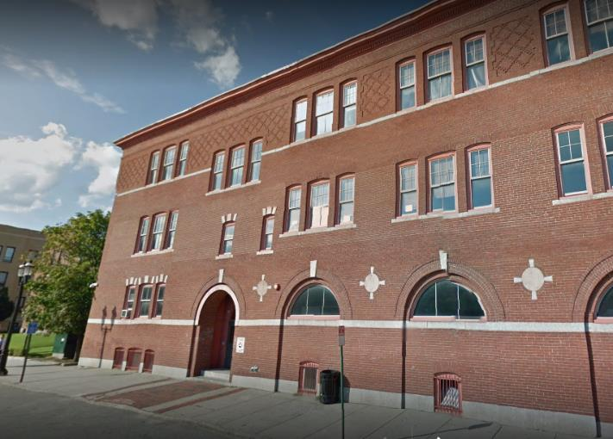

Prepared by:
Massachusetts Department of Public Health
Bureau of Environmental Health
Indoor Air Quality Program
January 2020

Background

Building: | Lowell High School, Freshman Academy (LHSFA)
Address: | 40 Paige Street, Lowell, MA
Assessment Coordinated Through: | Lowell Public School Department
Reason for Request: | Reassessment based on actions taken since the previous visit in 2017.
Date of Assessment: | January 13, 2020
Massachusetts Department of Public Health/Bureau of Environmental Health (MDPH/BEH) Staff Conducting Assessment: | Ruth Alfasso, Environmental Engineer/Inspector, Indoor Air Quality (IAQ) Program
Building Description: | The Freshman Academy building at 40 Paige Street was originally built in the 1800’s and renovated in the 1930’s and 1980’s. The three-story brick building contains classrooms, offices, laboratory spaces, an auditorium, and other spaces.
Windows: | Openable

This school was visited previously in 2017. Two visits were made: one during the summer when the school was unoccupied and again in the fall during normal occupancy. Recommendations were made in a report following each visit. The MDPH/IAQ Program returned to the school this year for a follow-up visit, in part to assess the response to recommendations made in our previous report as well as to provide further recommendations to improve IAQ. Appendix A shows recommendations from both 2017 reports. In addition, the LHS complex will be undergoing significant renovations over the next several years. Recommendations included in this report will also address planning for renovation-related issues.

Methods
Please refer to the IAQ Manual for methods, sampling procedures, and interpretation of results (MDPH, 2015).

IAQ Testing Results
Table 1 shows indoor air testing results, which are summarized below.
- Carbon dioxide levels were above 800 parts per million (ppm) in most areas assessed, indicating a lack of air exchange in the building. Appendix B is an additional resource about carbon dioxide.
- Temperature was within the recommended range of 70°F to 78°F in all areas on the day of assessment.
- Relative humidity was below the recommended range of 40 to 60% in the areas tested which is typical during the heating season.
- Carbon monoxide levels were non-detectable in all areas tested.
- Fine particulate matter (PM2.5) concentrations measured were below the National Ambient Air Quality (NAAQS) limit of 35 μg/m³ in all areas tested.

Ventilation
A heating, ventilating, and air conditioning (HVAC) system has several functions. First it provides heating and, if equipped, cooling. Second, it is a source of fresh air. Finally, an HVAC system will dilute and remove normally occurring indoor environmental pollutants by not only introducing fresh air, but by filtering the airstream and ejecting stale air to the outdoors via exhaust ventilation. Even if an HVAC system is operating as designed, point sources of respiratory irritation may exist and cause symptoms in sensitive individuals.
Ventilation for the Freshman Academy is provided by a single air-handling unit (AHU) located on the roof. The amount of fresh air drawn into the units is controlled by moveable louvers connected to an activator motor to alter fresh air intake to help maintain temperature. Fresh air is distributed via ductwork connected to ceiling or wall-mounted diffusers in classrooms (Picture 1). Exhaust ventilation is provided by ceiling or wall-mounted grates (Picture 2) that return air back to the AHU via ductwork.
Based on air testing results, most classrooms with normal occupancy appear to have a lack of air exchange provided by the HVAC system in its current operating mode. Given the age and operation of the existing HVAC system, it may be necessary to use windows to supplement fresh air supply for classrooms where available. Although these slightly elevated levels of carbon dioxide are not hazardous, it indicates that normally occurring indoor air pollutants (e.g., odors, water vapor, and VOCs) may accumulate in these rooms. Some exhaust vents were also not functioning at the time of the assessment.
The HVAC systems should be regularly maintained and operate continuously during occupied hours. It may be possible to adjust the HVAC system to allow more fresh air into the system, e.g. by opening supply louvers or adjusting the proportion of air exhausted rather than recirculated. Exhaust ventilation should also be checked periodically to ensure a draw of air from classrooms, restrooms and other areas. In one classroom, the supply vent was blocked with duct tape (Picture 3) due to occupant concerns about drafts. In order to function properly, supply and exhaust/return vents should be unblocked.
In order to have proper ventilation with a mechanical supply and exhaust system, these systems must be balanced to provide an adequate amount of fresh air while removing stale air from a room. It is recommended that existing ventilation systems be re-balanced every five years to ensure adequate air systems function (SMACNA, 1994). It is unknown the last time these systems were balanced.

Microbial/Moisture Concerns
Water-damaged ceiling tiles and ceiling plaster were observed in some classrooms, offices, and hallways (Pictures 4 through 6; Table 1). Water-damaged ceiling tiles should be replaced after the leak is found and repaired. Some stained tiles resulted from historic leaks while others represent new or ongoing leaking from the roof, plumbing or HVAC system. Note that the dark stains in Picture 6 are reported to result from a leak of coolant (glycol) from the HVAC system, which may encourage mold growth. Many ceiling tiles had also been removed due to leaks. In particular, sections of tiles had been removed in the hallway. Ceiling tiles used in the hallway are interlocked, so it is very difficult to replace individual damaged tiles. Facilities staff is working on a plan to replace some of these interlocking tiles in hallways with a newer style that will be easier to replace as needed.
In general, ceiling tiles have an open space above them (the ceiling plenum) and tend to dry out quickly, reducing the chance for mold colonization. Ceiling plaster does not contain organic material; therefore, it will not support microbial growth even when frequently moistened. In some cases, dust or paint on the surface of plaster can become mold colonized. If this occurs, plaster can often be cleaned to remove the mold.
Roof leaks reportedly account for many of the observed water damage in the building. It is reported that as sections of the roof are repaired, other sections become damaged. Some leaks are in areas which suggest that flashing around windows, skylights and other penetrations are damaged and should be repaired. Water was also observed pooling on sections of the roof (Picture 7). This indicates that the roof is not draining properly. Pooling water can damage the roof membrane due to freezing and thawing action during winter months.
Measures should be taken to ensure water-damaged materials are cleaned, replaced, and/or repaired in a manner consistent with the U.S. Environmental Protection Agency’s guidelines (US EPA, 2008). The US EPA and the American Conference of Governmental Industrial Hygienists (ACGIH) recommend that porous materials (e.g., ceiling tiles, gypsum wallboard) be dried with fans and heating within 24 to 48 hours of becoming wet (US EPA, 2008; ACGIH, 1989). If not dried within this time frame they should be removed/discarded.
Indoor plants were observed in some areas (Picture 8). Plants can be a source of pollen and mold, which can be respiratory irritants to some individuals. Plants should be properly maintained and equipped with non-porous drip pans and should be located away from air diffusers to prevent the aerosolization of dirt, pollen and mold.
There appeared to be some plumbing fixtures in the LHSFA that are no longer or seldom used, including a sink in a former darkroom, toilet fixtures in what is now a janitorial closet, and some classroom sinks. When drains aren’t moistened periodically, the drain traps can dry out and allow gases from the sewer into occupied areas.
Windows open in most exterior classrooms. Open windows can be an additional source of fresh air. However, windows need to be tightly closed at the end of each day to prevent water infiltration and pest intrusion.

Other Observations
Exposure to low levels of total volatile organic compounds (TVOCs) may produce eye, nose, throat, and/or respiratory irritation in some sensitive individuals. To determine if VOCs were present, BEH/IAQ staff examined rooms for products containing VOCs. BEH/IAQ staff observed air fresheners, hand sanitizers, cleaners, and dry erase materials in use within the building (Table 1). A scent/essential oil diffuser was found in one classroom (Picture 9). All of these products have the potential to be irritants to the eyes, nose, throat, and respiratory system of sensitive individuals. Note that scented products such as air fresheners do not remove odors; they only mask odors with another scent. These products contain volatile organic compounds (VOCs) and other fragrances which may cause irritation of the eyes, nose, and respiratory system.
A set of 3-D printers and other equipment was located in the Makerspace room on the lower level (Picture 10). Apart from the laser cutter, none of this equipment has any exhaust ventilation. 3-D printers can produce plastic fumes, particulates and odors during operation and should be used in well-ventilated areas, ideally with dedicated exhaust ventilation.
In one classroom, tennis balls were used as chair glides (Picture 11). Tennis balls are made of a number of materials that are a source of respiratory irritants. Constant wearing of tennis balls can produce fibers and lead to off-gassing of VOCs. Tennis balls are made with a natural rubber latex bladder, which becomes abraded when used as a chair leg pad. Use of tennis balls in this manner may introduce latex dust into the school environment. Some individuals are highly allergic to latex (e.g., spina bifida patients) (SBAA, 2001). It is recommended that the use of materials containing latex be limited in buildings to reduce the likelihood of symptoms in sensitive individuals (NIOSH, 1998).
Other issues were noted in the LHSFA. Accumulations of pencil shavings were noted in some classrooms (Picture 12; Table 1). This material can be irritating if aerosolized. Supply and return vents, personal fans and similar equipment were dusty in some areas (Picture 13). This dust can be reaerosolized when the equipment is used.
In many areas, items, including books, papers, equipment and decorative items were observed on floors, windowsills, tabletops, counters, bookcases, and desks (Table 1), which can make it more difficult for custodial staff to clean.
Most rooms in the LHSFA are not carpeted, but some carpeting and area rugs are present in the school (Picture 14). Carpeting should be cleaned regularly using a High Efficiency Particulate Arrestance (HEPA) equipped vacuum cleaner. Area rugs that are too worn or soiled to be cleaned should be discarded. Upholstered furniture and plush items should also be cleaned regularly to remove dust, debris and odors.

Conclusions/Recommendations
The following recommendations are made to assist in improving IAQ:
- Consult Appendix A for previous recommendations from the 2017 reports that need additional work.
- Operate all supply and exhaust ventilation equipment continuously during occupied periods.
- If possible, increase fresh air supply to the AHU.
- Unblock supply ventilation. Consider relocating or changing the style of supply vents to address concerns about drafts.
- Use openable windows to supplement fresh air during temperate weather. Ensure all windows are tightly closed at the end of the day.
- Check exhaust vents for air draw periodically and repair as needed. Do not block exhaust vents with furniture or items.
- Consider adopting a balancing schedule of every 5 years for all mechanical ventilation systems, as recommended by ventilation industrial standards (SMACNA, 1994).
- Ensure roof and plumbing leaks are repaired and replace water-damaged ceiling tiles.
- Repair other water-damaged building materials (e.g., wall/ceiling plaster).
- Properly maintain plants, including drip pans, to prevent water damage to porous materials. Plants should also be located away from air diffusers to prevent the aerosolization of dirt, pollen, and mold.
- Ensure that drains for seldom-used plumbing fixtures are moistened periodically to maintain the trap seal. If fixtures are no longer needed, they should be properly abandoned (e.g. cut and capped).
- Reduce or eliminate the use of products containing VOCs (e.g., air fresheners, scented cleaning products, and hand sanitizer).
- Consider the installation of supplemental or direct exhaust ventilation for the 3-D printers in the Makerspace room.
- Replace tennis balls with latex-free chair glides.
- Ensure that all pencil sharpeners have covers and are emptied regularly to prevent distribution of irritating dusts.
- Regularly clean supply/return/exhaust vents and fans to avoid aerosolizing accumulated particulate matter.
- Consider reducing the amount of items stored in rooms to make cleaning easier. Periodically move items to clean flat surfaces.
- For buildings in New England, periods of low relative humidity during the winter are often unavoidable. Therefore, scrupulous cleaning practices should be adopted to minimize common indoor air contaminants whose irritant effects can be enhanced when the relative humidity is low. To control dusts, a high efficiency particulate arrestance (HEPA) filter equipped vacuum cleaner in conjunction with wet wiping of all surfaces is recommended. Avoid the use of feather dusters. Drinking water during the day can help ease some symptoms associated with a dry environment (throat and sinus irritation).
- HEPA vacuum carpeting daily and clean carpeting annually (or semi-annually in soiled high traffic areas). Clean area rugs similarly. Discard area rugs that are too worn or soiled to be effectively cleaned.
- Encourage faculty to report classroom/building related issues via a tracking program.
- Continue to adopt the US EPA (2000) document, “Tools for Schools”, as an instrument for maintaining a good IAQ environment in the building available at: http://www.epa.gov/iaq/schools/index.html.
- Refer to resource manual and other related IAQ documents located on the MDPH’s website for further building-wide evaluations and advice on maintaining public buildings. These documents are available at: http://mass.gov/dph/iaq.

References
ACGIH. 1989. Guidelines for the Assessment of Bioaerosols in the Indoor Environment. American Conference of Governmental Industrial Hygienists, Cincinnati, OH.
MDPH. 2015. Massachusetts Department of Public Health. “Indoor Air Quality Manual: Chapters I-III”. Available at: http://www.mass.gov/eohhs/gov/departments/dph/programs/environmental-health/exposure-topics/iaq/iaq-manual/.
NIOSH. 1998. National Institute for Occupational Safety and Health. Latex Allergy A Prevention. National Institute for Occupational Safety and Health, Atlanta, GA.
SBAA. 2001. Latex In the Home And Community Updated Spring 2001. Spina Bifida Association of America, Washington, DC.
SMACNA. 1994. HVAC Systems Commissioning Manual. 1st ed. Sheet Metal and Air Conditioning Contractors’ National Association, Inc., Chantilly, VA.
US EPA. 2000. Tools for Schools. Office of Air and Radiation, Office of Radiation and Indoor Air, Indoor Environments Division (6609J). EPA 402-K-95-001, Second Edition. http://www.epa.gov/iaq/schools/index.html.
US EPA. 2008. “Mold Remediation in Schools and Commercial Buildings”. Office of Air and Radiation, Indoor Environments Division, Washington, DC. EPA 402-K-01-001. September 2008. Available at: http://www.epa.gov/mold/mold-remediation-schools-and-commercial-buildings-guide.
Picture 1
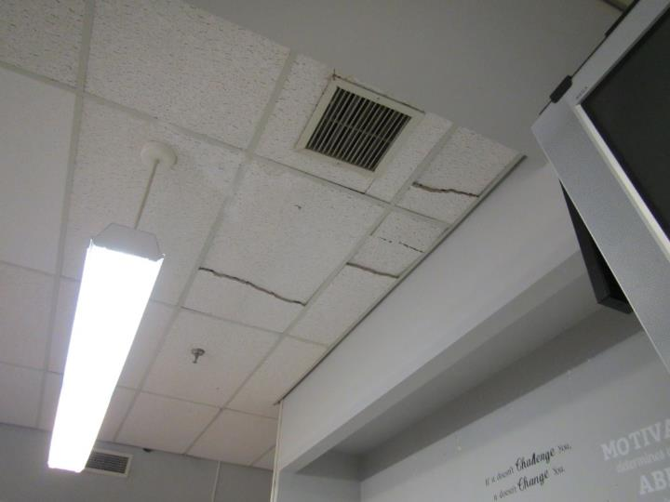
Ceiling-mounted supply vent
Picture 2
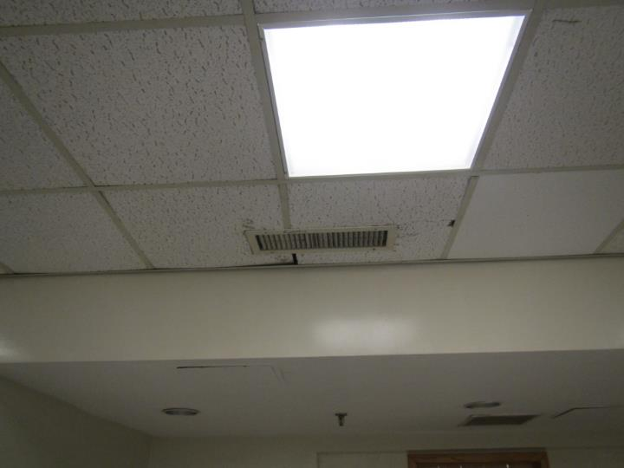
Ceiling-mounted return vent
Picture 3
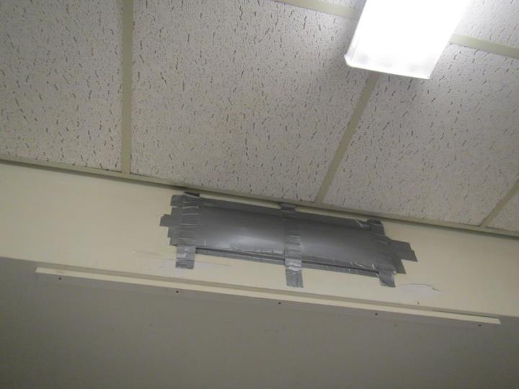
Blocked supply vent
Picture 4
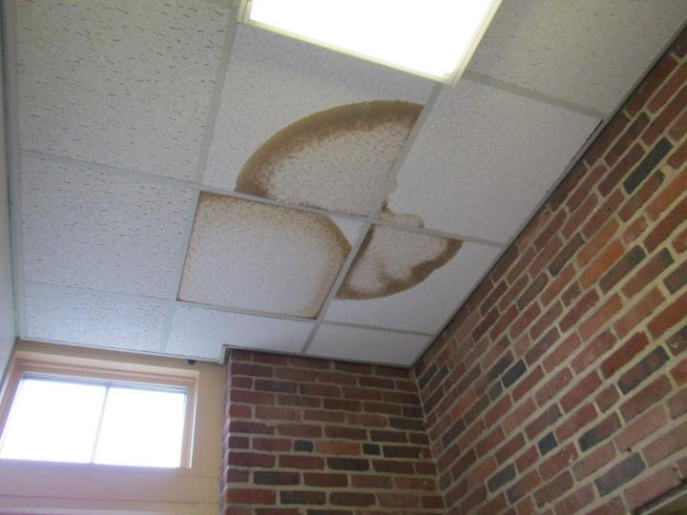
Water-damaged ceiling tiles in a stairwell
Picture 5
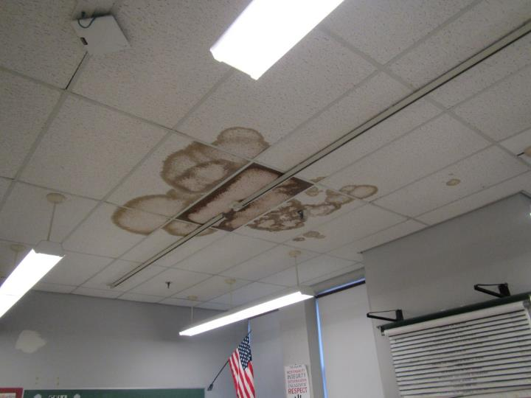
Water-damaged ceiling tiles in a classroom
Picture 6
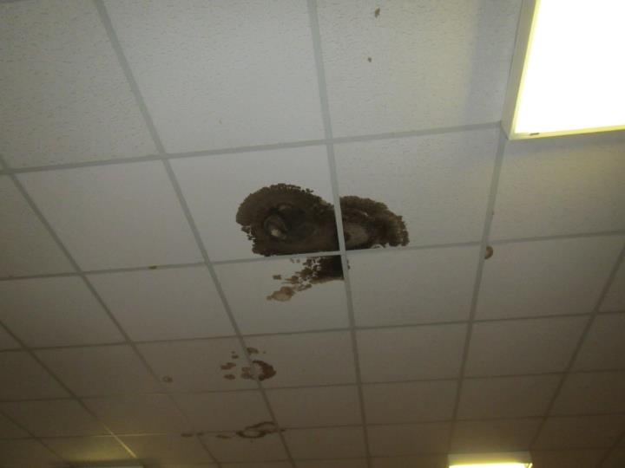
Dark staining on ceiling tiles, reportedly from a glycol leak from the HVAC system
Picture 7
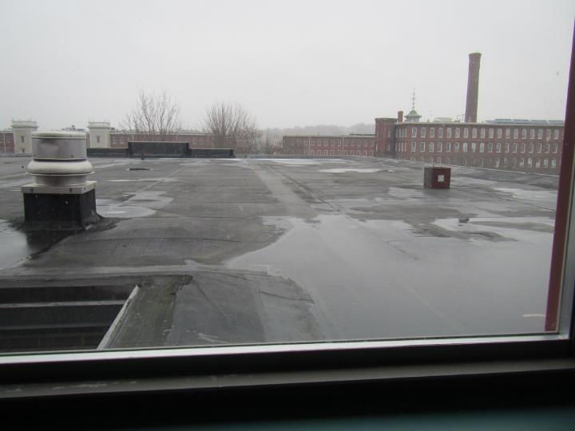
Water pooling on a lower level section of the roof
Picture 8
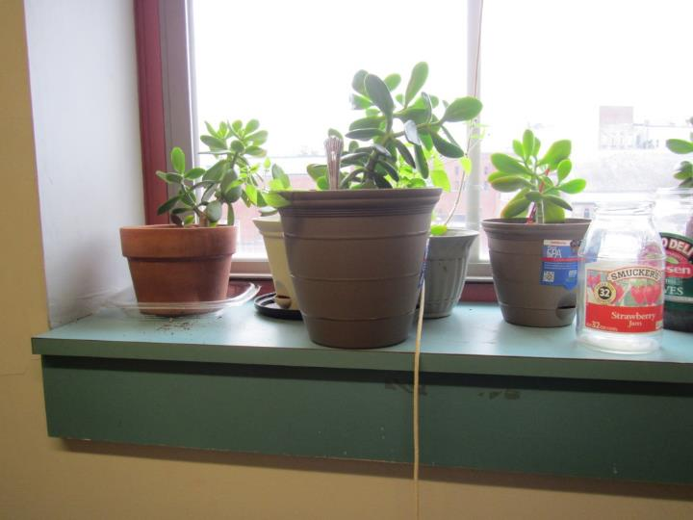
Plants on a windowsill
Picture 9
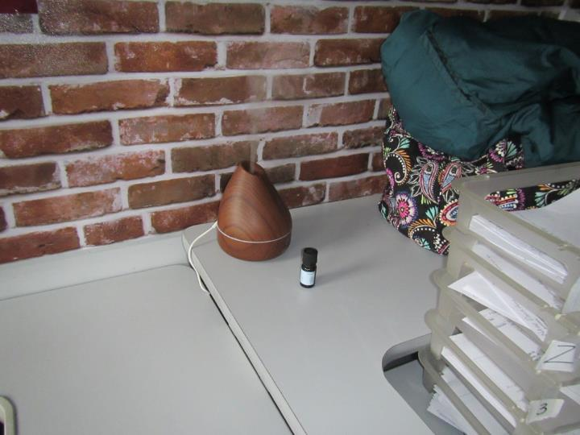
Scent diffuser in a classroom
Picture 10
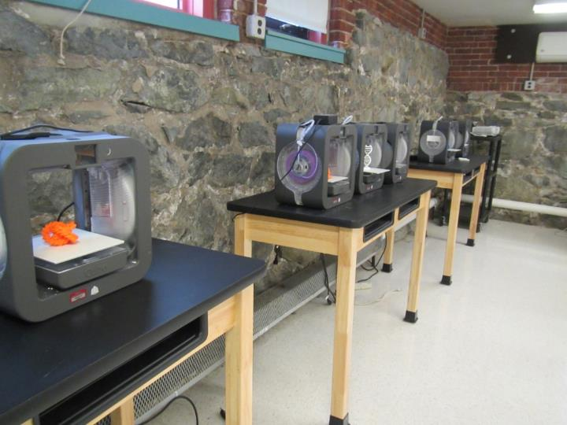
3-D printers in the Makerspace
Picture 11
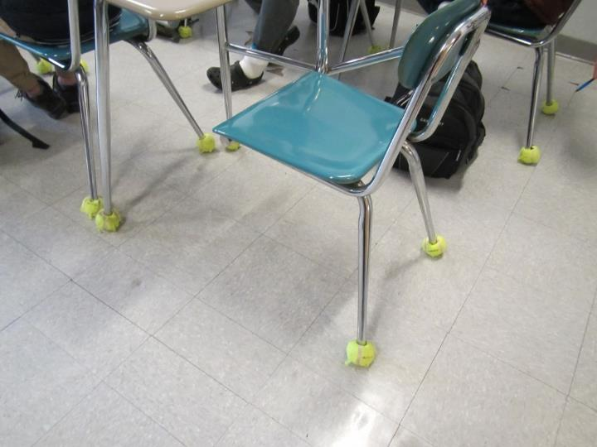
Tennis balls as chair glides
Picture 12
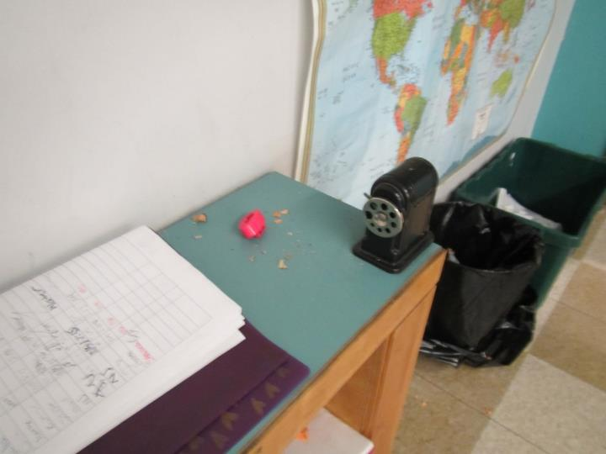
Pencil shavings
Picture 13
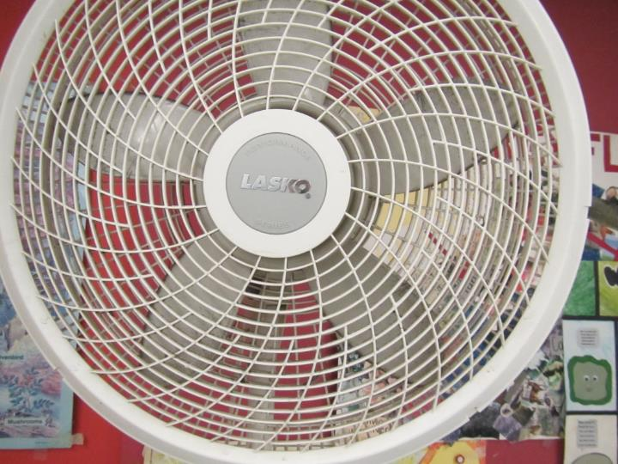
Dusty fan
Picture 14
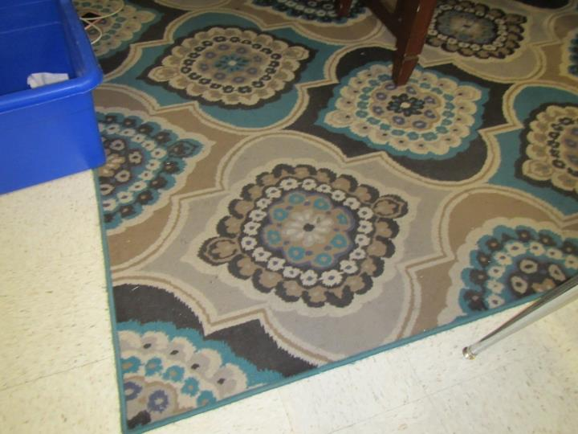
Area rug with debris
Location | Carbon  Dioxide  (ppm) | Carbon Monoxide  (ppm) | Temp  (°F) | Relative  Humidity  (%) | PM2.5  (µg/m³) | Occupants  in Room | Windows  Openable | Ventilation |  | Remarks
 |  |  |  |  |  |  |  | Supply | Exhaust
Background | 470 | ND | 44 | 40 | 7 |  |  |  |  | Flurries
Upper level
850 | 981 | ND | 73 | 27 | 4 | ~25 | Y 1 open | Y | Y | Sinks, DEM, NC, MT (wire pulling), HS
850 inner | 856 | ND | 73 | 22 | 3 | 1 | Y | Y | Y | NC, WAC
853 | 933 | ND | 74 | 24 | 4 | 18 | Y 1 open | Y | Y | DEM, MT, HS
852 | 924 | ND | 73 | 24 | 4 | 3 | N | Y | Y | NC
852 inner workroom | 983 | ND | 74 | 24 | 3 | 0 | Y 1 open | Y | Y | NC, fridge, sink
janitor (old restroom) | 901 | ND | 74 | 26 | 9 | 0 | N | N | ? | NC, toilet and sink (unused?), CP and pesticides
854 rear | 794 | ND | 74 | 20 | 2 | 0 | Y | Y | Y | plants, 2 WD CT
police office | 789 | ND | 75 | 20 | 3 | 1 | Y | Y | Y | plants, 2 WD CT (recent), NC, items
staff restroom |  |  |  |  |  |  |  |  | Y | NC
855 | 900 | ND | 74 | 22 | 13 | 1 | Y | Y | Y | NC, DEM
856 | 953 | ND | 74 | 22 | 4 | 0 | Y 1 open | Y | Y | NC, DEM, sink
858 | 946 | ND | 75 | 22 | 5 | 15 | Y | Y | Y | NC, DEM
857 | 984 | ND | 75 | 23 | 5 | 20 | Y 1 open | Y | Y | NC, DEM, sinks
860 | 789 | ND | 75 | 20 | 3 | 0 | Y | Y | Y | Many WD CT, NC
859 | 740 | ND | 74 | 21 | 2 | 0 | Y | Y | Y | 3 WD CT, HS, NC
First floor
823 | 720 | ND | 75 | 20 | 2 | 0 | Y | Y | Y | microwave, NC, HS, CP
821 | 900 | ND | 76 | 23 | 3 | 0 | Y | Y | Y | sink - dripping, NC, fridge, DEM
820 | 1139 | ND | 77 | 25 | 3 | 18 | Y | Y | Y | NC - missing floor tiles, PC, DEM, sink
818 | 1130 | ND | 77 | 25 | 5 | 20 | Y | Y | Y | NC, DEM, sink
819 | 1139 | ND | 77 | 24 | 4 | 25 | Y | Y | Y | DEM, NC, PF, plant, microwave, missing floor tiles
817 | 1248 | ND | 77 | 26 | 3 | 22 | Y | Y | Y | NC, sink dripping, fridge, DEM, missing floor tiles
816 | 1030 | ND | 77 | 20 | 2 | 1 | Y | Y | Y | Sink, NC, chalk, NC, missing floor tiles
women’s restroom |  |  |  |  |  |  |  |  | Y
813 | 1037 | ND | 77 | 21 | 7 | 13 | Y | Y | Y | NC, DEM, missing floor tiles
812 | 1063 | ND | 76 | 21 | 9 | 25 | Y 1 open | Y | Y | DEM, scent diffuser
nurses restroom |  | ND |  |  |  |  |  | Y |  | WD CT, CP/AF
810 computer lab | 988 | ND | 77 | 22 | 4 | 20 | Y 1 open | Y | Y | Computers, NC
811 | 970 | ND | 76 | 21 | 5 | 10 | Y |  | Y | small room, TBS, PF, DEM, area rug
902 | 1012 | ND | 75 | 22 | 6 | 1 | Y | N | Y | DEM, HS, PF, 1 WD CT, WD plaster
902A nurse | 1001 | ND | 73 | 23 | 6 | 2 | Y | Y | Y | NC
nurse’s office | 948 | ND | 73 | 23 | 5 | 0 | N | Y | N | sink, 6 WD CT and 1 MT
901 | 902 | ND | 73 | 22 | 4 | 0 | Y | Y | Y | science equipment: sinks, stove, NC, DEM
903 | 924 | ND | 72 | 23 | 6 | 0 | Y | Y | Y | computers, MTs and WD CT, NC
904 | 1099 | ND | 73 | 26 | 9 | 0 | Y | Y | Y | 5 WD CT, NC, PF, DEM
905 | 1084 | ND | 73 | 24 | 6 | 0 | Y | Y | Y | DEM, NC, sink
906 | 1049 | ND | 73 | 25 | 5 | 1 | Y | Y | Y | NC, DEM, books
908 | 1008 | ND | 74 | 26 | 16 | class left 10 min | Y | Y | Y | DEM, PF, NC, missing floor tiles
906 | 1159 | ND | 74 | 27 | 19 | 0 | Y | Y | Y | DEM, NC
909 | 1087 | ND | 72 | 26 | 8 | 1 | Y | Y | Y | DEM, PF, WD CT
911 | 1273 | ND | 71 | 27 | 5 | 0 | Y | Y | Y | DEM, sink, plants
912 | 1118 | ND | 71 | 26 | 15 | 16 | Y | Y | Y | WD CT, DEM, NC, sink
910 | 1191 | ND | 71 | 28 | 9 | class just left | Y | Y | Y | DEM, NC, heater, sink, PS
724 | 1047 | ND | 73 | 27 | 6 | 0 | Y | Y | Y | DEM, WD CT, MT
720 | 935 | ND | 73 | 25 | 5 | 0 | Y open | Y | Y | DEM, sink, PF
723 | 1044 | ND | 71 | 26 | 5 | 0 | Y | Y | Y | DEM, sink, NC
721 | 1070 | ND | 72 | 26 | 10 | 0 | Y | Y | Y | NC, DEM, chalk, PS
717 | 977 | ND | 73 | 25 | 5 | 1 | Y | Y | Y | PC, food odor, WD CT
717 inner | 986 | ND | 73 | 25 | 5 | 4 | Y | Y? | Y | dishwasher, sink
716 storage | 917 | ND | 73 | 23 | 4 | 1 | N | Y | Y | PF on
715 | 1066 | ND | 74 | 26 | 5 | 10 | Y | Y | Y | NC, DEM
711 | 1061 | ND | 73 | 25 | 8 | 1 | Y | Y | Y | NC, DEM, UF, are rug
713 | 1122 | ND | 73 | 26 | 8 | 0 | Y | Y | Y | NC, DEM, area rug, UF, has restroom inside
714 | 1086 | ND | 74 | 26 | 7 | 23 | Y | Y | Y | NC, DEM, has restroom
712 | 1069 | ND | 74 | 24 | 4 | 21 | Y | Y | Y
storage | 882 | ND | 74 | 23 | 4 | 0 | N
107 conference | 926 | ND | 73 | 23 | 4 | 1 | Y
Mrs. Jeffrey | 845 | ND | 72 | 23 | 6 | 1 | Y | Y | Y
109 | 848 | ND | 73 | 23 | 14 | 1 | Y | Y | Y | PF, usually too hot
Ms. G | 893 | ND | 73 | 23 | 4 | 1 | Y | Y | Y | PF on
112 | 888 | ND | 73 | 23 | 4 | 0 | Y | Y | Y | sink
women’s restroom |  |  |  |  |  |  |  |  | Y | restroom odors
main office | 853 | ND | 74 | 23 | 3 | 4 | Y | Y | Y | WAC
Main office call center | 828 | ND | 75 | 23 | 4 | 0 | Y | Y | Y | fridge and microwave
Main office conference | 831 | ND | 75 | 23 | 3 | 0 | N | Y | Y | sink
Main office conference/office | 823 | ND | 76 | 23 | 3 | 0 | Y | Y | Y | DEM
Main office (office) | 823 | ND | 75 | 23 | 3 | 1 | Y | Y | Y | Pop up AF, DEM
Main office (office) | 834 | ND | 75 | 22 | 3 | 1 | Y | Y | Y
Lower Level
706 cafeteria | 933 | ND | 73 | 29 | 4 | 3 | N | Y | Y | first lunch just left
704 | 891 | ND | 74 | 25 | 5 | 1 | N | Y | Y | DEM, PF
702 | 896 | ND | 75 | 24 | 4 | 1 | N | Y | Y | DEM, PF
701 | 1067 | ND | 76 | 27 | 4 | 21 | N | Y | Y | broken pipe in room previously, wall opened, cleaned, no current odor
703 | 1495 | ND | 76 | 28 | 4 | 21 | N | Y | Y | vent blocked
Auditorium | 724 | ND | 73 | 21 | 3 | 0 | N | Y | Y | carpet, UF
700 | 752 | ND | 73 | 24 | 3 | 0 | Y? | Y | Y | NC, 3D printers, laser cutters, etc.

APPENDIX A
Previous Recommendations

Conclusions/Recommendations from the visit made in July of 2017
The following recommendations are made to assist in improving IAQ:
- Operate all supply and exhaust ventilation equipment continuously during occupied periods.
- Remove dryer sheets from supply vents.
- Use openable windows to supplement fresh air during temperate weather. Ensure all windows are tightly closed at the end of the day.
- Check exhaust vents for air draw periodically and repair as needed. Do not block exhaust vents with furniture or items.
- Consider adopting a balancing schedule of every 5 years for all mechanical ventilation systems, as recommended by ventilation industrial standards (SMACNA, 1994).
- Consider working with a roofing contractor to examine methods of pitching roof towards drains to prevent water pooling.
- Ensure roof and plumbing leaks are repaired and replace water-damaged ceiling tiles.
- Repair other water-damaged building materials (e.g., wall/ceiling plaster).
- Repair sink backsplashes to prevent water damage. Refrain from storing porous items or large amounts of items under sinks.
- Repair broken plumbing fixtures, or ensure water is turned off to prevent leaks.
- Ensure that condensation from air conditioning equipment is draining properly. Check collector pans, piping and any associated pumps for clogs and leaks and clean periodically to prevent stagnant water build-up and remove debris that may provide a medium for microbial growth.
- Use pleated filters of MERV 8 in AHUs, if these can be used with the current equipment. Ensure filters are changed 2 to 4 times a year. Thoroughly clean inside of AHU cabinets during filter changes.
- Regularly clean/vacuum supply, exhaust/return vents and fans to avoid aerosolizing accumulated particulate matter. If soiled ceiling tiles around vents cannot be cleaned, replace.
- Clean window air conditioner filters prior to and periodically during the cooling season.
- Clean carpeting and area rugs regularly and discard those that are worn out or too soiled to be cleaned.
- Encourage faculty to report classroom/building related issues via a tracking program.
- Continue to adopt the US EPA (2000) document, “Tools for Schools”, as an instrument for maintaining a good IAQ environment in the building available at: http://www.epa.gov/iaq/schools/index.html.
- Refer to resource manual and other related IAQ documents located on the MDPH’s website for further building-wide evaluations and advice on maintaining public buildings. These documents are available at: http://mass.gov/dph/iaq.

Conclusions/Recommendations from the visit made in December of 2017
The following recommendations are made to assist in improving IAQ:
- Operate all supply and exhaust ventilation equipment continuously during occupied periods.
- Increase fresh air supply to HVAC units serving areas with elevated carbon dioxide (Table 2).
- Use openable windows to supplement fresh air during temperate weather. Ensure all windows are tightly closed at the end of the day.
- Check exhaust vents for air draw periodically and repair as needed. Do not block exhaust vents with furniture or items.
- Consider adopting a balancing schedule of every 5 years for all mechanical ventilation systems, as recommended by ventilation industrial standards (SMACNA, 1994).
- Ensure roof and plumbing leaks are repaired and replace water-damaged ceiling tiles.
- Repair other water-damaged building materials (e.g., wall/ceiling plaster).
- Reduce or eliminate the use of products containing VOCs (e.g., air fresheners, scented cleaning products, and hand sanitizer).
- Properly maintain plants, including drip pans, to prevent water damage to porous materials. Plants should also be located away from air diffusers to prevent the aerosolization of dirt, pollen, and mold.
- Investigate rooms with temperature complaints to provide for adequate comfort of occupants and prevent negative perception of building IAQ.
- Continue to implement the remaining recommendations from the preliminary walkthrough report (MDPH, 2017).
- Encourage faculty to report classroom/building related issues via a tracking program.
- Continue to adopt the US EPA (2000) document, “Tools for Schools”, as an instrument for maintaining a good IAQ environment in the building available at: http://www.epa.gov/iaq/schools/index.html.
- Refer to resource manual and other related IAQ documents located on the MDPH’s website for further building-wide evaluations and advice on maintaining public buildings. These documents are available at: http://mass.gov/dph/iaq.

