INDOOR AIR QUALITY ASSESSMENT
Lowell High School
Freshman Academy
40 Paige Street
Lowell, MA
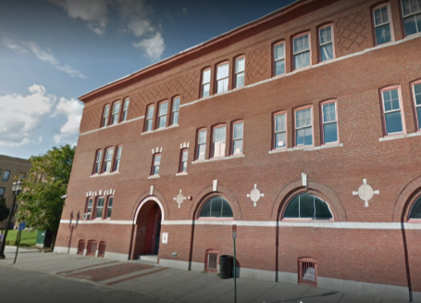
Prepared by:
Massachusetts Department of Public Health
Bureau of Environmental Health
Indoor Air Quality Program
August 2017

Background

Building: | Lowell High School, Freshman Academy
Address: | 40 Paige Street, Lowell, MA
Assessment Coordinated Through: | Lowell Public School Department
Reason for Request: | General Indoor Air Quality (IAQ) concerns. Note that this represents a preliminary walkthrough of the building. Additional visits, including air testing, will be conducted during the school year when the buildings are occupied.
Date of Assessment: | July 26, 2017
Massachusetts Department of Public Health/Bureau of Environmental Health (MDPH/BEH) Staff Conducting Assessment: | Mike Feeney Director, IAQ Program;  Cory Holmes, Environmental Analyst,  Jason Dustin, Environmental Analyst, and  Ruth Alfasso, Environmental Engineer
Building Description: | The Freshman Academy building at 40 Paige Street was originally built in the 1800’s and renovated in the 1930’s and 1980’s. The three-story brick building contains classrooms, offices, laboratory spaces, an auditorium, and other spaces.
Windows: | Openable

Ventilation
A heating, ventilating, and air conditioning (HVAC) system has several functions. First it provides heating and, if equipped, cooling. Second, it is a source of fresh air. Finally, an HVAC system will dilute and remove normally occurring indoor environmental pollutants by not only introducing fresh air, but by filtering the airstream and ejecting stale air to the outdoors via exhaust ventilation. Even if an HVAC system is operating as designed, point sources of respiratory irritation may exist and cause symptoms in sensitive individuals.
Note that during this preliminary site assessment no indoor air testing was performed and the building was mostly unoccupied. However, components of the HVAC were examined and are described here.
Ventilation for the Freshman Academy is provided by a single air-handling unit (AHU) located on the roof (Picture 1). Fresh air is distributed via ductwork connected to ceiling or wall-mounted diffusers in classrooms (Pictures 2 and 3). The amount of fresh air drawn into the units is controlled by moveable louvers connected to an activator motor to alter fresh air intake to help maintain temperature. Exhaust ventilation is provided by ceiling or wall-mounted grates that return air back to the AHU via ductwork.
In order to have proper ventilation with a mechanical supply and exhaust system, these systems must be balanced to provide an adequate amount of fresh air while removing stale air from a room. It is recommended that existing ventilation systems be re-balanced every five years to ensure adequate air systems function (SMACNA, 1994). It is unknown the last time these systems were balanced.

Microbial/Moisture Concerns
Water-damaged ceiling tiles and ceiling plaster were observed in some classrooms, offices, and hallways (Pictures 4 through 6; Table 3). Such damage indicates leaks from the building envelope or plumbing system. Water-damaged ceiling tiles should be replaced after the leak is found. In general, ceiling tiles have an open space above them (the ceiling plenum) and tend to dry out quickly, reducing the chance for mold colonization. Ceiling plaster does not contain organic material; therefore, it will not support microbial growth even when frequently moistened. In some cases, dust or paint on the surface of plaster can become mold colonized. If this occurs, plaster can often be cleaned to remove the mold.
Measures should be taken to ensure water-damaged materials are cleaned, replaced, and/or repaired in a manner consistent with the U.S. Environmental Protection Agency’s guidelines (US EPA, 2008). The US EPA and the American Conference of Governmental Industrial Hygienists (ACGIH) recommend that porous materials (e.g., ceiling tiles, gypsum wallboard) be dried with fans and heating within 24 to 48 hours of becoming wet (US EPA, 2008; ACGIH, 1989). If not dried within this time frame they should be removed/discarded.
Water was observed pooling on sections of the roof (Pictures 7 and 8). This indicates that the roof is not draining properly. Pooling water can damage the roof membrane because freezing and thawing action during winter months can lead to leakage. In several areas, the roof membrane was found damaged/detached (Pictures 9 and 10).
Windows open in most exterior classrooms. Open windows can be an additional source of fresh air. However, windows need to be tightly closed at the end of each day to prevent water infiltration and pest intrusion.
Some areas in the buildings are equipped with central air conditioning. Doors between air-conditioned and non-air-conditioned areas should be kept closed to prevent condensation from forming when chilled air mixes with humid air.
A few other areas were equipped with portable or window air conditioners. It is important that these units have the ability to properly drain any condensation they generate so that it does not leak and moisten building materials.
Sinks were observed in a number of classrooms. In a few areas, the backsplashes were unsealed (Table 3) which can lead to water damage to building materials. Some bathroom sinks were dripping and could not be shut off. Other fixtures, including toilets, urinals, and water fountains were found covered or labeled out of order (Picture 11). Leaking plumbing can be a source of moisture to classroom materials and the indoor environment, particularly when outdoor humidity is high. Some sinks examined also had porous items such as books and paper (Picture 12) stored inside the sink cabinet, which is a moist environment that can cause damage to items.

Other Observations
In a few areas of the basement, supply vents were covered/obstructed with what appeared to be dryer sheets (Picture 13). Air vents should remain unobstructed. In addition, dryer sheets contain chemical components that can be eye and respiratory irritants.
Equipment such as window and portable air conditioners and personal air filters are equipped with filters that need to be cleaned or changed. One window air conditioner filter was examined and found to be caked with dust (Picture 14). Dust can be a source of irritants and allergens in the indoor environment.
Filters for the AHU should be changed in accordance with manufacturer’s instructions (e.g., two to four times a year). The MDPH recommends pleated filters with a Minimum Efficiency Reporting Value (MERV) of 8, which are adequate for filtering out pollen and mold spores (ASHRAE, 2012). Note, although the AHUs appeared to have good/pleated filters, the interior of the units had accumulated dust/debris (Pictures 15 and 16) and should be cleaned out thoroughly (e.g., during regular filter changes).
Many classrooms had personal fans. Some of these had dusty blades (Table 3). Many supply and exhaust vents were also observed to be dusty (Picture 3, Table 3).
A few areas are carpeted. Carpets should be cleaned annually (or semi-annually in soiled/high traffic areas) in accordance with Institute of Inspection, Cleaning and Restoration Certification (IICRC) recommendations, (IICRC, 2012).

Conclusions/Recommendations
The following recommendations are made to assist in improving IAQ:
- Operate all supply and exhaust ventilation equipment continuously during occupied periods.
- Remove dryer sheets from supply vents.
- Use openable windows to supplement fresh air during temperate weather. Ensure all windows are tightly closed at the end of the day.
- Check exhaust vents for air draw periodically and repair as needed. Do not block exhaust vents with furniture or items.
- Consider adopting a balancing schedule of every 5 years for all mechanical ventilation systems, as recommended by ventilation industrial standards (SMACNA, 1994).
- Consider working with a roofing contractor to examine methods of pitching roof towards drains to prevent water pooling.
- Ensure roof and plumbing leaks are repaired and replace water-damaged ceiling tiles.
- Repair other water-damaged building materials (e.g., wall/ceiling plaster).
- Repair sink backsplashes to prevent water damage. Refrain from storing porous items or large amounts of items under sinks.
- Repair broken plumbing fixtures, or ensure water is turned off to prevent leaks.
- Ensure that condensation from air conditioning equipment is draining properly. Check collector pans, piping and any associated pumps for clogs and leaks and clean periodically to prevent stagnant water build-up and remove debris that may provide a medium for microbial growth.
- Use pleated filters of MERV 8 in AHUs, if these can be used with the current equipment. Ensure filters are changed 2 to 4 times a year. Thoroughly clean inside of AHU cabinets during filter changes.
- Regularly clean/vacuum supply, exhaust/return vents and fans to avoid aerosolizing accumulated particulate matter. If soiled ceiling tiles around vents cannot be cleaned, replace.
- Clean window air conditioner filters prior to and periodically during the cooling season.
- Clean carpeting and area rugs regularly and discard those that are worn out or too soiled to be cleaned.
- Encourage faculty to report classroom/building related issues via a tracking program.
- Continue to adopt the US EPA (2000) document, “Tools for Schools”, as an instrument for maintaining a good IAQ environment in the building available at: http://www.epa.gov/iaq/schools/index.html.
- Refer to resource manual and other related IAQ documents located on the MDPH’s website for further building-wide evaluations and advice on maintaining public buildings. These documents are available at: http://mass.gov/dph/iaq.

References
ACGIH. 1989. Guidelines for the Assessment of Bioaerosols in the Indoor Environment. American Conference of Governmental Industrial Hygienists, Cincinnati, OH.
ASHRAE. 2012. American Society of Heating, Refrigeration and Air Conditioning Engineers (ASHRAE) Standard 52.2-2012 -- Method of Testing General Ventilation Air-Cleaning Devices for Removal Efficiency by Particle Size (ANSI Approved).
IICRC. 2012. Institute of Inspection, Cleaning and Restoration Certification. Carpet Cleaning: FAQ. Retrieved from http://www.iicrc.org/consumers/care/carpet-cleaning.
SMACNA. 1994. HVAC Systems Commissioning Manual. 1st ed. Sheet Metal and Air Conditioning Contractors’ National Association, Inc., Chantilly, VA.
US EPA. 2000. Tools for Schools. Office of Air and Radiation, Office of Radiation and Indoor Air, Indoor Environments Division (6609J). EPA 402-K-95-001, Second Edition. http://www.epa.gov/iaq/schools/index.html.
US EPA. 2008. Mold Remediation in Schools and Commercial Buildings. US Environmental Protection Agency, Office of Air and Radiation, Indoor Environments Division, Washington, D.C. EPA 402-K-01-001. http://www.epa.gov/mold/mold-remediation-schools-and-commercial-buildings-guide.
Picture 1
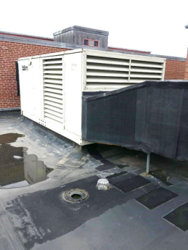
Rooftop air handling unit (AHU)
Picture 2
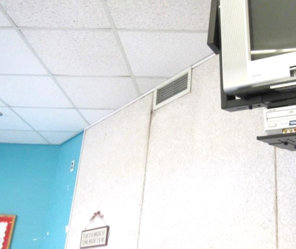
Wall-mounted supply diffuser (arrow)
Picture 3
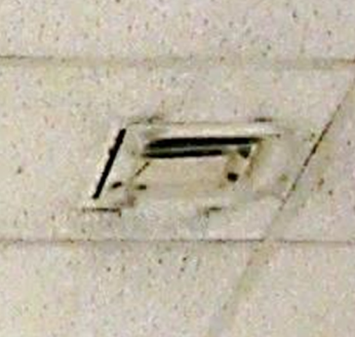
Ceiling-mounted supply diffuser, note accumulated dust/debris on louvers/ceiling tiles
Picture 4
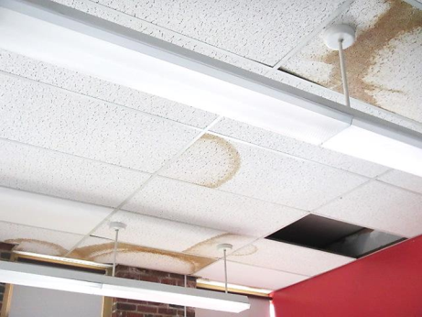
Water-damaged and missing ceiling tiles
Picture 5
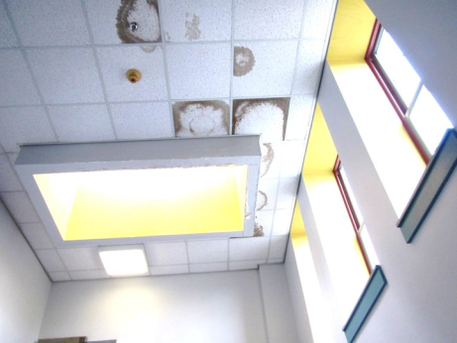
Water-damaged ceiling tiles next to skylight
Picture 6
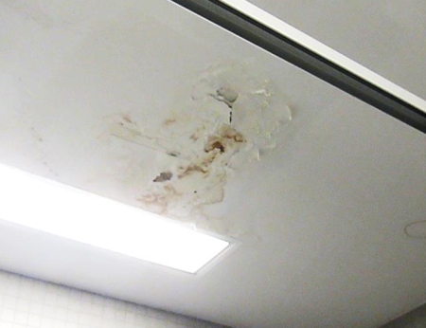
Water-damaged ceiling plaster
Picture 7
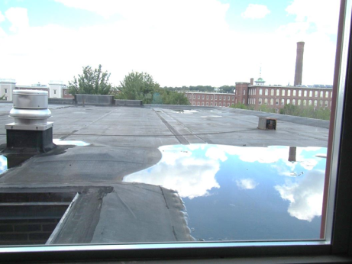
Water pooling on roof
Picture 8
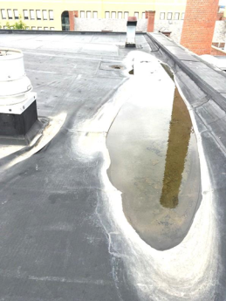
Water pooling on roof
Picture 9
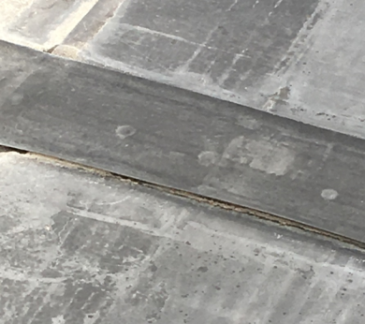
Detached roof membrane
Picture 10
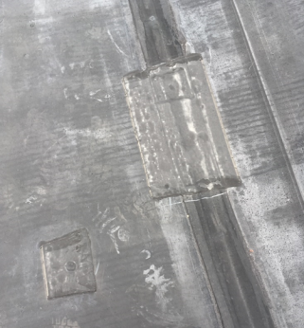
Detached roof patches
Picture 11
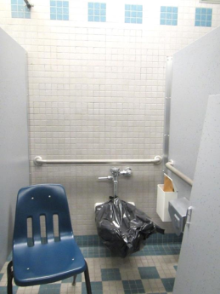
Broken toilet
Picture 12
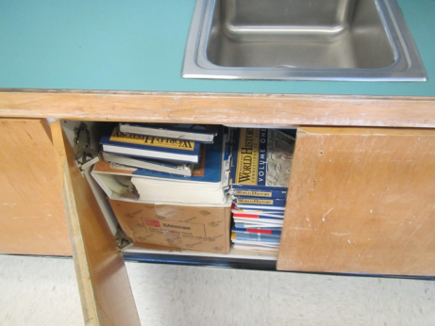
Books stored under sink
Picture 13
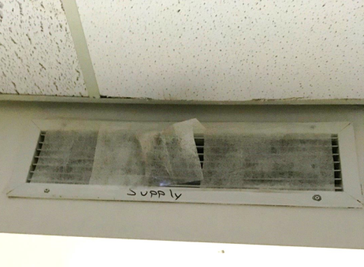
Dryer sheets on supply vent
Picture 14
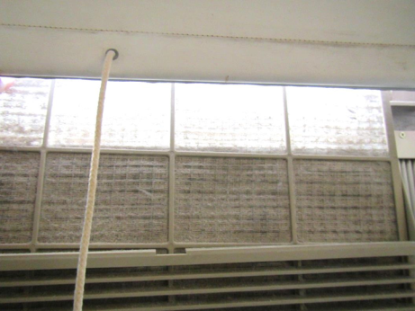
Very dusty window air conditioner filter
Picture 15
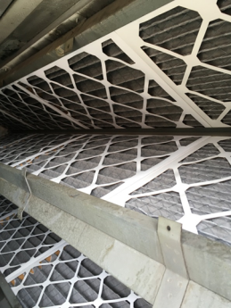
Bank of pleated filters in AHU
Picture 16
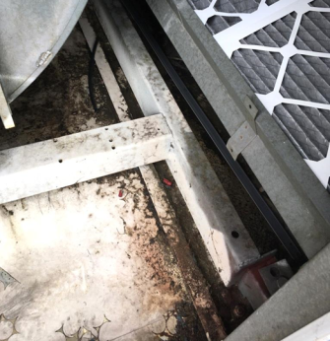
Dust/debris accumulation inside AHU
Location | Windows  Openable | Ventilation |  | Remarks
 |  | Intake | Exhaust
701 | N | Y | N | Supply blocked dryer sheets, tile floor
702 | N | Y | Y | Tile floor
703 | N | Y | N | Tile floor, DEM
703 Hallway |  |  |  | MT’s > 10
704 | N | Y | Y | Tile floor
711 | Y | Y | Y | WD CT
714 |  |  |  | Ajar CTs, dust/debris on vents
715 | Y | Y | Y | Odor
716 Guidance Suite |  |  |  | Dust/debris on vents, 3 WD CTs
720
723 | Y | Y | Y | Sink
724 | Y | Y | Y | WD and missing tiles, sink
Auditorium | N | Y | Y | No odor detected
Cafeteria | Y some | Y | Y | NC, large steel girders, overhead ductwork and exposed brick
Sick Bay |  |  |  | 1 WD CT
810
811 |  |  |  | WD CT
812 |  |  |  | Missing floor tiles, WD CT around vent
813 | Y open | Y | Y
816 |  |  |  | Missing floor tiles
817 | Y open | Y | Y | WAC not in window, sink, missing floor tiles
818
819 | Y open | Y | Y | Sink
820 |  |  |  | Missing floor tiles
821 | Y open | Y | Y | NC
851
852 |  |  |  | Missing/damaged floor tiles, dust/debris on vents
853 | Y open | Y | Y | Acoustical wall panels, classroom tiered, books, NC
854
855 | Y open | Y | Y | Books stored under sink, NC
856 |  |  |  | PF
857 | Y open | Y | Y | Paper stored under sink, WAC with dirty filter
858
859 | Y open | Y | Y | NC, roof puddles visible through window
860
861 Hallway |  |  |  | WD CP/CT
Boys Restroom | N | N | Y | Dusty vent
Girls Restroom | N | N | Y | Small water stain on ceiling
Women’s Restroom |  |  | Y | WD CT around vent
901 |  |  |  | 4 WD CT, dust/debris on vents, PF
903 Computer Lab
904 | Y | Y | Y
906 | Y | Y | Y | NC, WD CT,
907 |  |  |  | Dust/debris on vents, cobwebs corner
908 | Y | Y | Y | Missing floor tiles
909 |  |  |  | Numerous WD CTs
910 | Y | Y | Y | WD CT (3), sink
911 | Y open | Y | Y
912 | Y | Y | Y | Sink
Boys Restroom | N | N | Y
Girls Restroom | N | N | Y
Girls Restroom | Y | N | Y
Stairwell | Y | N | Y | MT

