

WARNING

Lower Mystic River Area
Area includes lower Mystic River and Chelsea Creek.
This is a great place to fish.
Eating fish from this area can make you sick.
Polluted fish can still look healthy.
IMPORTANT

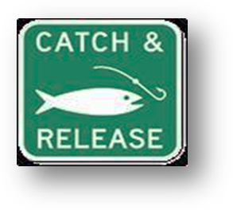
Everyone can catch and release fish. Most people should not eat any fish caught from this area.
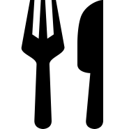
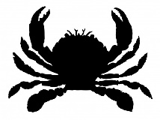
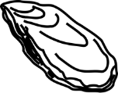
Shellfishing is not allowed in this area.
Nobody should catch or eat any shellfish from this waterbody, including oysters, clams, mussels, crabs, and lobsters.

          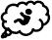   | 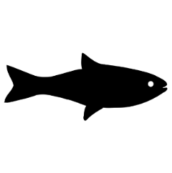  Children under 12, pregnant women, nursing mothers, and women that may become pregnant should not eat any fish or shellfish caught from this area.
 |   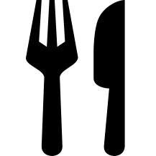  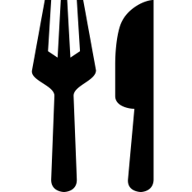  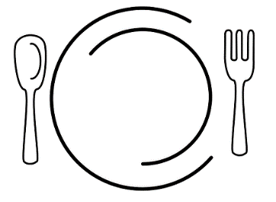  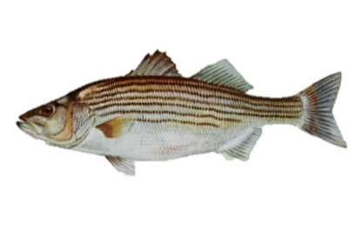  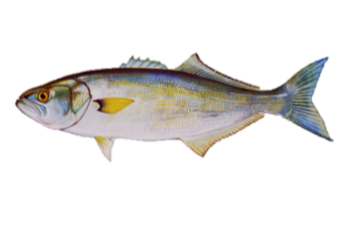  Everyone else should eat ONLY bluefish and striped bass from this waterbody.  Striped Bass  Bluefish

Issued by the Massachusetts Department of Public Health
More information about the Lower Mystic River Area is available at www.mass.gov/lower-mystic.

MDPH has issued other important health recommendations for eating fish.
To find out more information, please call 617-624-5757 or go to www.mass.gov/dph/fishadvisories.

